Reservoir Simulator for Two-Phase Flow

Tanvi Chheda

**ABSTRACT**

Implicit pressure, explicit saturation (IMPES) solver is used to develop a two phase simulator for two dimensional reservoir of quarter five-spot pattern. We assume the fluids and rock are incompressible. For homogenous reservoir, the saturation front is circular and progresses at a decreasing velocity from source to producer. The pressure profile is unsymmetrical, with pressure gradient being low near water front. Increasing oil mobility increases the area swept by water front as well as sweep efficiency. Heterogeneous reservoirs with same average mobility as homogenous ones have lower shock front velocity. Decreasing grid size requires time step to be decreased by square of the divisor for stability.

**INTRODUCTION**

IMPES method uses partially coupled pressure and saturation equations and solves them sequentially. The reservoir is quarter five spot pattern, water is injected into the reservoir at a constant volumetric rate and displaces the resident oil towards the production well.

For pressure, mobility is based on the saturation from the previous time step, and the equation is solved using Euler backward approach. The saturation equation takes velocity from pressure solver and initial saturation from previous step, making it explicit solver. This explicit approximation can cause instability if small enough time change is not chosen. Solving both equations implicitly would be computationally expensive, having to solve non-linear system of 2*Nx*Ny equations per time step. IMPES scheme needs to solve only half of that, hence for saturation we use explicit and use CFL condition to ensure an appropriate time is chosen for each step.

**METHODOLOGY**

We start by using mass conservation and Darcy’s law equations for individual fluids in a multiphase system.

$$\frac{∂}{∂t}\left( {}_{} S_{}\right)- .\left({}_{} {}_{} p\right)= {}_{} q_{}$$

Fluid and reservoir are assumed incompressible so $and {}_{}$ drop out. Corey correlation is used to approximate relative permeability, which is used to get mobility of the phases and fractional flow.

${ k}_{r,}=k_{r,, e}{\left({ S}_{, e}\right)}^{n_{}}$

$${}_{}= \frac{{K k}_{r,}}{{}_{}} , { f}_{}= \frac{{}_{}}{{}_{t}}$$

$$\frac{∂}{∂t}\left( S_{}\right)+ .\left(f_{} u_{t}\right)= q_{}$$

Saturations of the two phases and pressure are the three unknowns, and two conservation equations as above with $S_{}+S_{β}= 1$ are the three equations. Fractional flow form is advantageous because ut is obtained independently. Global pressure and saturation are loosely coupled. Saturation equation is non-linear and leads to shock formation.

**Assumptions:** We assume an isothermal, isotropic reservoir. Permeability K is usually a tensor that represents ease of flow in different directions due to fractures or rock fabric. However, in our simulation it is a scalar. When we substitute the Darcy’s law velocity in the mass conservation equation to obtain pressure equation, we assume no effect of gravity. No diffusion, fingering, dispersion, Newtonian mobility for all phases.

**Discretization:**

In pressure equation, for space discretization, we use the definition of a derivative:

$$\frac{∂p}{∂x}=\lim_{x→0} \frac{p_{i}-p_{i-1}}{Δx}$$

$$T_{i-1/2}= \frac{{}_{i}{}_{i} * {}_{i-1}{}_{i-1}}{2 ({}_{i}{}_{i} + {}_{i-1}{}_{i-1})} \frac{1}{{Δx}^{2}}$$

Since transmissivity is an interface parameter, it is calculated as a harmonic average. Since transmissivity changes as saturation changes, it is updated at each time step using mobility from saturation equation. The transmissivity can be arranged in a tri-diagonal matrix A and the linear system A p = q is solved.

In discrete form, the saturation equation is written as:

$$\frac{S_{i}^{n+1}-S_{i}^{n}}{Δ t}+\frac{1}{ ∆x} \left({\left[fu\right]}_{i+\frac{1}{2}}^{t}- {\left[fu\right]}_{i-\frac{1}{2}}^{t}\right)=0$$

f at the interface is taken from the cell in the direction that information comes from. In this 1st order upwind scheme if Λ > 0, fi+1/2 = fi and if Λ < 0, fi-1/2 = fi+1.

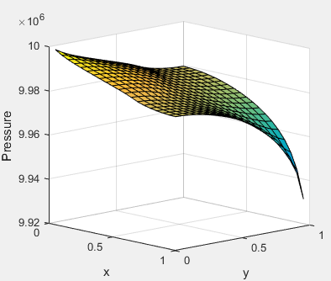**RESULTS**

*Fig. 1: Pressure profile of the base case: Nx = Ny = 20, Simulation time = 5E-7, viscosities: μwater = 1E-3, μoil = 1E-2. Pressure gradient is low behind the shock front and high ahead of it.*

*Fig. 2: Saturation profile of the base case. Water saturation at all points initially was Swc, then Sw at position (0, 0) was set as 1-Sor. Cells receive information from neighbors both to its west and south (upwind method).*

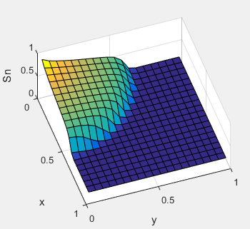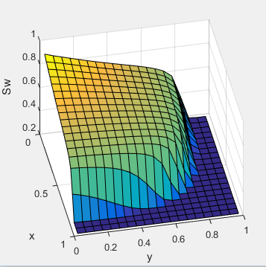

*Fig. 3: Same simulation time and grid configuration as base case of Fig. 2. But viscosity of oil is reduced to 5E-3 and shock front is seen to progress further towards producer, and has higher sweep efficiency where front has already passed.*

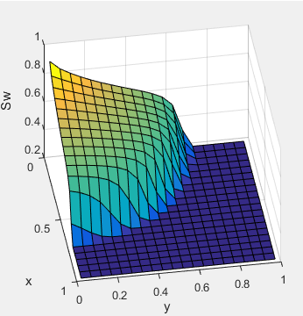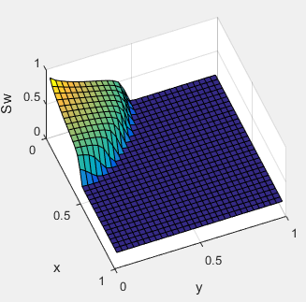

*Fig. 4: Grid resolution is increased to 30 x 30 from 20 x 20. Evidently, more time would be required to obtain the base case result. Doubling grid resolution i.e. halving cell size requires time step to be divided by four for stability.*

*Fig. 5: Random variation in mobility is introduced. Mean mobility is still same as base case, but notice that shock front has progressed less. This is because velocity is strongly reduced by bottlenecks where mobility is low.*

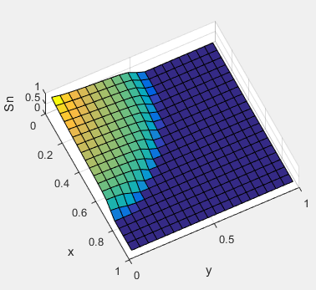

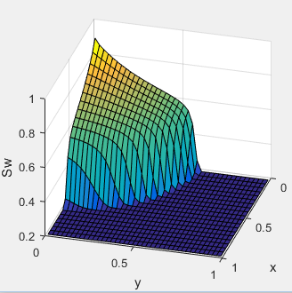*Fig. 6: Mobility is doubled in x-direction and halved in y-direction. This can happen in heterogeneous reservoir where rocks are more permeable in one direction than another. Shock front velocity is higher in more permeable direction.*

*Fig. 7: Unequal grid resolution: Nx = 20, Ny = 40. Front remains circular.*

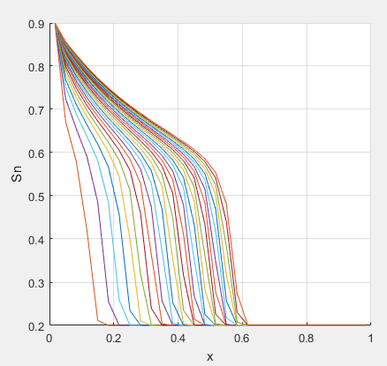

*Fig. 7: Saturation projected on 2D surface for a constant y. Saturation of front is constant. Spacing between two fronts is decreasing with time, i.e. its progressing with decreasing velocity. This is because it has to cover more area as radius increases.*

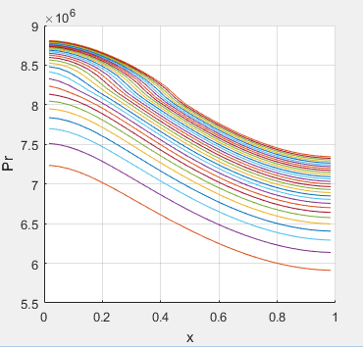

*Fig. 8: Pressure projected on 2D surface for a constant y. Rate constant well boundary condition.*

**CONCLUSIONS**

Front moves faster if water is less viscous. But though oil is pushed faster, there is early water breakthrough and soon lots of water is produced along with oil, increasing separation and refinement cost. To avoid early water breakthrough, we aim for piston like displacement which can occur if mobility of oil is more, which can be achieved through EOR methods.

IMPES is a great method if time step is adjusted to grid size and other factors. Instability in explicitly solved saturation equation occurs in regions where the velocities or saturation gradient is high. Maximum allowed time step using CFL stability condition keeps this in check.

.