Reservoir Simulator for Two-Phase Flow

Tanvi Chheda

**ABSTRACT**

Finite difference method is used to solve the transport equation for two immiscible fluids in one dimensional. Fractional flow formulation of incompressible water saturation transport through incompressible rock is solved numerically with a sequential simulation strategy. Explicit solver upwind method is stable only if CFL condition is valid. It is first order consistent in space. Newton Raphson iteration is used for implicit method which is unconditionally stable. Shock front is seen travel with constant velocity. Increasing relative permeability or decreasing viscosity of injected fluid increases the time until breakthrough. The velocity of fluid is constant throughout reservoir to maintain continuity.

**INTRODUCTION**

For secondary methods of oil recovery, fluids such as water are injected into the reservoir to displace oil. To understand this flow, we begin by writing the mass conservation and Darcy’s law equations for individual fluids in a multiphase system.

$\frac{∂}{∂t}\left( {}_{} S_{}\right)- .\left({}_{} {}_{} p\right)= {}_{} q_{}$ (1)

In this study, we consider two incompressible fluids and divide the equations by density on both sides. Since rock is also assumed incompressible, porosity is constant. No diffusion, fingering, dispersion, heat conduction, governing equations are 1st-order PDE’s, Newtonian mobility for all phases.

Saturations of the two phases and pressure are the three unknowns, and two conservation equations as above with $S_{}+S_{β}= 1$ are the three equations. Note that for now, pressure is a global variable. It’s not $p_{}$ specific to the phase, indicating we assume no capillary pressure.

To solve these equations, instead of solving for the unknowns simultaneously, we prefer to solve one hyperbolic saturation equation and one elliptical pressure equation, since adding Eq. 1 for both phases gives the simpler form

$$- .\left({}_{t}. p\right)= q$$

We solve for pressure and obtain total velocity, then use fractional flow definition.

${u_{t}. = }_{t}. p$; $f_{}={{}_{}}/{{}_{t}}$

Eq. 1 can be re-written as

$$\frac{∂}{∂t}\left( S_{}\right)+ .\left(f_{} u_{t}\right)= q_{}$$

Fractional flow form is advantageous because ut is obtained independently. Global pressure and saturation are loosely coupled. Saturation equation is non-linear and leads to shock formation. It can be solved analytically as Buckley Leverett solution or numerically as follows:

$$\frac{∂S_{}}{∂t}+\frac{u_{t}}{} \frac{∂f_{}}{∂S_{}} \frac{∂S_{}}{∂x_{}}= q_{}$$

$$\frac{S_{i}^{n+1}-S_{i}^{n}}{Δ t}+\frac{1}{ ∆x} \left({\left[fu\right]}_{i+\frac{1}{2}}^{t}- {\left[fu\right]}_{i-\frac{1}{2}}^{t}\right)=0$$

In this discretized form, f at the interface is taken from the cell in the direction that information comes from. In this 1st order upwind scheme if Λ > 0, fi+1/2 = fi and if Λ < 0, fi-1/2 = fi+1. Taking fractional flow at the interface as the mean of fw from cells on either side gives an unconditionally unstable situation.

Normalized saturation is defined as:

$${ S}_{, e}= \frac{{ S}_{}-{ S}_{,r}}{1-{ S}_{β,r}-{ S}_{β,r}}$$

Corey correlation is used to approximate relative permeability, which is used to get mobility of the phases and fractional flow.

${ k}_{r,}=k_{r,, e}{\left({ S}_{, e}\right)}^{n_{}}$

$${}_{}= \frac{{K k}_{r,}}{{}_{}} , { f}_{}= \frac{{}_{}}{{}_{t}}$$

Explicit solver uses the previous time step n to obtain the fractional flow. Implicit solver uses time step n+1 as:

$$\frac{S_{i}^{n+1}-S_{i}^{n}}{Δ t}+\frac{1}{ ∆x} \left(f_{i}^{n+1}u_{R}- f_{i-1}^{n+1}u_{L}\right)=0$$

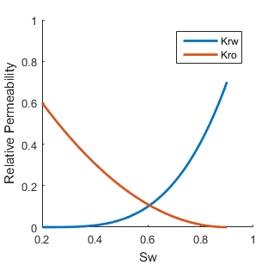

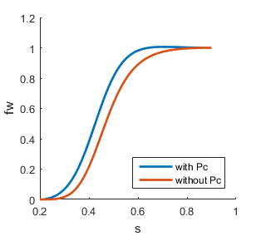

*Fig. 1: Relative permeability and S-shaped fractional flow vs saturation using Corey approximation. Corey-Brooks correlation was used to obtain f in case of capillary pressure.*

Input parameters for simulations in this report: Corey-coefficient nw = 3.5, no = 2.

Water endpoint rel. perm. Krwe = 0.7

Oil endpoint rel. permeability Kroe= 0.6

Connate water saturation Swc = 0.2

Residual oil saturation Sor = 0.1.

Corey Brooks: pc = pd Sw-1/2

Accounting for capillary pressure can give insights into imbibition effect of flow as opposed to just drainage.

To obtain fn+1 in implicit method, we use Newton linearization lemma.

$$f^{n+1} f^{}+\frac{∂f}{∂S}|^{} \left(S^{+1}-S^{}\right)$$

= ${ f}^{}+\frac{∂f}{∂S}|^{} δS^{+1}$

Substituting this in previous equation and moving all terms with $δS^{+1}$ to one side gives

$${δS}_{i}^{+1}+\frac{Δ t}{ ∆x}\left(\frac{∂f}{∂S}|_{i }u_{R} {δS}_{i}^{+1}- \frac{∂f}{∂S}|_{i-1}{ u}_{L} {δS}_{i-1}^{+1}\right)= -R_{i}$$

$$R_{i}={(S}_{i}^{+1}-S_{i}^{n})+ \frac{Δ t}{ ∆x} [f_{i}^{}u_{R}- f_{i-1}^{n}u_{L}]$$

The goal is to reduce residual R to specified tolerance. We do this by using Newton Raphson iterations to compute dS until it is small. dS = A\(-R), where A or Jacobian matrix is constructed using the coefficients of dS in equation above.

**RESULTS:**

Water saturation decreases gradually away from injector and is only Swc at the downward side of propagating front. Notice in Fig. 2, saturation of shock is same at each time step, indicating it is only function of initial and boundary conditions. Saturation of water at breakthrough and after can thus perhaps help in correcting the initial estimates of properties of the reservoir.

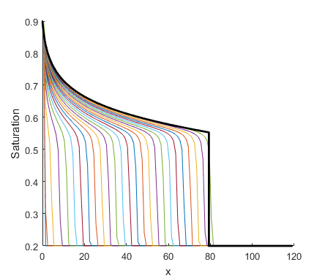*Fig. 2: Time evolution of saturation curve and match with Buckley Leverett analytic (black).*

*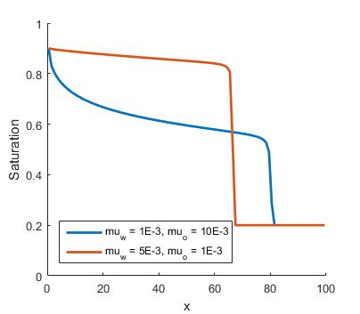Fig.3: Blue- water more viscous than oil, red- vice versa.*

Unconditionally stable implicit solution using Newton Raphson iteration for linearization is shown in Fig. 4. Krwe = 0.2 and Kroe = 0.6. In water wet reservoir relative permeability of water is lower, hence mobility and fractional flow of water is lower too. Shock front has not reached as far as Fig. 2 but shock saturation is higher. On the other hand, introduction of non-wetting phase drastically reduces relative permeability of the wetting phase because non-wetting phase occupies larger pore spaces, and is easier to push out do to more flow in large pores.

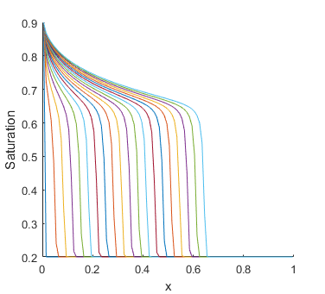

*Fig. 4: Implicit solution for oil wet reservoir: Krwe=0.2, other parameters same as Fig. 2.*

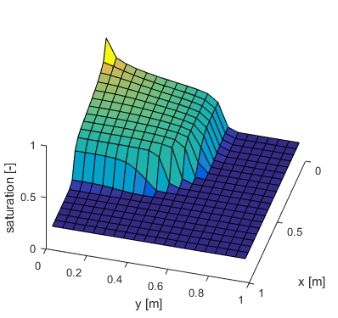

*Fig. 5: Water saturation at all points initially was Swc, then Sw at position (1,1) was set as 1-Sor. Cells receive information from neighbors both to its west and south.*

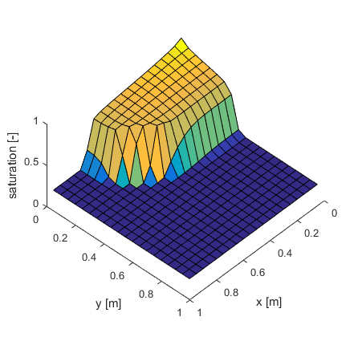

*Fig. 6: Velocity along x is twice that along y, say due to different pressure conditions or anisotropic rock matrix.*

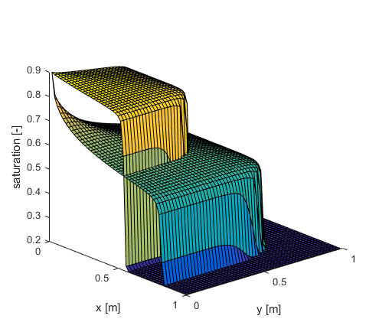

10

*μOil/ μwater*

0.2

*Fig. 7: Overlay of two simulations to show effect of viscosity on saturation in 2D. Same simulation time in both.*

**DISCUSSION**

To obtain position of shock front we looked for location of maximum value of ∂ fw/∂s. In Fig. 6 slope indicates velocity of front and it is constant for a given viscosity ratio. Front moves faster if water is less viscous. But though oil is pushed faster, there is early water breakthrough and soon lots of water is produced along with oil, increasing separation and refinement cost.

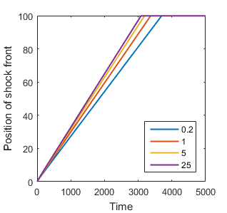

*μoil/ μwater*

*Fig. 8: Shock front movement in time and space for different oil to water viscosity ratios.*

Fig. 9 shows that produced fluid initially produces oil (Sw=Swc). Once shock reaches the last cell, water saturation jumps to shock saturation Sw,shock. More water is produced until recoverable oil is obtained and Sw of produced fluid reaches 1-Sor.

To avoid early water breakthrough, we aim for piston like displacement which can occur if mobility of oil is more than that of water:

$$M= \frac{krw/ w}{kro/ o}<1$$

To achieve this, relative permeability of injected fluid is decreased by altering rock wettability using polymers and viscosity of oil is increased by supplying heat through methods like steam injection.

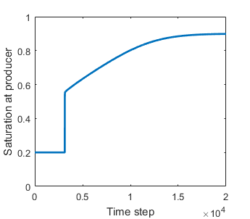

Shock reaches cell, produced fluid has much more water.

Sw-shock

Sw = 1-Sor

*Fig. 9: Water saturation at the end or producing cell with time.*

Sensitivity Analysis:

The difference between analytic solution and numerical solution can be due to three sources: 1. Discretization error depends on size of ∆x and ∆t. It can be estimated using Taylor expansion or consistency analysis. 2. Iteration error depends on the tolerance we specify. 3. Round-off error due to limited precision of software- this error is very small compared to first two.

Making ∆x and ∆t very small to reduce discretization error can increase computation time. Hence we analyze consistency, stability and convergence to know beforehand the cost and benefits of smaller steps.

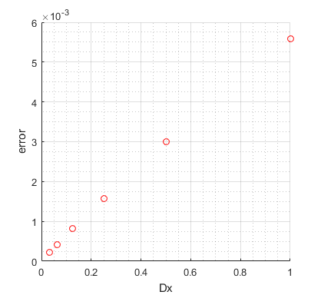

*Fig. 10: Plot of error (maximum difference between Buckley Leverett analytical solution and explicit transport solver) as Dx size is halved.*

Fig. 10 shows error is halved when the size of ∆x is halved for explicit 1D transport equation solver. Slope of the line in log-log plot of error and ∆x gives order of consistence with respect to ∆x = 1.

Consistency is essential but not sufficient to obtain convergence. The solution should also be stable, i.e. a perturbation must damp through time, not increase. Although explicit methods need less computation per time step, they have size restriction on time step size to be stable. Euler forward upwind method is stable if CFL condition is valid: ∆t < CFL* ∆x / Λ.

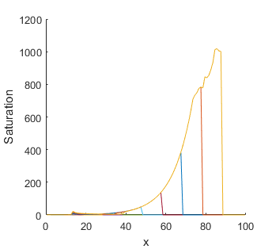

*Fig. 11: Unstable solution, S>1 when CFL condition is not satisfied in time step size explicit solver.*

Implicit solver is unconditionally stable, i.e. there is no restriction on the size of time step for stability. However, the implicit solver can fail to converge if the curvature of fractional flow vs saturation graph is such that the slope decreases and increases at successive steps of Newton linearization. It wouldn’t be able to approximate $s^{n+1} s^{+1} s^{}$.