Reservoir Simulator for Single-Phase Flow

Tanvi Chheda

**ABSTRACT**

Pressure equation for incompressible, semi compressible and compressible fluids is numerically solved in 1-D and 2-D. Homogenous reservoirs are found to have a linear pressure profile between two points at different pressures or between two wells. The velocity of fluid is constant throughout reservoir to maintain continuity. Semi compressible behavior is identical to incompressible when steady state is reached. Compressible fluids generate lower pressure gradient at high pressure because of high density. Stability of the solver is found to depend on the discretization method- implicit or Euler backward method is stable irrespective of time step size. It is also shown to be first order consistent with time and second order consistent with space.

**INTRODUCTION**

Quantifying flow in porous media is useful in many applications- production of oil and gas from hydrocarbon reservoirs, extraction of water from aquifers, understanding spread of contaminants etc. This paper introduces the basic model and method to simulate flow of single phase fluid in a homogenous porous medium in one and two dimensions.

A petroleum reservoir is often structurally complex so analytical solutions are difficult to obtain, and often require oversimplification of the geometry. Nonlinear equations cannot be solved analytically. Hence, we will use numerical methods- finite difference in this case. Simulation is used to predict the future state of a reservoir to optimize production and devise economic recovery strategies.

**METHODOLOGY**

We start by using mass conservation and Darcy’s law equations.

$$\frac{∂}{∂t}\left( \right)- .\left(\frac{K}{} . p\right)= q$$

If the fluid is incompressible, density and porosity are constant and the partial derivative is zero.

$- .\left(. p\right)= q,$ Mobility $=K/$

In one dimension, this can be written an

$$\frac{∂}{∂x}\left( .\frac{∂p}{∂x} \right)= q$$

For semi-compressible fluid in 1-D, the equation reduces to

$$c_{eff} \frac{∂p}{∂t}-\frac{∂}{∂x}\left( .\frac{∂p}{∂x} \right)= q$$

**Assumptions:** We assume an isothermal, isotropic reservoir. Permeability K is usually a tensor that represents ease of flow in different directions due to fractures or rock fabric. However, in our simulation it is a scalar. When we substitute the Darcy’s law velocity in the mass conservation equation to obtain pressure equation, we assume no effect of gravity. The source term is zero for the examples presented but the code can be modified to add source or sinks. The error formulation assumes that transmissivity is constant and pressure is continuous and differentiable for all x.

**Input parameters**: Length, number of grid cells, time steps, initial pressure, boundary conditions and maximum number of Newton approximation iterations are chosen appropriate to the problem. For comparison of analytic and numerical solutions in case of semi-compressible system in Figure 3, we use

Absolute permeability K=10-14 m2,

Length of reservoir L = 100 m,

Viscosity μ =10−3 Pa.s, Porosity φ = 0.3,

Effective compressibility ceff =10−6 Pa-1.

**Co-ordinate system:** Pressure, density and lambda are given at cell centers; transmissibility and velocity are calculated at interfaces.

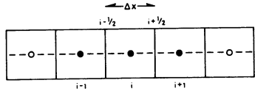

${}_{i}, {}_{i}, p_{i}$ ${}_{H}, T$, u

**Discretization:**

For incompressible flow we rewrite the differential equation by using the finite difference instead of the real derivative. For space discretization, we use the definition of a derivative:

$$\frac{∂p}{∂x}=\lim_{x→0} \frac{p_{i}-p_{i-1}}{Δx}$$

Since transmissivity is an interface parameter, it is calculated as a harmonic average. For compressible system:

$$T_{i-1/2}= \frac{{}_{i}{}_{i} * {}_{i-1}{}_{i-1}}{2 ({}_{i}{}_{i} + {}_{i-1}{}_{i-1})} \frac{1}{{Δx}^{2}}$$

In semi and incompressible cases, the transmissibility does not include density. First and last cells have half ∆x and this is accounted for.

$$T_{i-1/2} \left(p_{i}-p_{i-1}\right)+ T_{i+1/2} \left(p_{i}-p_{i+1}\right)=q/armonic average.ressible cases, the transmissibility semi-compressible system in Figure ximize economic returns.rbance must d$$

The transmissivity can be arranged in a tri-diagonal matrix A and the linear system A p = q is solved.

Semi compressible system updates the pressure at each time step, so time discretization is done and the linear system is solved at each time step. Pressure obtained from previous time step is used to update the initial condition for next step.

$$c \frac{∂p}{∂t}= \frac{c }{Δ t} (p_{i}^{n+1}- p_{i}^{n})$$

A diagonal matrix C where diagonal cells have value c φ/∆t. This term can be added to A p = q at time step n and solved explicitly.

$$C p^{n+1}=\left(q+C p^{n}\right)-A p^{n}$$

The initial condition is given and only unknown is pin+1. So only one equation for any point needs to be solved. This is explicit method, or Euler forward. But if backward difference is applied then N equations are solved simultaneously, N being total number of cells.

$$\left(C+A\right)p^{n+1}=\left(q+C p^{n}\right)$$

This is Euler backward or implicit method. The discretized form for compressible system by implicit method is:

$$\frac{{( )}^{n+1}-{( )}^{n}}{Δ t}-{ .\left(\frac{K}{} . p\right)}^{n+1}= {( q)}^{n+1}$$

**Linearization:** Since the system is non-linear, we use Newton linearization lemma.

$${}^{n+1} {}^{}+\frac{∂}{∂x}|^{} (p^{+1}-p^{})$$

ξ can be replaced by ρ φ and ρq.

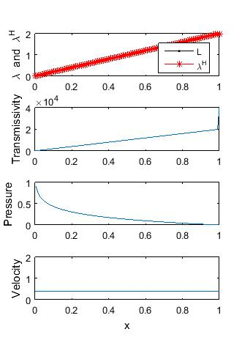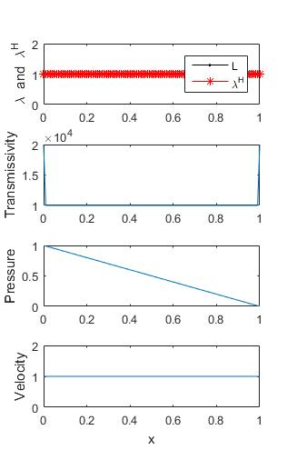

1(a)

1(b)

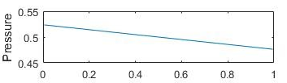

1(c)

*Fig. 1(a) 1-D homogenous reservoir for incompressible fluid, boundary condition pL= 1, pR= 0.*

*(b) Heterogeneous reservoir: Linearly increasing mobility. (c) Wells at first and last cell with pw1 = 1, pw2 = 0 and productivity index = 10 at both wells.*

Residual, R is defined as

$$R\left(p^{}\right)= {\left( q\right)}^{}-$$

$$\frac{{\left( \right)}^{}-{\left( \right)}^{n}}{Δ t}+{ .\left(\frac{K}{} . p\right)}^{}$$

The goal is to reduce R to zero, which happens when

$p^{}= p^{+1}=p^{n+1}$ or $\frac{∂R}{∂p}|^{}=0$

The latter is called the Jacobian, denoted by J. We start by approximating pressure at first Newton iteration as pressure at previous time step. Residual is used to revise this guess. This is done until the residual falls below the code’s specified tolerance. Nested for loops do this at subsequent time steps until steady-state solution to the non-linear equation is obtained.

**RESULTS:**

**1D Incompressible Dirichlet:** Numerically solving A p = q for incompressible fluid and homogenous reservoir i.e. mobility and transmissivity are constant throughout the reservoir gives linear profile for pressure as shown in Fig. 1(a). Dirichlet boundary conditions were applied, pressure was given at the first and last cell and there was no external source. For heterogeneous reservoir like Fig. 1(b), the pressure gradient is not constant but the velocity is still constant throughout the reservoir, because incompressible fluid has to have uniform velocity to maintain continuity.

**1D Incompressible Neumann:** Figure 1(c) shows pressure plot for mobility conditions similar to 1(a) and Neumann boundary condition of well in first cell with pressure pw1 = 1 and last cell with pw2 = 2. The diameter of the well is small compared to size of the blocks, so large pressure gradients can occur near perforated blocks. Hence, Peaceman solution: q = q0 + PI*pw*Lambda is used, where productivity index PI accounts for geometry and geology close to well. We obtain a constant gradient for pressure, though the slope is less than that of Dirichlet boundary condition. If we increase the value of productivity index, the gradient increases.

**1D Semi-compressible implicit:**

At initial time steps, potential and velocity are higher at high pressure. But once it reaches steady state, implicit solution resembles incompressible solution- shown in Fig. 2. Given different boundary conditions pL = 100, pR = 50, the pressure gradient is also negative at some points because the initial condition is pressure at all cells is zero. It evolves to linear pressure profile at steady state, but might require some more time steps or simulation times than that for Fig. 2.

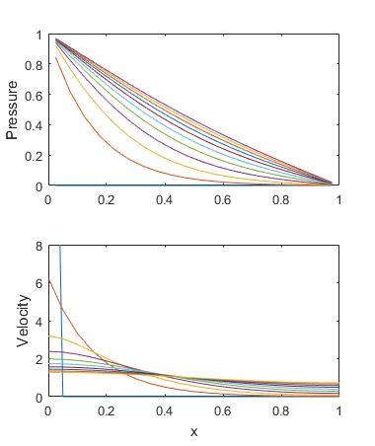

*Fig. 2: Pressure and velocity plots for slightly compressible fluid, porosity 0.4, time step = 0.01 and simulation time 0.1.*

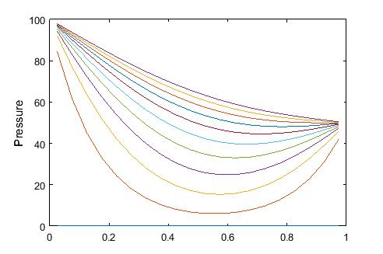

*Fig. 3: Pressure plot for same initial condition, mobility, time step and simulation time as Fig.2 but different boundary condition: pL = 100, pR = 50.*

**1D Semi-compressible explicit:**

Explicit method fails to converge with parameters same as Fig. 2. Explicit method assumes that pressure gradient in space doesn’t change much between time steps and uses existing value of pressure to obtain solution at time n+1. If the gradient is large, above assumption does not hold true and makes the solution unstable. If the time step is reduced to 10-4, the equations do converge but it would take two orders of magnitude time steps more to reach the steady state solution.

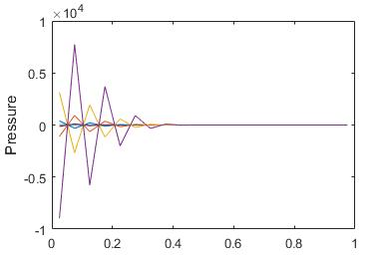

4(a)

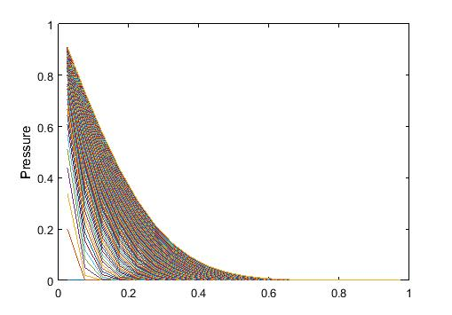

4(b)

*Fig. 4: (a) Semi-compressible fluid, explicit solution with time step DT = 0.001, simulation time T = 0.01 has not converged. (b) Dt = 0.0001, T = 0.01, solution hasn’t reached steady state even after 100 steps.*

**1D Compressible:**

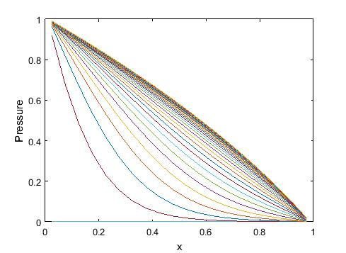

5(a)

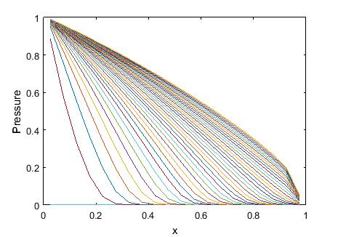

5(b)

*Fig. 5: (a) Compressible fluid, effective compressibility c = 1. (b) c = 50.*

Pressure gradient changes both in space (tangents drawn at last time step in Fig. 5a) and time (tangents drawn at x = 0.2). For a particular time step, at high pressure, density is high.

$$- p= u=constant$$

Since q = 0, mass flux is constant (Fig. 6), so density is inversely proportional to pressure gradient. For higher effective compressibility, the second derivative of pressure with x is bigger. The gradient is higher at high pressure and lower at low pressure in Fig. 5b than Fig. 5a for the same time step.

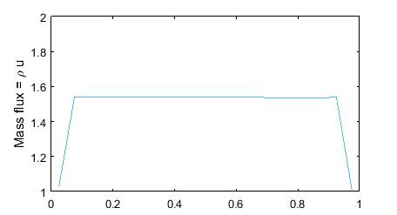

*Fig. 6: Mass flux, ρ u plotted for steady state solution for compressible fluid. Density times velocity is a constant.*

**2D Incompressible:**

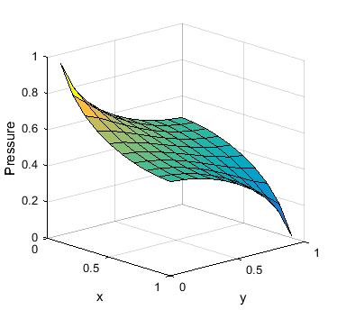

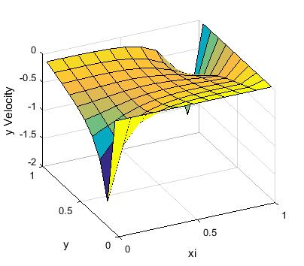

*Fig. 7: (a) Pressure (b) Velocity in 2-D space for incompressible fluid with well at cells (0,0) and at (1,1) with pressure 0 and 1 respectively and productivity index 1000 for both wells.*

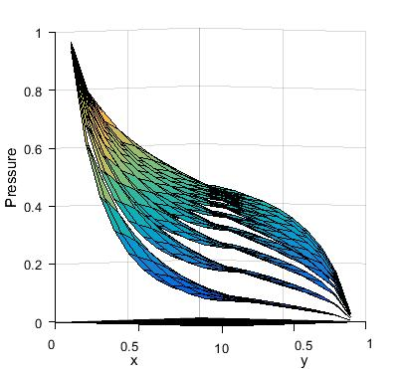

*Fig. 8: Evolution of pressure through time in a 2D space for compressible fluid.*

**DISCUSSION:**

Introducing heterogeneity in the system often reduces flow velocity or mass flux. 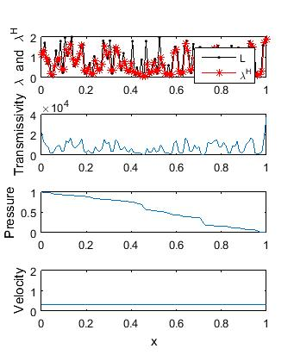

*Fig. 9: 1D incompressible random value of mobility with mean 1.*

*Fig. 10: Compressible 1D system with heterogeneous mobility shows lower velocity at steady state and lower mass flux about 1.36, compare with Fig. 6 where homogenous lambda = 1 gave mass flux ≈ 1.55, compressibility and porosity same in both cases.*

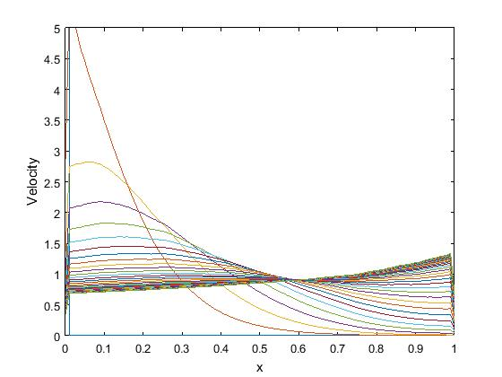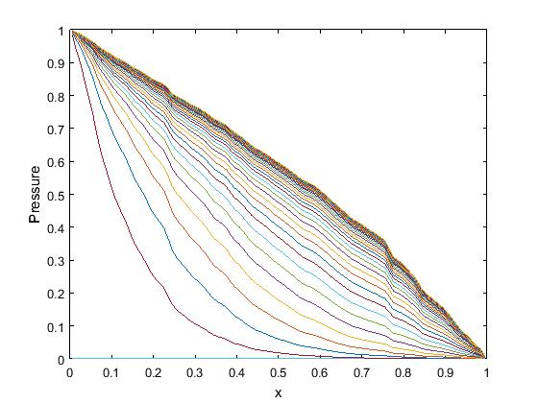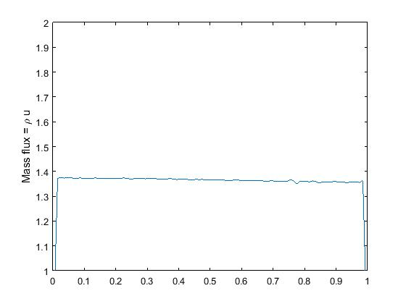

λ ~ N (μ = 1, σ = 0.3)

Overall flow can be influenced strongly by the slowest part of the reservoir, like a bottleneck. Geological permeability barriers might compartmentalize the reservoir and reduce the amount of recoverable hydrocarbons from a well. Identifying these bodies in seismic is therefore important to correctly identify size of the problem and boundary conditions.

Incompressible pressure equation is elliptic. It assumes that change in a parameter like pressure is communicated instantly to the whole reservoir and adaptation to the new condition is instantaneous too. When neighboring blocks are owned by different stakeholders, overproduction or unlawful practice in one block will be quickly identified in the logs of another for oil reservoir since it’s similar to the incompressible case.

Compressible pressure equation is parabolic. Although change in pressure or permeability at a point is instantaneously sensed by the entire system, it takes time for the system to find a new equilibrium. Initial and boundary conditions both determine the state of system.

**Consistency:** 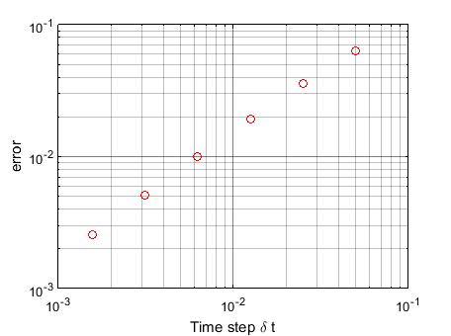

*Fig. 9: Log-log plot of error and time solution as time steps are halved in the slightly compressible 1D solver.*

Slope of the line in log-log plot of error and time step gives order of consistence of Euler backward method with respect to time is 1. This can also be shown by Taylor series expansion. Euler backward method is second order consistent in space.

Higher order consistent methods can be designed by using more neighboring blocks in the Taylor expansion of potential. However, given meter scale cell size and geological uncertainties therein, higher order approximation does not give us better results.

Consistency is essential but not sufficient to obtain convergence. The solution should also be stable, i.e. a perturbation must damp through time, not increase. Although explicit methods need less computation per time step, they have size restriction on time step size to be stable. Implicit solver is unconditionally stable, i.e. there is no restriction on the size of time step for stability.

We hope to extend the scope of this code and analysis to incorporate capillary effect and incorporate multiphase flow. Further work might allow for non-Darcy effects like turbulence, slip or Klinkenberg effect etc.

**REFERENCE:**

Aziz K. and Settari A. (1979). *Petroleum Reservoir Simulation*, Applied Science Publishers.