Roll No: 1906

Pet Supplies Website

**Introduction:**

The project is about an online pet supplies website where user can purchase products for there pets. The store sells supplies for dogs and cats. There are various categories of products like toys, food, bedding, grooming, and other accessories. The categories are further divided into subcategories. For example, food has subcategory as dry, wet, Grain free food etc.

The user needs to first login in order to select products. The selected products get stored in a cart. Once the user selects items in the cart the total is calculated based on the number of items user has purchased and their quantity. User can also remove item from the cart which he don’t want. The user can buy the items now or save for later. Once the user clicks on checkout button a form is displayed showing user data where he needs to insert the address and payment method. After clicking place order button a list will be shown displaying the items he has selected along with their total amount There is no cancellation and return policy.

**Objectives:**

Now a days shopping online is essential. Big and small companies needs to have its commercial website to increase its business all over places. The purpose of this website is to automate and facilitate the process of shopping easily.

**Requirements:**

**Design Of the System**

**E-R Diagram**

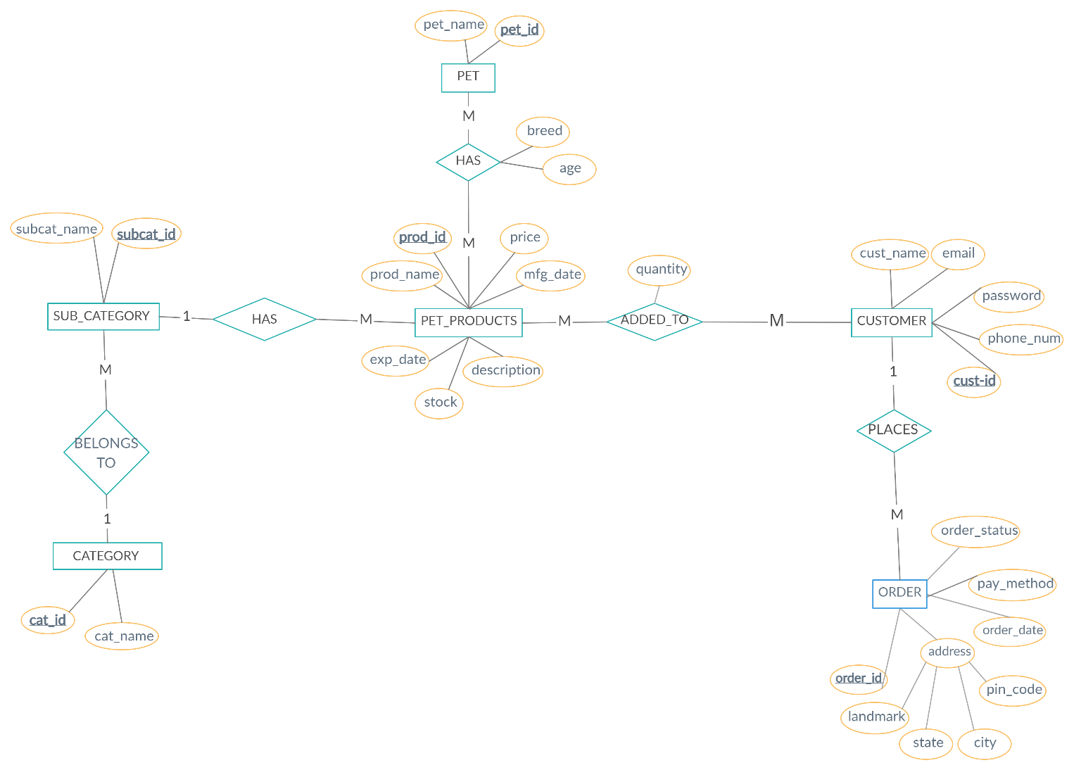

**Use Case Diagram**

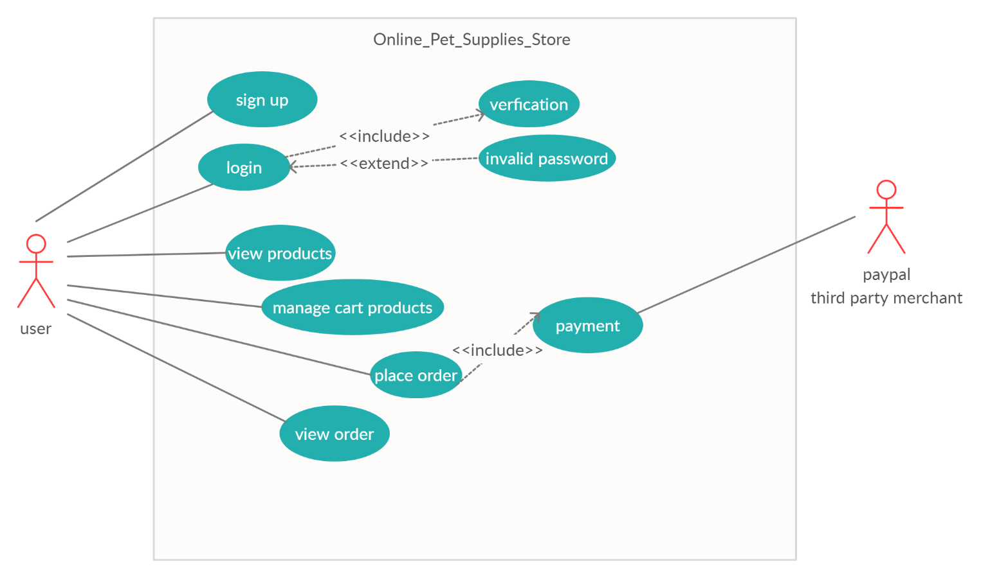

**Implementation:**

1)Inserting customer data into database and logging in

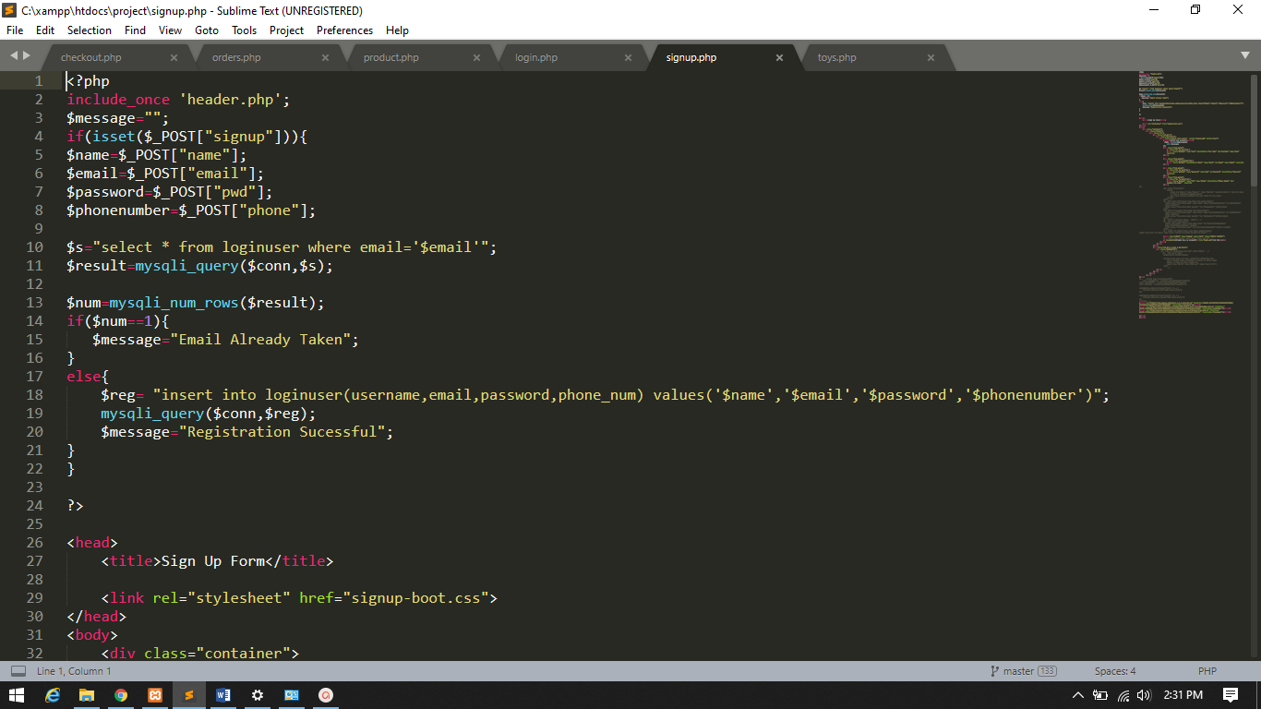

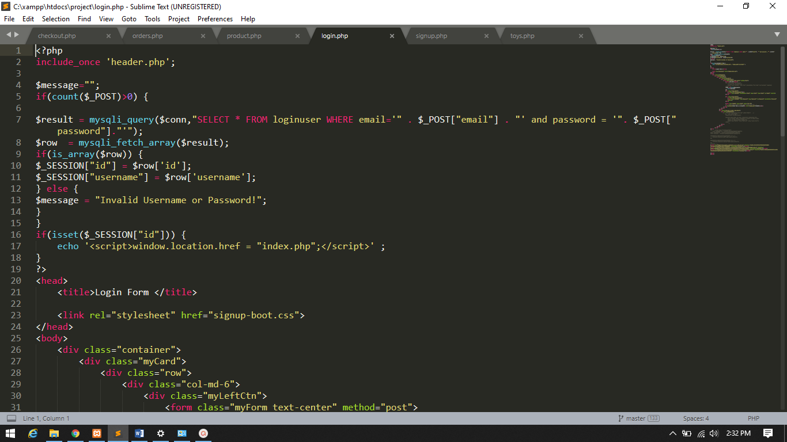

2)Displaying product from database and inserting in shopping cart and also deleting item from cart(report)

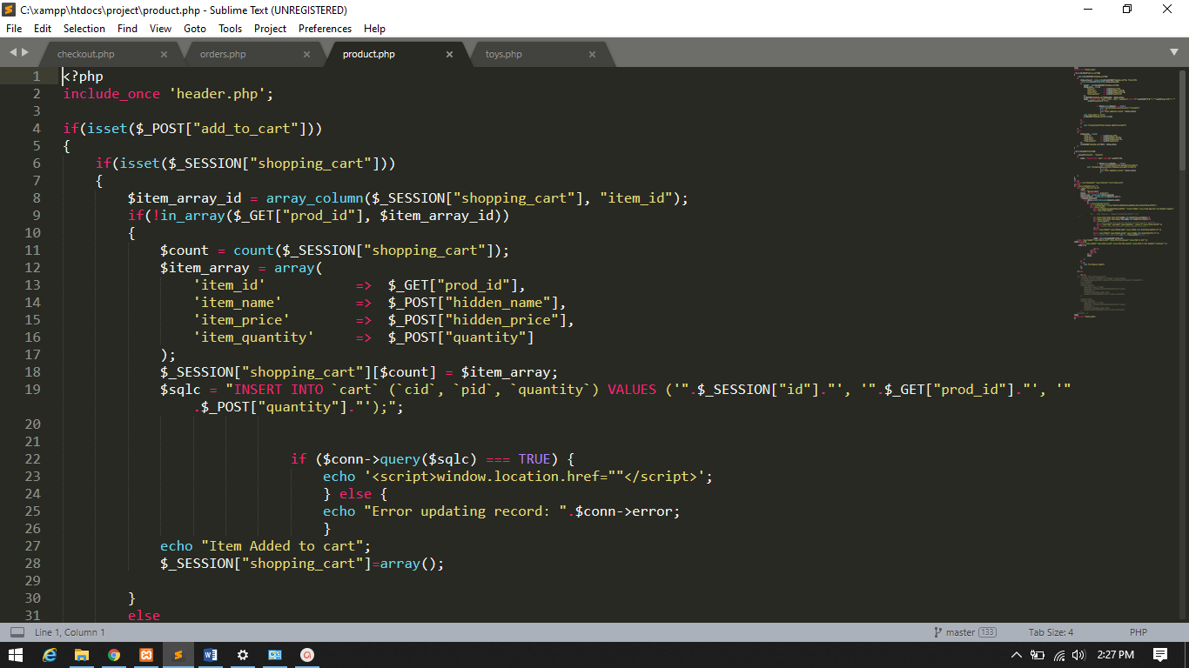

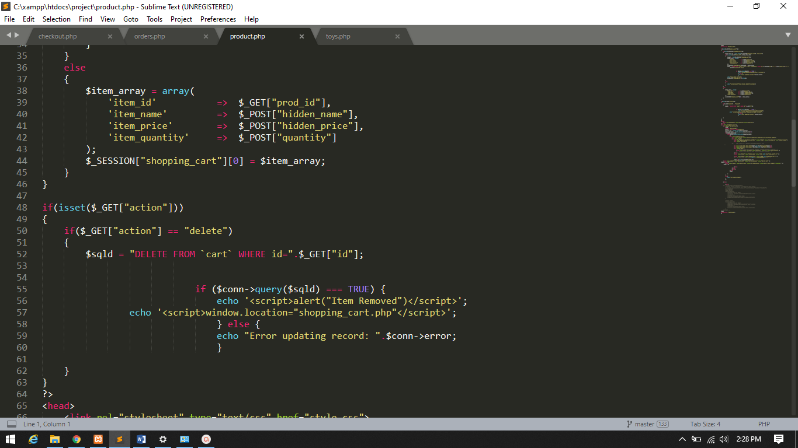

3)Displaying products from shopping cart

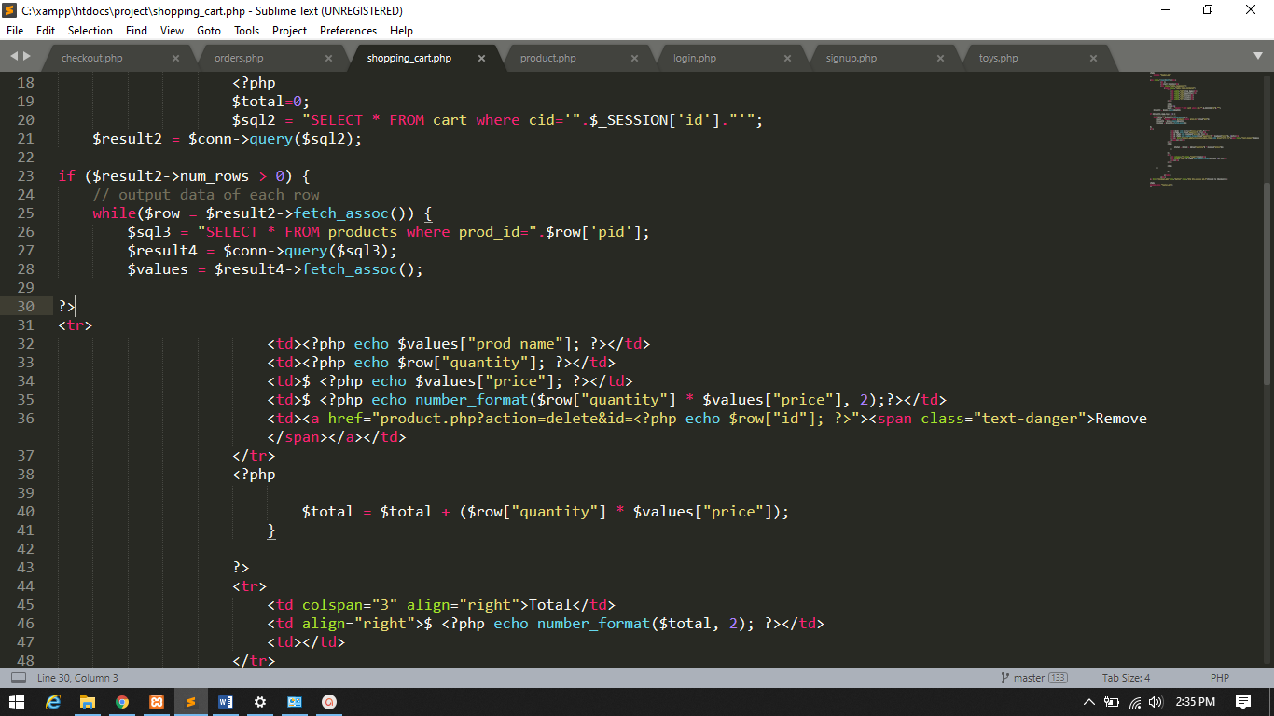

4)Order Details generated with bill when order is placed(report)

First the details are inserted in orders and than displayed

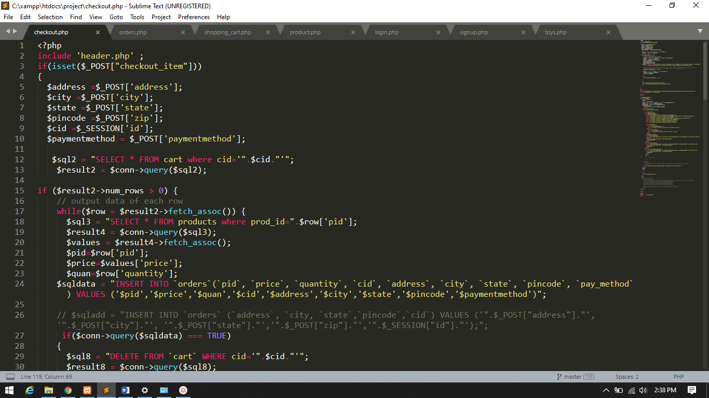

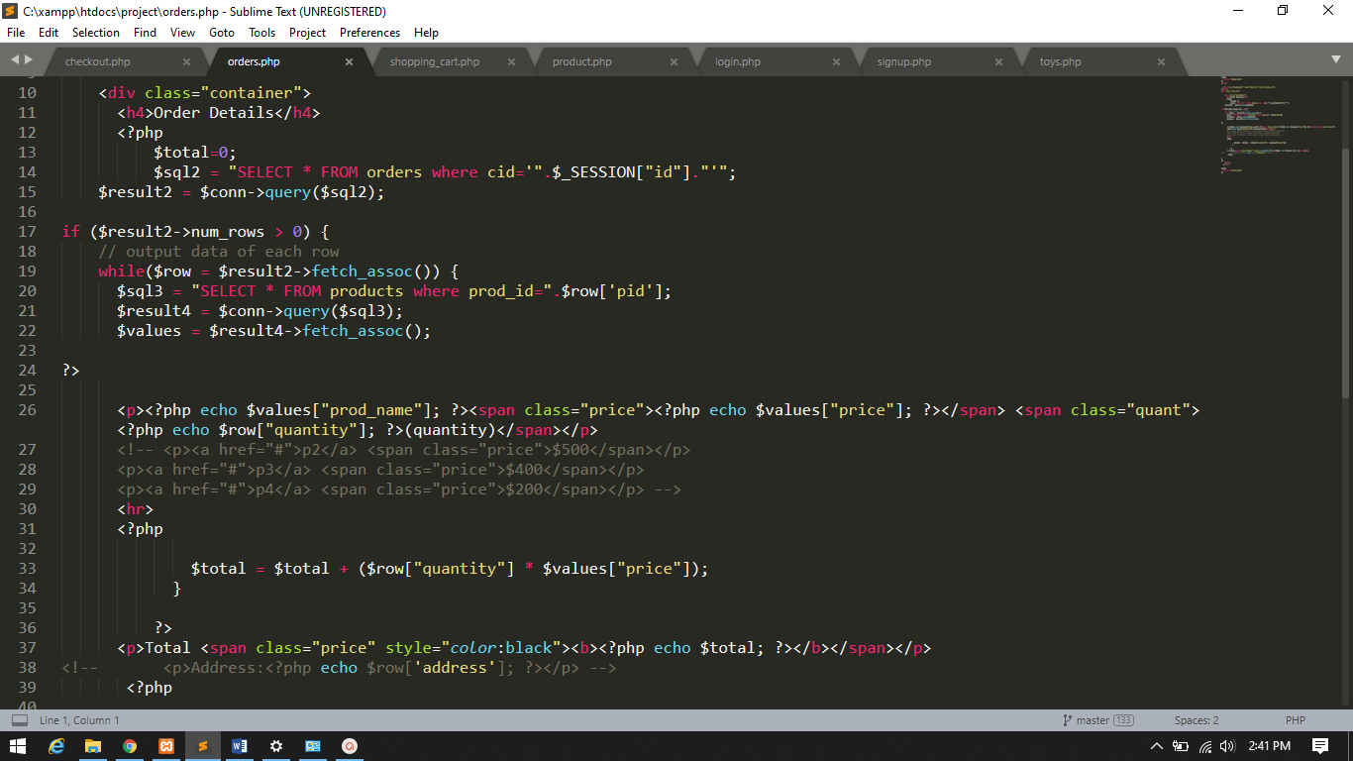

**Result:**

Index Page

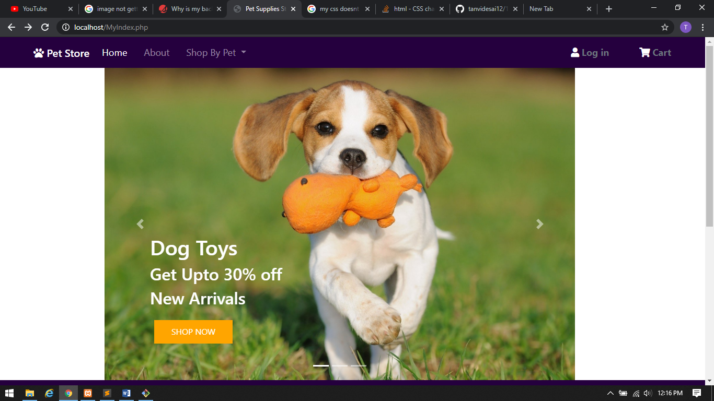

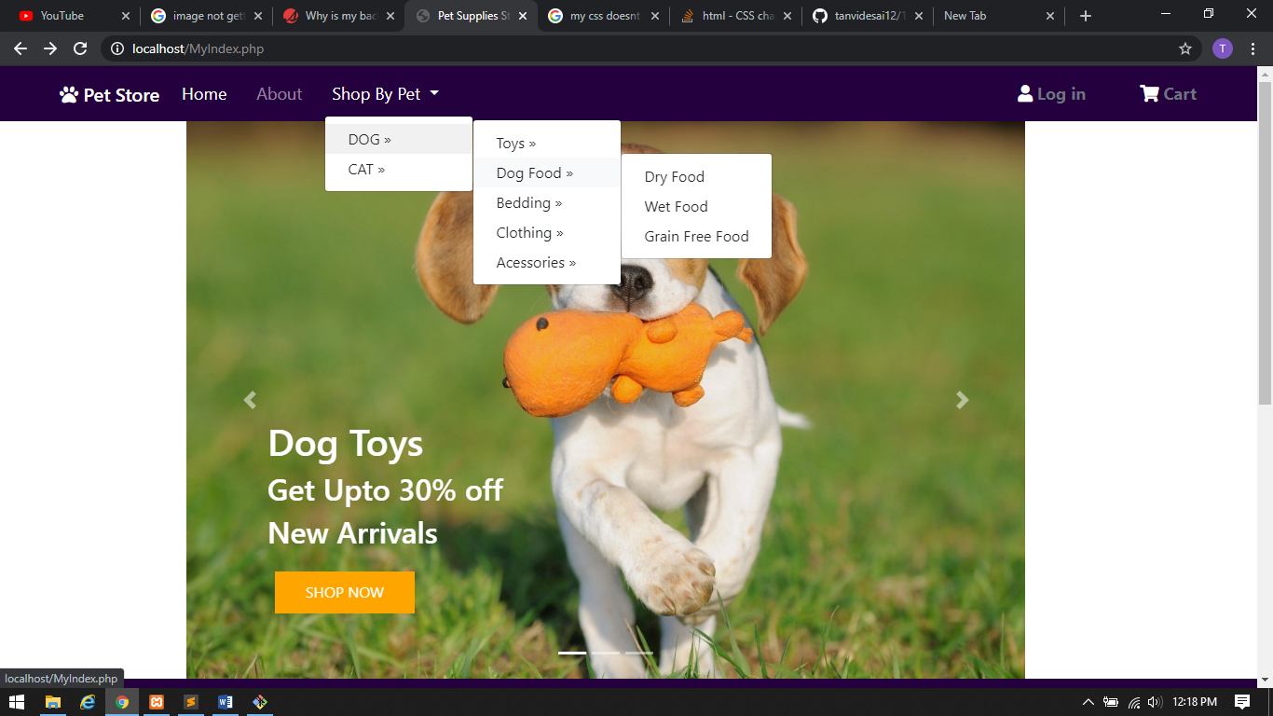

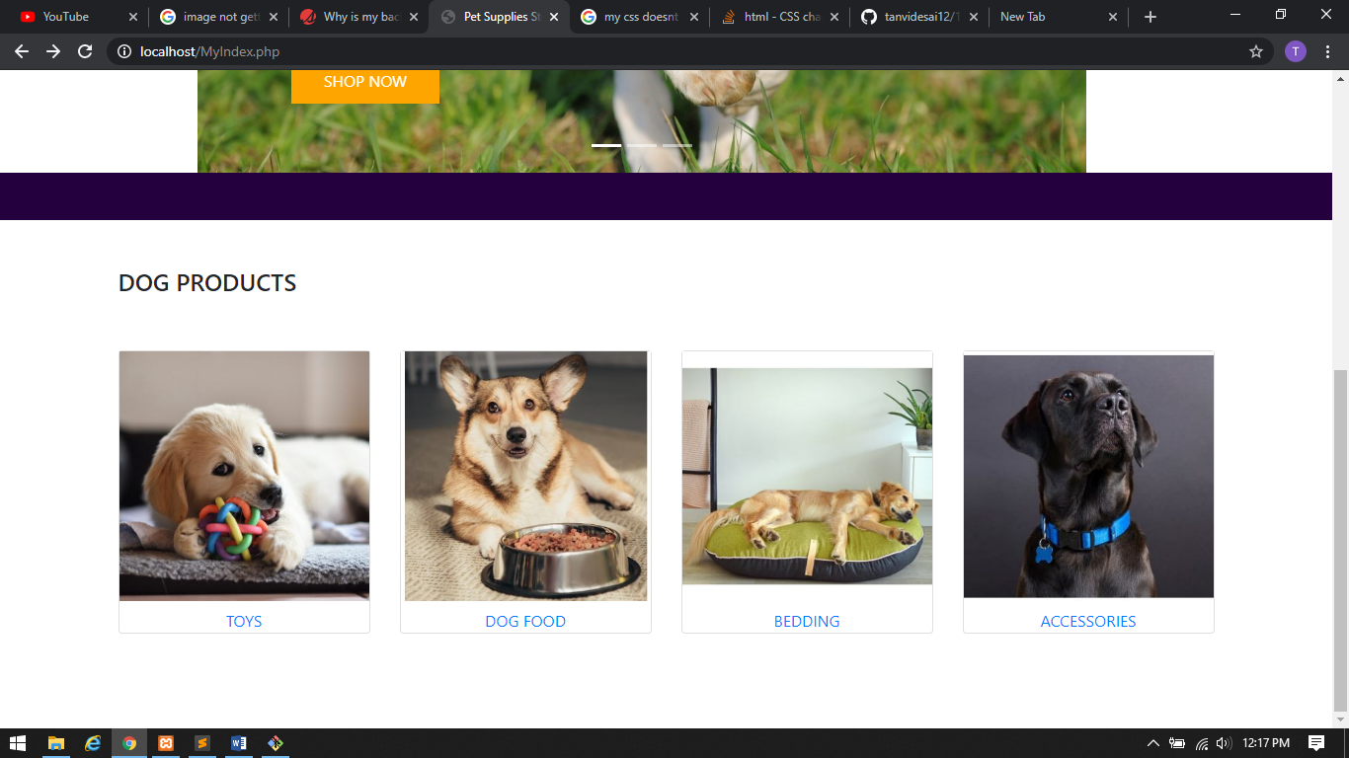

Sign Up Page

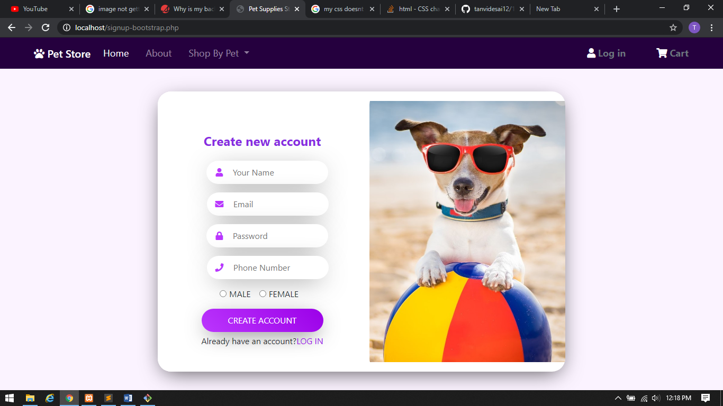

Login Page

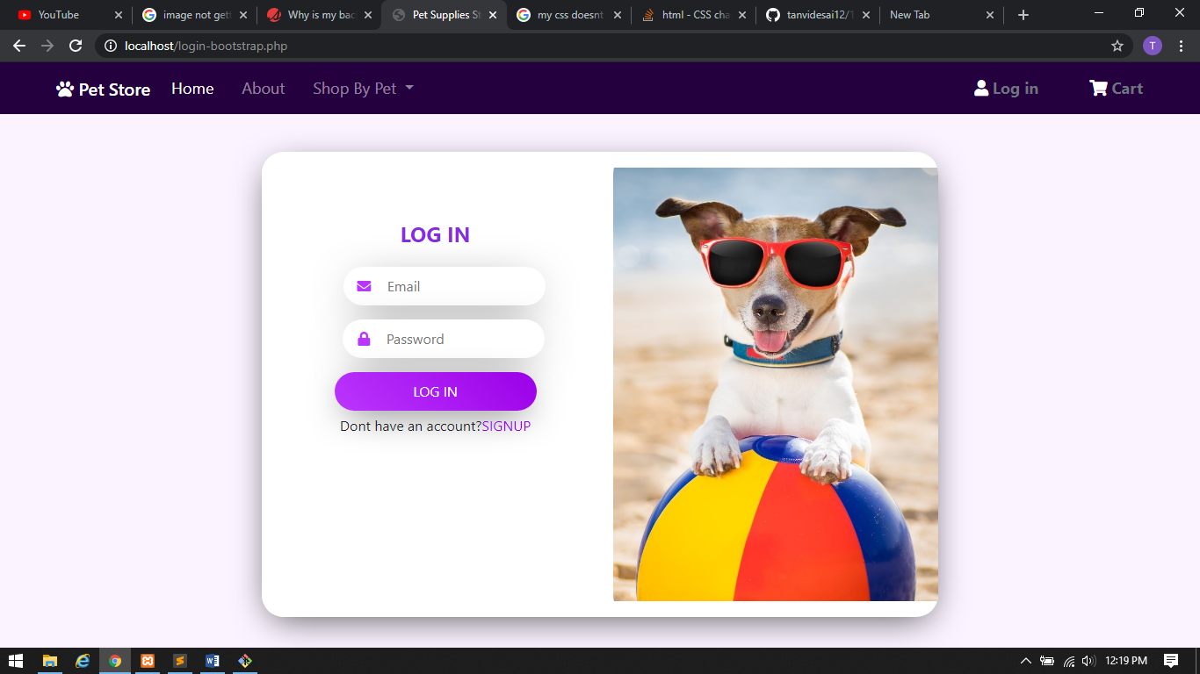

Shopping cart

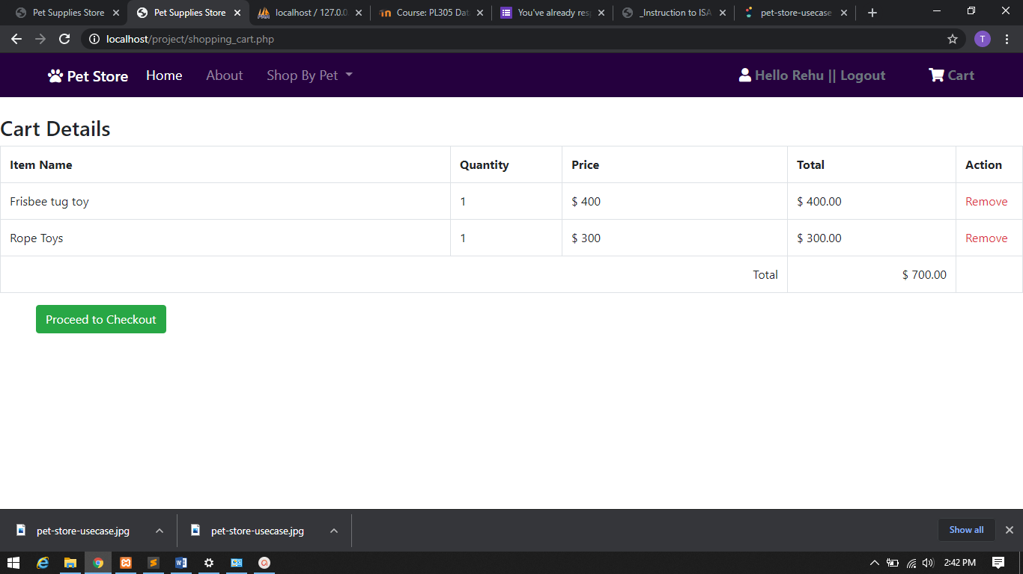

Checkout page

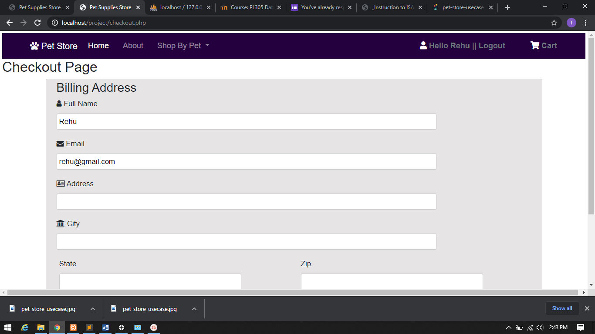

Order details

