**Decoding Transcriptional Regulation: Measuring RNA Interactions in the Nucleus**

Tanvi Ganapathy, California Institute of Technology

Mentor: Mitchell Guttman

Graduate Student Mentor: Andrew Perez

**Introduction**

The nucleus of every cell contains an identical copy of the organism’s complete genome, yet cells are differentiated into hundreds of cell types because of modulated gene expression at various levels from epigenetic to post-translational modifications. Within the nucleus, at the most basic level, the transcription of genes is regulated by proteins binding to the DNA which either “open” chromatin, making it available for transcription or “close” DNA, making it inaccessible for transcription. However, even among accessible genes, different genes are expressed at varying levels, and this is regulated by two main factors. Firstly, activating proteins can bind to certain genes to initiate or increase gene expression. Activating proteins can also recruit cofactor proteins that fine tune the gene’s transcription rate. Secondly, gene expression is modulated by the organization of chromatin within the nucleus. The localization of DNA and RNA sequences with certain proteins can influence gene expression, and moreover, studies suggest that nuclear RNA can impact chromatin structure (1). As a result, we hope to understand the regulation of transcription as a function of these three macromolecules: DNA, RNA, and proteins and their spatial relationship in the nucleus.

**Objective**

The Guttman Lab has previously developed a technique called Chromatin Immunoprecipitation – Done in Parallel (ChIP-DIP) to measure many protein and DNA interactions in a single experiment (2). In addition to ChIP-DIP, the Guttman Lab has developed the Split-Pool Recognition of Interactions by Tag Extension (SPRITE) tool to map DNA/DNA, DNA/RNA, and RNA/RNA interactions (3). Both techniques result in sequences tagged with a barcode that corresponds to associated proteins in the case of ChIP-DIP or associated nucleic acids in the case of SPRITE which allows more interactions to be measured in a single experiment (Figure 1 and 2). The overall aim of this project is to integrate ChIP-DIP and SPRITE to develop a method to measure proteins, RNA, and DNA and their organization in 3D space in the nucleus to understand the regulation of transcription.

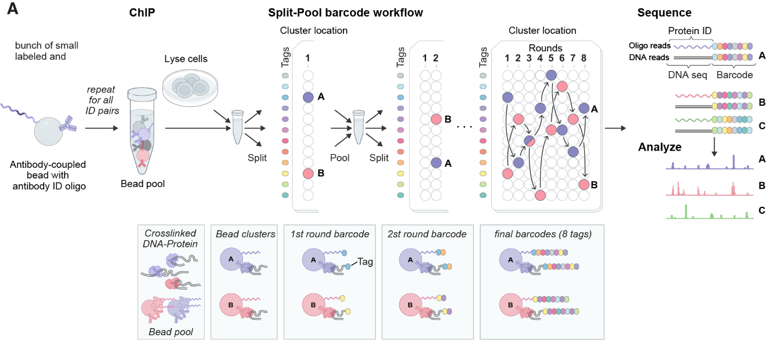However, the ChIP-DIP procedure can currently only be used to detect DNA. Therefore, we need a method to extend ChIP-DIP to detect RNA/protein interactions in the nucleus. This SURF’s specific aim is to develop a method to detect RNA and incorporate RNA into the ChIP-DIP pipeline to map RNA/protein, DNA/protein, RNA/RNA, DNA/DNA, and DNA/RNA interactions in nucleus.

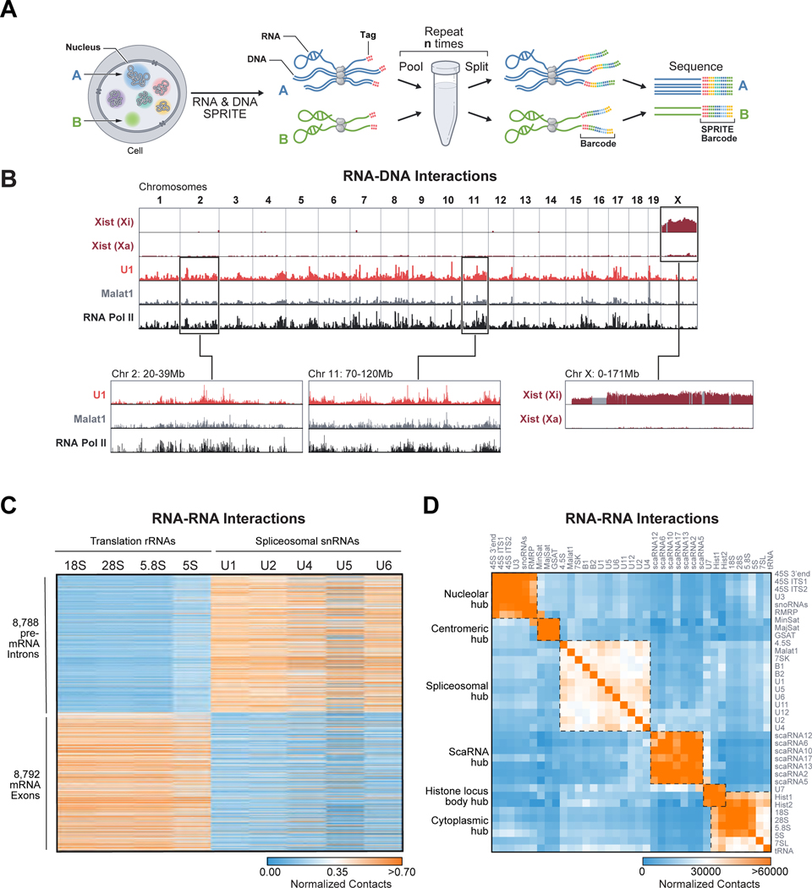Figure 1: ChIP-DIP protocol (2).

Figure 2: SPRITE protocol (4).

**Approach**

For the first step, we will design single-stranded DNA probes to bind select nuclear RNAs using Python. Start with 10-15 RNAs as a pilot to see if using a DNA probe to detect RNAs is feasible. We will use a bulk measurement to see if expressed RNA is enriched more than unexpressed RNA. At this stage, we are not considering whether off target RNAs are present. Additionally, wet lab protocols will be designed to be completed in approximately two days, allowing for fast iterations of conditions. If the first step is successful, we will then expand the number of RNAs we detect beyond the pilot 10-15 sequences. Use sequencing methods to determine if we are measuring the correct RNAs.

Once we have validated this RNA detection method, the next step will be to determine if this RNA detection method can be used to measure RNA/protein interactions. We will do this by immunoprecipitating a protein for inactive and active chromatin and analyzing the resulting transcripts to see if RNA/protein interactions are detected. Inactive chromatin is not transcribed, so to validate our method, we expect DNA/protein interactions, but fewer RNA/protein interactions compared to RNA/protein interactions at active chromatin.

**Work Plan**

Week 1: Laboratory safety and familiarization with the ChIP-DIP lab protocol.

Weeks 2-5: Computationally design DNA probes and experimentally validate whether DNA probes can be used to detect RNAs.

Weeks 6-8: Expand the number of RNAs we detect and validate with sequencing.

Week 9: Validate use of RNA detection method to map RNA/protein interactions by testing with immunoprecipitation.

Week 10: Document progress and prepare final presentation.

**References**

1. Holoch, D., & Moazed, D. (2015). RNA-mediated epigenetic regulation of gene expression. *Nature Reviews Genetics*, *16*(2), 71–84. https://doi.org/10.1038/nrg3863
2. Perez, A., et al. ChIP-DIP: A highly multiplexed method for mapping DNA binding proteins. Unpublished.
3. Quinodoz, S. A., et al. (2022). SPRITE: a genome-wide method for mapping higher-order 3D interactions in the nucleus using combinatorial split-and-pool barcoding. *Nature Protocols*, *17*(1), 36–75. https://doi.org/10.1038/s41596-021-00633-y
4. Quinodoz, S. A., et al. (2018). Higher-Order Inter-chromosomal Hubs Shape 3D Genome Organization in the Nucleus. *Cell*, *174*(3), 744-757.e24. https://doi.org/10.1016/j.cell.2018.05.024

This proposal was also informed by email correspondences and in-person meetings with Andrew Perez.