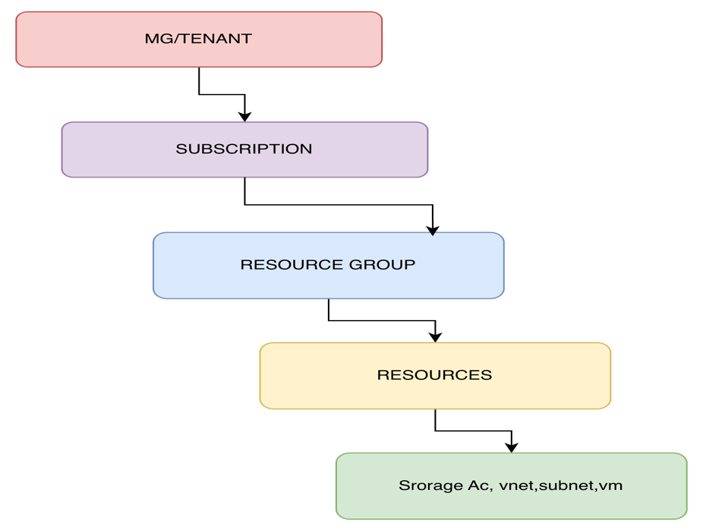

☁️ Compute Services

📌 Definition

Compute Services are cloud services that provide processing power (CPU, memory, runtime environment) to run applications, virtual machines, containers, and backend workloads without needing to manage physical hardware.
In Azure, compute services allow you to:
- Run applications on Virtual Machines, Containers, or Serverless models
- Scale resources up/down automatically
- Choose level of control (IaaS, PaaS, Serverless)
Service Resource Names
Service | Resource Name
Virtual Machine | Microsoft.Compute/virtualMachines
Virtual Machine Scale Set | Microsoft.Compute/virtualMachineScaleSets
App Service (Web App) | Microsoft.Web/sites
Azure Functions | Microsoft.Web/sites
Kubernetes (AKS) | Microsoft.ContainerService/managedClusters

🖥️ Virtual Machine (VM)
Azure VM ek on-demand scalable compute service hai jisme tum cloud pe Windows ya Linux server create kar sakte ho.
Azure Virtual Machine is an Infrastructure-as-a-Service (IaaS) offering that provides on-demand, scalable compute resources where we can deploy and manage full operating systems like Linux or Windows, commonly used for hosting applications, build servers, and CI/CD workloads.
📦Availability Sets
An Availability Set is a logical grouping of VMs that ensures high availability by distributing them across multiple fault and update domains, so that application downtime is minimized during hardware failure or maintenance.
⚙️ Fault Domain
Fault Domain = physical hardware failure boundary protection from hardware failure.

🔄 Update Domain
Update Domain = maintenance / patching group, Maintenance downtime avoid Karna.

🔐 How do you secure a VM?
VM security is done in layers
Network level -> Access level -> OS -> Monitoring

🌐 Network Level Security (NSG)
- NSG use karke inbound/outbound traffic control karte hain
- Only required ports open karte hain (e.g. 22 for SSH, 80/443 for web)
- Public IP access ko restrict ya disable kar sakte hain
- Subnet level isolation bhi apply kar sakte hain

🔑 Access Control (Authentication Layer)
- Password authentication avoid karte hain
- SSH key-based authentication use karte hain
- RBAC (Role-Based Access Control) se permissions manage karte hain

🧱 OS / System Level Security
- Firewall enable karte hain (Linux/Windows firewall rules)
- Regular OS patching & updates apply karte hain
- Unnecessary services disable karte hain

🛡️ Monitoring & Security Management
- Azure Security Center / Microsoft Defender for Cloud use karte hain
- VM activity monitoring & threat detection enable karte hain
- Logs collect karke analyze karte hain

📈 VMSS
VMSS :- VMSS is an Azure compute service that automatically deploys and manages a group of identical VMs with auto-scaling and load balancing.
⚙️ Orchestration:
multiple VMs ko automatically manage, coordinate and control krna. Meaning VM
create | Scale | Update | handling networking
🔄 Modes of Orchestration:
- Uniform: Identical VMs
- Flexible Orchestration mode: VMs different configuration ke ho sakte hain
- Flexible Orchestration mode: VMs different configuration ke ho sakte hain

🌐 Azure App Service
Azure App Service: Azure App Service ek PaaS (Platform as a Service) offering hai jisme tum bina infrastructure manage kiye web apps, APIs, aur backend services deploy aur run kar sakte ho.

Kya host kar sakte ho examples:
- Web Apps (ASP.NET, Node.js, Java, Python, PHP)
- REST APIs
- Mobile app backends
Azure App Service is a fully managed PaaS offering that allows us to host web applications and APIs without managing infrastructure. It supports multiple runtimes, integrates with CI/CD tools like Azure DevOps and GitHub, and provides features like auto-scaling, deployment slots for zero-downtime deployments, and built-in monitoring. In DevOps, it's commonly used for automated deployments and scalable web hosting. (satya bhai to explain a littlebit)
❓ Ask
bhai k iska practical kr sakte hai kya apni subscription mein and example se bata sakte hai kya ??

⚡ Azure Functions
Azure Functions ek serverless compute service hai jahan tum Chhoti Chhoti code functions run karte ho without managing servers.

Real-world Use Case
- Jab file upload ho → function trigger ho
- Timer pe daily job run ho
- HTTP request aaye → API jaisa kaam kare
- Queue message aaye → process ho

Key concept:
Azure Function = Trigger + Code + Output
Azure Functions is a serverless compute service that allows us to run event-driven code without managing infrastructure. It supports triggers like HTTP, timers, and queues, and automatically scales based on demand. In DevOps, it is used for automation, background jobs, and microservices, with CI/CD integration and pay-per-execution cost model.

☸️ Kubernetes (AKS)
Azure Kubernetes Service ek managed Kubernetes service hai jahan tum containers (Docker) ko orchestrate, scale, aur manage karte ho without control plane manage kiye.
Azure Kubernetes Service is a managed Kubernetes offering that allows us to deploy and manage containerized applications at scale. Azure manages the control plane while we manage node pools and workloads. It supports features like auto-scaling, rolling updates, and CI/CD integration with container registries. In DevOps, it is widely used for microservices architecture and complex, scalable applications.

🔥 VM vs App Service
VM vs App Service (MOST IMPORTANT)
VM is Infrastructure-as-a-Service where we manage OS and environment, whereas Azure App Service is Platform-as-a-Service where Microsoft manages infrastructure and we only deploy applications. VM gives full control, App Service gives ease of deployment.

🔥 VM vs AKS
VM hosts applications directly on virtual servers, whereas AKS is a managed Kubernetes service used to deploy and manage containerized applications with features like auto-scaling, load balancing, and self-healing.

🚀 Real-world usage
I would choose App Service for simple web apps, Azure Functions for event-driven workloads, and AKS for microservices and containerized applications requiring full control and scalability.

Azure Storage Overview
Azure Storage is a Microsoft-managed service providing cloud storage that is highly available, secure, durable, scalable, and redundant.
Service Resource Name
Service | Resource Name
Storage Account | Microsoft.Storage/storageAccounts
Blob Storage | (inside storage account)
File Share | (inside storage account)
Queue Storage | (inside storage account)
Table Storage | (inside storage account)

Storage Account

Definition
Azure Storage is a cloud storage service, while a Storage Account is a logical namespace that provides access to different storage services like Blob, File, Queue, and Table.

Example (Analogy)
- Azure Storage = 🏦 Bank system
- Storage Account = 💳 Tumhara bank account
- Blob/File = 💰 Tumhara data (paisa)

Storage Services (Based on Requirement)
“Now we choose storage type based on requirements:”

🖼️ Blob Storage
Stores unstructured data (images, videos, documents)
👉 Example:
In an e-commerce application, product images and invoices (PDFs) are stored in Blob Storage because it is optimized for large unstructured data.

📁 Azure File Storage
Cloud-based shared file system (like network drive)
👉 Example:
Multiple teams like support and operations use shared reports or files, so Azure File Storage is used as a shared drive.

📩 Queue Storage
Messaging service for asynchronous processing
👉 Example:
When a user places an order, a message is sent to Queue Storage to process order confirmation or email notification in the background without delaying the user response.

📊 Table Storage
NoSQL storage for structured key-value data
👉 Example:
Order metadata like order ID, user ID, and order status is stored in Table Storage for fast and scalable access.

🌍 4. Availability Zones (Concept Before Redundancy)
Availability Zones are physically separate datacenters within an Azure region that ensure high availability and disaster protection for applications.

🔁 5. Redundancy Types

🟡 LRS (Locally Redundant Storage)
Lowest cost option. Stores 3 copies of data within a single data center, protecting against hardware failures but not data center outages.
👉 Example:
Temporary reports generated for return-to-office tracking → use LRS as data can be regenerated.

🟠 ZRS (Zone Redundant Storage)
Data stored across multiple availability zones in the same region.
👉 Example:
Production web application where high availability within a region is required.

🔵 GRS (Geo Redundant Storage)
Data replicated to a secondary region far away for disaster recovery.
👉 Example:
Production application in Toronto with backup in another region.

🔴 GZRS (Geo Zone Redundant Storage)
Combination of ZRS + GRS providing maximum protection.
👉 Data stored across multiple zones and secondary region replication.

💰 Access Tier (Cost Optimization)
Access tier defines cost and performance based on data usage:
- Hot → Frequently accessed data (fast access, higher cost storage)
- Cool → Infrequently accessed data
- Archive → Rarely accessed data (lowest cost, slow retrieval)
👉 Mainly applicable for Blob Storage.
☁️ Azure Networking Services

Service | Resource Name
Virtual Network (VNet) | Microsoft.Network/virtualNetworks
Subnet | (inside VNet)
Network Interface | Microsoft.Network/networkInterfaces
Public IP | Microsoft.Network/publicIPAddresses
Load Balancer | Microsoft.Network/loadBalancers
Application Gateway | Microsoft.Network/applicationGateways
NSG (Network Security Group) | Microsoft.Network/networkSecurityGroups

🌐 VNet (Virtual Network)
VNet is the fundamental block of private network in Azure. It enables Azure resources to communicate with:
- Each other
- Internet
- On-premises networks

🔐 Virtual Network Security Features

🏰 Azure Bastion
- Paid service providing secure SSH/RDP connectivity to VMs
- With Bastion, VMs do NOT require a public IP
✔ Secure way to connect to VM (RDP/SSH)
✔ No public IP required
✔ Increased security (no open ports)

🔥 Azure Firewall
- Fully managed network firewall
- Used to control:
  - Inbound traffic (andar aane wala)
  - Outbound traffic (bahar jaane wala)

🧯 Azure DDoS Protection
(Attack scenario: attackers send huge fake requests to crash server)
Azure DDoS Protection safeguards applications from distributed denial-of-service attacks by automatically detecting and mitigating malicious traffic.

🧠 Security Summary
When creating a VNet, security can be enhanced using:
- Azure Bastion → secure VM access without public IPs
- Azure Firewall → control inbound/outbound traffic
- Azure DDoS Protection → protect from large-scale network attacks

📦 Subnets
Subnet is a component of VNet, not a separate Azure service. It is used for network-level segmentation of resources.

✔ Key Points:
- Subnets are used to logically divide a Virtual Network
- Improves security, traffic management, and resource organization
- Resource Group manages resources, Subnet controls communication

⚠️ Important Fact:
Azure firewall and Azure Bastion require dedicated subnets.

🚨 Special Fact (IP Reservation)
In each subnet, 5 IP addresses are reserved:
- First → Network address
- Last → Broadcast address
- Remaining 3 → Azure internal services (routing, DNS, etc.)
❌ Not available for resource allocation

🔌 Network Interface (NIC)
NIC enables VMs to communicate with:
- Internet
- Azure services
- On-premises resources

✔ NIC contains:
- Private IP (mandatory)
- Public IP (optional)
- NSG association (for traffic control)

🧠 IP Configurations (NIC)
NIC ke andar configuration block hota hai. Ek NIC pe multiple IPs assign kar sakte ho.

Why multiple IPs are used:

1️⃣ Multiple Applications on Same VM
- One VM hosts multiple applications
- Each app uses separate IP
👉 Example:
- App1 → IP1
- App2 → IP2

2️⃣ Different Environment / Service Separation
- Same VM pe services logically separate karna
👉 Example:
- Web traffic → IP1
- API traffic → IP2

3️⃣ SSL / Domain Mapping
- Different domains mapped to different IPs
👉 Example:
- abc.com → IP1
- xyz.com → IP2

4️⃣ High Availability / Failover
- Backup IP ready in case primary fails

🛡️ NSG (Network Security Group)
NSG is a virtual firewall in Azure that filters inbound and outbound traffic for NIC or Subnet using security rules based on priority.

✔ Key Points:
- NSG can be attached to:
  - Subnet
  - NIC

Behavior:
- Subnet NSG → broad control (all VMs in VNet segment)
- NIC NSG → fine-grained control (specific VM)
- If both applied → rules are combined

⚙️ NSG Components
- Security Rules
- Inbound Rules
- Outbound Rules
- Rule Priority (lower number = higher priority)

🔗 NSG Attachment
- Same NSG can be attached to both Subnet and NIC
- Both rule sets will apply (combined effect)

🧭 Networking Concept Flow
Virtual Network (VNet) ↓ Subnets ↓ Network Interface (NIC) ↓ Virtual Machine (VM) ↓ IP Configuration (Private / Public IP) ↓ NSG (Traffic filtering) ↓ Azure Bastion (Secure access) ↓ Azure Firewall (Traffic control) ↓ Azure DDoS Protection (Attack protection)

Public Ip
what is load balancing?
Load balancing distributes traffic across multiple backend resources to ensure high availability and fault tolerance.to ensure
High performance |Availability |prevent overload
Load Balancer :- Azure load balancer is a layer 4 load balancer that distributes incoming traffic among healthy virtual machine instances.
Load balancers uses a hash-based distribution algorithm. By default, it uses a 5-tuple (source IP, source port, destination IP, destination port, protocol type) hash to map traffic to available servers. ???
Load balancers can either be internet-facing where it is accessible via public IP addresses, or internal where it is only accessible from a virtual network.
Azure load balancers also support Network Address Translation (NAT) to route traffic between public and private IP addresses.

1️⃣ Azure Load Balancer (Layer 4 – Transport Layer) | No SSL termination | distributes traffic based on IP and port without inspecting content.

🔹 Works on: TCP / UDP (IP + Port level)

🔹 Types:

➤ Public Load Balancer : Internet traffic handle karta hai | Example: Website access

➤ Internal Load Balancer (ILB): Private traffic (within VNet) | Example: App server → DB server communication

2️⃣ Azure Application Gateway (Layer 7 – Application Layer) | that makes routing decisions based on URL, headers, and cookies.

🔹 Works on: HTTP / HTTPS

🔹 Key Features:
- URL-based routing
👉 /api → Server 1
👉 /images → Server 2
- SSL termination (offloading)
- Web Application Firewall (WAF)
- Cookie-based session affinity

🔹 Use Case:
- Web applications
- Microservices routing
- Secure HTTP traffic

Database Services

Azure Database Services are cloud-based, fully managed database offerings in Microsoft Azure that allow users to store, manage, and retrieve data without managing the underlying infrastructure.

Service | Type | Data Format | Kab Use Kare (Use Case) | Real Situation (Interview Answer Line)
Azure SQL Database | Relational (SQL) | Tables (rows/columns) | Structured data, normal apps | "If the application has structured data and standard transactions, I will use Azure SQL Database."
SQL Managed Instance | Relational (SQL) | Tables | Lift-and-shift / migration | "If I need to migrate an existing on-prem SQL Server with minimal changes, I will use Managed Instance."
Cosmos DB | NoSQL | JSON / flexible | High speed + global apps | "For globally distributed, low-latency applications, I will use Cosmos DB."
MySQL (Azure) | Relational | Tables | Open-source apps | "For applications like WordPress or PHP-based systems, I will use Azure Database for MySQL."
PostgreSQL (Azure) | Relational | Tables | Advanced / microservices | "For modern applications needing flexibility and extensions, I will use PostgreSQL."
Redis Cache | In-memory (cache) | Key-value | Performance boost | "To improve application performance and reduce DB load, I will use Redis Cache."
Synapse Analytics | Analytics | Big data | Reporting & analytics | "For large-scale data analytics and reporting, I will use Synapse Analytics."
TBC

🟠 DevOps & Containers
Service | Resource Name
Container Registry (ACR) | Microsoft.ContainerRegistry/registries
Container Instance | Microsoft.ContainerInstance/containerGroups
Kubernetes Service (AKS) | Microsoft.ContainerService/managedClusters

🔴 Monitoring & Management
Service | Resource Name
Log Analytics Workspace | Microsoft.OperationalInsights/workspaces
Application Insights | Microsoft.Insights/components
Azure Monitor | Microsoft.Insights

⚫ Identity & Security
Service | Resource Name
Key Vault | Microsoft.KeyVault/vaults
Managed Identity | Microsoft.ManagedIdentity/userAssignedIdentities
Azure AD (Entra ID) | (managed separately, not ARM resource)

🟤 Misc / Core
Service | Resource Name | Description
Resource Group | Microsoft.Resources/resourceGroups | A container (logical space) that holds related resources for an Azure solution. The resource group can include all the resources for the solution, or only those resources that you want to manage as a group.  TAGS :- apply tags to AZ resources to logically organise them.
Policy | Microsoft.Authorization/policyAssignments
Role Assignment (RBAC) | Microsoft.Authorization/roleAssignments

🟤 Azure PORTAL

