Potentiometer Controlled Servo Motor using Arduino (Tinkercad)

Project Description
This project demonstrates how a servo motor can be controlled using a potentiometer with the help of an Arduino Uno. The potentiometer acts as an analog input device whose varying resistance changes the voltage supplied to the Arduino. Based on this input, the Arduino generates a control signal that adjusts the angle of the servo motor. The entire circuit is designed and simulated using Tinkercad, making it ideal for learning basic concepts of analog input, PWM control, and actuator interfacing.

Circuit Diagram
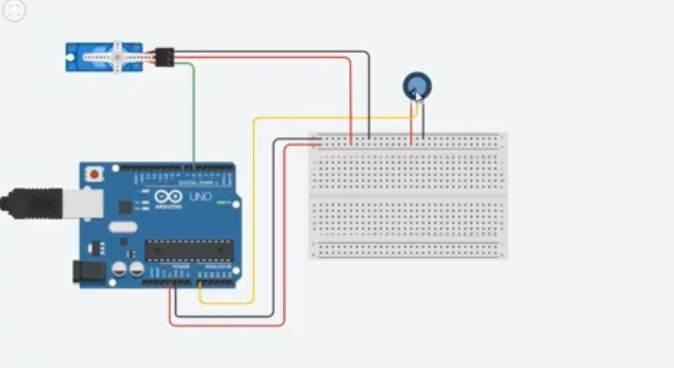

Components and Description
Arduino Uno: A microcontroller board based on the ATmega328P used to read analog input and control the servo motor.
Servo Motor: An electromechanical device that rotates to a specific angle according to control signals from the Arduino.
Potentiometer: A variable resistor used as an analog input device to vary voltage and control servo position.
Breadboard: A prototyping board that allows easy and temporary circuit connections without soldering.
Jumper Wires: Wires used to establish electrical connections between the Arduino, components, and breadboard.
USB Cable: Provides power to the Arduino and is used for uploading code from the computer.

