LAB 2: SYSTEM INFORMATION AND NETWORK DIAGNOSTICS

Name: _Tanvi Jindal__

Roll Number: __2610997570___

Course: BCA AI & ML

Subject: BCPS

1. Aim

To inspect the operating system, memory, disk space, network interfaces, routes, and connectivity using command-line tools.

2. Procedure

1. Opened Windows Command Prompt (CMD).
2. Executed commands to check the operating system version and computer name.
3. Viewed system details and memory information.
4. Listed the contents of the C: drive.
5. Inspected network interfaces and routing information.
6. Tested local TCP/IP connectivity using the loopback address.
7. Checked DNS resolution for "example.com".
8. Tested HTTPS connectivity using "curl".
9. Observed the outputs and recorded the findings.
10. Captured screenshots of the commands and their outputs as practical evidence.

3. Commands Used

S. No.| Task| Windows Command Prompt Command
1| OS version| "ver"
2| Host name| "hostname"
3| System details| "systeminfo"
4| Memory| "systeminfo"
5| Disk contents| "dir C:\"
6| IP interfaces| "ipconfig"
7| Routes| "route print"
8| Local TCP/IP| "ping -n 4 127.0.0.1"
9| DNS lookup| "nslookup example.com"
10| HTTPS connection| "curl -I --max-time 15 https://example.com"

4. Observations

1. Operating system: The Windows version was displayed using the "ver" command.

2. Total / available memory: The total and available physical memory values were displayed using "systeminfo".

3. Disk space: The "dir C:\" command displayed the files and directories present on the C: drive.

4. Active network interface: Network adapters and their configuration were displayed using "ipconfig".

5. Default gateway: The routing table was examined using "route print" to check for a default route.

6. Loopback replies: The local TCP/IP stack was tested using "ping -n 4 127.0.0.1". The actual number of successful replies was observed.

7. DNS resolution: The "nslookup example.com" command was used to check whether the domain name resolved to IP addresses.

8. HTTPS connection: The "curl" command was used to request HTTPS response headers. The displayed HTTP status or error was observed.

5. Interpretation

1. The "ver" command identifies the Windows version.
2. The "hostname" command displays the computer name.
3. The "systeminfo" command provides system configuration and memory information.
4. The "dir C:\" command lists the contents of the C: drive but does not reliably report available disk space.
5. The "ipconfig" command displays network interface configuration.
6. The "route print" command displays the routing table and helps identify the default gateway.
7. Successful loopback replies indicate that the local TCP/IP stack is responding; they do not prove Internet access.
8. DNS resolution and HTTPS connectivity are separate tests.
9. Ping may be blocked even when HTTPS works.

6. Result

The Windows command-line tools were executed to inspect system information, network configuration, routing, local TCP/IP connectivity, DNS resolution, and HTTPS connectivity.

7. Conclusion

This practical helped me understand how to use Windows Command Prompt for basic system inspection and network diagnostics. It also demonstrated the difference between local network testing, DNS resolution, and HTTPS connectivity.

8. Screenshots

Attach screenshots of the commands and their actual outputs below this heading.

Suggested screenshot labels:

1. Figure 1: Windows Version ("ver")
2. Figure 2: Computer Name ("hostname")
3. Figure 3: System Information ("systeminfo")
4. Figure 4: Disk Contents ("dir C:\")
5. Figure 5: Network Configuration ("ipconfig")
6. Figure 6: Routing Table ("route print")
7. Figure 7: Loopback Test ("ping -n 4 127.0.0.1")
8. Figure 8: DNS Lookup ("nslookup example.com")
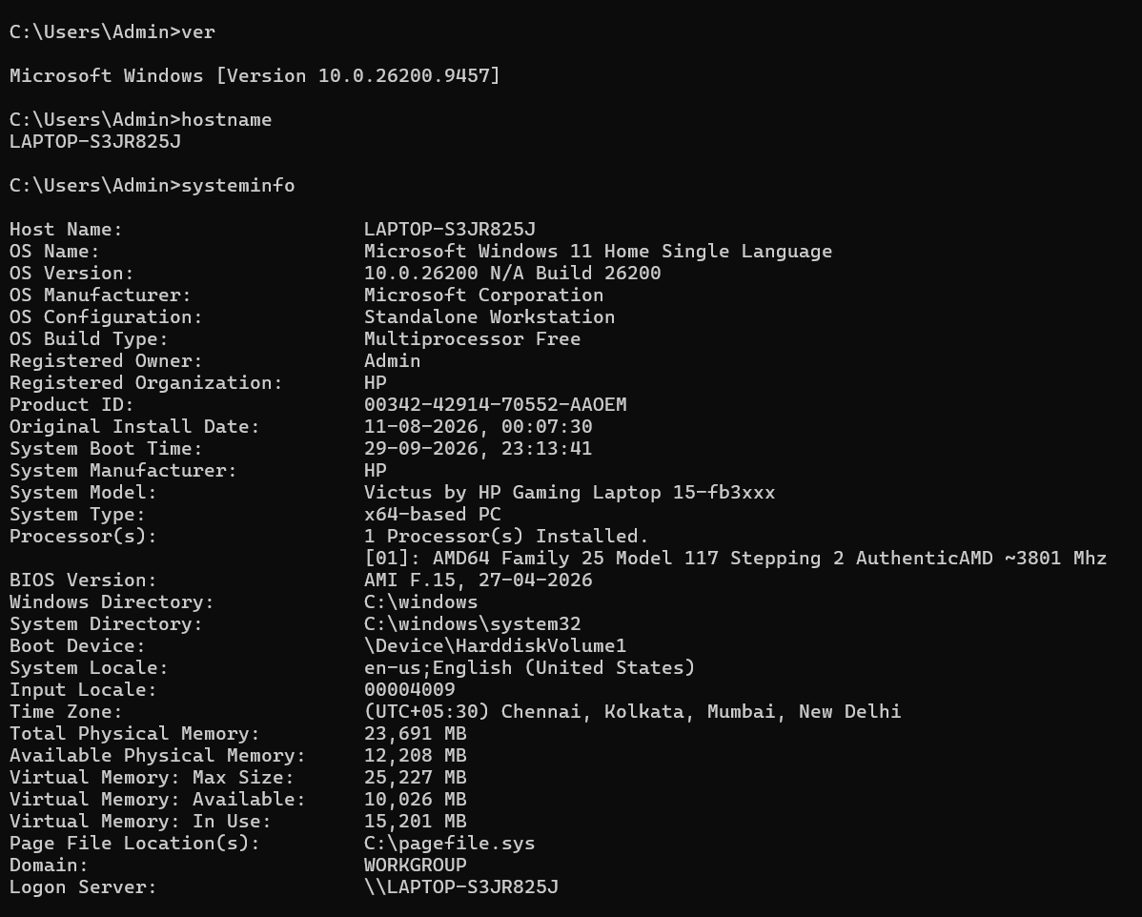
9. Figure 9: HTTPS Connection ("curl -I --max-time 15 https://example.com")
