# Project Description

The project performs CRUD operation on an Employee details. It uses dapper ORM for RestApi calls. The API contains an HTML in itself so the project can be run directly. Also the UI can be run through the Angular project (EmployeeUI). The scripts for creating the database and the stored procedures for insert, update, delete and get operations are in the “dbo” folder inside “DBScripts”.

# Changes needed to run the project.

To run the project the following needs to be updated.

1. In “RestApiWithDapper” project change the connection string (Database name and server) in AppSettings.Json file.
2. In “RestApiWithDapper” project update line 36 in startup.cs file to refer to the App URL that angular runs on.
3. Run the table and stored procedure scripts that are saved in “SQLScript.sql” to create the tables and stored Procedures.

# Angular UI

UI for the Angular project:

1. Main Page

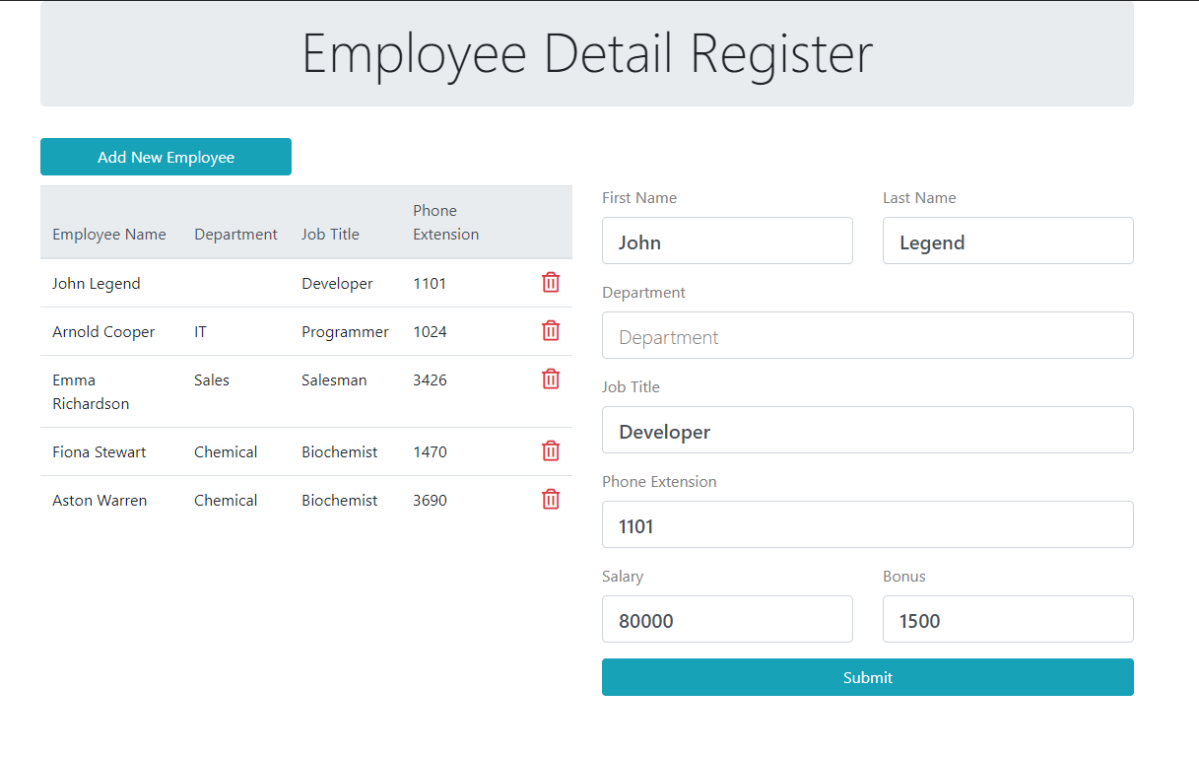

The page contains a list and a form. The list displays basic details of employees.

# Actions

**Create:**

The user can fill the details of the employee in the form and select the submit button. The form requires the user to enter mandatory details (First Name, Job Title, Phone Extension, and salary). If any details of the mandatory details are not entered, the form will mark the fields in red as shown in the picture below.

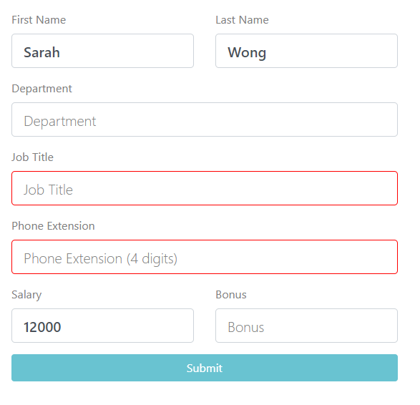

On Successfully adding the new employee records a pop-up message is shown that the record was added successfully.

**Update**

To update and already existing employee record, the user can select the employee record from the grid. The selected employee record is displayed in the form. After making the changes you can select the submit button to save the changes.

**Delete**

To delete an employee record, select the delete icon on the employee record from the list. A message will be shown after the record is successfully deleted.