Contents

Executive summary 2

Business Value 2

Recommended Project Sponsor 2

Underlying Data 3

Potential Obstacles 3

Resource Requirements 4

Technology 4

Human Capital 4

Overall Budget Required 4

Implementation Details 5

Dashboard Development Methodology 5

Timeline 5

Architectural Diagram 6

Outcomes and Insights 6

Dashboard Outcomes and Insights 6

Return on Investment 8

Defining Success 8

# Executive summary

This business proposal aims at arming our agency ‘Green Side Immigration Consulting’ with the information we require to make better business decisions. We could use the data insights we obtain from this project to better understand our target demographic i.e. to whom we should be marketing our services and also help us guide people better through their immigration process. This would effectively increase the quality of our service offerings. We will be using a business intelligence dashboard that helps us visualize the data we have and answer some relevant questions. The data being used was sourced from the US Department of Labor (DOL) and consists of information about applications for permanent visas between 2012 and 2017. It includes information about the sponsoring employer, the person’s education level, wage offered, job posting history, employee education and past visa history, and final decision. The insights we are looking for would tell us what attributes of a person are either beneficial or detrimental to their chances of having their permanent visa application certified.

What follows here is a detailed proposal of how this project will be useful for Green Side Immigration Consulting for better targeting advertising and also prove to be a tool for conducting research in the field. We will and also touch upon the implementation details, scheduling and the costs involved in developing this project. We will also briefly discuss potential obstacles and desired outcomes.

# Business Value

* **Identifying our customer** – If we could find out the attributes of customers that make them more likely to get their permanent visa certified, this translates to more success stories for our consultancy. We could then better decide which cases are worth pursuing and which will not really lead to any good outcome.
* **Guiding people more accurately** – Having this information at our disposal would enable us to even guide people better and be honest with them about what their chances are. This way the customers would not get mislead and would better understand what kind of outcome they can expect from this entire application process. Considering how expensive and time consuming the whole process is, we do not want to disappoint our customers by showing them a better picture of the scenario than what it actually is. Setting up realistic expectations will lead to less disgruntled customers. This dashboard will help us stay current with the situation in the real world.

# Recommended Project Sponsor

We are proposing that this project be sponsored by the CFO of Green Side Immigration Consulting, Mr. John Doe. Mr. Doe has successfully led several Business Intelligence initiatives in the past. With his domain knowledge and decades of experience in the field, we believe he would be the right person to decide if this project deserves sponsorship and how much value it can add to our business. The ideal budget for the project should be approximately 15% of the annual budget allocated to the Strategic Initiatives Department at Green Side Immigration Consulting.

# Underlying Data

The underlying data used to implement ‘The American Dream’ was originally collected and distributed by the Unites Stated Department of Labor. For our use, we will be using the publicly available version of this dataset on Kaggle.com. This can be found at the following address:

<https://www.kaggle.com/jboysen/us-perm-visas>

While this data is very comprehensive, it contains a lot of information that is irrelevant to our business problem. This data had to be cleaned and processed in order to get the data we want to answer our questions. Many columns were eliminated, a calculated field was added, and the data was cleaned and rectified wherever discrepancies were found. Below is the final list of attributes that will actually be used to create the dashboard.

|  |  |
| --- | --- |
| **Field** | **Interpretation** |
| Case_no | Uniquely Identifies each application case |
| Case_status | The final outcome of the application – Certified, Denied, Expired etc. |
| Class_of_admission | The current non-immigrant visa held by the applicant |
| Country_of_citizenship | The applicant’s country of citizenship |
| foreign_worker_info_education | The highest level of education completed by the applicant |
| Employer_state | The American state where the employer is located |
| Pw_unit_of_pay_9089 | The unit of pay whether yearly, hourly, etc. |
| Wage_offer_from_9089 | The wage offered to the applicant |
| Correct Wage | A calculated field where the yearly salary is calculated |
| Us_economic_sector | The economic sector under which the applicant’s profession falls |

# Potential Obstacles

Potential obstacles we might have to face with ‘The American Dream’

* **Currency of the data:**

While the data we have spans a very relevant timeframe for our business case, allowing us to gauge the current situation in the real world, it may not be very easy to periodically update this data as there is a lot of cleaning and even some calculation involved in the preprocessing of data that comes in with every update.

* **Null Values:**

We cannot directly eliminate null values as they might dilute our numbers. There might be certain fields that do not apply to every applicant causing a missing value. This does not mean the application does not count. It simply means we cannot use that particular row while answering a certain question. We might still want to use other information about this application to answer other questions or while performing analysis on the entire data. We must therefore carefully tread around null/empty values and exclude them at the visualization stage rather than at the data preprocessing stage.

# Resource Requirements

## Technology

Considering the size of the dataset and the computational power required to perform our analysis, it would make sense to use cloud based virtualized hardware. We can go with a dedicated Amazon EC2 m4 server that costs us about $2.42 per hour. This also takes care of our storage needs. We would also require 3 Tableau Creator subscriptions costing us a total of $420.

A decent capacity server will cost approximately $5,000. Maintenance of the technology over the next few years can be taken as approximately $2,000 per year.

|  |  |
| --- | --- |
| **Expenses** | **Costs** |
| * Amazon EC2 m4 Dedicated server | $3484 |
| * Visualization Tool (Tableau) | $ 420 |
| TOTAL EXPENSES | $4268 |

## Human Capital

The American Dream team would consist of the following resources:

|  |  |  |  |
| --- | --- | --- | --- |
| **Resource Type** | **Duration** | **Cost/ Hr ($)** | **Total Cost ($)** |
| Immigration Lawyer | 1 month | 27 | 4860 |
| Data Analyst | 2 months | 25 | 9000 |
| Project Manager | 2 months | 45 | 16200 |
| Business Analyst 1 | 2 months | 30 | 10800 |
| Business Analyst 2 | 2 months | 30 | 10800 |
| Total Human Capital Cost | | | 51,660 |

The Immigration Lawyer’s expertise will be required in the earlier stages of the project to understand the legal implications of the insights we get and what we plan to do with that information. They will be integral to help us understand immigration laws and how they differ for different countries.

The Business Analysts will gather requirements from the project stakeholders and prepare the actual business case. They will frame relevant questions based on the information we have and map it to what we can do with the skill set we have in the team. They will be present throughout the course of the project to oversee the progress and make any changes necessary.

The Data Analyst will work on the data make sure it is prepared and stored correctly and build the dashboard application as required based on the business questions framed by the Business Analysts.

The Project Manager will co-ordinate all the internal moving parts of the team to make sure the project is progressing according to schedule and meets all the time, cost and scope goals. The project manager will also act like a bridge between the core team and the project stakeholders to communicate important milestones or issues encountered.

## Overall Budget Required

The overall budget required for the project is as shown below:

|  |  |
| --- | --- |
| **Expenses** | **Costs** |
| * Technology Costs | $ 4268 |
| * Human Resource Costs | $ 51660 |
| TOTAL EXPENSES | $55928 |

# Implementation Details

## Dashboard Development Methodology

We will be using an incremental, iterative approach to developing our product. The methodology used will be Agile. Each of our sprints will last for 2 weeks. With the expected velocity of our team, we should be able to have a shippable product within 4 sprints i.e. 2 months.

## Timeline

The following is the anticipated timeline for project ‘The American Dream’

|  |  |
| --- | --- |
| **Tasks** | **Duration** |
| Project Kickoff | 1 day |
| Release 1 - Sprint 1   * Gather all the requirements. * Develop a formal business case * Perform analysis on the processed data * Create a dashboard prototype * Derive business insights from prototype developed * Demo initial prototype to stakeholders | 2 weeks |
| Release 1 - Sprint 2   * Revise initial requirements * Revise business case as required * Perform further analysis on the available data * Update dashboard with updated functionalities * Derive insights and compare to initial findings * Demo resultant prototype to stakeholders | 2 weeks |
| Release 1 - Sprint 3   * Revise requirements after second iteration * Revise business case as required * Perform further analysis on the available data * Update dashboard with updated functionalities * Derive insights and compare to previous iterations’ * Demo resultant prototype to stakeholders | 2 weeks |
| Release 1 - Sprint 4   * Revise requirements after third iteration * Prepare business case with final changes * Perform last round of analysis on available data * Create final version with all functionalities * Derive insights and test validity * Demo final product to stakeholders and deploy publicly | 2 weeks |
| Project Closure | 1 day |

# Architectural Diagram

The architecture is relatively simple as we are not hosing any hardware ourselves. A simplified version of the architecture is shown below.

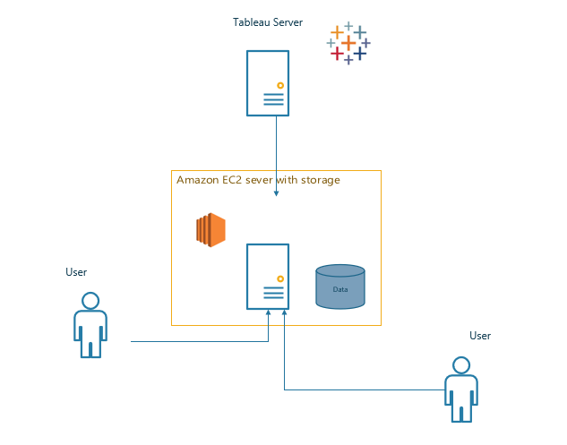

# Outcomes and Insights

## Dashboard Outcomes and Insights

The primary category of insights we are trying to gain here is the profile of people who are most likely to have their permanent visas approved and to picture them as our ideal customer. A dashboard such as the one pictured below would be of interest to our consultants to better understand the immigration situation and business strategists to make better marketing and business decisions.

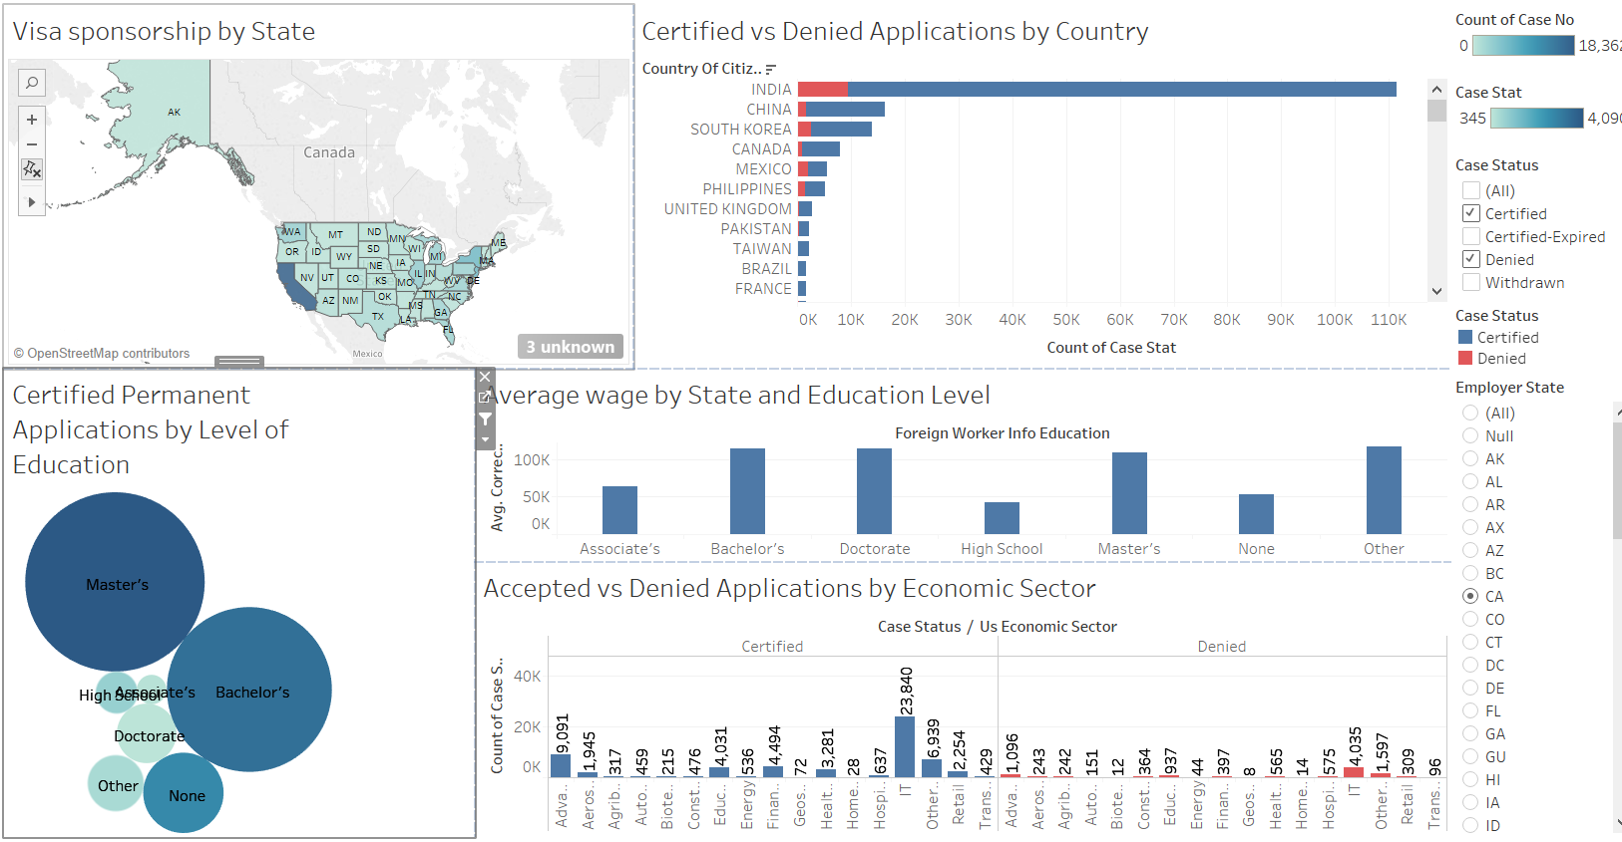

Insights from the dashboard above are:

1. **The dates where Employers are most willing to sponsor permanent visas.**

The top left-hand corner of the dashboard has a section titles ‘Visa Sponsorship by State’. This map of the United States shows us the different states where employers sponsor permanent visas. Darker the hue of blue, the larger the number of sponsored visa applicants. Immigration candidates can be encouraged to apply for jobs in the states where employers are more willing to sponsor so as to increase their chances of even initiating the process.

1. **Ratio of Certified vs Denied Applications by Country of Citizenship**

The section at the top right-hand side of the dashboard shows us a visualization where we can see a horizontal bar chart where we can see the number of applications from different countries and what ratio of them were certified (in blue) vs what ratio were denied. This can again help us understand where do all the applications come from and what are an applicant’s chances of getting a permanent visa certified based on their country of citizenship.

1. **Affect of education level on permanent visa certification**

The bubble chart shown on the bottom left of the dashboard shows us the number of certified permanent visa applications based on the education level of the applicants. This can help us find the right applicants with higher chances of getting a permanent visa. Based on the situation we might also be able to suggest to our customers that they might have higher chances if they were to pursue a higher degree before beginning their application process.

1. **Average wage by State and Education Level**

The bar chart in the center tells us the average wage offered to an applicant based on their level of education and based on the state where their employer is located. This might be of interest to customers to make more informed decisions about which is the best state for them to apply for jobs.

1. **Accepted vs Denied Applications by Economic sectors**

The bottom right hand side of the dashboard shows us a split bar graph depicting the number of certified and denied applications based on the Economic sector under which the applicant’s profession falls. This could help us gauge what kind of professionals are more likely to get their permanent visa applications certified. The economic sectors with the highest number of certified applications is our target demographic.

## Return on Investment

While the return on investment in the case of this project cannot be pin pointed in our financial statements, we can look forward to a lot of intangible benefits such as:

1. Higher application success rate in the long run
2. Higher customer satisfaction
3. Better goodwill among our customers
4. A more focused pool to use as customer base

# Defining Success

This project will definitely help us elevate our expertise in the field of immigration consulting and help us improve our brand image. We would be focusing more on actual promising cases, rather than banking on the numbers game of taking up a large number of cases hoping some of them will work. This would lead to a greater success rate in terms of how many of our customers have certified visa applications and save us a lot of cost and effort. Trying to profile our customers would also lead us to do more stringent background checks which would help us check the validity of a case.

Under the unerring leadership of Mr. John Doe, we can expect this project to be a great success.