**Q.1 SDLC?**

SOFTWARE DEVELOPMENT LIFE CYCLE IS A SERIES OF STEPS OR PHASES THAT PROVIDES THE MODEL OF DEVELOPMENT

IT IS THE LIFE CYCLE MANAGEMENT FOR THE PIECE OF SOFTWARE OR APPLICATION.

PHASES OF SDLC:

1. PLANNING

2. IMPLEMENTATION

3. TESTING

4. DOCUMENT

5. DEPLOYMENT

6. ONGOING MAINTAINACE AND SUPPORT.

**Q.2 What is software testing?**

* it is an activity in which we check whether the actual output matches the expected output.
* It makes the software error free, defect free and bug free.
* It indentifies the errors, gaps and missing requirements in contrary to the actual requirements.
* It identifies the correctness, completeness and quality of the software product.
* It is a process of executing the program with the intent to find a software bug.

Q.3 What is agile(done quick) **methodology**?

* It is a combination iterative and increment model.
* It divides the software into small incremental builds, this build are provided in iterations, that means the big projects are divided into small chunks (iterations)
* Each iteration last about one to three weeks.
* Each iteration involves all the team members working simultaneously on areas like planning, requirement analysis, design, coding, unit testing and acceptance testing.
* At the end of the iteration the working product is displayed to the customer or the important stake holder and it is released in the market.
* After the release we check for the feedback of the deployed software.
* If any enhancement is needed in the project then it’s done and it’s **re-released.**

**Advantage of Agile method:**

1. Frequent delivery
2. Face to face communication with the customer
3. Less time
4. Adaptability

**Disadvantage of agile method:**

1. Less documentation
2. Maintenance problem.

**Q.4 What is SRS**

Software requirement specification:

SRS is a complete description of an application which is to be developed.

SRS contains use case diagram that describes all the interaction user will have with the software application.

**Q.5 What is oops**

Object oriented programming is way of writing the programs in organized way

Objects are like a black box where data are hidden.

**Q.6 Write Basic Concepts of oops**

1. Class

2. Object

3. Inheritance

4. Polymorphism

1. Over ridding

2. Overloading

5. Encapsulation

6. Abstraction.

**Q.7 What is object**

Object gives the permission to access functionality of class.

**Q.8 What is class**

Class is a collection of data member and member function.

**Q.9 What is encapsulation**

The process wrapping the data in a single unit. To secure the data from outside world.

**Q.10 What is inheritance**

Making a class from an existing class. Deriving the attribute of some other class.

**Q.11 What is polymorphism**

One name multiple form.

Type: over riding

Same name of function with same parameter but definition will be different.

Over loading

1.function overloading: same function name but different parameter.

2.constructor overloading: same constructor name but different parameter.

3.operator overloading. Using the operator to add the object instead of variable operands.

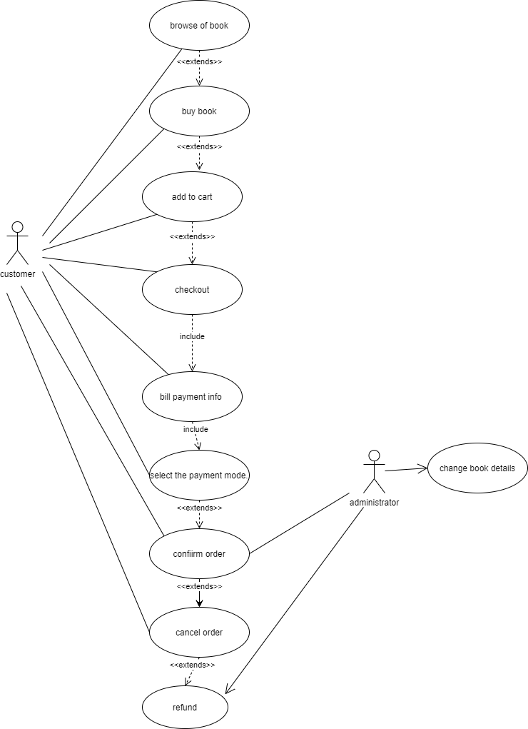

**Q.12 Draw Usecase on Online book shopping**

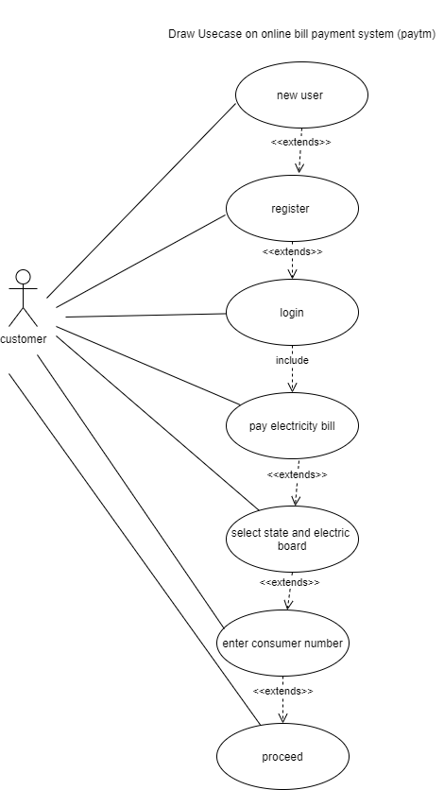

**Q.14 Write SDLC phases with basic introduction**

Software development life cycle.

Phases:

1. Planning : to make a plan for the project for e.g.: to create the SRS as per the requirement
2. Implementation: to start the implementation of the project as per SRS.
3. Testing: to test the implementation.
4. Documentation: to make the documents as per the progress of the project
5. Deployment: to release the project in market
6. Ongoing maintenance and support : to provide the support for any future defect, bug and error and adapt any new feature as per the requirement