12/10/2024
Overall Security Program
Stellar SCOPE Emporium
Stellar Scope Emporium
Cybersecurity Program
Tanvi Patel

Table of Contents

Tables
1.0 Introduction 4
2.0 Program Foundation 5
2.1 Goals and Objectives 5
2.2 Summary of Previous Findings 5
2.3 Budgetary Considerations 6
1. Encryption Implementation: $50,000 6
2. Audit Processes: $30,000 annually 6
3. Training Programs: $20,000 annually 6
4. Incident Response Tools: $25,000 6
5. Physical Security Enhancements: $15,000 7
3.0 Program Framework and Compliance 7
3.1 Framework Overview 7
3.2 Compliance and Standards 7
4.0 Risk Management and Physical Security 8
4.1 Risk Management Strategies 8
4.2 Physical Security Measures 8
5.1 Leadership Overview 8
People in lead positions include the Chief Information Security Officer, IT Manager, and the Compliance Officer, who are responsible to see the whole program and oversee to make sure everything is done according to best practices. 8
• CISO: Shall be considered accountable with respect to whole scale handling of the overall organizational cyber security program. 8
• IT Manager: responsible for the technical setup, interacting with all the staff within the company. 8
• Compliance Officer: Is Responsible for ensuring that the organization complies with all the rules and regulations. 8
5.2 Personnel Roles and Security 8
5.3 Training Plan 10
6.0 Policy, Technology, and Asset Management 10
6.1 Policy Development 10
6.2 Technology and Tools 11
6.3 Data Classification 11
6.4 Asset Management 12
7.1 Configuration Management 14
7.2 Patch Management 15
7.3 Network Security 15
7.4 Website Security 15
7.4.1 Social Media 16
8.1 Ongoing Monitoring and Evaluation 16
8.1.1 Key Performance Indicators (KPIs) 16
8.1.2 Review Schedule of the Cybersecurity Program 16
8.1.3 Continuous Improvement Methodology 17
8.1.4 Reporting 17
8.2 Conclusion 17
9.0 Revision History Table 19
9.1 Change Control Process 19
Appendices 20
Appendix A – Sample Policy 20
Appendix B – Sample Standard 22
Appendix C – Sample SOP 23

Introduction
Stellar Scope Emporium carries a great collection of fine telescopes and accessories, along with software for sky mapping. It only has a single storage facility in Glassboro, New Jersey, and sells to a national clientele through an online-only business model. An IT team, management personnel, customer service agents, and marketing experts make up the remote workforce.
Key Operations Include:
- Online Sales: The largest selection of telescopes and astrophotography equipment through an e-commerce platform and other online sites such as Amazon, EasyBuy and Walmart websites.
- Customer Support: Customer support provides technical support like order placing and challenges facing through websites and unsuccessful payment orders.
- Marketing: Using digital platforms such as Instagram, Facebook, and marketing sites promoting telescopes.
- Inventory Management: Stock updates, order delivery, and safe warehouse handling and storing.
- Data Management: Sensitive data handling of customers such as Name, Mobile Number, and Address as well as safe payment transactions.
- Supply Chain Management: Stellar Scope Emporium manages a supply chain using third-party vendors like distributors and suppliers.
- Quality Assurance: Stellar Scope has different product testing measures until delivered to the customer which ensures the quality of the product.
In recognition of the importance of protecting its digital infrastructure and sensitive customer information, Stellar Scope Emporium is committed to ensuring a complete cybersecurity program. This document discusses measures to enhance security and ensure compliance while also creating a culture of awareness around cybersecurity across the business.

2.0 Program Foundation

2.1 Goals and Objectives
Objectives:
The program aims to ensure data confidentiality, maintain system integrity, and guarantee service availability. It also emphasizes employee awareness and robust incident response mechanisms to protect against evolving cybersecurity threats.

- Ensure Data Confidentiality (C): Protect sensitive customer and corporate data so that it remains inaccessible or less likely to leak through unauthorized access.
- Maintain System Integrity (I): Integrity of the system assures that the system and its data are not accessed or modified without authorization and thus behave dependably.
- Guarantee Data Availability (A): This is to make sure that employees and customers have continuous access to the systems and services without interruptions.
- Develop Robust Incident Response Capabilities (I, A): Create mechanisms that will detect and recover from any form of cybersecurity.
- Promote Cybersecurity Awareness (C, I, A): Launch a continuous and proactive security practice updated with employees.

2.2 Summary of Previous Findings
Audits have exposed weaknesses, such as obsolete encryption, inadequate employee training, and vulnerabilities related to unpatched software, which have all contributed to formulating remedial actions contained in this program.

- Audits: In this regard, old software, poorly controlled access, and weak encryption protocols were discovered.
- Threat Assessments: Essential threats like phishing attacks and insider threats such as ransom efforts need to be identified.
- Business Continuity Planning (BCP): The procedure concerning continuity with minimum disruption of and protection to core activities during any incident. An exhaustive BCP is presented in the Appendix.

2.3 Budgetary Considerations
A comprehensive budget ensures the successful implementation of encryption upgrades, regular audits, workforce training, incident response tools, and physical security enhancements.

Encryption Implementation: $50,000
The fund is intended to enhance the encryption protocols that secure sensitive information and data for customers and organizations.
- It comprises related costs for acquiring advanced encryption tools such as SSL/TLS for data in transitions and AES for data at rest.
- Its execution will involve putting in place end-to-end encryption for ensuring customer transactions and internal communications.
- Ongoing technical support services and licensing fees for encryption tools.

2. Audit Processes: $30,000 annually
Regular audits are essential to identify vulnerabilities, ensure compliance with standards, and monitor system performance. This budget covers:
- Contracting third-party auditors to perform comprehensive security assessments twice a year.
- Procuring tools to automate vulnerability scans and generate compliance reports.
- Addressing findings from audits, such as patching, upgrades, and configurating the changes.

3. Training Programs: $20,000 annually
Employee awareness is crucial in mitigating human-error risks. The budget for training includes:
- Initial training for new employees on the cybersecurity fundamentals, such as phishing awareness and data handling.
- Biannual refresher courses for existing staff, including simulated threat scenarios.
- Advanced training for administrators and IT staff on incident response and secure system configurations.
- Subscription costs for training platforms like KnowBe4 or similar e-learning systems.

4. Incident Response Tools: $25,000
Effective response to cybersecurity incidents minimizes damage and make sure quick recovery. This budget includes:
- Procurement of forensic tools to investigate and resolve breaches.
- Subscription to incident response platforms (e.g., SIEM systems) for real-time threat detection and response.
- Establishing a cyber incident playbook and resources for testing incident recovery processes.

5. Physical Security Enhancements: $15,000
While the focus is digital security, physical security makes sure the protection of IT infrastructure. This includes:
- Installing the badge readers to allow access into sensitive areas such as server rooms.
- Implement CCTV systems to watch and monitor whatever transpired at any time, day or night.
- Environmental fire suppression systems and climate control are part of environmental protection for key IT equipment.

3.0 Program Framework and Compliance

3.1 Framework Overview
The cybersecurity framework in strategy will incorporate governance, risk management, compliance, incident response, and employee training into a single entity that protects assets and supports the business strategy.
- Governance: Roles and responsibilities are to be defined here for accountability in cyber security.
- Risk Management: Continuous assessment and elimination of risks.
- Compliance: Adequate standards and rules to go with them.
- Incident Response: Processes for timely incident response effectiveness for breaches.
- Training: Comprehensive training for employees.

3.2 Compliance and Standards
The program aligns with GDPR, PCI-DSS, and ISO 27001 to ensure adherence to national and international regulations, demonstrating a commitment to customer data protection.
- General Data Protection Regulation (GDPR): This law heavily impacts on personal data protection.
- Payment Card Industry Data Security Standard (PCI-DSS): This standard rule keeps the payment details secured.
- ISO/IEC 27001: This framework sets the guidelines to maintain information security distribution

4.0 Risk Management and Physical Security

4.1 Risk Management Strategies
Risk management involves continuous monitoring, prioritizing vulnerabilities based on severity, and implementing mitigation measures such as multi-factor authentication and regular updates.
- Continuous Monitoring: Using the real time monitoring tools in identifying vulnerabilities.
- Prioritization: Risks management accordingly to severity and the likely event.
- Mitigation Measures: Updating regularly, patching, and multi-factor authentication.

4.2 Physical Security Measures
Physical measures include controlled access to sensitive areas, 24/7 surveillance, and climate controls to protect IT infrastructure from environmental threats.
- Access Controls: Secure premises using badge entry systems and appropriate CCTV.
- Asset Management: Physical assets with their security requirements are to be inventoried.
- Environmental Protections: Fire suppression and climate control for servers.5.0 Cybersecurity Leadership & Workforce Development

5.1 Leadership Overview
People in lead positions include the Chief Information Security Officer, IT Manager, and the Compliance Officer, who are responsible to see the whole program and oversee to make sure everything is done according to best practices.

CISO: Shall be considered accountable with respect to whole scale handling of the overall organizational cyber security program.

IT Manager: responsible for the technical setup, interacting with all the staff within the company.
- Compliance Officer: Is Responsible for ensuring that the organization complies with all the rules and regulations.

5.2 Personnel Roles and Security
Role-based access control (RBAC) along with necessary background checks to ensure workers have access to what they need, reducing the insider threats.
- Roles: Provide details on the role of admin-type users, IT staff, and regular employees.

- Background Checks: Provide background check screening for any position offering access to sensitive areas.

- Role-Based Access Control-RBAC: Implement role-based access control to give employees access to what they need and must have to perform in the work environment.

The table below will provide the background checks for respective position. And also, all employees are required to sign the Non-Disclosure Agreements (NDA) and the Non-Compete Agreements (NCA).
Employee Title | Employment Checks | User Training Group
Chief Executive Officer (CEO) | Criminal History Check, Credit History Check, Employment Verification, Education Verification and Drug Test | ADMIN
Chief Technology Officer (CTO) |  | ADMIN
Chief Financial Officer (CFO) |  | ADMIN
Chief Compliance Officer (CCO) |  | ADMIN
Administrative Assistant | Criminal History Check, Employment Verification, Education Verification, Professional References and Drug Test | ADMIN
Public Information Officer |  | ADMIN
Marketing Manager |  | GEN
Marketing Intern |  | GEN
HR Manager |  | ADMIN
Sales Manager |  | GEN
Customer Support Specialist |  | GEN
Supply Chain Manager |  | GEN
Data Analyst |  | GEN
Procurement Specialist |  | GEN
IT Security Specialist | Criminal History Check, Employment Verification, Education Verification, Professional References, Technical assessment test, Professional Interview and Drug Test. | IT
Product Development Engineer |  | IT
Quality Assurance Engineer |  | IT
Table 1 – Employee Background Check List Table

5.3 Training Plan
Training remains a key activity to be undertaken in order to take care of the human element in cybersecurity.
All employees, upon joining and employees, upon joining and as required by their role from time to time, need to undergo training in awareness and capability enhancement.
Admin Training Plan:
Training Topics:
Cybersecurity Awareness Training
- Overview of current cybersecurity threats and their potential business impact.
- Understanding risk management in cybersecurity to protect company assets.
Cyber Risk Mitigation:
- Best practices to manage and mitigate risks within a corporate environment.
- Compliance management guidelines for cybersecurity regulations.

IT and General Training Plan:
Training Topics:
This training will be attended by the IT and General departments.
Advanced cybersecurity: network defense, endpoint security, cloud security, and more to come.
Hands-on training in threat identification, mitigation, and response.
Deployment of security software, configuration of firewalls, and intrusion detection systems-workshops on all this.
Latest Updates on Malware, Phishing, and Cyber Threats
Frequency:
- Quarterly trainings
- Monthly workshops
The staff will also be educated on the policies regarding the physical security of sensitive information, such as a Clear Desk Policy.

6.0 Policy, Technology, and Asset Management

6.1 Policy Development
Policies for instance Information Security Policy, Incident Response Policy, and Data Classification Policy provide a structured approach to secure the digital and physical assets.
- Acceptable Use Policy: Specifies proper use of company resources.
- Access Control Policy: Regulates permissions based on roles and responsibilities.
- Data Breach Response Policy: Details procedures for handling breaches.
- Encryption Policy: Mandates secure data storage and transmission.
- Remote Access Policy: Provides guidelines for secure remote work practices

6.2 Technology and Tools
The firewalls, multi-factor authentication, encryption tools, and VPNs are the technologies form the backbone of the cybersecurity program.
- Firewall and IDS: For real-time threat detection and network security.
- MFA: Multi-factor authentication for enhanced access control.
- Encryption: SSL/TLS for securing transactions and AES for data storage.

6.3 Data Classification
Data classification ensures sensitive information is adequately protected by assigning categories that dictate access and handling requirements:
- Confidential: Highly sensitive data such as customer personally identifiable information (PII), payment details and internal financial records. Access is limited to authorized personnel only, with encryption applied at all stages.
- Restricted: Data with a moderate level of sensitivity, including strategic business plans and internal forecasts. Restricted access ensures only specific departments can utilize this information.
- Internal Use: Documents and communications relevant to day-to-day operations, such as policies and general procedures, accessible to all employees but not shared outside the organization.
- Public: Non-sensitive materials like marketing content and publicly shared product information, which do not require stringent security measures.
To ensure appropriate handling and protection, all data at Stellar Scope Emporium is categorized into four classification levels:
Confidential:
  - The Customer payment information, such as credit card details.
  - Personally identifiable information (PII), including names, addresses, and contact data.
  - Sensitive corporate data, including business strategies, financial records, and intellectual property.
  - Security credentials, such as encryption keys and system access passwords.
Restricted:
  - Employee records, including payroll and performance data.
  - Internal operational reports and vendor agreements.
  - System logs containing non-critical yet sensitive information.
Internal Use Only:
  - Marketing strategies and non-sensitive campaign materials.
  - Training manuals and internal guidelines for employees.
  - Inventory management details and product specifications.
Public:
  - Product descriptions, user manuals, and promotional materials.
  - Publicly available company information, such as contact details and press releases.

6.4 Asset Management
Maintain an updated inventory of all hardware and software assets, including:
- Servers, routers, firewalls, and workstations.
- Licenses for productivity, security, and analytics tools.
- Security devices such as cameras and badge readers.
Stellar Scope has the following assets:
Type | Hardware Category | Serial Number
Laptop (25) | Computers & Laptops | LP00001 – LP00025
Desktop (5) | Computers & Laptops | DK00001 – DK00005
Dev Server (2) | Servers | SV00001 – SV00002
Prod Server (1) | Servers | SV00003
Backup Server (1) | Servers | SV00004
Router/Firewall (2) | Networking | NW00001 – NW00002
Switch (5) | Networking | SW00001 – SW00005
External Hard Drive (3) | Storage | HD00001 – HD00003
Mobile Device (10) | Mobile Devices | MD00001 – MD00010
Tablets (5) | Mobile Devices | TB00001 – TB00004
Printers (2) | Other Devices | PR00001 – PR00002
Monitors (25) | Other Devices | MN00001 – MN00025
Smart Board (2) | Other Devices | SB00001 – SB00002
Video Conferencing (2) | Other Devices | VC00001 – VC00002
Surveillance Cameras (20) | Security | CM00001 – CM00020
Biometric Scanners (2) | Security | BS00001 – BS00002
Badge Readers (10) | Security | BR00001 – BR00010
Uninterruptible Power Supply (5) | Security | UPS0001 – UPS0005
Table 2 – Hardware Category Table - Assets

Stellar Scope Emporium has the following software licenses:
Type | Software Category
Software Development Environment (5) | Development Tools
Version Control Systems for code versioning (5) | Development Tools
Software Development Kits (5) | Development Tools
Project Management (5) | Development Tools
Virtual Environment (5) | Development Tools
Office Suite / Google 365 (20) | Productivity Software
Adobe Acrobat (20) | Productivity Software
Adobe Creative Suite (5) | Productivity Software
File Sharing (20) | Productivity Software
Antivirus / Antimalware (20) | Security Software
Encryption Tools (20) | Security Software
Backup Software (20) | Security Software
ERP (5) | Specialty Software
CRM (5) | Specialty Software
Analytics Tool / Power BI (20) | Specialty Software
Table 3 – Software License Category Table

7.1 Configuration Management
Establishing secure baseline configurations and regular reviews ensures systems remain compliant with security standards. Key actions include:
- Baseline Configuration: Build a secure baseline configuration for all systems to make sure consistency and security.
- Automated Change Detection: Use automated tools to find all unauthorized configuration changes in real time.
- Configuration Reviews: Regularly review and update baseline configurations to address new threats and operational needs.
- Access Control Policies: Limit configuration changes to authorized personnel only.
- Documentation: Maintain detailed documentation of baseline configurations and changes for audit and troubleshooting purposes.

7.2 Patch Management
Proactive patching eliminates vulnerabilities and ensures the system remains secure. The following steps have been implemented to ensure consistent patch compliance:
- Critical Patches: Applied within 48 hours of identification to minimize potential exploitation risks.
- High-Priority Patches: Implemented within one week to address significant vulnerabilities without immediate critical impact.
- Quarterly Audits: Regular audits to verify patch compliance and ensure all systems are updated according to the defined timelines.
- Patch Testing: Conduct testing in isolated environments before deployment to ensure stability and prevent service disruptions.
- Automated Updates: Employ automation tools to streamline the patch management process and reduce manual intervention.

Patch Priority | Risk Level | Time to instal
Critical / High Urgency | immediate risk | within 48 hours
High Priority Patches | potential risk | within one week
Medium Priority Patches | moderate risk | within one month
Low Priority Patches | minimal risk | with three months
Table 4 – Patch Priority Table

7.3 Network Security
Network segmentation, encryption, and robust access controls are implemented to secure sensitive data.
- Deploy firewalls and intrusion detection systems.
- Utilize VPNs for remote employees.
- Segment networks to isolate sensitive data.

7.4 Website Security
There should be regular vulnerability scans and penetration testing to make sure a secure online presence.
- Implementing SSL/TLS certificates to provide secure communication.
- Every quarter conduct regular vulnerability scan and penetration tests.
- Maintain secure backup copies of website data.

7.4.1 Social Media
- Enforce multi-factor authentication for account access.
- Monitor accounts for unauthorized activity.
- Provide training on secure practices for social media usage.8.0 Program Monitoring and Future Outlook

8.1 Ongoing Monitoring and Evaluation
Continuous monitoring and evaluation is important in the effectiveness of the program. The security measures must stay effective as threats change continuously and the business needs are continually met.

8.1.1 Key Performance Indicators (KPIs)
The following shall constitute some of the indicative parameters which will be used to assess the effectiveness of the Cybersecurity Program:
- Time on response to incident: Time frame in which notification, response, and mitigation happen to security incidents. Serious threats will receive a server response in less than 1 hour.

- Patch compliance rate: Percentage of systems applying the latest available security patches. The target will be to approach 100% compliance within 30 days from the release date of the patch.

- Employee Training Completion Rate: The percentage of employees completing cybersecurity training. The target is to have 100% completion within 60 days of employment with 100% for refresher courses continuously.

- Phishing Attack Success Rate: The percentage of employees that fell for a simulated phishing attack. Target reduction for the next year at 40%.
- Data Encryption Status: The percentage of sensitive customer data that is encrypted in transit/rest; target 100% encryption.
Number of Breaches: Overall number of data breaches or unauthorized access; the next years reduce it to 40%.

8.1.2 Review Schedule of the Cybersecurity Program
The cybersecurity program will undergo regular reviews to ensure it is adapting to new challenges:
- Quarterly Reviews: The quarterly reports given by the incidence reported teams, system log of trains, and analysis in view of the development emerging issues.
- Annual Review: A comprehensive review of the whole cybersecurity program will be done annually. This will involve a full audit of security controls, policies, and procedures to identify gaps or areas for improvement.
- Ad-hoc Reviews: Special reviews will be conducted in response to significant changes in the threat landscape, such as the emergence of new types of attacks or major software vulnerabilities.

8.1.3 Continuous Improvement Methodology
The program will adopt a Plan-Do-Check-Act (PDCA) model for continuous improvement:
- Plan: Assess the current security risks and business needs periodically. Update the security policies, controls, and training materials to correct any weaknesses identified.
- Do: Implement the updated policies and controls and deploy new technologies or tools where necessary.
- Check: Monitor the effectiveness of the updated controls by measuring through monitoring, audits, and KPI tracking.
- Act: Use monitoring data, audit findings, and lessons learned from incidents to make adjustments and further refine security practices.

8.1.4 Reporting
Transparency and accountability will depend on clear and timely reporting:
- Internal Reports: Regular internal reports will be submitted to management, showing the status of the cybersecurity program, open security incidents, compliance status, and risk assessments. These will be submitted monthly.
- Annual Security Report: A yearly report will be submitted to senior leadership, which will outline the year's accomplishments, challenges, and areas of improvement in cybersecurity. The report will also suggest future security investments and enhancements.
Incident Reports: All significant cybersecurity incidents will be reported in detailed incident reports that will include timelines, impact assessments, response actions, and lessons learned. The reports will be reviewed to improve the incident response process.

8.2 Conclusion
The cybersecurity program of Stellar Scope Emporium showcases the proactive approach to sensitive information and ensuring business continuity. With the integration of advanced technologies, well-defined policies, and comprehensive training of employees, the organization provides a resilient framework in countering evolving cyber threats. This program showcases Stellar Scope Emporium's commitment towards maintaining customer trust, its digital assets, and maintaining industry standards.
Through consistent monitoring, detailed incident response strategies, and ongoing improvements, the program positions Stellar Scope Emporium as a secure and reliable e-commerce leader. As the threat landscape changes, the organization remains focused on adjusting and enhancing their cybersecurity posture to be best prepared for the challenges in the future. This kind of comprehensive approach will both secure the current operations but also provide a strong base for growth and innovation to be sustained in the following years.

9.0 Revision History Table
The table below includes the revision history for this document.
Version | Author | Date | Changes
v 0.1.0 | Tanvi Patel | 12.12.24 | First draft
v 0.2.0 | Tanvi Patel | 12.14.24 | Updated budget consideration
v 1.0.0 | Tanvi Patel | 12.20.24 | Presented documents to CEO, and made changes requested
v 2.0.0 | Tanvi Patel | 12.25.24 | The version approved by CEO Sally.
Table 5 - Revision History Table

9.1 Change Control Process
A structured process for documenting and approving changes ensures that updates to the program are carefully reviewed and effectively implemented.
- Submit change request forms to the IT Manager.
- Conduct impact analysis and review by the CISO.
- Notify stakeholders and implement changes.
- Update documentation and train employees as necessary.

Appendices

Appendix A – Sample Policy

Title: Remote access security policy
Department: IT Department | Version: Original
Approved by: Joy | Approval date: 13-12-2024
Senior management approval: Alice /12-12-2024
Effective date:15-12-2024 | Last updated: 12-12-2024
Author: IT Department
Scope
These provisions cover all necessary employees, contractors, and other appropriate third-party organizations for access remotely to the IT network. A secure passage to all such business relevant IT resources, software, and data is ensured.

.
Authority

This policy is hereby approved and authorized.
_____joy_____ ___CSO__________ ____13-12-2024_____
Name Title Date

_____Sam_______. _CIO____________ 13-12-2024_____
Name Title Date

Purpose

This policy provides guidelines for safeguarding remote access to Stellar Scope Emporium's information systems, networks, and data from cybersecurity threats whenever there is remote access by employees, contractors, and third-party providers.
Scope

The Remote Access Security Policy will apply to all the necessary information technology systems, applications, databases, software, and network resources used by the company in doing business and to Access Security Controls that must safeguard them while being accessed remotely. It related to all employees, contractors, and other third parties authorized to get access into such resources with no exceptions.

Policy
The IT department is responsible for the management of all remote access security activities. Other departments have a responsibility to provide input about their remote access needs.
- Remote Access Security Procedures:
  - The IT department shall establish appropriate remote access technology for authenticated users that follows best practices in cybersecurity and standards of data protection.
  - This shall include planning, design, selection of secure remote access technologies, and security controls.
- Security Program Activities:
  - The IT department should establish a comprehensive security program that includes the following elements:
    - Risk assessments and impact analyses
    - Authentication and role-based access controls
    - Data encryption and integrity measures
    - Continuous monitoring and incident management
- Training and Awareness:
  - Employees, contractors, and third parties should receive periodic security training and awareness programs to make them knowledgeable about their responsibilities and about new cybersecurity threats.
- Monitoring and Analysis:
  - Remote access data traffic will be constantly monitored for security anomalies. Automated alerts will be set up by the IT department, and logs will be periodically reviewed.
- Security Review and Testing:
- The remote access security plans will be periodically reviewed, tested, and updated if necessary, and reports of remote access security activities will be provided to management.
Remote access security specifications

General
- Regular remote access activities shall be performed for company data security.
- Eligibility for remote access will be clearly defined by identifying specific job roles and responsibilities.
- In case of security concern, it shall immediately report to the IT department.
Remote access procedures
- Remote systems accessing company IT resources must use encrypted connections and comply with the company's security protocols.
- Secure remote access session establishment, maintenance, and termination procedures will be defined.
- Security controls will be regularly validated.
- Monitoring of remote access traffic will identify any potential issues.
Policy responsibilities

- Policy Approval: This policy is approved by Joy.
- Policy Implementation: The IT department is responsible for implementing this policy.
- Policy Maintenance and Updating: The IT department will review and update this policy periodically.
- Policy Monitoring and Review: This shall be done by the IT department, through regular checking and reviews regarding adherence to the policy.
Management review

The IT department will review and update this policy every year or as needed. Changes to this policy should be made through the Change Management Process
Penalties for noncompliance

When the activities of a user or more remote user show a breach from performing remote access security activities under this policy, the IT department staff assigned to the activity shall prepare a report outlining the reason(s) for the breach against this policy and present it to IT management for resolution purposes. Noncompliance with the stipulated provisions of this policy on remote access security will be subject to timely written and verbal warnings or counseling as appropriate or even reprimanding one's name on the personnel file, separation, and/or any other corrective action as may be required or appropriate.
Policy location

The policy will be signed, thereafter scanned into electronic format and shall be posted on the following place in network: USA..

Appendix B – Sample Standard

Standard: Access control policy

Making sure the access to company system and data is essential to protect the sensitive information and maintain the CIA (confidentiality, Integrity, Availability) for important resources.
Scope: The standard applies to all the employees, freelancers and third -party vendors for accessing the application and data of the company.

Requirements:
1. Enabled MFA (Multi Factor Authentication) to access the systems.
2. All the access roles will be reviewed for every 6 months to remove unnecessary access.
3. Implemented RBAC (role-based access control) to give permission based on roles.
4. The access status is changed/updated immediately after the role changes or loss in job.
5. Granting temporary access to only specific tasks and removed it after completion of task.
6. All the audits are checked to confirm the compliance with access control policy.
7. Accessing the logs is monitored continuously for any suspicious activities.
8. Conducting the security assessments to find any vulnerability in access control.
9. All third-party vendors should follow the access control standards same as internal
10. Policy violation may result in legal action.

Appendix C – Sample SOP

1. Purpose
This policy prescribes the cybersecurity protocols and procedures necessary to protect Stellar Scope Emporium's online retail platform. The measures described herein ensure protection against data compromise, unauthorized access, and loss of customer trust.
2. Scope
This SOP will apply to all employees, contractors, and systems associated with the operations of Stellar Scope Emporium. It entails security updates for employees, employee training on access controls, incident response, and many more in order to mitigate the risks and ensure security.
3. Responsibilities
Employees:
Undergo and complete all the required cybersecurity training programs provided.
Adhere to the access control policies. These involve multi-factor authentication.
Report any suspicious activity and / or security incident found by the person to the IT Department immediately.
1.IT Team:
Initialize all security patches to e-commerce platforms.
Install and monitor cyber security tools, which are inclusive of firewalls, intrusion detection systems among other tools.
Plan incident responses with regular review and update actions.
Monitoring and auditing logs, access would be enabled by meeting the requirements in respect therefore.
3.Administration:
Allocate your budget in respect to a cybersecurity measure.
Review and approve the updates of the cybersecurity protocols
Follow through with the insurance and compliance requirements.
4. Processes
Security Patches and Platform Upgrades:
Maintenance Schedule:
Allocate $100,000 annually to patch and upgrade the e-commerce platform.
Run a monthly vulnerability scan to identify patches that need to be applied.
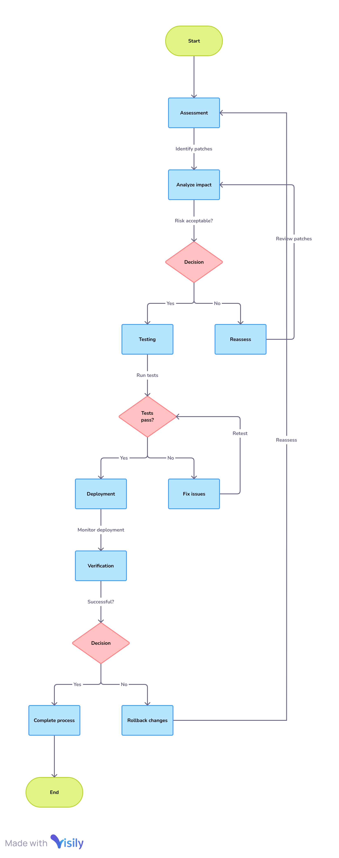
- Implementation:
Apply tested updates during low-traffic times.
Test updates in a staging environment before deploying them.[2]

- Verification:
Scan for vulnerabilities after applying the patches to ensure they are effective.

- Employee Cybersecurity Training:
- Training Modules:
Spend $30,000 per year on a training program on phishing prevention, password security, and secure system use.
Use a mix of online courses and in-person workshops.

- Evaluation:
Test employees to measure their knowledge quarterly.
Employees who score below 80% on tests, give them a refresher course.

- Access Controls:
- Multi-Factor Authentication (MFA):
Provide $50,000 for implementing MFA for all employee accounts.
Make sure MFA setup during employee onboarding.

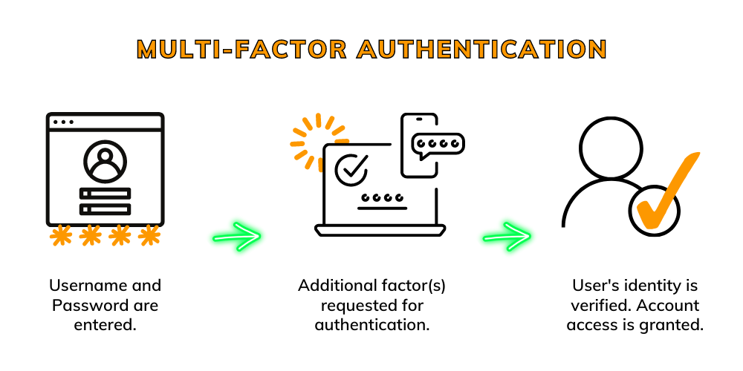

- Role-Based Access Control:
Provide access to sensitive data based on job responsibilities.
Conduct quarterly reviews of access permissions.[3]

- Cybersecurity Tools:
- Deployment:
Use $40,000 annually for subscribing to tools like firewalls, intrusion detection systems, and endpoint security.
Regularly update tools to their latest versions.

- Monitoring:
Perform weekly audits of firewall logs and intrusion alerts.
Use AI tools to send alerts in case of suspect activity
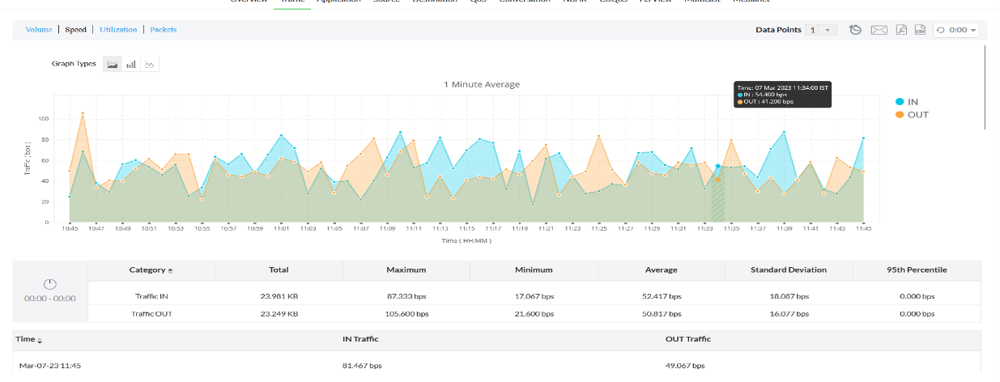
- Cyber Insurance:
- Policy Management:
Designate $20,000 per annum for a cyber insurance policy for data breach liabilities.
Review and adjust the terms of the policy annually for the right level of cover

- Incident Response and Tabletop Exercises:
- Planning:
Provide $10,000 per year for developing and updating the incident response plan.
Clarify roles and escalation processes in incident response.[2]
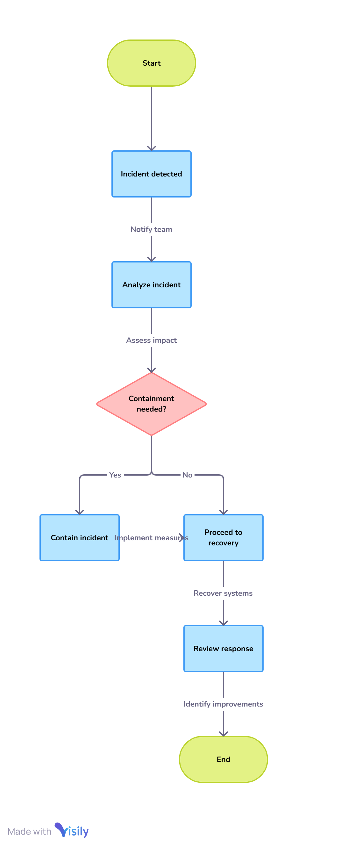
- Tabletop Exercises:
Provide tabletop simulations to train the company for potential security incidents every six months.
Analyze response times and modify the plan according to findings.

- Post-Incident Review:
- Record the incident timeline, response actions, and outcomes.
- Identify mistakes in the response process and update procedures accordingly.
- Share lessons learned with employees to improve future readiness.

References:
  - https://drata.com/grc-central/iso-27001/statement-of-applicability?utm_campaign=CL_cap_goog_all_all-dsa-iso27001-content-ungated_AMS_NA_USCA_demo_requestdemo&utm_source=google&utm_medium=paidsearch&utm_term=&utm_content=&utm_campaignid=21321177103&utm_adgroup=163801423818&utm_creative=700430329914&utm_targetid=dsa-2306616548568&gad_source=1&gbraid=0AAAAABpLT495Vf0F0u9iyRVp-Kj-ZcJ8R&gclid=CjwKCAiA9vS6BhA9EiwAJpnXw41-mxorwlK4XyjsqXBxsBxAB-oup8Ntp27by1NDZv3u-fqtoywN5RoCl9EQAvD_BwE
  - https://www.nist.gov/cyberframework
  - https://gdpr-info.eu
  - https://www.pcisecuritystandards.org
  - https://csrc.nist.gov/pubs/sp/800/53/r5/upd1/final
  - https://csrc.nist.gov/glossary/term/role_based_access_control
  - https://www.lean.org/lexicon-terms/pdca/#:~:text=PDCA%20is%20an%20improvement%20cycle,in%20Japan%20in%20the%201950s.
  - https://oag.ca.gov/privacy/ccpa
  - https://www.iso.org/standard/27001
  - https://www.knowbe4.com/security-awareness-training
  - https://www.ftc.gov/business-guidance/resources/protecting-personal-information-guide-business
  - https://owasp.org/www-project-top-ten/
  - https://www.ready.gov/business/emergency-plans/continuity-planning
  - https://termly.io/resources/articles/gdpr-in-the-us/
  - https://link.springer.com/book/10.1007/979-8-8688-0506-6

