* **original.cpp**: In the original code, I used input integers such as equal number of people preferring dogs and cats, but the output said ‘It was more cats than dogs’. I also put in negative numbers for the students preferring cats and dogs to get a nonsensical output as well as more number of students preferring cats and dogs than total students participating in the survey. The screenshots below show the respective outputs.

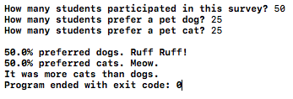

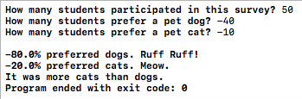

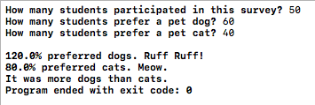

* **logic_error.cpp**: I changed the formula for pctDogs and pctCats for the logic_error.cpp file as this seemed like a logic error someone could make. The program still ran but there was an error in the output. I have attached screenshots below of the changed part of the code as well as the result.

Changed code:

/Users/tanvipati/Desktop/Screen Shot 2018-01-13 at 2.54.32 PM.png

Output:

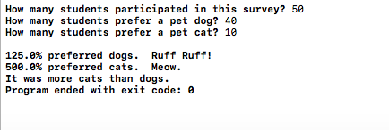

* **compile_error.cpp**: For this code, I removed the ‘;’ at the end of the statement. I also did not put the curly bracket ‘}‘ at the end of the code. After cout, I used ‘>>’ instead of ‘<<’. Introducing these errors did not allow the program to build and the error message ‘Build Failed’ appeared.

/Users/tanvipati/Desktop/Screen Shot 2018-01-13 at 2.39.00 PM.png

../../../../Screen%20Shot%202018-01-17%20at%207.56.18%20AM.png

/Users/tanvipati/Desktop/Screen Shot 2018-01-13 at 2.38.40 PM.png