**Experiment Number: 7**

**UID : 2019140050** **Name: Tanvi Sunil Pen**

**Batch: C** **Branch: TE IT**

**AIM:** To create and read QR Codes for the given exercise

**PROCEDURE:**

1. **The quickest way to create a QR code is with the Qrencode command-line utility. Any major distribution can install Qrencode via the package manager. The following command then creates a QR code containing the text “Hello World!”: $ qrencode -o qrcode.png 'Hello World!'**

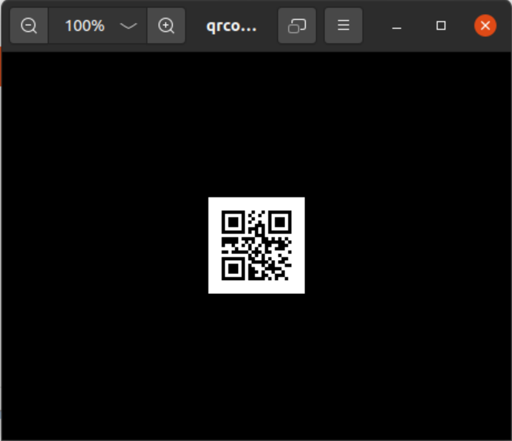

1. **$ qrencode -t EPS -o qrcode.eps 'Hello World!'**

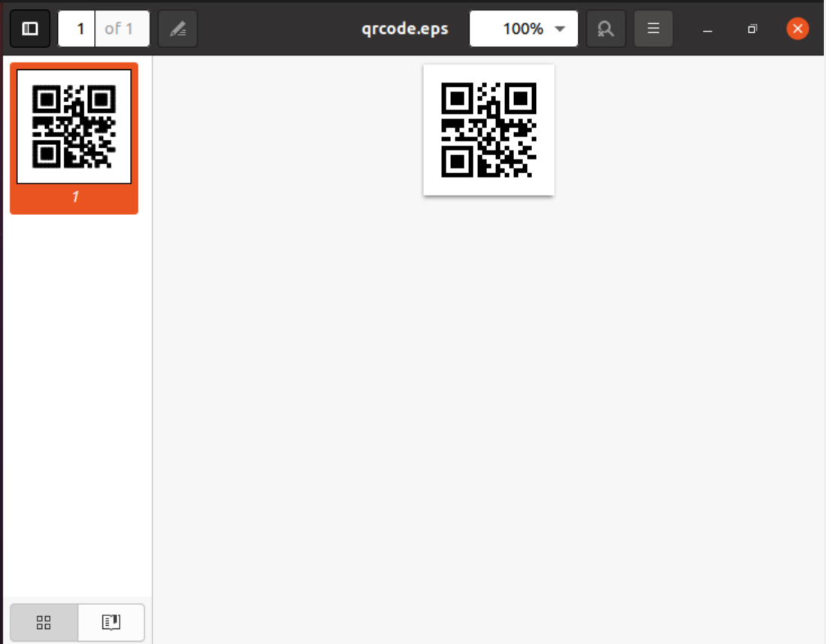

1. **qrencode -m 10 -o qrcode.png 'Hello World!'**

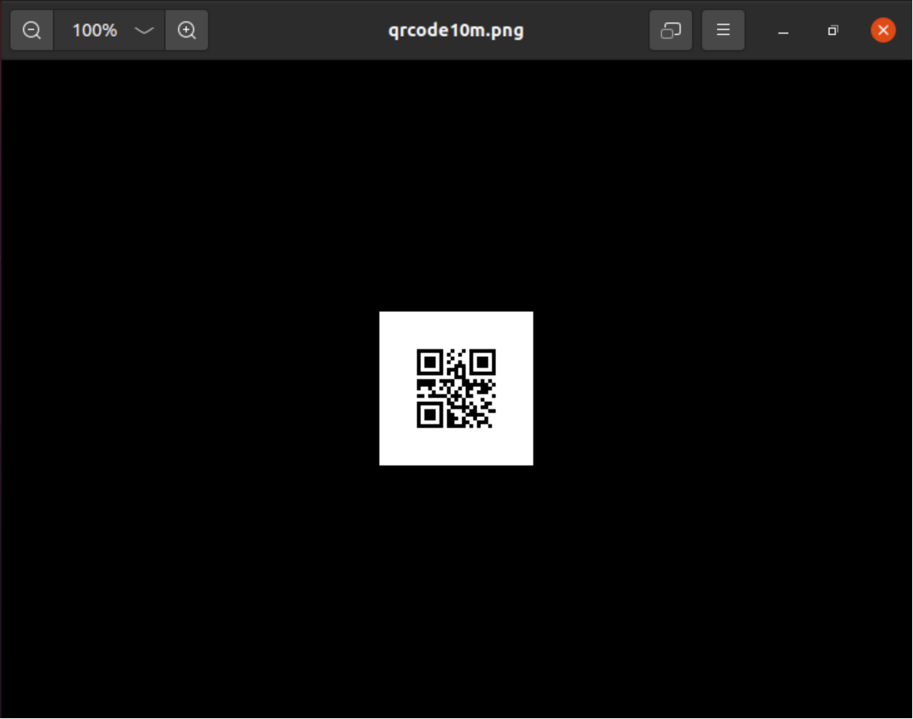

1. **qrencode -s 2 -m 10 -o qrcode.png 'Hello World!'**

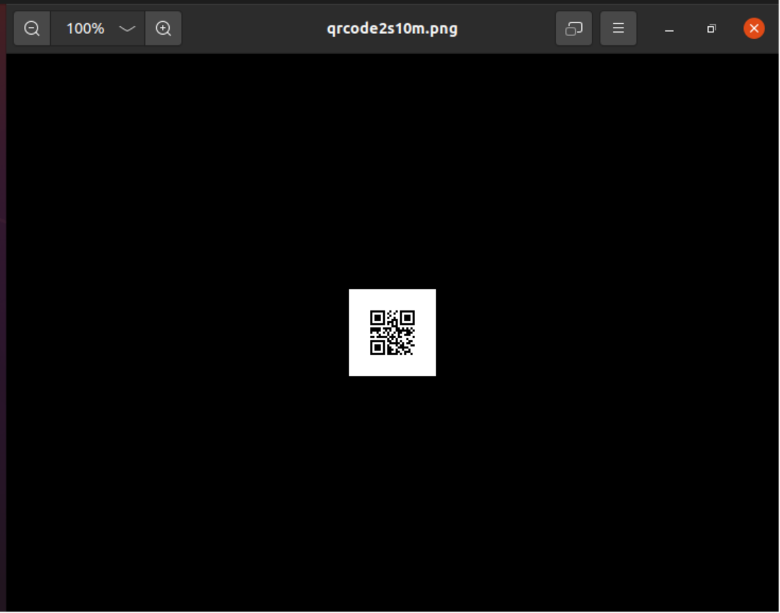

1. **Checking tolerance**



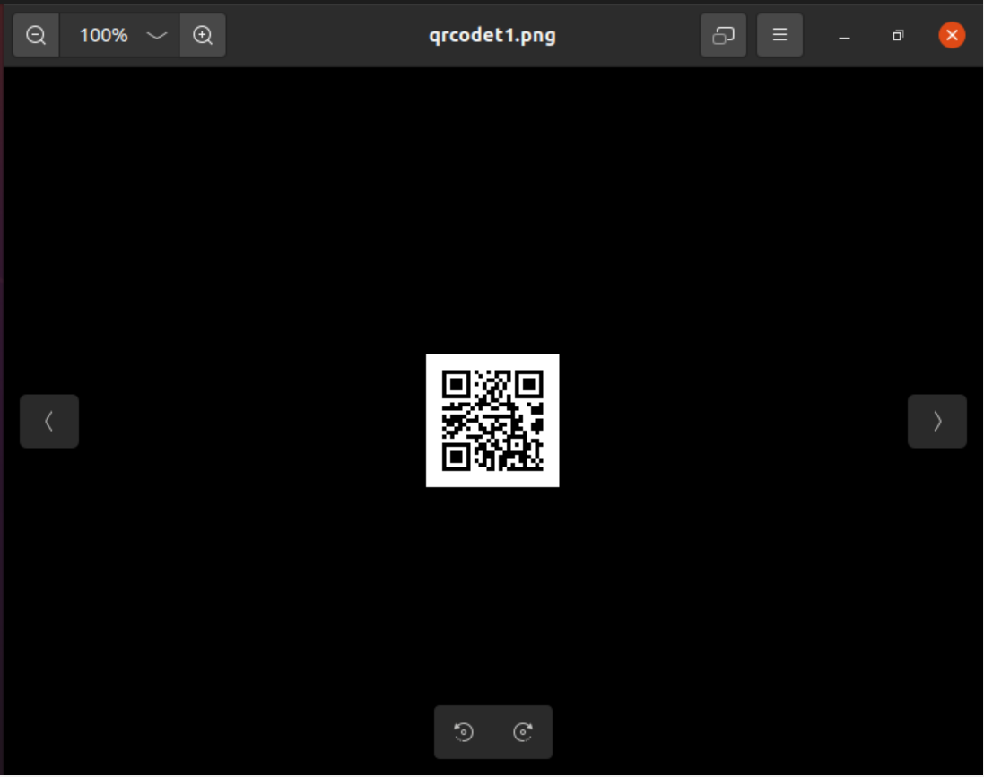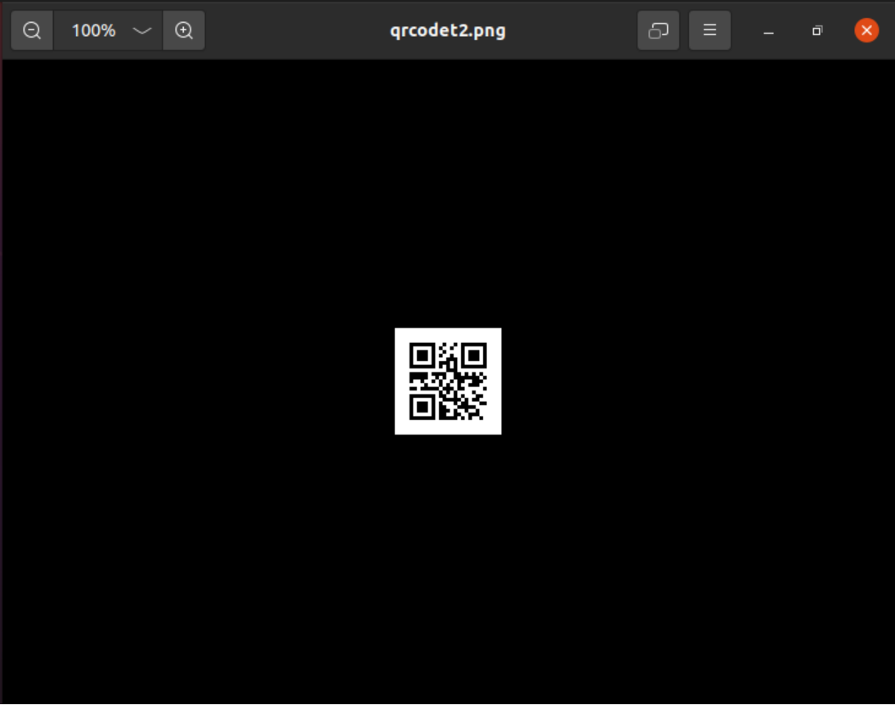

**Generating a key:**

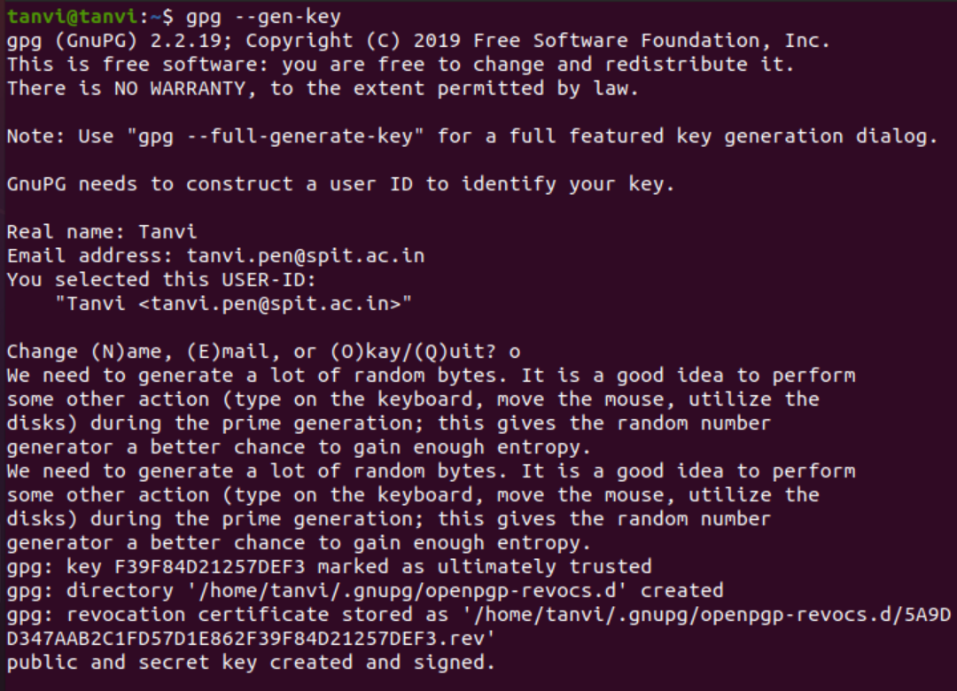

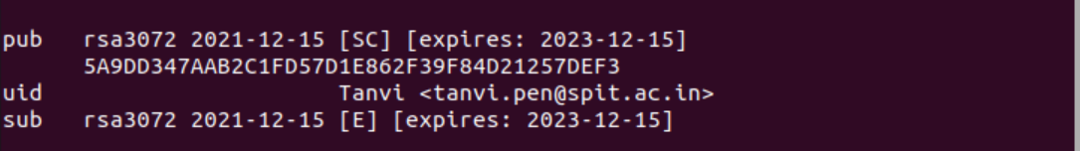

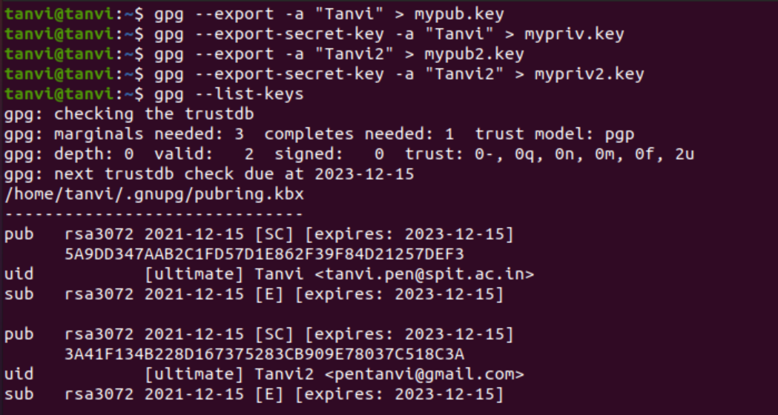

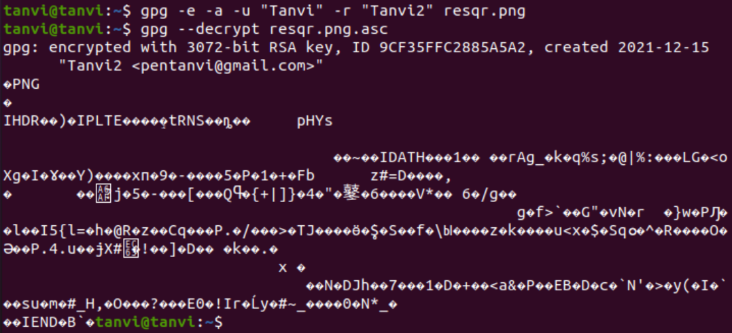

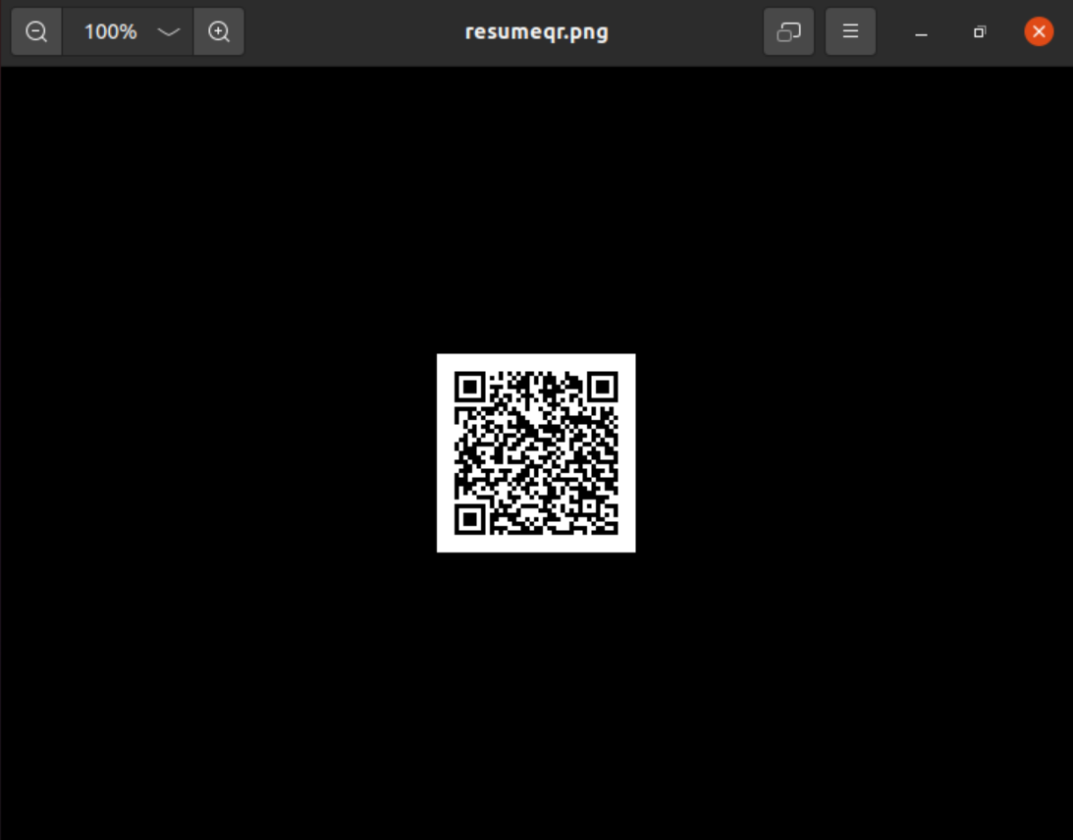

**Conclusion:**

Here we saw how to generate qr code for text or URL. Further we also saw how can we secure this by encrypting.