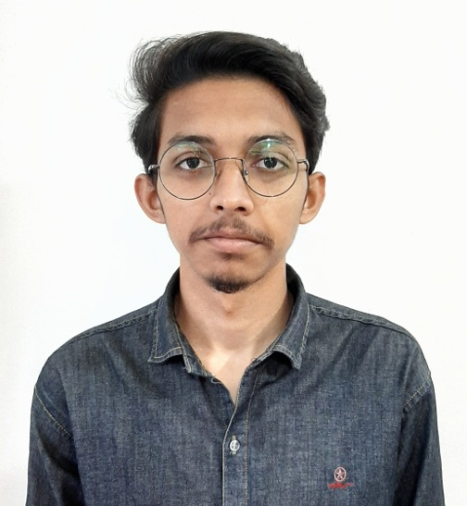

**Md. Tanvir Hossen**

**(Back-end Developer)**

Objectives

To learn and innovate in the field of “Programming”. To be confident and make contribution to the organization and share knowledge, skills over new technology. Want to create something new.

Skill Highlights

|  |  |
| --- | --- |
| * Project management * Strong decision maker * Complex problem solver * English Proficiency | * Innovative * Service-focused * User Friendly * Presentation Skill |

Project

* **Employee Tracking System**
  1. **Demo:** [**https://smartwetrack.xyz/**](https://smartwetrack.xyz/)
  2. **Github:** [**https://github.com/R0k37/wetrack**](https://github.com/R0k37/wetrack)
* **Hospital Management System**
  1. **Github:** [**https://github.com/R0k37/Hospital-Management-System**](https://github.com/R0k37/Hospital-Management-System)

Education

**Diploma in Engineering**: Data Telecommunication And Networking Technology- 2020

Feni Compute Institute, Feni

**Secondary School Certificate**: Khaja Ajmeri High School,

Chittagong - 2016

Training

|  |  |  |  |
| --- | --- | --- | --- |
| Certification | Institute | Location | Duration |
| About PHP & Laravel  Framework | **TMSS ICT** | **Mirpur 10, Dhaka** | **8 February 2020 – Running** |

Technology Knowledge

* HTML
* CSS
* Bootstrap
* Javascript
* Jquery
* Git
* **Operating Syetem:** Linux,Windows

.

Contact

**Present Address:**

Kazipara, Mirpur 10, Dhaka

**Phone:**

+8801840010344

**Email:**

[tanvirhossen112@gmail.com](mailto:tanvirhossen112@gmail.com)

**LinkedIn:**

[www.linkedin.com/in/tanvir112](http://www.linkedin.com/in/tanvir112)

**Github:**

https://github.com/R0k37

Languages

English

Bangla

* Ajax
* PHP
* Laravel
* MySQL