**Higher Order Function:** A function which takes another function as parameter or a function which returns another function or does both is called as *higher order function.*  
  
**Callback Function:** A function which is passed as argument of another function is called as *Callback Function.*

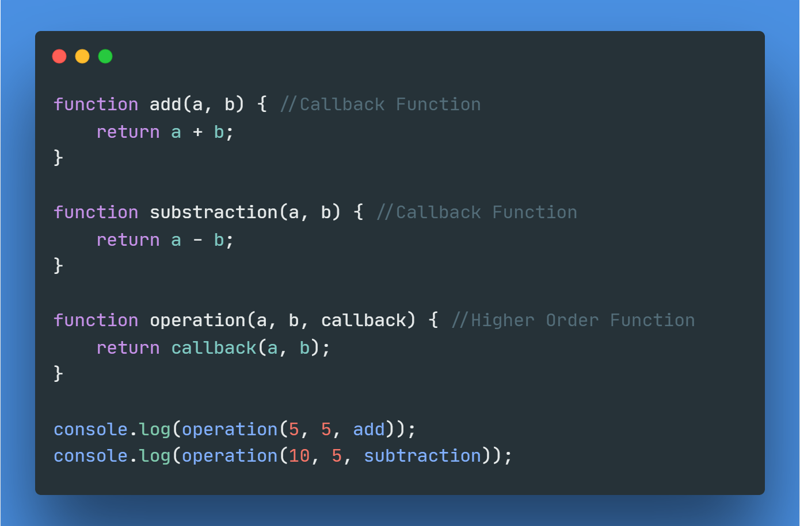

**Code Snippet**: Example of Higher Order Function & Callback Function.

Here, in the above code snippet, the operation function takes 3 arguments as params. Parameter a & b are two values and callback parameter take another function as argument. As operation function takes callback function as argument, it is now a higher order function. On the other hand, add & subtraction functions are passed as argument to the parameter of operation function. So, both add & subtraction functions are now callback function.