**1.Design a topology using 4 PC and a Switch with following IP address**

* At first take 4pc as 4 host from ‘End devices’ and named them PC-0, PC-1, PC-2 PC-3.
* Take a switch ‘2960-24TTT’ from ‘network devices’.
* Connect each host with switch with ethernet cable.
* Give them specific Ip address and Subnet Mask from ‘IP configuration’ as given in the instructions.

**2.Observe the flow of data from host to host by creating network traffic.**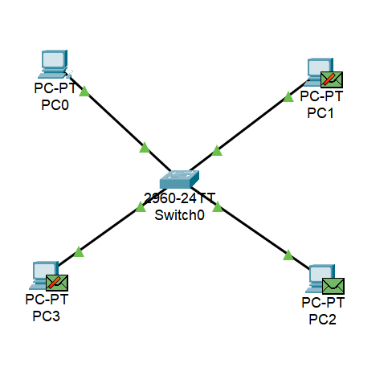

In this example, Host 1(PC-0) wants to send a packet to Host 2(PC-2) within the same Network.

* Host 1(PC-0) goes through the OSI Layer to construct Packets.
* Host 1 initiates the ARP to identify the MAC address of Host 2(PC-2) . ARP request includes the source and destination IP and source MAC Address.
* When the request reaches the Switch, Switch checks its ARP Cache. Since the mapping is not found, it Floods the ARP Request on all the Hosts in the Network.
* Host 2(PC-2) acknowledges the ARP Request and sends an ARP Response with its MAC Address to the Switch while other Hosts ignore the request.
* Switch updates its ARP Cache and forwards it to Host 1(PC-0).
* Host 1(PC-0) learns the MAC Address of Host 2(PC-2) and updates its ARP Cache