



**6.8.1: Skills Integration Challenge-Planning Subnets and Configuring IP Addresses**

**Topology Diagram**

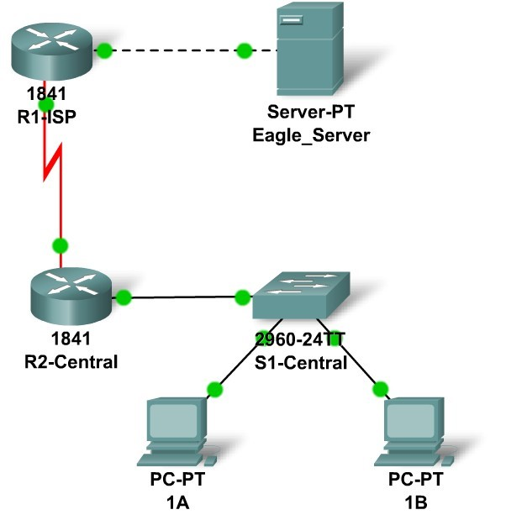

**Addressing Table**

|  |  |  |  |  |
| --- | --- | --- | --- | --- |
| **Device** | **Interface** | **IP Address** | **Subnet Mask** | **Default**  **Gateway** |
| **R1-ISP** | **Fa0/0** | 192.168.23.110 | 255.255.255.240 | N/A |
| **S0/0/0** | 192.168.23.122 | 255.255.255.252 | N/A |
| **R2-**  **Central** | **Fa0/0** | 192.168.23.62 | 255.255.255.192 | N/A |
| **S0/0/0** | 192.168.23.121 | 255.255.255.252 | N/A |
| **PC 1A** | **NIC** | 192.168.23.1 | 255.255.255.192 | 192.168.23.62 |
| **PC 1B** | **NIC** | 192.168.23.2 | 255.255.255.192 | 192.168.23.62 |
| **Eagle Server** | **NIC** | 192.168.23.109 | 255.255.255.240 | 192.168.23.110 |