

MAWLANA BHASHANI SCIENCE AND TECHNOLOGY UNIVERSITY

Santosh,Tangail-1902

LAB REPORT

Lab Report No : 01

Lab Report name : How to install Linux operating system.

Course Title : Operating System Lab

Course Code : ICT-3110

Date of Performance :

Date of Submission :

Submitted to,

Nazrul Islam

Assistant Professor

Dept. of ICT,

MBSTU.

Submitted by,

Student Name : Tanvir Ahmed

Student ID : IT-18043

Session : 2017-18

3rd Year 1st semester

Dept. of ICT

Experiment NO : 01

Experiment Name : How to install Linux operating system.

Introduction :

1. 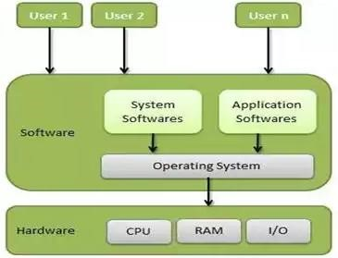What is Linux Operating system?

Linux® is an open source operating system (OS). An operating system is the software that directly manages a system’s hardware and resources, like CPU, memory, and storage. The OS sits between applications and hardware and makes the connections between all of your software and the physical resources that do the work.

1. Different Type of Linux Distribution.

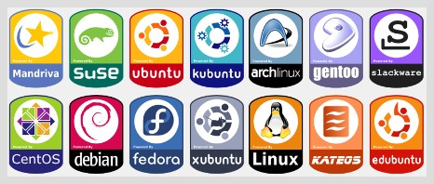

1. How can we install Linux Operating System?

# Installing Linux using USB stick

This is one of the easiest methods of installing Ubuntu or any distribution on your computer. Follow the steps.

**Step 1)** Download the .iso or the OS files on your computer from this [link.](http://www.ubuntu.com/download/desktop)

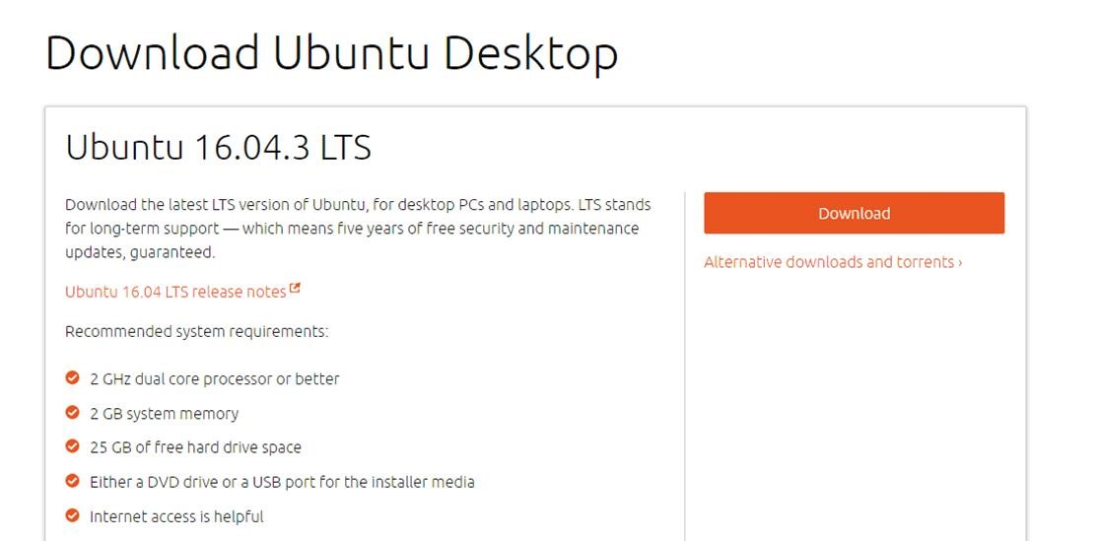

**Step 2)** Download free software like '[Universal USB installer](http://www.pendrivelinux.com/universal-usb-installer-easy-as-1-2-3/) to make a bootable USB stick.

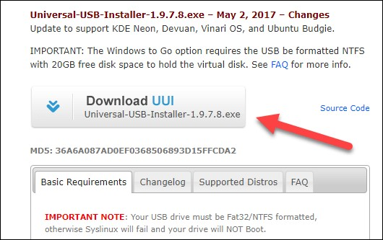

**Step 3)** Select an Ubuntu Distribution form the dropdown to put on your USB

Select your Ubuntu iso file download in step 1. Then select the drive letter of USB to install Ubuntu and Press create button.

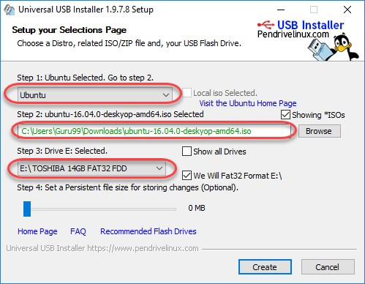

**Step 4)** Click YES to Install Ubuntu in USB.

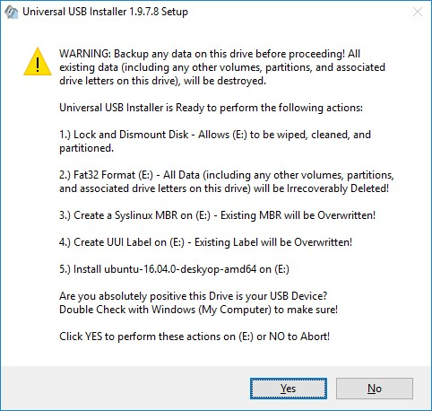

**Step 5)** After everything has been installed and configured, a small window will appear Congratulations! You now have Ubuntu on a USB stick, bootable and ready to go.

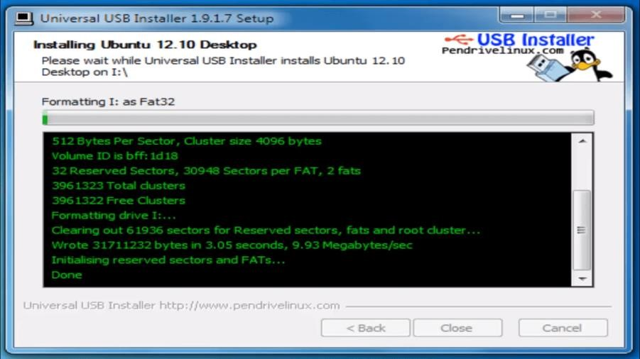

**Step-6)** You have an option to Run Ubuntu WITHOUT installing. In this tutorial will install Ubuntu

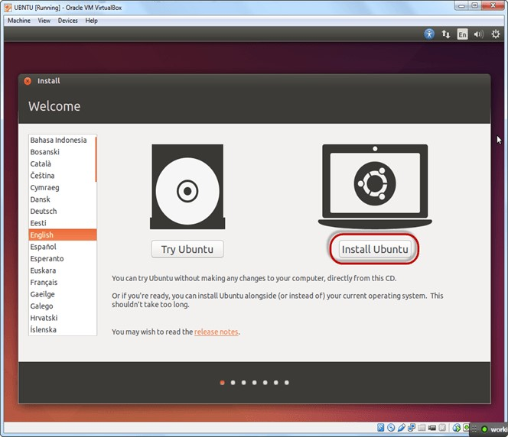

**Step-7)** Select option to erase the disk and install Ubuntu and click on install now. This option installs Ubuntu into our virtual hard drive which is we made earlier. It will not harm your PC or Windows installation

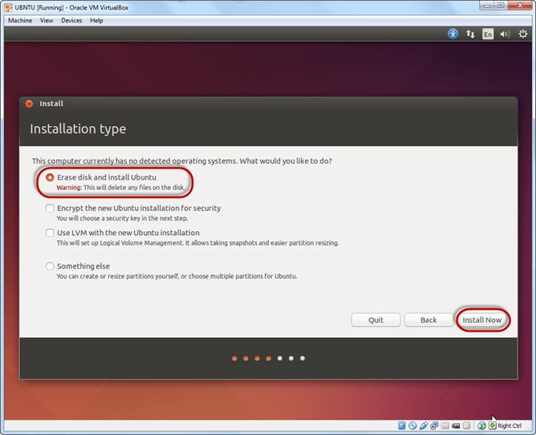

**Step-8)** Select your location for setting up time zone, and click on continue

**Step-9)** Select your keyboard layout, by default English (US) is selected but if you want to change then, you can select in the list. And click on continue

**Step-10)** Select your username and password for your Ubuntu admin account. This information has been needed for installing any software package into Ubuntu and also for login to your OS. Fill up your details and tick on login automatically to ignore login attempt and click on continue

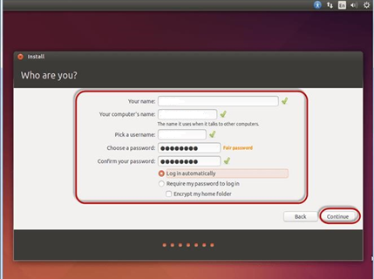

**Step-11)** Installation process starts. May take up to 30 minutes. Please wait until installation process completes.

**Step-12)** After finishing the installation, you will see Ubuntu Desktop.

