

MAWLANA BHASHANI SCIENCE AND TECHNOLOGY UNIVERSITY

Santosh,Tangail-1902

LAB REPORT

Lab Report No : 02

Lab Report name : Basic Command of Linux Operating System.

Course Title : Operating System Lab

Course Code : ICT-3110

Date of Performance :

Date of Submission :

Submitted by,

Student Name : Tanvir Ahmed

Student ID : IT-18043

Session : 2017-18

3rd Year 1st semester

Dept. of ICT

Submitted to,

Nazrul Islam

Assistant Professor

Dept. of ICT,

MBSTU.

Experiment NO : 02

Experiment Name : Basic Command of Linux Operating System.

Introduction :

Basic Linux Commands

1. **whoami** : This command prints the username associated with the current effective user ID.



1. **hostname** : The **hostname** command shows or sets the system hostname.

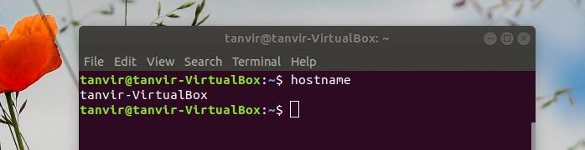

1. **pwd:** hort for **print working directory**, **pwd** is a Linux, Unix, and FTP command to print the directory you're currently working in when at the command line.

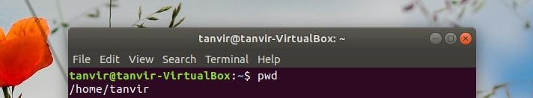

1. **ls** : ls lists the files in the current working folder.

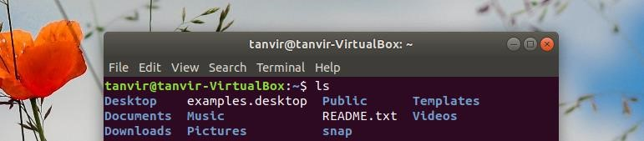

1. **ls -a:** list all files including hidden file starting with '.'

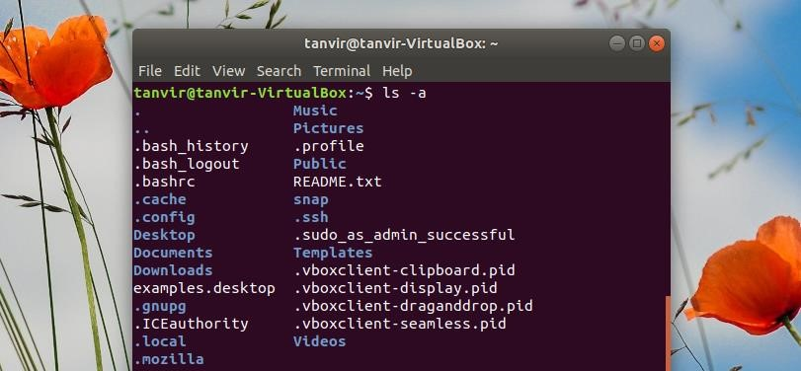

1. **cd:** The **cd** command, which stands for "change directory", changes the shell’s current working directory .

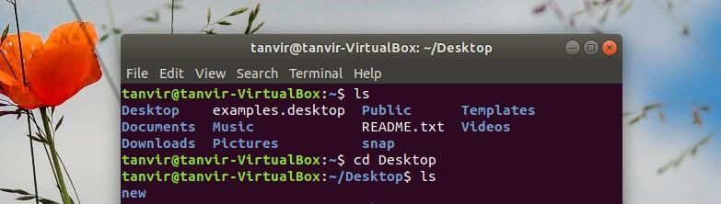

1. **mkdir:** The **mkdir** command creates new directories in your file system.

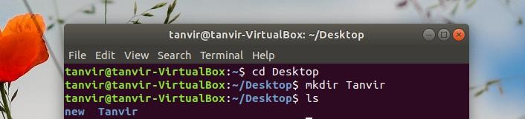

1. **cd .. :** Move one directories up.

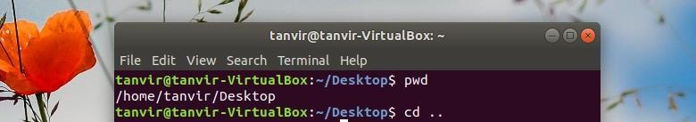

1. **cd .. .. :** Move two directories up.

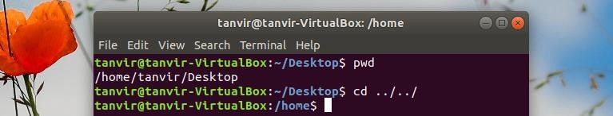

1. **rmdir:** remove a directory.

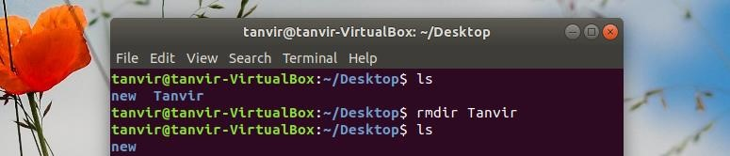

1. **rm -r:** remove directory with its content.

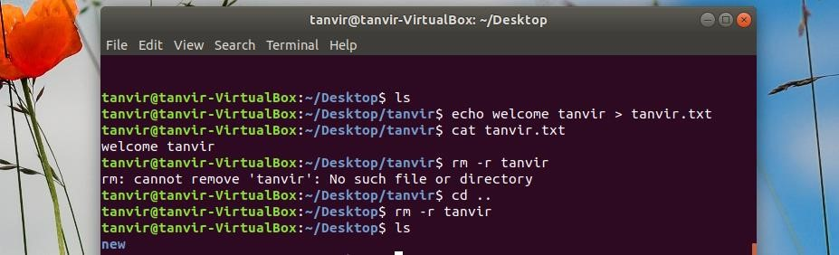

1. **gedit :** Working with text editors: $ gedit ---> its an editor

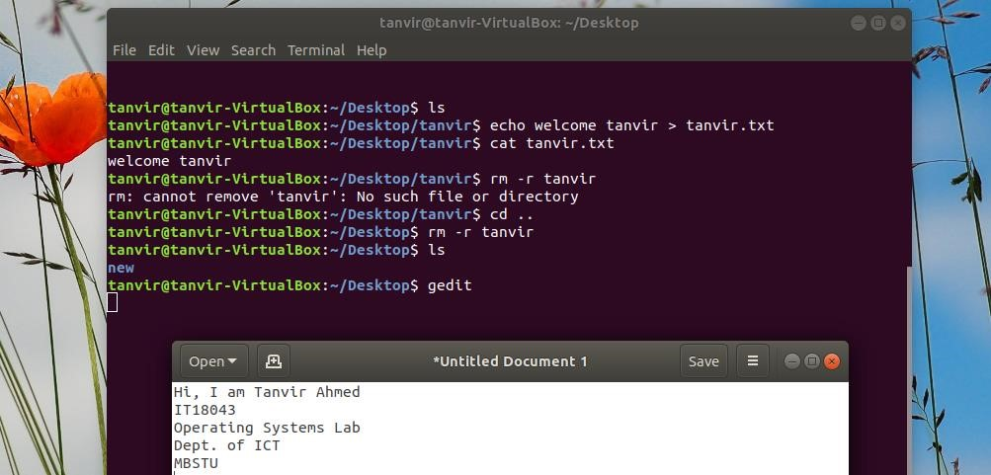

1. **cat:** creates new file.

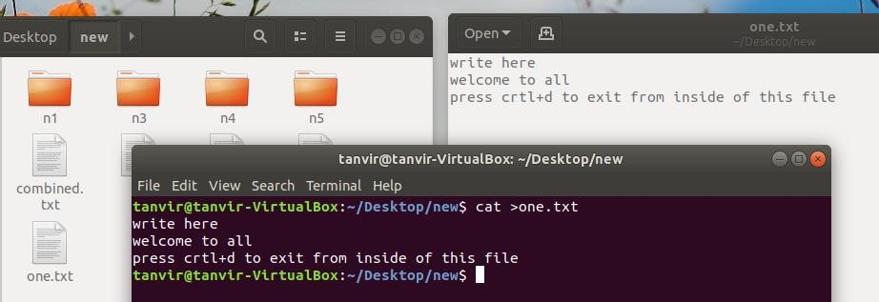

1. **echo:** show something on the terminal.



1. **sudo:** sudo (**S**uper **U**ser **DO**) command in Linux is generally used as a prefix of some command that only superuser are allowed to run.

