

MAWLANA BHASHANI SCIENCE AND TECHNOLOGY UNIVERSITY

Santosh,Tangail-1902

LAB REPORT

Lab Report No : 03

Lab Report name : How to view threads of a process on linux and thread program .

Course Title : Operating System Lab

Course Code : ICT-3110

Date of Performance :

Date of Submission :

Submitted by,

Student Name : Tanvir Ahmed

Student ID : IT-18043

Session : 2017-18

3rd Year 1st semester

Dept. of ICT

Submitted to,

Nazrul Islam

Assistant Professor

Dept. of ICT,

MBSTU.

**Lab Report No –** 03

**Lab Name-** How to view threads of a process on linux and thread program.

**Objectives:**

i. What is Thread. ii. Types of Thread iii. Implementation of Thread

**Theory :**  A thread is a flow of execution through the process code, with its own program counter that keeps track of which instruction to execute next, system registers which hold its current working variables, and a stack which contains the execution history.

A thread shares with its peer threads few information like code segment, data segment and open files. When one thread alters a code segment memory item, all other threads see that.

A thread is also called a **lightweight process**. Threads provide a way to improve application performance through parallelism. Threads represent a software approach to improving performance of operating system by reducing the overhead thread is equivalent to a classical process.

**What are the differences between process and thread?**

Threads are not independent of one other like processes as a result threads shares with other threads their code section, data section and OS resources like open files and signals. But, like process, a thread has its own program counter (PC), a register set, and a stack space.

**Types of Thread:**

Threads are implemented in following two ways −

* **User Level Threads** − User managed threads.
* **Kernel Level Threads** − Operating System managed threads acting on kernel, an operating system core.

**Multithreading Models:**

Some operating system provide a combined user level thread and Kernel level thread facility. Solaris is a good example of this combined approach. In a combined system, multiple threads within the same application can run in parallel on multiple processors and a blocking system call need not block the entire process. Multithreading models are three types

* Many to many relationship.
* Many to one relationship.
* One to one relationship.

**Corresponding Code:**

|  |
| --- |
| #include<stdio.h>  #include<string.h>  #include<pthread.h>  #include<stdlib.h> #include<unistd.h> pthread_t tid[2];  void* doSomeThing(void *arg)  {  unsigned long i = 0; pthread_t id = pthread_self();  if(pthread_equal(id,tid[0]))  {  printf("\n First thread processing\n");  }  else  {  printf("\n Second thread processing\n");  }  for(i=0; i<(0xFFFFFFFF);i++);  return NULL;  }  int main(void)  {  int i = 0; int err;  while(i < 2)  {  err = pthread_create(&(tid[i]), NULL, &doSomeThing, NULL); if (err != 0)  printf("\ncan't create thread :[%s]", strerror(err)); else  printf("\n Thread created successfully\n");  i++;  }  sleep(5); return 0;  } |

**Output:**

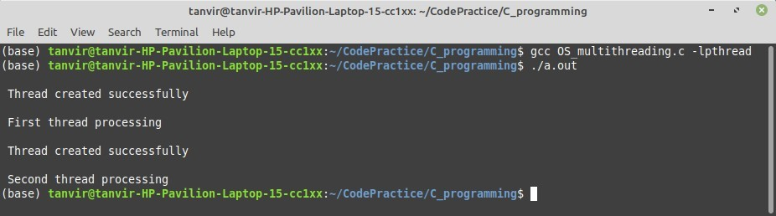

**Thread in command line:**

Here are several ways to show threads for a process on Linux.

**1: PS**

In ps command, "-T" option enables thread views. The following command list all threads created by a process with <pid>

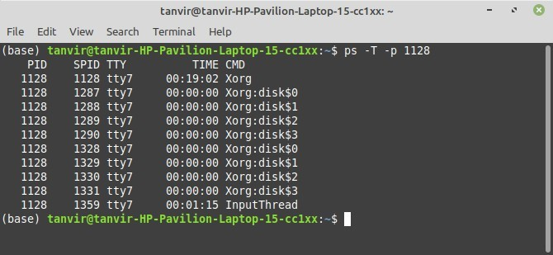

The "SID" column represents thread IDs, and "CMD" column shows thread names.

**2: Top:**

The top command can show a real-time view of individual threads. To enable thread views in the top output, invoke top with "-H" option. This will list all Linux threads.

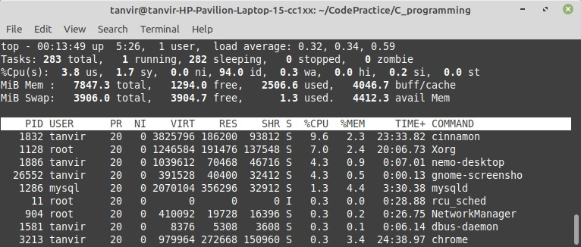

To restrict the top output to a particular process <pid> and check all threads running inside the process: then we use $ top -H -p <pid>

**3: Htop:**

A more user-friendly way to view threads per process is via htop, an ncurses-based interactive process viewer. This program allows you to monitor individual threads in tree views.

