

MAWLANA BHASHANI SCIENCE AND TECHNOLOGY UNIVERSITY

Santosh,Tangail-1902

LAB REPORT

Lab Report No : 04

Lab Report name : File operation and permission

Course Title : Operating System Lab

Course Code : ICT-3110

Date of Performance :

Date of Submission :

Submitted by,

Student Name : Tanvir Ahmed

Student ID : IT-18043

Session : 2017-18

3rd Year 1st semester

Dept. of ICT

Submitted to,

Nazrul Islam

Assistant Professor

Dept. of ICT,

MBSTU.

**Lab report** – 04

**Lab report Name** - File operation and permission

Objectives:

1. File operation
2. File permission

Filr Operation : To use the Linux terminal like a pro, we’ll need to know the basics of managing files and navigating directories.Differnet file operation is given below…

1. **ls** – List Files

The ls command lists the files in a directory. By default, ls lists files in the current directory.

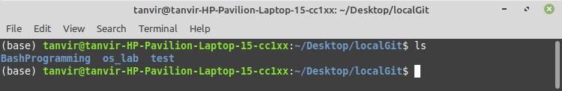

1. we can also list files recursively — that is, list all files in directories inside the current directory — with **ls -R**.

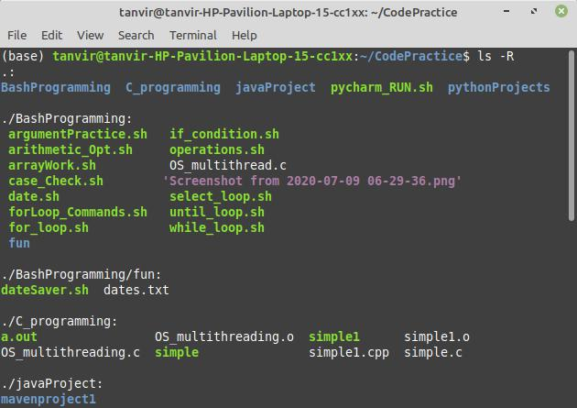

3. **cd** – Change Directory

The cd command changes to another directory. For example, cd Desktop will take you to your Desktop directory if you’re starting from your home directory.

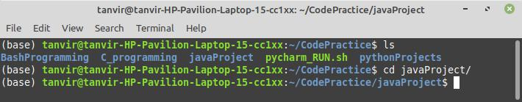

4. **cd . .** will take you up a directory.

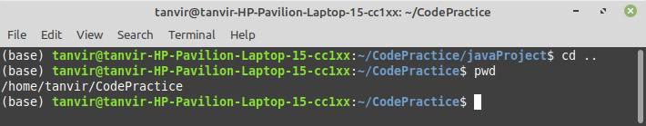

5.**rmdir** – Remove Directories

The rmdir command removes an empty directory. rmdir directory would delete the directory named “directory” in the current directory.

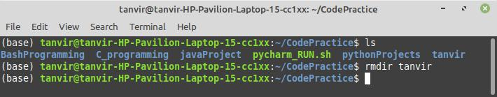

6) **mkdir** – Make Directories

The mkdir command makes a new directory. mkdir example will make a directory with the name “example” in the current directory.

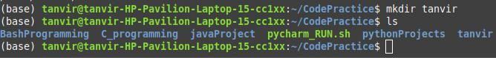

7) **ln** – Create Links

The ln command creates links. The most commonly used type of link is probably the symbolic link, which you can create with ln -s.

For example, the following command creates a link to our Downloads folder on our

Desktop:

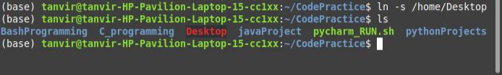

**File Permissions:**

**There are 3 types of permissions:**

1. Read
2. Write
3. Execute permission

Read (r): this gives permission to merely open a file or folder and view its contents.

Write (w): this gives permission to overwrite, append-to or delete a file or folder.

Execute (x): this gives permission to "run" a file. For example to run a script or a program.

So, how can we put this all into context? Let's have a look at the contents of a typical folder. I used the command ls -l to bring up this list:

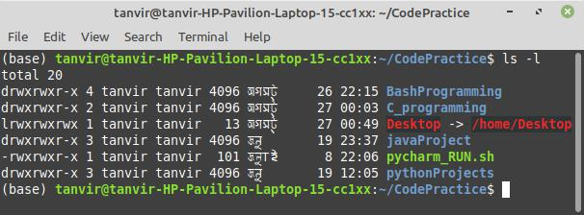

we can also do this via the command-line. Go to a directory that has files in it and type the following command to view all files in a list:

**ls -al**

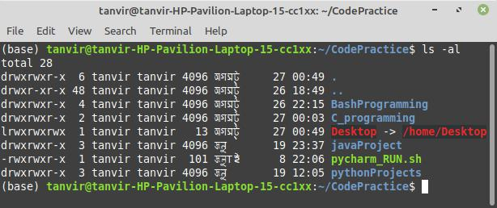

Next to each file and directory, we’ll see a special section that outlines the permissions it has. It looks like this:

**-rwx rw- r–**

The r stands for “read,” the w stands for “write,” and the x stands for “execute.” Directories will be start with a “d” instead of a “-“. You’ll also notice that there are 10 spaces which hold value. You can ignore the first, and then there are 3 sets of 3. The first set is for the owner, the second set is for the group, and the last set is for the world.

To change a file or directory’s permissions, let’s look at the basic form of the chmod command.

chmod [class][operator][permission] file

chmod [ugoa][+ or –] [rwx] file

1. This is for the owner.
   1. This is for the group.
   2. This is for all others.
   3. This will change permissions for all of the above.

+: The plus sign will add the permissions which follow.

-: The minus sign will remove the permissions which follow.

1. Allows read access.
   1. Allows write access.
   2. Allows execution.