

MAWLANA BHASHANI SCIENCE AND TECHNOLOGY UNIVERSITY

Santosh,Tangail-1902

LAB REPORT

Lab Report No : 05

Lab Report name : Connecting a database (MySQL) with linux

Course Title : Operating System Lab

Course Code : ICT-3110

Date of Performance :

Date of Submission :

Submitted by,

Student Name : Tanvir Ahmed

Student ID : IT-18043

Session : 2017-18

3rd Year 1st semester

Dept. of ICT

Submitted to,

Nazrul Islam

Assistant Professor

Dept. of ICT,

MBSTU.



**Lab 05 - Connecting a database (MySQL) with linux**

**1. Install MySQL on Ubuntu**

sudo apt-get install **mysql-server**

**2. Log into mysql by linux ubuntu.**

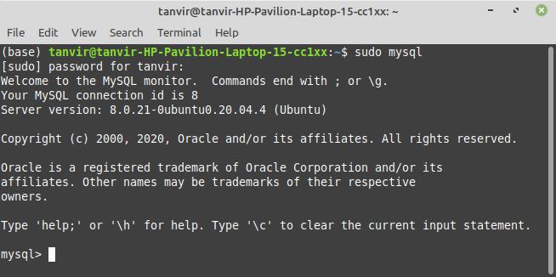

**3.show and create database :**

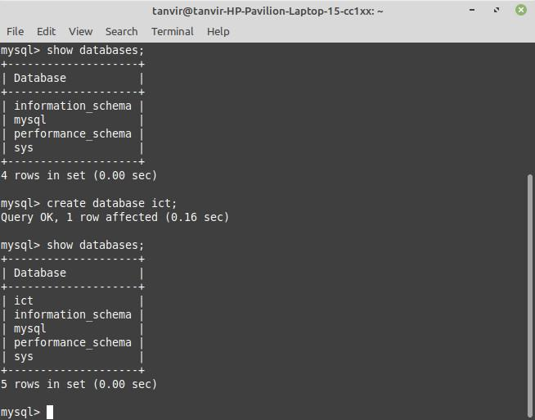

**3. show and create table :**

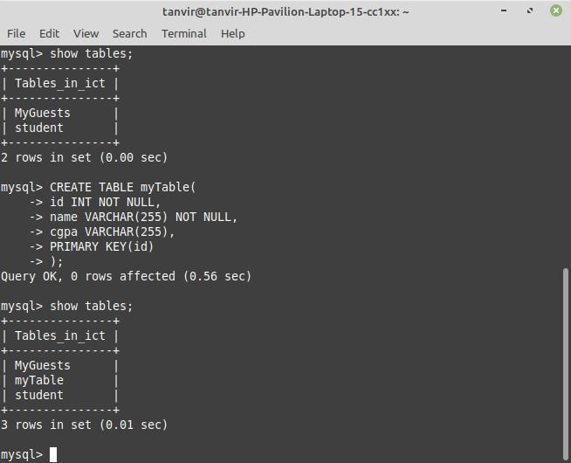

**4. insert data into table :**

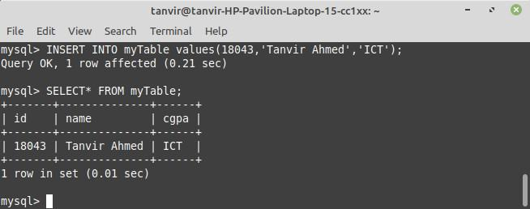

**5. Describe table:**

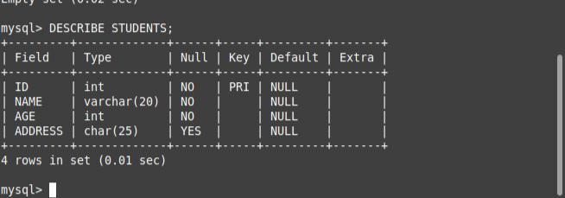

**6. alter table :**

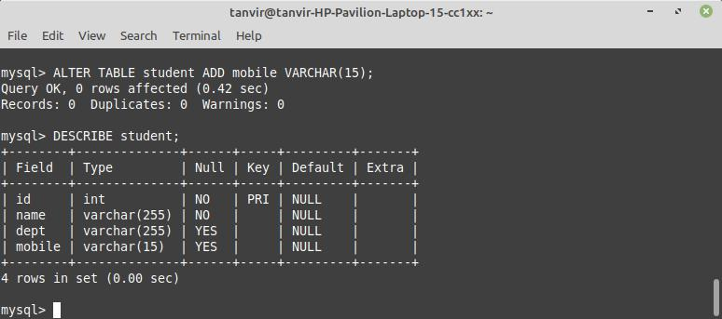

**7.modify table:**

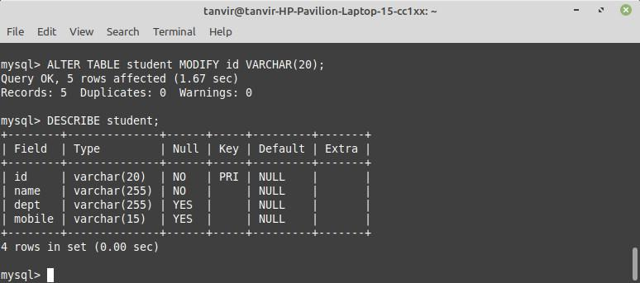

**8. drop data from table:**

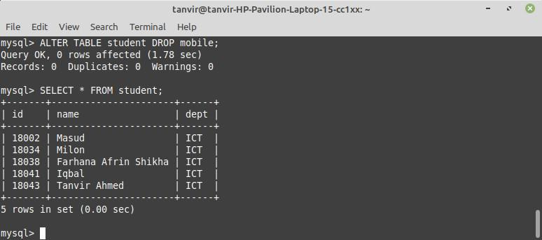

**9.update data of table:**

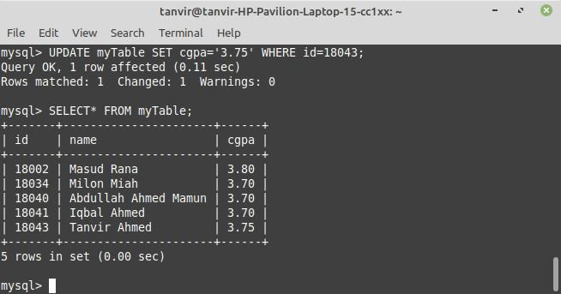

**10. Where and delete operation:**

