

MAWLANA BHASHANI SCIENCE AND TECHNOLOGY UNIVERSITY

Santosh,Tangail-1902

LAB REPORT

Lab Report No : 06

Lab Report name : Linux command for process

Course Title : Operating System Lab

Course Code : ICT-3110

Date of Performance :

Date of Submission :

Submitted by,

Student Name : Tanvir Ahmed

Student ID : IT-18043

Session : 2017-18

3rd Year 1st semester

Dept. of ICT

Submitted to,

Nazrul Islam

Assistant Professor

Dept. of ICT,

MBSTU.

**Lab 06 - Linux command for process**

1. **top:** The top command is the traditional way to view your system’s resource usage and see theprocesses that are taking up the most system resources. Top displays a list of processes, with the ones using the most CPU at the top.

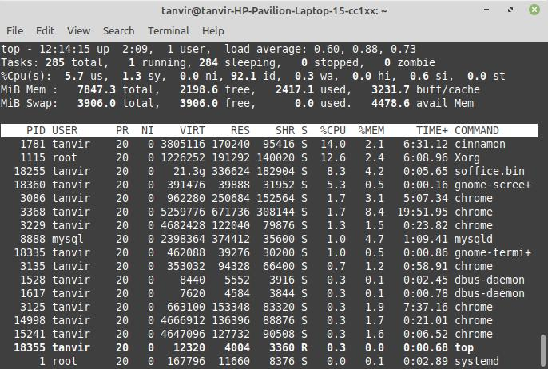

To exit top or htop, use the Ctrl- C keyboard shortcut. This keyboard shortcut usually kills the currently running process in the terminal.

1. **htop:** The **htop** command is an improved top. It’s not installed by default on most Linuxdistributions — here’s the command you’ll need to install it on Ubuntu:

sudo apt-get install htop

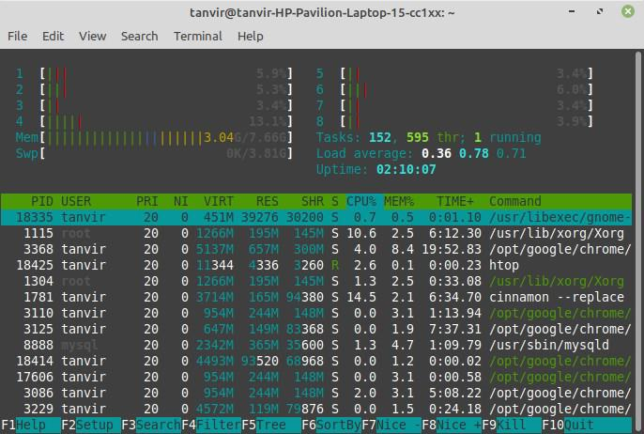

1. **ps -A :** The **ps** command lists running processes. The following command lists all processesrunning on your system:

ps -A

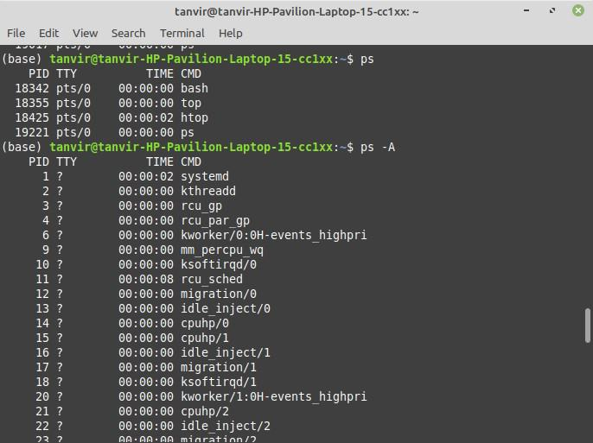

1. **ps -A | less: *ps -A*** may be too many processes to read at one time, so we can pipe the outputthrough the **less** command to scroll through them at own pace.

ps -A | less:

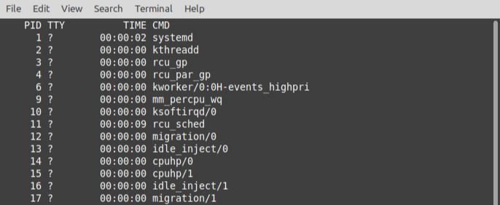

Press q to exit when you’re done.

1. **ps -A | grep** : We could also pipe the output through **grep** to search for a specific processwithout using any other commands. The following command would search for the Firefox process:

ps -A | grep firefox

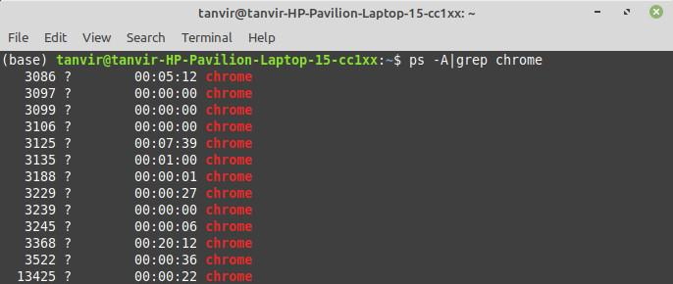

**6) pstree:**

The **pstree** command is another way of visualizing processes. It displays them in tree format.

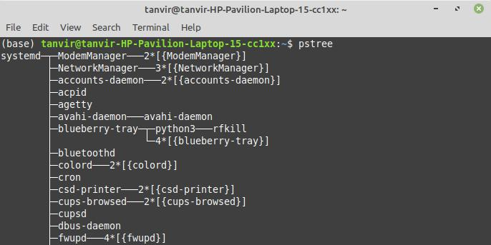

**7) kill :**

The **kill** command can kill a process, given its process ID. You can get this information from the **ps** **-A**, **top** or **pgrep** commands.

kill PID

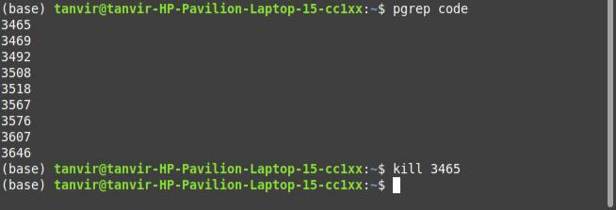

**8) pgrep :**

Given a search term, **pgrep** returns the process IDs that match it. For example, you could use the following command to find Firefox’s PID:

pgrep firefox



**9) pkill & killall :**

The **pkill** and **killall** commands can kill a process, given its name. Use either command to kill

Firefox:

pkill firefox

killall firefox

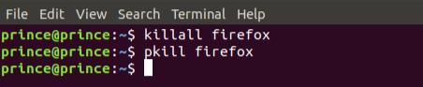

**10) r enice:**

The **renice** command changes the nice value of an already running process. The nice value determines what priority the process runs with. A value of **-19** is very high priority, while a value of **19** is very low priority. A value of **0** is the default priority.

The renice command requires a process’s PID. The following command makes a process run with very low priority:

renice 19 *PID*

