Operating System:
- Windows 7 – must have .NET installed
- Windows 7 above – fully compatible
- Any OS other than Windows, NOT compatible with current scenario.

Pre-requisite:
- BCC CA Client software | 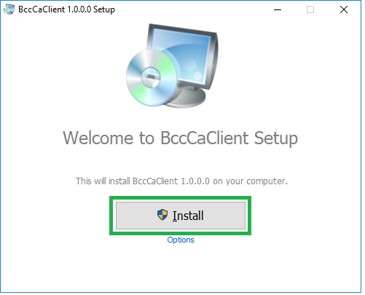
- Web browsing application | 

Major activities are as follows:
- Offline software installation
  - Download necessary software
  - Install BCC CA Client
- Online registration & digital certification process
  - Online registration
  - Profile update
  - Online enrollment
  - Key pair generation
  - Payment procedure
  - Download certificate

Pre-requisite: BCC CA Client software should be installed in the machine.

- Offline software installation
  - To download all necessary software please visit BCC-CA’s official website as following
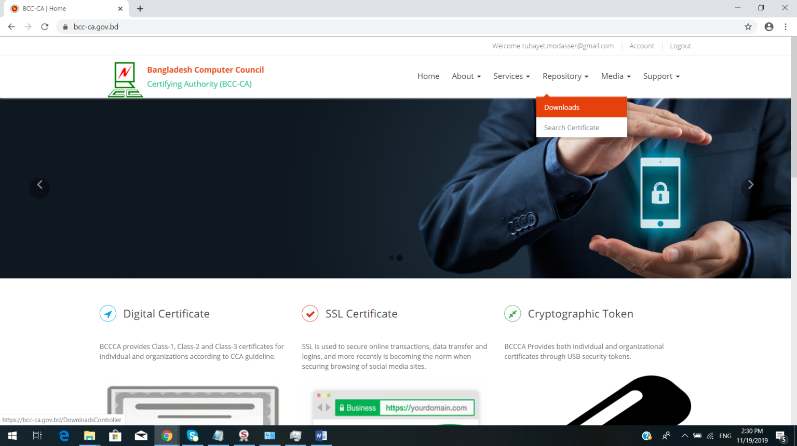
www.bcc-ca.gov.bd

  - Go to “Repository Downloads”, it will look like as below image, click on “Download Button right of BCC CA Client”.
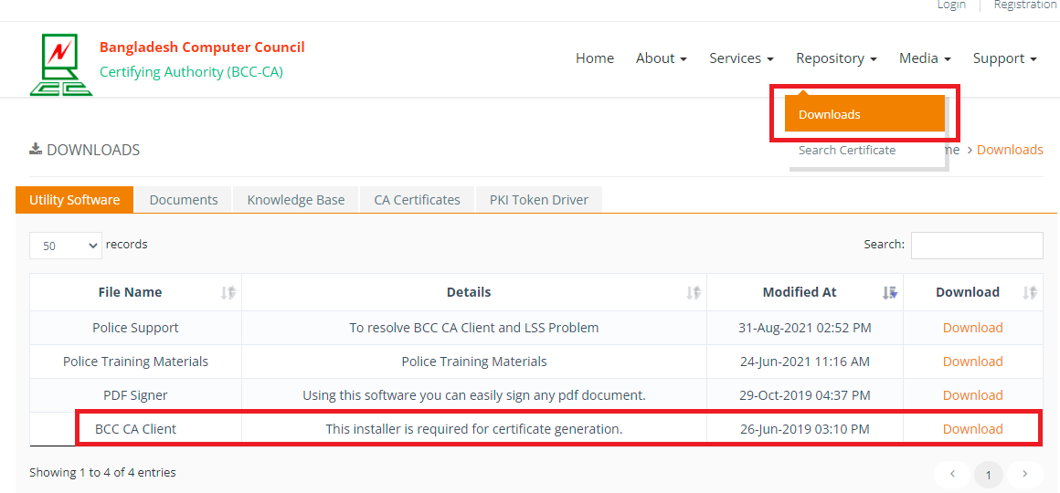
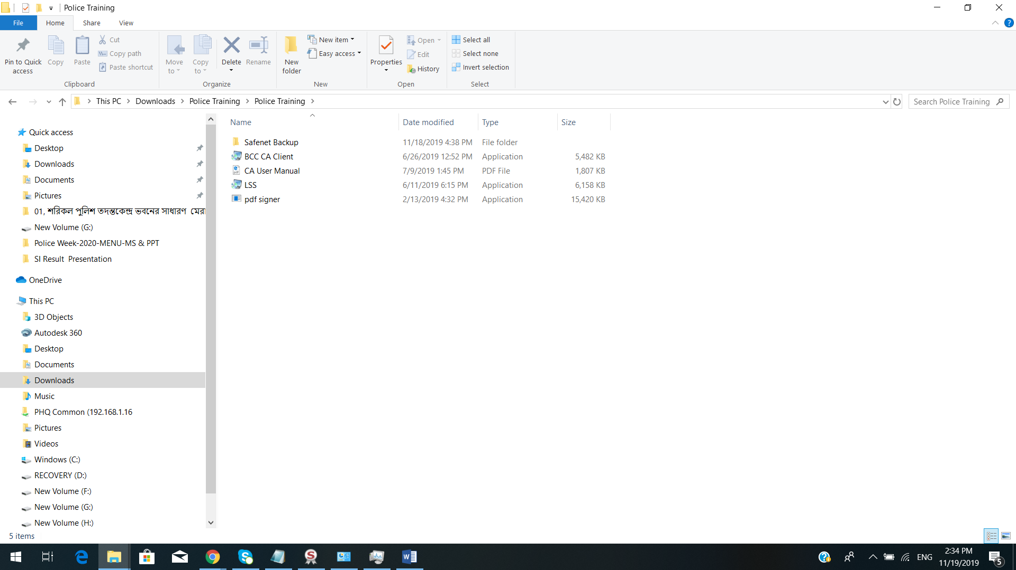

  - Now we’ll install and launch BCC CA Client by “Run as Administrator” clicking on the file as named.

  - After complete installation we’ve to launch this client application.

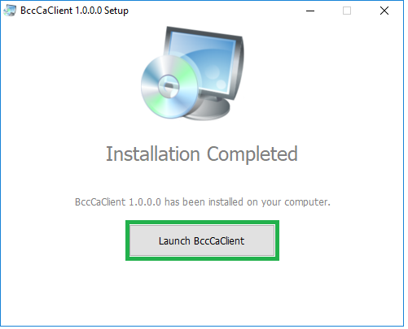

2.Registration Process :
Visit the link https://www.bcc-ca.gov.bd/Login

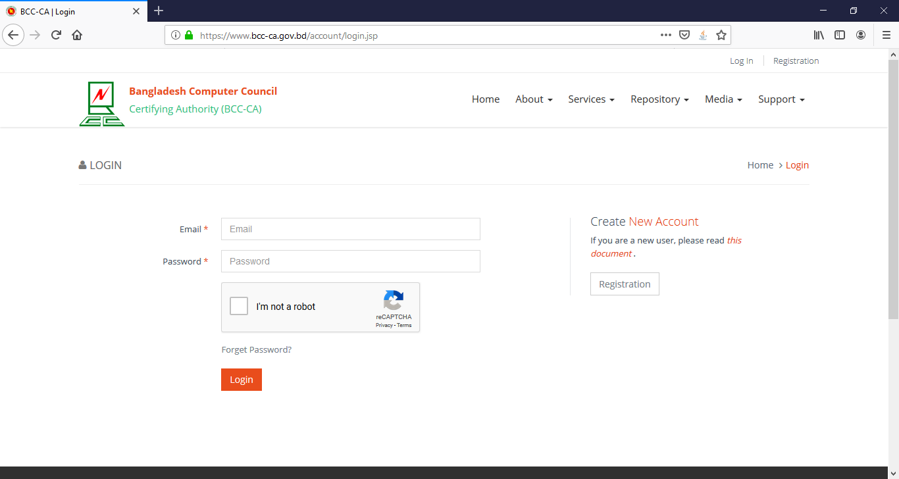

2.1 Click on ‘Registration’ and fill up the form with appropriate information

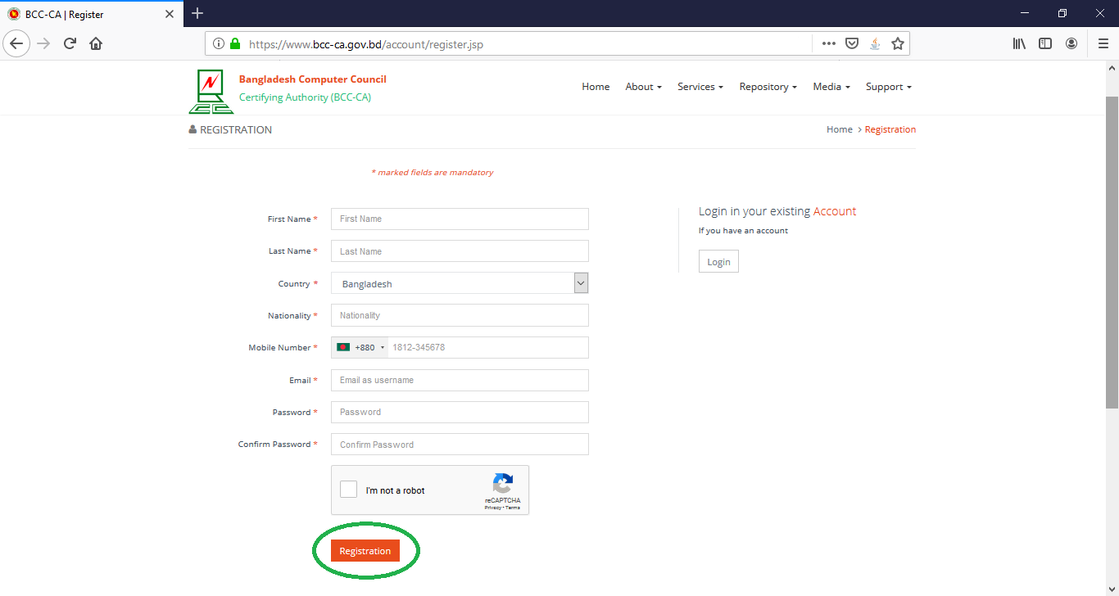

2.2 After completed the registration, you need to log on for enrollment. Use your email ID and password provided during registration.

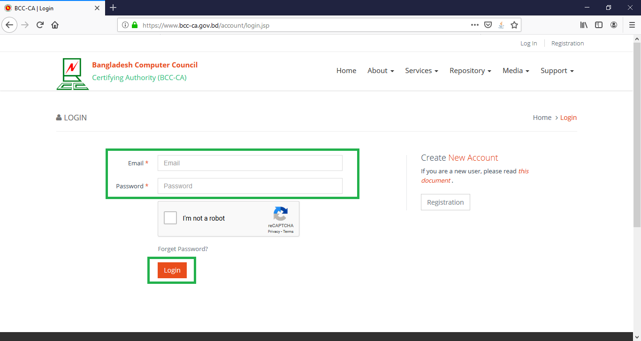

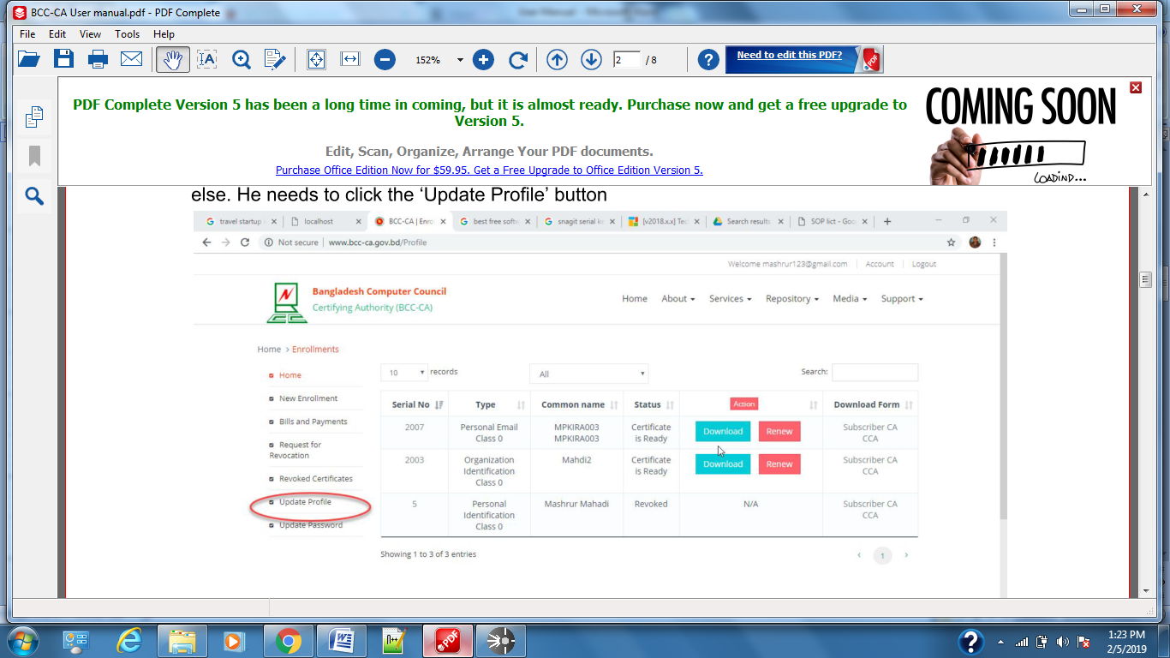
2.3 After Log On, screen will be viewed as below :

2.4 Before doing Enrollment, profile should be updated. Please click on ‘Update Profile’.
Click on ‘Edit’ from updating your profile.
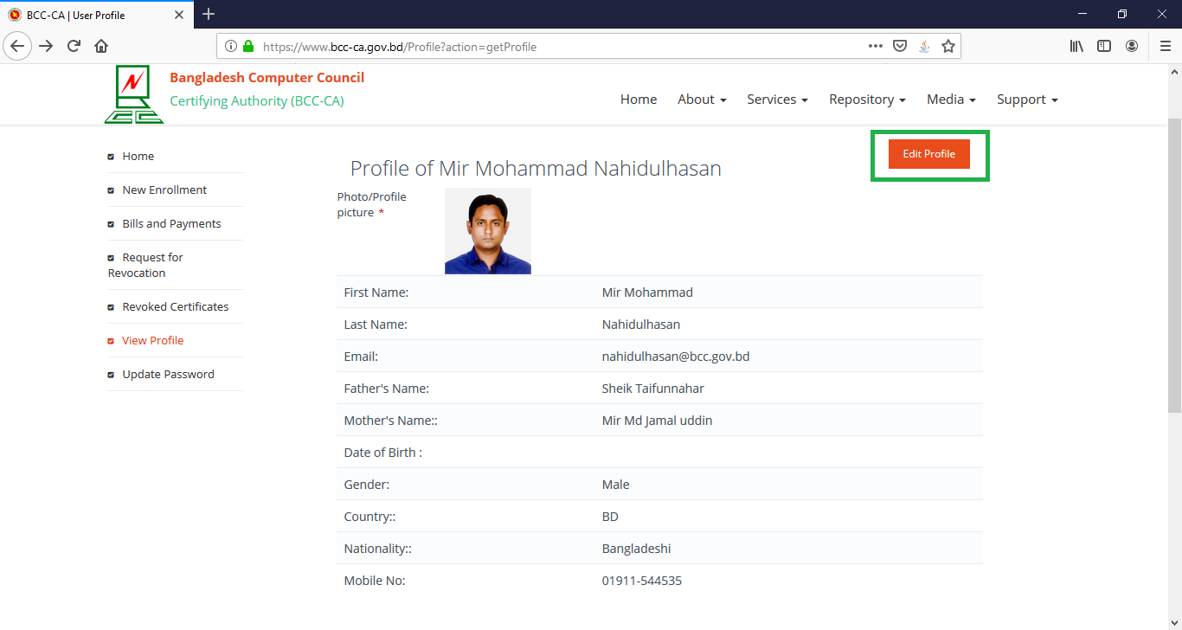

2.5 Enrollment
For enrollment, please click on new enrollment button

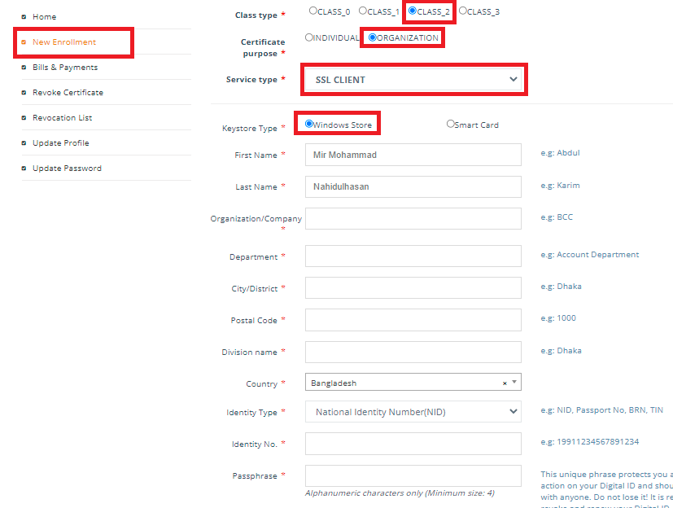

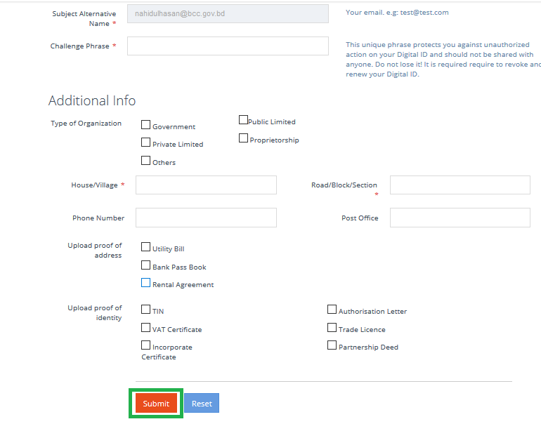

Please fill up the form carefully and remember the following important issues :
Class Type : Class 2
Certificate Purpose : Organization
Service Type : SSL Client
Keystore Type : Windows Store
Identity Type : National ID (NID)
Identity : NID number
Please remember your ‘Challenge Phrase’ which you will put on here.
Additional Info: Type of organization: Government/anyone available there.
Upload address : Upload scan copy of your official ID Card.
Identity proof: Upload scan copy of your National ID card
After giving required information, click submit button to complete the enrollment.

2.6 After completion of enrollment, you will get ‘Generate PK’ option in your profile as like below Clcik Yes to generate key pair. After clicking “Generate PK” you’ll be requested to input “Passphrase” as Section 2.5 to complete the download process.

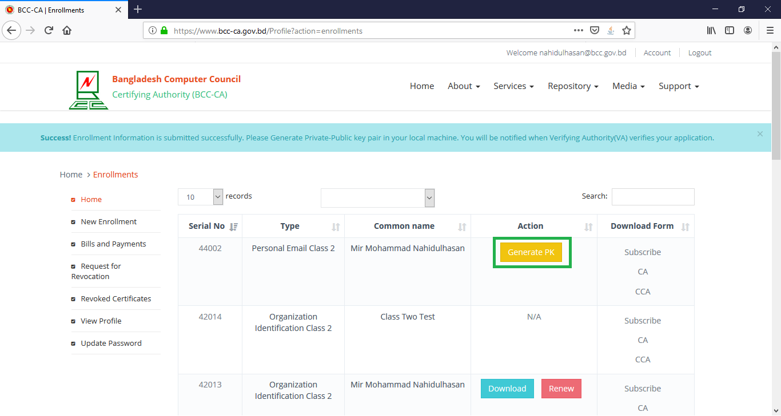

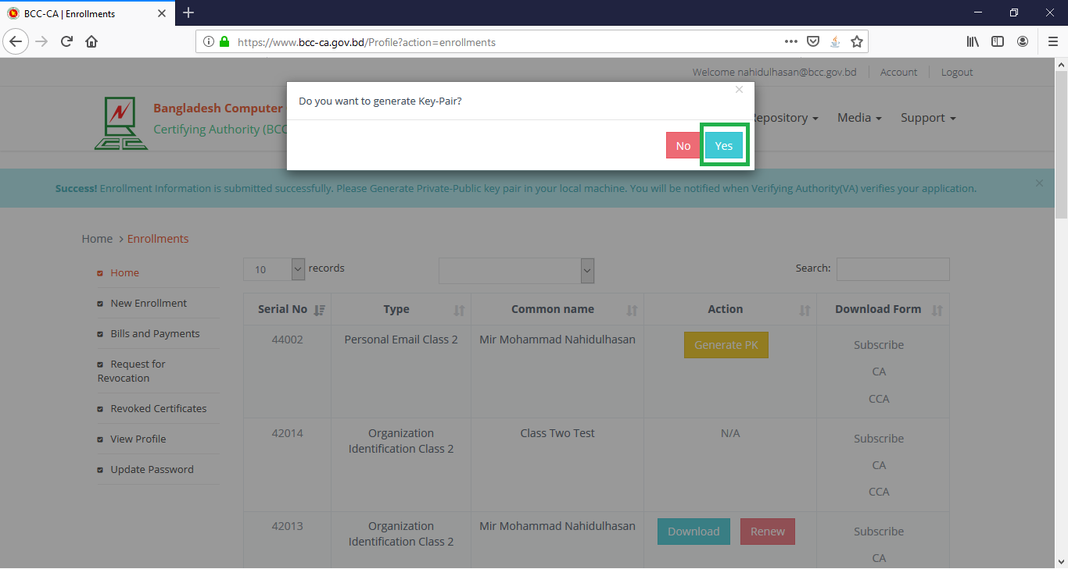

2.7 Provide Challenge Passphrase which you set at 2.5.

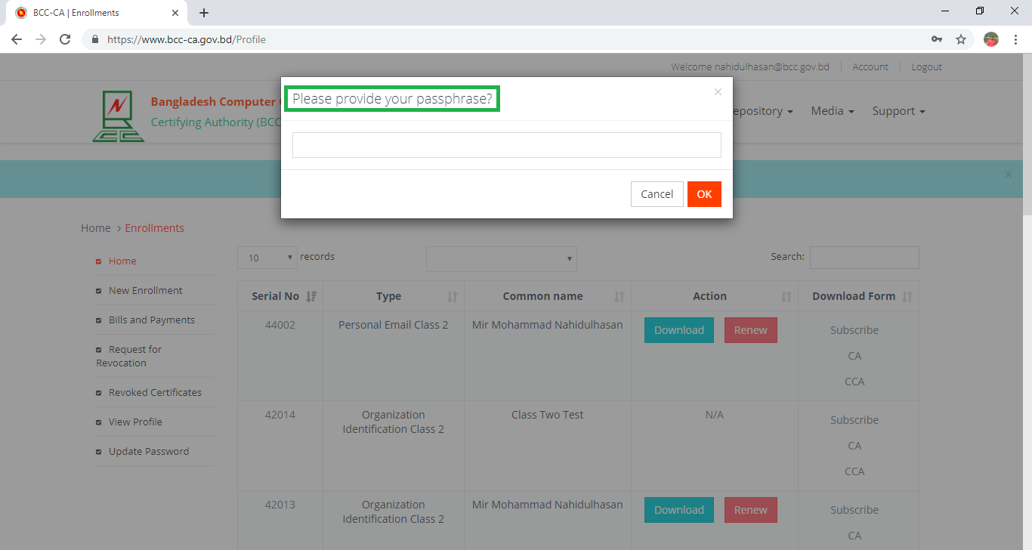

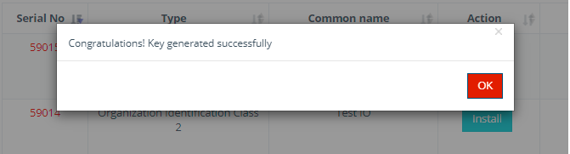

2.8 Click on Payment to complete your payment.

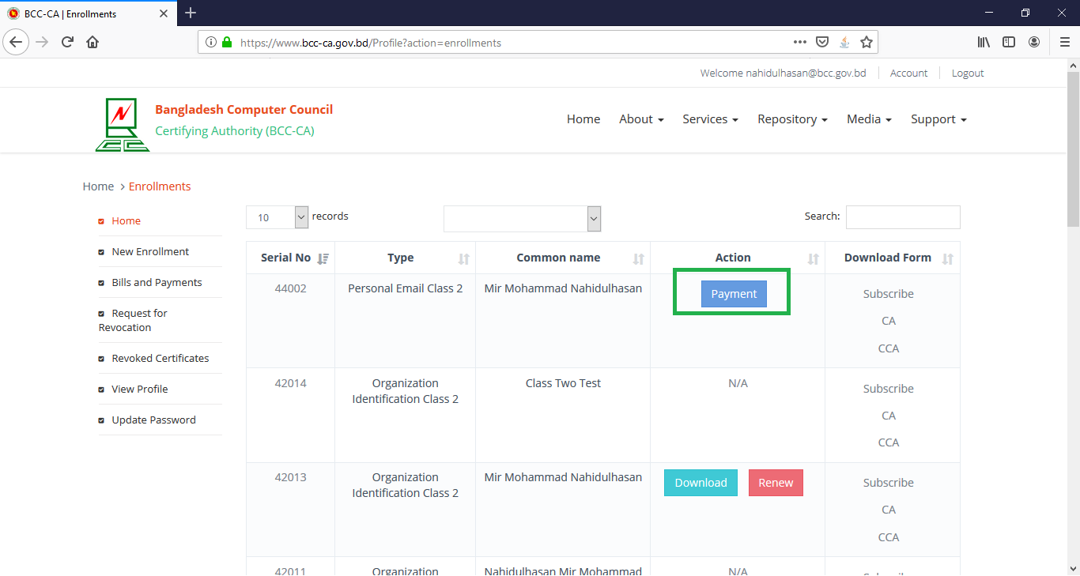

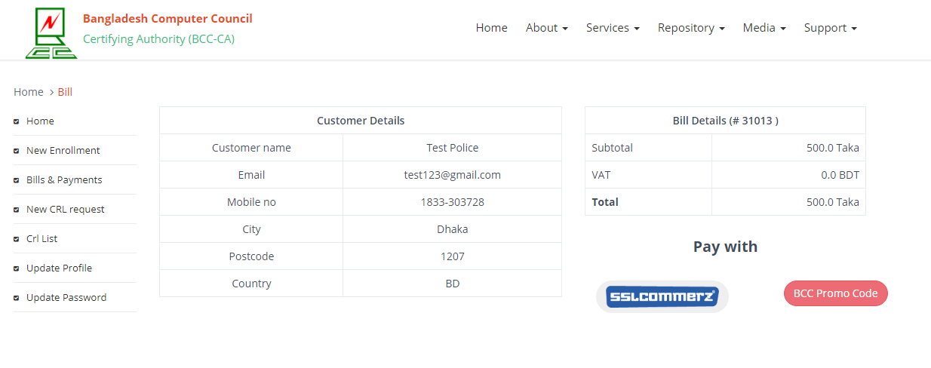
2.9 Choose Payment method. If You choose BCC Promo Code. Please contact with BCC CA Team for the “PROMO CODE”.

2.10 Please provide your transaction Number/ Promo Code as validation number here. A “Transaction/Validation Number” will be provided by the authority for completing the session. Later need to click on “Submit” to complete the payment procedure.
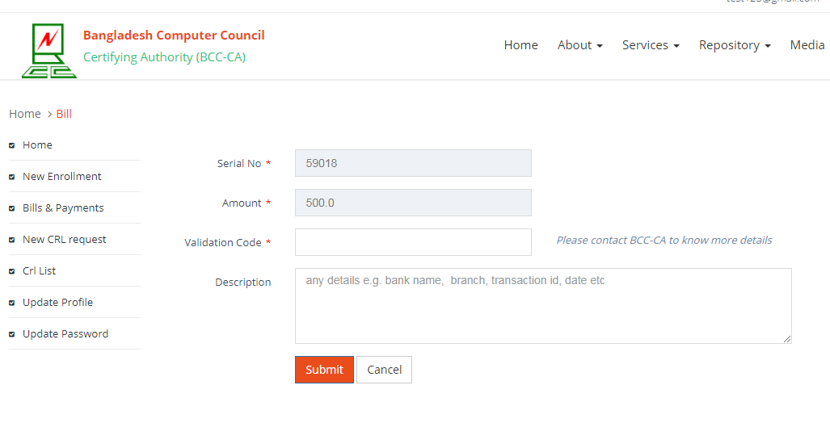

Waiting for RA/VA approval from BCC-CA.

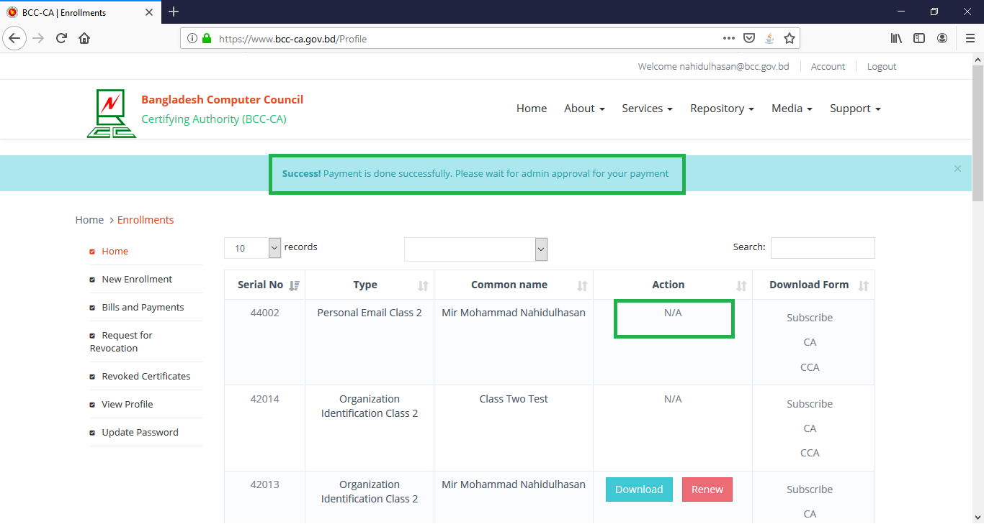

2.11 After being reviewed/approved from RA and VA of BCC-CA, it will be ready to download certificate. Now we can click on “Download” and complete the enrollment process. After clicking “Download” you’ll be requested to input “Passphrase” as Section 2.5 and to complete the download process.

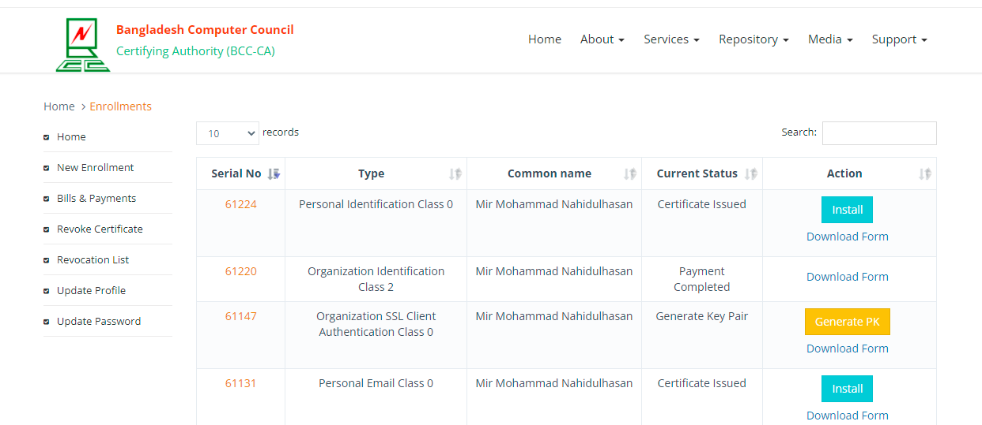

Certificate Successfully Installed in Windows Keystore.

