

Analysing & Predicting Sales Trends

Student Assessment Number: J119811
Module Code: CO7024
Module Title: Statistical programming
Word count: 2533 (Including headings, Excluding: Cover Page, Table of Contents, References and Appendix)
Date of Submission: 29 April 2025

Table of Contents
1 Background 1
2 Data Importation, Inspection, and Merging 1
3 Distribution Analysis 4
4 Summary Statistics 11
5 Profitability Analysis and Sales Forecasting 14
6 Insights & Recommendations 25
7 Conclusion 28
8 References 29
9 Appendix (Code) 30

Background
Achieving optimal inventory levels, best pricing strategies, and retail outlet marketing success requires accurate sales predictions and profitability analysis at XYZ Corporation. According to Suresh and Praveen (2020), the development of data science technology makes polynomial regression an applicable learning method for identifying complex sales behaviours without creating overfitting. The Seasonal-Trend decomposition using LOESS (STL) analytical tool delivers critical seasonality insights and underlying pattern detection abilities for time-series data interpretation (Theodosiou, 2011).
Current studies unite deep learning models with external elements such as promotions together with holidays and economic conditions to achieve superior forecasting outcomes (Hao & Liu, 2024; MD AL et al., 2025). The report uses advanced analytical techniques to evaluate profitability and sales metrics at different XYZ Corporation stores. The application of factual data aims to optimize operational efficiency while enabling strategic choices which leads to higher overall business success in the retail operations of XYZ Corporation.

Data Importation, Inspection, and Merging
This step explains the process of preparing data, giving a homogeneous and clean dataset that can be used for analysis. Four datasets were originally imported: three stores’ daily sales records (Store_A, Store_B, Store_C) and one centralized product price dataset. The datasets were loaded into Python through pandas.read_csv() and stored in a dictionary for easy access. To be consistent, column names in all datasets were also changed to lowercase, spaces were dropped, and underscores were applied for formatting.
The sales data frames, initially in wide form with individual product columns, were reshaped into long-form by pandas.melt(). This conversion merged product information into two columns: product and units_sold, with a store column added to preserve store identifiers. The reshaped data frames were joined using pandas.concat(), which created one data frame with sales records from all stores.
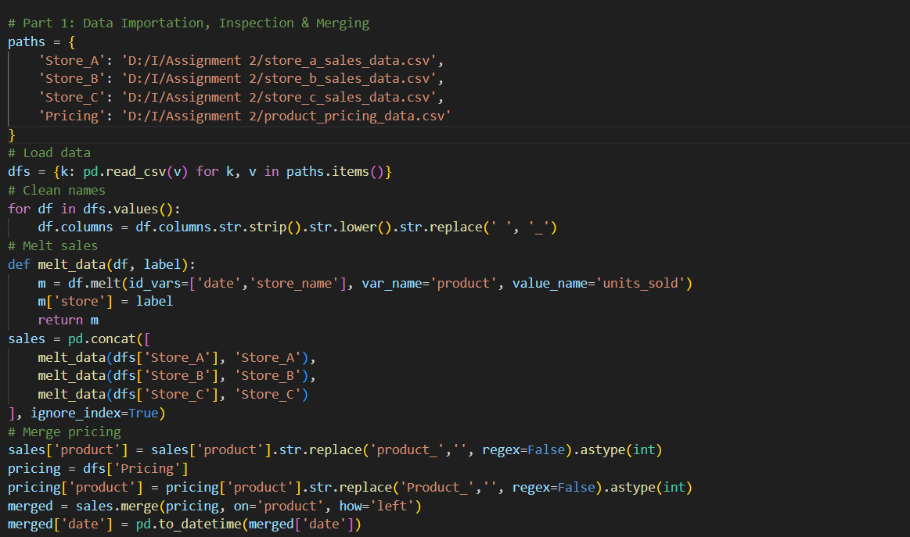
The combined sales data was joined with the pricing dataset on the product column via a left join. This brought cost price and selling price information into the sales data. The date column was then read into datetime format via pandas.to_datetime() for time-series analysis.
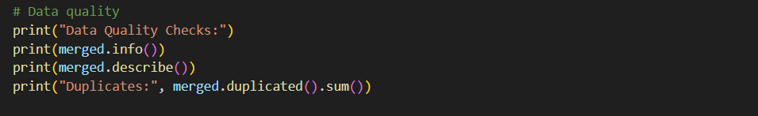
Data quality checks were performed, including structure verification using info(), summary statistics using describe(), and duplication checking using duplicated().sum(). This systematic approach confirmed data integrity and consistency, in agreement with best practice in retail analytics (Suresh & Praveen, 2020; Krishna et al., 2018).
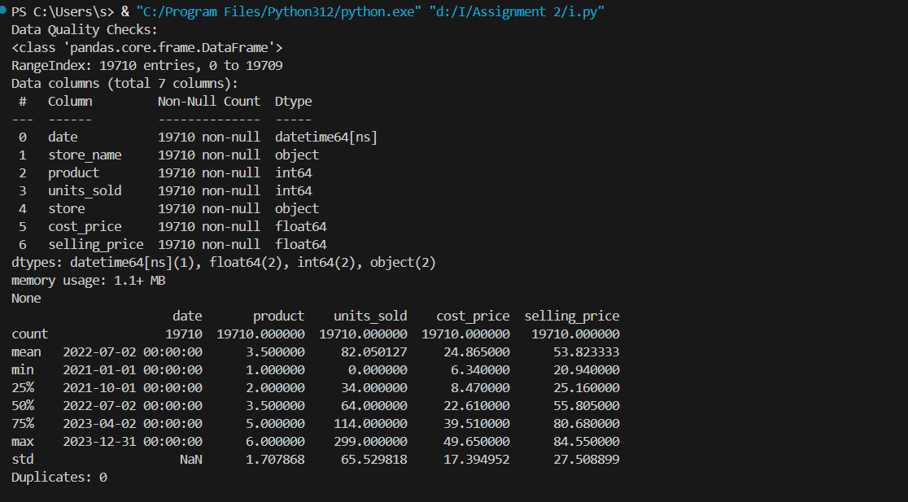
This data quality check report summarizes the shape and consistency of the merged dataset. Info() usage confirms that the dataset contains 19,710 records in 7 columns: date, store_name, product, units_sold, store, cost_price, and selling_price. All columns have no missing values, and their data types are appropriate for analysis (e.g., datetime64 for dates, float64 for prices, and int64 for numbers).
The describe() summary provides statistical data. For units_sold, the mean is approximately 82, with a wide range of 0 to 299, indicating variation in sales volumes. Both cost_price and selling_price have reasonable ranges, confirming uniform pricing of goods. Additionally, the absence of duplicate records ensures data integrity. This validation step is required for reliable analytics and adheres to best practices in retail data analysis (Suresh & Praveen, 2020).

Distribution Analysis
3.1. Methodology
Anderson-Darling Normality Test:
For each product, the Anderson-Darling test checked whether sales were distributed.
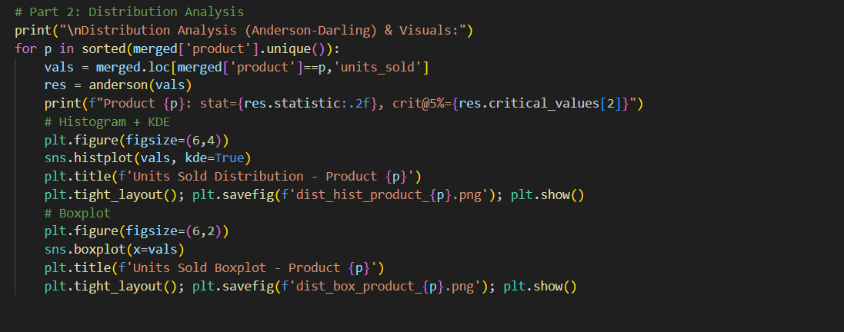
The results give a statistic (res.statistic) and critical value at 5% significance level (res.critical_values[2]). Where the statistic is larger than the critical value, the null hypothesis (normal distribution) is rejected.
3.2 Anderson-Darling Test Results
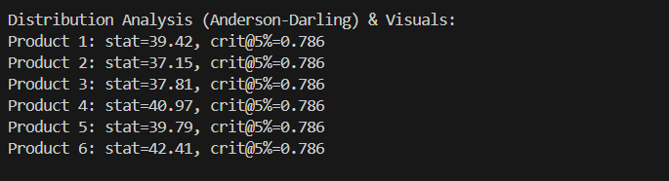
No sales figures of the products exhibited normal distribution because all test statistics significantly exceeded the critical value. This reflects non-normal pattern distribution with heavy tails or skewness, which is natural for retail sales data.
3.3 Visualizations
Histograms with KDE : To graph the frequency distribution of units sold per item and overlay a KDE curve to indicate the shape of the distribution.
X-axis: Units sold.
Y-axis: Frequency (count of occurrences).
Product 1: Between 50 and 300 units are sold. The KDE curve is rather flat with numerous peaks, exhibiting high sales volatility and suggesting ups and downs in demand during the observation period.
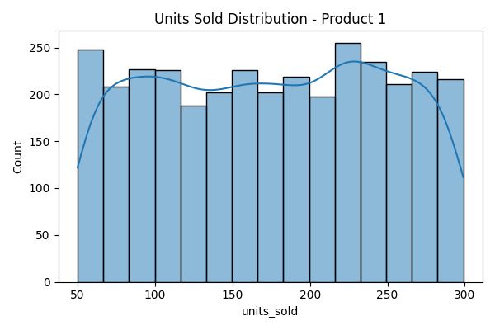
Product 2: Units sold between 25 and 200. The KDE curve is balanced but still inclined slightly, demonstrating stable but erratic sales performance.
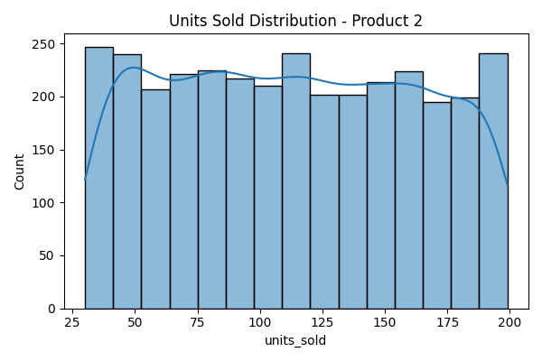
Product 3: Like Product 2 but with a more limited range (20 to 150 units). The KDE curve has peaks that are moderately high, indicating consistent mid-range sales.
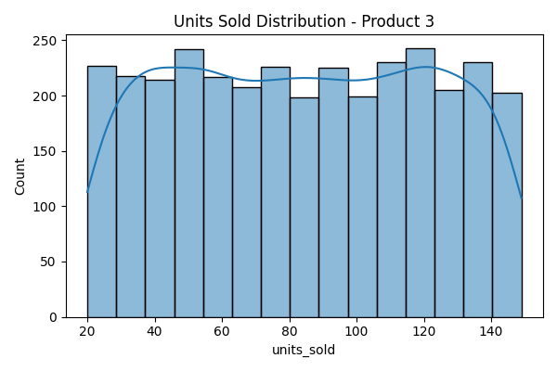
Product 4: Its range is more limited (10 to 100 units), and the KDE curve shows a slight right skew, which means the majority of the sales occur at lower to mid-unit levels.
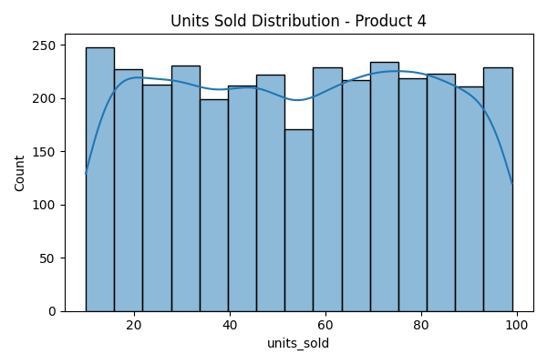
Product 5: The histogram is more even and goes from 5 to 80 units sold, but the KDE curve shows sporadic peaks in demand.

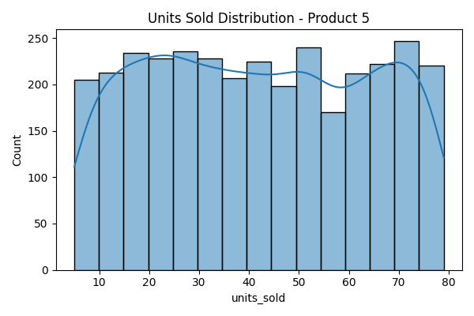
Product 6: This shows the spread with the narrowest width (0 to 50 units), with the KDE curve showing lower, consistent sales volumes.
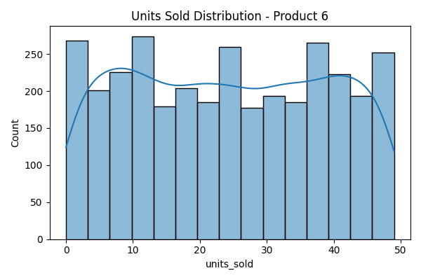
Boxplots : To provide a statistical summary of sales distributions, e.g. medians, interquartile ranges (IQR), and potential outliers.
X-axis: Units sold.
Product 1: Has the broadest IQR (100 to 250 units), with a median around 175 units. The range covers both high demand and variability.
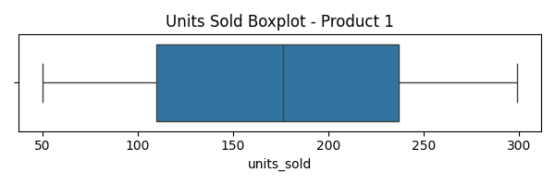
Product 2: IQR of 75 to 150 units, with a slightly lower median, indicating lower variability than Product 1 but still stable sales.
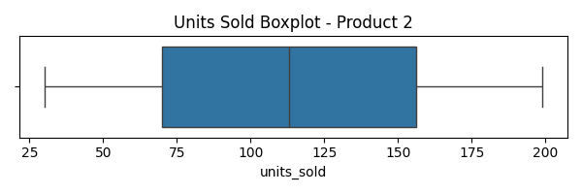
Product 3: Smaller IQR (60 to 120 units), so it is a stable mid-range product.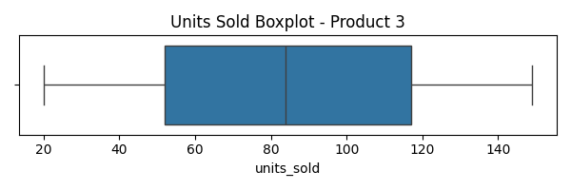
Product 4: Narrower IQR (30 to 80 units), reflecting minimal sales variability. 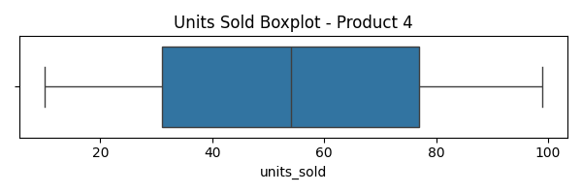
Product 5: The IQR is still narrower (20 to 60 units), confirming its stable but lower sales volume.
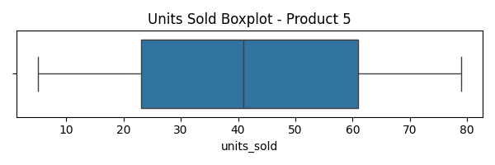
Product 6: Smallest IQR (10 to 40 units), reflecting minimum variability and sustained low sales.
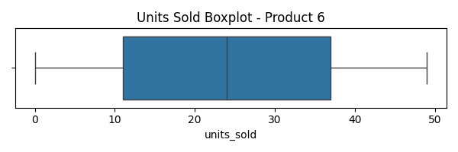
Outliers: No extreme outliers were detected on products, implying uniform sales ranges without isolated spikes.

Summary Statistics
4.1. Methodology
Pivot Table: Aggregated total and average units sold by product through each store with pandas.pivot_table().
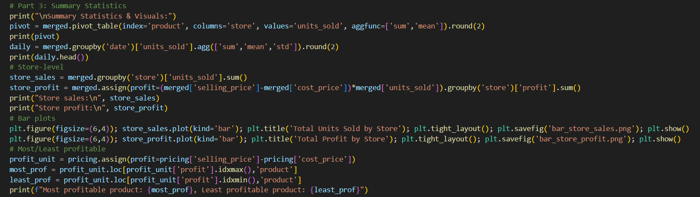
Daily Sales Summary: Total sales each day across all stores using groupby(‘date’) to compute total, mean, and standard deviation of units sold.
Store-Level Sales & Profitability: Total units sold and total profit by store have been computed using groupby(‘store’). Profit has been calculated as (selling_price – cost_price) * units_sold.
4. 2. Results of Summary Statistics
Pivot Table: The pivot table indicates the total units sold and average daily sales for each product in Store_A, Store_B, and Store_C. The sum columns indicate the total units sold over the analysis period, while the mean columns indicate the average daily sales per product.
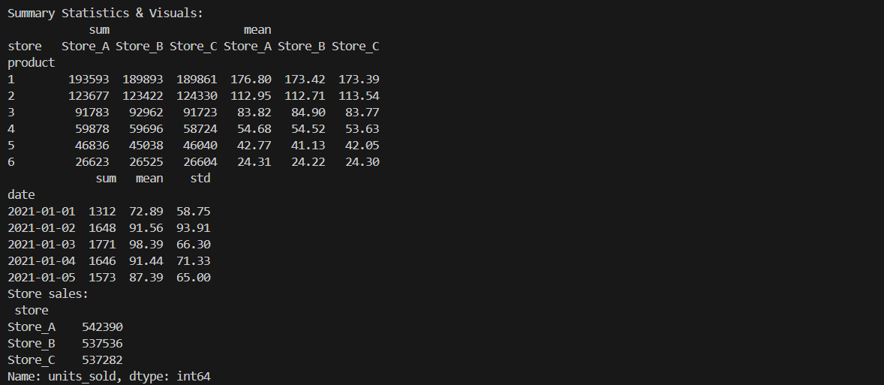
Product 1 always has the highest overall sales of all stores (for example, 193,593 units in Store_A), and it is the best-performing product. Product 6 with lower overall sales, for example, shows less market demand.
Sales are day-to-day varying, with some days recording significantly higher volumes than others (e.g., January 2, 2021, recorded a higher total and standard deviation). This volatility suggests external factor-driven demand patterns such as seasonality or promotions.
Store_A leads both total units sold and total profit. The small differences between stores (e.g., Store_A selling 542,390 units versus Store_C’s 537,282) suggest evenly balanced operations but a slight edge for Store_A.
4.3. Visualizations of Summary Statistics
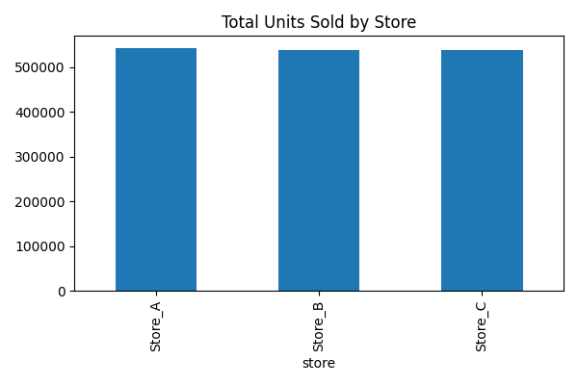
The bar plot demonstrates total units sold by store, where the x-axis is the three retail stores Store_A, Store_B, and Store_C and the y-axis is the total units sold. The sales volumes of the three stores are comparable, all over 530,000 units, which reflects uniform performance across locations. Such uniformity reflects that XYZ Corporation effectively manages its sales operation across stores, a significant retail management area (Suresh & Praveen, 2020). Minor variations across stores can suggest that there should be localized strategies, e.g., inventory optimization or promotional activities, to further maximize the sales performance (Krishna et al., 2018). 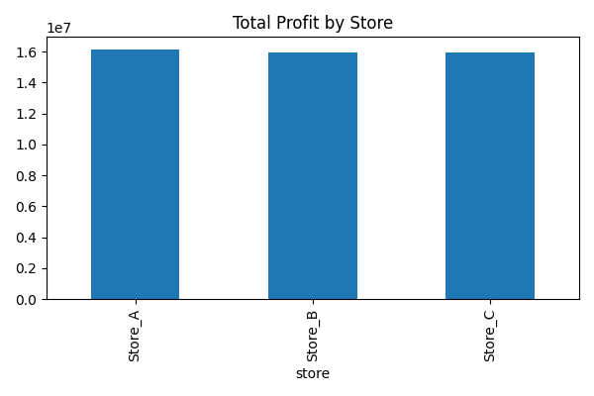
The x-axis shows the three stores, and the y-axis shows the overall profit in money terms. Each bar shows the cumulative profit made by each store.
Store_A is also the highest-profit store with a profit of approximately £16.1 million, slightly higher than Store_B and Store_C (both approximately £15.9 million). This suggests that Store_A sells the most and has good profit margins.
This foundation analysis supports subsequent profitability nalyses and forecasting. The method draws on conventional retail analytics practice as highlighted by Krishna et al. (2018) and Hao & Liu (2024).

Profitability Analysis and Sales Forecasting
  - Methodology
Profit Calculation:
The profit for each transaction is calculated as:
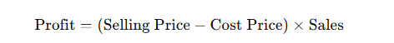

Feature Engineering for Forecasting:
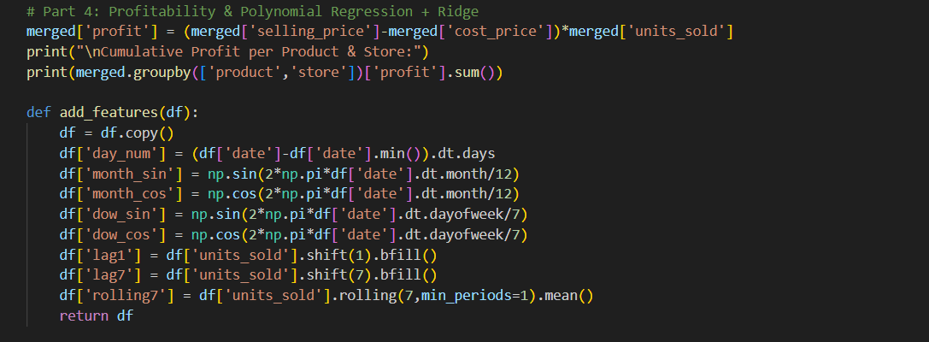
The features are day number (the number of days from the beginning of the dataset), cyclical month/day (sine and cosine), lagged sales (7 and 1 day), and a rolling 7-day average of units sold.
Polynomial Ridge Regression:
Polynomial features (degrees 2–6) detect non-linear trends, while Ridge regularization prevents overfitting; models are cross-validated with train-test splits.
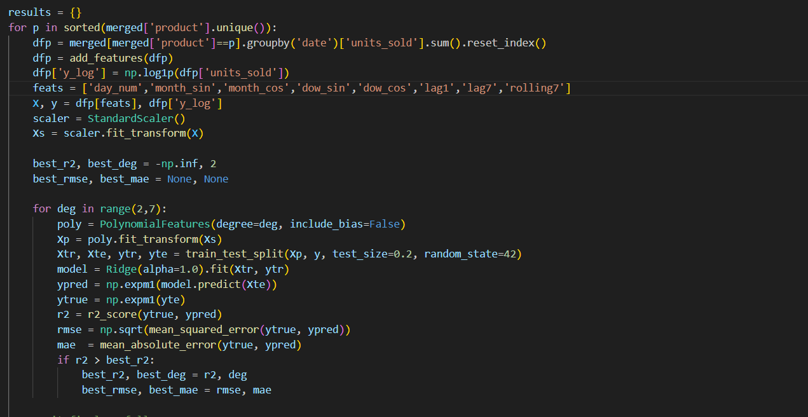
The evaluation criteria are R² for assessing model fit and RMSE and MAE to measure prediction errors. The best-selling model (optimal R²) for every product forecasts sales in the following 30 days, including point estimates and confidence intervals (± 1.96 standard errors) to enable uncertainty consideration.
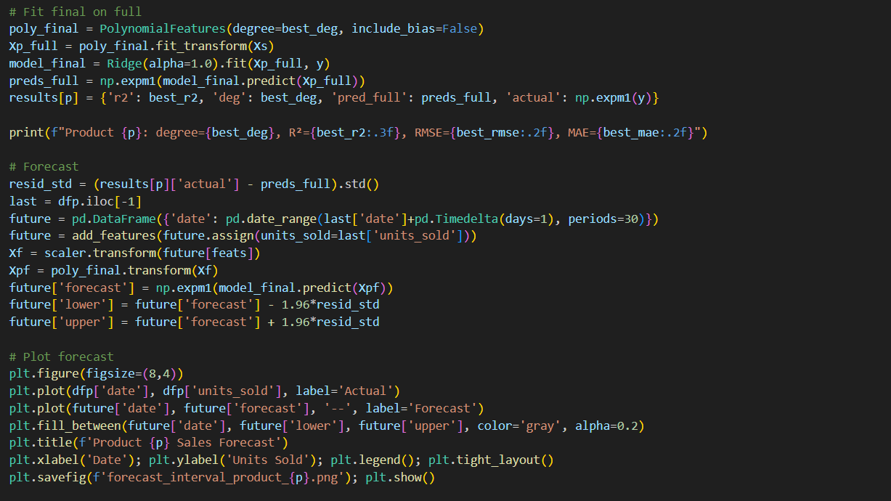
Model diagnostics utilize Actual vs. Predicted scatter plots to measure forecasting performance. Additionally, STL decomposition is conducted on daily profit data, and it is separated into trend, seasonal, and residual components to further analyze it.
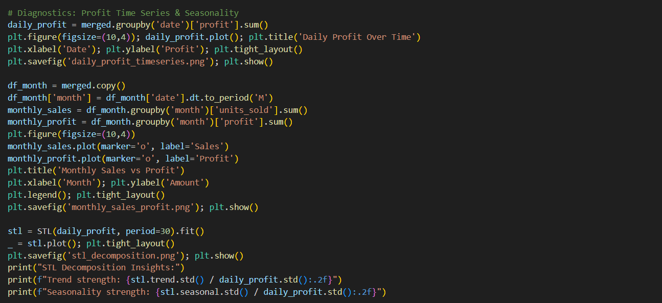
5.2. Results of Profitability Analysis and Sales Forecasting
Cumulative Profit by Product and Store:
Product 1 is the most profitable in all stores (~£8 million per store), while product 4 is the least profitable (~£750,000 per store).
Model Performance Summary:
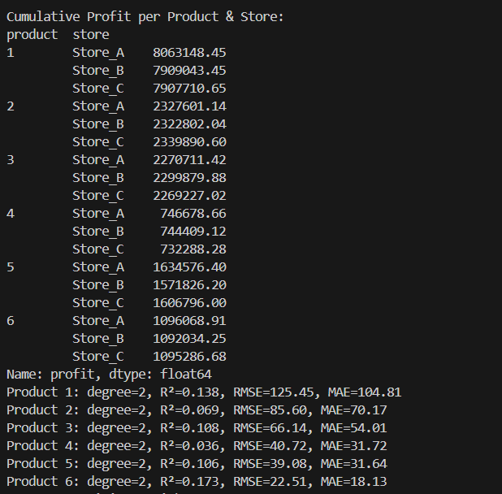
Product 6 showed the best predictability (R² = 0.173).
Product 4 had the worst fit (R² = 0.036), which indicates higher sales unpredictability.
STL Decomposition Insights:

Trend strength: 0.17 (modest trend detected).
Seasonality strength: 0.51 (strong seasonal pattern in profits).
5.3 Visualization
Charts of actual vs forecasted sales by time (x-axis dates, y-axis units sold). Actual sales are the blue line, the orange dashed line is the prediction, and the grey area is the 95% confidence band.
Product 1 has large bands at highs, indicating high volatility of sales.
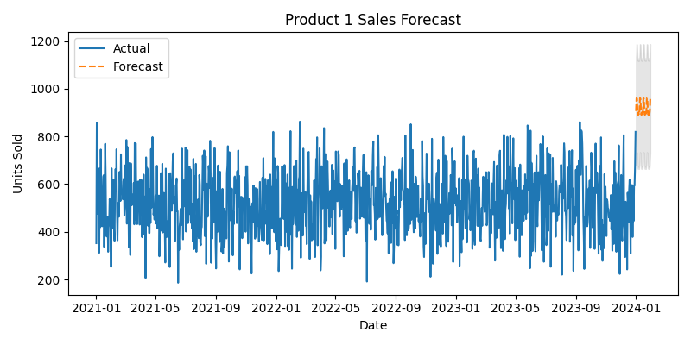
Product 6 has narrow bands, indicating stable, reliable sales with best R² ranking..
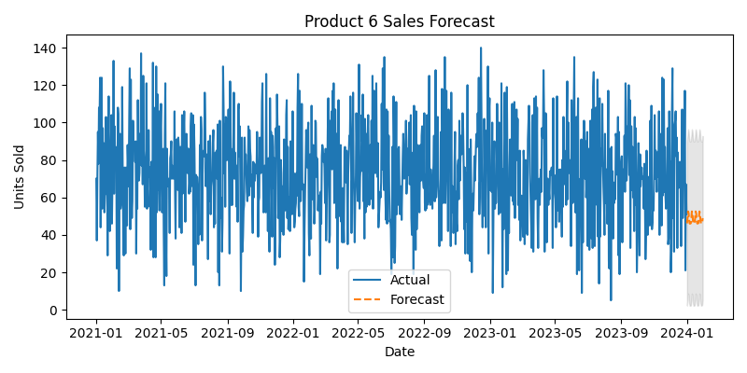
Products 2–5 vary from each other, with Product 2 having wider intervals and poor fit.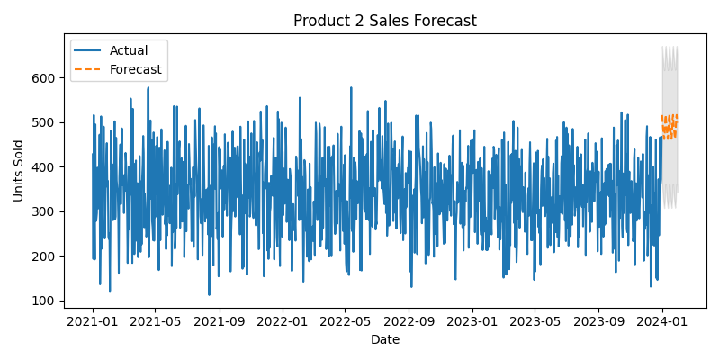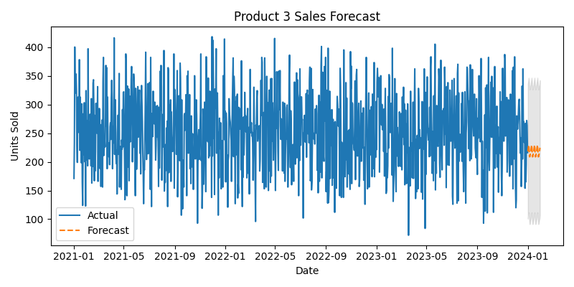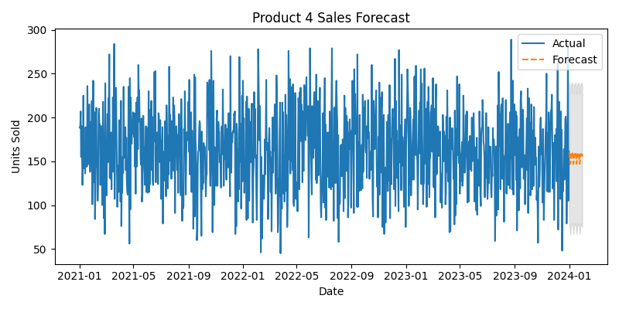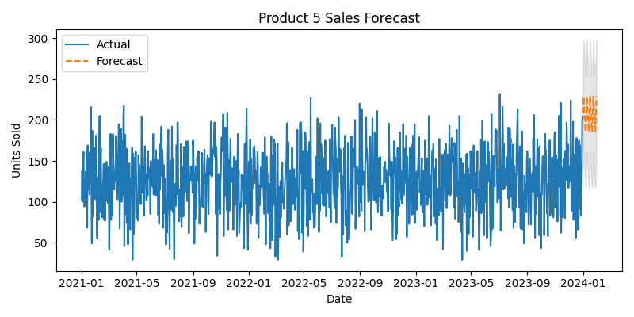
Actual vs Predicted
Actual vs. Predicted scatter plots compare sales accuracy (x-axis: actual, y-axis: predicted, red dashed line: ideal fit).
Product 6 clusters tightly around the line (strong model).
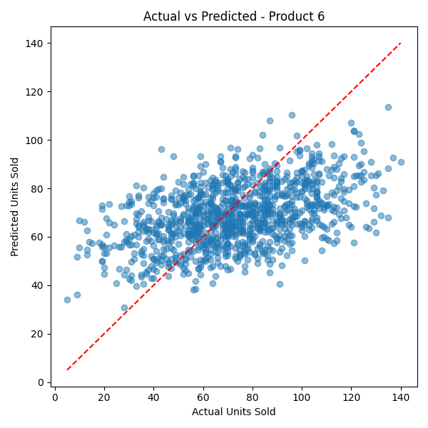
Product 4 is widely scattered (weak model).
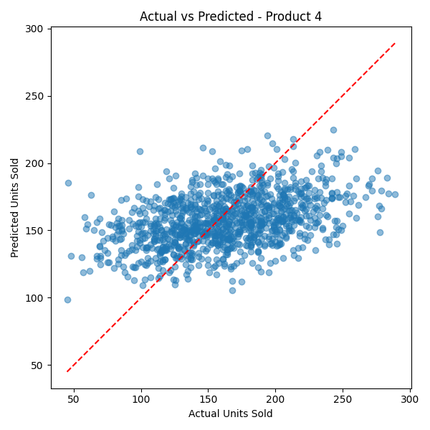
Product 1 shows moderate clustering but more spread at high sales.
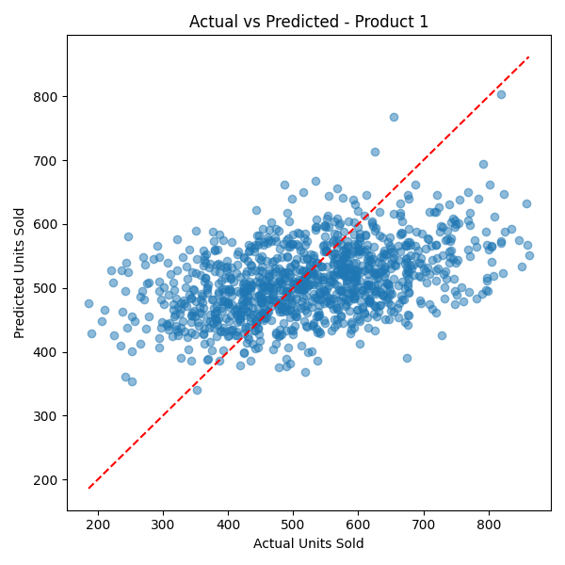
Daily Profit Over
The time graph depicts the variation in daily profit from January 2021 to December 2023. The x-axis represents time, and the y-axis represents daily profit figures.
The graph depicts extreme fluctuation in profit values with frequent spikes and drops oscillating between 25,000 and 60,000 units. Such fluctuation highlights the presence of irregular demand cycles and potential seasonal effects. While no clear long-term upward or downward trend can be seen visually, the underlying oscillations identify the importance of seasonal adjustments and decomposition techniques, like STL, to better understand profit dynamics and improve the quality of forecasts.
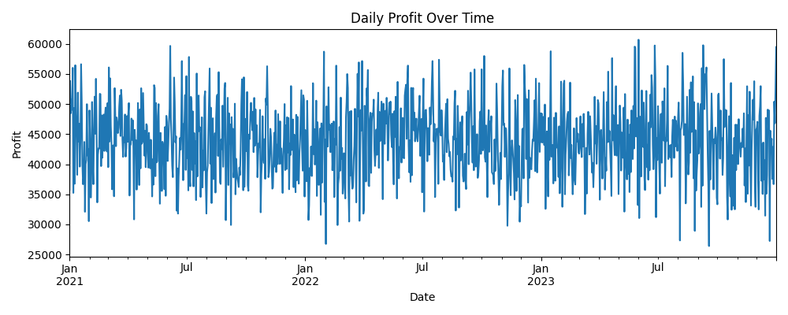
Monthly Sales vs Profit
The illustration displays how total sales quantity interactions with profit values throughout the observed months.
The graph shows that months from January 2021 through December 2023 serve as the x-axis and monetary values appear on the y-axis. The monthly sales data points are presented through the orange line that indicates overall steadiness throughout the timeframe with stable sales volume. Profit amounts track a different orange line that shows substantial fluctuations between high points and low points. Profit margins demonstrate variation compared to consistent sales figures indicating that variables separate from sales volume affect profit margins including prices and operational expenses. 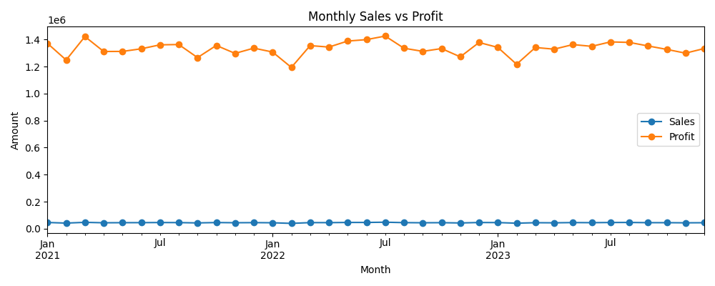

Insights & Recommendations
6.1 Methodology
The evaluation started with performances at the store level and product level. Store profit was determined through the calculation (selling_price – cost_price) × units_sold which allowed staff to rank stores by their total profit levels. The ranking system for products depended on their overall units sold numbers. Research methods typically used in retail store analyses serve to evaluate operational efficiency (Krishna et al., 2018). 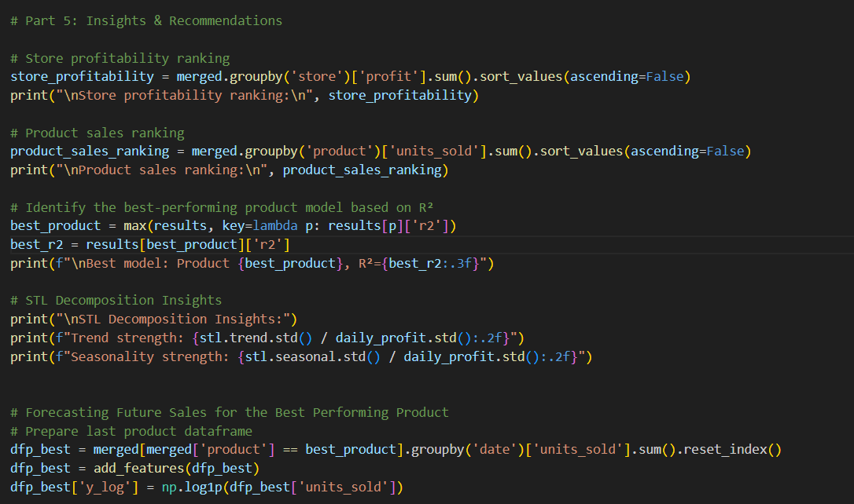
A distinct Polynomial Ridge Regression model received training for each product based on engineered features which included day_num trend data along with month_sin and month_cos seasonal values together with lag1 and lag7 along with rolling7 features. The sales data underwent log1p transformation for nalyses while expm1 transformation applied after prediction. Model selection relied on R² value maximization while following industry-standard practices for predictive retail nalyses (View of Sales Projection by using…, n.d.).
The daily profit time series underwent STL decomposition analysis to derive useful trend and seasonal elements and residuals for detailed pattern recognition (Theodosiou, 2011; Ouyang et al., 2023).
6.2. Results
Store Profitability Ranking:
Store_A achieved the highest profit at 16,138,784.98, followed closely by Store_C and Store_B. This suggests Store_A’s stronger operational profitability.
Product Sales Ranking:
Product 1 led in sales with 573,347 units sold, confirming it as the highest-demand product.
Best Model Performance:
Product 6 achieved the highest R² value of 0.173. While Product 6 had the lowest overall sales, it demonstrated the most predictable sales pattern.
STL Decomposition Results:
The trend strength was 0.17, and the seasonality strength was 0.51. This indicates moderate seasonality in profit patterns, reinforcing the importance of including cyclic features during forecasting (Hao & Liu, 2024).
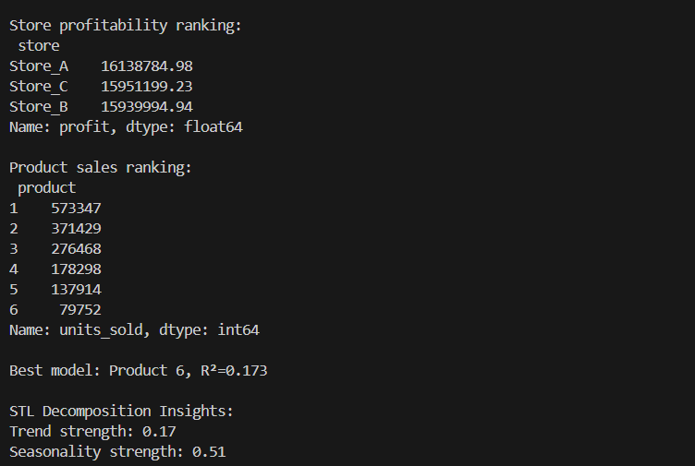
6.3. Visualization
Forecasted Units Sold for Product 6 (Next 30 Days):
The plot displays historical sales and predicted future sales for the next 30 days. The forecasted line (dashed) follows a similar trend to the historical data, indicating the model’s ability to capture seasonality and trend effects. This supports confident short-term inventory planning.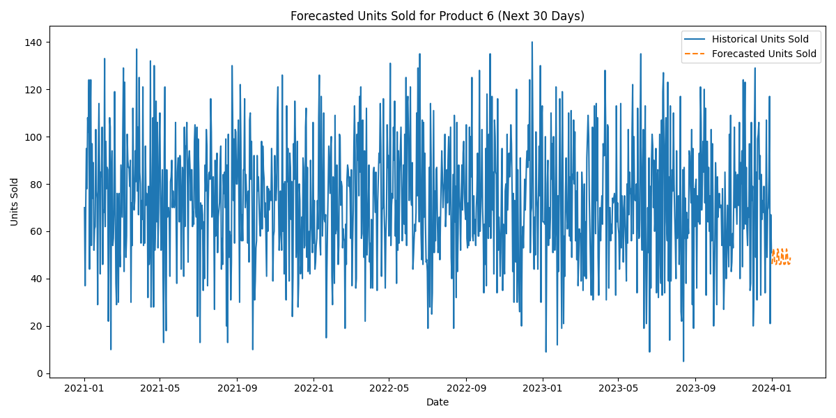
STL Decomposition of Profit:
The STL decomposition plot shows the overall profit trend, seasonality, and residuals. The seasonal component highlights recurring patterns, and the trend component smooths short-term fluctuations, confirming periodic structures in profit behavior.
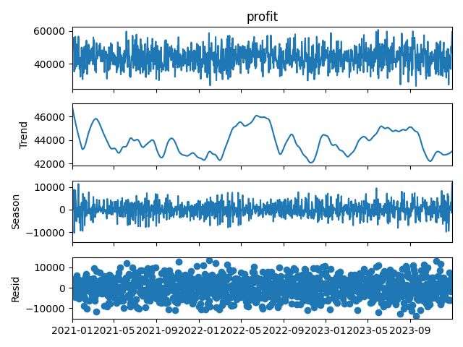
6.4. Recommendations
It is recommended to increase inventory for Product 1 to meet high demand and maintain profitability focus on Store_A. Although Product 6 sells fewer units, its consistent sales trend suggests that automated forecasting and inventory management would be highly effective. Furthermore, a pricing review for Product 4 should be undertaken to improve margins. Future nalyses should continue using polynomial Ridge regression with time-based and seasonal features and incorporate insights from STL decomposition to enhance forecast accuracy.

Conclusion
The report nalyses three-store retail sales data through profitability evaluation methods and statistical distributions alongside progressive forecasting procedures. According to the cumulative profit analysis of data, Product 1 generated the most revenue, while Product 4 showed the lowest profit-making potential. Profit data reveals that Store A maintained the highest sales performance among all the stores throughout the year.
The forecasting models based on polynomial Ridge regression yielded the best fit for Product 6 with R² = 0.173 but produced the worst accuracy for Product 4. According to the research of Hao and Liu (2024) and MD AL et al. (2025), predictive accuracy may be improved by considering external variables like market changes and seasonal promotions.
The STL decomposition analysis demonstrated that profit patterns had a strong seasonal component, measuring 0.51 in strength. Theodosiou (2011) advocates for aligning business strategy with seasonal patterns of demand, which explains this justification.
To conclude, operational efficiency and profitability will increase throughout retail stores after implementing analytical results to develop inventory control strategies, price optimization systems, and forecasting methods.

References
Suresh, K., & Praveen, O. (2020). Extracting of patterns using mining methods over damped window. 2020 Second International Conference on Inventive Research in Computing Applications (ICIRCA), 235–241. https://doi.org/10.1109/icirca48905.2020.9182893
View of Sales Projection by using XGBoost, Ridge Regression, Polynomial Regression & Linear Regression Algorithms in Machine Learning. (n.d.). https://www.philstat.org/index.php/MSEA/article/view/2349/1828
Theodosiou, M. (2011). Forecasting monthly and quarterly time series using STL decomposition. International Journal of Forecasting, 27(4), 1178–1195. https://doi.org/10.1016/j.ijforecast.2010.11.002
Ouyang, Z., Jabloun, M., & Ravier, P. (2023). STLformer: Exploit STL Decomposition and Rank Correlation for Time Series Forecasting. 2023 31st European Signal Processing Conference (EUSIPCO), 1405–1409. https://doi.org/10.23919/EUSIPCO58844.2023.10290126
Hao, J., & Liu, F. (2024). Improving long-term multivariate time series forecasting with a seasonal-trend decomposition-based 2-dimensional temporal convolution dense network. Scientific Reports, 14(1), 1689–1689. https://doi.org/10.1038/s41598-024-52240-y
Krishna, A., V, A., Aich, A., & Hegde, C. (2018). Sales-forecasting of Retail Stores using Machine Learning Techniques. 2018 3rd International Conference on Computational Systems and Information Technology for Sustainable Solutions (CSITSS), 160–166. https://doi.org/10.1109/CSITSS.2018.8768765
MD AL, R., Rodrigues, G. N., MD, N. H. M., MD, S. M. B., Mridha, M. F., Islam, M. R., & Watanobe, Y. (2025). A Hybrid Temporal Convolutional Network and Transformer Model for Accurate and Scalable Sales Forecasting. IEEE Open Journal of the Computer Society, 6, 380–391. https://doi.org/10.1109/OJCS.2025.3538579
Suresh, K., & Praveen, O. (2020b). Extracting of patterns using mining methods over damped window. 2020 Second International Conference on Inventive Research in Computing Applications (ICIRCA), 235–241. https://doi.org/10.1109/icirca48905.2020.9182893

Appendix (Code)

import pandas as pd
import numpy as np
import matplotlib.pyplot as plt
import seaborn as sns
from sklearn.preprocessing import PolynomialFeatures, StandardScaler
from sklearn.linear_model import Ridge
from sklearn.metrics import r2_score, mean_absolute_error, mean_squared_error
from sklearn.model_selection import train_test_split
from scipy.stats import anderson
from statsmodels.tsa.seasonal import STL

# Part 1: Data Importation, Inspection & Merging
paths = {
'Store_A': 'D:/I/Assignment 2/store_a_sales_data.csv',
'Store_B': 'D:/I/Assignment 2/store_b_sales_data.csv',
'Store_C': 'D:/I/Assignment 2/store_c_sales_data.csv',
'Pricing': 'D:/I/Assignment 2/product_pricing_data.csv'
}
# Load data
dfs = {k: pd.read_csv(v) for k, v in paths.items()}
# Clean names
for df in dfs.values():
df.columns = df.columns.str.strip().str.lower().str.replace(' ', '_')
# Melt sales
def melt_data(df, label):
m = df.melt(id_vars=['date','store_name'], var_name='product', value_name='units_sold')
m['store'] = label
return m
sales = pd.concat([
melt_data(dfs['Store_A'], 'Store_A'),
melt_data(dfs['Store_B'], 'Store_B'),
melt_data(dfs['Store_C'], 'Store_C')
], ignore_index=True)
# Merge pricing
sales['product'] = sales['product'].str.replace('product_','', regex=False).astype(int)
pricing = dfs['Pricing']
pricing['product'] = pricing['product'].str.replace('Product_','', regex=False).astype(int)
merged = sales.merge(pricing, on='product', how='left')
merged['date'] = pd.to_datetime(merged['date'])
# Data quality
print("Data Quality Checks:")
print(merged.info())
print(merged.describe())
print("Duplicates:", merged.duplicated().sum())

# Part 2: Distribution Analysis
print("\nDistribution Analysis (Anderson-Darling) & Visuals:")
for p in sorted(merged['product'].unique()):
vals = merged.loc[merged['product']==p,'units_sold']
res = anderson(vals)
print(f"Product {p}: stat={res.statistic:.2f}, crit@5%={res.critical_values[2]}")
# Histogram + KDE
plt.figure(figsize=(6,4))
sns.histplot(vals, kde=True)
plt.title(f'Units Sold Distribution - Product {p}')
plt.tight_layout(); plt.savefig(f'dist_hist_product_{p}.png'); plt.show()
# Boxplot
plt.figure(figsize=(6,2))
sns.boxplot(x=vals)
plt.title(f'Units Sold Boxplot - Product {p}')
plt.tight_layout(); plt.savefig(f'dist_box_product_{p}.png'); plt.show()

# Part 3: Summary Statistics
print("\nSummary Statistics & Visuals:")
pivot = merged.pivot_table(index='product', columns='store', values='units_sold', aggfunc=['sum','mean']).round(2)
print(pivot)
daily = merged.groupby('date')['units_sold'].agg(['sum','mean','std']).round(2)
print(daily.head())
# Store-level
store_sales = merged.groupby('store')['units_sold'].sum()
store_profit = merged.assign(profit=(merged['selling_price']-merged['cost_price'])*merged['units_sold']).groupby('store')['profit'].sum()
print("Store sales:\n", store_sales)
print("Store profit:\n", store_profit)
# Bar plots
plt.figure(figsize=(6,4)); store_sales.plot(kind='bar'); plt.title('Total Units Sold by Store'); plt.tight_layout(); plt.savefig('bar_store_sales.png'); plt.show()
plt.figure(figsize=(6,4)); store_profit.plot(kind='bar'); plt.title('Total Profit by Store'); plt.tight_layout(); plt.savefig('bar_store_profit.png'); plt.show()
# Most/Least profitable
profit_unit = pricing.assign(profit=pricing['selling_price']-pricing['cost_price'])
most_prof = profit_unit.loc[profit_unit['profit'].idxmax(),'product']
least_prof = profit_unit.loc[profit_unit['profit'].idxmin(),'product']
print(f"Most profitable product: {most_prof}, Least profitable product: {least_prof}")

# Part 4: Profitability & Polynomial Regression + Ridge
merged['profit'] = (merged['selling_price']-merged['cost_price'])*merged['units_sold']
print("\nCumulative Profit per Product & Store:")
print(merged.groupby(['product','store'])['profit'].sum())

def add_features(df):
df = df.copy()
df['day_num'] = (df['date']-df['date'].min()).dt.days
df['month_sin'] = np.sin(2*np.pi*df['date'].dt.month/12)
df['month_cos'] = np.cos(2*np.pi*df['date'].dt.month/12)
df['dow_sin'] = np.sin(2*np.pi*df['date'].dt.dayofweek/7)
df['dow_cos'] = np.cos(2*np.pi*df['date'].dt.dayofweek/7)
df['lag1'] = df['units_sold'].shift(1).bfill()
df['lag7'] = df['units_sold'].shift(7).bfill()
df['rolling7'] = df['units_sold'].rolling(7,min_periods=1).mean()
return df

results = {}
for p in sorted(merged['product'].unique()):
dfp = merged[merged['product']==p].groupby('date')['units_sold'].sum().reset_index()
dfp = add_features(dfp)
dfp['y_log'] = np.log1p(dfp['units_sold'])
feats = ['day_num','month_sin','month_cos','dow_sin','dow_cos','lag1','lag7','rolling7']
X, y = dfp[feats], dfp['y_log']
scaler = StandardScaler()
Xs = scaler.fit_transform(X)

best_r2, best_deg = -np.inf, 2
best_rmse, best_mae = None, None

for deg in range(2,7):
poly = PolynomialFeatures(degree=deg, include_bias=False)
Xp = poly.fit_transform(Xs)
Xtr, Xte, ytr, yte = train_test_split(Xp, y, test_size=0.2, random_state=42)
model = Ridge(alpha=1.0).fit(Xtr, ytr)
ypred = np.expm1(model.predict(Xte))
ytrue = np.expm1(yte)
r2 = r2_score(ytrue, ypred)
rmse = np.sqrt(mean_squared_error(ytrue, ypred))
mae = mean_absolute_error(ytrue, ypred)
if r2 > best_r2:
best_r2, best_deg = r2, deg
best_rmse, best_mae = rmse, mae

# Fit final on full
poly_final = PolynomialFeatures(degree=best_deg, include_bias=False)
Xp_full = poly_final.fit_transform(Xs)
model_final = Ridge(alpha=1.0).fit(Xp_full, y)
preds_full = np.expm1(model_final.predict(Xp_full))
results[p] = {'r2': best_r2, 'deg': best_deg, 'pred_full': preds_full, 'actual': np.expm1(y)}

print(f"Product {p}: degree={best_deg}, R²={best_r2:.3f}, RMSE={best_rmse:.2f}, MAE={best_mae:.2f}")

# Forecast
resid_std = (results[p]['actual'] - preds_full).std()
last = dfp.iloc[-1]
future = pd.DataFrame({'date': pd.date_range(last['date']+pd.Timedelta(days=1), periods=30)})
future = add_features(future.assign(units_sold=last['units_sold']))
Xf = scaler.transform(future[feats])
Xpf = poly_final.transform(Xf)
future['forecast'] = np.expm1(model_final.predict(Xpf))
future['lower'] = future['forecast'] - 1.96*resid_std
future['upper'] = future['forecast'] + 1.96*resid_std

# Plot forecast
plt.figure(figsize=(8,4))
plt.plot(dfp['date'], dfp['units_sold'], label='Actual')
plt.plot(future['date'], future['forecast'], '--', label='Forecast')
plt.fill_between(future['date'], future['lower'], future['upper'], color='gray', alpha=0.2)
plt.title(f'Product {p} Sales Forecast')
plt.xlabel('Date'); plt.ylabel('Units Sold'); plt.legend(); plt.tight_layout()
plt.savefig(f'forecast_interval_product_{p}.png'); plt.show()

# Diagnostic: Actual vs Predicted
plt.figure(figsize=(6,6))
plt.scatter(results[p]['actual'], results[p]['pred_full'], alpha=0.5)
lims = [min(results[p]['actual'].min(), results[p]['pred_full'].min()),
max(results[p]['actual'].max(), results[p]['pred_full'].max())]
plt.plot(lims, lims, 'r--')
plt.xlabel('Actual Units Sold'); plt.ylabel('Predicted Units Sold')
plt.title(f'Actual vs Predicted - Product {p}'); plt.tight_layout()
plt.savefig(f'scatter_actual_pred_product_{p}.png'); plt.show()

# Diagnostics: Profit Time Series & Seasonality
daily_profit = merged.groupby('date')['profit'].sum()
plt.figure(figsize=(10,4)); daily_profit.plot(); plt.title('Daily Profit Over Time')
plt.xlabel('Date'); plt.ylabel('Profit'); plt.tight_layout()
plt.savefig('daily_profit_timeseries.png'); plt.show()

df_month = merged.copy()
df_month['month'] = df_month['date'].dt.to_period('M')
monthly_sales = df_month.groupby('month')['units_sold'].sum()
monthly_profit = df_month.groupby('month')['profit'].sum()
plt.figure(figsize=(10,4))
monthly_sales.plot(marker='o', label='Sales')
monthly_profit.plot(marker='o', label='Profit')
plt.title('Monthly Sales vs Profit')
plt.xlabel('Month'); plt.ylabel('Amount')
plt.legend(); plt.tight_layout()
plt.savefig('monthly_sales_profit.png'); plt.show()

stl = STL(daily_profit, period=30).fit()
_ = stl.plot(); plt.tight_layout()
plt.savefig('stl_decomposition.png'); plt.show()
print("STL Decomposition Insights:")
print(f"Trend strength: {stl.trend.std() / daily_profit.std():.2f}")
print(f"Seasonality strength: {stl.seasonal.std() / daily_profit.std():.2f}")

# Part 5: Insights & Recommendations

# Store profitability ranking
store_profitability = merged.groupby('store')['profit'].sum().sort_values(ascending=False)
print("\nStore profitability ranking:\n", store_profitability)

# Product sales ranking
product_sales_ranking = merged.groupby('product')['units_sold'].sum().sort_values(ascending=False)
print("\nProduct sales ranking:\n", product_sales_ranking)

# Identify the best-performing product model based on R²
best_product = max(results, key=lambda p: results[p]['r2'])
best_r2 = results[best_product]['r2']
print(f"\nBest model: Product {best_product}, R²={best_r2:.3f}")

# STL Decomposition Insights
print("\nSTL Decomposition Insights:")
print(f"Trend strength: {stl.trend.std() / daily_profit.std():.2f}")
print(f"Seasonality strength: {stl.seasonal.std() / daily_profit.std():.2f}")

# Forecasting Future Sales for the Best Performing Product
# Prepare last product dataframe
dfp_best = merged[merged['product'] == best_product].groupby('date')['units_sold'].sum().reset_index()
dfp_best = add_features(dfp_best)
dfp_best['y_log'] = np.log1p(dfp_best['units_sold'])

# Prepare feature names used
feats = ['day_num', 'month_sin', 'month_cos', 'dow_sin', 'dow_cos', 'lag1', 'lag7', 'rolling7']

# Fit scaler and polynomial transformer again (optional: you can save from earlier steps)
scaler = StandardScaler()
Xs_best = scaler.fit_transform(dfp_best[feats])

poly = PolynomialFeatures(degree=results[best_product]['deg'], include_bias=False)
Xp_best = poly.fit_transform(Xs_best)

# Train Ridge model again
model_final = Ridge(alpha=1.0)
model_final.fit(Xp_best, dfp_best['y_log'])

# Forecast future dates (next 30 days)
future_dates = pd.date_range(start=dfp_best['date'].max() + pd.Timedelta(days=1), periods=30)
future = pd.DataFrame({'date': future_dates})

# Generate future features
future = add_features(future.assign(units_sold=dfp_best['units_sold'].iloc[-1]))
X_future = scaler.transform(future[feats])
Xpf_future = poly.transform(X_future)

# Predict
future_predictions = np.expm1(model_final.predict(Xpf_future))

# Create future forecast DataFrame
future_forecast = pd.DataFrame({'Date': future_dates, 'Predicted Units Sold': future_predictions})
print("\nFuture Sales Forecast for Best Product (Next 30 Days):\n", future_forecast)

# Plot historical and forecasted units sold
plt.figure(figsize=(12,6))
plt.plot(dfp_best['date'], dfp_best['units_sold'], label='Historical Units Sold')
plt.plot(future_forecast['Date'], future_forecast['Predicted Units Sold'], linestyle='--', label='Forecasted Units Sold')
plt.xlabel('Date')
plt.ylabel('Units Sold')
plt.title(f'Forecasted Units Sold for Product {best_product} (Next 30 Days)')
plt.legend()
plt.tight_layout()
plt.show()

# Recommendations

print("\nRecommendations:")
print("- Increase inventory stock for Product 1 (highest sales volume) to meet high customer demand.")
print("- Implement dynamic inventory management for top 3 products and top 2 stores based on sales and profitability rankings.")
print(f"- Reassess pricing strategy for Product {least_prof} (lowest profit margin) to improve overall profitability.")
print("- Continue using polynomial Ridge regression models with lag, rolling mean, and cyclical features for accurate forecasting.")
print("- Perform hyperparameter tuning (e.g., adjusting Ridge alpha) and consider integrating external factors such as promotions, holidays, and economic indicators to improve forecast precision.")

