**Teller**

A text to speech application for people who like to listen more then reading. This application takes the given text from the user & speech those text.

Read it for me!

“Teller” a revolutionary software that allows people to finish their reading more quick and fun way. This software can be use as a story teller/book reader for children, blind people, and people who don’t like to read.

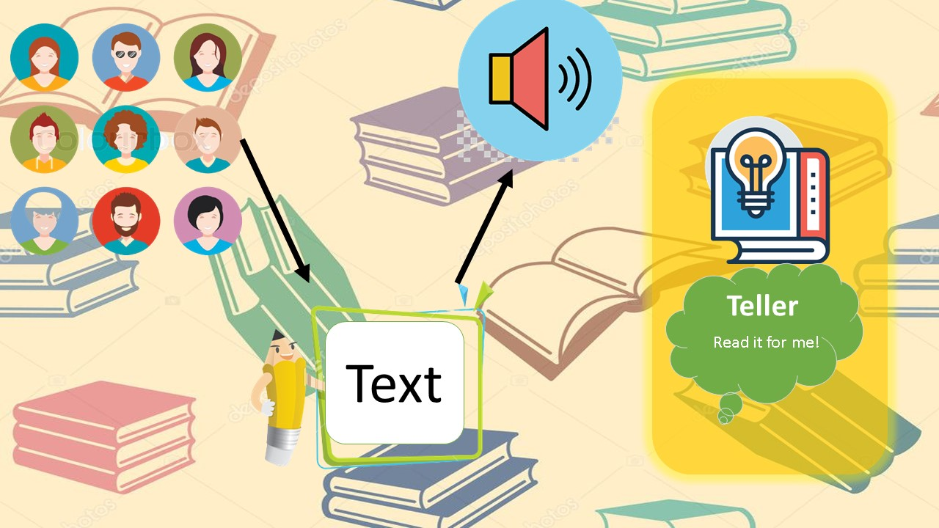

**Layout**

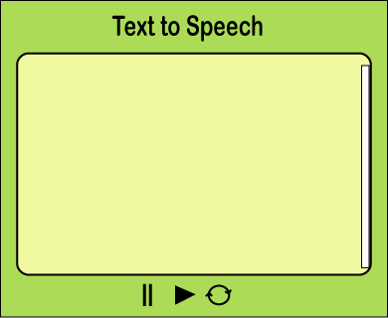

**icons**

