**ITECH 7201**

**Assignment 1**

**Part A - Individual Task**

**Employee Management System**

**(Sub-System)**

**Submitted By:**

**Syeda Tamanna Sheme**

**Student ID : 30432670**

**Table of Contents**

|  |  |  |
| --- | --- | --- |
| **Number** | **Topics** | **Page Number** |
| **1.** | **Description of scenario Scenario**   1. Scenario ------------------------------------------------- 2. Screenshot of Questions Asked ---------------------- | **2**  **3** |
| **2.** | **Brief Use Case Description**   1. Screenshot of the Queries and Drafts --------------- 2. Critique Of The Final Answer ----------------------- 3. Final Use Cases ---------------------------------------- | **6**  **9**  **10** |
| **3.** | **Use Case Diagram**   1. Use case Diagram ------------------------------------- 2. Explanation --------------------------------------------- | **11**  **12** |
| **4.** | **Domain model Class Diagram**   1. The Answer From The AI Tool ---------------------- 2. Critique of AI Tool Response ------------------------ 3. Final Domain Model Class Diagram ---------------- 4. Description and Assumptions ------------------------ | **12**  **15**  **15**  **17** |
| **5.** | **Sequence Diagram**   1. Sequence Diagram ------------------------------------- 2. Description of Sequence Diagram------------------- | **18**  **23** |
| **6.** | **Constructive Reflection** ------------------------------------ | **24** |
| **7.** | **References** ---------------------------------------------------- | **25** |

**Employee Management System**

1. **Description of Scenario**
2. **Scenario**

A well-known technology company with a reputation for developing innovative software manages a dynamic staff that is dispersed across multiple sites through the HR department. An essential component of the company's extensive HR system, the Employee Management Subsystem (EMS) was created to improve productivity and streamline operations. The goal of the EMS is to centralise the administration of large amounts of employee data by providing a centralised platform that facilitates easy access to and control of this data. This subsystem is in charge of keeping comprehensive records on staff members, including biographical information, work requirements, pay information, performance reviews, and a comprehensive employment history. HR personnel can easily update current records, onboard new team members, and handle the offboarding procedure with accuracy and ease.

This subsystem's key features include processing promotions and transfers with ease, keeping careful tabs on attendance, managing leave requests, and complying with external legal requirements as well as internal business standards. Additionally, the system empowers workers by giving them immediate access to update personal information, request leaves of absence, and access employment histories, promoting openness and participation. Security is a top priority, so the EMS is designed with robust safeguards to secure sensitive data and only permits authorised workers to access the system. Access levels vary, based on the specific requirements and authorised power of supervisors, HR managers, and other staff members. The subsystem was built with scalability at its heart, so it can handle the expanding needs of the company as it grows. It seamlessly combines with other HR elements like payroll and recruitment to provide a unified solution that supports the business's strategic objectives. The EMS demonstrates its worth as a company asset by improving HR operations and increasing employee engagement through its intuitive interface, contributing significantly to the company's continuous growth and prosperity.

1. **Screenshot of Questions Asked**

I started by asking the AI tool general questions regarding employee management systems to get a better understanding of the essential elements and capabilities that make up a well-rounded system. This laid the groundwork for investigating how human resources operations and employee-related procedures can be efficiently supported by an Employee Management System (EMS). I began by asking things like, "What are the key components of an employee management system?" as an example. as well as "How can a performance management subsystem be integrated into an EMS?" These wide-ranging questions gave me a general understanding of the key duties that should be performed by an EMS, including payroll, benefits administration, performance management, and personnel records management.

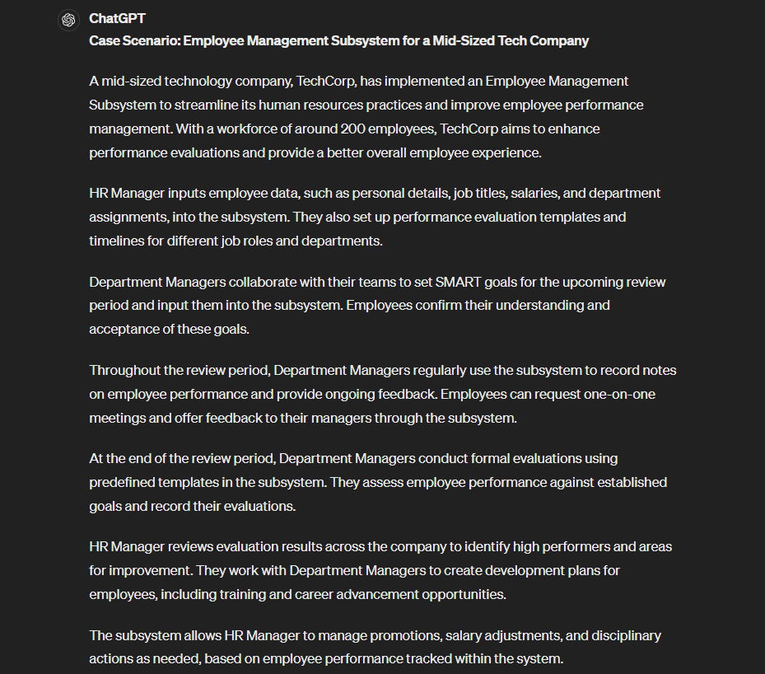

After receiving initial responses, I began refining my questions to gather more specific and targeted information. I delved deeper into the intricacies of performance management by asking about best practices for managing employee performance, techniques for setting and tracking goals, and the role of reporting and analytics in an EMS. This level of detail allowed me to understand how to implement effective performance evaluations and identify trends within the workforce. I also asked questions about employee self-service portals, learning and development features, and how an EMS can support career advancement and employee satisfaction. This information guided me in designing a system that fosters employee growth and aligns with organizational objectives.

By focusing on particular areas and refining my questions, I was able to gain comprehensive insights that informed the design and implementation of a robust Employee Management System. This process allowed me to identify key features that contribute to overall efficiency and effectiveness, ultimately supporting a more productive and engaged workforce.

## **Brief Use case description**

### **Screenshot of the Queries and Drafts**

To begin with, I asked the AI tool broad questions about the possible use cases for an Employee Management Subsystem. Initial queries included:

* "What are the use cases for an Employee Management System?"
* "How can an Employee Management System be utilized in a company?"
* "What functions can an EMS perform for HR?"

The responses from these broad questions provided a range of potential use cases, from managing employee records to conducting performance evaluations.

* 1. **Critique Of The Final Answer**

**Refinement of Queries for Targeted Use Cases:**

The broad array of features outlined for the Employee Management System (EMS) informed the selection of relevant use cases, with queries tailored to unearth the nuances of user interaction. This led to identifying specific use cases where employees can review their work history, apply for leave, and receive timely updates. Simultaneously, a distinct set of inquiries focused on functionalities that empower managers to oversee employee records and performance, culminating in use cases that facilitate record updates, leave approvals, and the generation of insightful performance analytics.

**Selection and Exclusion of Relevant Queries:**

The refinement phase was guided by the EMS's fundamental aim to efficiently manage employee data and performance metrics. Each query was evaluated for its pertinence to the system's primary objectives, ensuring a laser focus on accurate employee data management. Queries that strayed from the EMS's primary functions, such as general HR activities not directly linked to employee data management, were systematically excluded. This process guaranteed that the final use cases were intrinsically connected to the EMS's designated capabilities.

**Rationale for Appropriate Use Case Development:**

The development of use cases, which included functionalities for updating employee profiles, endorsing leave requests, and generating performance insights, was justified by their coherence with the EMS's declared features. These use cases substantially improve the user experience by providing intuitive tools for both employees and managers to navigate employee records and evaluations with ease. Additionally, the EMS's capacity for real-time updates, attendance tracking, and performance trend analysis elevates operational efficiency and contributes to more streamlined and precise workforce management. The emphasis on automation and real-time accessibility underscores the EMS's commitment to optimizing HR processes while ensuring the accuracy and availability of employee information.

* 1. **Final Use Cases:**

After refining the questions and critically assessing the answers from the AI tool, I arrived at the following 10 use cases for the Employee Management Subsystem at GlobeTech Inc.:

1. **Add New Employee:** HR Managers input and secure new employee data into the system during the hiring process.
2. **Update Employee Details:** HR Managers make updates to employee profiles to reflect changes like promotions or personal information changes.
3. **Process Termination:** HR Managers handle the removal and archiving of an employee's data from the system when they leave the company.
4. **Manage Attendance Records:** HR Managers or Supervisors track and manage daily employee attendance, addressing any discrepancies.
5. **Submit a Leave Request:** Employees apply for leave, specifying details such as the type and duration.
6. **Approve Leave Request:** Supervisors or HR Managers review and decide on leave applications based on policy and available leave balances.
7. **Record Performance Review:** Supervisors document performance reviews, noting feedback, ratings, and objectives.
8. **View Employee Profile:** Employees can access and review their personal and job-related details.
9. **Generate Employment Reports:** HR Managers compile reports detailing various aspects of employee data for review and decision-making.
10. **Edit Security Settings:** HR Managers modify security settings to protect sensitive data and manage system access rights.
11. **Use Case Diagram**
    1. **Use case Diagram:**

The diagram is a use case diagram for an Employee Management System, detailing how different actors interact with various parts of the system. It outlines the functions that the HR Manager, the Supervisor, and the Employee can perform. The HR Manager has a central role, interacting with most of the use cases, such as "Add New Employee," "Update Employee Details," and "Process Termination." The Supervisor has specific interactions such as "Approve Leave Request" and "Record Performance Review." The Employee can "Submit Leave Request" and "View Employee Profile." The use cases are connected to actors via lines, indicating which actor can initiate or is involved in each use case.

* 1. **Explanation:**

The diagram shows the interactions between the primary actors (HR Manager, Supervisor, Employee) and the use cases (functions) of the EMS. The diagram also includes <<include>> and <<extend>> relationships:

**<<include>> Relationships:**

The <<include>> notation is used when a use case is always executed as part of another use case. In the diagram, "Submit Leave Request" is included in "Approve Leave Request," which means that whenever the leave approval process is initiated, the submission process is included as a necessary part of it.

**<<extend>> Relationship:**

The <<extend>> notation is used when a use case is conditionally executed as an addition to the behaviour of another use case. In the diagram, "Record Performance Review" extends "View Employee Profile," which indicates that the performance review may occasionally require additional steps that involve viewing the employee's profile, but not always. Similarly, "Save PDF" extends from "View Employee Profile," suggesting that the action of saving the profile as a PDF is an additional feature that does not occur every time the profile is viewed.

1. **Domain Model Class Diagram**
   1. **The Answer From The AI Tool**

A domain model class diagram is a visual representation of the classes, attributes, and relationships within a specific domain—in this case, the EMS. This diagram represents the entities involved in the EMS and their attributes, as well as how these entities are related to one another. The domain model supports all the use cases identified for the EMS.

**AI Tool Response:** Here are the classes and attributes provided by the AI tool for an EMS:

**Employee**:

Attributes: employee_id, name, contact_info, job_title, department, salary, performance_reviews, attendance_records, leave_balance

Relationships: Has a one-to-many relationship with PerformanceReview, AttendanceRecord, and LeaveRequest

**PerformanceReview:**

Attributes: review_id, employee_id, supervisor_id, review_date, feedback, rating, goals

Relationships: Belongs to Employee and is conducted by Supervisor

**AttendanceRecord:**

Attributes: record_id, employee_id, date, clock_in, clock_out

Relationships: Belongs to Employee

**LeaveRequest:**

Attributes: request_id, employee_id, type, start_date, end_date, status, reason

Relationships: Belongs to Employee and can be approved by Supervisor or HR Manager

**HRManager**:

Attributes: hr_manager_id, name, contact_info, permissions

Relationships: Manages Employee data and can approve or reject LeaveRequest

**Supervisor:**

**Attributes**: supervisor_id, name, contact_info, department

Relationships: Manages Employee performance, attendance, and leave requests.

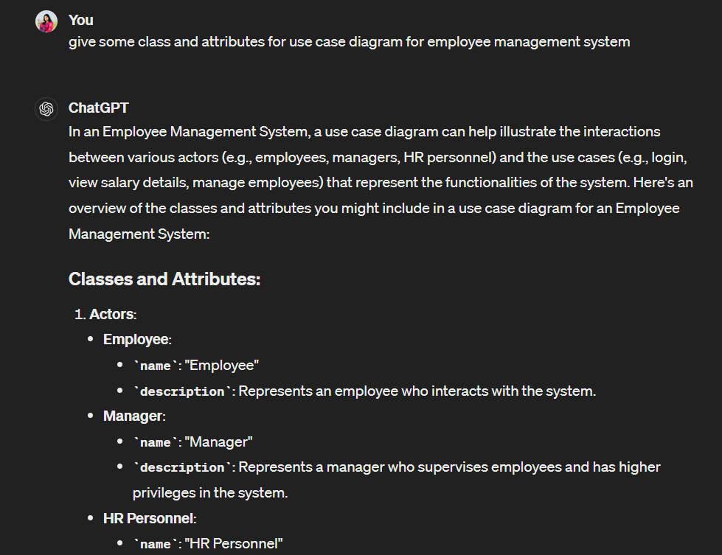

* 1. **Critique of AI Tool Response**

The AI tool's response provides a good starting point, but some refinements are needed:

* **Entity Relations:** Relationships between classes need to be clearly defined and made explicit.
* **Attributes:** The attributes provided are mostly relevant, but additional attributes such as start_date and end_date for Employee can be added.
* **Role of HR Manager and Supervisor:** Clarification of their roles about the Employee class is needed.

**c. Final Domain Model Class Diagram**

Using the refined list of classes and attributes, a domain model class diagram can be created to visually represent the EMS:

**Classes and Attributes:**

* **Employee:**
  + - employee_id: int
    - name: String
    - contact_info: String
    - job_title: String
    - department: String
    - salary: float
    - start_date: Date
    - end_date: Date
* **HRManager:**
  + - manager_id: int
    - name: String
    - contact_info: String
* **Supervisor:**
  + - supervisor_id: int
    - name: String
    - contact_info: String
    - department: String
* **AttendanceRecord:**
  + - record_id: int
    - employee_id: int
    - date: Date
    - clock_in: Time
    - clock_out: Time
* **LeaveRequest:**
  + - request_id: int
    - employee_id: int
    - type: String
    - start_date: Date
    - end_date: Date
    - status: String
    - reason: String
* **PerformanceReview:**
  + - review_id: int
    - employee_id: int
    - supervisor_id: int
    - review_date: Date
    - feedback: String
    - rating: float
    - goals: String
* **EmploymentReport:**
  + - report_id: int
    - generated_by: int
    - date: Date
    - content: String
* **SecuritySettings:**
  + - settings_id: int
    - managed_by: int
    - access_level: String

**Relationships:**

* **Employee - AttendanceRecord:**
  + A one-to-many relationship, indicating that an employee has multiple attendance records, possibly reflecting daily attendance logs.
* **Employee - LeaveRequest:**
  + A one-to-many relationship, where each employee can have multiple leave requests, reflecting the various times an employee has asked for leave.
* **Employee - PerformanceReview:**
  + A one-to-many relationship, suggests that employees have multiple performance reviews, potentially annually or semi-annually. This relationship would be typical to allow tracking performance over time.
* **Employee - HRManager:**
  + A one-to-many relationship from the perspective of the HRManager, who manages multiple employees within the company.
* **Supervisor - PerformanceReview:**
  + A one-to-many relationship, indicating a supervisor conducts multiple performance reviews, likely for different employees under their supervision.
* **HRManager - EmploymentReport:**
  + A one-to-many relationship, showing that an HRManager can generate multiple reports, which could be for different departments, periods, or purposes.
* **HRManager - SecuritySettings:**
  + A one-to-one relationship, indicating that each HRManager has associated security settings, likely pertaining to their access level within the EMS.

**d. Description and Assumptions**

**Description:** The domain model class diagram visually represents the entities involved in the EMS, their attributes, and their relationships. It provides a clear overview of how the different entities interact within the system.

**Assumptions:** The assumptions made are that the data types and relationships between classes are standard and follow common practices in HR systems. It is also assumed that attributes such as contact_info and department have been standardized for consistency.

1. **Sequence Diagram**
   1. **Sequence Diagram:**

**Add New Employee Sequence Diagram**

**Update Employee Details:**

**Process Termination:**

**

**Approve Leave Request:**

**Manage Attendance Records:**

**Record Performance Review:**

**View Employee Profile:**

**Generate Employment Reports:**

**Edit Security Settings:**

* 1. **Description of Sequence Diagram:**

Each diagram systematically captures the flow of activities and interactions between different actors and the system:

* **Add New Employee:** This diagram details the procedure followed by an HR Manager to enter a new employee's data into the system, including verification steps and the confirmation of successful addition.
* **Update Employee Details:** This sequence illustrates the method by which an HR Manager updates an employee's record, such as job title or contact information changes, ensuring that the current data is accurately reflected in the system.
* **Process Termination:** This diagram depicts the sequence of actions an HR Manager takes to terminate an employee's record in the system, including the archiving of their data and the communication of the termination's completion.
* **Submit a Leave Request:** The diagram outlines the steps an employee must take to submit a leave request through the system and how this request is recorded and queued for approval.
* **Approve Leave Request:** The sequence here describes how a Supervisor or HR Manager reviews a leave request and either approves or rejects it, with updates on the decision being fed back into the system.
* **Manage Attendance Records:** This diagram illustrates the process by which HR Managers or Supervisors record and manage attendance data for employees, dealing with any potential discrepancies that may arise.
* **Record Performance Review:** It showcases the interaction of a Supervisor with the system to document an employee's performance review, including feedback entry and performance ratings.
* **View Employee Profile:** This sequence presents the actions taken by an employee to access and review their personal and professional details stored in the system.
* **Generate Employment Reports:** The diagram captures the steps an HR Manager follows to compile and generate reports that summarize various employment-related metrics and data for analysis.
* **Edit Security Settings:** It lays out the process for an HR Manager to modify the security settings within the system to ensure data integrity and appropriate access control based on user roles.

Each diagram is a visual representation of the interaction between the system's users and the database, reflecting the creation, update, or retrieval of data as per the use cases' requirements. The diagrams aim to clarify the system's functionality and to ensure that the Employee Management System is both comprehensive and efficient in handling its tasks.

**6. Constructive Reflection**

The Employee Management System (EMS) at GlobeTech Inc. was developed and implemented using reflection, and Gibbs' Reflective Cycle to analyse the process offers a methodical approach to evaluate and enhance it. Based on my subsystem, I could employ each level of Gibbs' Reflective Cycle as follows:

* **Description:** Technology company GlobeTech Inc. developed the EMS to handle a flexible workforce. The system centralises employee data management, making hiring, keeping personnel records, and processing terminations easier HR operations. Everything is tracked, including performance evaluations and personal data.
* **Feelings:** Early on in the EMS deployment process, there was likely a mix of excitement about potential efficiency gains and anxiety over the new system's adoption. A portion of the unhappiness or opposition might have resulted from challenges in training employees to utilise the new system and incorporating old data.
* **Evaluation:** The EMS has various functions, such as leave management, performance reviews, and attendance tracking, that increase operational efficiency and compliance. These are but a handful of its advantages. On the other hand, challenges might have included data transfer issues, human resistance resulting from process modifications, or technological issues with the deployment.
* **Analysis:** The success of the EMS can be attributed to meticulous planning and an understanding of HR requirements, which resulted in a system that was ideal for GlobeTech's requirements. On the other hand, insufficient technical support or training might have made it more difficult for the new system to be implemented smoothly, which would have affected the system's initial acceptability and efficacy.
* **Conclusion:** The experience shows how important it is to ensure that, in addition to building a system that meets organisational goals, all end users have enough support, including training and readily available technical assistance. It also highlights how important it is to do extensive testing and feedback loops to identify and fix issues before a system is widely used.
* **Action Plan:** Before the system goes live for subsequent projects, further in-depth user training sessions could be arranged. It may also be necessary to implement a pilot plan that has a small department use the technology and give input. This might help identify any issues in a controlled environment, which could speed up the broader rollout.

HR managers and the GlobeTech project team may continuously enhance their approach to managing such important projects by using Gibbs' Reflective Cycle to reflect on these issues and make sure that the technical and human components of implementation are appropriately addressed. The team is better prepared for upcoming updates or the introduction of new technology thanks to this reflective practice, which also increases the efficacy of the current system [**[1].**](%5b1%5d%20The%20University%20of%20Edinburgh,%20“Gibbs’%20Reflective%20Cycle,”%20The%20University%20of%20Edinburgh,%20Nov.%2011,%202020.%20https:/www.ed.ac.uk/reflection/reflectors-toolkit/reflecting-on-experience/gibbs-reflective-cycle)

1. **References**

[1] The University of Edinburgh, “Gibbs’ Reflective Cycle,” *The University of Edinburgh*, Nov. 11, 2020. <https://www.ed.ac.uk/reflection/reflectors-toolkit/reflecting-on-experience/gibbs-reflective-cycle>