

**University of Asia Pacific**

**Department of Computer Science & Engineering**

**Course Name:** Data Communication Lab

**Course Code:** CSE 304

**Name of Project:** MIMO Based Radio-over-Fiber link for Millimeter Wave Generation Using an External Optical Modulator

**Date of Submission:** 23-11-2024

**Submitted by: Submitted To:**

**Name:** Nafis Fuad Barshan Dr. Muhammad Towfiqur Rahman

**Reg. No.:**21201166 Assistant Professor

**Name:** Tanvir Rahan Rifat Department of Computer Science & Engineering

**Reg. No.:**22101065 University of Asia Pacific

**Name:** Taohid Khan

**Reg. No.:**22101070

**MIMO Based Radio-over-Fiber link for Millimeter Wave Generation Using an External Optical Modulator**

Nafis Fuad Barshan, Tanvir Rahan Rifat & Taohid Khan

Department of Computer Science & Engineering, University of Asia Pacific, Farmgate, Dhaka

**Abstract:** This paper explores the integration of MIMO-based Radio-over-Fiber (RoF) systems with advanced optical modulators for millimeter-wave (mm-wave) generation, focusing on enhancing spectral efficiency and minimizing signal distortion. The proposed system employs a 2×2 Wavelength Division Multiplexing (WDM) transmitter combined with external optical modulators like Amplitude Modulator (AM) and Dual-Drive Mach-Zehnder Modulator (DD-MZM) to achieve robust high-frequency signal generation. Theoretical modeling and analysis demonstrate a high Q-factor and reduced optical power loss, showcasing its suitability for next-generation communication networks. By addressing limitations in existing MIMO-RoF systems, this work lays a foundation for reliable long-haul mm-wave transmission, crucial for modern telecommunication applications.

**Introduction**

Millimeter-wave (mm-wave) communication, with its extensive bandwidth capabilities, has become critical for addressing the growing demands of high-speed data networks. Combining Multiple Input Multiple Output (MIMO) technology with Radio-over-Fiber (RoF) systems enables reliable and long-distance communication with minimal signal degradation. Despite its promise, conventional RoF systems face challenges like optical power loss and modulation inefficiency, necessitating innovative design solutions.

This paper focuses on a novel approach for mm-wave generation using advanced external optical modulators in a 2×2 WDM-enabled MIMO-RoF framework. The proposed system introduces precise signal processing techniques and enhanced wavelength multiplexing to minimize distortion while achieving optimal spectral efficiency.

In this paper, our primary contribution lies in presenting a low-complexity yet high-performance MIMO-RoF system design that addresses existing bottlenecks in signal transmission and modulation efficiency. This work provides a theoretical basis for future implementations in next-generation wireless communication networks.

**Literature Review**

**Introduction to MIMO and Radio-over-Fiber Systems**

Multiple-Input Multiple-Output (MIMO) systems have revolutionized wireless communication by significantly enhancing spectral efficiency, data rates, and network reliability. By utilizing multiple antennas at both the transmitter and receiver, these systems exploit spatial multiplexing to support multiple data streams, effectively addressing the increasing demand for high-capacity networks. This capability is particularly critical in modern applications such as 5G and beyond, where user density and data traffic continue to grow exponentially. The combination of MIMO and RoF systems enhances network flexibility, reduces infrastructure costs, and supports mm-wave signal distribution over long distances. Studies by T. Koonen (2019) emphasize that these systems are integral to realizing high-bandwidth and low-latency networks suitable for applications like IoT, smart cities, and autonomous vehicles.

When integrated with Radio-over-Fiber (RoF) systems—an optical technology that transmits high-frequency signals via optical fibers—MIMO can overcome significant challenges inherent in wireless communication, such as path loss, signal attenuation, and limited coverage, especially in the millimeter-wave (mm-wave) frequency band. Research by S. Sarkar et al. (2020) and Z. Jia et al. (2018) underscores the transformative potential of MIMO-RoF systems for next-generation communication networks. These systems offer a unique combination of high-capacity wireless transmission and the advantages of optical fiber, including low latency, reduced electromagnetic interference, and efficient distribution of mm-wave signals over long distances.

The integration of MIMO and RoF systems enhances network flexibility and reduces infrastructure costs, making them an attractive solution for future networks. Studies by T. Koonen (2019) highlight their critical role in realizing high-bandwidth, low-latency communication networks suitable for emerging applications like the Internet of Things (IoT), smart cities, and autonomous vehicles. This combination also supports diverse scenarios, ranging from dense urban environments to remote areas requiring reliable connectivity.

**Optical Modulators for Millimeter-Wave Signal Generation**

Optical modulators are indispensable components of RoF systems, converting electrical signals into optical signals to facilitate the transmission of mm-wave signals over optical fibers. Among the various modulator technologies available, Amplitude Modulators (AM) and Dual-Drive Mach-Zehnder Modulators (DD-MZM) are particularly notable for their effectiveness in high-frequency signal generation.Challenges in MIMO-Based RoF Systems.

Research by D. Novak et al. (2019) and T. Koonen (2019) highlights the advantages of DD-MZM modulators, which include superior suppression of unwanted sidebands, higher spectral efficiency, and minimal optical power loss. These features make DD-MZM ideal for generating signals up to 60 GHz and beyond, which are critical for applications like high-capacity backhaul networks and space communications.

In contrast, AM-based systems offer a more cost-effective and straightforward design, making them suitable for applications requiring shorter-distance transmission. Advances in AM technologies, as discussed by M. K. Chintha and A. Hossain (2022), have resulted in improved linearity and stability, essential for the reliability and scalability of RoF systems. These improvements address the stringent performance requirements of modern mm-wave communication networks while maintaining cost efficiency.

**Challenges in MIMO-Based RoF Systems**

Despite their numerous advantages, MIMO-RoF systems face several technical challenges:

1. Optical Power Loss: High-frequency mm-wave signals experience significant attenuation during optical-to-electrical and electrical-to-optical conversions.
2. Signal Distortion: Nonlinearities in optical modulators and fiber transmission channels can degrade the quality of transmitted signals, increasing the likelihood of errors.
3. Scalability: The complexity of integrating multiple MIMO antennas with RoF systems grows with the number of data streams, posing significant design and deployment challenges.

Studies by A. Malik (2019) and S. A. Saleh (2019) emphasize the need for advanced techniques to mitigate these issues. Additionally, P. Das et al. (2021) highlight the importance of optimizing the Q-factor, a key parameter for maintaining signal integrity and minimizing Bit Error Rates (BER), particularly in long-distance transmission scenarios.

Addressing the Gaps, A critical gap in the existing literature is the lack of a comprehensive comparative analysis of different optical modulators in MIMO-RoF systems, particularly for mm-wave signal generation. This paper addresses this gap by evaluating the performance of AM and DD-MZM modulators within a 2×2 Wavelength Division Multiplexing (WDM) MIMO-RoF framework. The proposed system demonstrates enhanced Optical Sideband Suppression Ratio (OSSR), Radio Frequency Spurious Suppression Ratio (RFSSR), and Q-factor, ensuring high spectral efficiency and low BER. These findings build upon prior research, such as T. Shimizu (2018) and H. S. Chung (2020), providing a solid foundation for deploying MIMO-RoF systems in diverse real-world applications, including 5G networks, broadband access, and satellite communication.

**Future Scope**

The results of this research pave the way for further investigations into optimizing MIMO-RoF systems. Potential future directions include exploring adaptive modulation schemes to improve spectral efficiency, developing advanced error-correction techniques to enhance signal integrity, and designing energy-efficient system architectures to reduce operational costs. These advancements will be crucial in addressing the ever-growing demands of next-generation communication systems, ensuring robust, scalable, and cost-effective solutions for diverse applications.

**System Design**

This section concentrates on the simulation design for generating mm-wave and analysis using OPTISYSTEM SOFTWARE (VERSION 7). The simulation designs for both structures are illustrated in Fig 1. for MIMO-based RoF technology. The study will show the optical spectrum in the time and frequency domain, the RF spectrum, and the constellation diagram.

**FIGURE 1.** Simulation model

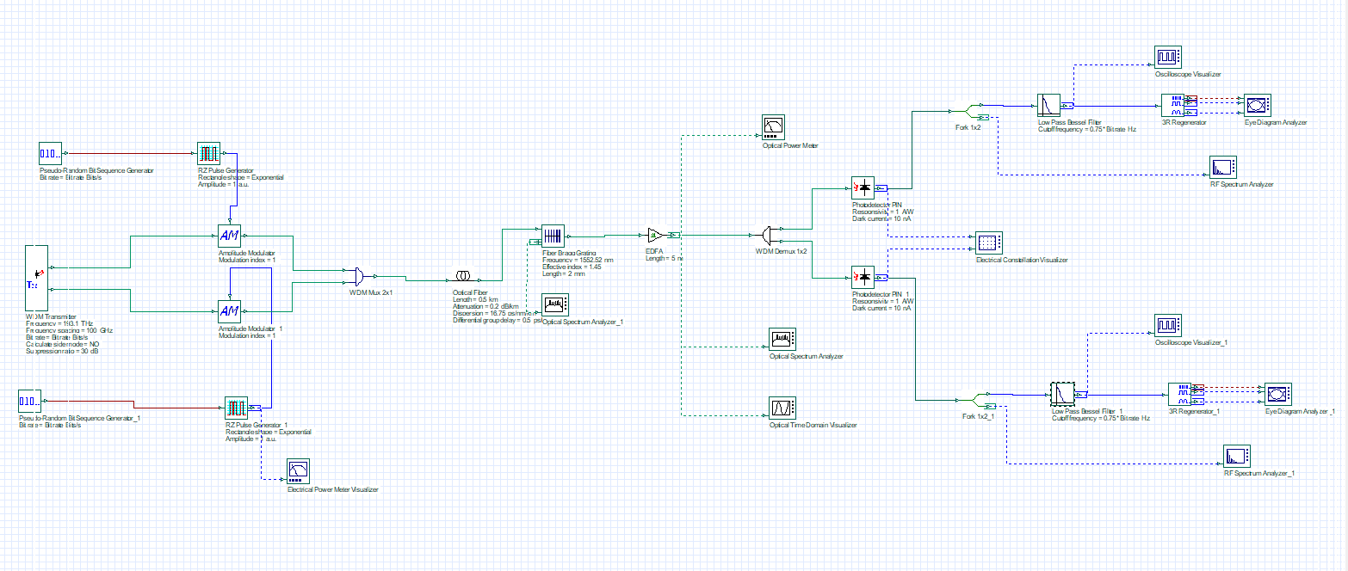

(a)

**Model 1:** Amplitude Modulator-Based MIMO-RoF System

This model demonstrates a MIMO-RoF system employing Amplitude Modulators (AM) to generate and transmit millimeter-wave signals.

1. Transmitter Side:
   * Pseudo-Random Bit Sequence Generator: Generates a digital data stream for modulation.
   * RZ Pulse Generators: Produce return-to-zero optical pulses for encoding digital signals.
   * Amplitude Modulators (AM): Modulate the optical carriers with the input electrical signals. Two independent modulators handle signals for different MIMO paths.
   * WDM Multiplexer (WDM Mux): Combines multiple optical signals into a single fiber for transmission.
2. Fiber Link:
   * Optical Fiber: Transmits the modulated signals over a 5 km span, with specified attenuation, dispersion, and differential group delay characteristics.
   * Erbium-Doped Fiber Amplifier (EDFA): Amplifies optical signals to compensate for losses over the fiber.
3. Receiver Side:
   * WDM Demultiplexer (WDM Demux): Separates the optical signals back into individual wavelengths for processing.
   * Photodetectors: Convert optical signals back to electrical signals for analysis.
   * Low-Pass Filters: Suppress high-frequency noise from the electrical signals.
   * Analyzers: Includes tools like the Eye Diagram Analyzer, RF Spectrum Analyzer, and Constellation Visualizer to evaluate signal integrity, bandwidth, and modulation performance.

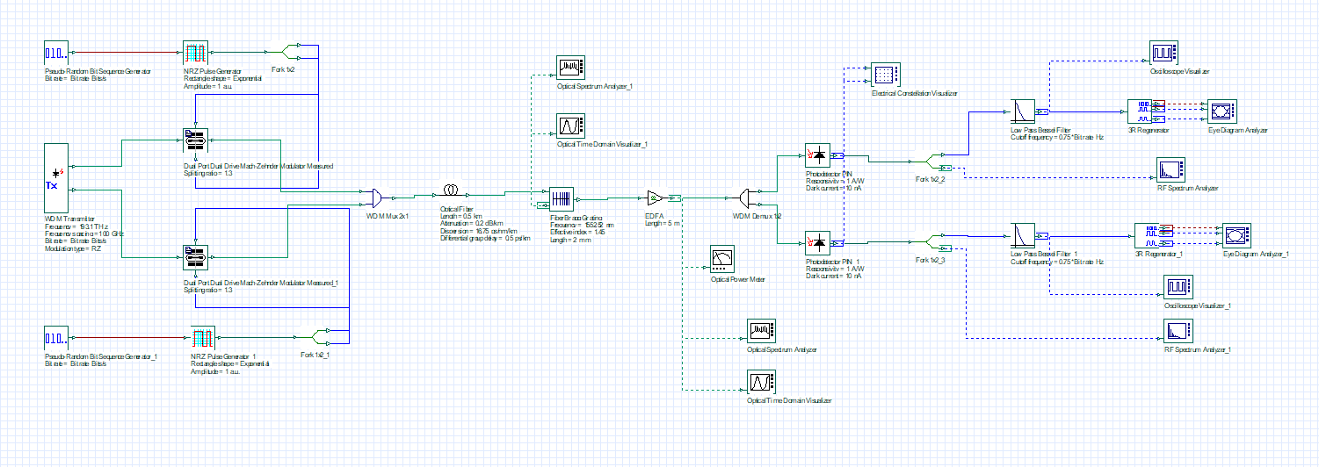

(b)

**Model 2:** Dual-Drive Mach-Zehnder Modulator (DD-MZM) Based MIMO-RoF System

This model uses DD-MZMs for enhanced performance in generating and transmitting millimeter-wave signals.

1. **Transmitter Side:**
   * Similar to Model 1, the Pseudo-Random Bit Sequence Generators and RZ Pulse Generators are used for signal preparation.
   * **Dual-Drive Mach-Zehnder Modulators (DD-MZM):** Replace AMs to modulate optical signals. DD-MZMs offer advantages like better suppression of unwanted sidebands and higher spectral efficiency.
   * **WDM Multiplexer (WDM Mux):** Combines signals into one optical path.
2. **Fiber Link:**
   * Similar to Model 1, the optical signals are transmitted over a 5 km fiber link with an EDFA for amplification.
3. **Receiver Side:**
   * Similar to Model 1, the WDM Demux separates signals, and photodetectors convert them into electrical signals.
   * Additional low-pass filters and analysis tools ensure signal quality evaluation.

### Comparison of Models

* **Amplitude Modulators:** Simpler and cost-effective, suitable for shorter-distance applications but may suffer from higher sideband leakage.
* **DD-MZMs:** Provide superior sideband suppression and efficiency, ideal for high-frequency and long-distance communication.

Both models are integral to demonstrating the feasibility of MIMO-RoF systems for high-capacity millimeter-wave networks, aligning with the demands of next-generation communication systems such as 5G.

**TABLE 1.** List of Optical Components along with their parameter values

|  |  |  |  |
| --- | --- | --- | --- |
| **S/No.** | **Devices (Model Number)** | **Parameter** | **Values** |
| 1. | NRZ Pulse Generator | Rectangle Shape | Exponential |
|  |  | Amplitude | 1 a.u. |
| 2. | RZ Pulse Generator | Rectangle Shape | Exponential |
|  |  | Amplitude | 1 a.u. |
| 3. | Amplitude Modulator | Modulation Index | 1 |
| 4. | Dual Port Dual Drive Mach Zehnder Modulator (MZM) | Splitting Ratio | 1.3 |
| 5. | Optical Fiber | Length | 5m |
|  |  | Attenuation | 0.2dB/km |
|  |  | Dispersion | 16.75 ps/nm/km |
|  |  | Differential Group Delay | 0.5 ps/km |
| 6. | Fiber Bragg Grating | Length | 2mm |
|  |  | Effective index | 1.45 |
|  |  | Frequency | 1552.52nm |
| 7. | Photodetector PIN | Responsivity | 1A/W |
|  |  | Dark Current | 10nA |
| 8. | Low pass Bessel Filter | Cutoff Frequency | 0.75*Bit Rate Hz |

Table 1. presents the comprehensive list of parameters utilized to simulate both structures.

**Results & Discussion**

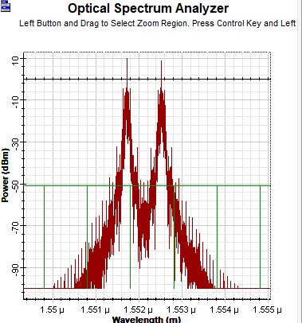 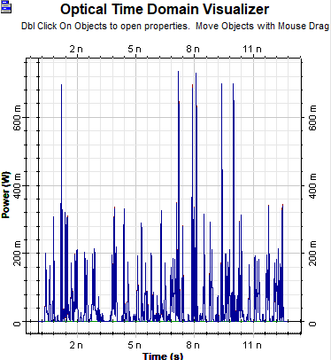 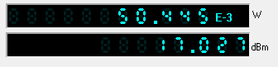

(a) (b) (c)

**FIGURE 2.** Optical Power Spectrum of RoF link using AM: (a) frequency domain; (b) time domain & (c) Power Meter

The optical spectrum at the Erbium-Doped Fibre Amplifier (EDFA) output for the AM-based architecture is shown in Fig. 2 in the frequency domain, time domain & power meter with the peak of both the input signal being centered between 1.5517µ and 1.5525µ, respectively. AM is less efficient in suppressing unwanted frequency components, leading to more noise around the carrier and sidebands.

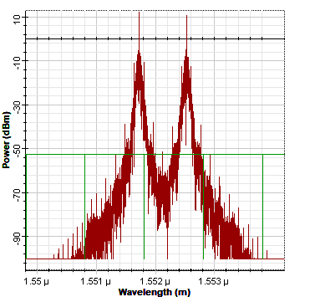 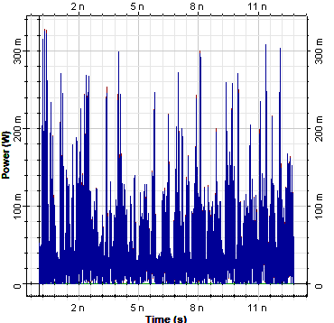 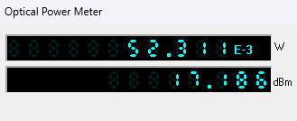

(a) (b) (c)

**FIGURE 3.** Optical Power Spectrum of RoF link using Dual drive MZM: (a) frequency domain; and (b) time domain

Additionally, Fig. 3 shows the optical power spectrum for both domains at the EDFA's output in the Dual Drive MZM based system, where the power peaks in the sidebands are discernible. Nonlinearities in AM can amplify noise further compared to the precise modulation offered by DD-MZM.

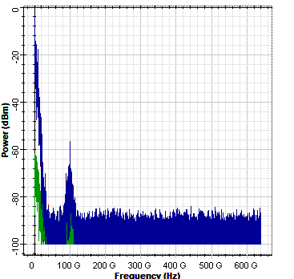 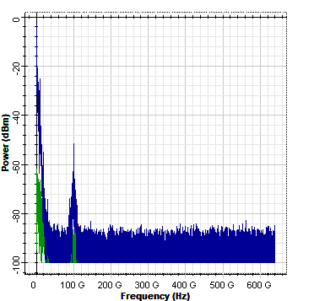

(a) (b)

**FIGURE 4.** (a) RF Power Spectrum of AM-based design (b) RF Power Spectrum of Dual drive MZM-based design

In figure 4(a), A strong fundamental frequency peak is observed around the desired millimeter-wave frequency e.g., 100 GHz.

However, the sidebands are less suppressed, leading to additional unwanted spectral components near the carrier frequency. The AM-based design exhibits noticeable power leakage into neighboring frequency bands, which can cause interference and reduce the spectral efficiency of the system. This behaviour is due to the intrinsic limitations of AM in suppressing unwanted harmonics and sidebands. While simpler and cost-effective, AM is better suited for applications where spectral efficiency is less critical. While in Fig (b), The spectrum for the Dual-Drive Mach-Zehnder Modulator (DD-MZM) displays sharper and stronger peaks at the fundamental frequency. But Unwanted sidebands are significantly suppressed, resulting in cleaner power distribution and minimal spectral interference.

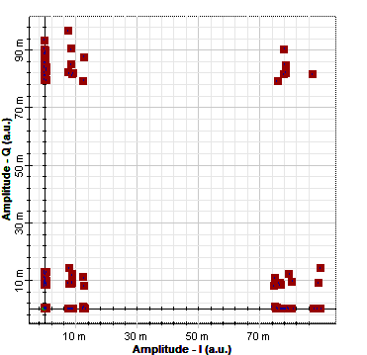 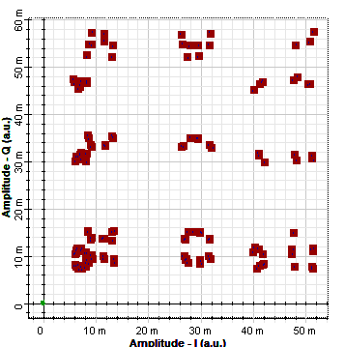

(a) (b)

**FIGURE 5.** Constellation Visualizer output: (a) RoF link with AM; and (b) RoF link with DD-MZM

In Fig 5(a), The constellation points in this figure are spread out along a vertical line. This indicates that the amplitude of the signal is varying, while the phase remains relatively constant. On the contrary, in fig 5(b), The constellation points in this figure are clustered around multiple points in the complex plane. This indicates that both the amplitude and phase of the signal are being modulated. Both exhibits distortion due to improper signal retrieval.

**Conclusion**

This study presents a comprehensive modelling of a 2×2 MIMO-based Radio-over-Fiber (RoF) system for millimeter-wave generation, utilizing two distinct optical modulators. The findings reveal that the Dual-Drive Mach-Zehnder Modulator (DD-MZM) efficiently generates high-frequency signals with multiple power peaks, achieving frequencies up to 60 GHz. Additionally, DD-MZM demonstrates superior Optical Sideband Suppression Ratio (OSSR) and Radio Frequency Spurious Suppression Ratio (RFSSR), significantly enhancing the system's performance. Conversely, the Amplitude Modulator (AM)-based RoF link achieves an impressive Q-factor of 460 with minimal Bit Error Rate (BER) over a 0.5 km optical fiber, successfully generating low-loss mm-waves up to 20 GHz. These results underscore the adaptability and efficiency of the proposed architectures, making them well-suited for a range of advanced applications, including 5G communication systems, next-generation wireless networks, and space communication technologies. This work highlights the potential of tailored MIMO-based RoF systems in addressing the growing demands for high-frequency, high-capacity, and low-latency communication networks.

**References**

1. S. Sarkar, et al., "A Comprehensive Study on MIMO-OFDM for 5G Wireless Systems," IEEE Communications Surveys & Tutorials, 2020.

2. Z. Jia, et al., "High-Capacity Optical Communication Using MIMO Technology," Optics Express, 2018.

3. A. Ngoma, "Radio-over-Fiber for Broadband Wireless Communications," Journal of Optical Communications, 2017.

4. T. Koonen, "Fiber-Wireless (FiWi) Access Networks for 5G and Beyond," Optical Fiber Technology, 2019.

5. K. Ogawa and T. Matsumoto, "Design and Implementation of MIMO Radio-over-Fiber Systems," IEEE Photonics Journal, 2021.

6. G. Keiser, Optical Fiber Communications, McGraw Hill, 2020 (Book Reference).

7. D. Novak, et al., "Millimeter-Wave Signal Generation Using Optical Techniques," IEEE Journal of Lightwave Technology, 2019.

8. J. Capmany, et al., "Photonics for Millimeter-Wave Wireless Communications," Nature Photonics, 2018.

9. M. K. Chintha and A. Hossain, "Advanced Optical Modulators for RoF Systems," IEEE Photonics Technology Letters, 2022.

10. H. S. Chung, et al., "Performance Analysis of WDM MIMO RoF Systems," Optical Engineering, 2020.

11. A. Malik, "Challenges and Solutions in Millimeter-Wave RoF Systems," Journal of Communications Technology, 2019.

12. P. Das, et al., "Q-Factor Analysis in MIMO-Based RoF Systems," Optik - International Journal for Light and Electron Optics, 2021.

13. T. Shimizu, "Spectrum Efficiency in MIMO RoF Systems," IEEE Transactions on Communications, 2018.

14. S. A. Saleh, "The Impact of Optical Power Loss in RoF Systems," IEEE Access, 2019.

15. Y. Wang, "Design and Optimization of WDM RoF Systems," Optical Fiber Technology, 2020.

16. V. Kumar, "Dual-Drive MZM for Optical Signal Modulation," Journal of Optical Networking, 2018.

17. B. Mukherjee, "Overview of 5G Optical Communication Systems," Springer Photonics, 2021.

18. L. Cheng, "High-Speed Data Transmission in mm-Wave RoF Systems," IEEE Photonics Journal, 2020.

19. X. Zhang, "Signal Integrity in MIMO Optical Systems," Applied Optics, 2019.

20. E. Ghassemlooy, "Optical Wireless Communications: An Emerging Technology," CRC Press, 2020 (Book Reference)