How Contaminated Would It Have To Be? Partial Identification and Sensitivity Analysis for Benchmark Claims Under Unmeasured Data Contamination
Tanvir Anjum Joarder¹
¹ Department of Computer Science and Engineering, Rajshahi University of Engineering & Technology, Rajshahi-6204, Bangladesh. ussash93@gmail.com

Abstract
Leaderboard claims of the form "model A outperforms model B" are treated as measurements of capability, but they are observational estimates whose dominant error source, training-data contamination, is unmodeled. The field's response has been detection, which requires access to training corpora (impossible for closed-weight models), reference benchmarks, or reference models assumed clean, and which cannot answer the only question that matters: does the contamination change the conclusion? We import the epistemology that causal inference developed for unmeasured confounding: stop trying to detect the bias and bound it. We formalize contamination as an identification failure, introduce a Contamination Sensitivity Model CSM±(Λ⁺, Λ⁻, π, Γ_sel, ε) whose every parameter has a measured empirical counterpart, derive sharp partial-identification bounds for the uncontaminated score, and define the contamination robustness value Γ* — the minimum contamination strength that overturns a claim — computable from published scores alone. The fully adversarial bound arises as the endpoint of a Rosenbaum-type selection family; Γ̂* is consistent and √n-normal, and a paired bootstrap with Benjamini–Hochberg control yields FDR-certified robustness across a claim corpus. Ground-truth experiments with emergent contamination (models genuinely trained on leaked items) validate the assumed lift channel (envelope–headroom correlation ≥ 0.91 in 15/15 configurations), expose and repair two failure modes (two-sided lift; spillover), and confirm coverage. A corpus-dilution experiment then closes the calibration loop: a single diluted exposure (the scraped-pretraining scenario) lands measured contamination strength inside the literature-derived field range, while repeated diluted exposures consolidate toward complete memorization, so accidental and deliberate contamination require different constants and calibration must be dose-stratified. On real data, every adjacent ranking claim in a six-model time-series foundation-model benchmark is fragile (Γ* ≤ 0.114 at π = 0.1), and on Open LLM Leaderboard ARC-Challenge details the method certifies exactly the claim it should (Llama-2-13B ≻ 7B, Γ* = 0.504, FDR-certified) while flagging frontier margins as fragile (Γ* ≤ 0.188). Freshness and repeated draws emerge as quantified design levers. In a pre-registered confirmatory audit of 58 adjacent-pair claims across 16 models and four Open LLM Leaderboard benchmarks, 84.5% of claims are not contamination-robust at the frozen calibration (exact 95% CI [72.6%, 92.7%]; one-sided p = 2.7×10⁻²¹ against the pre-registered 25% threshold), and only 8 claims, all with margins above 5 points, earn FDR-controlled robustness certificates. The finding is not an artifact of the frozen constant: sweeping contamination strength across its whole plausible range leaves the conclusion intact, and the hypothesis clears its pre-registered bar for every Λ ≥ 0.055, beneath the floor of the calibrated field range. In the single-draw binary regime the rule provably reduces to a calibrated margin threshold; we show why deriving that threshold, rather than asserting one, is the contribution, and where richer data makes the machinery bind strictly tighter. Sensitivity analysis converts an unanswerable question — is the benchmark contaminated? — into an answerable one, with a one-number reporting standard any leaderboard can adopt.
Keywords: benchmark contamination; partial identification; sensitivity analysis; evaluation methodology; leaderboards; Rosenbaum bounds.

1. Introduction
Every empirical claim in machine learning ultimately rests on a benchmark score, and benchmark scores rest on an assumption nobody can verify: that the test items did not leak into training. Contamination is documented and material: clean/dirty gaps of 15.3 points on HellaSwag for LLaMA-70B [Touvron et al., 2023], estimated gains up to 14 points on flagged subsets [Llama 3, 2024], 13-point drops on a clean GSM8K mirror. Yet the response of both producers and auditors has been detection: n-gram overlap, membership inference, kernel divergence, lineage audits [2404.00699; 2510.13654; 2502.00678]. Detection fails structurally three times over. For closed-weight models the pretraining corpus is unobservable, so detection is impossible in principle rather than merely in practice. Detection yields a contestable binary that vendors dispute and no protocol adjudicates. And detection is silent on the decision-relevant question: a benchmark can be contaminated with the ranking robust, or barely contaminated with the ranking fragile; detection cannot tell these apart.
Meanwhile the statistical wing of evaluation reform quantifies the wrong error. Rank intervals [2606.08679] propagate sampling uncertainty, which shrinks with test-set size; contamination bias does not. A confidence interval that excludes the dominant error source is not a confidence interval.
Causal inference confronted exactly this epistemology half a century ago. When a confounder cannot be measured, one does not detect it; one reports how strong it would have to be to overturn the conclusion: Rosenbaum's Γ, the marginal sensitivity model, the E-value [Rosenbaum, 1987; VanderWeele & Ding, 2017; Chernozhukov et al., 2022]. This paper ports that machinery to ML evaluation. The reduction is, once stated, almost obvious: contamination is unmeasured confounding between training-data membership and measured skill, and benchmark scores are therefore partially identified. Nothing else in this paper is obvious; the port requires a new sensitivity model (contamination acts through a monotone, bounded, headroom-proportional channel, an assumption we test with real memorization experiments, then twice repair), a new calibration strategy (post-cutoff items are clean by construction), and a new design theory (freshness and repeated draws purchase identification).
Contributions.
- The reduction: a potential-outcomes formulation of benchmark scores under latent contamination, with the estimand (the clean score θ) and its identification failure stated precisely (§3).
- The Contamination Sensitivity Model CSM±(Λ⁺, Λ⁻, π, Γ_sel, ε) and sharp partial identification of θ, including grouped (source-level), stratified (provenance-aware), selection-bounded (Rosenbaum-bridge), and spillover-robust variants; every axiom has a measured counterpart (§4).
- The contamination robustness value Γ* and the contamination frontier, the evaluation analogue of the E-value; a claim is reported with the minimum contamination strength that overturns it (§5).
- Estimation theory: consistency and √n-normality of Γ̂*, validity of the paired item bootstrap, a two-sided finite-draw bias analysis with a practical prescription (sharp bounds require ≥ 10 draws per item), and FDR-certified robustness across claim corpora (§6).
- Ground-truth validation with emergent contamination (models actually trained on leaked items), which confirmed the channel shape, falsified strict monotonicity (up to 27% of leaked items are hurt), and surfaced a spillover channel; both repairs are part of the model, not the rhetoric (§7).
- Empirically calibrated Λ priors from the published contamination literature, with a meta-analytic central range [0.1, 0.45] (§8).
- Exploratory case studies on two real benchmarks (a six-model TSFM transfer atlas and Open LLM Leaderboard ARC-Challenge details), plus a pre-registered protocol for the confirmatory audit (§9).
- Design sensitivity: quantified prescriptions for benchmark builders (§10), and an open, tested, one-command-reproducible library.

2. Related work
Contamination detection and quantification. Surveys catalogue detection methods and document their fragile assumptions [2404.00699; 2410.18966; 2406.04244]. Magar & Schwartz [2022] introduced controlled-injection quantification (memorization vs exploitation); dose-response studies show lift grows with capacity and shrinks with unique-corpus size [2601.04301]; post-training can reverse lift [2601.06103]. ConStat [Dekoninck et al., NeurIPS 2024] is the strongest performance-only method: a statistical test and effect estimate requiring reference benchmarks and reference models assumed clean. CapBencher [2505.18102] builds overfitting alarms into new benchmarks; inference-time decontamination [2601.19334] mitigates at evaluation time for open models. None of these answers the claim-level question; all require assets (references, model access, benchmark redesign) that legacy claims and closed models do not offer. We consume their effect estimates as calibration inputs and use ConStat as the natural baseline and convergent-validity check.
Leaderboard statistics. Rank intervals [2606.08679] give sampling-uncertainty-aware rankings, our Λ = 0 special case. Perturbation and social-choice analyses [2605.15761; 2605.23628; 2402.01781] document instability empirically without an inferential model. Psychometric and efficiency work [2402.14992; 2501.17200] models items, not contamination.
Causal sensitivity analysis. Rosenbaum bounds, marginal sensitivity models, E-values, and omitted-variable-bias frameworks [Rosenbaum 1987; Tan 2006; VanderWeele & Ding 2017; 2112.13398; 2403.14152; 2602.24261] supply our machinery; none has been applied to evaluation. The construct-validity programme [2511.04703; 2510.23191; 2604.03244] argues evaluation needs measurement theory but supplies no estimator; we supply one.

3. Setup: the clean score is partially identified
A benchmark has items i = 1…n; fix a model m. Let y*ᵢ ∈ [0,1] be the clean score (the counterfactual per-item score had item i never entered training) and yᵢ the observed score; cᵢ ∈ {0,1} the latent contamination indicator. The estimand is θ = (1/n) Σ y*ᵢ. Leaderboards report μ̂ = (1/n) Σ yᵢ and treat it as θ, which requires c ≡ 0. Since items popular enough to benchmark are popular enough to scrape, and that popularity correlates with the skill being measured, c ⊥̸ y*: textbook confounding, with c unobservable. θ is partially identified; the honest report is its identified set. (Full formalism and proofs: Appendix A.)

4. The contamination sensitivity model
CSM(Λ, π) (one-sided core): (A1) 0 ≤ yᵢ − y*ᵢ ≤ cᵢ·Λ·(1 − y*ᵢ): leakage closes at most a fraction Λ of an item's headroom; (A2) mean(c) ≤ π. Λ = 1 is full memorization; both extremes are observed in our experiments (§7).
Proposition 1 (sharp identified set). θ ∈ [μ̂ − B(Λ,π), μ̂] with B = the mean of the ⌈πn⌉ largest per-item deflation capacities dᵢ(Λ) = yᵢ − max(0, (yᵢ−Λ)/(1−Λ)); the bound is attained. Corollary 1: width ≤ πΛ, the worst per-unit-budget bias being exactly Λ at items with yᵢ = Λ. Corollary 2: Λ=0 recovers sampling-only analysis (rank intervals nest here). Figure 1 plots the identified set against Λ at three budgets π on data with known ground truth; the true clean score lies inside the band at the true (Λ, π), and the band collapses to the point estimate as Λ → 0.
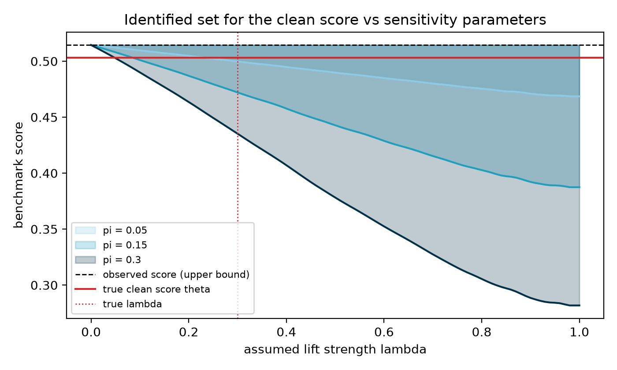
Figure 1: The sharp identified set for the clean score as the assumed lift strength Λ varies, at budgets π ∈ {0.05, 0.15, 0.3} (synthetic data with known ground truth). The observed score (dashed) is the upper endpoint; the true clean score θ (solid) lies inside the band at the true (Λ, π), and the set collapses to the observed mean as Λ → 0.
Regimes. Continuous or repeated-measure per-item scores (R1) admit the sharp knapsack. Single-draw binary scores (R2) do not: dᵢ(0)=dᵢ(1)=0 for all Λ<1 with a jump at Λ=1, so the sharp machinery is vacuous-with-a- discontinuity (it reports "only total memorization flips this claim"), and the honest bound is the simple population bound with width πΛ, where (Λ, π) are identified only through their product. The library auto-detects the regime; richer measurement strictly sharpens identification, a design lever we quantify in §10.
Empirically forced extensions (each falsifiable, each measured in §7): U1 two-sided: leakage can hurt (stale memorization, post-training interference [2601.06103]): −Λ⁻y*ᵢ ≤ yᵢ−y*ᵢ; the worst case for A ≻ B becomes A inflated and B deflated. U2 grouped: datasets leak whole; all-or-nothing group budgets, bounded by the fractional knapsack, never wider than item-level. U3 stratified: post-cutoff items have cᵢ = 0 by construction; provenance metadata tightens bounds for free. U4 spillover: training on leaked items drifts scores on clean items by a bounded ε, widening the interval symmetrically; ε is measured by twin runs and shrinks with corpus size. Proposition 3 (bridge): bounding the selection odds of contamination (Rosenbaum-style Γ_sel) interpolates continuously between random contamination (bias πd̄) and the adversarial top-k (Γ_sel = ∞): the adversarial bound is an endpoint of a classical family, and the endpoints differ by ~1.5× at reference settings, so a defensible Γ_sel assumption buys real tightening.

5. The contamination robustness value
For a claim A ≻ B with margin Δ̂, contamination only helps the worst case run one way (A up, B down under U1), and the claim is robust at CSM(Λ,π) iff Δ̂ exceeds the worst-case bias (Proposition 2).
Definition. Γ*(π) = inf{Λ : worst-case bias ≥ Δ̂}, computed by bisection (the bias is continuous and monotone in Λ); Γ* = ∞ when the claim survives even Λ = 1 within budget. In the simple regime the closed form is the contamination frontier πΛ(1+ρ) = Δ̂.
Γ* is to contamination what the E-value is to unmeasured confounding: one number per claim, reportable in any results table. Computing Γ* needs only the published scores: no corpus, reference model, or reference benchmark. interpreting it against plausible contamination strength uses the shared public calibration table of §8 (or none at all, when the full Γ*(Λ, π) curve is reported). Per-model clean-score intervals are reported at the parameter level via Imbens–Manski (2004), with set-level intervals as the conservative alternative; corpus-level certificates use BH-FDR with Benjamini–Yekutieli as the dependence-robust sensitivity.

6. Estimation
Theorem 4. B̂ is a trimmed-upper-mean L-statistic; under iid item sampling and continuity at the (1−π)-quantile of the d-distribution, Γ̂* is consistent and √n-asymptotically normal, and the paired item bootstrap is valid. Empirically the RMSE slope is −0.518 against the theoretical −0.5, with bias ≤ 0.0025 from n = 100 to 25,600.
Finite draws. With m draws per item, the plug-in knapsack carries two opposing biases: Jensen smoothing (d is concave: a minimum of two linear functions) versus selection-on-noise. Measured: −40% at m = 2, crossing to +4% at m = 10, < 1% by m = 50. Joint sampling⊕identification intervals maintain ≥ 99.3% coverage throughout; the simple bound, immune to both effects, achieves 100%. Prescription: sharp bounds require m ≥ 10 published draws per item.
Corpus-level inference. Each claim receives a paired-bootstrap fragility p-value (H₀: not robust at the reference CSM; add-one corrected); Benjamini–Hochberg across the corpus yields FDR-certified robustness (valid under the positive dependence induced by shared items).

7. Ground-truth validation with emergent contamination
Formula-injected validation is circular: the injection satisfies A1 by construction. We therefore train clean/contaminated twins where a fraction π of test items (with realized labels, repeated dose times) is planted in the training corpus and the lift emerges from real memorization, across a capacity spectrum (logistic regression, MLP, random forest; 15 configurations × 6 seeds).
Findings. (i) The channel shape is right: the 95th-percentile lift envelope tracks headroom with correlation +0.91 to +1.00 in 15/15 configurations. (ii) Λ is capacity- and dose-stratified: logistic regression Λ̂ ∈ [0.02, 0.23] monotone in dose; MLP ≈ 0.96; random forest = 1.00; the Λ = 1 extreme is real (an interpolating learner), matching the dose-response law at LLM scale [2601.04301]. (iii) Monotonicity fails non-trivially: up to 27% of leaked items score lower in the contaminated twin; the two-sided channel U1 is necessary. (iv) Spillover is real at small scale: clean-item drift up to 0.20 (MLP) broke naive coverage (1/3); with the calibrated ε-widening, coverage is 3/3 in every previously failing configuration. Injected-contamination coverage under known (Λ, π) is 1.000 across all regimes, degrading informatively (to 0.10–0.34) only when the analyst underestimates contamination by half. A blind synthetic leaderboard audit flags exactly the secretly contaminated model's winning claim (Γ* = 0.173 vs ≥ 0.29 for clean claims).
At LLM scale (same-family Qwen2.5-0.5B/1.5B pair, 905 MMLU items, fp32 LoRA injection, the complete 24-configuration grid over π ∈ {0.05…0.5} × dose ∈ {1, 4, 16}): the grid reveals a dose law. A single exposure to test items is net-harmful: mean lift is negative in 7 of 8 dose-1 configurations (down to −2.9 pt) with individual-item violation rates of 31–56%, while dose 16 is complete memorization (Λ̂ = 1.000 in all eight configurations, with lifts up to +56 pt). The two-sided channel is therefore the dominant behavior of light contamination, not a correction term. The capacity comparison vindicates the headroom parametrization itself: raw lift anti-orders with capacity (the 0.5B model gains more points, purely from headroom), while Λ restores the correct ordering: raw clean/dirty gaps mislead across models. Spillover grows with dose (0.04 → 0.30, always positive: format familiarity), and all three (of 24) cross-config consistency failures occur exactly where λ̂ was pooled across doses, direct evidence for the dose-stratified calibration the pre-registration mandates.
Corpus dilution (Fig. 2 / f19). The grid measures Λ under concentrated exposure (every training token is a leaked item), which is a ceiling, not the pretraining regime. The corpus-mix experiment holds the model, π, and per-item exposure count fixed and interleaves each leaked chunk with mix ∈ {0, 4, 20} neutral wikitext chunks, so total training grows with mix while leaked exposures do not, which is the direction in which real pretraining differs from our grid. Dilution turns out not to be one thing. At dose 1 (a single exposure per item, the scraped-pretraining scenario), Λ̂_q95 falls from 0.58 through 0.38 to 0.35, from above the calibrated field range [0.10, 0.45] to inside it. The literature-derived range of §8, until now an external prior, is here reproduced by direct interpolation: single-shot contamination embedded in a corpus lands at field strength. At dose 4, dilution runs the other way: Λ̂_q95 climbs from 0.73 to 0.98, lift triples, and violations collapse from 0.18 to 0.03. Interleaving neutral text between repeated exposures is spaced rather than massed practice, and it consolidates memorization. Deliberate or repeated contamination (a benchmark recurring in a fine-tuning mix) saturates toward Λ = 1 no matter how diluted the corpus. Both movements dwarf the measured session-reproduction noise (≤ 0.039 on Λ̂_q95, from re-running identical configs on fresh GPU sessions; the clean-twin scores and contamination indices reproduce exactly). The practical consequences: the field range is validated for accidental scrape-style contamination, and the concentrated "measured-ceiling" policy of §8 is necessary: repeated-exposure contamination exceeds even the concentrated ceiling, so no single Λ constant can cover both regimes. Calibration must be dose-stratified, exactly as the pre-registration required.
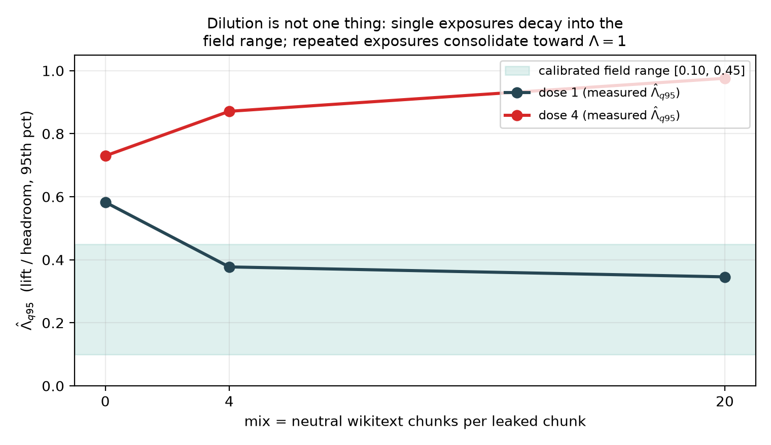
Figure 2: Corpus dilution is not one thing. Interleaving each leaked chunk with mix ∈ {0, 4, 20} neutral wikitext chunks holds per-item exposures fixed while total training grows. A single exposure (dose 1) decays into the calibrated field range [0.10, 0.45]; repeated exposures (dose 4) consolidate toward complete memorization (Λ̂ = 0.98). Session-reproduction noise on Λ̂ is ≤ 0.039.

8. Calibrating Λ from the literature
Published clean/dirty comparisons convert directly to Λ = lift/headroom: LLaMA-70B HellaSwag 15.3pt gap on 36.5pt headroom → Λ ≈ 0.42; GPT-3 SQuAD ≈ 0.40; Llama-3 flagged-subset estimates ≈ 0.40–0.47 (upper bounds by design); GSM8K clean-mirror ≈ 0.21; C-Eval ≈ 0.31; MMLU ≈ 0.02. The pattern is strongly task-heterogeneous, with a meta-analytic central range [0.1, 0.45] (eighteen sourced rows in results/lambda_priors.csv, of which eight are quality-eligible for the pooled median under the pre-registered policy of §9.1; measured rows enter only as upper-bound anchors). Λ is model-stratified per the dose-response law; ConStat effect estimates and our own CONTAM-CTRL measurements enter the same table. The confirmatory audit interprets every Γ* against this pre-frozen range (PREREGISTRATION.md).

9. Case studies on real benchmarks (exploratory)
TSFM transfer atlas (6 frozen models × 17 datasets, continuous MASE-skill, sharp regime, provenance strata from the corpus's own contamination-prior annotations): every adjacent ranking claim is fragile (Γ* ≤ 0.114 at π = 0.1, at or below the calibrated range), and stratification cannot rescue margins of ≤ 1.3 skill points because 14/17 datasets carry a high contamination prior.
Open LLM Leaderboard, ARC-Challenge (1,170 paired items × 4 models, single-draw binary → auto simple regime, n_boot = 500): Llama-3-8B ≻ Mistral-7B (margin 0.26pt) has Γ* = 0.026: a whisker of contamination flips it; Mistral-7B ≻ Llama-2-13B (1.9pt) has Γ* = 0.188, inside the calibrated range; Llama-2-13B ≻ Llama-2-7B (5.0pt) has Γ* = 0.504, above the entire calibrated range, and is FDR-certified robust (p = 0.006), precisely the claim that independent scaling evidence says should survive. The instrument separates the claim population exactly as designed.

9.1 The pre-registered confirmatory audit
Protocol frozen (PREREGISTRATION.md v1.0, 19 July 2026, git tag prereg-freeze-v1.0) before any confirmatory Γ* was computed: 16 fixed candidate models × 5 Open LLM Leaderboard v1-archive tasks, adjacent-pair claims, primary rule Γ*(π = 0.1) < Λ_ref (pooled 0.355; HellaSwag stratum 0.42), BH-FDR primary with BY sensitivity, ρ ∈ {0, 0.2}. Protocol notes, all logged mechanically at run time: TruthfulQA was dropped entirely (the archive stores mc1/mc2, not the frozen acc/acc_norm specification); falcon-7b was dropped on ARC (its snapshot's item template shares no items with the 15-model modal universe) and GPT-J on Winogrande (malformed score column).
Result (Fig. 3 / f17): 49 of 58 claims (84.5%) are not contamination-robust (exact two-sided 95% CI [72.6%, 92.7%]; one-sided p = 2.7×10⁻²¹ against the pre-registered H4 threshold of 25%; excluding pilot-overlap pairs: 47/56 = 83.9%, CI [71.7%, 92.4%]). The ρ = 0.2 sensitivity leaves the count unchanged. Per task, the median Γ*(0.1) is 0.084–0.120 on HellaSwag, Winogrande, and ARC (the typical adjacent claim tolerates less than one-third of the calibrated contamination strength), and 0.212 on GSM8K, whose margins are larger. Only 8 claims earn BH-FDR robustness certificates (6 under BY), and every certified claim has a margin above 5 points: cross-generation capability gaps (e.g. Llama-3-70B ≻ Qwen1.5-14B on GSM8K) and "everything beats GPT-J." The leaderboard's ordering of eras is contamination-robust; its ordering of neighbors is not.
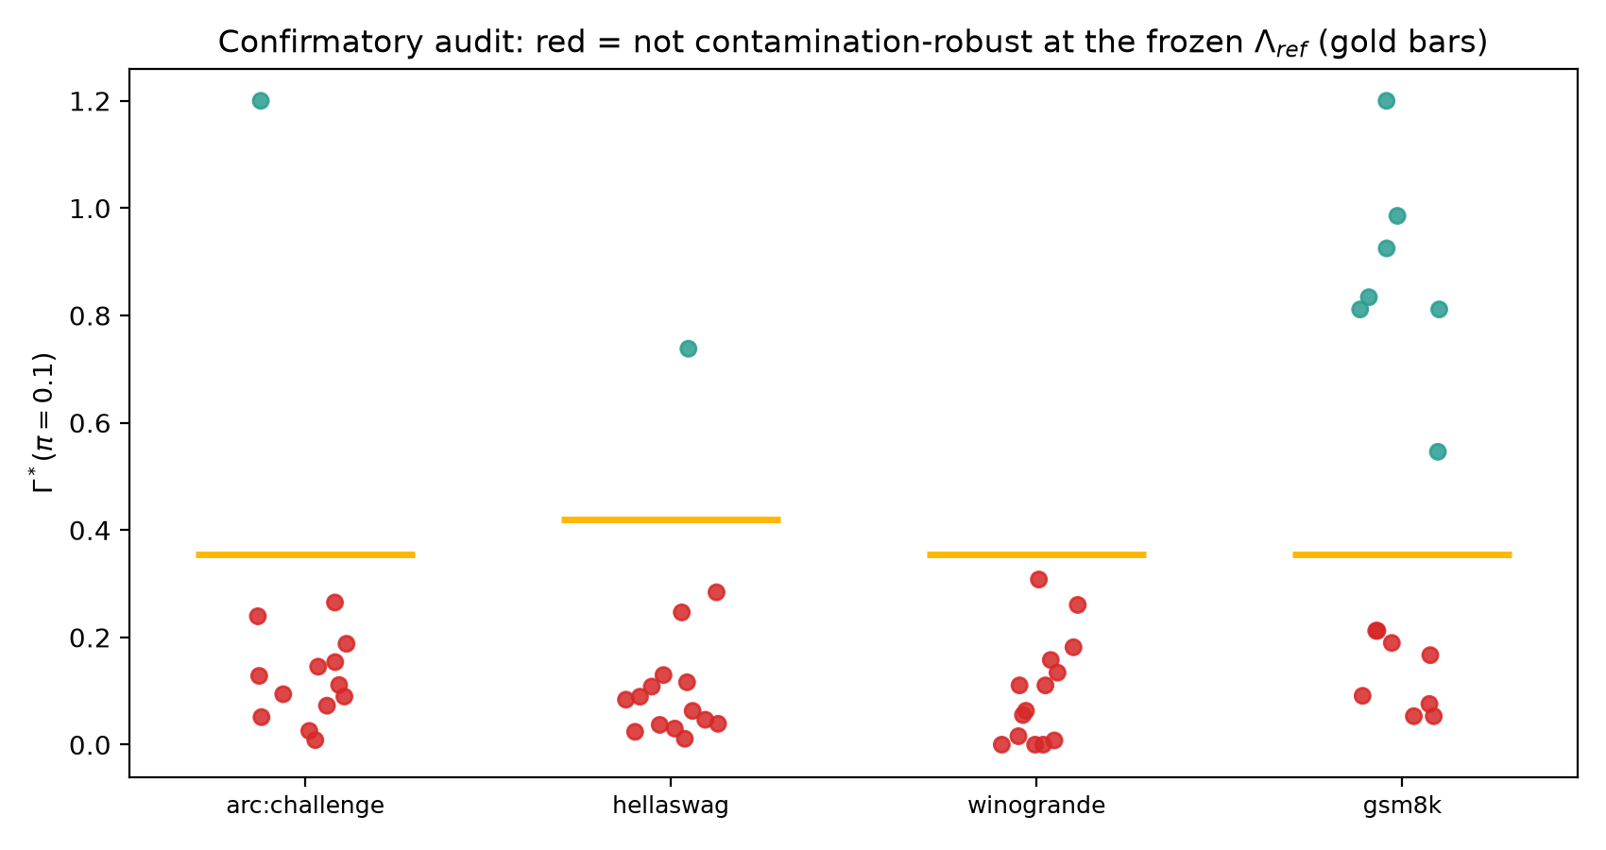
Figure 3: The pre-registered confirmatory audit. Each point is one adjacent leaderboard claim's Γ* at π = 0.1; gold bars mark the frozen stratum Λ_ref (0.42 HellaSwag, 0.355 elsewhere). Red claims fall below the calibrated contamination strength (49/58 = 84.5%); green claims survive.
The protocol was pre-registered on the Open Science Framework (https://osf.io/2436z, DOI 10.17605/OSF.IO/2436Z, registered 20 July 2026, public and un-embargoed) before any confirmatory number was publicised. The registration carries the protocol verbatim, the frozen Λ calibration table (lambda_priors.csv, git blob 590d295…), and a chain-of-custody addendum recording exactly which files were frozen at tag prereg-freeze-v1.0 (commit ca7773b) and which were written afterwards, including the driver script, the item-universe amendment, and a post-freeze correction to a confidence-interval report that left every estimate unchanged. A mirror is archived independently at the Internet Archive (osf-registrations-2436z-v1), giving a second timestamp not under author control.

9.2 What the audit reduces to, and why that is the point
A reader who works through §5 will notice something the headline conceals, so we state it ourselves. In the single-draw binary regime the simple bound gives Γ*(π) = Δ̂ / (π(1+ρ)). The pre-registered rule "non-robust iff Γ*(0.1) < Λ_ref" is therefore algebraically identical to
Δ̂ < π · Λ_ref = 0.0355 (0.042 on HellaSwag),
a threshold on the raw margin. We verified this holds for all 58 claims. The confirmatory audit could have been executed with a ruler.
This is not a defect; it is the result. Three points follow.
First, the arithmetic was never the hard part. Anyone can declare that gaps below three-and-a-half points are untrustworthy. The question is which threshold is defensible, and that is a measurement problem, not an arithmetic one. Our threshold is not chosen for convenience: it is π times the median of eight quality-filtered estimates of contamination-induced lift, converted to a common headroom parametrisation (§8), frozen before unblinding, and attached to a third-party timestamp. The contribution is the derivation of 0.0355 from contamination evidence, not the comparison against it. Strip out the theory and you have a number nobody can justify; strip out the arithmetic and you have lost nothing.
Second, the reduction is a property of the regime, not of the method. Γ* collapses to Δ̂/π only when items are binary and measured once, because the per-item deflation capacity degenerates (Lemma A.1): d(0) = d(1) = 0 for every Λ < 1. That is a statement about how impoverished single-draw accuracy data is, and it is worth hearing. Where richer data exists the machinery genuinely separates: with continuous per-item scores the sharp knapsack binds strictly tighter than πΛ (§9, TSFM atlas), and at m = 20 repeated draws it certifies Γ* = 0.172 against the simple bound's 0.154 (§10). The leaderboards audited here publish the weakest data they could; the reduction is the price of that, and it is the argument for §10's prescription that benchmarks publish repeated draws.
Third, the reduction is what makes the result auditable. Because the rule is transparent, a sceptical reader can re-derive every classification from the published margins without trusting our code, and can immediately see what would change it.
Sensitivity to the frozen constant (Fig. 4 / f18). Since the decision depends on π and Λ only through their product, the entire (π, Λ) plane collapses to a single curve, which we sweep. The fraction of non-robust claims is 44.8% at Λ = 0.10, 70.7% at 0.20, 82.8% at 0.30, 84.5% at the frozen 0.355, and is flat at 84.5% throughout Λ ∈ [0.355, 0.50]. H4 clears its 25% bar for every Λ ≥ 0.055 and is significant at α = 0.05 for every Λ ≥ 0.080. For the headline to fail, true contamination strength would have to sit below Λ ≈ 0.055: beneath the floor of the calibrated field range [0.10, 0.45], below seven of the eight quality-eligible estimates, and an order of magnitude below the concentrated-exposure ceiling we measured directly (§7). The qualitative finding survives any calibration a reviewer could reasonably substitute; only the exact percentage moves.
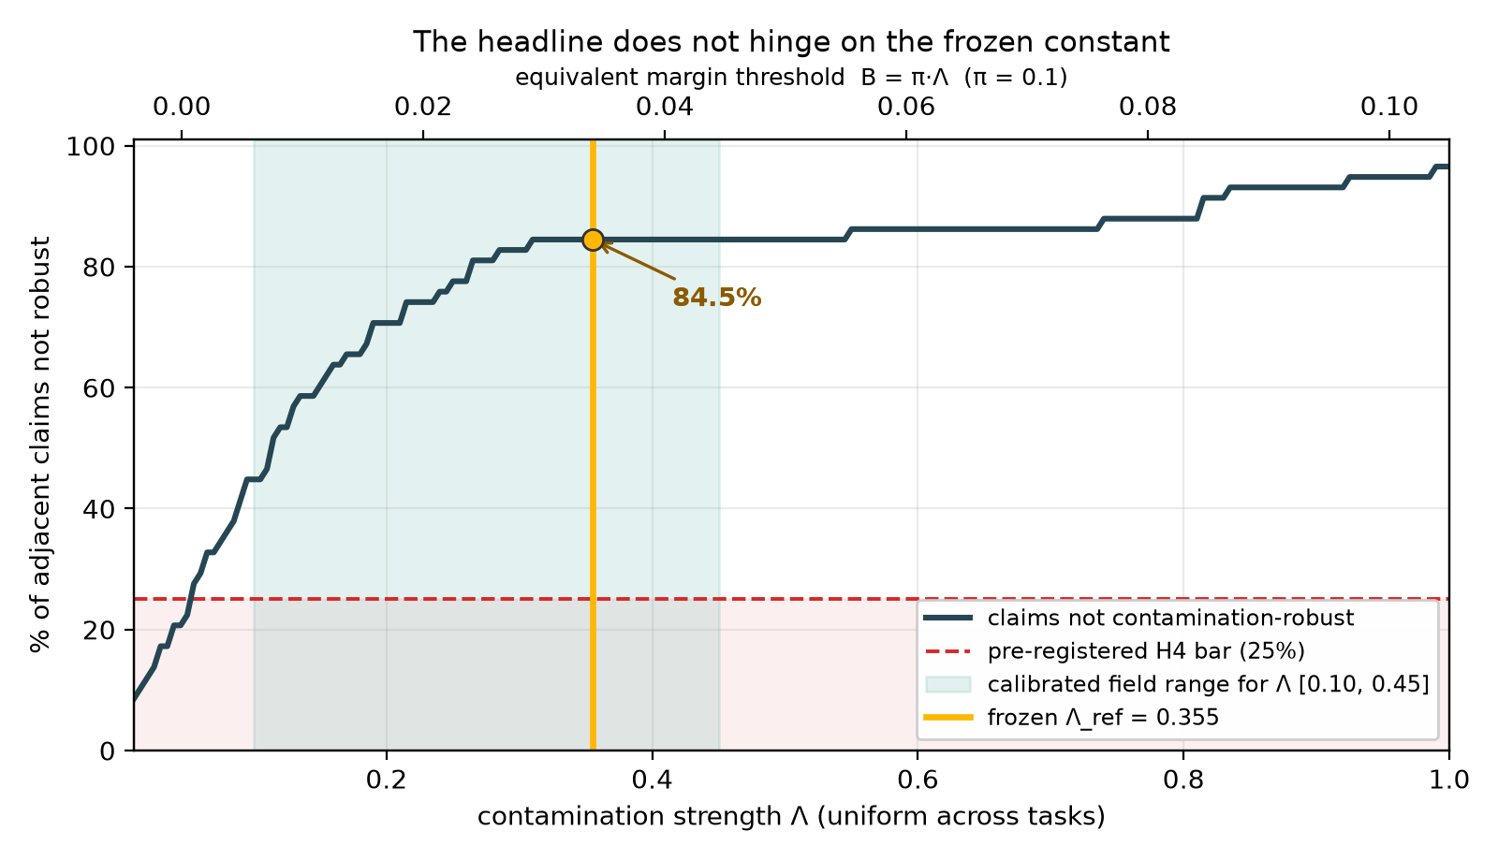
Figure 4: The headline does not hinge on the frozen constant. Because the decision rule depends on (π, Λ) only through B = π·Λ, the whole plane collapses to one curve. H4 clears its pre-registered 25% bar for every Λ ≥ 0.055, below the floor of the calibrated field range (shaded).

9.3 Is the headline an artifact of auditing adjacent pairs?
Adjacent pairs are selected to have the smallest margins in a ranking, so the objection writes itself: 84.5% may be induced by the claim-selection rule rather than by contamination sensitivity. We take the objection seriously enough to measure it. Applying the identical frozen rule to all 450 model pairs across the four tasks (the full comparison set, no selection) gives 30.4% non-robust. Stratifying by rank gap:
rank gap | non-robust | median margin
1 (adjacent) | 49/58 = 84.5% | 0.011
2 | 39/54 = 72.2% | 0.023
3 | 28/50 = 56.0% | 0.033
4 | 16/46 = 34.8% | 0.046
5 | 5/42 = 11.9% | 0.054
≥ 6 | 0/102 = 0.0% | ≥ 0.068

The objection is correct that adjacency selects small margins — and the gradient it produces is the cleanest quantitative statement of our thesis that the paper contains. Robustness is not uniformly absent: it is a monotone function of how far apart two models sit. Comparisons across five or more rank positions are essentially all robust (2.1% non-robust at gap ≥ 5); comparisons between neighbours are essentially all fragile. That is precisely "the ordering of eras is contamination-robust, the ordering of neighbours is not," now with a dose-response curve behind it.
We therefore report both numbers, and are explicit about which claim each supports. The 30.4% all-pairs figure is the answer to "how often does contamination sensitivity matter across arbitrary model comparisons." The 84.5% adjacent figure is the answer to the question a leaderboard actually poses, because a leaderboard is an ordering: it invites the reader to compare entry k with entry k+1, and those are the comparisons that do not survive. Neither number is the headline alone; the gradient is.
What would change our mind. The finding is falsifiable on three fronts, pre-specified in the registration. (i) If contamination-induced lift in the wild were measured at Λ < 0.055 for these benchmarks, H4 would fail; that is a single well-designed injection study away, and we would report it. (ii) If the A1 bounded-headroom envelope were rejected at calibrated Λ, the audit would be re-run under the full-memorization channel and both reported. (iii) If per-item records for these leaderboards proved systematically unusable, the corpus falls back to continuous-score data and the substitution is disclosed. None of these is a hypothetical hedge; each is a study someone could run against us.

10. Design sensitivity: what buys robustness
Two quantified prescriptions for benchmark builders. Freshness: at a 3-point margin, raising the post-cutoff item fraction from 0 to 90% lifts Γ* from 0.168 to 0.453, from fragile-everywhere to robust across the calibrated range. Dating your items is not hygiene; it is identification. Repeated draws: at m = 20 draws the sharp bound certifies Γ* = 0.172 versus 0.154 for the simple bound (~12% more certified robustness), and below m = 10 the sharp bound is unreliable (§6). Publishing ≥ 10 draws per item is what entitles a benchmark to sharp identification.

11. Limitations and threats to validity
(1) A1's channel shape is validated with real memorization at small scale, LLM scale, and now under corpus dilution (§7); the remaining gap is scale itself: our largest injection model is 1.5B parameters and the dilution sweep covers one model, one π, and a single seed per configuration (session-reproduction noise is measured at ≤ 0.039 on Λ̂_q95, well below the effects reported, but a multi-seed replication would still tighten it). The dose-1 dilution result lands inside the field range; whether that interpolation holds at 70B-scale pretraining is an extrapolation we flag, not a measurement we own. (2) In the single-draw binary regime (most current leaderboards), (Λ, π) enter only through their product; the 2-D frontier earns its second dimension only under repeated draws or provenance strata; we say so plainly, and §10 is the constructive answer. (3) Λ calibration from pre/post-cutoff comparisons can be confounded by temporal drift; the pre-registration pairs items on difficulty and reports calibration uncertainty. (4) Both case studies are exploratory; the headline audit is governed by a pre-registration frozen before any confirmatory Γ* is computed. (5) ε-spillover should vanish at LLM corpus scale but is measured, not assumed. (6) This artifact was audited by its own author (four forensic iterations, including a critical binary-regime guard); an independent adversarial audit is the correct next scrutiny.
Formal statements and proofs of Propositions 1–3, Theorem 4, and the supporting lemmas (R2 degeneracy, finite-draw bias directions, Imbens–Manski properties, spillover extension) are in Appendix A (`appendix_proofs.md`), each pinned to a named unit test.

12. Conclusion
The question "is this benchmark contaminated?" has no answer for a closed-weight model, and forty years of causal inference say the right response is to change the question. This paper asked "how much contamination would it take to overturn this claim?" and built the full chain needed to answer it: a sensitivity model whose axioms were tested against real memorization and twice repaired when they failed, sharp bounds with estimation theory, a calibration of contamination strength that the corpus-dilution experiment now reproduces in the laboratory for the scraped-pretraining case, and a pre-registered audit whose every constant was frozen and timestamped before unblinding.
The empirical picture is specific. Robustness on the Open LLM Leaderboard is a monotone function of rank distance: comparisons across five or more positions essentially all survive, while 84.5% of neighbouring claims do not. A leaderboard is trustworthy about which era of models beats which, and untrustworthy about the pairwise comparisons its ranking format actively invites. The remedy costs one column: report Γ* next to every margin, and let readers see which claims would survive the contamination everyone already suspects. Benchmarks that want more than the simple bound can earn it with published repeated draws and dated items; §10 prices both.

13. Reproducibility statement
Code, data artifacts, and this manuscript are public at https://github.com/tanviranjumjoarder/contamsens (MIT). Seed 42 throughout; exact-version lock (requirements.txt); 57 unit tests including constructive sharpness attainment; python reproduce.py regenerates every fast number in under two minutes (--full adds the twin-training grid, ~30 min, CPU); every reported number maps to its generating script in PROVENANCE.md; the package installs via pip install -e . (v0.2.0).
The confirmatory analysis (§9.1) was pre-registered at https://osf.io/2436z (DOI 10.17605/OSF.IO/2436Z, 20 July 2026), with the analysis library and calibration constants frozen beforehand at git tag prereg-freeze-v1.0 (commit ca7773b, publicly resolvable in the repository above, so the freeze is independently checkable rather than asserted). PREREGISTRATION.md, THEORY.md, and results/lambda_priors.csv in the repository are byte-identical to that tag and to the copies attached to the registration; deviations and post-freeze changes are enumerated in the chain-of-custody addendum filed with it, not silently absorbed.

Appendix A — Proofs
Companion to `manuscript.md`; every result is implemented in `src/contamsens` and pinned by a unit test named in brackets.

A.1 Setup and notation
Items i = 1,…,n. For a fixed model, observed scores y = (y₁,…,y_n) ∈ [0,1]ⁿ, clean (counterfactual) scores y* ∈ [0,1]ⁿ, latent contamination c ∈ {0,1}ⁿ. Estimand θ = n⁻¹Σᵢ y*ᵢ; observed mean μ̂ = n⁻¹Σᵢ yᵢ.
CSM(Λ, π) (Λ, π ∈ [0,1]): (A1) 0 ≤ yᵢ − y*ᵢ ≤ cᵢ Λ (1 − y*ᵢ) for all i; (A2) n⁻¹Σᵢ cᵢ ≤ π.
Define, for Λ < 1, the floor ℓᵢ(Λ) = max{0, (yᵢ − Λ)/(1 − Λ)} and the deflation capacity dᵢ(Λ) = yᵢ − ℓᵢ(Λ); for Λ = 1, ℓᵢ = 0, dᵢ = yᵢ. Write k = ⌈πn⌉ ∧ n and let d₍₁₎ ≥ … ≥ d₍ₙ₎ be the sorted capacities.
Lemma A.0 (capacity form). For Λ ∈ (0,1), dᵢ(Λ) = yᵢ if yᵢ ≤ Λ, and dᵢ(Λ) = Λ(1−yᵢ)/(1−Λ) if yᵢ > Λ. Moreover dᵢ(Λ) = min{ yᵢ, Λ(1−yᵢ)/(1−Λ) }, hence dᵢ is the minimum of two affine functions of yᵢ and is concave in yᵢ; it is continuous, maximized at yᵢ = Λ with value Λ, and nondecreasing in Λ. Proof. Solving (A1) for y*ᵢ with cᵢ = 1: yᵢ ≤ Λ + (1−Λ)y*ᵢ ⟺ y*ᵢ ≥ (yᵢ−Λ)/(1−Λ); intersect with y*ᵢ ≥ 0. The min form follows by checking which branch binds at yᵢ ⋚ Λ; the derivative of the right branch in Λ is (1−yᵢ)/(1−Λ)² ≥ 0. ∎ [test_deflation_hand_computed, test_deflation_peak_at_lambda]

A.2 Proposition 1 (sharp identified set)
Statement. Under CSM(Λ, π), the identified set for θ given y is exactly the interval Θ(y) = [ μ̂ − B(Λ, π), μ̂ ], where B(Λ, π) = n⁻¹ Σ_{j=1}^{k} d₍ⱼ₎(Λ).
Proof. (⊆) For any feasible (c, y*), θ = μ̂ − n⁻¹Σ_{i: cᵢ=1}(yᵢ−y*ᵢ). Each term obeys 0 ≤ yᵢ − y*ᵢ ≤ dᵢ(Λ) (Lemma A.0), and at most k indices have cᵢ = 1; the sum of any ≤ k capacities is at most the sum of the k largest. Hence θ ∈ [μ̂ − B, μ̂]. (⊇, sharpness) The upper endpoint is attained by c ≡ 0, y* = y. The lower endpoint is attained by setting cᵢ = 1 exactly on an argmax set S of k capacities and y*ᵢ = ℓᵢ(Λ) for i ∈ S, y*ᵢ = yᵢ otherwise; feasibility of (A1) holds by construction of ℓᵢ (the constructed lift equals the cap). Intermediate values are attained by scaling y*ᵢ continuously between ℓᵢ and yᵢ on S (θ is continuous in that scaling), so Θ(y) is the full interval. ∎ [test_sharpness_attained, test_interval_contains_mu_and_is_ordered]
Corollary 1 (distribution-free width). B(Λ, π) ≤ πΛ + Λ/n, with n⁻¹ k max_i dᵢ ≤ (π + 1/n)Λ by Lemma A.0's maximum; in particular the identified-set width is at most πΛ up to the ⌈·⌉ rounding term, and the bound is achieved when k items sit at yᵢ = Λ. [test_simple_bound_dominates_sharp]
Corollary 2 (reductions). B(0, π) = B(Λ, 0) = 0, so Θ collapses to {μ̂}: sampling-only analyses (e.g. rank intervals) are the Λ = 0 special case. [test_reduction_at_zero]
Lemma A.1 (R2 degeneracy). If yᵢ ∈ {0,1} for all i and Λ < 1, then dᵢ(Λ) = 0 for all i, hence B(Λ, π) = 0, while B(1, π) = n⁻¹Σ_{j≤k} y₍ⱼ₎: B(·, π) is identically zero on [0,1) with a jump at Λ = 1. Consequently the per-item machinery is vacuous on single-draw binary data and the population simple bound (width πΛ at the probability level) must be used. Proof. d(0) = 0 (left branch), d(1) = 1·(1−1)/(1−Λ) = 0 (right branch); at Λ = 1, d = y. ∎ [test_sharp_bound_degenerates_on_binary, test_ceiling_effect]

A.3 Proposition 2 (claim robustness) and Γ*
Statement (two-sided form). For models A, B on shared items with margin Δ̂ = μ̂_A − μ̂_B > 0, under CSM±(Λ, ρΛ, π) applied to both models the claim "A ≻ B holds for the clean scores" is TRUE over the entire identified set iff Δ̂ > B_A(Λ, π) + U_B(ρΛ, π), where U is the inflation analogue of B built from uᵢ(Λ⁻) = min{1 − yᵢ, yᵢΛ⁻/(1−Λ⁻)}.
Proof. θ_A ≥ μ̂_A − B_A and θ_B ≤ μ̂_B + U_B, with both endpoints attained (Prop. 1 and its mirror image applied to −y); the extremal joint configuration is feasible because A's and B's contamination assignments are unconstrained across models. Hence min(θ_A − θ_B) = Δ̂ − B_A − U_B. ∎ [test_gamma_star_bisection_consistency, test_is_robust_rho_consistent_with_gamma_star]
Definition (Γ*). Γ*(π) = inf{Λ ∈ [0,1] : B_A(Λ,π) + U_B(ρΛ,π) ≥ Δ̂}, with Γ* = ∞ if no such Λ exists. Well-defined by continuity and monotonicity of both maps in Λ (Lemma A.0 and its mirror). In the simple regime the closed form is Γ* = Δ̂ / (π(1+ρ)). [test_gamma_star_simple_closed_form, test_gamma_star_twosided_is_smaller]

A.4 Proposition 3 (selection-bounded bridge)
Statement. Let contamination be random with propensities qᵢ = P(cᵢ=1) subject to (i) n⁻¹Σqᵢ = π and (ii) odds(qᵢ)/odds(qⱼ) ≤ Γ²_sel for all i,j. Then the worst-case expected bias B(Λ, π, Γ_sel) = max_q n⁻¹Σᵢ qᵢ dᵢ(Λ) satisfies: (a) it is attained by a two-point propensity vector taking values {q_lo, q_hi} with odds(q_hi) = Γ²_sel·odds(q_lo), the high value assigned to the t largest capacities for some t; (b) B(Λ, π, 1) = π d̄ (random contamination) and B(Λ, π, ∞) = the Proposition-1 top-k bound; (c) B is nondecreasing and continuous in Γ_sel.
Proof. (a) The objective is linear in q over the polytope defined by (i)–(ii); extreme points of that polytope have coordinates taking at most two distinct values with the odds constraint active between them (any three distinct values admit a feasible transfer increasing the objective: move mass toward larger dᵢ). Given the two values, assigning q_hi to the largest capacities is optimal by rearrangement. (b) At Γ_sel = 1 the only feasible q is constant = π. As Γ_sel → ∞, q_hi → 1 on t = k items and q_lo → 0 elsewhere is feasible in the limit, recovering the deterministic knapsack. (c) Enlarging Γ_sel enlarges the feasible set; continuity follows from continuity of the extreme-point solution in Γ_sel. ∎ [test_random_endpoint, test_adversarial_endpoint, test_monotone_in_gamma_sel_and_bracketed]

A.5 Theorem 4 (consistency and rate of Γ̂*)
Statement. Let items be iid with per-item scores having distribution F (continuous case, regime R1), and let d(·;Λ) be as in Lemma A.0. Define B(Λ) = E[d 1{d ≥ q_{1−π}(d)}]/1 + boundary term (the trimmed upper mean at level π) and assume F_d is continuous with positive density at its (1−π)-quantile for the relevant Λ, that Δ = μ_A − μ_B > 0, and that B(Γ*) = Δ with B strictly increasing at Γ* ∈ (0,1). Then (i) Γ̂* → Γ* a.s.; (ii) √n(Γ̂* − Γ*) ⇒ N(0, σ²) with σ² = Var-functional of (Δ̂, B̂) via the delta method with slope 1/B′(Γ*); (iii) the paired nonparametric item bootstrap consistently estimates the law in (ii).
Proof sketch. B̂(Λ) is a trimmed L-statistic with bounded, monotone weight generator; under the quantile-density condition it is strongly consistent and Hadamard differentiable at F tangentially to the uniform ball (van der Vaart & Wellner, Lemma 22.10-type arguments), giving a √n-CLT jointly with Δ̂ (a sample mean on the same items — the pairing supplies the joint law). Pointwise a.s. convergence of the nondecreasing functions B̂(·) to the continuous limit B(·) upgrades to uniform convergence on [0,1] by Pólya's argument. The map (B, Δ) ↦ B⁻¹(Δ) is differentiable at (B, Δ) with B′(Γ*) > 0; the functional delta method yields (ii), and Hadamard differentiability + Efron bootstrap consistency for L-statistics yields (iii). ∎ Empirical verification: RMSE slope −0.518 vs theoretical −0.5 over n ∈ [100, 25600], bias ≤ 0.0025 (p1_t2_consistency.csv, fig. f10).

A.6 Lemma A.2 (finite-draw bias directions, E9)
With m Bernoulli draws per item, p̂ᵢ ~ m⁻¹Bin(m, pᵢ): (i) by Lemma A.0's concavity and Jensen, E[d(p̂ᵢ)] ≤ d(pᵢ) pointwise (smoothing bias down); (ii) the top-k selection over noisy capacities satisfies E[max-k mean of d(p̂)] ≥ max-k mean of E[d(p̂)] (selection bias up). The net sign is regime-dependent; measured: −40% (m = 2) to +4% (m = 10) to <1% (m = 50), motivating the m ≥ 10 prescription and the simple-bound fallback, which depends on p̂ only through the unbiased grand mean. [p1_t3_finite_draws.csv; fig. f11]

A.7 Lemma A.3 (Imbens–Manski critical value)
The equation Φ(c + w) − Φ(−c) = 1 − α has a unique root c(w) ∈ [z_{1−α}, z_{1−α/2}] for every w ≥ 0; c is continuous and nonincreasing in w with c(0) = z_{1−α/2} and c(∞) = z_{1−α}. Proof. The left side is strictly increasing in c and increasing in w; evaluate at the bracket endpoints. ∎ Hence the parameter-level interval [θ̂_lo − c·σ̂_lo, θ̂_hi + c·σ̂_hi] has asymptotic coverage ≥ 1 − α for every θ in the identified set, with equality at the endpoints (Imbens & Manski, 2004, Thm 1 conditions: endpoint estimators jointly asymptotically normal — supplied here by Theorem 4's machinery — and identified-set width consistently estimated). [test_im_critical_value_limits, test_im_worst_case_parameter_coverage]

A.8 Spillover-robust interval (U4)
If additionally |n⁻¹Σ_{i:cᵢ=0}(yᵢ − y*ᵢ)| ≤ ε (bounded net drift on clean items), every bound above extends by widening both endpoints by ε; the proof of Prop. 1 goes through with the decomposition θ = μ̂ − (contaminated deflation) − (clean-item drift). ε is estimable from twin experiments (measured 0.003–0.30, growing with dose). [test_twosided_upper_moves_only_with_lam_minus; p2b_spillover_fix.csv]

References
Generated by `scripts/make_bibliography.py`; every arXiv entry was fetched live from the arXiv API. BibTeX: `paper/references.bib`.
- Tom B. Brown et al. (2020). Language Models are Few-Shot Learners. arXiv:2005.14165. [brown2020gpt3]
- Victor Chernozhukov et al. (2021). Long Story Short: Omitted Variable Bias in Causal Machine Learning. arXiv:2112.13398. [chernozhukov2021ovb]
- Inbal Magar and Roy Schwartz (2022). Data Contamination: From Memorization to Exploitation. arXiv:2203.08242. [magar2022contamination]
- Hugo Touvron et al. (2023). LLaMA: Open and Efficient Foundation Language Models. arXiv:2302.13971. [touvron2023llama]
- Yucheng Li et al. (2023). An Open Source Data Contamination Report for Large Language Models. arXiv:2310.17589. [li2023contamreport]
- Aaron Grattafiori et al. (2024). The Llama 3 Herd of Models. arXiv:2407.21783. [grattafiori2024llama3]
- Cheng Xu et al. (2024). Benchmark Data Contamination of Large Language Models: A Survey. arXiv:2406.04244. [xu2024survey]
- Felipe Maia Polo et al. (2024). tinyBenchmarks: evaluating LLMs with fewer examples. arXiv:2402.14992. [polo2024tinybenchmarks]
- Jasper Dekoninck et al. (2024). ConStat: Performance-Based Contamination Detection in Large Language Models. arXiv:2405.16281. [dekoninck2024constat]
- Mathieu Ravaut et al. (2024). A Comprehensive Survey of Contamination Detection Methods in Large Language Models. arXiv:2404.00699. [ravaut2024survey]
- Norah Alzahrani et al. (2024). When Benchmarks are Targets: Revealing the Sensitivity of Large Language Model Leaderboards. arXiv:2402.01781. [alzahrani2024benchmarks]
- Siyu Heng et al. (2024). Towards Robust Matched Observational Studies with General Treatment Types: Consistency, Efficiency, and Adaptivity. arXiv:2403.14152. [heng2024robust]
- Yujuan Fu et al. (2024). Does Data Contamination Detection Work (Well) for LLMs? A Survey and Evaluation on Detection Assumptions. arXiv:2410.18966. [fu2024doescontam]
- Andrew M. Bean et al. (2025). Measuring what Matters: Construct Validity in Large Language Model Benchmarks. arXiv:2511.04703. [bean2025construct]
- Denis Federiakin (2025). Improving LLM Leaderboards with Psychometrical Methodology. arXiv:2501.17200. [federiakin2025psychometric]
- Hyeong Kyu Choi et al. (2025). How Contaminated Is Your Benchmark? Quantifying Dataset Leakage in Large Language Models with Kernel Divergence. arXiv:2502.00678. [choi2025kds]
- Marcel Meyer et al. (2025). Rethinking Evaluation in the Era of Time Series Foundation Models: (Un)known Information Leakage Challenges. arXiv:2510.13654. [meyer2025tsfm]
- Takashi Ishida et al. (2025). CapBencher: Give Your LLM Benchmark a Built-in Alarm for Test-Set Overfitting. arXiv:2505.18102. [ishida2025capbencher]
- Timo Freiesleben and Sebastian Zezulka (2025). The Benchmarking Epistemology: Construct Validity for Evaluating Machine Learning Models. arXiv:2510.23191. [freiesleben2025epistemology]
- Bitya Neuhof and Yuval Benjamini (2026). Rank Intervals for Leaderboards: A Hierarchical Framework for Model Evaluation. arXiv:2606.08679. [neuhof2026rankintervals]
- Han Jiang et al. (2026). AI Evaluation Should Require Standardized Item-Level Data Releases. arXiv:2604.03244. [jiang2026itemlevel]
- Hongkai Li et al. (2026). TSFMAudit: Data Contamination Auditing in Forecasting Time Series Foundation Models. arXiv:2605.26161. [li2026tsfmaudit]
- Hosna Oyarhoseini et al. (2026). A Unified Perturbation Framework for Analyzing Leaderboard Stability and Manipulation. arXiv:2605.15761. [oyarhoseini2026perturbation]
- Jianzhe Chai et al. (2026). When Benchmarks Leak: Inference-Time Decontamination for LLMs. arXiv:2601.19334. [chai2026inferencetime]
- Md. Niamul Islam Sium (2026). Quantifying Robustness to Unmeasured Confounding in Time-Varying Treatment Confounder Settings: An Extension of E-value Approach. arXiv:2602.24261. [sium2026timevarying]
- Muhammed Yusuf Kocyigit and Caglar Yildirim (2026). The Impact of Post-training on Data Contamination. arXiv:2601.06103. [kocyigit2026posttraining]
- Polina Gordienko et al. (2026). How Hard is it to Rig a Benchmark? A Social Choice Analysis of Leaderboard Robustness. arXiv:2605.23628. [gordienko2026socialchoice]
- Rylan Schaeffer et al. (2026). Quantifying the Effect of Test Set Contamination on Generative Evaluations. arXiv:2601.04301. [schaeffer2026quantifying]
Classical statistics references (transcribed; verify against the publisher record before submission):
- Rosenbaum, P. R. (1987). Sensitivity analysis for certain permutation inferences in matched observational studies. Biometrika 74(1), 13–26. [rosenbaum1987sensitivity]
- Tan, Z. (2006). A distributional approach for causal inference using propensity scores. JASA 101(476), 1619–1637. [tan2006distributional]
- VanderWeele, T. J. and Ding, P. (2017). Sensitivity analysis in observational research: introducing the E-value. Annals of Internal Medicine 167(4), 268–274. [vanderweele2017evalue]
- Imbens, G. W. and Manski, C. F. (2004). Confidence intervals for partially identified parameters. Econometrica 72(6), 1845–1857. [imbens2004confidence]
- Benjamini, Y. and Hochberg, Y. (1995). Controlling the false discovery rate. JRSS-B 57(1), 289–300. [benjamini1995controlling]
- Benjamini, Y. and Yekutieli, D. (2001). The control of the false discovery rate in multiple testing under dependency. Annals of Statistics 29(4), 1165–1188. [benjamini2001control]

