In order run the internet and to make the computer networking more user friendly and secure we use different network services and there are a lot of net work services. and they are directly connected with the network business .

DNS

Computer speak to each other with numbers .Computer only understand the binary .Reading binary number can be easy for the computer but they are not easy for human. for example ip address is a 32 bit binary number but we represent it with dotted decimal number for us to understand. But remembering ip address for every address is really not a good idea. because you may visit thousands of different website and to do that you need to know all of their ip address. And for some reason these ip address can be changed . And human are not very good at remembering numbers .but we can assign different name for different address and thats where DNS come .DNS stands for the domain name system.

DNS is a a global and highly distributed network services that resolves string of letters into ip address . It may sound quite simple .that a server take an string name and return the corresponding ip address. But to make sure the internet is working properly there is a lot of rules and process should be followed . if you want to search for some thing it is much easier to type www.google.com instead of their ip address. The name is call the domain name .domain name is a term that we use for something that can be resolved by the DNS.ip addres can change for different reason . But if the domain name is resolved the new address the end user dont eve know this thing other wise you have to keep tracking of the new ip address It gives the system administrator does changes in the server without any notice.

Another important thing is the more hop is going to cross to get the information the slower the process become .so if you are from india and try to reach www.google.com it will redirect you to the the nearest google server with the same domain name.because a singe domain name can have multiple ip address and can be run through multiple data center.dns helps to make the choice to select a ip address based on the geographical location . The process of resolving the ip address using the name is called the name resolution.

DNS server needs to configure at a node on a sepecfic number. To simplify the process just remember four things must be configured for a host to operate on a network

1) ip address
2) Subnet mask
3) Gateway
4) DNS server

you can work without configuring the dns sever.but it will be difficult for you to use it

there are five primary type DNS servers

1) Caching name server
2) Recursive name servers
3) Root name servers
4) TLD(Top level Domain) name servers
5) Authoritative name servers

any dns servers can do multiple task at the same time. Caching and recursive DNS server can be provided by the Local ISP (Internet service provider)

Recursive name server :
recursive name server are those server who send the full DNS resolution request in a simple word it send the request to find the ip address of that domain name to other server

Caching name server: once the Recursive name server finds the ip address of the domain name .the caching server remember the ip address for that dns . So if any one on that network or you ask for the domain this server does not have to do a domain resolution again .most of the ISP server does both at the same time.but they can operate separately

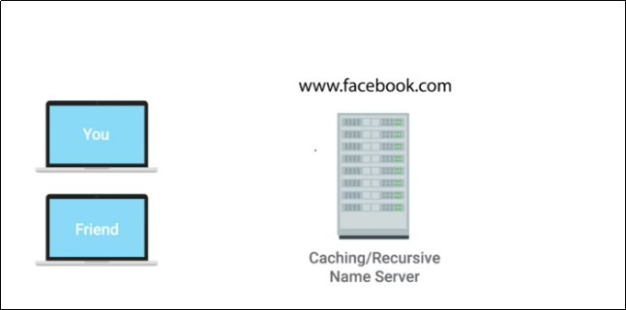
for example suppose you and your friend are on the same network. And a caching and recursive DNS server is configured .so when your friend try to access the www.facebook.com the recursive server will send a domain resolution request and after it getting the information it will send it to you and the caching server will store the information ,so next time when you try to visit the site the server does not have to send the request.

All domain in the global domain name have a TTL.TTL stands for Time To Live .this is a value in seconds . This value can be configured by the owner of a domain name for how long a name server is allowed to cache an entry before it should discard it and perform a full resolution again.in past it was very long but now a days this TTL has dropped to a few hours.

Until this point we know the recursive server send the DNS resolution request .lets find out what happen next

the Recursive name server contact the Root Name server .there are 13 total Root main server in the world and they are responsible for directing queries to TLD name server.

The Root server will reply lookup with a TLD name server.TLD stands for top lavel domain . A TLD is the last part of any domain name.like .com or .net or .edu Basically the Root server told the recursive server the lcoation of the TLD server that has that TLD. For each TLD there is a TLD name server.then the TLD server respond with a redirect .this time it send the Authoritive server to look up .

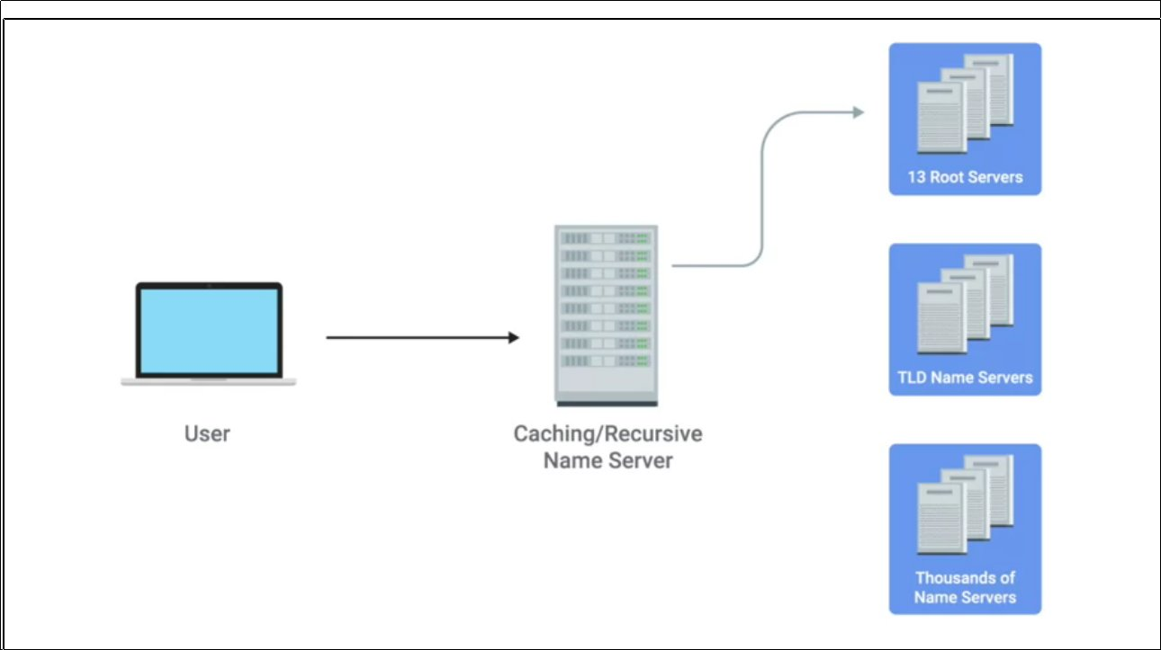

Authoritative name server is responsible for the last two part of any domain name .which may be a DNS server for a organization responsible for look up. this server may be run by the organization .then the ip address from the authoritative server will be redirect to the recursive server and then the caching server save this information for a certain amount of time .this strict hierarchy is very important to get the correct ip address. Other wise malicious party can redirect traffic to do harmful things

DNS used UDP instead of the TCP for commication you may wonder why .thats because TCP is a connection oriented protocol thats why it send a lot of packets communicating than UDP Especially for creating connection it use three way handshake and for terminating connection it need four way handshake.so in UDP make less traffic for dns resolution

here are the difference

DNS RUNNING ON TCP:

1)User create connection with recursive server with three way handshake. Thats 3 packets

2) after the connection is established the host send the actual request for domain resolution thats 1 more packet then the recursive server send the host another ACK .so that's another packet.

3) now the recursive name server try to connect to the Root name server
thats take

3 way hand shake for opening+Actual request+ACK for request+response +Ack of the response + 4 way hand shake = 11 packets

4) now the recursive server has the TLD .then it needs another 11 packets to the TLD the server.

5) after getting the authoritative name server it will take another 11 packets to find

6) now the local recursive name server knows the ip address then It respond to the initial request thats 1 packet.then the host send a ACK thats another packets

7)Then the connection close with a 4 way handshake thats 4 packets

if we callculate it will be

3(cs)+1(re)+1(rep)+11(root)+11(tld)+11(auth)+1( ini rep)+1(reply of the reply)+4(end) = 44 packets

so it needs 44 total packets for a TCP connection to query a dns resolution

DNS RUNNING ON UDP:

1) host computer send 1 packet to recursive server
2) recursive server send the request to Root server thats 1 packet
3) Root server send the TLD server to recursive server thats 1 packet
4) then another 2 packets for TLD server
5) another 2 packets for the Authoritative server
6) then recursive server send the ip to the computer thats 1 packet

1+2+2+2+1 = 8 packets

UPD does not have any mechanism for reply.if the connection lost then it just send another request. Because UDP does not have error recovery.

Resources Record Type:

DNS have a set of resources record type

1)A Record : An A record is used to point a certain domain name at a certain IPv4 IP address.A single A record is listed for a single domain name.but a single domain name can have multiple A records.

The multiple ip is managed by a process called “Round Robin”.using this process it makes afairly equal balance in each entry of the list

suppose you have a address like www.example.com and it has 4 address

1)10.0.0.1
2)10.0.0.2
3)10.0.0.3
4)10.0.0.4

when there is a ip look up .all the 4 address will be replied with this pattern

1)10.0.0.1
2)10.0.0.2
3)10.0.0.3
4)10.0.0.4

the dns resolving computer will know that it should try to use the first one .but If one fails use the second one.
But when the second look up request,it gets the list of ip address like
1)10.0.0.2
2)10.0.0.3
3)10.0.0.4
4)10.0.0.1

the first one will be popped from the first and added in the last .this is called the Round Robin logic.

2) AAAA Record . In this record instead of ipv4 it takes ipv6 address

3) CNAME recod is used to redirect traffic to one domain to other.it is used to redirect the treaffic.suppose you use the example.com instead of www.example.com the CNAME record is used to redirect the traffic od the first to the second. Suppose you changed the ip of the www.example.com then the CNAME record will allow you to point to the new www.example.com without any configuration change.

4) MX Record : MX for mail exchange .its used for transporting mail

5)SRV record: service record.its like MX record.

6) TXT record: descriptive and configuration record

Domain Name

A domain name has three primary parts for example

www.google.com has three part

1) www
2) google
3) com

the last part “com” is a TLD (top level domain) there are different TLD like ,”.com”,”.net”,”.org” .today we have something called vanity domain like

www.pizzashop.pizza
www.example.musium

this kind of domian name is introduced because the traditional top level domain become crowded .All the domain name is controlled by an organization called ICANN (The Internet Corporation for Assigned Names and Numbers) this is a sister ogranization of IANA . Together they controll the ip address and the domain name distribution

The second part is the Domain like “google” in www.google.com

Domains are Controlled by the authoritive name server that are outside the ICANN. Independent company controll this

the “www” is the subdomain .with all the three parts you will get a FQDN or fully qualified domain name.you hav to pay money to purchase a domain but the subdomain is in your controll.the registra is a company who sell domain which is unregistered domain with the proper permission of the ICANN.you can have lot of subdomain .But there is a limit you can add

1) 127 subdomain maximum
2) Each individual Section can be 63 character long
3) and the complete FQDN is limited with 255 character

DNS ZONES

suppose you have large company called largecompany.com this company has office in three different place in the world
for example in los angels , mumbai,and china and they each have 200 member so total 600 people and each have the unique domain name configured .so there need to add 600 A records in a single zone . Insted we can use different dns zone like

for los angles ls.largecompany.com
got mumbai in.largecompany.com
and for china ch.largecompany.com

so that we need 4 different server 1 for the largecompany.com and the three other for three dns zones

this is controller by a zone files which is a simple configuration file that declare all resources records for a particular zone .this configuration file must have a SOA and resources record declaration .

SOA (Start of authority) contains the zone and the name server that is authoritative for it.

Reverse lookup zone files

this is something that DNS resolvers ask for an IP and get the FQDN associated with it. It holds the PTR Record it resolves an IP to a name

DHCP (Dynamic host configuration protocol)

every single computer in a network shoud have four things
1) ip address
2) Subnet Mask
3) gateway address
4) DNS server

in a specfic network the last three may be all the same except the ip address. The ip address have to be different in different node and setting up different ip address in a network of 100 pc can be very difficult for a network administrator .This is where the DHCP come. With the help of a DHCP server the node is a network can collect the avilave network configuration
it also helps to determine which ip address should use in which machine. For server and the gateway ip address must be a static ip address . Bu if we deal with the mobile devices and the client laptop or desktop allwe have to worry about is connecting them into network it does not matter the ip address

in a dhcp dynamic allocation a range of IP address is set aside for client devices and one of these ip is issued to these devices when they request one

in automatic allocation the dhcp server keeps track the ip address of the node .and try to assign them the same ip address they are previously given

in fixed allocation the dhcp server is configured with the specfic MAC with a specfic ip address . When the node with these MAC address they will get the specfic address and no other client can use it

DHCP is a application layer protocol . But the dhcp helps to configure the network layer itself.

The process of a client get a network level configuration is known as DHCP Discovery.

server Discovery: since at first the client dont know any of the ip address even the dhcp server too .it creates a special request .it send A udp datagram with a destination post 67 from a source port 68 . then it encapsulated inside a ip datagram with a source ip 0.0.0.0 and a destination port 255.255.255.255 . so this is a broadcast message. The dhcp server takes the request and search for if there is any reserved ip address for the client. Then the dhcp server send another broadcast message with its own ip address .and in this broadcast message it includes the MAC address so the specfic node can detect that it is intended for itself

DHCP Request : then the client send a dhcp request message since the client dont get any ip address yet it will again broadcast address

DHCP ACK : after getting the request The dhcp send a response which is called DHCP ACK . It also send a broadcast message including the MAC address.with the configuration. The dhcp give a lease for a certain of time.

NAT:

