INTRODUCTION TO NETWORK LAYER

we know that the MAC adddress is unique so every network card in the world has a unique number.so in a Local area network the switch can remember the MAC address and then just forwared the data in the preffered destination.but what about the whole wrold ? What happened if you want to send a messgage to a friend who is at the other side of the world.you dont know which network card he is using and even you know the MAC address is not given in any order and there is no way that you can identify the location of any node using the MAC address so you need another approach which is the IP address

IP ADDRESS

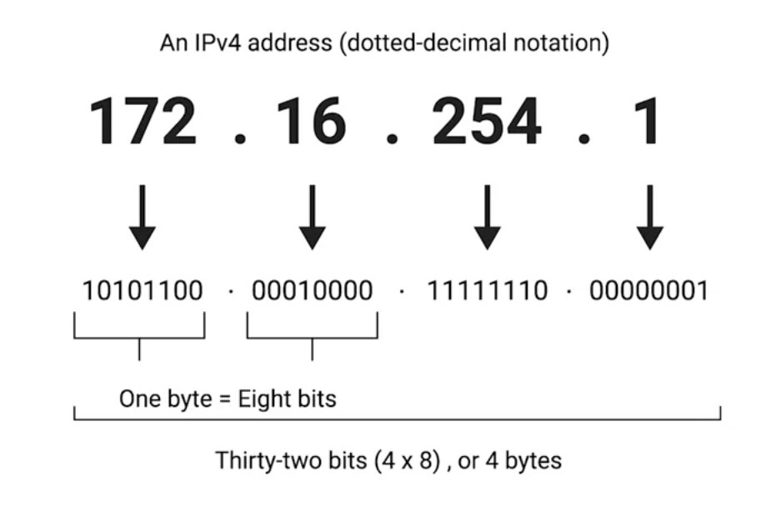

ip addrress are 32 bits octet.means 8 bit of data a single octet can represent decimal data from 0 to 255.ip address is distributed in large section in different organization. IP address is hierarchical .
One of the most important thing is IP address belongs to a networks no the devices that means if you change the network your ip address will change.but your mac address will not change.you may never set ip address in your laptop you just connect to your wireless network and start working ever wonder how your laptop got an ip address??.its because mordan networks used DHCP (dynamic host configuration protocol) so your laptop will automatically get an ip address and all other configuration to be a part of the network.but you cant do it on a server becayse server needs a static and permanent address .for server you have to give static address

IP Datagrams and Encapsulation

data packets in the ethernet layer known as the ethernet frames . And data packets in the network layer known as another name called ip datagram.the maximum size of the ip datagram is the largest number that you can represent with 16 bits which is 65535.

ip datagram is a highly structured series of fields that are strictly defined

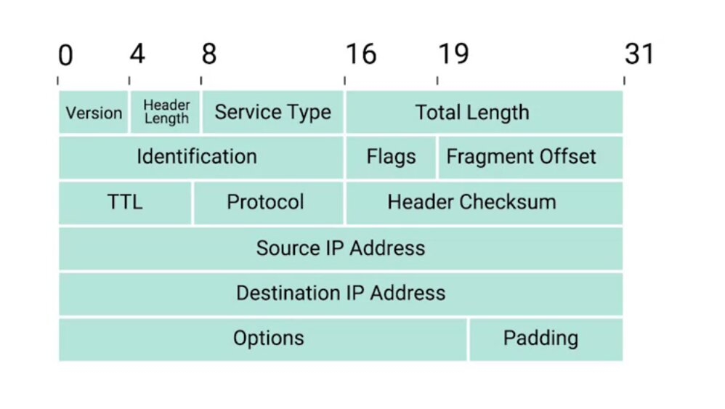
two primary section in the ip datagram is headers and payload

the first field is

1) version : uses 4 bits and it shows what version if internet protocol is used (ipv4 or ipv6)

2) header length: this is also a 4 bit field that shows the length of the total header length
[remember the minimum size of the header length is 20 bytes.it is impossible to store all the header information in less than 20 bytes ]

3)service type: this is a 8 bits of information and it stores the quality of operation

5) Total length: this is a 16 bit filed called the total length field.it indicate the total length of the ip datagram

6) identification field: identification field is a 16 bit number thats is used to group messages together.if for some reason the data you sending needs to send is larger than what can fit in a single datagram.the IP layer needs to split this data up to many individual packets.so then the receiving end it will know with the help of the identification number that these data packets are under the same transmission

7) flag fild: now when we talk about the fragmentation .there is a field that is called flag field that indicate if the data gram is allowed to be fragmented.or it shows if the datagram is already fragmented.

8) Fragmantation offset : supoose your network devices is configured with a specific fragmentation size and it enter another network devices that has smaller fragmentation size .then the datagram have to be fragmented into smaller datagram.so the fragmantation offset will combine them with correct order

9) TTL (Time To live) field:
An 8 bit field that indicates how many router I will traverse before its thrown away.it is very necessary to solve the forever loop.every time packet reach the router it TTL filed decrement by one so when it becomes 0 the data packet is thrown away it no longer routed to another router.

Suppose your router has a misconfiguration .so ti send the data to the router it coming from so it will create a loop data will be go back and forth and create problem in the network.so TTL prevents that.even there is a misconfiguration the data packet will be thrown away after the ttl is going to be 0

10)Protocol: Protocol is another 8 bit field that contains the data about what transport layer protocol is being used.the most common is TCP and UDP

11) Header Checksum : Header checksum field is another field that contains the checksum of the entire datagram header.it works like the ethernet frame checksum

12)Source IP address: its 32 bit long ip address that gives the source ip address

13)Destination Ip address: 32 bit destination ip address

14)IP options field: An optional field that is used to set special characteristics for data grams primarily used for testing purpose

15) padding: padding filed is a series of 0 to make sure that the data is the correct total size

[RELATION WITH THE IP DATAGRAM AND THE ETHERNET FRAME]

REMEMBER the payload section in the ethernet data frame is the ip datagram.This process is called encapsulation. The entire data of the ip datagram is encapsulated as a payload in the ethernet frame.
But remember the ip datagram also has a payload section

ip address can be split into two sections:

1) Network ID
2) Host ID

ADDRESS CLASS SYSTEM

address class system is a way of defining how the global IP address space is split up

threre are three primary class

→ class A
→ class B
→ class C

class A → first octet used for the network last three use for the host address

class B → first two octet used for the network and the last two octet is used for the host

class C → first three octet used for the network and the last one octet used for host

if the very first bit of an ip address is 0 it belongs to a class A ip address

if it is 10 then it belongs to class B network

if the it is 110 then it belongs to class C network

there are two other class

class D and class E

class D range is 224-239 and it is used for multicasting

and class E are reserved for testing purpose

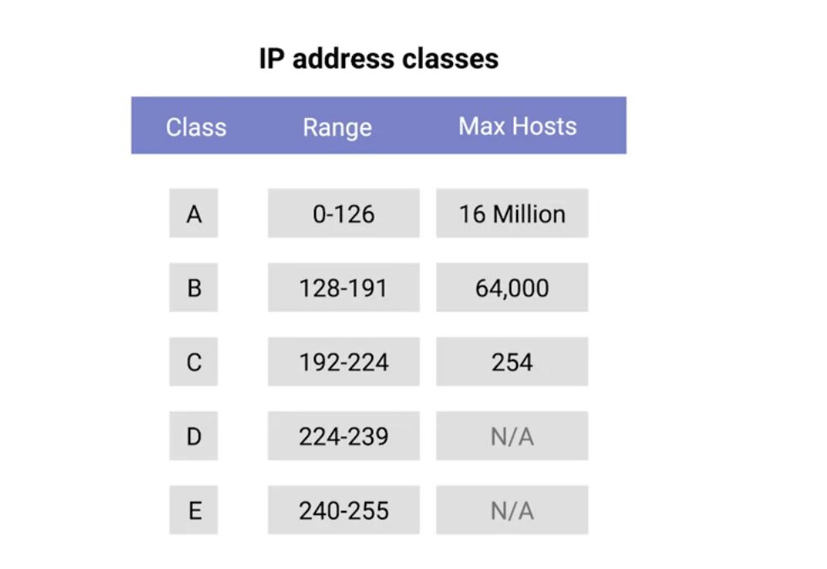

But in the Paractical life this system is actually replaced by a system classed CIDR

CIDR (Classless inter domain routing)

So now you know the ip address and the network layer and MAC address at the data link layer
now you can combine those with another prtotocol called ARP . Lets see how to find your destination using ARP

ARP

ARP is a protocol used to discover the hardware address of a node with a certain ip address

ARP starts for address resolution protocol already know that the IP datagram is encapsulated in the ethernet frame.so the transmitting device needs a MAC address to complete the trasmission.so how to find the mac address then??

ans :
using ARP table

ARP TABLE

a list of ip address and the MAC address associate with them

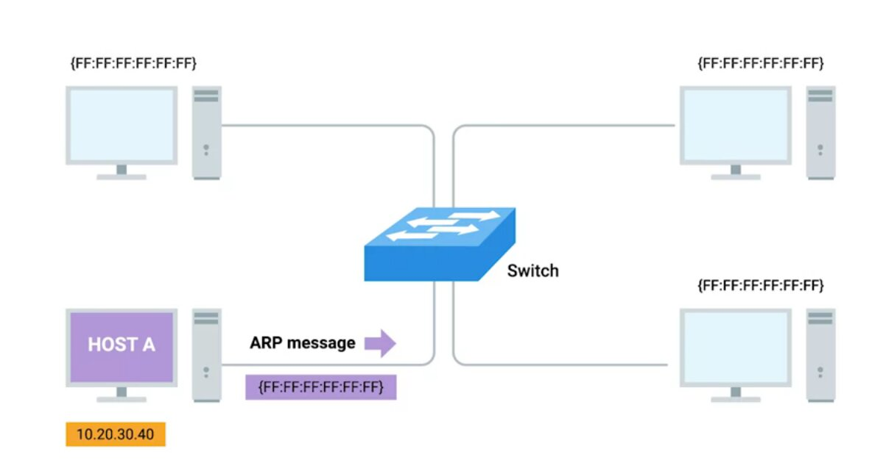

suppose the host A try to send an information to

10.20.30.40 thse things will happen

1) it will send a Broadcast message to the network
(its like announcing “is anyone in the network has ip 10.20.30.40”)

2)then the device with ip send a reply message called arp response and in the arp response it will give the MAC address

(like telling yes I am here and here is my MAC address)

3) then transmission device know the MAC of the destination ip

4) they also store the mac address in their local arp table so they dont have to broadcasr a arp request everytime.

[But remember Arp table enrty is not parmanent it expires after a short ammount of time.to ensure the change in the network]

SUBNETTING

The process of taking a large network and splitting it up into many individual and smaller subnet works is called subnetting

as you know them the address class system divide the total ip address in to groups.but you can see that the that a class A ip addres has almost 16 million user you can easily understand that you can never connect this ammount of user in a single router. So now we are going to divide them further and each of the segment have their own gateway router to communicate with each other .

SUBNET MASK

A ip address is a 32 bit number and some portion is used for the network and the rest is used for the host portion .when you are dividing the network even further some portion that are used for the host id may used for the network.and to to do this a new concept arrived which is subnet ID.subnet id is calculated by SUBNET MASK

WHAT IS SUBNET MASK?

Subnet mask is a 32 bit number that are normally written out as four octets in decimal
that separate the network id and the host id

lets see an example to see this clearly. Suppors an ip address is 9.100.100.100

you can easily remember that it is a class A ip address .and the first octet is used for the network id and the last three octets is used for the host id.

But what if I want to use the first three octets for network id and the last one for host id like a class C address.is it possible? Yes. you can do it with subnet mask

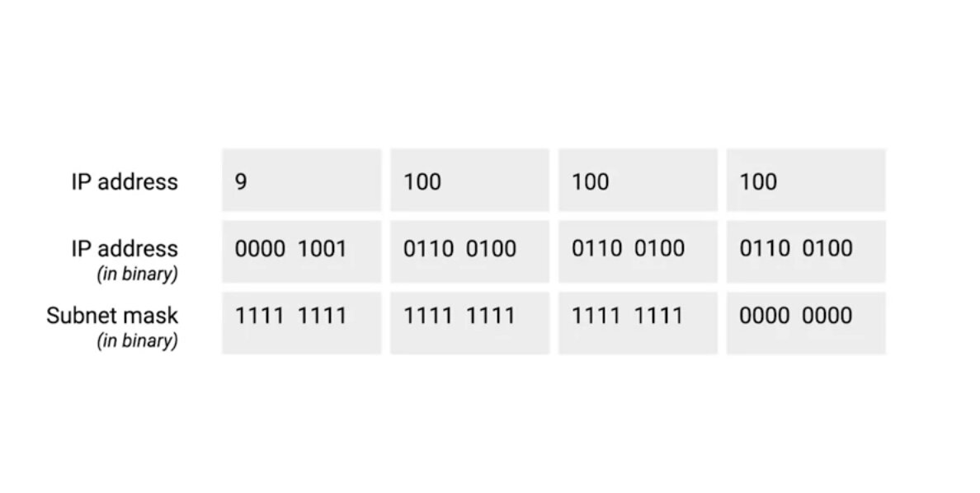
now if we use the subnet mask as 255.255.255.0
and we can see in the picture if we convert this on binary.we can see that the first three octet is filled with ones and the last is zero.the octet with one will be considered as a network id and the zeros will be considered as a host id.so by using subnet mask you can explicitly say which one will be network id and which one will be host id .so using this subnet mask we get the total 256 hosts.because asingle 8 bit number can represent 256 different numbers or numbers between 0-255.

but you can use only 254.because the first host id 0 is not used and the host id 255 is used for broadcasting .so just remember that the usable host is 2 less than the total number

now we see that the subnet mask that cover 8 bit in octets .Lets see another ip address that do not cover totally the 8 bits of octets

what will happen if I use 255.255.255.224 as a subnet mask

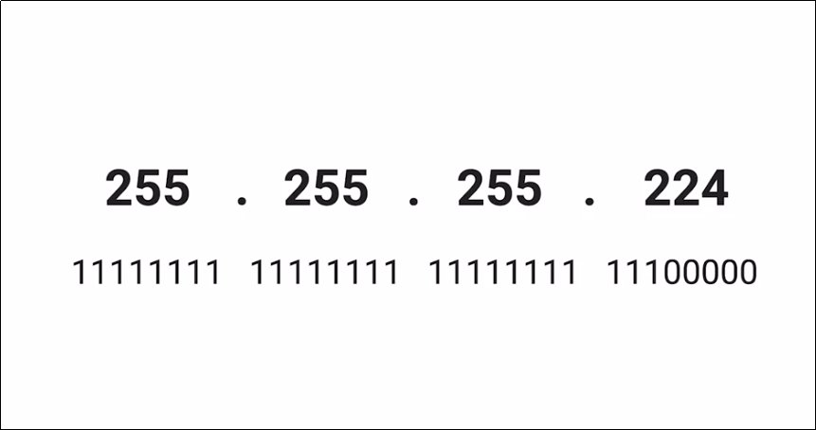
it takes 27 ones and 5 zeros.so if we suppose the ip address is 9.100.100.100 and the number of ones is 27 we call the ip address in a CIDR notations which is 9.100.100.100/27

how to determine the host and the network portion with bits like this

you have to do simple binary operation to extract the network and the host id,in fact the computer find the network id and the host id the exact same way

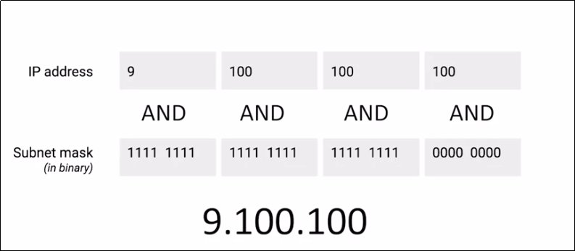
suppose your ip address is 9.100.100.100/27 in the CIDR notation now if you look at the image and perform a binary AND operation you will get the 9.100.100 which is the network id and the rest is the host id

CIDR

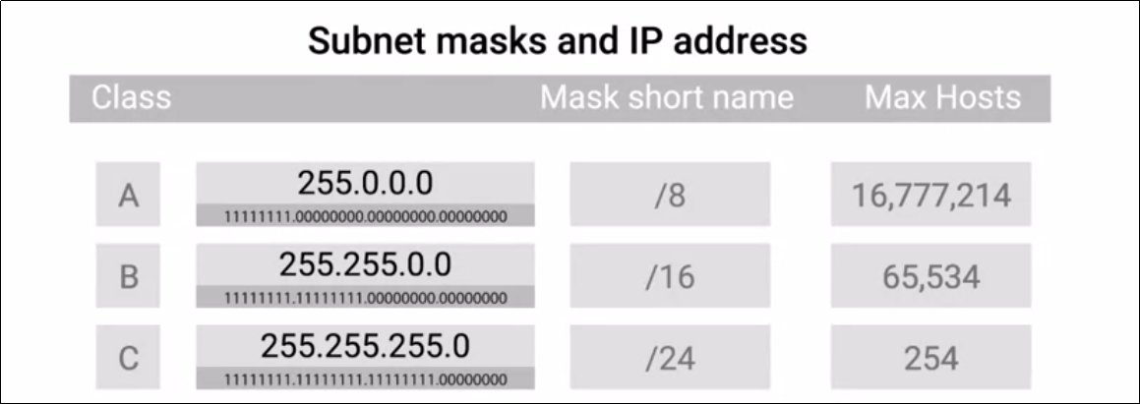

254 hosts can be small for use cases but for the class B and the class A there are 65534 and the 16777214 ip address respectively which is a huge number of ip address is very large. And cant be under a single router so most of the time these ip address are broken down into smaller network and multiple class C address is joined togather and routed to the same palce.this is where the CIDR comes .CIDR is used for this doing this . Suppose in a office there are hosts more more than a class C ip address can accommodate so you need two class C ip address could you join this togather and routed to a same palce .yes it is possible you just need to use the the netmask /23.that means the router needs one gateway router to deliver path to all the two different class C network.
Lets do some math to understand whats going on
we know for a /24 network with 8 host bit we have the host = 2^8 =256-2 = 254 [2 for the broadcast and the network]

so if we need two class C ip address we get the hosts
254+254 = 508

now if we use the /23 ip address we get the host bit 9
so the hosts is 2^9 = 512-2 = 510

so we can see by using the CIDR we can accommodate any combination of network and the host id.

ROUTING

when you say the word cloud in the IT field.it does not mean anu location in the sky. When you say I am storing the data in the cloud it means you are storing the data in a computer someplace else. You already know the internet is not just a specfic place with a lot of resource .internet is just a interconnection between millions of individual networks.so on one side can access resources shared by other people or organization on the other place of the world.But how this communication done? Because you already know that it is not possible to exactly locate a host using just their MAC address.Then we introduce the ip address.but how one individual network can communicate with other individual network.and how the travel from one side of the world to another side within a fraction of second?

