SSH: THE SECURE SHELL

What is ssh:
SSH is a cryptographic network protocol for secure network services

uses:
→ It is used for the remote login
→ Secure File Transfer (SFTP/SCP)
→ Port Forwarding
→ SOCKS protocols for web browsing through encrypted proxy
→ Secure remote file mounting via SSHFS

login with ssh using password:

requirements:
→ we have two server
1) server1, ip:192.168.0.10/24
2) server2, ip :192.168.0.11/24
1) step1
we need to install the openssh-server in server2[in centos server its actually pre-installed]
=>yum update -y
=>yum install sshd -y
2) from server1 use the command and give the password
=>ssh root@192.168.0.11
password: <server2 password>

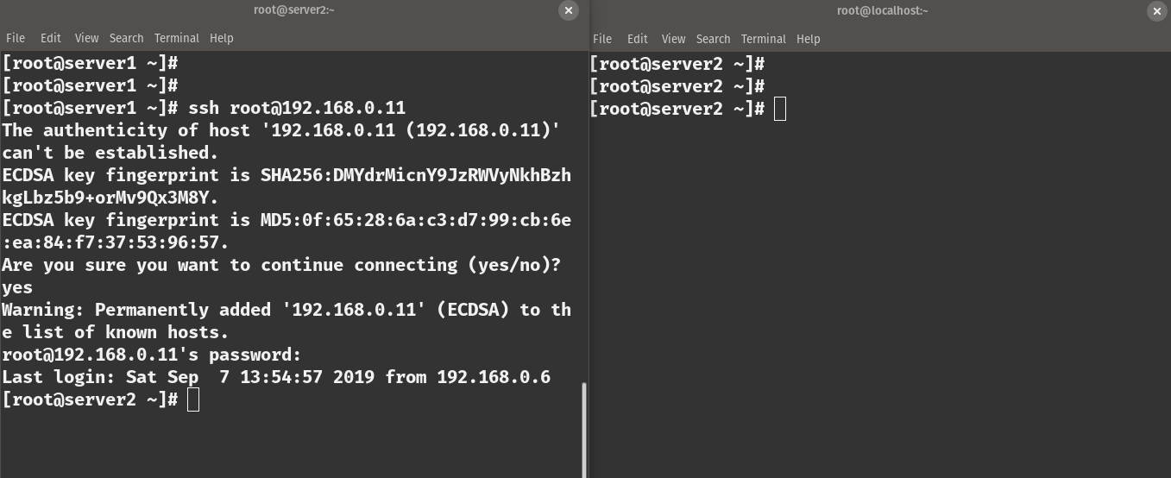

now you are logged in in server 2

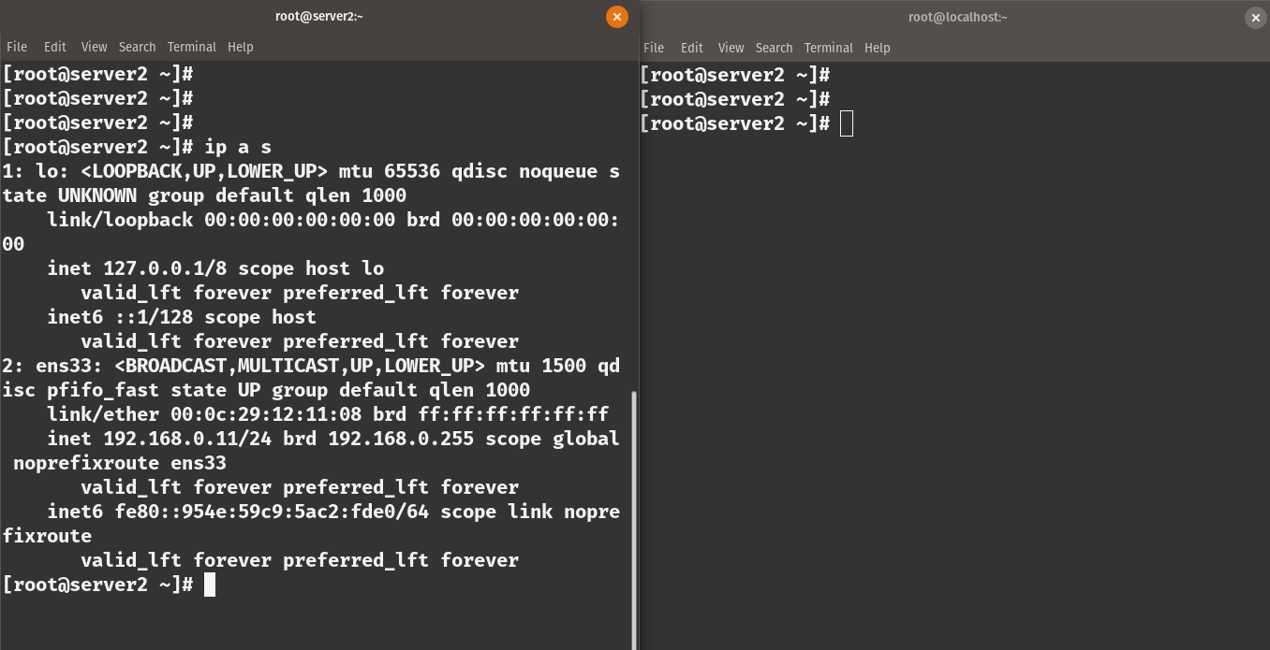

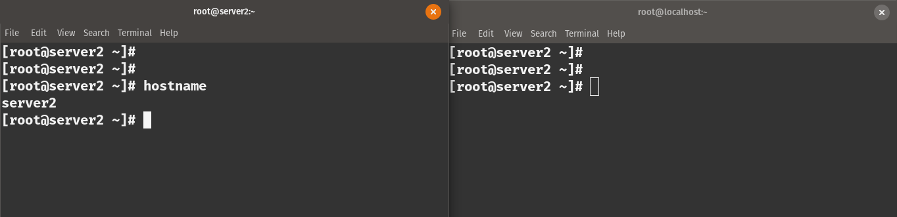

login with ssh without password(more secure way):

using password to login with ssh is one way but it is not very secure the other way is to use a private and public key pair. we use a public private key pair for login rather than a password.

Step 1:

see if there is an existing key
=> ls -l ~/.ssh

Step 2:

Create the key pair from server1

[syntax:ssh-keygen -t <algorithm> -b <size>]

=>ssh-keygen -t rsa -b 4096
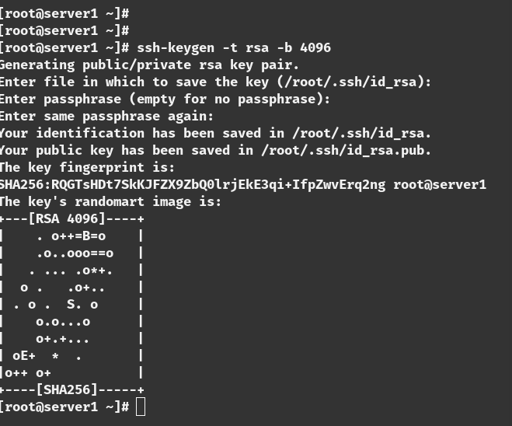

[it will ask you for a passphrase for now we skip it we will discuss it later]

Step 3:

we need to send the public key to ther server2.we can do it manually or we can do it using this command

=>ssh-copy-id server2@192.168.0.11

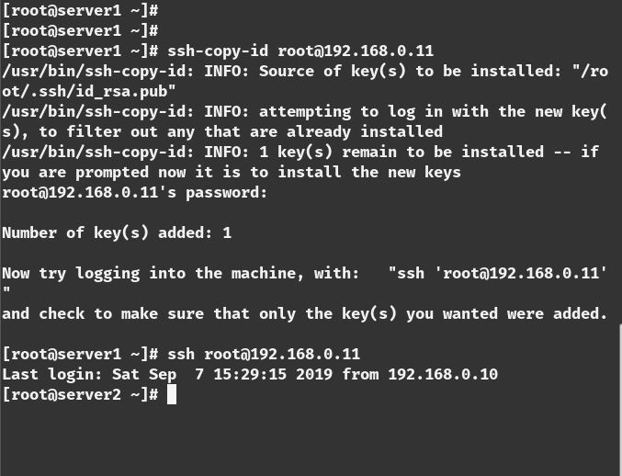

Step 3:

login with

=>ssh root@192.168.0.11

and this time no password will be asked.

[
what is passphrase:
sometime the ssh connectivity is used by you sometimes not. for example you can make a cron job to connect automatically to a server for data backup. when you are going to use the ssh only its a good idea to use a passphrase .but for automation you should not use it cause there will be no one to type the passphrase .when you use a script to automatically connect to a server don’t use any passphrase.
]

copy file with SCP(Secure copy and paste):

syntax:
scp <local_file> <destination>

we are going to send a file name ‘test.txt’ from server1 to server2

=>scp test.txt 192.168.0.11/test.txt

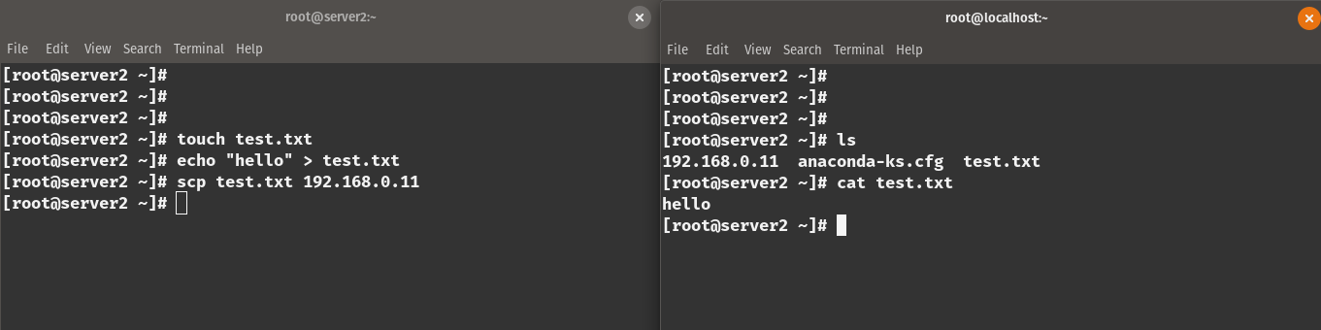

Copy file with SFTP(Secure File Transfer Protocol):

its a interactive process for sending file over SSH. its a sub system for ssh

=>sftp 192.168.0.10
sftp> cd /etc [go to etc directory]
sftp> get redhat-release [download the file]

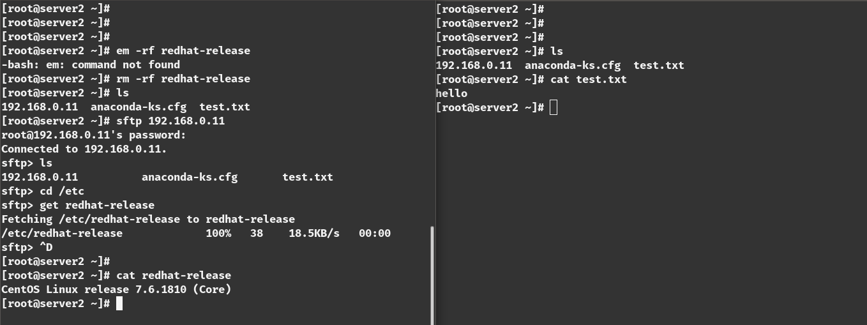

Port Forwarding:

Port forwarding allows us to access from one system to another system and use their network services .for exmple you are running a web server in the server2 in port 80.you can access it with a browser or see the html using this command in server2

=>curl localhost

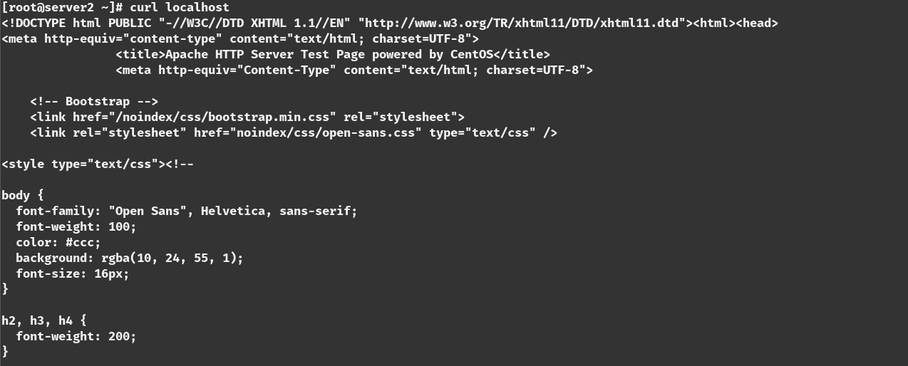

but you cant browse it with the server1using curl .you have to do port forwarding to established that connection.

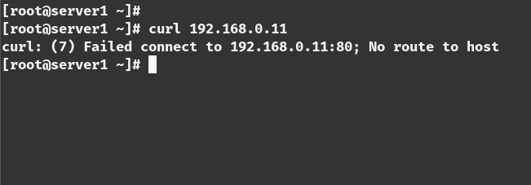

So if we forward the port 80 of the server2 to port 8000 in server1 we can access the content of the web server in server2 with server1in port 8000

command from server1:

=>ssh -L 8000:localhost:80 root@192.168.0.11

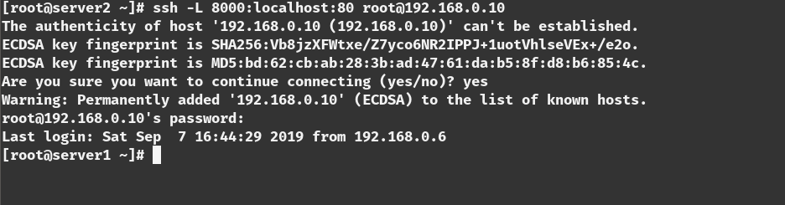
it will forward the port and we can access the resources from server1.it can be very useful for accessing a file that is behind a firewall.

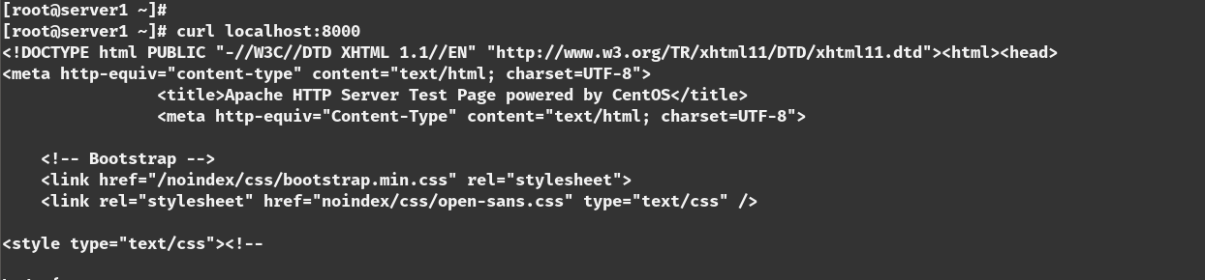

Copy configuration :

ssh server and configuration file is in the ‘/etc/ssh/’ directory.

1) ‘sshd_config’ is the ssh server configuration file
2) ‘ssh_config’ is the ssh client configuration file

Lets see the server configuration file and important propertise

vim /etc/ssh/sshd_server

PasswordAuthentication yes
Port 22
PubkeyAuthentication yes
X11Forwarding yes
PermitRootLogin no

→ you can change the port from 22 to any port you want but default is 22

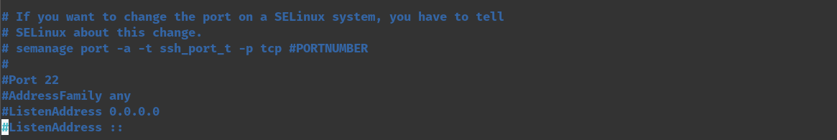
→ password authentication is set to no for some cloud server Because the use public private key pair which is more secure

→ X11 forwarding is by default set to yes. if you want to work with a gui interface this will let you do this



→ Permit root login is set to no. It should be always set to no because root login can make major security risk



