SETTING IPA SERVER ON UBUNTU

[centralized authentication system]

steps for installing ipa server:

step1: setting up a static ip address for the server and the host
1)In this lab the server address is
ip: 192.168.0.102
gateway:192.168.0.1
dns: 8.8.8.8

and the client address

ip:192.168.0.103
gateway: 192.168.0.1
dns:192.168.0.102 [server address]

restart the connection to take effect:
5) nmcli device down <NIC/device> / ifdown <NIC>
6) nmcli device up <NIC/device> / ifup <NIC>

[important note if you give the client dns to the server address you have to install packages from local repository unless you have a second nic connected to the internet because in order to work with online repository you need a public dns like 8.8.8.8 but if you use the local repo in the client its all fine]

[see the ip address section for the process of giving a static ip address]

step2: set a static host name of the server using ‘hostnamectl’ command
[server]
1) => hostnamectl set-hostname “ipa.it.local”
2) => exec bash

step2: edit the “/etc/hosts” of the server

=> vim /etc/hosts
[add this line

192.168.0.102 ipa.it.local ipa
192.168.0.103 client1.it.local client1
]

step4: test with ping commnad

1)=> ping ipa.it.local

step5: update the server repository

1) =>apt update -y

step(addional): reboot the system

1) =>reboot

step6: install “rng-tools” packages in server machine
rng tools is basically used got cryptography
=>apt install rng-tools -y

step7: configure rng-tools
=>vim /etc/default/rng-tools

set the input source for random random data by adding line

HRNGDEVICE=/dev/urnadom

step8: Enable and start rng-tools

=>systemctl enable rng-tools
=>systemctl start rng-tools

step9: install “free-Ipa” packages in server machine

[server]
1) => apt install freeipa-server -y

it will prompt you with this options

1) Enter the Hostname for kerberos server
=>ipa.it.local

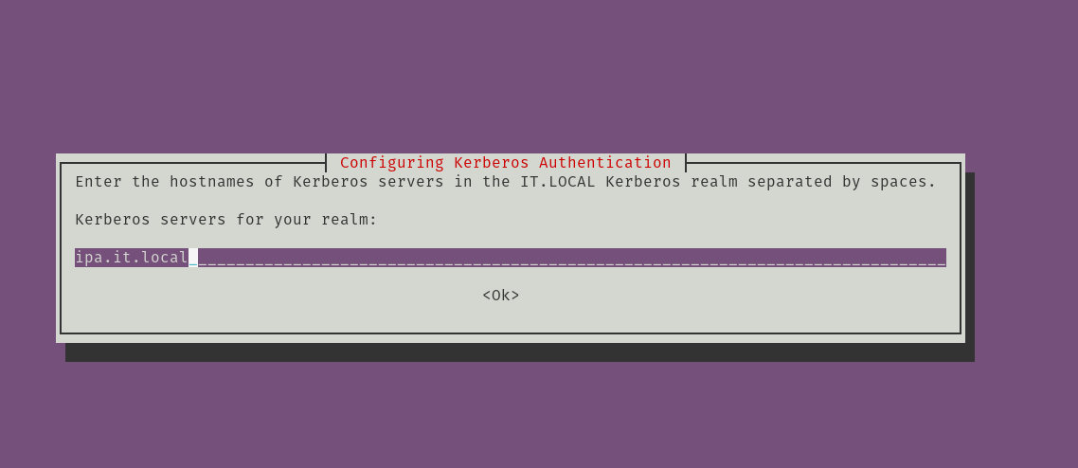

2)

Enter administrative server for kerberos realm
=>ipa.it.local

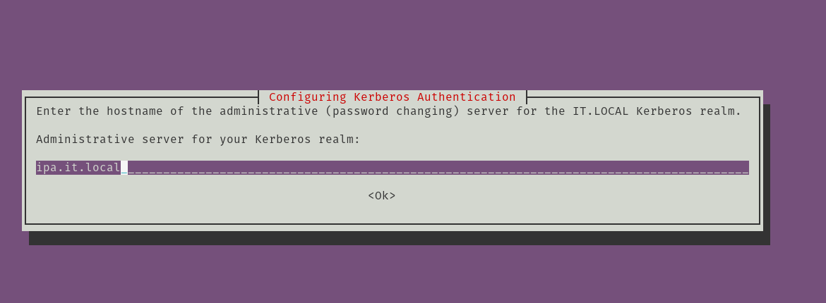

step9: install IPA server in server machine

[server]
1) => ipa-server-install

8-1: Do you want to configure integreted DNS?
=>no
8-2: Server Host name [ipa.test.system]
=>[Enter]
8-3: Please confirm Domain name [test.system]?
=>[Enter]
8-4: Please provide a realm name [TEST.SYSTEM]?
=>[Enter]
8-5: Directory manager password?
=><give_a_password>
example: admin@ipa
8-6: IPA admin Password?
=><give_a_password>
example: admin@redhat
8-7:Continue to configure the system with these values?
=>yes

step9: Enable ufw

[server]
1) =>ufw enable

step10: allow tcp port

=> for i in 80 443 389 636 88 464;do sudo ufw allow proto tcp from any to any port $i;done

step11:allow the udp port

=> for i in 88 464 123;do sudo ufw allow proto udp from any to any port $i;done

step12: restart the ufw

=>ufw reload

step13: initialize the admin user [varify weather the admin user get token from the kerberos] [you can login with just the user and password but to login with kerberos you have to issue the command]
[server]
1)=> kinit admin
[password: ] [same password for installation during FreeIPA]
2)=> klist

step12: reboot the system again

2)=> reboot

step16: Go to the administration page and login with username and password
[server]

username: admin
password: <admin_password>

[go to web browser to url “http://ipa.test.system”]

step16: create a user in the administration page
[server]

username: <give a username> / ex: ipa1
Firstname: ipa
lastname : user1
password : <give_password> /ex: redhat@ipa1

