SAMBA SERVER ON CENTOS 7

installing samba server(server side configuration):

step1:

requirements :
1) Centos server , ip: 192.168.0.50
2) client (ubuntu or centos), ip: 192.168.0.100
3) internet connection

step2:

update repository and install the necessary samba packages

=> yum update -y
=>yum install samba samba-client samba-common

step3:

create a group and add user in that group who can use the samba share.

=>groupadd test
=>useradd user1
=>useradd user2
=>usermod -a -G test user1
=>usermod -a -G test user2

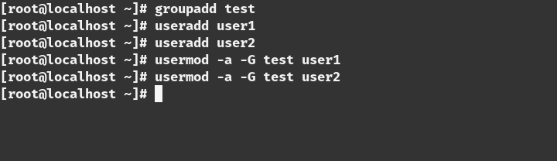

step4:

Create a directory and give proper permission for that user and group

=>mkdir /share
=>chmod 777 /share
=>chgrp test /share

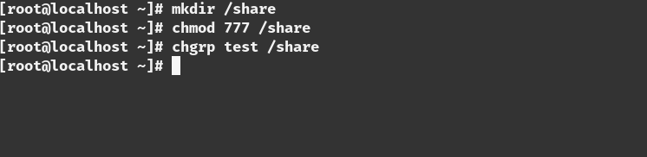

step5:

Configure SElinux .you can either disable the SEinux or set the proper boolean value and security otherwise it will not let you connect to the server.In this we are not going to disable SElinux we will change the boolean value.

=> setsebool -P samba_export_all_ro=1 samba_export_all_rw=1
=> getsebool –a | grep samba_export
=> semanage fcontext –at samba_share_t "/share(/.*)?"
=> restorecon /share

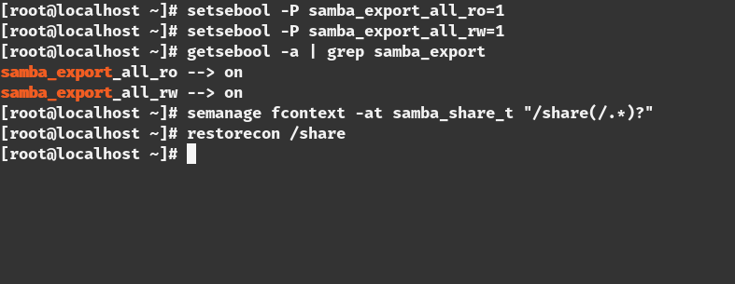

step6:

we have to change the firewall settings for allowing the connection
=>firewall-cmd –permanent –add-service=samba
=>firewall-cmd –reload

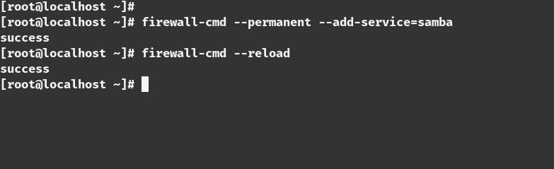

step7:

This is the most important path of the part.we need to edit the configuration of the samba share
=> vim /etc/samba/smb.conf

[share]
comment=Directory for for samba share
browsable=yes
path=/share
public=no
valid users=@test
write list=@test
writeable=yes
create mask=0770
Force create mode=0770
force group=test

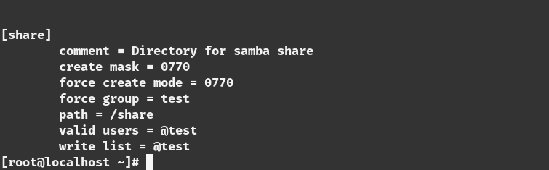
step8:

Test the configuration with the ‘testparm’ command.if there is any error in the configuration this command will tell you that
=>testparm

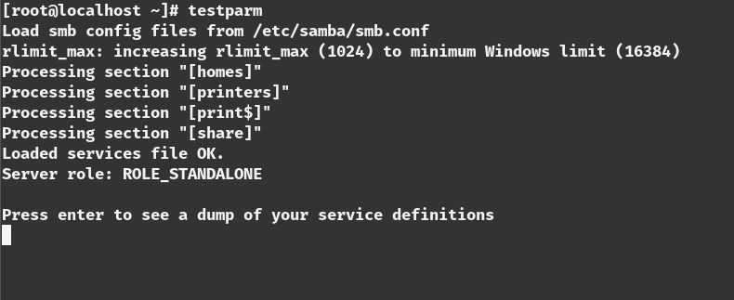

step9:

we have to add the user of the test group to the samba
=>smbpasswd -a user1
=>smbpasswd -a user2

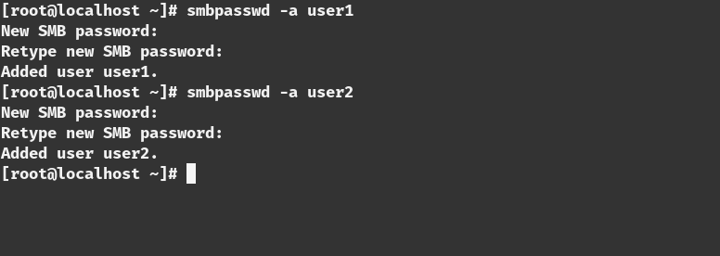

step10:

restart the samba server to make the change the in effect
=>systemctl start smb
=>systemctl start nmb

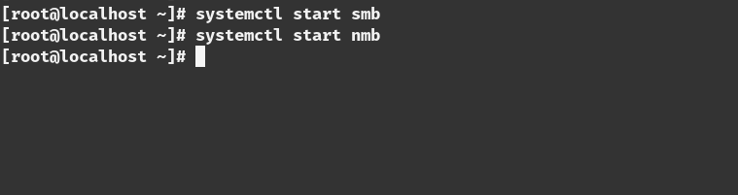
step11:

we have to enable the smb and nmb service to make start this on boot time

=>systemctl enable smb
=>systemctl enable nmb

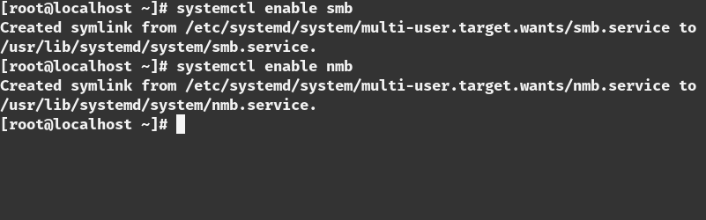

step12:

Test the connection from the server
=>smbclient -L localhost -U user1

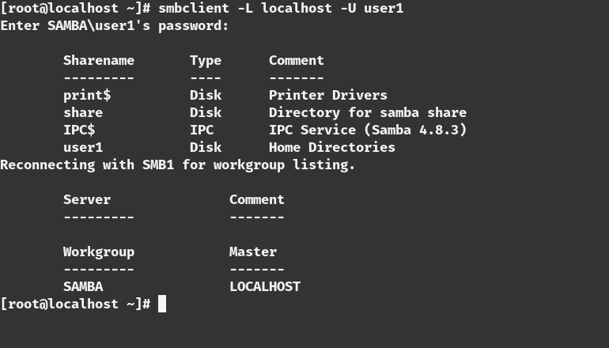
=>smbclient -L localhost -U user2

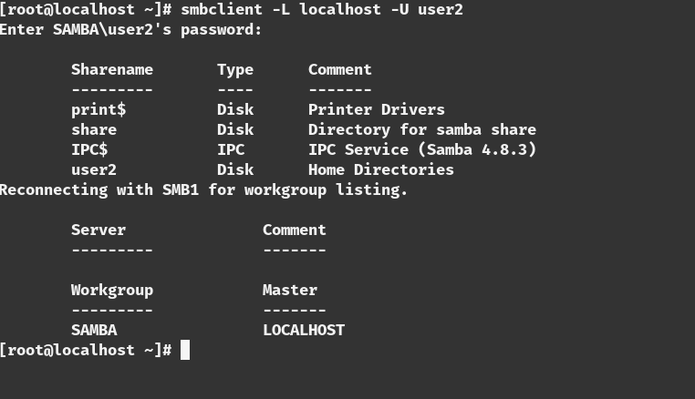

installing samba Client(linux client):

step1:

install packages in the client
=>yum update -y
=>yum install samba samba-client samba-common -y
=>yum install cifs-utils -y

step2:

Test the connection from the client
=>smbclient -L 192.168.0.50 -U user1

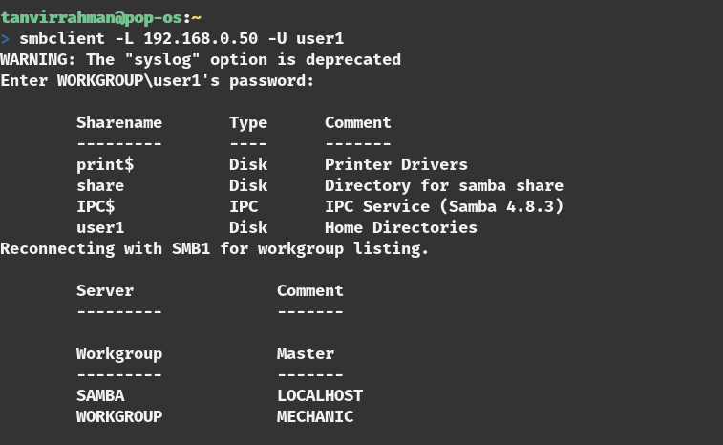

step3:

make the directory for mounting and give the proper permission
=>mkdir /share
=>chmod 777 /share

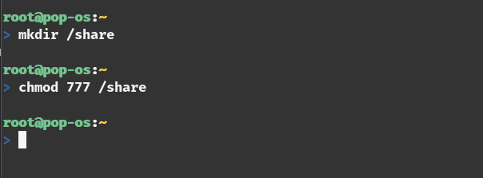

step4:

mount the the network share
=>mount //192.168.0.50/share /share -o username=user1

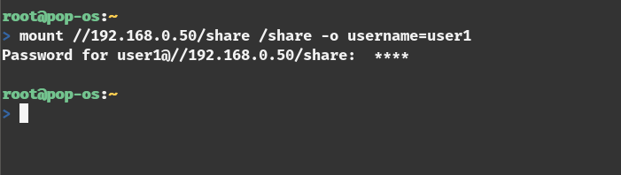

step5:

see the the network share
=>mount | grep cifs

Additional step(permanent mount):

adding a credential file in /share folder
=> vim /share/.smbcredentials
username=user1
password=<password_for_user_1>

adding an entry to the ‘/etc/fstab’ file
=>vim /etc/fstab

//192.168.0.50/share /share cifs credentials=/share/.smbcredentials

Test the share:
create a file in the /share folder from the client side
=>touch /share/test.txt

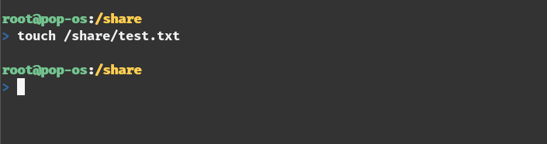

Now test from the server side
=>ls -l /share

