Computer networking & IP Addressing

Computer Network:

A computer network is a group of computer and other computing peripherals that linked together through some kind of communication channels to communicate with each other and share their resources among a width range of users.
Their jobs are

1) Facilitate communication via email,file server,web server,instant messaging etc
2) Share resources of the hardware like printer or scanner
3) Enable File sharing
4) create a centralized control among the total network

Types Of Computer network:

Network Basically divided into three groups:

1) Local Area Network (LAN)
2) Metropolitan Area Network (MAN)
3) Wide Area Network (WAN)

LAN:
A local area network (LAN) within a small area like home,school,office or group of buildings. They can share their resources and device like printer and scanner and data storage. Most of them are centrally organized. And because of the type of the communication the data transfer rate is very high. And local area network does not need any leased communication line

MAN:
A metropolitan area network (MAN) spans an entire campus by connecting multiple LAN. MAN is larger than the LAN, because it consists of a number of LAN .MAN works like more of a ISP but it does not owned by a single organization. instead MAN provides a shared network connection to all its users

WAN:

A wide area network (WAN) within a large scale of geographical area is called WAN. It is created by connecting different LAN from a long distance. And the transmission speed generally is slower than the LAN or MAN but the data transfer rate is increasing .

TCP/IP PROTOCOL SUITE

A majority of the internet users use a protocol suite called Internet protocol suite which is also known as the TCP/IP protocol suite.The two protocols are TCP (Transmission control protocol)
& IP (internet protocol).In here TCP is a connection oriented protocol means it transmit data in a sequence and it has a acknowledgment process. If the acknowledgment are not recived

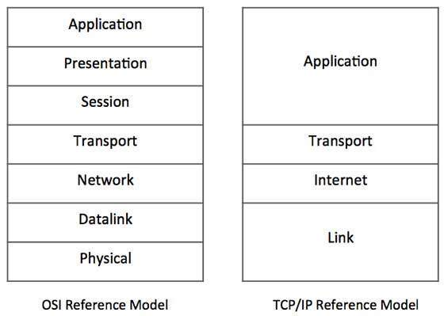

then the data will be re transmitted.so it can guarantee the delivery of the data to the host and IP is used to maintain the address of the specific host.

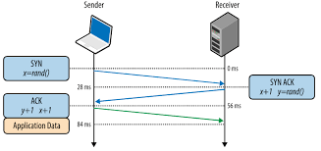

IP Addressing:

IP addressing is the most important topic in the networking.ip address is basically a numeric identifier that used to identify a Machine .Ip address is a software address not a hardware address that means it can change depending on the network you are connected.The hardware address is the NIC address thats called the Physical address that cant be changed.

Important Clement of a IP address:

Bit: Bit is one digit either 0 or 1

Byte: made up with 8 bits its just a ordinary 8 bit binary number.

Network Address : Network address is used send packets to the network .for example 10.0.0.0,192.168.0.0 etc

Broadcast Address : It is used by the host to send information to all the nodes on a network. The address are like 192.168.0.255,172.166.255.255

Every ip address there are two different parts

1) Network part
2) Host Part

Every ip address gives the information about the network and the hosts

Subnet Mask:
A subnet mask is a 32 bit umber that masks an ip address and devides the ip address to a network address and hosts address.
Is is done by setting all the network bits to ‘1’ and setting hosts bit to ‘0’

[Two host ip address are reserved for special purpose The ‘0’ address and the ‘255’ address.the ‘0’ address is reserved for the Network .so if any ip address have a ‘0’ on its last its a network address.and ‘255’ is the broadcast address they cant be assign to a host]

5 types of IP address:

1) class A ip address
2) class B ip address
3) class C ip address
4) class D ip address
5) class E ip address

Class A ip address:

In class A ip address the first byte is reserved for the network address and three remaining bytes are for the hosts.
[it starts with 0.0.0.0 and ends with 127.255.255.255]
subnet mask: 255.0.0.0

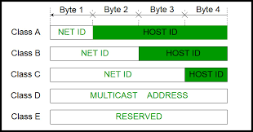
It has a small network with huge number hosts.

Class B ip address:

In class A ip address the first two bytes is reserved for the network address and two remaining bytes are for the hosts. More network less hosts
[it starts with 128.0.0.0 and ends with 191.255.255.255]
subnet mask : 255.255.0.0

Class C ip address:

class C ip address the first three bytes is reserved for the network address and remaining one bytes are for the hosts. If you need a lot of network and small number of hosts in every networks class C ip address is used.
[it starts with 192.0.0.0 and ends with 223.255.255.255]
subnet mask : 255.255.255.0

Class D ip address:

class D ip address is a special address. Its called a multicast address. It is basically used for finding router
[it starts with 224.0.0.0 and ends with 239.255.255.255]

Class E ip address:

Reserved for the Scientific Experiment

Private IP address:

Not all the address of these class is used for public network .some are not routable through the internet.private ip address is used in the Localy and a local ip address can connect to the internet through a public ip address with NAT (Network address translation).NAT allows a public address to the internet

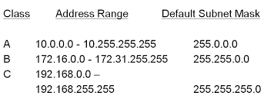

Loopback address:

Loopback address is used to test the communication on a local NIC (Network Interface Card) .Data packets are sent by the node in the loopback address are re-routed back into the same node.It is used for testing the connected physical network. it also enables the user to test an application with an instance of server and client on the same machine.we call it localhost

it starts with 127.0.0.0 and ends 127.255.255.255

Ping:

ping stands for Packet Internet Gopher is a ICMP echo request and reply message that used to check the physical and logical connectivity of the machine on a internet network.

Traceroute:

Traceroue is used to find the path of the packet traverses through the internet.

