Setting ip address in Ubuntu server using netplan

New version of ubuntu linux has a new tools for setting ip address .This is called netplan. now its a little bit hard because you have to maintain indentation and certain rules to give it.and the main challenge is you have to do it by editing a file

First:

The network configuration stored in ‘/etc/netplan’ directory

Second:

There are different ‘yaml’ configuration file for different inteterface.in my VM there are two different interfaces.so there are two different interfaces.you have to configure the configuration file based on what interface you want to configure

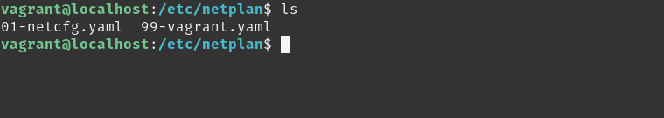

Third: [very very important]

you mast take backup before you edit the file

=>cp 99-vagrant.yaml 99-vagrant.yaml.bak

[this is very very important cause if you make mistake in the indentation you have to]

Fourth:

Edit the file
=>sudo vim 99-vagrant.yaml

the file format will be like this

# the datasource. Changes to it will not persist across an instance.
# To disable cloud-init's network configuration capabilities, write a file
# /etc/cloud/cloud.cfg.d/99-disable-network-config.cfg with the following:
# network: {config: disabled}
network:
ethernets:
eth1:
addresses: []
dhcp4: true
version: 2

the ip address we assign will be

ip address : 192.168.0.102
subnetmask : 255.255.255.0
gateway : 192.168.0.1
dns : 8.8.8.8,8.8.8.4

Fifth:

Fill like this

# the datasource. Changes to it will not persist across an instance.
# To disable cloud-init's network configuration capabilities, write a file
# /etc/cloud/cloud.cfg.d/99-disable-network-config.cfg with the following:
# network: {config: disabled}
network:
ethernets:
eth1:
addresses: [192.168.0.102/24]
gateway4: 192.168.0.1
nameservers:
addresses: [8.8.8.8,8.8.4.4]
dhcp4: no
version: 2

Sixth:

find error

=>sudo netplan -debug apply

Seventh:

=>sudo netplan apply

