KERNEL MANAGEMENT

The kernel is the operating system .It performs all the core task like managing memory and disk access it will connect to all the hardware that makes your system. It gives you the multitasking and multi user support .It handles all the communication with all the devices like CD ROM USB drive .Basically user sends the request signal that go through the kernel to the device .Based on different different hardware the configuration of the kernel will very .Suppose you have to add a new device to the system then you have to change the kernel support for the specific devices. you can download the binary version of the kernel or you can download the source code and compile it. Its now the job of the system administrator to worry for the code of the kernel but you must know how to add and remove kernel module and detect if any kernel module not working or malfunctioning .And he must know how to compile and add new kernel to the system

kernel sets up several presses some process are internal to the kernel.
We can see the internal process the with this command

=> ps aux | egrep ‘\[’

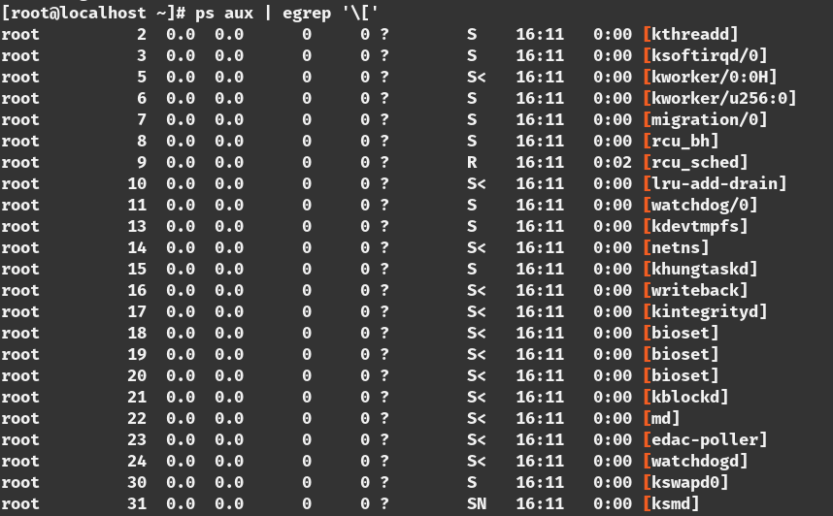

this process are all kernel process.Some of this process are very important for the system administrator to know.

For example

‘kthreadd’ manages the kernel thread
‘md/0’ manages the raid subsystem
‘kswapd’ manages the swap space available for the system

[this generally don’t impact the system administrator .some times the system can misbehave and can occur memory overflow if it happens you will see the kswapd process on the top of the process list which you can find in the ‘top’ command ]

Kernel Modules:

kernel modules lies in the directory under ‘/lib/modules’
=> cd /lib/modules

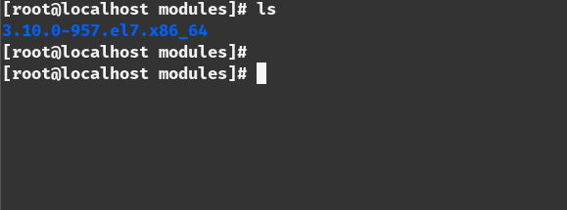

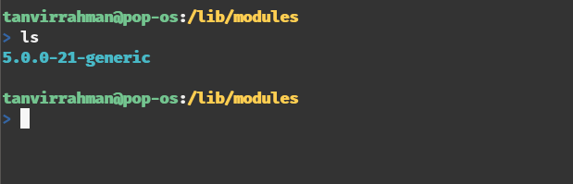

in this directory there can be multiple directory .each directory for each kernel .Under this directory there are a lot of files that can be for different different devices.

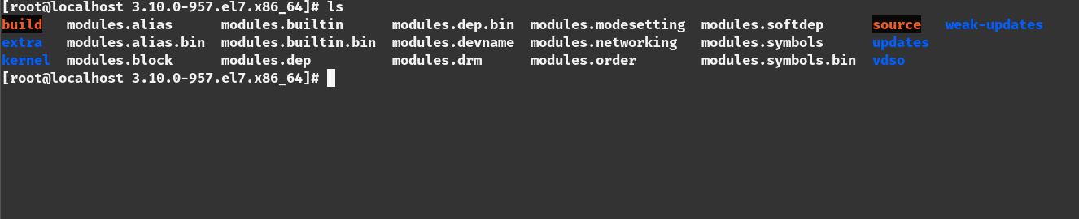

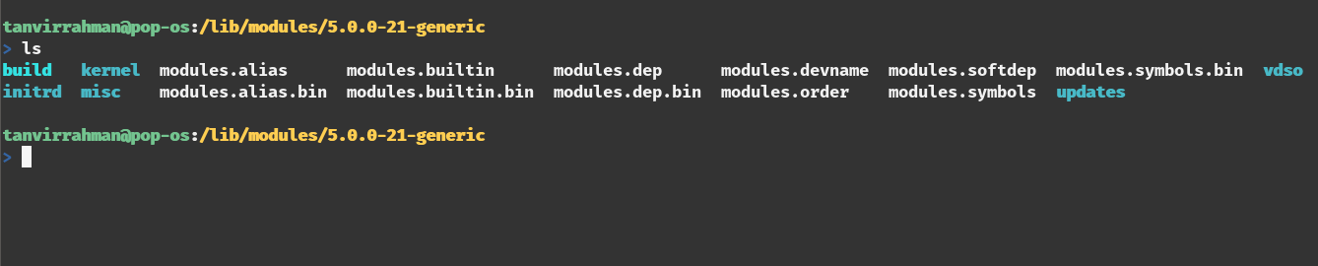

kernel module varies depending on the hardware manufacturer modules loaded by the kernel at the boot time. you can manage which driver will be loaded and which driver will not.
To find which model is loaded we use the ‘lsmod’ command.[you have to be a root user for that]

=>lsmod

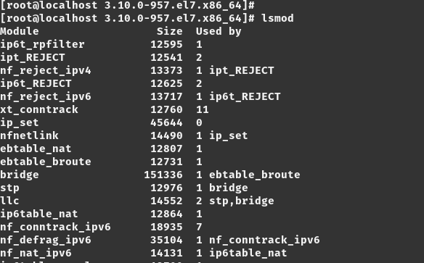

To add any kernel modules we use the ‘modprobe’ command
for example if we want to add the blue tooth module to the system
this command is used

=>modeprobe bluetooth

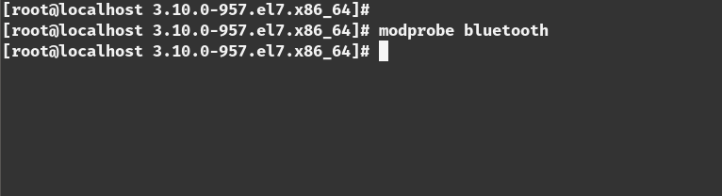

Synthetic File System

There are two different type of file system. one is the the real file system that lies on some disk. like ‘/root’, ‘/boot’ this are the real file system.

There are another file system that are fake file system that are created by the kernel .Its useful for the system administrator to access the internal variable within the kernel. one of the file system is ‘/proc’. This is meant for process information. Inside the directory there are a lot of directory with numbers.
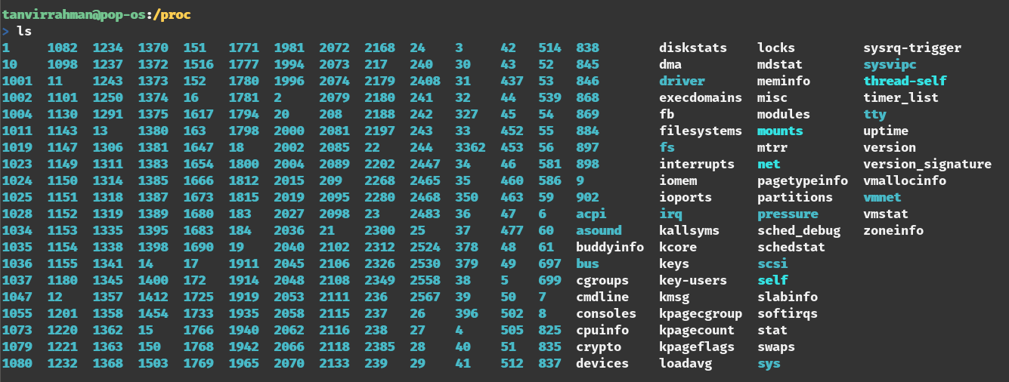

thease are all process id.process id 1 is the init process.so if you fo to the ‘/proc/1’ it will show you the detail of that process.

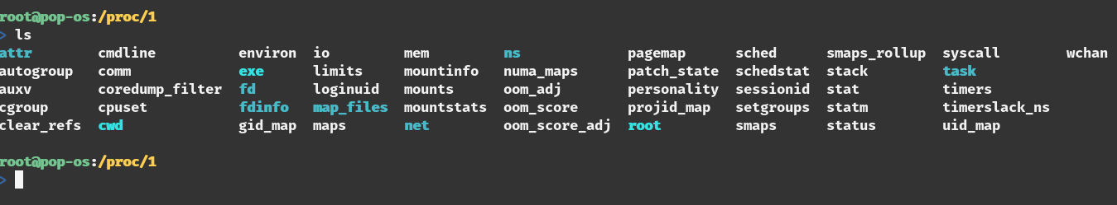

Another synthetic file system is ‘/sys’ although it works with the devices but the main target is the same which is accessing the settings of the kernel.

