Basic MAIL protocol

protocols for receiving mail:

1)pop3 protocol
2)imap protocol

protocols for sending mail:

1)smtp protocol

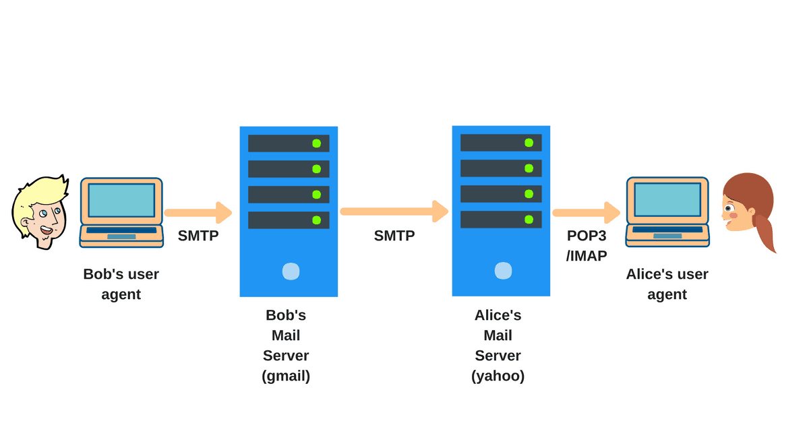

pop3 and imap are actually used for reviving email. If you use any email client like mozila Thunderbird or Microsoft outlook you configure with pop3 protocols or imap to retrieve the email and you can configure your tabs even your mobile devices .with this protocols

but if you want to know which protocols you should use or which protocols is better you may have to know know .and its not like one is better than the other it actually depends on what you need

pop3

pop3 stands for the post office protocol. Its a very simple and straightforward protocol because the only thing it does is download the email from the email server to your devices from a mail server.And it only download the the mail from your inbox. And that it.it does not do anything more than that .it does not download your drafts,your sent items or anything and it does not provide any synchronization .If you configure a same email account with pop3 in two different computer .And you can see the folder structure is different in two different computer in two different devices because it is not synchronize with the email server.

But this is not the mail issue with the pop3 protocols the main problem is when you download mail with pop3 in your devices from the email server. it will get deleted from the mail server. no copy of the email is kept on the server. so consider you have two devices one is mobile device and another with a desktop with the same email account with pop3 protocol and you download email with your mobile device then you can not download the same email in your desktop because the moment you download the mail in your mobile devices it is deleted from the server .so thats a downside of the pop3 if you use multiple device to manage your email .

IMAP

imap stands for Internet message access protocols . IMAP is little bit complicated than pop3.It is perfect for managing email from multiple devices because it leaves a cache (local copy) in the mail server.And it synchronize the folder structure and every file inside it.so if the mail client is configured with the IMAP you will see the same folder structure on every devices you used to access it.But it has a downside two if you delete any email from one of your devices your mail will be delete in the server and the other devices to maintain the synchronization .If you added a folder in the folder structure all other client will do that too.

To set the protocols you have to change the settings of the mail client for example if you want to use the the pop or imap from a mail server you have to add ‘’pop.example.com” ot ‘’imap.gmail.com” in the incoming mail server settings

IMAP VS POP3

pop3 advantage:
1) pop3 is better if you use it from only one devices
2) pop3 saves the mail server location
3) saves internet bandwidth because it only use the internet when new mail come

pop3 disadvantage:
1) no backup for email
2) cant use with multiple client simultaneously
3) your devices can be infected with virus since the whole file with attachment is downloaded

IMAP advantage:
1) All the mail is stored in the mail server
2) you can manage it with multiple devices
3) Synchronization

IMAP disadvantage:
1) you cant see the email without an internet connection

SMTP

SMTP is the protocols for sending email .while pop3 and IMAP is for revving email .SMTP is a set of command that authenticate and transfer your email .When you send email from your email client it will send to the email server with SMTP protocols.Your mail server is also known as SMTP server like the gmail (smtp.gmail.com).Then your SMTP server will send the email again with smtp protocols with the receivers SMTP server .Then you can download the email with pop3 or IMAP or you can read it directly from the server with WEBMAIL

SMTP uses the TCP protocol which is a connection oriented protocol. That means it assure you in delivery. So if by any chance the email wont deliver to the destination you will get notification about that .And just like the pop3 and IMAP you

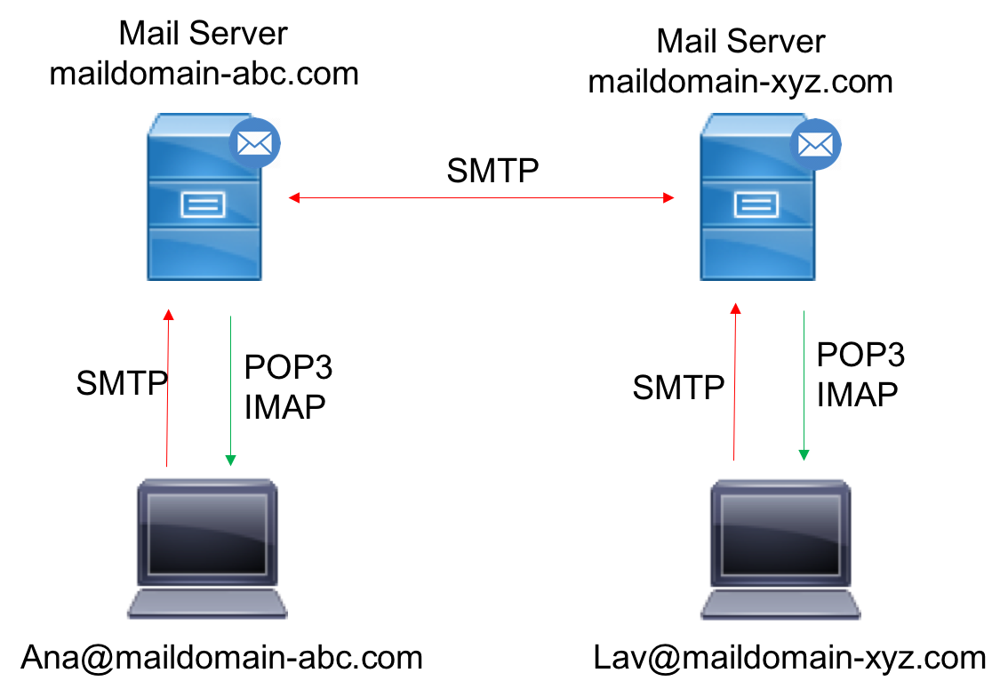

have to configure it to your email client for example if you use the Gmail.
You have to add the ‘smtp.gmail.com’ in your outgoing mail service

