UBUNTU & CENTOS SERVER ADMINISTRATION

This is the keyword-rich, attention-grabbing subtitle

MD. TANVIR RAHMAN

To my niece Safiyah Nawar and Nujaira Zaynab

UBUNTU & CENTOS SERVER ADMINISTRATION
Copyright © 2019 by MD. Tanvir Rahman.

For information contact :
(Address, website)
http://www.tanvirrahman.ml

First Edition: December 2019

CONTENTS
UBUNTU & CENTOS SERVER ADMINISTRATION i
INTRODUCTION 1
VMware Installation 11
Ubuntu Server Installation 14
CENTOS Server Installation 20
COMMAND LINE IN LINUX 26
BASIC LINUX COMMANDS 30
ip addressing 59
SETTING STATIC IP IN CENTOS7 71
SETTING STATIC IP IN ubuntu 87
Package management in linux 101
Comparison Between two Package management system 134
YUM SERVER 137
APT SERVER 138
5 147
could be a subtitle 147
ABOUT THE AUTHOR 155
Acknowledgments 156

INTRODUCTION
subtitle
An operating system is a software that runs on our computer. Handling all the instructions between a user and the Computer hardware .But the operating system is not just one software it also consists of a lot of other smaller program that runs on this operating system to that helps users to do their work. we run this smaller program on top of this operating system to do everything.
Liunx is just another operating system. Its a rock solid operating system. Linux work both as a server and Desktop operating system.
Linux operating system is great for a lot of reason . thease are the following

* Multi user OS: Linux is a multi user operating system. That means more than one user can work on a system at the same name
* Multi tasking OS: Linux is a multi taking operating system you can run multiple program at once .this allows the operating system to run several process all at once.
* Multi Platform OS: Linux can run currently more that 24 types of platform and 64-bit Intel based personal computer .All variants of Apple mac,Sun Spark and ipod ,even the Microsoft xbox.

* Interoprable OS: Linux can operate with most network protocols and also most Language it can easily interact with Windows OS,NOVEL,UNIX and other operating system that has a smaller market

* Scalabel OS: Linux operating system has support for even Raspberry pi which is a credit card size computer to Very powerful Server. Most of the server of the world is running Linux OS. They have also run in low power computer

* Portable OS: Linux is portable operating system. Linux is mostly written in C programming language .C is a language that is specially for writing operating system level software. And it can be ported to run on a new computer.
* Flexible OS: Linux operating system can be used to make a router,graphical workstation,home entertainment computer,file server,web server,mail server,cluster, just any computing purpose.
* Stable: Linux kernel is very mature. For being stable it is used for most of the server in the world.

* Efficient: The design of the Linux enables you to include on only the thing you needed thats why it can run on both raspberry pi to a big server.

* Free : Linux is a Free operating system.

GNU PROJECT
GNU Stands for (GNU is NOT UNIX). To make a free clone of the UNIX OS GNU project started 1984.To maintain the free software FSF(Free Software Foundation) is created. It Creates the GNU C compiler ,EMACS Text editor and many other software.
The GNU General Public License (GPL) is a very creative license that used to copyright to protected the freedom of the software user. When a software is licensed under the GPL recipients are bound by the copyright to respect freedom of anyone to use and share the software and also change the source code if necessary.

HISTORY OF LINUX
Linux is a clone of the UNIX based operating system. Unix is created at BEL LABS for AT&T corporation. To make a free clone of the unix Linus Trovalds created a minix .he wrote the kernel which is the heart of the linux .After that a lot of developer helped him to add more feature and functionality .and at that time the GNU Project was making free software for the computer and to make an OS they need a functional kernel which can communicate with the hardware .They took the linux kernel and add the GNU software on top of the kernel and made the GNU/LINUX Operating system.
Linux Trovalds is still considered as the dictator of the Linux kernel. He ultimately determines which feature will be added in the linux kernel and what features are not.

Packaging Linux:Distribution
A complete linux system is called distribution. A linux distribution contains the Linux kernel and the GNU project Tools and any number of software that can make the OS diverse functionality.
There are a lot of distribution on linux .Some of them specifically for servers and some of them are Desktop. Every customized distribution includes software packages for different users.
A single linux distribution often appears in different version .For example CENTOS distribution comes with a full core distribution and a LIVE CD version.
Ubuntu is based on Debian Distribution And Centos is community version of the Commercial RED HAT linux distribution.

Core Linux Distribution
Core linux distribution contains the Linux Kernel and GNU operating system one or more DE(Desktop Environment) and application that is available ready to install and run. The core linux Distribution are the compete linux distribution. These are the popular distribution

* Red Hat linux
* Fedora Core
* Centos Linux
* SUSE linux
* Ubuntu Linux
* Gentoo Linux
* Debian Linux
* Slackware Linux
* Mandriva Linux
* Turbo Linux
* Puppy Linux
we use the UBUNTU linux and the CENTOS linux to illustrate how the servers work.

PRINCIPLE OF LINUX

* Everything works as a file , even the system hardware
* Small work is done by the individual program
* Any complected work will be divided into smaller part and then process this by different different module.
* All the configuration will be stored in a text file
* linux OS use a standard hierarchical file structure in which the files/user files are arranged

***

UBUNTU SERVER

Ubuntu is built on the Debian architecture and comprised linux server and Dsktop. Ubuntu release updates every six months Ubuntu packages are based on packages from Debians unstable branch. Ubuntu is currently funded by the Canonical LTD.And GENOME 3 is the default GUI interface for the ubuntu from 17.10 version. We are goinf to use Ubuntu Server 18.04.3 LTS for our work.you can download the latest long term varsion of ubuntu server in this URL
https://ubuntu.com/download/server

CENTOS SERVER

Ubuntu is built on the Debian architecture and comprised linux server and Dsktop. Ubuntu release updates every six months Ubuntu packages are based on packages from Debians unstable branch. Ubuntu is currently funded by the Canonical LTD.And GENOME 3 is the default GUI interface for the ubuntu from 17.10 version. We are going to use Ubuntu Server 18.04.3 LTS for our work.you can download the latest long term varsion of ubuntu server in this URL
https://ubuntu.com/download/server

VMware Installation

Step 1:
install the required build packages
=> sudo apt install build-essential

Step 2:
Download VMware workstation player from the
website.

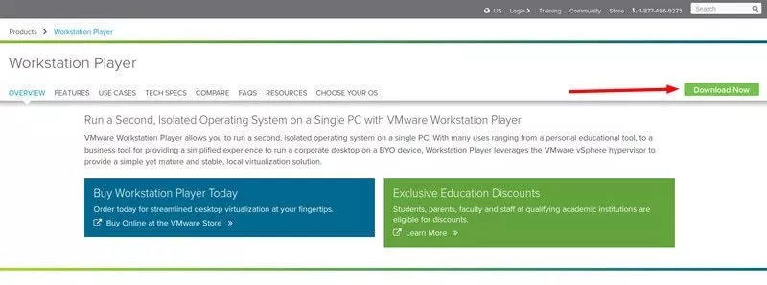

Step 3:
go to the installed directory make the file executable
=> chmod 777 Vmware-Player*
[we will talk about the chmod 777 later for now just use it]

Step 4:
execute the program with sudo
=>sudo ./Vmware-Player*

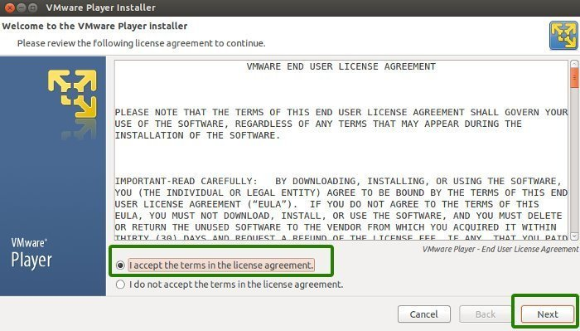

[no license key is required .If you want to install vmware workstation instead of vmware player you need to have the license key]

after a successful installation screen will show to you

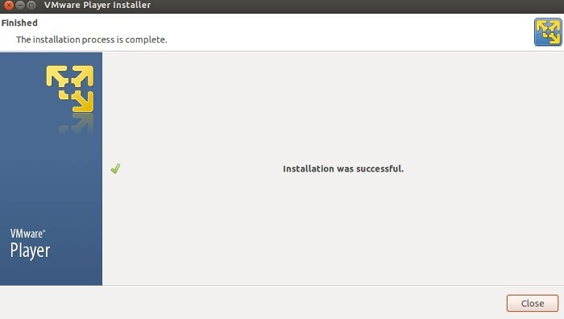

***

Ubuntu Server Installation
Ubuntu

Requirements:
1)Host PC with at least 4GB of ram
2)VMware Workstation/Virtualbox
3)Ubuntu server ISO image

Step 1:
Lunch VMware Workstation New Virtual Machine Wizard
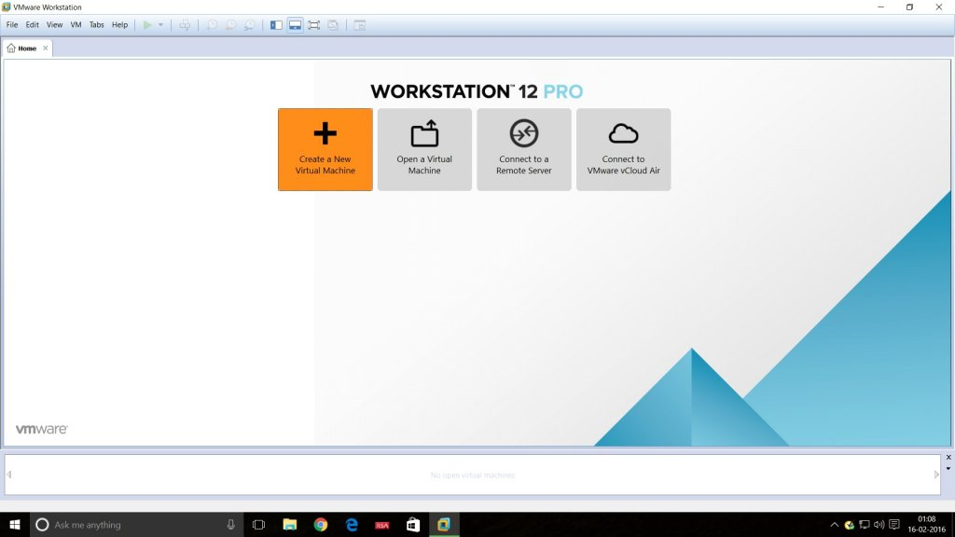
Step 2:
Select the installation media or source and choose the disk size.
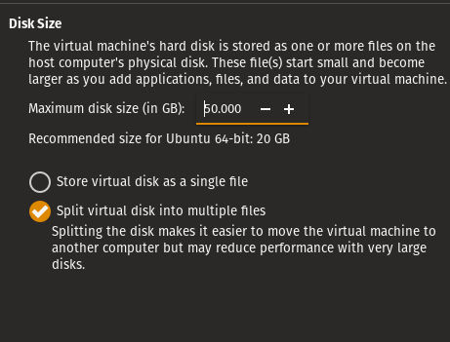

Step 3:
final configuration of the Vmware will be like this
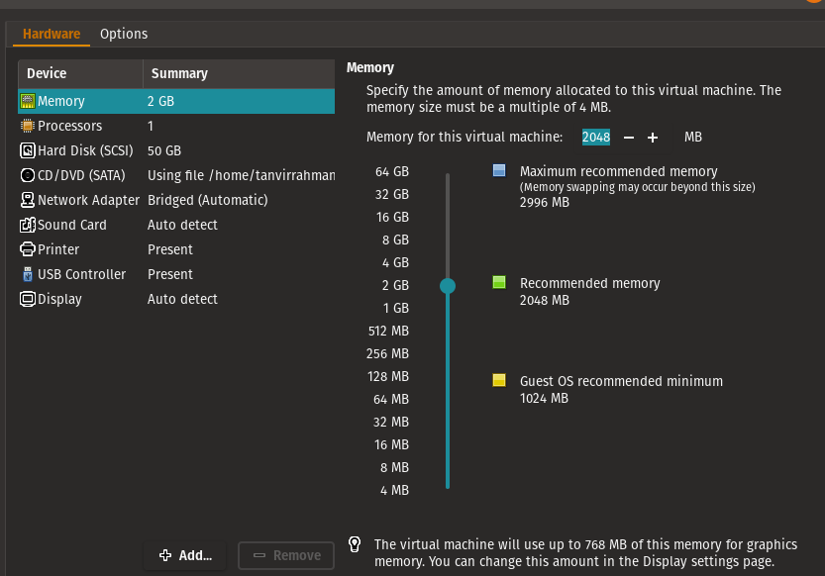

Step 4:
start the installation ,first set the language

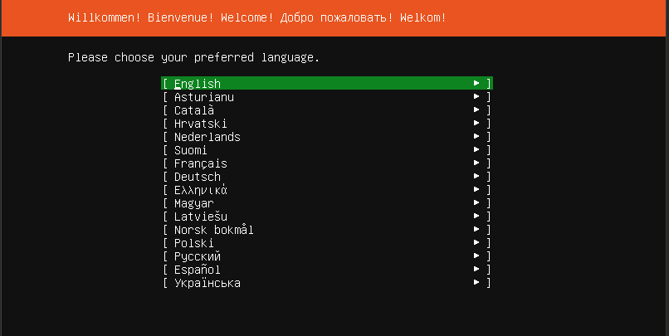
Step 5:
select DHCP for network for now .we change the ip address of the server later
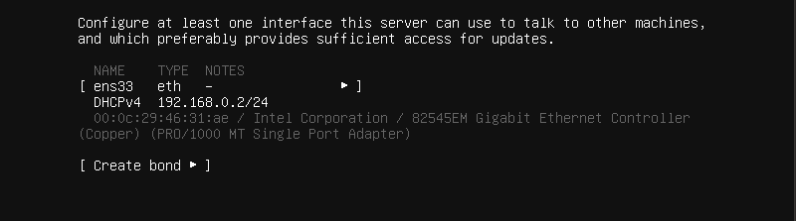

Step 5:
Select “install openSSH server” so we can connect to the computer with our hosts
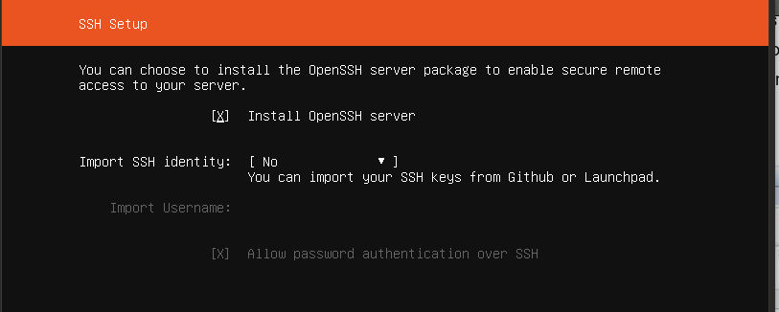
Step 6:
There are three types of partition

* Guided : use entire disk : it use the entire disk with guided partition system

* Manual : In manual partition user have to allocate the space manually.
For minimal settings three partition is a mandatory
1) /boot
2) /swap
3) /root
* Guided : on LVM :this option allow user to set a LVM based partition

Select the entire disk for installation .we select the Entire disk guided partition will talk about the other boot system later.

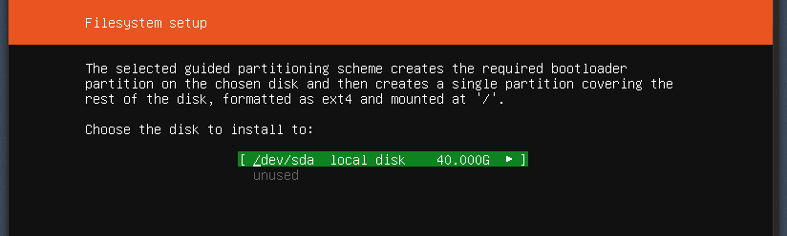

Step 7:
login to the system with your credential .

SUMMARY:
we learn how to set up a ubuntu server on Vmware Virtual machine with a dhcp network. Using guided partition.

***

CENTOS Server Installation
Centos

Requirements:
1)Host PC with at least 4GB of ram
2)VMwareWorkstation/Virtualbox 3)CENTOS7 server ISO image

Step 1:
Lunch VMware Workstation New Virtual Machine Wizard

Step 2:
Select the installation media or source and choose the disk size.

Step 3:
final configuration of the Vmware will be like this
Step 4:
start the installation , First set the language
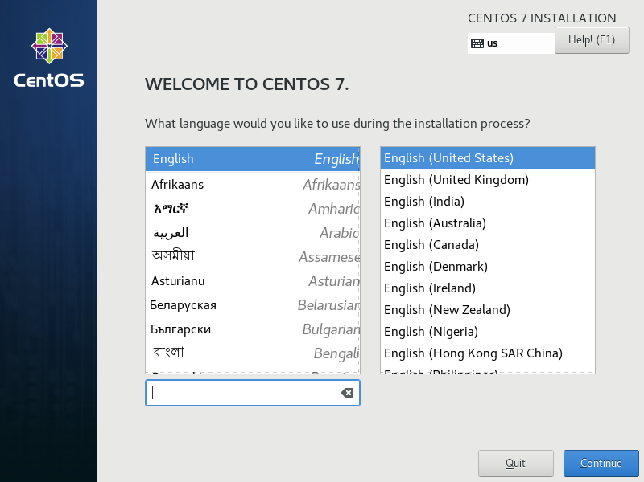
Step 5:
From the software selection select server with a GUI
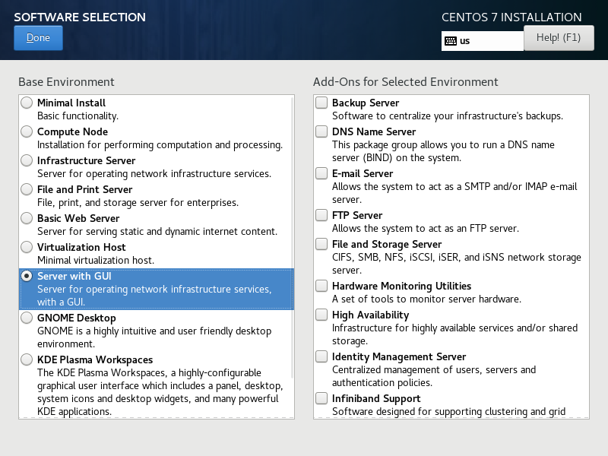

Step 6:
Select the volume for installing .in this installation we go for the entire disk guided partition

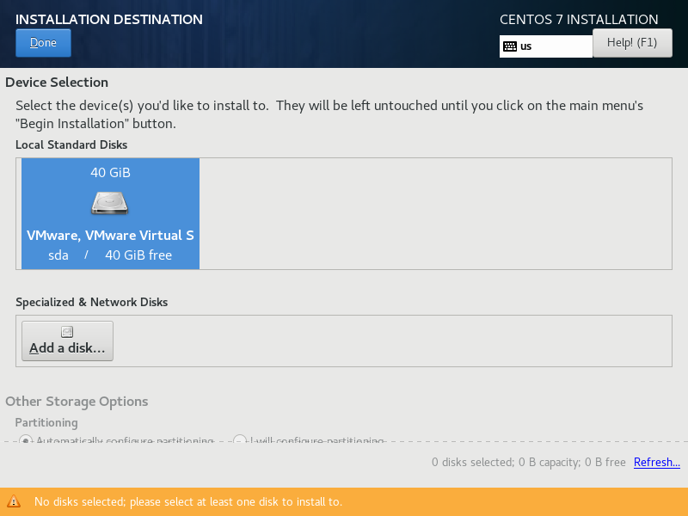

Step 7 :
Enter the root password and confirm it. and create a user and set password for the user

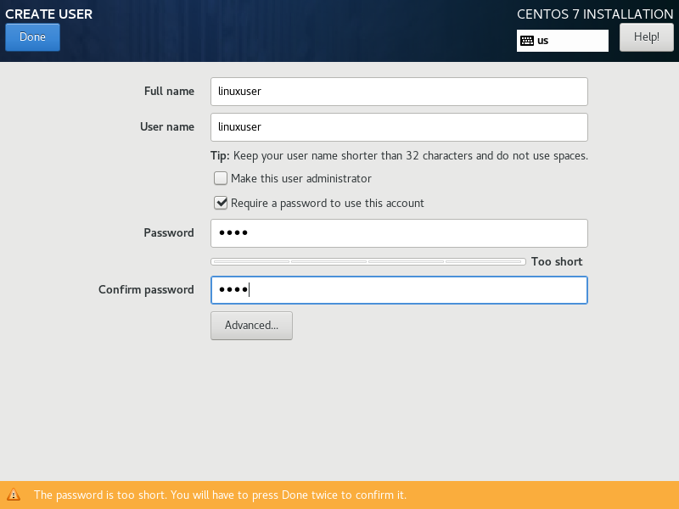

Step 7 :
wait for the installation to finished. After that reboot the system

Step 8 :
login with root credentials

SUMMARY:
we learn how to set up a Centos server on Vmware Virtual machine with Using guided partition.

***

COMMAND LINE IN LINUX
Every workstation version of linux has a Beautiful GUI(Graphical User Interface ) but most of the server Ubuntu ot CENTOS run on command line mode.you can add graphical user interface to that but without the command line you cant manage the server properly. Once you learn Command line you will find that it is more powerful and flexible for user to manage your server than a graphical mode.

WORKING AS ROOT

By default every linux OS creates a user root.Many operating system like CENTOS ask for a root password .But Ubuntu server don’t do that .There is a very good reason behind that .in Linux OS root has a limitless power .root can do anything ,change anything even can delete anything from the server .so it is very important to be careful when you work as root .Thats why in ubuntu server every time you do anything that need superuser privileges you use the command ‘sudo’ .This command allows the normal user so they can peform task that needs superuser privileges.you type sudo then your command it may ask for password after providing the password it will perform the action with the superuser privileges . But if you want the root shell then type this command
=> sudo su

But it is not recommended to work with the root shell .Do not use the root shell unless it is absolutely necessary . work with sudo if you need superuser privilege.

TERMINAL & SHELL

What is Terminal:
Terminal is a program that opens a window and lets you play with the shell. There are a bunch of different terminal emulators that you can see in the linux Distribution. such as Gnome terminal, konsole ,xterm, rxvt .nxterm ,eterm, Tilix etc. Terminal lets you interact with the shell
What is shell :
Shell itself is a program that takes command from the keyboard and gives them to the operating system to perform. You can work with the graphical user interface but if the server you are using has no graphical user interface this will be the only interface you got and you have to do all of your work in the CLI interface
there are different types of shell
* tsh → tsh is a shell with a scripting language similar to the C programming language
* sash → stand alone shell .its a very minimal shell runs almost every system .it is basically popular for troubleshooting the system
* zsh → zsh is a shell which is compatible with bash but has a lot of extra functionality
* fish → fish stands for friendly interactive shell .mostly popuar in desktop. It has a very good auto completion feature
* Bash → bash stands for Bourne Again Shell that is the enhanced version of the original UNIX program sh .it is written by the Steve Bourne. It is the most populer shell and the default shell of the most linux operating system.
We will use the Bash all over the example.

***

BASIC LINUX COMMANDS

These are the basic command to operate a linux operating system

Command name: ls
description:
ls command used to see the files and folder inside a directory . it is the most used command in linux.
syntax:
ls -[option] <directory>

1) ls -m will show the files and folder with comma

2) ls -a show the hidden files also

3) ls -l will show the files and folder in a listing format

4) ls -lh will show the file with listing and size

5) ls -i will show the list of files and folders with Inode

6) ls -t will show the modification time with directory listing

example:
[pic]

Command name: more
description:

It works like the more command .it also give scrolling options

syntax:
More <options> <file_name>

1) less -E : automatically exit the first time it reaches end of file.
2) less -f : forces non-regular file to open.
3) less -F : exit if entire file can be displayed on first screen
4) less -g : highlight the string which was found by last search command
5) less -G : suppresses all highlighting of strings found by search commands
6) less -i : cause sears line numbers
7) less -p <pattern> : it tells less to start at the first occurrence of pattern in the file
8) less -s : causes consecutive blank lines to be squeezed into a single blank line to ignore case
9) less -n : suppresses line numbers
10) less -p <pattern> : it tells less to start at the first occurrence of pattern in the file
11) less -s : causes consecutive blank lines to be squeezed
12) less -N : shows line number

example:
[pic]

Command name: strings
description:
To display the content of the file
syntax:
strings <filename>
example:
[pic]

Command name: tree
description:
To display the Directory stricture in a tree format
syntax:
Tree <directory>
[you may have to tool with package manager]

example:
[pic]
Command name: dir
description:
To display the files and folder inside the directory
syntax:
dir <directory_name>
[you have to install ‘tree’ tools before using this command]
example:
[pic]
Command name: cal
description:
To display the calendar
syntax:
Cal
cal <year>
cal <month> <year> command]
example:
[pic]
Command name: clear
description:
clear the screen
syntax:
clear
example:
[pic]
Command name: bc
description:
basic calculator
syntax:
bc
example:
[pic]
Command name: mkdir
description:
making directory
syntax:
mkdir <directory> : for making single directory
mkdir -p <directory/directory>:
for making recursive directory
example:
[pic]
Command name: rmdir
description:
Remove empty directory
[you cant remove any directory which has file in it with this command]
syntax:
rmdir <empty_directory>
example:
[pic]
Command name: file
description:
display the file type
syntax:
file <filename>
example:
[pic]
Command name: ln
description:
Create a link of the source filename.In case in hard link if you delete the main file link wont remove but in case of the soft link if you delete the main file the the linked file will be removed

syntax:
ln <option> <source_file> <shortcut_file>
ln -s : for creating soft link
ln -P : for creating hard link

example:
[pic]
Command name: history
description:
Shows users command history it will show the last 1000 command of the user you can set the limit if you like

syntax:
history

example:
[pic]
Command name: locate
description:
It will search the entire system for that file [you need to apply the command ‘updatedb’ for getting latest entry]

syntax:
Locate <file_name>

example:
[pic]
Command name: uname
description:
Show all the information about the kernel , OS and hardware-platform
syntax:
uname -a : all information, in the following order
uname -s :print the kernel name
uname -n : print host name
uname -r : print the kernel release
uname -v : print the kernel version
uname -m : print the machine hardware name
uname -p : print the processor type
uname -i : print the hardware platform
uname -o : print the operating system

example:
[pic]
Command name: tar
description:
For creating archive and extracting archive hardware-platform
syntax:
tar -cvf <archive_name> <source> : for creating archive
tar -xvf : for extracting archive

example:
[pic]

Command name: gzip
description:
For compressing normal file or archive file
syntax:
gzip <file_name>

example:
[pic]

Command name: gunzip
description:
It is used for uncompromising a compressed file

syntax:
gunzip <compressed_file>

example:
[pic]
Command name: lsmod
description:
Show a list of the modules used by the kernel
syntax:
lsmod

example:
[pic]
Command name: rmmod
description:
Delete any module used by the kernel
[not Recommended . don’t do it unless you are absolutely sure what you are doing ]

syntax:
mmod <module_name>
[you need to be a root user to perform this action]
rmmod-f , forces a module unload and may crash your machine. This requires Forced Module Removal option in your kernel. DANGEROUS

rmmod -v, enables more messages
rmmod -V, show version

example:
[pic]
Command name: modprobe
description:
Adding new module to the system

syntax:
modprobe <module_name>
example:
[pic]
Command name: ps
description:
See the current running process of the system
syntax:
ps
example:
[pic]

Command name: top
description:
Top command is used for process monitoring.
[more information about top in Process management]
syntax:
top
example:
[pic]

Command name: renice
description:
Used for changing the priority of a process running on a system. [more info in process management chapter]
syntax:
renice -n <priority> -p <pid
example:
[pic]
Command name: kill
description:
Used for terminating process for this purpose
syntax:
Kill -<sigterm> -p pid
example:
[pic]
Command name: uptime
description:
Shows the system’s running time. and load averages of previous 1 minute ,5 minute and 15 minute.
[this information can be found in top and htop command also]
syntax:
uptime
example:
[pic]
Command name: iostat
description:
Shows the Cpu and I/O information
[more information in process management Devices ]
syntax:
1) Iostat -c : generate cpu status only
2) iostat -d : generate I/O statistics for all the devices
3) iostat -x : generate detail I/O statistics
4) iostat -x : generate detail I/O statistics and CPU information
5) iostat -p <devices> : generate details for that specific devices
6) iostat -m : generate statistics in Megabyte
7) iostat -k : generate statistics in Kilobyte
8) iostat -N : generate LVM options
9) iostat -t : generate statistics with timestamp
10)nfsiostat : Shows information of NFS devices
example:
[pic]
Command name: hostnamectl
description:
Display hostname and its related settings also change hostname and its related settings
syntax:
Hostnamectl : provide information about current host and its properties

hostnamectl set-hostname <hostname> :It will change the hostname

example:
[pic]
Command name: pwd
description:
Print the current directory path
syntax:
pwd

example:
[pic]

Command name: dmesg
description:
Display the detected hardware status during boot time
[the file location is ‘var/log/dmesg’]
syntax:
dmesg

example:
[pic]
Command name: init
description:
Display the detected hardware status during boot time
[the file location is ‘var/log/dmesg’]
syntax:
Init <run_lavel>

0 :Power-off the machine
6 :Reboot the machine
2, 3, 4,5 :start runlevel X.
1, s, S :Enter rescue mode
q, Q : Reload init daemon configuration
u, U :Reexecute init daemon

example:
[pic]
Command name: mkswap
description:
Used to format the partition used for swap space
syntax:
mkswap <file_system>

example:
[pic]
Command name: swapon
description:
To activate the swap space
syntax:
swapon -a <file_system>:
[enable all swaps from /etc/fstab]

example:
[pic]

Command name: swapoff
description:
To deactivate the swap partition
syntax:
swapoff <file_system>

example:
[pic]
Command name: mkfs
description:
To format the partition this tools is used
[more information about file system]
syntax:
mkfs -t <fs_type> <file_system>
To format the partition this tools is used
[more information about file system]
1) mkfs.ext2 /dev/sdx: for ext2 file system
2) mkfs.ext3 /dev/sdx:for ext3 file system
3) mkfs.ext4 /dev/sdx: for ext3 file system
4) mkfs.minix /dev/sdx :for minix file system
5) mkfs.xfs /dev/sdx :for xfs file system

example:
[pic]
Command name: poweroff
description:
power off the machine
syntax:
poweroff

example:
[pic]
Command name: whoami
description:
Display the username which is currently logged in
syntax:
whoami

example:
[pic]
Command name: wc
description:
Used to find out number of lines, word count, byte and characters count in the files specified in the file arguments

syntax:
1) wc <file_names>
2) wc -m <file> : print the character in in the file
3) wc -w <file> : print the word in in the file
4) wc -l <file> : print the line in in the file

example:
[pic]
Command name: w
description:
Used to show who is logged in to the computer and what they are doing

syntax:
w

example:
[pic]
Command name: arch
description:
Display the computer architecture

syntax:
arch
example:
[pic]
Command name: alias
description:
Instructs the shell to replace one string with another string while executing the commands

syntax:
Alias <string>=’<target straing>’
example:
[pic]

Command name: bg
description:
Used to send any foreground job to background
syntax:
bg
example:
[pic]
Command name: cp
description:
Used to copy a file or a group file from one destination to other
syntax:
cp <source_file> <target_destination>
example:
[pic]
Command name: echo
description:
Used to display line of text/string that are passed as an argument
syntax:
echo <arguments>
example:
[pic]
Command name: fdisk
description:
Format disk as well as creating and manipulating disk partition table
[more information in disk management chapter]
syntax:
fdisk <file_system>
example:
[pic]
Command name: cfdisk
description:
Format disk as well as creating and manipulating disk partition table using a text based GUI interface
[more information in disk management chapter]
syntax:
sudo cfdisk
example:
[pic]

Command name: lsblk
description:
Displays the total amount of free space available along with the amount of memory used and swap memory in the system
syntax:
lsblk
example:
[pic]
Command name: lsmod
description:
List the current kernel modules that are currently loaded
[it actually print the content of the ‘/proc/modules’ with a nice format]

syntax:
lsmod
example:
[pic]
Command name: lspci
description:
Display the information about the currently connected PCI Buses .
[list of devices that are connected to the computer]
syntax:
lspci
example:
[pic]
Command name: lshw
description:
List all the Details information of the hardware of the computer
syntax:
lshw
example:
[pic]
Command name: lshcpu
description:
Display the detailed information about the CPU
syntax:
lscpu
example:
[pic]
Command name: man
description:
Display the reference of the tools or command that are you using
syntax:
man <command>
example:
[pic]
Command name: sudo
description:
give you the superuser privileges
syntax:
sudo <command>
example:
[pic]
Command name: ip
description:
Used for performing several network administration tasks
syntax:
Ip <option> <command>
example:
[pic]
Command name: touch
description:
Create an empty file
syntax:
touch <file_name>
example:
[pic]
Command name: ifconfig
description:
shows the ip address related information
syntax:
ifconfig
example:
[pic]
Command name: gerp
description:
global regular expression used for searching keyword
syntax:
ls | grep initrd
example:
[pic]
Command name: wget
description:
interactive cli based downloader
syntax
wget <download_url>
example:
[pic]
Command name: reboot
description:
reboot the system
syntax
reboot
example:
[pic]
Command name: ping
description:
test any host or network which is alive physically and logically

syntax
ping <pi_address/domain_name>
example:
[pic]
These are the basic commands to run a linux system .There are a lot of command more to maintain the server.

***

ip addressing

COMPUTER NETWORK

A computer network is a group of computer and other computing peripherals that linked together through some kind of communication channels to communicate with each other and share their resources among a width range of users.

Their jobs are

1) Facilitate communication via email,file server,web server,instant messaging etc
2) Share resources of the hardware like printer or scanner
3) Enable File sharing
4) create a centralized control among the total network

TYPES OF COMPUTER NETWORK

Network Basically divided into three groups:
1) Local Area Network (LAN)
2) Metropolitan Area Network (MAN)
3) Wide Area Network (WAN)

LAN
A local area network (LAN) within a small area like home,school,office or group of buildings. They can share their resources and device like printer and scanner and data storage. Most of them are centrally organized. And because of the type of the communication the data transfer rate is very high. And local area network does not need any leased communication line

MAN

A metropolitan area network (MAN) spans an entire campus by connecting multiple LAN. MAN is larger than the LAN, because it consists of a number of LAN .MAN works like more of a ISP but it does not owned by a single organization. instead MAN provides a shared network connection to all its users

WAN

A wide area network (WAN) within a large scale of geographical area is called WAN. It is created by connecting different LAN from a long distance. And the transmission speed generally is slower than the LAN or MAN but the data transfer rate is increasing .

TCP/IP PROTOCOL SUITE

A majority of the internet users use a protocol suite called Internet protocol suite which is also known as the TCP/IP protocol suite.The two protocols are TCP (Transmission control protocol) & IP (internet protocol).In here TCP is a connection oriented protocol means it transmit data in a sequence and it has a acknowledgment process. If the acknowledgment are not recived

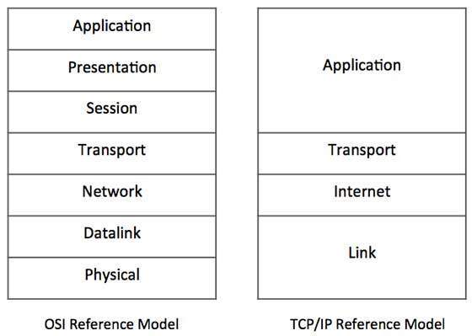

then the data will be re transmitted it can guarantee the delivery of the data to the host and IP is used to maintain the address of the specific host.

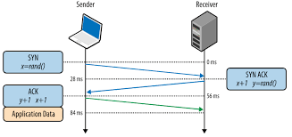

IP Addressing

IP addressing is the most important topic in the networking.ip address is basically a numeric identifier that used to identify a Machine .Ip address is a software address not a hardware address that means it can change depending on the network you are connected.The hardware address is the NIC address thats called the Physical address that cant be changed.

Important Clement of a IP address

Bit: Bit is one digit either 0 or 1

Byte: made up with 8 bits its just a ordinary 8 bit binary number.

Network Address : Network address is used send packets to the network .for example 10.0.0.0,192.168.0.0 etc

Broadcast Address : It is used by the host to send information to all the nodes on a network. The address are like 192.168.0.255,172.166.255.255

Every ip address there are two different parts

1) Network part
2) Host Part

Every ip address gives the information about the network and the hosts

Subnet Mask

A subnet mask is a 32 bit umber that masks an ip address and devides the ip address to a network address and hosts address.
Is is done by setting all the network bits to ‘1’ and setting hosts bit to ‘0’

[Two host ip address are reserved for special purpose The ‘0’ address and the ‘255’ address.the ‘0’ address is reserved for the Network .so if any ip address have a ‘0’ on its last its a network address. and ‘255’ is the broadcast address they cant be assign to a host]

5 types of IP address:

1) class A ip address
2) class B ip address
3) class C ip address
4) class D ip address
5) class E ip address

Class A ip address:

In class A ip address the first byte is reserved for the network address and three remaining bytes are for the hosts.
[it starts with 0.0.0.0 and ends with 127.255.255.255]
subnet mask: 255.0.0.0

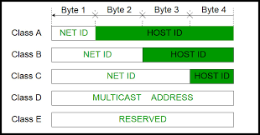
It has a small network with huge number hosts.

Class B ip address:

In class A ip address the first two bytes is reserved for the network address and two remaining bytes are for the hosts. More network less hosts
[it starts with 128.0.0.0 and ends with 191.255.255.255]
subnet mask : 255.255.0.0

Class C ip address:

class C ip address the first three bytes is reserved for the network address and remaining one bytes are for the hosts. If you need a lot of network and small number of hosts in every networks class C ip address is used.
[it starts with 192.0.0.0 and ends with 223.255.255.255]
subnet mask : 255.255.255.0

Class D ip address:

class D ip address is a special address. Its called a multicast address. It is basically used for finding router
[it starts with 224.0.0.0 and ends with 239.255.255.255]

Class E ip address:

Reserved for the Scientific Experiment

Private IP address:

Not all the address of these class is used for public network .some are not routable through the internet.private ip address is used in the Localy and a local ip address can connect to the internet through a public ip address with NAT (Network address translation).NAT allows a public address to the internet

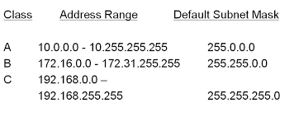

Loopback address

Loopback address is used to test the communication on a local NIC (Network Interface Card) .Data packets are sent by the node in the loopback address are re-routed back into the same node.It is used for testing the connected physical network. it also enables the user to test an application with an instance of server and client on the same machine.we call it localhost

it starts with 127.0.0.0 and ends 127.255.255.255

Ping

ping stands for Packet Internet Gopher is a ICMP echo request and reply message that used to check the physical and logical connectivity of the machine on a internet network.

Traceroute

Traceroue is used to find the path of the packet traverses through the internet.

***

SETTING STATIC IP IN CENTOS7
EASY WAY

Every Server needs to have a network connection. without a static ip address you cant run a server .Giving a server a static ip address is the most important thing to do.

When you install a server the most of the time your installer automatically configure your server network and gets the ip address from a DHCP server. But to run a server you need a static ip address. So we need to change its network from DHCP to static and give the server a static ip address .Here we talk about how to give static ip address to a centos7/Redhat7 server.

There are multiple way to give server static address ,Here we talk about easy method

first step

you need to select a static ip address , subnet mask and the gateway that you give your machine .according to your network specifications.

In his example we used a virtual centos7 box . And we give the following ip address subnet mask ,gate way and DNS

ip address : 192.168.0.10
subnet mask: 255.255.255.0
Gateway:192.168.0.1
DNS: 8.8.8.8

second step

you need to find the network interface that you give the static ip address
A Server can have multiple network interface.

In our virtual machine there are two network interface. We can see the interface from this command

=>ifconfig
or
=> ip address show

result:

we are currently connected to the server with a ssh connection through eth0.So we cant change the ip address to eth0.this will disconnect the ssh connectivity .we are going to give the static ip address to the eth1 interface

Third step

use the nmtui command and you have to be root to give this command

=>sudo nmtui

After giving this command this screen appear. From there Select The “Edit a connection”

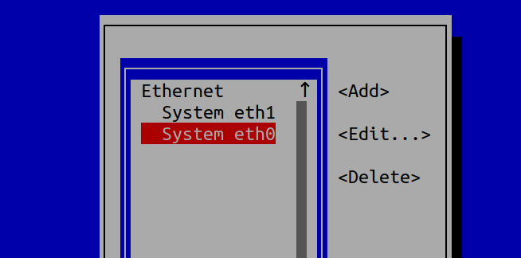

Fourth step

it will show you all the interface .choose your interface in this case we will choose eth1.
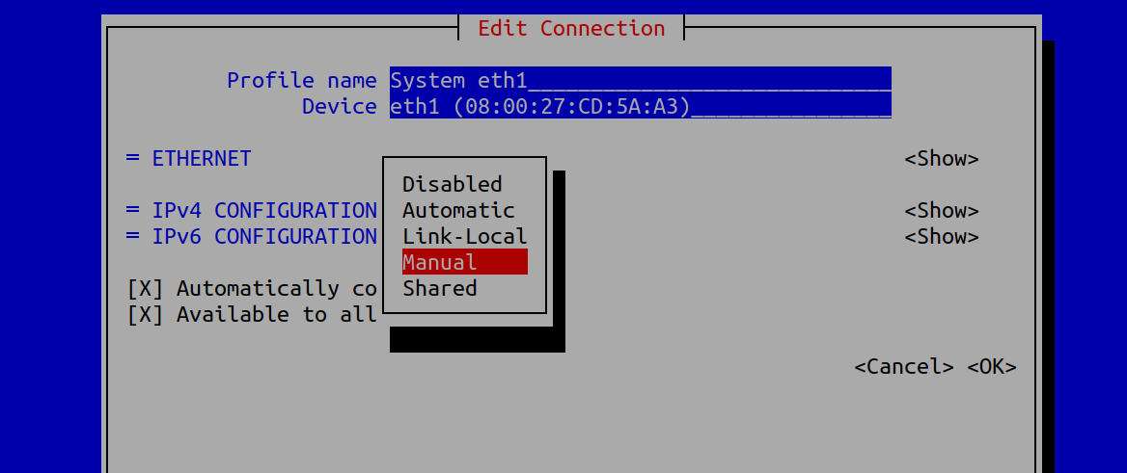

Fifth step

we choose the ipv4 and from the option we choose ‘manual’ and Edit the menu

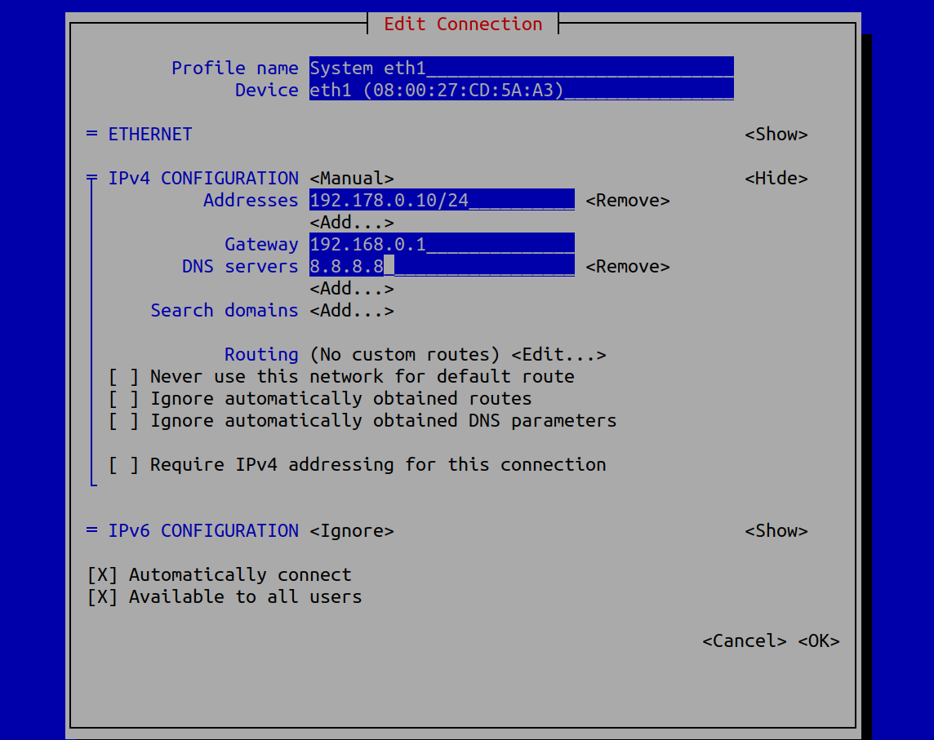

Sixth step

we give the ip address.we have to give the subnet mask with CIDR notation.
Gateway and the The DNS address and click ok. Then quit the program.

Seventh step

if we see our ip address we can see the the ip address still dont change.to make the change we need to restart the interface.

We shutdown the interface with this command

=>sudo ifdown eth1

Then we start the interface again

=>sudo ifup eth1

Eighth step
Then if we check ip address using
=>ifconfig eth1

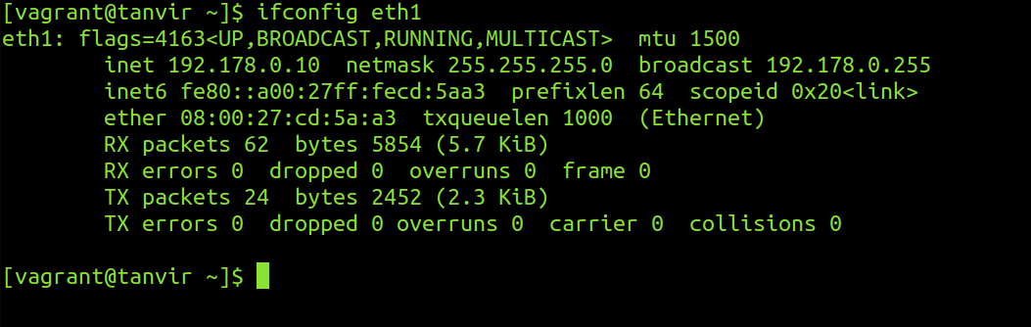
we can see the ip address changed .

Ninth step

We have to test the connection via pinging a network.

=>ping 8.8.8.8

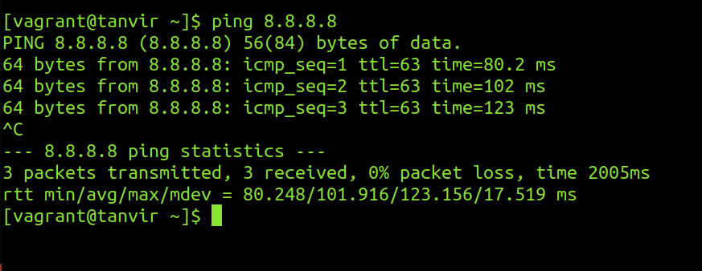

So the connection is up and running. Thats is the easy way of giving an ip address to a cenos7/Redhat7 server a static address.

TRADITIONAL WAY

first step

you need to select a static ip address , subnet mask and the gateway that you give your machine .according to your network specifications.

we give the following ip address subnet mask ,gate way and Dns

I p address : 192.168.0.10
subnet mask: 255.255.255.0
Gateway:192.168.0.1
DNS: 8.8.8.8

second step

you need to find the network interface that you give the static ip address
A Server can have multiple network interface.

In our virtual machine there are two network interface. We can see the interface from this command

=>ifconfig
or
=> ip address show
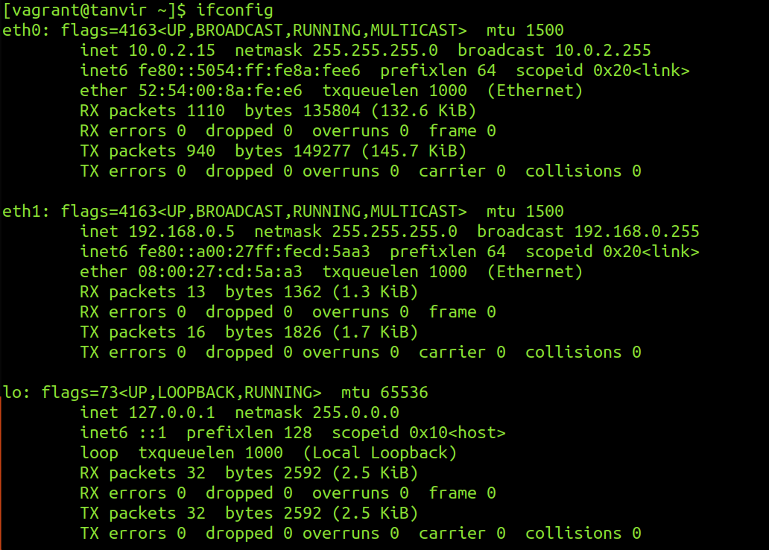

we are currently connected to the server with a ssh connection through eth0.So we cant change the ip address to eth0.this will disconnect the ssh connectivity .we are going to give the static ip address to the eth1 interface

Third step

we have to do to the ‘/etc/sysconfig/network-scripts’ directory

=> cd /etc/sysconfig/network-scripts

In this directory There are a lot of files .From there we have to select the ‘ifcfg-eth1’ [yours can be different .select the file based on your interface it will be like ifcfg-<interface>]

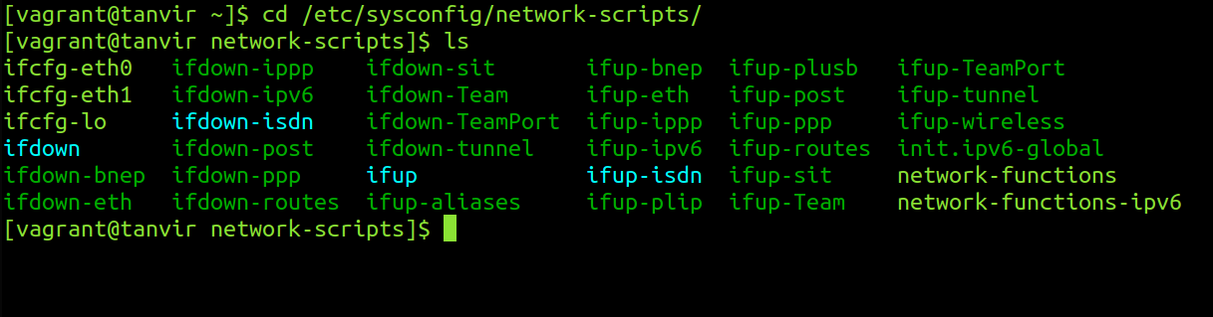

Fourth step

we have to edit the file with a text editor with root privileges.
We have to edit the file ifcfg-eth1
=>vim ifcfg-eth1

BOOTPROTO=static
ONBOOT=yes
IPADDR=192.168.0.10
PREFIX=24
GATEWAY=192.168.0.1
DNS1=8.8.8.8
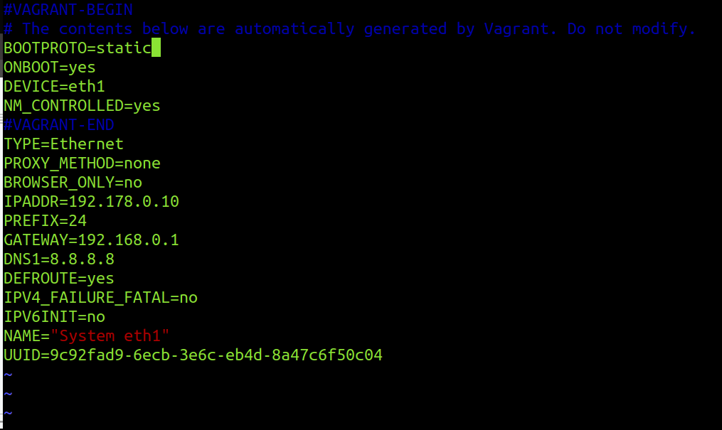

fifth step
if we see our ip address we can see the the ip address still dont change.to make the change we need to restart the interface.

We shutdown the interface with this command

=>sudo ifdown eth1

Then we start the interface again

=>sudo ifup eth1

Sixth step
Then if we check ip address using
=>ifconfig eth1

we can see the ip address changed .

Seventh step

We have to test the connection via pinging a network.

=>ping 8.8.8.8

So the connection is up and running. Thats is the another way of giving an ip address to a cenos7/Redhat7 server a static address.

***

SETTING STATIC IP IN ubuntu
EASY WAY

Setting the ip address in a debian machine with a easy method
You have to follow these steps

first step

you need to select a static ip address , subnet mask and the gateway that you give your machine . according to your network specifications.

In his example we used a virtual debian box . And we give the following ip address subnet mask , gateway and Dns

ip address : 192.168.0.10
subnet mask: 255.255.255.0
Gateway:192.168.0.1
DNS: 8.8.8.8

second step

you need to find the network interface that you give the static ip address A Server can have multiple network interface.
In our virtual machine there are two network interface. We can see the interface from this command

=>ifconfig
or
=> ip address show

result:

we are currently connected to the server with a ssh connection through eth0.So we cant change the ip address to eth0.this will disconnect the ssh connectivity .we are going to give the static ip address to the eth1 interface

Third step

use the nmtui command and you have to be root to give this command

=>sudo nmtui

After giving this command this screen appear. From there Select The “Edit a connection”

Fourth step
it will show you all the interface .choose your interface in this case we will choose eth1.

Fifth step

we choose the ipv4 and from the option we choose ‘manual’ and Edit the menu

Sixth step
we give the ip address.we have to give the subnet mask with CIDR notation.
Gateway and the The DNS address and click ok. Then quit the program.

Seventh step
if we see our ip address we can see the the ip address still dont change. to make the change we need to restart the interface.

We shutdown the interface with this command

=>sudo ifdown eth1
or
=>nmcli connection down eth1

Then we start the interface again

=>sudo ifup eth1
or
=>nmcli connection up eth1

Eighth step

Then if we check ip address using
=>ifconfig eth1

we can see the ip address changed .

Ninth step

We have to test the connection via pinging a network.

=>ping 8.8.8.8

So the connection is up and running. Thats is the easy way of giving a static ip address to a Ubuntu/Debian server

NETPLAN

New version of ubuntu linux has a new tools for setting ip address .This is called netplan. now its a little bit hard because you have to maintain indentation and certain rules to give it.and the main challenge is you have to do it by editing a file

First step

The network configuration stored in ‘/etc/netplan’ directory

Second step

There are different ‘yaml’ configuration file for different interface .in my VM there are two different interfaces. so there are two different interfaces. you have to configure the configuration file based on what interface you want to configure

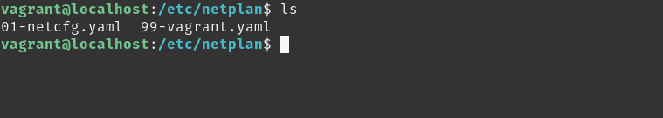

Third step [very very important !!!]

you mast take backup before you edit the file

=>cp 99-vagrant.yaml 99-vagrant.yaml.bak

[this is very very important cause if you make mistake in the indentation you have to]

Fourth step

Edit the file
=>sudo vim 99-vagrant.yaml

the file format will be like this

# the datasource. Changes to it will not persist across an instance.
# To disable cloud-init's network configuration capabilities, write a file
# /etc/cloud/cloud.cfg.d/99-disable-network-config.cfg with the following:
# network: {config: disabled}
network:
ethernets:
eth1:
addresses: []
dhcp4: true
version: 2

the ip address we assign will be

ip address : 192.168.0.102
subnetmask : 255.255.255.0
gateway : 192.168.0.1
dns : 8.8.8.8,8.8.8.4

Fifth step

Fill like this

# the datasource. Changes to it will not persist across an instance.
# To disable cloud-init's network configuration capabilities, write a file
# /etc/cloud/cloud.cfg.d/99-disable-network-config.cfg with the following:
# network: {config: disabled}
network:
ethernets:
eth1:
addresses: [192.168.0.102/24]
gateway4: 192.168.0.1
nameservers:
addresses: [8.8.8.8,8.8.4.4]
dhcp4: no
version: 2

Sixth step

find error

=>sudo netplan -debug apply

Seventh step

apply the changes

=>sudo netplan apply

that is the new way of giving static ip address

***

Package management in linux

As a server administrator you will need to install different software on your server on different occasion .Most of the Linux operating system(Ubuntu Server/Centos server/Open SUSE server) has two different ways of installing software. First are the software packages that contain the programs that are ready to install and that integrate with the server easily. The server keeps the list of installed packages in the database that makes maintaining very easy. The second option to install software in via tarball. Which basically just an archive of the software. Archive can be anything (can be any record of the data) but it can b also used to deliver software. The first method is proffered most of the time Because server can keep track of the software that are installed via packages .Software installed via tarball are not tracked. There is a second difference between packages and tarballs that some software need other packages for working properly (this is called dependency).both tarball and packages have program installed that check if the dependencies are met but only the software packages interact with the package manager. And in that way it can install the missing dependencies which other installation system cant do. So now a days software packages are preferred. Software packages mostly made in two different formats .On Red Hat and openSUSE and similar distribution rpm packages is used .And debian based operating system like ubuntu server deb package is used.But this packages can be converted. And the other advantage is software can be install by compiling the source code too.

High level and Low level Pckage management Tools

in order to interact with the software packages there are two types of available tools. low level package management also known as local package management system. and the high level tools are known as online package management tools.

Distribution | Low-Level Tools | High Level Tools
Debian based distribution | dpkg | apt/aptitude
Centos/Red Hat | rpm | yum
Open SUSE | rpm | zypper

[do not use red hat rpm file in openSUSE system]

If you already download or create your own .deb package you can manage it with dpkg command.

UBUNTU PACKAGE MANAGEMENT

Installing package with dpkg

For installing packages with dpkg . command is

=>dpkg -i <package_name>

List of current package:

To list all the current packages that are currently installed in Ubuntu server the command is
=>dpkg -L

it will show the name,version,architecture and a small description

Check packages installation status

if you need to know any packages installed or not then following command can show if the package installed or not

=>dpkg –get-selections <package_name>

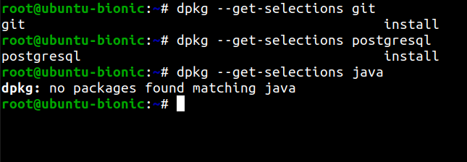

Check Details information about packages:

To check details about a installed packages use this command

=>sudo dpkg -s <package_name>

Disadvantage of dpkg:

suppose we want to install a downloaded packages webmin.deb. We will show some dependency problem like this and it install the program without the dependency and the program wont run you have to install dependency manually the other dependencies that's a big complexity .If you remove the program it still create the problem if you try to install other program.

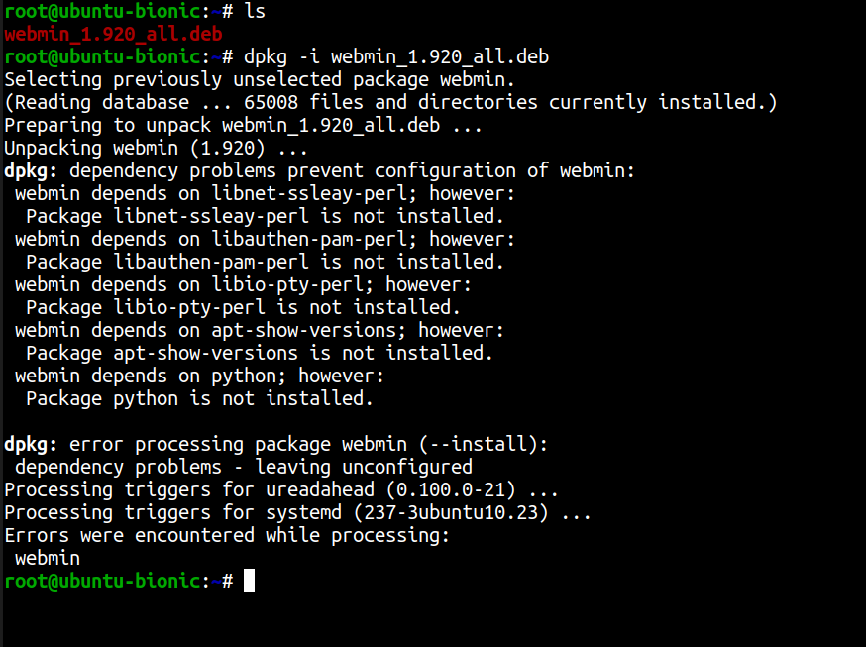
[To fix this problem we can use the online package management system
=>sudo apt-get install -f
it will search the dependencies and install them

Remove packages:

to remove packages from the system this command is used

=>dpkg -r <package_name>

Completely remove package and configuration file:

to completely remove package and the related configuration file this command is used

=>dpkg -P <package_name>

If you find a file and want to know which package it belongs to use this command

=>dpkg -S <file_path>
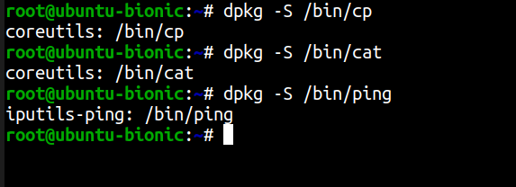

Reconfigure packages:

if you face any problem in your package configuration. You can reconfigure the package with this command
=>dpkg-reconfigure <package_name>

But to do this you need to know the exact name of the package. It will automatically rewind the installation process and give you chance to reconfigure.

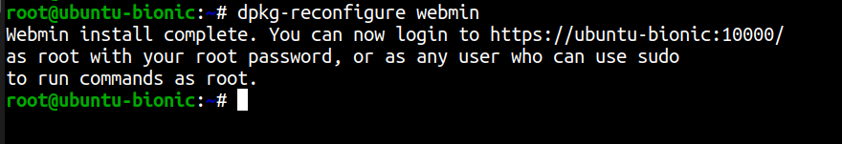

Installing packages with apt

The apt utility is a powerful and free package management command line program, that is used to work with Ubuntu’s APT (Advanced Packaging Tool) library to perform installation of new software packages, removing existing software packages, upgrading of existing software packages and even used to upgrading the entire operating system

On ubuntu server or any debian based OS there is a list repository url which is populated during the installation in ‘/etc/apt/sources.list’ but you can add repository.

Update repository:

Before installing any package you need to update the software repository.
Command
=>sudo apt update

[you need to be root to perform the action]

Upgrade existing Software:

To upgrade every package in the latest version use this command
=>sudo apt upgrade

Update OS distribution

to upgrade the distribution for example upgrading ubuntu 16.0 to ubuntu latest version this command is used

=>sudo apt dist-upgrade

Install Packages

for installing packages this command is used
=>sudo apt install <package_name>

for example
to install vim editor we use this command
=>sudo apt install vim

Remove Packages

for removing packages this command is used
=>sudo apt remove <package_name>

for example
to remove vim editor we use this command
=>sudo apt remove vim

[this command will remove the packages but not the dependencies .To remove this command is used
=>sudo apt autoremove

apt-cache command

The apt-cache command line tool is used for searching apt software package cache. In simple words, this tool is used to search software packages, collects information of packages and also used to search for what available packages are ready for installation on Ubuntu based systems.

Apt-cache search command

=>sudo apt-cache search <package_name>

This command show all the program will show all the program that depends on the packages. suppose you install gmail packages this command

=>sudo apt-cache search gmail
will show all the packages that are depends on this packages like ‘thunderbird’

Package Details

You can also see the details of any packages with apt just like the dpkg -s.
command

=>sudo apt-cache show vim

Find Unmet Dependencies:

This command will find all the unmet dependencies of the system

=>sudo apt-cache unmet

Find Specific Dependency of Packages:

=>sudo apt-cache depends <package_name>

This command will give all the dependencies of the Packages.

Find Reverse Dependencies:

=>sudo apt-cache rdepends <package_name>

This command will find the reverse dependencies of the program .That means it will show all the packages that depends on that packages.

For example:
=>sudo apt-cache rdepends git

this command will show all the other program that depends on the git program.

Aptitude package management tool:

There is a new package management tools called aptitude. to use that first you have to install it with this command

=>sudo apt install aptitude

Install package via aptitude:

installing command with aptitude is

=>sudo aptitude install <package_name>
example:
=>sudo aptitude install emacs

Search package via aptitude

For searching any packages this command is used

=>sudo apttitude search <package_name>

The main advantage of the aptitude is when you run the aptitude program without any flag

=>aptitude

this will open a menu based installer inside the terminal. That means you will get almost a gui based installer inside a terminal.

Graphical Package management System:

If you want to use a graphical Package management system you can use synaptic package management software. its very easy to install,remove,and
upgrade packages with synaptic package management.

Apt Repository:

when we install or search a package with apt command it will search some online repository for that packages. The list of that url is stored in a file
‘/etc/apt/sources.list’ and the file contained in ‘/etc/apt/sources.list.d’

if we see the ‘sources.list’ file with this command

=>cat /etc/apt/sources.list
we will see something like this

the information available from the configured sources is acquired by ‘apt update’ or equivalent command from another apt fronted.
Users can manually add repository url in that file. after adding repository you have to issue ‘apt update’ command to make it available for using.

Or you can just create a file in /etc/apt/sources.list.d directory.The file must be end with .list extension. The apt package manager also read repository configuration from there

for example:
first open a file with vim editor inside the sources.list.d repo

=>vim /etc/apt/sources.list.d/games.list

add the repository path in that file

deb http://archive.getdeb.net/ubuntu wily-getdeb games

Or user can add repository by interactive command.
Use the add-apt-repository (or symlink apt-add-repository) command to add repository. You just need to provide reference address as the following command.
=>add-apt-repository 'deb http://archive.getdeb.net/ubuntu wily-getdeb games'

to remove any repository from by using this following command
=>add-apt-repository -r 'deb http://archive.getdeb.net/ubuntu wily-getdeb games'

[every time you make a change to repository you must apply ‘apt update’ command to make the change on effect ]

CENTOS PACKAGE MANAGEMENT

Rpm (Red Hat Package Manager)and Yum(Yellowdog Updater Modified) package management tools are basically Centos/Redhat,fedora like Operating system.

Like dpkg in debian based OS. Rpm is the local package management tool(low level package management tool).and Yum is the online package management tool(high level package management tool).Yum is like apt in ubuntu OS.

[just like the dpkg the rpm command may face dependency problem while installing software .and yum search the dependency automatically and install them.]

rpm package management

Install package:

For install package with rpm this command is used

=>rpm -i <package_name>

remove package

For remove this package with rpm this command is used
=>rpm -e <package_name>

[if one package depends on the other package you cant remove it with rpm command unless you remove the other packages that depends on it. For example if you want to remove the ‘openssh’ package because the ‘open-ssh client’ packages depends on it .First you have to remove this. But if you use the yum command to remove the any packages this will happen automatically.]

Force Install package:

if you want to install a packages with or without the dependency (force install) you can do it with this command

=>rpm -i –nodeps <package_man>

[its not recommended because it leaves you a broken dependency problem ]

Verbosity:

if we want to see whats happening when installing or removing we can use the verbosity flag.

Install package with verbosity flag

=>rpm -i -v <package_name>

Remove package with verbosity flag

=>rpm -e -v <package_name>

Check Package install Status:

if you want to check is a package is installed or not .you can do with this command

=>rpm -Vv <package_name>
for example

=>rpm -Vv nano-2.3.1-10.el7.x86_64.rpm

[if you want to find out that your package is intact you can find it by checking the output flag. Because if you change any configuration and run the command again it will show you different result. That proves that file is changed]

Check Package Checksum:

To check the file checksum this command is used

=>rpm -vK <package_name>

Find Package Description:

To find the description of any installed package this command is used

=>rpm -qi <installed_package>
for example

=>rpm -qi nano

Query All Packages:

To query all the packages this command is used

=>rpm -q -a

you can find any installed packages with this command
=>rpm -q -a | grep <packages_name>
example
=>rpm -q -a | grep dhcp

Yum package management:

yum(Yellowdog Updater Modified) is more advance package management tools you can do everything with yum that can be done with rpm.yum uses a lot of third party repository to install packages automatically by resolving their dependency issue

Find Package information:

To find detail information about any packages this command is used .it will search the repository and give detail information about the packages.

=>yum info <package_name>

Search package:

To search the packages in the repository this command is used

=>yum search <package_name>

Install package:

To install packages this command is used.it will install the packages with the dependency

=>yum install <package_name>

This command will ask for confirmation. to install automatically. Just add a -y option .

=>yum install -y <package_name>

Remove package:

To remove package with all its dependencies this command is used.

=>yum remove <package_name>

This command will ask for confirmation. to install automatically. Just add a -y option .

=>yum remove -y <package_name>
or
=>yum erase -y <package_name>

Update package:

If you have any outdated version of any packages and you need to update it. you can use the update command to update to its latest stable version. If it needs any additional dependency it will automatically resolve them
=>yum update <package_name>

List packages:

To list all the available packages in the Yum repository this command is used

=>yum list | more

To list all the installed packages this command is used

=>yum list installed

you can use the list function as a searching purpose .for searching packages this command is used

=>yum list <package_name>

Yum provides function:

if you find any program or any files and want to find out which packages it belongs to. You can find it with this command

=>yum provides <file_name/program_names>

Check update packages:

If you want to check weather any update available for your installed packages you can check using this command
=>yum check-update

Update system:

If you want to update all your packages and system and install all the latest patches and security updates in your system this command is used

=>yum update

[one of the main advantage of the yum over the apt command is before installing any packages yum will automatically update the repository ]

List all the group packages:

Number of packages are bundled up to make a particular group. Instead of installing individual packages you can install the whole particular group. To list all the group this command is used

=>yum grouplist

Install group packages:

To install a particular package group we use the groupinstall.

=>yum groupinstall ‘<group package name>’

for example

=>yum groupinstall ‘Basic Web Server’

Update group packages:

To update a particular package group we use the groupupdate.

=>yum grouupdate ‘<group package name>’

for example

=>yum grouupdate ‘Basic Web Server’

Remove group packages:

To remove a particular package group we use the groupremove.

=>yum groupremove ‘<group package name>’

for example

=>yum groupremove ‘Basic Web Server’

List Enabled yum repository:

To list all the enabled yum repository this command is used

=>yum repolist

List All yum repository

To list all the enabled and disabled yum repository this command is used

=>yum repolist all

List packages from a particular repository:

To install a packages from a particular repository this command is used

=>yum –enablerepo=epel install java

[This command wont enable the repository parmanently.its only for the current command]

Permanently Enable/Disable a particular repository:

To enable a repository permanently this command is used

=>yum-config-manager –enable <repo_name>

[This command will enable the repository permanently]

To disable a repository permanently this command is used

=>yum-config-manager –disable <repo_name>

[This command will disabled the repository permanently]

Clean yum Cache

To clean all the cached files from enabled repository this following command is used.

=>yum clean all

View History

To view all the past transactions of the yum command this following command is used

=>yum history

Yumdownlaoder

there is another tools called ‘yumdownloader’ in the redhat/centos based system. The job of this tools is to download the rpm file. Means it just download the rpm file but doesn't install it. The following command is used to download rpm file

=>yumdownloader <pakage_name>

for example

=>yumdownloader git

it will install the git.rpm file but it wont download the dependency. To download any package with the dependencies this command is used

=>yumdownloader --resolve <pakage_name>

for example

=>yumdownloader --resolve git

Yum Repository

just like the ‘sources.list’ file in the ubuntu package management there is also a place where the repository files stored.its in the ‘/etc/yum.repos.d’
we can list all the files with the ‘ls -s’ command.you will see something like this

there can be more than one .repo file if you look inside the file with this command

=>cat repofile.repo

example
=>cat CentOS-Base.repo

if you look inside the file it will like the ‘sources.list’ . Just a little bit different

There are different different mirror list for ‘base’,’updates’,’extras’ and additional ‘packages’ and every section has a

1) name for the mirror list
2) baseurl for that mirror
3) gpgcheck option
4) enable option
5) gpgkey

if you want you can disable the gpgcheck cause the the repository may not be encrypted.

there is a configuration file in /etc/yum.conf .By changing the configuration you can customize the operation of the yum tools.

=>keepcache=0 will not keep the cache file
=>logfile=’/var/log/yum/log’ will store the log file in that file
=>obsolute=1 delete the obsolete packages
=>gpgcheck=1 will check gpg every time it install packages
=>plugins=1 will allow yum to install plugins

[yum uses different plugins. one of them is fastest mirror.it founds the fastest mirror so the user find the packages as fast as possible]

Comparison Between two Package management system

Operation | Debian package management | Centos package Management
Show package information | sudo apt show <pkg>  sudo dpkg -s <pkg> | sudo yum info <pkg>  sudo rpm -qi <pkg>
List all the packages | Sudo apt list  sudo dpkg -L | Sudo yum list  sudo rpm -q -a
Download Packages | sudo apt download <pkg> | Yumdownloader <pkg>  Yumdownloader –resolve <pkg>
Search packages | sudo apt search <pkg>  sudo aptitude search <pkg> | Sudo Yum search <pkg>
Install packages | Sudo apt install <pkg>  sudo aptitude install <pkg>  sudo dpkg -i <pkg> | Sudo yum install <pkg>  sudo rpm -i <pkg>
Remove Packages | Sudo apt remove <pkg>  sudo dpkg -r <pkg>  sudo aptitude remove <pkg> | Sudo yum remove <pkg>  sudo yum erase <pkg>  sudo rpm -e <pkg>
Check integrity | Sudo dpkg -V <pkg> | Sudo rpm -V <pkg>
Update packages/system | Sudo apt update | Sudo yum update
Upgrade System | Sudo apt upgrade | Sudo yum upgrade

YUM SERVER
WITHOUT CONFIGURING FTP SERVER
every centos or red hat installation DVD is shipped with a lot of necessary packages for all kinds of basic server setup. We can use those packages to make a local yum server so we can install the packages with their dependencies. We can achive this goal by creating a ftp server and configure it . Or we can create yum server without creating any ftp server.if you create a FTP server multiple host on the network can access your yum server and pul the necessary packages but if you configure without the FTP server only you can use your local yum sevrer

First Step

we mount the cdrom in the /media folder

=> mount /dev/cdrom /media
Second Step

create a directory in the / directory name “/myrepo”

Third Step
copy the whole file in the cdrom in the “/myrepo”
=> cp -r /media/* /myrepo
Fourth Step
go to /etc/yum.repos.d

[root@localhost ~]# cd /etc/yum.repos.d/

[if you want to keep only local you can delete rest of the file in the folder
]
create a file name “myrepo.repo”
First Step

=>vim myrepo.repo
[myrepo]
baseurl=file:///myrepo
enabled=1
gpgcheck=0

Sixth Step
update with this command

[root@localhost ~]# yum update --disablerepo="*" --enablerepo='myrepo'

Seventh Step
install packages

yum install --disablerepo="*" --enablerepo='myrepo' <package name>

WITH A FTP SERVER
First we have to install a file server. To install it we have to install some dependencies first because rpm do not install dependencies. Vsftpd is a file server packages . These packages are in the sr0 drive we first mount it
First Step
=>mount /dev/sr0 /mnt
=>cd /mnt/Packages
Second Step
for working properly we have to install these packages which are the dependencies of the vsftpd

1) python-deltarpm
2) createrepo
Third Step

installing command:
=> rpm ivh –force –nodeps python-deltarpm*
for creating repo we have to install another packages
=> rpm –ivh –force –nodeps createrepo*
after that we install vsftpd and set the file server
Fourth Step

=> rpm -ivh –force –nodeps vsftpd*

after installing the vsftpd automatically the /var/ftp/pub directory will be created. in the pub directory all the files in the file server stay publicly. Inside the pub directory we create another directory called rhel7(you can name it anything) .Create the folder (if not created)

=>mkdir -p /var/ftp/pub/rhel7
now copy all the thing in the sr0 in this folder
Fifth Step
=>cp -rv /mnt/* /var/ftp/pub/rhel7/
Sixth Step
now we will create configuration file .before that we have to remove all the configuration file
from the /etc/yum.repos.d folder
=>cd /etc/yum.repos.d=>rm -rf *
create a file with vim editor

Seventh Step
=>vim rhel7.repo
in the file add the line for setting the path:
in the editor
[base]
name=”red har local packages”
baseurl=”file:///var/ftp/pub/rhel7/Packages”
enabled=1
gpgcheck=0

Eights Step

now we create the repo with the packages
command is
=>createrepo -v /var/ftp/pub/rhel7/Packages
Ninth Step
=> yum clean all
=> yum list all
=> yum repolist

APT SERVER
WITH A APACHE SERVER

Just like the centos, the debian /Ubuntu server also gives opportunity to make a local server for package management. And in the Debian server or debian based other server we use the local APT repository.It is necessary because setting up a local repository saves a lot of bandwidth and make possible for local clients to install necessary pacakges .so the client dont have to pull the packages from the public server

First Step

log in to the server with root user and update the system

=> apt update && apt upgrade

Second Step

install the packages to make a local repository

=> apt install build-essential

Third Step

we need a web server to serve all the packages to the clients.we will use the apache web server

=> apt install apache2

Fourth Step
we go to the web browser and see if the web server is up and running

Fifth Step

Create a Directory inside the web server public directory to save packages depending on the system architecture .For example if you use a 32 bit system create a “i386” directory or for 64 bit system use “amd64” directory. You can keep both directory and serve packages to different architecture system at the same time.In this example we only make repo for 64 bit system only.

=> mkdir /var/www/html/packages/amd64

Sixth Step

copy all the DEB packages from the Debian installation media
I) debian server comes with three DVD all of them have different packages .you have to copy from all the dvd one by one to the destination

1) Mount the first DVD and search and copy all the “.deb” files to the
/var/www/html/packages/amd64

=> mount /dev/cdrom /media/cdrom

2) Search and copy all the .deb file to the destination with this command

=> find /media/cdrom/pool -name “*.deb” -exec cp {} /var/www/html/packages/amd64 \;

[it will find and search all the deb packages to thedestination]

3) unmount the dvd and insert the next DVD and repeat the last two process and copy all the packages to the destination.
Seventh Step

To varify this go to the web browser and go to the ‘http://localhost/packages/amd64’ url .you will find all the packages there.
Eight Step
Navigate to the “/var/www/html/packages/amd64” directory.

=>/var/www/html/packages/amd64

Ninth Step

Now we have to scan The packages to make a catalog file for using by the APT command.
=>dpkg-scanpackages . /dev/null | gzip -9c >Packages.gz

[Packages.gz – the ‘P’ have to be capital letter]

[depending on the number of packages this will take time]

sample output:

dpkg-scanpackages: info: Wrote 1151 entries to output Packages file.

[we have created the catalog file.but we have to do that process everytime we add new packages]

Tenth Step
Edit /etc/apt/sources.list

1) “/etc/apt/sources.list” contain all the repository localtion.we have to delete[or comment out all the online repo and add this line in the file].and we have to add a flag to force the server to install packages fro untrusted/insecure repo.

=>vim /etc/apt/sources.list

deb [allow-insecure=yes] file:/var/www/html/packages/amd64 /

[note there have to be a space after the amd64 : amd64/<space>/ ]

Eleventh Step

Update Repository

=> apt update

Twelveth Step

11) Install packages
=>apt install <package_name>

[example]
=>apt install vsftpd

WITHOUT A APACHE SERVER

5

could be a subtitle

ENAS PORTITOR ANTE. Pellentesque tincidunt metus vel congue hendrerit. Aenean vehicula, odio nec dapibus auctor, mi nibh rutrum felis, nec molestie ipsum nisi nec purus. Ut felis mauris, volutpat at vulputate et, sodales sed arcu. Nunc ac velit condimentum, imperdiet turpis id, accumsan dolor. Ut ornare velit in tempus ullamcorper. Vivamus mauris velit, congue eget ultrices eu, pharetra id nisi. Curabitur eget lacus quis justo ultricies consequat id ultricies lacus. Donec et tempor augue, at consequat ipsum. Donec sapien urna, feugiat id interdum vitae, pretium vel nisi. Nullam suscipit consectetur pulvinar. Aliquam ac libero nisl. Ut pretium nisi cursus scelerisque dictum. Sed vitae bibendum tortor.
Cras a dui at quam fringilla conse- quat. Vestibulum ante ipsum primis in faucibus orci luctus et ultrices posuere cubilia Curae; Duis at ornare libero. Nunc rutrum volutpat tortor, a faucibus augue congue non. Integer ultricies et magna nec iaculis. Sed tincidunt quis felis vel euismod. Nam pretium elit elementum est ullamcorper dic- tum. Praesent dapibus dolor ut lorem hendrerit volutpat. Curabitur vulputate placerat turpis at luctus. Suspendisse vel aliquam nulla. Nam tristique sed ipsum eget cursus. Aliquam in adipiscing magna. In quis elit nisi. Donec eu lorem ut nisl adipiscing suscipit eget eu libero.

The rest of this template is just dummy text that you can replace or delete.
Maecenas scelerisque felis sed diam pretium, ac adipiscing neque elementum. Quisque mi sapien, tristique et tristique a, euismod vitae lectus. Aenean sed cursus neque. Etiam molestie luctus egestas. Sed molestie iaculis consequat. Quisque euismod erat est, sed vehicula mi convallis viverra. Cum sociis natoque penatibus et magnis dis par- turient montes, nascetur ridiculus mus. Cras et odio iaculis, eleifend justo at, pretium elit. Phasellus tincidunt sit amet nibh quis gravida. Quisque auctor aliquet justo et volutpat. Aenean a felis in tortor ultri- cies feugiat non et eros. Phasellus sapien justo, congue sit amet diam ut, euismod ornare arcu. Proin mollis justo ut nulla lacinia, at pellen- tesque sem fringilla. Donec vel feugiat odio, vel viverra sapien. Curabi- tur sed lacus enim.
Cras lectus ante, egestas quis blandit non, mattis quis metus. Viva- mus sapien dui, ornare nec massa eget, porttitor gravida tellus. Donec hendrerit posuere placerat. Nulla facilisi. Cras non orci at nisi rutrum sagittis ac congue dolor. Aliquam pellentesque libero sed libero male- suada laoreet. In venenatis dignissim sagittis. Mauris ligula elit, accum- san vel arcu et, dignissim rutrum dolor. Praesent vehicula lacus nunc, sed feugiat ligula semper et. Nunc id massa venenatis magna ornare faucibus quis sit amet arcu. Nam hendrerit mauris vitae urna pharetra lacinia. Aenean blandit nisi quis urna porta, id euismod magna condi- mentum.
Vivamus non arcu dolor. Integer in pulvinar orci, ac viverra purus. Pellentesque congue eleifend elit, et blandit arcu fringilla sit amet. Nulla blandit neque sed nisi tempus pretium. Aenean lacinia vel mau- ris sit amet tincidunt. Sed eget quam rhoncus, egestas mi id, facilisis sapien. Donec ut risus pulvinar enim imperdiet suscipit eget vitae lec- tus.
Vestibulum vehicula tortor ut metus tincidunt, sed feugiat do- lor tempus. Class aptent taciti sociosqu ad litora torquent per conu- bia nostra, per inceptos himenaeos. Aliquam ut erat ipsum. Donec blandit, sem quis adipiscing adipiscing, diam magna laoreet purus, eu gravida dui justo sit amet risus. Nulla varius a libero eget ultricies. Etiam in pharetra augue. Pellentesque dui dui, egestas eu nisi vel, euismod feugiat ante. Sed consequat euismod nisl a sollicitudin. Nunc ac nisl cursus, mollis eros at, imperdiet ipsum. Fusce vehicula neque sit amet tortor bibendum interdum. Aliquam posuere elit eget tellus eleifend, eget molestie nunc scelerisque. Cras ut commodo enim, eget semper magna. Fusce ut pretium augue. Lorem ipsum dolor sit amet, consectetur adipiscing elit. Mauris in scelerisque quam.
Praesent laoreet ante et ornare mollis. Mauris libero leo, accum- san vitae leo sit amet, aliquam bibendum diam. Sed in odio eget tel- lus tempus tincidunt. Aenean et nunc quis erat hendrerit imperdiet nec vitae felis. Vivamus pharetra diam aliquam nisi tempus gravida. Vestibulum posuere auctor iaculis. Etiam convallis nunc ac accumsan vehicula. Etiam varius bibendum nisl non molestie. Phasellus facilisis rhoncus suscipit. Donec vel felis eget quam imperdiet eleifend.
In hac habitasse platea dictumst. Sed cursus ornare fermentum. Sed tempus sodales sapien id ultricies. Sed nec varius orci. Nullam consequat est ac velit posuere elementum. Proin nec lorem sceler- isque lacus vehicula facilisis sit amet at ligula. Pellentesque volutp feugiat suscipit. Integer lacinia est sed placerat scelerisque. In tem- por scelerisque faucibus. Cras eu turpis ut mi tincidunt facilisis a sed est. Vestibulum ultricies, tellus eget dignissim hendrerit, lacus ligula vulputate leo, pulvinar tincidunt dui ligula vitae dui. Ut sit amet con- vallis tellus. Vestibulum ante ipsum primis in faucibus orci luctus et ul- trices posuere cubilia Curae; Aliquam ligula lacus, luctus ut tellus nec, ultricies imperdiet urna. Phasellus fermentum lacinia arcu, nec hen- drerit mauris euismod tempor. Nullam quis felis eleifend urna laoreet consectetur vitae quis orci.
In a sapien tincidunt, ultrices magna ultrices, eleifend urna. In sed nisi sapien. Donec eu tortor et erat dictum elementum sed nec justo. Etiam sit amet dignissim erat. Fusce elementum eget augue vel fer- mentum. Vestibulum bibendum nec nulla sit amet lobortis. Aenean ac hendrerit risus. Nullam placerat suscipit enim et fringilla. Donec luctus enim eget ornare ullamcorper. Vivamus dolor lectus, varius at mi la- cinia, auctor lobortis sem.
Maecenas aliquam sagittis augue in condimentum. Etiam ac enim quis mi mollis rutrum a eget metus. Sed ut orci libero. Donec pretium fringilla enim id posuere. Nulla rutrum pulvinar laoreet. Nam iaculis metus convallis massa molestie tristique. Etiam at dolor at massa euis- mod luctus vitae non sapien.
Nunc id libero et mi dictum aliquam a sed nunc. Sed congue me- tus nec leo pretium, eu pulvinar neque porttitor. Sed mauris lectus, ultrices ut ultricies in, facilisis nec lorem. Suspendisse ornare vel massa eu convallis. Phasellus consectetur nunc et tristique tempor. Integer lorem risus, sagittis et adipiscing eu, imperdiet id est. Proin in tristique turpis, lobortis imperdiet sem.
Fusce lacinia mi quis sollicitudin auctor. Aenean eget odio orci. Sed vulputate scelerisque diam, id mollis do- lor. Nullam id felis porta, malesuada est sed, feugiat sem. Suspendisse at neque sed est viverra consequat. Curabitur ac libero non lorem lo- bortis vestibulum vel quis sapien. Vivamus quis aliquam libero. Morbi viverra eleifend nibh eu tristique.
Maecenas pulvinar erat quis libero molestie, id consequat est tem- por. Nunc elementum orci ullamcorper convallis laoreet. In ac justo commodo, ornare dolor sit amet, viverra leo. Nam dictum mauris tor- tor, eu commodo neque venenatis eget. Pellentesque habitant mor- bi tristique senectus et netus et malesuada fames ac turpis egestas. Praesent sodales est nec ipsum semper consectetur. Integer pulvinar molestie luctus. Vivamus quis aliquam lorem, in interdum nisi. Morbi iaculis non mi porta consectetur. Sed vulputate viverra felis, eu adipi- scing arcu facilisis ut. Aliquam nec massa rhoncus, ullamcorper ante sed, commodo tellus. Nullam libero quam, volutpat in metus nec, condimentum malesuada est. Proin scelerisque dapibus purus, eu elementum elit consectetur in. Nulla blandit ligula non est rhoncus suscipit. Aenean pretium ligula vel enim hendrerit, ac interdum lectus vestibulum. Duis varius metus sit amet tortor feugiat mattis.
Aliquam eget faucibus orci, eu mollis dolor. Aenean sed libero porttitor, faucibus purus et, auctor nisl. Aliquam tincidunt nulla felis, ac tempus lorem suscipit vitae. Integer rhoncus molestie leo, id ul- lamcorper lorem ullamcorper convallis. Duis dapibus, ligula sit amet vehicula auctor, nisi ligula bibendum turpis, eget gravida lectus augue non arcu. Pellentesque lacus nisi, tristique dictum tincidunt id, adipi- scing eu mi. Phasellus erat ligula, consectetur in aliquam rutrum, com- modo fringilla nibh.
Ut sit amet orci ligula. Ut tincidunt metus vitae libero condimentum molestie. Proin tristique, nibh quis vulputate porttitor, magna mi vestibulum est, sit amet imperdiet nunc urna et elit. Fusce ultrices, libero a luctus bibendum, dolor nibh porttitor lig- ula, vitae condimentum lacus felis lobortis odio. Mauris rhoncus tur- pis dolor, eget varius risus sagittis eget. Mauris placerat convallis risus eget rhoncus. Duis ullamcorper orci orci, eu volutpat nunc porta non. Nunc eget adipiscing quam, eget vestibulum turpis. In aliquam ornare libero, in dignissim velit elementum eget.
Aliquam tempus, diam sit amet pharetra egestas, diam massa grav- ida nunc, eget aliquet leo libero in elit. Aenean eget neque et magna tincidunt ornare non id erat. Quisque vel dolor turpis. Pellentesque hendrerit dignissim auctor. Mauris et justo et odio dapibus blandit. Nunc vestibulum, nunc et commodo venenatis, orci justo fermentum eros, accumsan tincidunt velit augue sed elit. Aliquam erat volutpat. Sed leo velit, semper sed magna tristique, rhoncus vehicula velit. Ali- quam suscipit pulvinar risus sollicitudin fermentum. Praesent quis tel- lus vitae justo accumsan fringilla.

ABOUT THE AUTHOR

Your book should have two “about the author” sections. The little blip on the back of your book cover is part of the sales copy: You add anything that makes you sound or appear more attractive to your target audience. You want to seem human. It’s short: a sentence or two about where you live, what you enjoy, preferably something that ties in with your genre.
This section in the back of the book can be longer: you can give more history. This is for readers who have finished your book and want to get to know you better. It’s also where you should remind them to leave a book review, or go sign up on your email list for a special bonus, or follow you on Facebook or Twitter. You can add links in here, and they’ll work when you convert to ebook, (so link to your Twitter and Facebook as well if you want). But remember the links won’t work on the print book, so you’ll need to edit it to display the full link.

www.website.com

Acknowledgments

Aliquam tempus, diam sit amet pharetra egestas, diam massa grav- ida nunc, eget aliquet leo libero in elit. Aenean eget neque et magna tincidunt ornare non id erat. Quisque vel dolor turpis. Pellentesque hendrerit dignissim auctor. Mauris et justo et odio dapibus blandit. Nunc vestibulum, nunc et commodo venenatis, orci justo fermentum eros, accumsan tincidunt velit augue sed elit. Aliquam erat volutpat. Sed leo velit, semper sed magna tristique, rhoncus vehicula velit. Ali- quam suscipit pulvinar risus sollicitudin fermentum. Praesent quis tel- lus vitae justo accumsan fringilla.

Thanks for reading! Please add a short review on Amazon
and let me know what you thought!

It’s nice to have a final call to action like this in the back to drive reviews. I would also add an optin offer, like “download the next book in the series for free!”/ “Get the quickstart guide to implementing the tools in this book!” A very simple 10 page PDF can be a great optin offer for non-fiction. For fiction you can offer future books, prequels or short stories. Also add an optin offer at the front of the book; people who just “Look Inside” can still see your offer and click the link, leading to more subscribers.

If this template was useful for you, why not share it with your writer friends? You could even write a blog post about your book formatting learning curve, and link to www.diybookformats.com so more authors can get the free templates and tutorials.

Thanks and good luck!
Derek Murphy

