PROXY SERVER

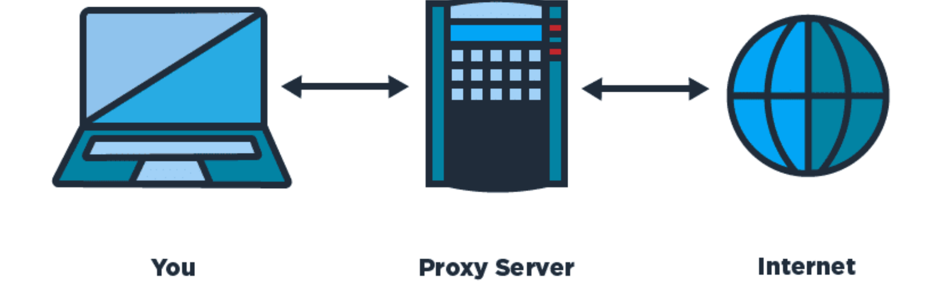

what is a proxy server:

A proxy server act like a gateway between you and the internet.its a server that separate clients computer from the websie they browse.The proxy server browse the internet for you and then they redirect the data to your personal computer .But thats not just it.it has a lot of extra functionality that make it so useful.if you are using a proxy server The internet traffic flows through the proxy server . The proxy server create the web request and then it send it to your computer.But the question is that why it makes it so important why not go the internet diirectly?

Proxy server was a vey important thing during 1990 because if you want to make multiple computer to go on the internet they all have to go througha proxy server But after putting NAT(Network address translation) in the router that makes computer capable of surfing through the internet but without the NAT if you want to go to the internet you need a proxy server.its the proxy sever that route the network in the past.

SQUID is a open source package that can be installed in a linux computer and you can make it work like a proxy server .But the question remains why making a proxy server if you have NAT. The ans it the squid proxy server has a lot of other functionality that makes it special

WHY PROXY SERVER IS IMPORTANT:

1) CACHE:

proxy server gives you a cache that will improve your network performance. Now the question is what is a cache?? cache is a a local copy of the web site or data that is stored in the proxy server. So when you ask for something like “www.youtube.com” the proxy server will check that if the most recent copy of the site is saved in the servers and then send the saved copy to the user.So if 100 people go to the youtube through the proxy server then the proxy server will send only one requsest and then send the local copy to the user.Thats save the bandwidth and improve the performance
not only that if you downloaded a file and the other user try to download the same file then it can be server by the proxy server by the local copy that is saved when the first user downloaded the file.suppose your company has a thousands employee and they all are using windows os that needs regular updates and the updates take a lot of time.but if it goes through a proxy server then this computer can downlaod the local copy of the updates with a great speed because it does not using the internet after the local copy is made\

Improved security:

Proxy servers provide security benefits on top of the privacy benefits. You can configure your proxy server to encrypt your web requests to keep prying eyes from reading your transactions. You can also prevent known malware sites from any access through the proxy server. And another important feature is block harmful website easily.for example we can block this website using opendns but it is a little hard to configure in the router lavel.but using acl in the proxy server we can customize which site they can go ans which site they cant go.its really easy to configure.

Get access to blocked resources:
Proxy servers allow users to circumvent content restrictions imposed by companies or governments. suppose you are in a country where some website you want to go is blocked by the provider.but you can easily connect to a proxy server in other country and easily surf the internet through the proxy server.the proxy server will surfe the blocked the website for you and send the data to your computer

Monitor the traffic:
if you are a system administrator and sometimes you need to monitor the traffic that the user made through the proxy server. you can easily monitor the traffic and cache of the server.

