RAID

what is raid?

RAID stands for “Redundant Array of Independent Disk”. Fault tolerance is a very important thing in server administration. Data loss like disk failure can have a serious impact on the industry that’s why need redundancy for the data to make sure if one disk fails for any reason we must have the backup. That’s why system administrators employ multiple hard drive for ensuring the the data reliability and with a organized hard drive .Ina raid setup data is not stored in a single disk it stored in multiple disk.

There are Four common Raid

→ Raid 0 (Not Fault tolerant)
→ Raid 1 (Fault tolerant )
→ Raid 5 (Fault tolerant)
→ Raid 10 (Fault tolerant)

Raid 0:

Raid 0 is not a fault tolerant .Even the Raid 0 should not be called RAID cause it does not fulfill the main target of RAID. Its actuall y called Striping .In RAID 0 data is stored or spread into two separate disk .It treats the two hard drive like a single hard drive and store the data .So By any chance if any of the disk failed or data is removed or

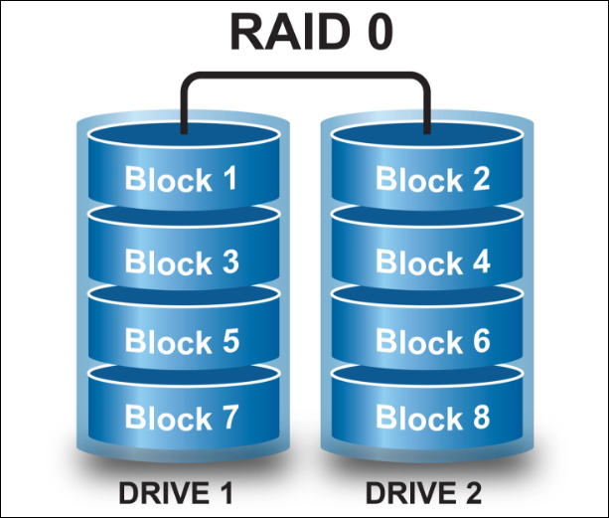

data become damaged there is no way that the data even get recovered ,So now the question arrives why we use the RAID 0

The main advantage of using RAID 0 is “SPEED”.Because when you use multiple disk controller instead of one Accessing data become faster

Raid 1:

Raid 0 is fault tolerant . RAID 1 is called MIRRORING .in mirroring data is written to each RAID devices .Each disk has a complete copy of data of the other .so if one disk fails you can access the same data from the other disk.

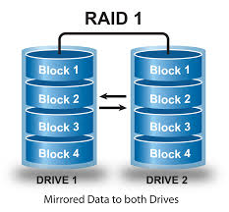

Its extremely safe . But it is very inefficient. Because it consumes Double the size of space for data. For example to store a 80GB of data you need 160 Gb of storage and since data has to write in multiple disk that’s why its a slow process

Raid 5:

Raid 5 is also fault tolerant . Its a alternative to the mirroring .It does not save the data with full duplication but with parity information. Parity information takes one drive that can be used to recover the data in case of data loss. Thats why you need to have three or more disk for RAID 5.That’s the very popular method for storing disk .The parity in formation is evenly spread through the disk. The downside of the data is the parity takes a complete 1 drive equivalent .That means if you gave 4 disk of 1TB then you can only store 3TB of data in the disk with RAID 5.This is the combination of

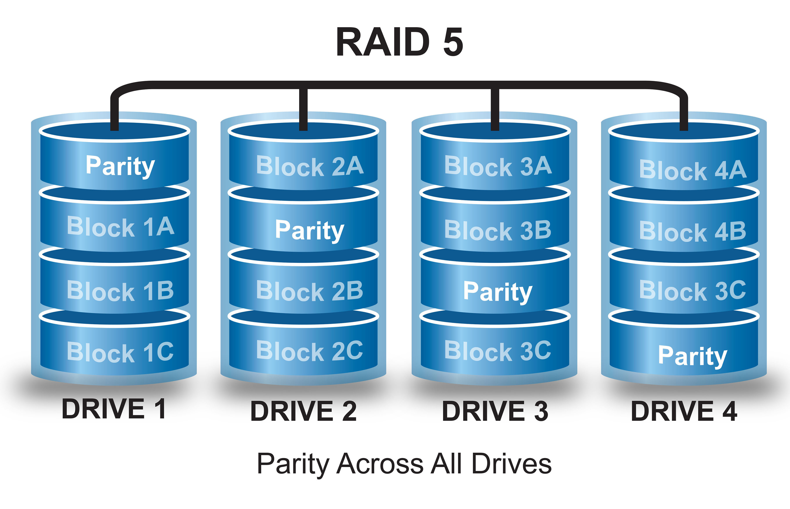

the striping and the parity. RAID provides faster access and recover capability making it the most used redundancy approach for servers.

Raid 10 (1+0):

Raid 10 is actually RAID 1 + RAID 0 .It used both technique for storing data.you have to used a minimum 4 disk to implement RAID 10.In RAID 10 data is stripped in multiple disk like RAID 0 but each disk has a exact copy in another disk like raid 1.

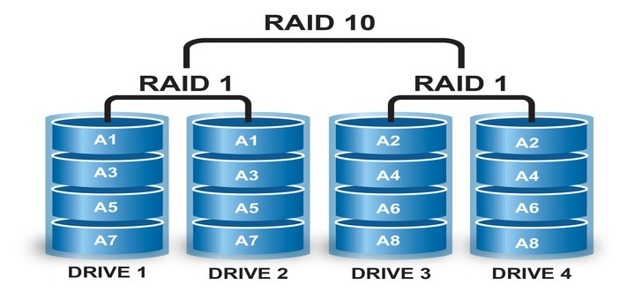

So its a combination of striping and mirroring . So RAID 10 gives us the fault tolerance of the RAID 1 and speed of the RAID 0 .But the downside is you can only use the half of your total storage of you implement RAID 10.

