UBUNTU & CENTOS SERVER ADMINISTRATION

ADVANCE SERVER SETUP AND MONITORING

MD. TANVIR RAHMAN

To my niece Safiyyah Nawar and Nuzairah Zainab

UBUNTU & CENTOS SERVER ADMINISTRATION
Copyright © 2019 by MD. Tanvir Rahman.

For information contact:
http://www.tanvirrahman.ml
First Edition: Octobre 2019

CONTENTS
UBUNTU & CENTOS SERVER ADMINISTRATION i
INTRODUCTION 1
VMware Installation 11
Ubuntu Server Installation 14
CENTOS Server Installation 20
COMMAND LINE IN LINUX 26
BASIC LINUX COMMANDS 30
ip addressing 59
SETTING STATIC IP IN CENTOS7 71
CLIENT SIDE DNS 87
SETTING STATIC IP IN ubuntu 91
Package management in linux 105
Comparison Between two Package management system 139
YUM SERVER 142
APT SERVER 150
KERNEL MANAGEMENT 162
SSH: THE SECURE SHELL 171
TELNET 184
DISK MANAGEMENT 190
Partition id 194
Create File system 196
CRON 199
RAID 202
Creating RAID 1 in CENTOS 7 220
Creating RAID 5 in CENTOS 7 235
Creating RAID 10 in CENTOS 7 245
Linux Process management 258
Advance Linux Process management cclxxxiv
Virtualization 299
CONTAINERS 304
CREATING UBUNTU VIRTUAL SERVER 309
APACHE WEB SERVER 313
ADVANCE APACHE WEB SERVER CONFIGURATION 323
OPEN LITE SPEED WEB SERVER 336
MAIL SERVER 355
FILE SERVER 379
PROXY SERVER 388
SETTING SQUID PROXY SERVER IN UBUNTU 393
SETTING SQUID PROXY SERVER IN CENTOS 400
NFS SERVER 406
SETTING NFS SERVER IN CENTOS 409
SETTING NFS SERVER IN UBUNTU 413
SAMBA SERVER 418
SETTING SAMBA SERVER IN CENTOS 419
SETTING SAMBA SERVER IN UBUNTU 437
COCKPIT 450
SETTING COCKPIT FOR SERVER IN UBUNTU 452
SETTING COCKPIT FOR SERVER IN CENTOS 459
AIDE 468
SETTING AIDE IN CENTOS 471
SETTING AIDE IN UBUNTU 474
WEBMIN 479
CONFIGURE WEBMIN IN CENTOS 480
CONFIGURE WEBMIN IN ubuntu 485
Database Server 488
MARIADB SERVER INSTALLATION AND CONFIGURATION IN CENTOS & UBUNTU 490
IPA SERVER 499
CONFIGURE IPA SERVER IN UBUNTU 502
CONFIGURE IPA SERVER IN CENTOS 512
CONFIGURE IPA CLIENT IN CENTOS 520
CONFIGURE NFS SERVER ON IPA 524
CONFIGURE SAMBA SERVER ON IPA 530

INTRODUCTION

An operating system is a software that runs on our computer. Handling all the instructions between a user and the Computer hardware .But the operating system is not just one software it also consists of a lot of other smaller program that runs on this operating system to that helps users to do their work. we run this smaller program on top of this operating system to do everything.
Liunx is just another operating system. Its a rock solid operating system. Linux work both as a server and Desktop operating system.
Linux operating system is great for a lot of reason . Which are the following

* Multi user OS: Linux is a multi user operating system. That means more than one user can work on a system at the same name
* Multi tasking OS: Linux is a multi taking operating system you can run multiple program at once .this allows the operating system to run several process all at once.
* Multi Platform OS: Linux can run currently more that 24 types of platform and 64-bit Intel based personal computer .All variants of Apple mac,Sun Spark and ipod ,even the Microsoft xbox.

* Interoprable OS: Linux can operate with most network protocols and also most Language it can easily interact with Windows OS,NOVEL,UNIX and other operating system that has a smaller market

* Scalabel OS: Linux operating system has support for even Raspberry pi which is a credit card size computer to very powerful Server. Most of the server of the world is running Linux OS. They have also run in low power computer

* Portable OS: Linux is portable operating system. Linux is mostly written in C programming language .C is a language that is specially for writing operating system level software. And it can be ported to run on a new computer.
* Flexible OS: Linux operating system can be used to make a router,graphical workstation,home entertainment computer,file server,web server, mail server, cluster, just any computing purpose.
* Stable: Linux kernel is very mature. For being stable it is used for most of the server in the world.

* Efficient: The design of the Linux enables you to include on only the thing you needed that’s why it can run on both raspberry pi to a big server.

* Free : Linux is a Free operating system.

GNU PROJECT
GNU Stands for (GNU is NOT UNIX). To make a free clone of the UNIX OS GNU project started 1984.To maintain the free software FSF(Free Software Foundation) is created. It Creates the GNU C compiler ,EMACS Text editor and many other software.
The GNU General Public License (GPL) is a very creative license that used to copyright to protected the freedom of the software user. When a software is licensed under the GPL recipients are bound by the copyright to respect freedom of anyone to use and share the software and also change the source code if necessary.

HISTORY OF LINUX
Linux is a clone of the UNIX based operating system. Unix is created at BELL LABS for AT&T corporation. To make a free clone of the Unix Linus Trovalds created MINIX .he wrote the kernel which is the heart of the Linux . After that a lot of developer helped him to add more feature and functionality .and at that time the GNU Project was making free software for the computer and to make an OS they need a functional kernel which can communicate with the hardware .They took the Linux kernel and add the GNU software on top of the kernel and made the GNU/LINUX Operating system.
Linux Trovalds is still considered as the dictator of the Linux kernel. He ultimately determines which feature will be added in the Linux kernel and what features are not.

Packaging Linux:Distribution
A complete Linux system is called distribution. A Linux distribution contains the Linux kernel and the GNU project Tools and any number of software that can make the OS diverse functionality.
There are a lot of distribution on Linux .Some of them specifically for servers and some of them are Desktop. Every customized distribution includes software packages for different users.
A single Linux distribution often appears in different version .For example Centos distribution comes with a full core distribution and a LIVE CD version.
Ubuntu is based on Debian Distribution And Centos is community version of the Commercial RedHat linux distribution.

Core Linux Distribution
Core Linux distribution contains the Linux Kernel and GNU operating system one or more DE(Desktop Environment) and application that is available ready to install and run. The core Linux Distribution are the compete Linux distribution. These are the popular distribution

* Red Hat linux
* Fedora Core
* Centos Linux
* SUSE linux
* Ubuntu Linux
* Gentoo Linux
* Debian Linux
* Slackware Linux
* Mandriva Linux
* Turbo Linux
* Puppy Linux
we use the Ubuntu Linux and the Centos Linux to illustrate how the servers work.

PRINCIPLE OF LINUX

* Everything works as a file , even the system hardware
* Small work is done by the individual program
* Any complected work will be divided into smaller part and then process this by different different module.
* All the configuration will be stored in a text file
* linux OS use a standard hierarchical file structure in which the files/user files are arranged

***

UBUNTU SERVER

Ubuntu is built on the Debian architecture and comprised linux server and Desktop. Ubuntu release updates every six months Ubuntu packages are based on packages from Debian’s unstable branch. Ubuntu is currently funded by the Canonical LTD. And GENOME 3 is the default GUI interface for the ubuntu from 17.10 version. We are going to use Ubuntu Server 18.04.3 LTS for our work. You can download the latest long term version of ubuntu server in this URL
https://ubuntu.com/download/server

CENTOS SERVER

The CentOS Project is a community-driven free software effort focused on delivering a robust open source ecosystem around a Linux platform. Its Basically a clone of Redhat. CentOS Linux is a consistent, manageable platform that suits a wide variety of deployments. For some open source communities, it is a solid, predictable base to build upon .You can download the latest long term version of Centos server in this URL
https://centos.org/download/

VMware Installation

Step 1

install the required build packages
=> sudo apt install build-essential

Step 2
Download VMware workstation player from the
website.


Step 3

go to the installed directory make the file executable
=> chmod 777 Vmware-Player*
[we will talk about the chmod 777 later for now just use it]

Step 4

execute the program with sudo
=>sudo ./Vmware-Player*



[no license key is required .If you want to install vmware workstation instead of vmware player you need to have the license key]

after a successful installation screen will show to you



***

Ubuntu Server Installation
Ubuntu

Requirements:
1)Host PC with at least 4GB of ram
2)VMware Workstation/Virtualbox
3)Ubuntu server ISO image

Step 1

Lunch VMware Workstation New Virtual Machine Wizard

Step 2

Select the installation media or source and choose the disk size.


Step 3
Final configuration of the Vmware will be like this


Step 4

start the installation ,first set the language


Step 5
select DHCP for network for now .we change the ip address of the server later


Step 6
Select “install openSSH server” so we can connect to the computer with our hosts

Step 7

There are three types of partition

* Guided : use entire disk : it use the entire disk with guided partition system

* Manual : In manual partition user have to allocate the space manually.
For minimal settings three partition is a mandatory
1) /boot
2) /swap
3) /root
* Guided : on LVM :this option allow user to set a LVM based partition

Select the entire disk for installation .we select the Entire disk guided partition will talk about the other boot system later.



Step 8

login to the system with your credential .

SUMMARY:
we learn how to set up a ubuntu server on Vmware Virtual machine with a dhcp network. Using guided partition.

***

CENTOS Server Installation
Centos

Requirements:
1)Host PC with at least 4GB of ram
2)VMwareWorkstation/Virtualbox 3)CENTOS7 server ISO image

Step 1

Lunch VMware Workstation New Virtual Machine Wizard

Step 2

Select the installation media or source and choose the disk size.

Step 3
final configuration of the Vmware will be like this
Step 4

Start the installation , First set the language

Step 5
From the software selection select server with a GUI


Step 6
Select the volume for installing .in this installation we go for the entire disk guided partition



Step 7
Enter the root password and confirm it. and create a user and set password for the user



Step 8
Wait for the installation to finished. After that reboot the system

Step 9

login with root credentials

SUMMARY:
we learn how to set up a Centos server on Vmware Virtual machine with Using guided partition.

***

COMMAND LINE IN LINUX
Every workstation version of Linux has a Beautiful GUI(Graphical User Interface ) but most of the server Ubuntu or Centos run on command line mode .you can add graphical user interface to that but without the command line you cant manage the server properly. Once you learn Command line you will find that it is more powerful and flexible for user to manage your server than a graphical mode.

WORKING AS ROOT

By default every Linux OS creates a user root. Many operating system like Centos ask for a root password .But Ubuntu server don’t do that .There is a very good reason behind that .in Linux OS root has a limitless power . root can do anything ,change anything even can delete anything from the server .so it is very important to be careful when you work as root .That’s why in ubuntu server every time you do anything that need superuser privileges you use the command ‘sudo’ .This command allows the normal user so they can perform task that needs superuser privileges .you type sudo then your command it may ask for password after providing the password it will perform the action with the superuser privileges . But if you want the root shell then type this command
=> sudo su

But it is not recommended to work with the root shell .Do not use the root shell unless it is absolutely necessary . work with sudo if you need superuser privilege.

TERMINAL & SHELL

What is Terminal
Terminal is a program that opens a window and lets you play with the shell. There are a bunch of different terminal emulators that you can see in the Linux Distribution. such as Gnome terminal, konsole ,xterm, rxvt , nxterm ,eterm, Tilix etc. Terminal lets you interact with the shell
What is shell
Shell itself is a program that takes command from the keyboard and gives them to the operating system to perform. You can work with the graphical user interface but if the server you are using has no graphical user interface this will be the only interface you got and you have to do all of your work in the cli interface
there are different types of shell
* tsh → tsh is a shell with a scripting language similar to the C programming language
* sash → stand alone shell .its a very minimal shell runs almost every system .it is basically popular for troubleshooting the system
* zsh → zsh is a shell which is compatible with bash but has a lot of extra functionality
* fish → fish stands for friendly interactive shell .mostly popular in desktop. It has a very good auto completion feature
* Bash → bash stands for Bourne Again Shell that is the enhanced version of the original UNIX program sh .it is written by the Steve Bourne. It is the most popular shell and the default shell of the most Linux operating system.
We will use the Bash all over the example.

***

BASIC LINUX COMMANDS

These are the basic command to operate a Linux operating system

Command name: ls
description:
ls command used to see the files and folder inside a directory . it is the most used command in Linux.
syntax:
ls -[option] <directory>

1) ls -m will show the files and folder with comma

2) ls -a show the hidden files also

3) ls -l will show the files and folder in a listing format

4) ls -lh will show the file with listing and size

5) ls -i will show the list of files and folders with Inode

6) ls -t will show the modification time with directory listing

Command name: more
description:

It works like the more command .it also give scrolling options

syntax:
More <options> <file_name>

1) less -E : automatically exit the first time it reaches end of file.
2) less -f : forces non-regular file to open.
3) less -F : exit if entire file can be displayed on first screen
4) less -g : highlight the string which was found by last search command
5) less -G : suppresses all highlighting of strings found by search commands
6) less -i : cause sears line numbers
7) less -p <pattern> : it tells less to start at the first occurrence of pattern in the file
8) less -s : causes consecutive blank lines to be squeezed into a single blank line to ignore case
9) less -n : suppresses line numbers
10) less -p <pattern> : it tells less to start at the first occurrence of pattern in the file
11) less -s : causes consecutive blank lines to be squeezed
12) less -N : shows line number

Command name: strings
description:
To display the content of the file
syntax:
strings <filename>

Command name: tree
description:
To display the Directory stricture in a tree format
syntax:
Tree <directory>
[you may have to tool with package manager]

Command name: dir
description:
To display the files and folder inside the directory
syntax:
dir <directory_name>
[you have to install ‘tree’ tools before using this command]
Command name: cal
description:
To display the calendar
syntax:
Cal
cal <year>
cal <month> <year> command]
Command name: clear
description:
clear the screen
syntax:
clear
Command name: bc
description:
basic calculator
syntax:
bc
Command name: mkdir
description:
making directory
syntax:
mkdir <directory> : for making single directory
mkdir -p <directory/directory>:
for making recursive directory

Command name: rmdir
description:
Remove empty directory
[you cant remove any directory which has file in it with this command]
syntax:
rmdir <empty_directory>
Command name: file
description:
display the file type
syntax:
file <filename>
Command name: ln
description:
Create a link of the source filename. In case in hard link if you delete the main file link wont remove but in case of the soft link if you delete the main file the the linked file will be removed

syntax:
ln <option> <source_file> <shortcut_file>
ln -s : for creating soft link
ln -P : for creating hard link

Command name: history
description:
Shows users command history it will show the last 1000 command of the user you can set the limit if you like

syntax:
history

Command name: locate
description:
It will search the entire system for that file [you need to apply the command ‘updatedb’ for getting latest entry]

syntax:
Locate <file_name>

Command name: uname
description:
Show all the information about the kernel , OS and hardware-platform
syntax:
uname -a : all information, in the following order
uname -s :print the kernel name
uname -n : print host name
uname -r : print the kernel release
uname -v : print the kernel version
uname -m : print the machine hardware name
uname -p : print the processor type
uname -i : print the hardware platform
uname -o : print the operating system

Command name: tar
description:
For creating archive and extracting archive hardware-platform
syntax:
tar -cvf <archive_name> <source> : for creating archive
tar -xvf : for extracting archive

Command name: gzip
description:
For compressing normal file or archive file
syntax:
gzip <file_name>

Command name: gunzip
description:
It is used for uncompromising a compressed file

syntax:
gunzip <compressed_file>

Command name: lsmod
description:
Show a list of the modules used by the kernel
syntax:
lsmod

Command name: rmmod
description:
Delete any module used by the kernel
[not Recommended . don’t do it unless you are absolutely sure what you are doing ]

syntax:
mmod <module_name>
[you need to be a root user to perform this action]
rmmod-f , forces a module unload and may crash your machine. This requires Forced Module Removal option in your kernel. DANGEROUS

rmmod -v, enables more messages
rmmod -V, show version

Command name: modprobe
description:
Adding new module to the system

syntax:
modprobe <module_name>
Command name: ps
description:
See the current running process of the system
syntax:
ps

Command name: top
description:
Top command is used for process monitoring.
[more information about top in Process management]
syntax:
top

Command name: renice
description:
Used for changing the priority of a process running on a system. [more info in process management chapter]
syntax:
renice -n <priority> -p <pid
Command name: kill
description:
Used for terminating process for this purpose
syntax:
Kill -<sigterm> -p pid
Command name: uptime
description:
Shows the system’s running time. and load averages of previous 1 minute ,5 minute and 15 minute.
[this information can be found in top and htop command also]
syntax:
uptime

Command name: iostat
description:
Shows the cpu and I/O information
[more information in process management Devices ]
syntax:
1) Iostat -c : generate cpu status only
2) iostat -d : generate I/O statistics for all the devices
3) iostat -x : generate detail I/O statistics
4) iostat -x : generate detail I/O statistics and CPU information
5) iostat -p <devices> : generate details for that specific devices
6) iostat -m : generate statistics in Megabyte
7) iostat -k : generate statistics in Kilobyte
8) iostat -N : generate LVM options
9) iostat -t : generate statistics with timestamp
10)nfsiostat : Shows information of NFS devices
Command name: hostnamectl
description:
Display hostname and its related settings also change hostname and its related settings
syntax:
Hostnamectl : provide information about current host and its properties

hostnamectl set-hostname <hostname> :It will change the hostname

Command name: pwd
description:
Print the current directory path
syntax:
pwd

Command name: dmesg
description:
Display the detected hardware status during boot time
[the file location is ‘var/log/dmesg’]
syntax:
dmesg

Command name: init
description:
Display the detected hardware status during boot time
[the file location is ‘var/log/dmesg’]
syntax:
Init <run_lavel>

0 :Power-off the machine
6 :Reboot the machine
2, 3, 4,5 :start runlevel X.
1, s, S :Enter rescue mode
q, Q : Reload init daemon configuration
u, U :Reexecute init daemon

Command name: mkswap
description:
Used to format the partition used for swap space
syntax:
mkswap <file_system>

Command name: swapon
description:
To activate the swap space
syntax:
swapon -a <file_system>:
[enable all swaps from /etc/fstab]

Command name: swapoff
description:
To deactivate the swap partition
syntax:
swapoff <file_system>

Command name: mkfs
description:
To format the partition this tools is used
[more information about file system]
syntax:
mkfs -t <fs_type> <file_system>
To format the partition this tools is used
[more information about file system]
1) mkfs.ext2 /dev/sdx: for ext2 file system
2) mkfs.ext3 /dev/sdx:for ext3 file system
3) mkfs.ext4 /dev/sdx: for ext3 file system
4) mkfs.minix /dev/sdx :for minix file system
5) mkfs.xfs /dev/sdx :for xfs file system

Command name: poweroff
description:
power off the machine
syntax:
poweroff

Command name: whoami
description:
Display the username which is currently logged in
syntax:
whoami

Command name: wc
description:
Used to find out number of lines, word count, byte and characters count in the files specified in the file arguments

syntax:
1) wc <file_names>
2) wc -m <file> : print the character in in the file
3) wc -w <file> : print the word in in the file
4) wc -l <file> : print the line in in the file

Command name: w
description:
Used to show who is logged in to the computer and what they are doing

syntax:
w

Command name: arch
description:
Display the computer architecture

syntax:
arch

Command name: alias
description:
Instructs the shell to replace one string with another string while executing the commands

syntax:
Alias <string>=’<target string>’

Command name: bg
description:
Used to send any foreground job to background
syntax:
bg
Command name: cp
description:
Used to copy a file or a group file from one destination to other
syntax:
cp <source_file> <target_destination>

Command name: echo
description:
Used to display line of text/string that are passed as an argument
syntax:
echo <arguments>
Command name: fdisk
description:
Format disk as well as creating and manipulating disk partition table
[more information in disk management chapter]
syntax:
fdisk <file_system>
Command name: cfdisk
description:
Format disk as well as creating and manipulating disk partition table using a text based GUI interface
[more information in disk management chapter]
syntax:
sudo cfdisk

Command name: lsblk
description:
Displays the total amount of free space available along with the amount of memory used and swap memory in the system
syntax:
lsblk
Command name: lsmod
description:
List the current kernel modules that are currently loaded
[it actually print the content of the ‘/proc/modules’ with a nice format]

syntax:
lsmod
Command name: lspci
description:
Display the information about the currently connected PCI Buses .
[list of devices that are connected to the computer]
syntax:
lspci
Command name: lshw
description:
List all the Details information of the hardware of the computer
syntax:
lshw
Command name: lshcpu
description:
Display the detailed information about the CPU
syntax:
lscpu
Command name: man
description:
Display the reference of the tools or command that are you using
syntax:
man <command>

Command name: sudo
description:
give you the superuser privileges
syntax:
sudo <command>
Command name: ip
description:
Used for performing several network administration tasks
syntax:
Ip <option> <command>
Command name: touch
description:
Create an empty file
syntax:
touch <file_name>

Command name: ifconfig
description:
shows the ip address related information
syntax:
ifconfig
Command name: gerp
description:
global regular expression used for searching keyword
syntax:
ls | grep initrd
Command name: wget
description:
interactive cli based downloader
syntax
wget <download_url>
Command name: reboot
description:
reboot the system
syntax
reboot
Command name: ping
description:
test any host or network which is alive physically and logically

syntax
ping <pi_address/domain_name>
These are the basic commands to run a Linux system .There are a lot of command more to maintain the server.

***

ip addressing

COMPUTER NETWORK

A computer network is a group of computer and other computing peripherals that linked together through some kind of communication channels to communicate with each other and share their resources among a width range of users.

Their jobs are

1) Facilitate communication via email,file server,web server,instant messaging etc
2) Share resources of the hardware like printer or scanner
3) Enable File sharing
4) create a centralized control among the total network

TYPES OF COMPUTER NETWORK

Network Basically divided into three groups:
1) Local Area Network (LAN)
2) Metropolitan Area Network (MAN)
3) Wide Area Network (WAN)

LAN
A local area network (LAN) within a small area like home,school,office or group of buildings. They can share their resources and device like printer and scanner and data storage. Most of them are centrally organized. And because of the type of the communication the data transfer rate is very high. And local area network does not need any leased communication line

MAN

A metropolitan area network (MAN) spans an entire campus by connecting multiple LAN. MAN is larger than the LAN, because it consists of a number of LAN .MAN works like more of a ISP but it does not owned by a single organization. instead MAN provides a shared network connection to all its users

WAN

A wide area network (WAN) within a large scale of geographical area is called WAN. It is created by connecting different LAN from a long distance. And the transmission speed generally is slower than the LAN or MAN but the data transfer rate is increasing .

TCP/IP PROTOCOL SUITE

A majority of the internet users use a protocol suite called Internet protocol suite which is also known as the TCP/IP protocol suite. The two protocols are TCP (Transmission control protocol) & IP (internet protocol).In here TCP is a connection oriented protocol means it transmit data in a sequence and it has a acknowledgment process. If the acknowledgment are not received



then the data will be re transmitted it can guarantee the delivery of the data to the host and IP is used to maintain the address of the specific host.



IP Addressing

IP addressing is the most important topic in the networking. Ip address is basically a numeric identifier that used to identify a Machine .Ip address is a software address not a hardware address that means it can change depending on the network you are connected. The hardware address is the NIC address that’s called the Physical address that cant be changed.

Important Element of a IP address

Bit: Bit is one digit either 0 or 1

Byte: made up with 8 bits its just a ordinary 8 bit binary number.

Network Address : Network address is used send packets to the network .for example 10.0.0.0,192.168.0.0 etc

Broadcast Address : It is used by the host to send information to all the nodes on a network. The address are like 192.168.0.255,172.166.255.255

Every ip address there are two different parts

1) Network part
2) Host Part

Every ip address gives the information about the network and the hosts

Subnet Mask

A subnet mask is a 32 bit umber that masks an ip address and divides the ip address to a network address and hosts address.
Is is done by setting all the network bits to ‘1’ and setting hosts bit to ‘0’

[Two host ip address are reserved for special purpose The ‘0’ address and the ‘255’ address.the ‘0’ address is reserved for the Network .so if any ip address have a ‘0’ on its last its a network address. and ‘255’ is the broadcast address they cant be assign to a host]

5 types of IP address:

1) class A ip address
2) class B ip address
3) class C ip address
4) class D ip address
5) class E ip address

Class A ip address:

In class A ip address the first byte is reserved for the network address and three remaining bytes are for the hosts.
[it starts with 0.0.0.0 and ends with 127.255.255.255]
subnet mask: 255.0.0.0


It has a small network with huge number hosts.

Class B ip address:

In class A ip address the first two bytes is reserved for the network address and two remaining bytes are for the hosts. More network less hosts
[it starts with 128.0.0.0 and ends with 191.255.255.255]
subnet mask : 255.255.0.0

Class C ip address:

class C ip address the first three bytes is reserved for the network address and remaining one bytes are for the hosts. If you need a lot of network and small number of hosts in every networks class C ip address is used.
[it starts with 192.0.0.0 and ends with 223.255.255.255]
subnet mask : 255.255.255.0

Class D ip address:

class D ip address is a special address. Its called a multi cast address. It is basically used for finding router
[it starts with 224.0.0.0 and ends with 239.255.255.255]

Class E ip address:

Reserved for the Scientific Experiment

Private IP address:

Not all the address of these class is used for public network .some are not routable through the internet. private ip address is used in the Locally and a local ip address can connect to the internet through a public ip address with NAT (Network address translation).NAT allows a public address to the internet



Loop back address

Loop back address is used to test the communication on a local NIC (Network Interface Card) .Data packets are sent by the node in the loop back address are re-routed back into the same node .It is used for testing the connected physical network. it also enables the user to test an application with an instance of server and client on the same machine .we call it localhost

it starts with 127.0.0.0 and ends 127.255.255.255

Ping

ping stands for Packet Internet Gopher is a ICMP echo request and reply message that used to check the physical and logical connectivity of the machine on a internet network.

Traceroute

Traceroute is used to find the path of the packet traverses through the internet.

***

SETTING STATIC IP IN CENTOS7
EASY WAY

Every Server needs to have a network connection. without a static ip address you cant run a server .Giving a server a static ip address is the most important thing to do.

When you install a server the most of the time your installer automatically configure your server network and gets the ip address from a DHCP server. But to run a server you need a static ip address. So we need to change its network from DHCP to static and give the server a static ip address .Here we talk about how to give static ip address to a centos7/Redhat7 server.

There are multiple way to give server static address ,Here we talk about easy method

step 1

you need to select a static ip address , subnet mask and the gateway that you give your machine .according to your network specifications.

In his example we used a virtual centos7 box . And we give the following ip address subnet mask ,gate way and DNS

ip address : 192.168.0.10
subnet mask: 255.255.255.0
Gateway:192.168.0.1
DNS: 8.8.8.8

step 2

you need to find the network interface that you give the static ip address A Server can have multiple network interface.

In our virtual machine there are two network interface. We can see the interface from this command

=>ifconfig
or
=> ip address show

result:

we are currently connected to the server with a ssh connection through eth0.So we cant change the ip address to eth0.this will disconnect the ssh connectivity .we are going to give the static ip address to the eth1 interface

step 3

use the nmtui command and you have to be root to give this command

=>sudo nmtui

After giving this command this screen appear. From there Select The “Edit a connection”


Step 4

it will show you all the interface .choose your interface in this case we will choose eth1.


Step 5

we choose the ipv4 and from the option we choose ‘manual’ and Edit the menu


Step 6

we give the ip address .we have to give the subnet mask with CIDR notation.
Gateway and the The DNS address and click ok. Then quit the program.

Step 7

if we see our ip address we can see the the ip address still don;t change. to make the change we need to restart the interface.

We shutdown the interface with this command

=>sudo ifdown eth1

Then we start the interface again

=>sudo ifup eth1
step 8
Then if we check ip address using
=>ifconfig eth1


we can see the ip address changed .

Step 9

We have to test the connection via pinging a network.

=>ping 8.8.8.8



So the connection is up and running. Thats is the easy way of giving an ip address to a cenos7/Redhat7 server a static address.

TRADITIONAL WAY

first step

you need to select a static ip address , subnet mask and the gateway that you give your machine .according to your network specifications.

we give the following ip address subnet mask ,gate way and Dns

I p address : 192.168.0.10
subnet mask: 255.255.255.0
Gateway:192.168.0.1
DNS: 8.8.8.8

step 2

you need to find the network interface that you give the static ip address

In our virtual machine there are two network interface. We can see the interface from this command

=>ifconfig
or
=> ip address show


we are currently connected to the server with a ssh connection through eth0.So we cant change the ip address to eth0.this will disconnect the ssh connectivity .we are going to give the static ip address to the eth1 interface

step 3

we have to do to the ‘/etc/sysconfig/network-scripts’ directory

=> cd /etc/sysconfig/network-scripts

In this directory There are a lot of files .From there we have to select the ‘ifcfg-eth1’ [yours can be different .select the file based on your interface it will be like ifcfg-<interface>]



step 4

we have to edit the file with a text editor with root privileges.
We have to edit the file ifcfg-eth1
=>vim ifcfg-eth1

BOOTPROTO=static
ONBOOT=yes
IPADDR=192.168.0.10
PREFIX=24
GATEWAY=192.168.0.1
DNS1=8.8.8.8


Step 5

If we see our ip address we can see the the ip address still don’t change .to make the change we need to restart the interface.

We shutdown the interface with this command

=>sudo ifdown eth1

Then we start the interface again

=>sudo ifup eth1

Step 6
Then if we check ip address using
=>ifconfig eth1

we can see the ip address changed .

Step 7

We have to test the connection via pinging a network.

=>ping 8.8.8.8

So the connection is up and running. That’s is the another way of giving an ip address to a cenos7/Redhat7 server a static address.

***

CLIENT SIDE DNS

Changing Hostname

for configuring hostname in the redhat Linux 7 we use the
hostnamectl command for administrating hostname
To see the status of the hostname command
=>hostnamectl status
To change the hostname we use
=>hostnamectl set-hostname <name>
For removing hostname
=>hostnamectl set-hostname “”

On a Linux system we use dns to resolve hostname .first we need to know that how to configure the client side .there is a few location where we need to look /etc/hosts if we see the file we see something like this

=>cat /etc/hosts
127.0.0.1 localhost localhost.localdomain
::1 localhost localhost.localdomain

if you use the command
=>ping localhost
the computer will find from this hosts file its ip address and that’s how the computer knows who to talk to.

Lets add mysite to 127.0.0.1
=>cat /etc/hosts
127.0.0.1 localhost localhost.localdomain mysite
::1 localhost localhost.localdomain

Then if we ping mysite we can see that
=> ping mysite
PING localhost (127.0.0.1) 56(84) bytes of data.
64 bytes from localhost (127.0.0.1): icmp_seq=1 ttl=64
time=0.129 ms
64 bytes from localhost (127.0.0.1): icmp_seq=2 ttl=64
time=0.112 ms

127 ip group is a loopback address but this method is not very efficient . we can never possibly add thousands of domain and ip manually .it is not possible whats why the dns server come .what dns does is automatically resolve the domain through a server the server is configured in a file in /etc/resolv.conf

if we go see the file
=>cat /etc/resolv.conf
# Generated by NetworkManager
nameserver 10.0.2.3

the name server 10.0.2.3 (may be different in your computer).actually in here 10.0.2.3 is the ip of our dns server. we can add some public dns server in the file like

nameserver 8.8.8.8
nameserver 8.8.4.4

8.8.8.8 is the google name server for public use. But there is a question arrives that when computer use the /etc/hosts file and when the /etc/resolv.conf that decision is stored a file called /etc/nsswitch.conf file
if we see the file
=>cat /etc/nsswitch.conf| grep hosts
in the file we see the line

hosts: files dns

that means It will first look in the hosts file then the dns server .if it wont find it there it will give up. If you wrote the following in the hosts file
127.0.0.1 www.google.com
after that when you ping www.google.com it will ping the localhost address
=> ping www.google.com
PING www.google.com (127.0.0.1) 56(84) bytes of data.
64 bytes from www.google.com (127.0.0.1): icmp_seq=1
ttl=64 time=0.087 ms
64 bytes from www.google.com (127.0.0.1): icmp_seq=2
ttl=64 time=0.105 ms

it is a very useful technique .lets assume you are developing a
website and you don't want to test it into your live site. so you can trick the computer by setting the local address to your live server and after that it exactly just like the production server but it is actually your development server

SETTING STATIC IP IN ubuntu
EASY WAY

Setting the ip address in a debian/ubuntu machine with a easy method
You have to follow these steps

step 1

you need to select a static ip address , subnet mask and the gateway that you give your machine . according to your network specifications.

In his example we used a virtual debian box . And we give the following ip address subnet mask , gateway and Dns

ip address : 192.168.0.10
subnet mask: 255.255.255.0
Gateway:192.168.0.1
DNS: 8.8.8.8

step 2

you need to find the network interface that you give the static ip address A Server can have multiple network interface.
In our virtual machine there are two network interface. We can see the interface from this command

=>ifconfig
or
=> ip address show

result:

we are currently connected to the server with a ssh connection through eth0. So we cant change the ip address to eth0.this will disconnect the ssh connectivity .we are going to give the static ip address to the eth1 interface

step 3

use the nmtui command and you have to be root to give this command

=>sudo nmtui

After giving this command this screen appear. From there Select The “Edit a connection”

step 4
it will show you all the interface .choose your interface in this case we will choose eth1.

Step 5

we choose the ipv4 and from the option we choose ‘manual’ and Edit the menu

Step 6
we give the ip address .we have to give the subnet mask with CIDR notation. Gateway and the The DNS address and click ok. Then quit the program.

Step 7
if we see our ip address we can see the the ip address still don’t change. to make the change we need to restart the interface.

We shutdown the interface with this command

=>sudo ifdown eth1
or
=>nmcli connection down eth1

Then we start the interface again

=>sudo ifup eth1
or
=>nmcli connection up eth1

Step 8

Then if we check ip address using
=>ifconfig eth1

we can see the ip address changed .

Ninth step

We have to test the connection via pinging a network.

=>ping 8.8.8.8

So the connection is up and running. That’s is the easy way of giving a static ip address to a Ubuntu/Debian server

NETPLAN

New version of ubuntu linux has a new tools for setting ip address .This is called netplan. now its a little bit difficult because you have to maintain indentation and certain rules to give it. and the main challenge is you have to do it by editing a file

Step 1

The network configuration stored in ‘/etc/netplan’ directory

Step 2

There are different ‘yaml’ configuration file for different interface .in my VM there are two different interfaces. so there are two different interfaces. you have to configure the configuration file based on what interface you want to configure



Step 3 [very very important !!!]

you mast take backup before you edit the file

=>cp 99-vagrant.yaml 99-vagrant.yaml.bak

[this is very very important cause if you make mistake in the indentation you can use the backup to continue]

Step 4

Edit the file
=>sudo vim 99-vagrant.yaml

the file format will be like this

# the datasource. Changes to it will not persist across an instance.
# To disable cloud-init's network configuration capabilities, write a file
# /etc/cloud/cloud.cfg.d/99-disable-network-config.cfg with the following:
# network: {config: disabled}
network:
ethernets:
eth1:
addresses: []
dhcp4: true
version: 2

the ip address we assign will be

ip address : 192.168.0.102
subnetmask : 255.255.255.0
gateway : 192.168.0.1
dns : 8.8.8.8,8.8.8.4

Step 5

Fill like this

# the datasource. Changes to it will not persist across an instance.
# To disable cloud-init's network configuration capabilities, write a file
# /etc/cloud/cloud.cfg.d/99-disable-network-config.cfg with the following:
# network: {config: disabled}
network:
ethernets:
eth1:
addresses: [192.168.0.102/24]
gateway4: 192.168.0.1
nameservers:
addresses: [8.8.8.8,8.8.4.4]
dhcp4: no
version: 2

Step 6

find error

=>sudo netplan -debug apply

Step 7

apply the changes

=>sudo netplan apply

that is the new way of giving static ip address

***

Package management in linux

As a server administrator you will need to install different software on your server on different occasion .Most of the Linux operating system(Ubuntu Server/Centos server/Open SUSE server) has two different ways of installing software. First are the software packages that contain the programs that are ready to install and that integrate with the server easily. The server keeps the list of installed packages in the database that makes maintaining very easy. The second option to install software in via tarball. Which basically just an archive of the software. Archive can be anything (can be any record of the data) but it can b also used to deliver software. The first method is proffered most of the time Because server can keep track of the software that are installed via packages .Software installed via tarball are not tracked. There is a second difference between packages and tarballs that some software need other packages for working properly (this is called dependency).both tarball and packages have program installed that check if the dependencies are met but only the software packages interact with the package manager. And in that way it can install the missing dependencies which other installation system cant do. So now a days software packages are preferred. Software packages mostly made in two different formats .On Red Hat and openSUSE and similar distribution rpm packages is used .And debian based operating system like ubuntu server deb package is used. But this packages can be converted. And the other advantage is software can be install by compiling the source code too.

High level and Low level Package management Tools

in order to interact with the software packages there are two types of available tools. low level package management also known as local package management system. and the high level tools are known as online package management tools.

Distribution | Low-Level Tools | High Level Tools
Debian based distribution | dpkg | apt/aptitude
Centos/Red Hat | rpm | yum
Open SUSE | rpm | zypper

[do not use red hat rpm file in openSUSE system]

If you already download or create your own .deb package you can manage it with dpkg command.

UBUNTU PACKAGE MANAGEMENT

Installing package with dpkg

For installing packages with dpkg . command is

=>dpkg -i <package_name>

List of current package:

To list all the current packages that are currently installed in Ubuntu server the command is
=>dpkg -L

it will show the name,version,architecture and a small description

Check packages installation status

if you need to know any packages installed or not then following command can show if the package installed or not

=>dpkg –get-selections <package_name>



Check Details information about packages:

To check details about a installed packages use this command

=>sudo dpkg -s <package_name>

Disadvantage of dpkg:

suppose we want to install a downloaded packages webmin.deb. We will show some dependency problem like this and it install the program without the dependency and the program wont run you have to install dependency manually the other dependencies that's a big complexity .If you remove the program it still create the problem if you try to install other program.


[To fix this problem we can use the online package management system
=>sudo apt-get install -f
it will search the dependencies and install them

Remove packages:

to remove packages from the system this command is used

=>dpkg -r <package_name>

Completely remove package and configuration file:

to completely remove package and the related configuration file this command is used

=>dpkg -P <package_name>

If you find a file and want to know which package it belongs to use this command

=>dpkg -S <file_path>


Reconfigure packages:

if you face any problem in your package configuration. You can reconfigure the package with this command
=>dpkg-reconfigure <package_name>

But to do this you need to know the exact name of the package. It will automatically rewind the installation process and give you chance to reconfigure.



Installing packages with apt

The apt utility is a powerful and free package management command line program, that is used to work with Ubuntu’s APT (Advanced Packaging Tool) library to perform installation of new software packages, removing existing software packages, upgrading of existing software packages and even used to upgrading the entire operating system

On ubuntu server or any debian based OS there is a list repository url which is populated during the installation in ‘/etc/apt/sources.list’ but you can add repository.

Update repository:

Before installing any package you need to update the software repository.
Command
=>sudo apt update

[you need to be root to perform the action]

Upgrade existing Software:

To upgrade every package in the latest version use this command
=>sudo apt upgrade

Update OS distribution

to upgrade the distribution for example upgrading ubuntu 16.0 to ubuntu latest version this command is used

=>sudo apt dist-upgrade

Install Packages

for installing packages this command is used
=>sudo apt install <package_name>

for example
to install vim editor we use this command
=>sudo apt install vim

Remove Packages

for removing packages this command is used
=>sudo apt remove <package_name>

for example
to remove vim editor we use this command
=>sudo apt remove vim

[this command will remove the packages but not the dependencies .To remove this command is used
=>sudo apt autoremove

apt-cache command

The apt-cache command line tool is used for searching apt software package cache. In simple words, this tool is used to search software packages, collects information of packages and also used to search for what available packages are ready for installation on Ubuntu based systems.

Apt-cache search command

=>sudo apt-cache search <package_name>

This command show all the program will show all the program that depends on the packages. suppose you install gmail packages this command

=>sudo apt-cache search gmail
will show all the packages that are depends on this packages like ‘thunderbird’

Package Details

You can also see the details of any packages with apt just like the dpkg -s.
command

=>sudo apt-cache show vim

Find Unmet Dependencies:

This command will find all the unmet dependencies of the system

=>sudo apt-cache unmet

Find Specific Dependency of Packages:

=>sudo apt-cache depends <package_name>

This command will give all the dependencies of the Packages.

Find Reverse Dependencies:

=>sudo apt-cache rdepends <package_name>

This command will find the reverse dependencies of the program .That means it will show all the packages that depends on that packages.

For example:
=>sudo apt-cache rdepends git

this command will show all the other program that depends on the git program.

Aptitude package management tool:

There is a new package management tools called aptitude. to use that first you have to install it with this command

=>sudo apt install aptitude

Install package via aptitude:

installing command with aptitude is

=>sudo aptitude install <package_name>
example:
=>sudo aptitude install emacs

Search package via aptitude

For searching any packages this command is used

=>sudo apttitude search <package_name>

The main advantage of the aptitude is when you run the aptitude program without any flag

=>aptitude

this will open a menu based installer inside the terminal. That means you will get almost a gui based installer inside a terminal.

Graphical Package management System:

If you want to use a graphical Package management system you can use synaptic package management software. its very easy to install,remove,and
upgrade packages with synaptic package management.

Apt Repository

when we install or search a package with apt command it will search some online repository for that packages. The list of that url is stored in a file
‘/etc/apt/sources.list’ and the file contained in ‘/etc/apt/sources.list.d’

if we see the ‘sources.list’ file with this command

=>cat /etc/apt/sources.list
we will see something like this

the information available from the configured sources is acquired by ‘apt update’ or equivalent command from another apt fronted.
Users can manually add repository url in that file. after adding repository you have to issue ‘apt update’ command to make it available for using.

Or you can just create a file in /etc/apt/sources.list.d directory. The file must be end with .list extension. The apt package manager also read repository configuration from there

for example:
first open a file with vim editor inside the sources.list.d repo

=>vim /etc/apt/sources.list.d/games.list

add the repository path in that file

deb http://archive.getdeb.net/ubuntu wily-getdeb games

Or user can add repository by interactive command.
Use the add-apt-repository (or symlink apt-add-repository) command to add repository. You just need to provide reference address as the following command.
=>add-apt-repository 'deb http://archive.getdeb.net/ubuntu wily-getdeb games'

to remove any repository from by using this following command
=>add-apt-repository -r 'deb http://archive.getdeb.net/ubuntu wily-getdeb games'

[every time you make a change to repository you must apply ‘apt update’ command to make the change on effect ]

CENTOS PACKAGE MANAGEMENT

Rpm (Red Hat Package Manager)and Yum(Yellowdog Updater Modified) package management tools are basically Centos/Redhat,fedora like Operating system.

Like dpkg in debian based OS. Rpm is the local package management tool(low level package management tool).and Yum is the online package management tool(high level package management tool).Yum is like apt in ubuntu OS.

[just like the dpkg the rpm command may face dependency problem while installing software .and yum search the dependency automatically and install them.]

rpm package management

Install package:

For install package with rpm this command is used

=>rpm -i <package_name>

Remove package

For remove this package with rpm this command is used
=>rpm -e <package_name>

[if one package depends on the other package you cant remove it with rpm command unless you remove the other packages that depends on it. For example if you want to remove the ‘openssh’ package because the ‘open-ssh client’ packages depends on it .First you have to remove this. But if you use the yum command to remove the any packages this will happen automatically.]

Force Install package:

if you want to install a packages with or without the dependency (force install) you can do it with this command

=>rpm -i –nodeps <package_man>

[its not recommended because it leaves you a broken dependency problem ]

Verbosity:

if we want to see whats happening when installing or removing we can use the verbosity flag.

Install package with verbosity flag

=>rpm -i -v <package_name>

Remove package with verbosity flag

=>rpm -e -v <package_name>

Check Package install Status:

if you want to check is a package is installed or not .you can do with this command

=>rpm -Vv <package_name>
for example

=>rpm -Vv nano-2.3.1-10.el7.x86_64.rpm

[if you want to find out that your package is intact you can find it by checking the output flag. Because if you change any configuration and run the command again it will show you different result. That proves that file is changed]

Check Package Checksum:

To check the file checksum this command is used

=>rpm -vK <package_name>

Find Package Description:

To find the description of any installed package this command is used

=>rpm -qi <installed_package>
for example

=>rpm -qi nano

Query All Packages:

To query all the packages this command is used

=>rpm -q -a

you can find any installed packages with this command
=>rpm -q -a | grep <packages_name>
example
=>rpm -q -a | grep dhcp

Yum package management:

yum(Yellowdog Updater Modified) is more advance package management tools you can do everything with yum that can be done with rpm.yum uses a lot of third party repository to install packages automatically by resolving their dependency issue

Find Package information:

To find detail information about any packages this command is used .it will search the repository and give detail information about the packages.

=>yum info <package_name>

Search package:

To search the packages in the repository this command is used

=>yum search <package_name>

Install package:

To install packages this command is used .it will install the packages with the dependency

=>yum install <package_name>

This command will ask for confirmation. to install automatically. Just add a -y option .

=>yum install -y <package_name>

Remove package:

To remove package with all its dependencies this command is used.

=>yum remove <package_name>

This command will ask for confirmation. to install automatically. Just add a -y option .

=>yum remove -y <package_name>
or
=>yum erase -y <package_name>

Update package:

If you have any outdated version of any packages and you need to update it. you can use the update command to update to its latest stable version. If it needs any additional dependency it will automatically resolve them
=>yum update <package_name>

List packages:

To list all the available packages in the Yum repository this command is used

=>yum list | more

To list all the installed packages this command is used

=>yum list installed

you can use the list function as a searching purpose .for searching packages this command is used

=>yum list <package_name>

Yum provides function:

if you find any program or any files and want to find out which packages it belongs to. You can find it with this command

=>yum provides <file_name/program_names>

Check update packages:

If you want to check weather any update available for your installed packages you can check using this command
=>yum check-update

Update system:

If you want to update all your packages and system and install all the latest patches and security updates in your system this command is used

=>yum update

[one of the main advantage of the yum over the apt command is before installing any packages yum will automatically update the repository ]

List all the group packages:

Number of packages are bundled up to make a particular group. Instead of installing individual packages you can install the whole particular group. To list all the group this command is used

=>yum grouplist

Install group packages:

To install a particular package group we use the groupinstall.

=>yum groupinstall ‘<group package name>’

for example

=>yum groupinstall ‘Basic Web Server’

Update group packages:

To update a particular package group we use the groupupdate.

=>yum grouupdate ‘<group package name>’

for example

=>yum grouupdate ‘Basic Web Server’

Remove group packages:

To remove a particular package group we use the groupremove.

=>yum groupremove ‘<group package name>’

for example

=>yum groupremove ‘Basic Web Server’

List Enabled yum repository:

To list all the enabled yum repository this command is used

=>yum repolist

List All yum repository

To list all the enabled and disabled yum repository this command is used

=>yum repolist all

List packages from a particular repository:

To install a packages from a particular repository this command is used

=>yum –enablerepo=epel install java

[This command wont enable the repository permanently .its only for the current command]

Permanently Enable/Disable a particular repository:

To enable a repository permanently this command is used

=>yum-config-manager –enable <repo_name>

[This command will enable the repository permanently]

To disable a repository permanently this command is used

=>yum-config-manager –disable <repo_name>

[This command will disabled the repository permanently]

Clean yum Cache

To clean all the cached files from enabled repository this following command is used.

=>yum clean all

View History

To view all the past transactions of the yum command this following command is used

=>yum history

Yumdownlaoder

there is another tools called ‘yumdownloader’ in the redhat/centos based system. The job of this tools is to download the rpm file. Means it just download the rpm file but doesn't install it. The following command is used to download rpm file

=>yumdownloader <pakage_name>

for example

=>yumdownloader git

it will install the git.rpm file but it wont download the dependency. To download any package with the dependencies this command is used

=>yumdownloader --resolve <pakage_name>

for example

=>yumdownloader --resolve git

Yum Repository

just like the ‘sources.list’ file in the ubuntu package management there is also a place where the repository files stored. its in the ‘/etc/yum.repos.d’
we can list all the files with the ‘ls -s’ command. you will see something like this

there can be more than one .repo file if you look inside the file with this command

=>cat repofile.repo

example
=>cat CentOS-Base.repo

if you look inside the file it will like the ‘sources.list’ . Just a little bit different

There are different different mirror list for ‘base’,’updates’,’extras’ and additional ‘packages’ and every section has a

1) name for the mirror list
2) baseurl for that mirror
3) gpgcheck option
4) enable option
5) gpgkey

if you want you can disable the gpgcheck cause the the repository may not be encrypted.

there is a configuration file in /etc/yum.conf .By changing the configuration you can customize the operation of the yum tools.

=>keepcache=0 will not keep the cache file
=>logfile=’/var/log/yum/log’ will store the log file in that file
=>obsolute=1 delete the obsolete packages
=>gpgcheck=1 will check gpg every time it install packages
=>plugins=1 will allow yum to install plugins

[yum uses different plugins. one of them is fastest mirror.it founds the fastest mirror so the user find the packages as fast as possible]

Comparison Between two Package management system

Operation | Debian package management | Centos package Management
Show package information | sudo apt show <pkg>  sudo dpkg -s <pkg> | sudo yum info <pkg>  sudo rpm -qi <pkg>
List all the packages | Sudo apt list  sudo dpkg -L | Sudo yum list  sudo rpm -q -a
Download Packages | sudo apt download <pkg> | Yumdownloader <pkg>  Yumdownloader –resolve <pkg>
Search packages | sudo apt search <pkg>  sudo aptitude search <pkg> | Sudo Yum search <pkg>
Install packages | Sudo apt install <pkg>  sudo aptitude install <pkg>  sudo dpkg -i <pkg> | Sudo yum install <pkg>  sudo rpm -i <pkg>
Remove Packages | Sudo apt remove <pkg>  sudo dpkg -r <pkg>  sudo aptitude remove <pkg> | Sudo yum remove <pkg>  sudo yum erase <pkg>  sudo rpm -e <pkg>
Check integrity | Sudo dpkg -V <pkg> | Sudo rpm -V <pkg>
Update packages/system | Sudo apt update | Sudo yum update
Upgrade System | Sudo apt upgrade | Sudo yum upgrade

YUM SERVER
WITHOUT CONFIGURING FTP SERVER
Every centos or red hat installation DVD is shipped with a lot of necessary packages for all kinds of basic server setup. We can use those packages to make a local yum server so we can install the packages with their dependencies. We can achieve this goal by creating a ftp server and configure it . Or we can create yum server without creating any ftp server. if you create a FTP server multiple host on the network can access your yum server and pull the necessary packages but if you configure without the FTP server only you can use your local yum server

Step 1

we mount the cdrom in the /media folder

=> mount /dev/cdrom /media
Step 2

create a directory in the / directory name “/myrepo”
Step 3
copy the whole file in the cdrom in the “/myrepo”
=> cp -r /media/* /myrepo
Step 4
go to /etc/yum.repos.d

[root@localhost ~]# cd /etc/yum.repos.d/

[if you want to keep only local you can delete rest of the file in the folder
]
create a file name “myrepo.repo”
Step 5

=>vim myrepo.repo
[myrepo]
baseurl=file:///myrepo
enabled=1
gpgcheck=0

Step 5
update with this command

[root@localhost ~]# yum update --disablerepo="*" --enablerepo='myrepo'
Step 7
install packages

yum install --disablerepo="*" --enablerepo='myrepo' <package name>

WITH A FTP SERVER
First we have to install a file server. To install it we have to install some dependencies first because rpm do not install dependencies. Vsftpd is a file server packages . These packages are in the sr0 drive we first mount it
Step 1
=>mount /dev/sr0 /mnt
=>cd /mnt/Packages
Step 2
for working properly we have to install these packages which are the dependencies of the vsftpd

1) python-deltarpm
2) createrepo
Step 3

installing command:
=> rpm ivh –force –nodeps python-deltarpm*
for creating repo we have to install another packages
=> rpm –ivh –force –nodeps createrepo*
after that we install vsftpd and set the file server
Step 4

=> rpm -ivh –force –nodeps vsftpd*

after installing the vsftpd automatically the /var/ftp/pub directory will be created. in the pub directory all the files in the file server stay publicly. Inside the pub directory we create another directory called rhel7(you can name it anything) .Create the folder (if not created)

=>mkdir -p /var/ftp/pub/rhel7
now copy all the thing in the sr0 in this folder
Step 5
=>cp -rv /mnt/* /var/ftp/pub/rhel7/
Step 6
now we will create configuration file .before that we have to remove all the configuration file
from the /etc/yum.repos.d folder
=>cd /etc/yum.repos.d=>rm -rf *
create a file with vim editor

Step 7
=>vim rhel7.repo
in the file add the line for setting the path:
in the editor
[base]
name=”red har local packages”
baseurl=”file:///var/ftp/pub/rhel7/Packages”
enabled=1
gpgcheck=0

Step 8

now we create the repo with the packages
command is
=>createrepo -v /var/ftp/pub/rhel7/Packages
Step 9
=> yum clean all
=> yum list all
=> yum repolist
***

APT SERVER
WITH A APACHE WEB SERVER

Just like the centos, the debian /Ubuntu server also gives opportunity to make a local server for package management. And in the Debian server or debian based other server we use the local APT repository. It is necessary because setting up a local repository saves a lot of bandwidth and make possible for local clients to install necessary packages .so the client don't have to pull the packages from the public server

Step 1

log in to the server with root user and update the system

=> apt update && apt upgrade

Step 2

install the packages to make a local repository

=> apt install build-essential

Step 3

we need a web server to serve all the packages to the clients .we will use the apache web server

=> apt install apache2

Step 4
we go to the web browser and see if the web server is up and running

Step 5

Create a Directory inside the web server public directory to save packages depending on the system architecture .For example if you use a 32 bit system create a “i386” directory or for 64 bit system use “amd64” directory. You can keep both directory and serve packages to different architecture system at the same time .In this example we only make repo for 64 bit system only.

=> mkdir /var/www/html/packages/amd64

Step 6

copy all the DEB packages from the Debian installation media
I) debian server comes with three DVD all of them have different packages .you have to copy from all the dvd one by one to the destination

1) Mount the first DVD and search and copy all the “.deb” files to the
/var/www/html/packages/amd64

=> mount /dev/cdrom /media/cdrom

2) Search and copy all the .deb file to the destination with this command

=> find /media/cdrom/pool -name “*.deb” -exec cp {} /var/www/html/packages/amd64 \;

[it will find and search all the deb packages to the destination]

3) unmount the dvd and insert the next DVD and repeat the last two process and copy all the packages to the destination.

Step 7

To varify this go to the web browser and go to the ‘http://localhost/packages/amd64’ url .you will find all the packages there.

Step 8

Navigate to the “/var/www/html/packages/amd64” directory.

=>/var/www/html/packages/amd64

Step 9

Now we have to scan The packages to make a catalog file for using by the APT command.
=>dpkg-scanpackages . /dev/null | gzip -9c >Packages.gz

[Packages.gz – the ‘P’ have to be capital letter]

[depending on the number of packages this will take time]

sample output:

dpkg-scanpackages: info: Wrote 1151 entries to output Packages file.

[we have created the catalog file.but we have to do that process everytime we add new packages]

Step 10
Edit /etc/apt/sources.list

1) “/etc/apt/sources.list” contain all the repository localtion.we have to delete[or comment out all the online repo and add this line in the file].and we have to add a flag to force the server to install packages fro untrusted/insecure repo.

=>vim /etc/apt/sources.list

deb [allow-insecure=yes] file:/var/www/html/packages/amd64 /

[note there have to be a space after the amd64 : amd64/<space>/ ]

Step 11

Update Repository

=> apt update

Step 12

Install packages
=>apt install <package_name>

[example]
=>apt install vsftpd

***

WITHOUT A APACHE SERVER
Step 1
log in to the server with root user and update the system

=> apt update && apt upgrade

Step 2

install the packages to make a local repository

=> apt install build-essential

Step 3
we go to the web browser and see if the web server is up and running

Step 4

Create a Directory

=> mkdir -p /packages/amd64

Step 5

copy all the DEB packages from the Debian installation media
I) debian server comes with three DVD all of them have different packages .you have to copy from all the dvd one by one to the destination

1) Mount the first DVD and search and copy all the “.deb” files to the
/packages/amd64

=> mount /dev/cdrom /media/cdrom

2) Search and copy all the .deb file to the destination with this command

=> find /media/cdrom/pool -name “*.deb” -exec cp {} /packages/amd64 \;

[it will find and search all the deb packages to the destination]

3) unmount the dvd and insert the next DVD and repeat the last two process and copy all the packages to the destination.

Step 6

Navigate to the “/packages/amd64” directory.

=>cd /packages/amd64

Step 7

Now we have to scan The packages to make a catalog file for using by the APT command.
=>dpkg-scanpackages . /dev/null | gzip -9c >Packages.gz

[Packages.gz – the ‘P’ have to be capital letter]

[depending on the number of packages this will take time]

sample output:

dpkg-scanpackages: info: Wrote 1151 entries to output Packages file.

[we have created the catalog file.but we have to do that process everytime we add new packages]

Step 8
Edit /etc/apt/sources.list

1) “/etc/apt/sources.list” contain all the repository localtion.we have to delete[or comment out all the online repo and add this line in the file].and we have to add a flag to force the server to install packages fro untrusted/insecure repo.

=>vim /etc/apt/sources.list

deb [allow-insecure=yes] file:/packages/amd64 /

[note there have to be a space after the amd64 : amd64/<space>/ ]

Step 9

Update Repository

=> apt update

Step 10

11) Install packages
=>apt install <package_name>

[example]
=>apt install vsftpd

***

KERNEL MANAGEMENT

The kernel is the operating system .It performs all the core task like managing memory and disk access it will connect to all the hardware that makes your system. It gives you the multitasking and multi user support .It handles all the communication with all the devices like CD ROM USB drive .Basically user sends the request signal that go through the kernel to the device .Based on different different hardware the configuration of the kernel will very .Suppose you have to add a new device to the system then you have to change the kernel support for the specific devices. you can download the binary version of the kernel or you can download the source code and compile it. Its now the job of the system administrator to worry for the code of the kernel but you must know how to add and remove kernel module and detect if any kernel module not working or malfunctioning .And he must know how to compile and add new kernel to the system

kernel sets up several presses some process are internal to the kernel.
We can see the internal process the with this command

=> ps aux | egrep ‘\[’



this process are all kernel process. Some of this process are very important for the system administrator to know.

For example

‘kthreadd’ manages the kernel thread

‘md/0’ manages the raid subsystem
‘kswapd’ manages the swap space available for the system

[this generally don’t impact the system administrator .some times the system can misbehave and can occur memory overflow if it happens you will see the kswapd process on the top of the process list which you can find in the ‘top’ command ]

Kernel modules

kernel modules lies in the directory under ‘/lib/modules’
=> cd /lib/modules





in this directory there can be multiple directory .each directory for each kernel .Under this directory there are a lot of files that can be for different different devices.





kernel module varies depending on the hardware manufacturer modules loaded by the kernel at the boot time. you can manage which driver will be loaded and which driver will not.To find which model is loaded we use the ‘lsmod’ command.[you have to be a root user for that]

=>lsmod



To add any kernel modules we use the ‘modprobe’ command
for example if we want to add the blue tooth module to the system
this command is used

=>modeprobe bluetooth



Synthetic File System

There are two different type of file system. one is the the real file system that lies on some disk. like ‘/root’, ‘/boot’ this are the real file system.

There are another file system that are fake file system that are created by the kernel .Its useful for the system administrator to access the internal variable within the kernel. one of the file system is ‘/proc’. This is meant for process information. Inside the directory there are a lot of directory with numbers.


thease are all process id. process id 1 is the init process.so if you fo to the ‘/proc/1’ it will show you the detail of that process.



Another synthetic file system is ‘/sys’ although it works with the devices but the main target is the same which is accessing the settings of the kernel.
***

SSH: THE SECURE SHELL

WHAT IS SSH?

SSH is a cryptographic network protocol for secure network services

USES

→ It is used for the remote login
→ Secure File Transfer (SFTP/SCP)
→ Port Forwarding
→ SOCKS protocols for web browsing through encrypted proxy
→ Secure remote file mounting via SSHFS

Login With SSH Using Password

requirements:
→ we have two server
1) server1, ip:192.168.0.10/24
2) server2, ip :192.168.0.11/24

Step 1

we need to install the openssh-server in server2 [in centos server its actually pre-installed]
=>yum update -y
=>yum install sshd -y

Step 2
2) from server1 use the command and give the password
=>ssh root@192.168.0.11
password: <server2 password>


Step 3

now you are logged in in server 2.Check with the ifconfig and hostnamectl command


Login with SSH Without Using Password
(More Secure Way)

using password to login with ssh is one way but it is not very secure the other way is to use a private and public key pair. we use a public private key pair for login rather than a password.

Step 1

see if there is an existing key
=> ls -l ~/.ssh

Step 2

Create the key pair from server1
[syntax:ssh-keygen -t <algorithm> -b <size>]
=>ssh-keygen -t rsa -b 4096

[it will ask you for a passphrase for now we skip it we will discuss it later]

Step 3

we need to send the public key to their server2.we can do it manually or we can do it using this command

=>ssh-copy-id server2@192.168.0.11



Step 4

login with

=>ssh root@192.168.0.11

and this time no password will be asked.

What is a Passphrase?

sometime the ssh connectivity is used by you sometimes not. for example you can make a cron job to connect automatically to a server for data backup. when you are going to use the ssh only its a good idea to use a passphrase .but for automation you should not use it cause there will be no one to type the passphrase .when you use a script to automatically connect to a server don’t use any passphrase.

Copy File With SCP(Secure copy and paste)

syntax:
scp <local_file> <destination>

we are going to send a file name ‘test.txt’ from server1 to server2

=>scp test.txt 192.168.0.11/test.txt


Copy File With SFTP(Secure File Transfer Protocol )

its a interactive process for sending file over SSH. its a sub system for ssh

=>sftp 192.168.0.10
sftp> cd /etc [go to etc directory]
sftp> get redhat-release [download the file]

Port Forwarding

Port forwarding allows us to access from one system to another system and use their network services .for exmple you are running a web server in the server2 in port 80.you can access it with a browser or see the html using this command in server2

=>curl localhost


but you cant browse it with the server1using curl .you have to do port forwarding to established that connection.


So if we forward the port 80 of the server2 to port 8000 in server1 we can access the content of the web server in server2 with server1in port 8000

command from server1:
=>ssh -L 8000:localhost:80 root@192.168.0.11


it will forward the port and we can access the resources from server1.it can be very useful for accessing a file that is behind a firewall.


Configuration

ssh server and configuration file is in the ‘/etc/ssh/’ directory.

1) ‘sshd_config’ is the ssh server configuration file
2) ‘ssh_config’ is the ssh client configuration file
Lets see the server configuration file and important propertise
vim /etc/ssh/sshd_server
PasswordAuthentication yes
Port 22
PubkeyAuthentication yes
X11Forwarding yes
PermitRootLogin no

→ you can change the port from 22 to any port you want but default is 22
→ password authentication is set to no for some cloud server Because the use public private key pair which is more secure
→ X11 forwarding is by default set to yes. if you want to work with a gui interface this will let you do this
→ Permit root login is set to no. It should be always set to no because root login can make major security risk

***

TELNET
CENTOS CONFIGURATION

What is Telnet?

Telnet is a network protocol that is used to connect to remote computer over TCP/IP based network .it use port 23 by default. Its basically used for remote administration .when you connect to the other computer with telnet it will allow you to communicate with the host from your local system.

Problems With Telnet

There are some security vulnerability in telnet Because
→ It Transmit login data in a clear format .Its not encrypted. Everything is sent in plain text
→ it is nor recommended to use telnet over public network (WAN)

→ better alternative is the SSH which is encrypted.

Telnet Server Install(Centos)

Step 1
1) install the telnet client and the telnet server

=> yum install telnet telnet-server

Step 2
2) enable the telnet service in boot time

=> systemctl enable telnet.socket
=> systemctl start telnet.socket

Step 4
3) Enable Telnet in Firewall

=> firewall-cmd –premanent --add-port=23/tcp
=> firewall-cmd --reload

Step 5
4) Create user [root login is disabled by default]

=> useradd <user_name>
=> passwd <user_name>

This is the end of server side configuration

Telnet Client Install (centos)

Step 1
1) install the telnet client
=> yum install telnet
Step 2
2) Connect to the system

=>telnet <server_ip_address>

example:

=>telnet 192.168.0.100

UBUNTU CONFIGURATION

Telnet Server Install(Ubuntu)

Step 1
1) install the telnet client and the telnet server

=> apt install telnetd xinetd -y

Step 2
2) restart xinetd service

=> systemctl restart xinetd

The service should be fired-up automatically once the installation is done.
Step 3
3) check the service status

=>systemctl status xinetd

Step 4
4) Enable Telnet in Firewall .Telnet works at port 23. so add the port
=> ufw allow 23
=> ufw reload

[ufw is the firewall used in ubuntu/debian server]

[root login is disabled by default]

This is the end of server side configuration

Telnet Client Install (Ubuntu)

Step 1
1) install the telnet client
=> apt install telnet -y

Step 2

2) Connect to the system

=>telnet <server_ip_address>

example:

=>telnet 192.168.0.100

***

DISK MANAGEMENT

Hard drive provide spaces .before working with the hard drive we have to divide it into pieces .it can be just one giant piece (means one partition) of it can be divide into multiple pieces (multiple partition).for example we can divide it to four primary partition we wan divide it more with extended partition with different size. And after that each partition could be formatted in an way that windows can recognize it another could be formatted just like the Linux and so on. Each individual pieces works as a file system .where different data is stored and we can work with it. To work with the partition we inserted a drive. we can do it physically or if you are on a virtual machine you can add blank drive. After adding the drive (can be physical can be virtual) we can show the status by this command
=>sudo fdisk -l
and to see the block drives we can use the command
=>lsblk
for my computer I have added two virtual drives so the results for
my computer is like this

so we have block devices sdb and sdc both 30 gigabytes. and its completely blank. its just a raw disk. So these are the block devices it has not done any partition yet. The swap partition in the table are work as a virtual memory to support the ram .in case of ram is out of memory its helps ram to not going out of ram.
to create partition in block sdb
the command is:
=> sudo fdisk /dev/sdb
then to see the command we have to type the ‘m’


to create the partition first enter p to print the table to see weather we are in the wrong block. after assuring that
→ type ‘n’ n for new partition
→ type ‘p’ for primary and give the partition number 1
→ press enter for starting from the beginning from the drive
→ allocate the size
→ enter “+<size G/M/K>”
→ press enter
→ press ‘w’ to save it



Partition id
partition id is another important thing by default the partition id is 83 which actually for linux partition .to change it on fdisk we have to type ‘t’ for type and press ‘L’ for the list of the id .then give the partition number and then type the partition id and after that we type ’w’ for write. For example we need to make the swap partition so we have to apply the following command.


Here 14 is used for swap but for mordan system it is 82 it is always good to check the id .To check the status we have to use the lsblk command

=>lsblk



Create File system
after creating partition the next thing we have to do is creating file system. To create an ext4 file system in sdb1
the command is
=> sudo mkfs.ext4 /dev/sdb1
it will make the ext4 file system .To make a swap file system int sdb2 we have to do this command
=> sudo mkswap /dev/sdb2
we can use the ext2 ext3 xfs and riserfs .the command is
→ sudo mkfs -t ext2 /dev/sdb2
→ sudo mkfs -t ext3 /dev/sdb2
→ sudo mkfs -t xfs /dev/sdb2
→ sudo mkfs -t riserfs /dev/sdb2
mounting the drive
after creating the file system we have to mount it on a folder to use it. To mount it
first we have to create a folder then use the command
=> sudo mkdir /first_drive
=> sudo mount /dev/sdb1 /first_drive/
=> cd /first_drive/
if we fount ‘lost+found’ directory we can assume that it is successfully added .
***

CRON

What is cron

cron is a system daemon that is designed to execute scheduled commands in background .Cron has a specific syntax and you have to write it to a specific file called crontab. To manipulates crontab ‘crontab’ command is used. crond daemon is used to do that work in a periodic manner. The command that is written on the crontab will be executed in the background .This command is called cronjobs.

Syntax of the crontab

=> minute hour day_of_the_month wekday command

→minute range (0-59)
→hour range (0-23)
→day of the month range (1-31)
→month range (1-23)
→weekday range (0-6)
=>command

to edit the cronfile the command is
=>crontab -e

for example
=>0 0 31 10 * lsblk
[it means that in October(10) day31 at midnight it will run the lsblk command on background ]

Another example
this command is used for mail a person in a in a specific time

=>30 7 * * 1-5 echo “check system” | mail -e “check the server uptime” admin@example.com
[if you read it from backwards then you will see it mail the admin of the server 6 days in a week ,every month every day in the month, at 7.30 am ]

Basic Use of Cron
→ backup the server file automatically
→ Email notification for the server admin
→ System monitoring
→ file system cleanup
→ Restarting any service
→ Database maintenance rask

RAID

What is RAID ?

RAID stands for “Redundant Array of Independent Disk”. Fault tolerance is a very important thing in server administration. Data loss like disk failure can have a serious impact on the industry that’s why need redundancy for the data to make sure if one disk fails for any reason we must have the backup. That’s why system administrators employ multiple hard drive for ensuring the the data reliability and with a organized hard drive .Ina raid setup data is not stored in a single disk it stored in multiple disk.

There are Four common Raid

→ Raid 0 (Not Fault tolerant)
→ Raid 1 (Fault tolerant )
→ Raid 5 (Fault tolerant)
→ Raid 10 (Fault tolerant)

Raid 0

Raid 0 is not a fault tolerant .Even the Raid 0 should not be called RAID cause it does not fulfill the main target of RAID. Its actually called Striping .In RAID 0 data is stored or spread into two separate disk .It treats the two hard drive like a single hard drive and store the data .So By any chance if any of the disk failed or data is removed or



data become damaged there is no way that the data even get recovered ,So now the question arrives why we use the RAID 0

The main advantage of using RAID 0 is “SPEED”.Because when you use multiple disk controller instead of one Accessing data become faster

Raid 1

Raid 0 is fault tolerant . RAID 1 is called MIRRORING .in mirroring data is written to each RAID devices .Each disk has a complete copy of data of the other .so if one disk fails you can access the same data from the other disk.


Its extremely safe . But it is very inefficient. Because it consumes Double the size of space for data. For example to store a 80GB of data you need 160 Gb of storage and since data has to write in multiple disk that’s why its a slow process

Raid 5

Raid 5 is also fault tolerant . Its a alternative to the mirroring .It does not save the data with full duplication but with parity information. Parity information takes one drive that can be used to recover the data in case of data loss. That’s why you need to have three or more disk for RAID 5.That’s the very popular method for storing disk .The parity in formation is evenly spread through the disk. The downside of the data is the parity takes a complete 1 drive equivalent .That means if you gave 4 disk of 1TB then you can only store 3TB of data in the disk with RAID 5.This is the combination of


the striping and the parity. RAID provides faster access and recover capability making it the most used redundancy approach for servers
Raid 10(1+0)

Raid 10 is actually RAID 1 + RAID 0 .It used both technique for storing data. you have to used a minimum 4 disk to implement RAID 10.In RAID 10 data is stripped in multiple disk like RAID 0 but each disk has a exact copy in another disk like raid 1.


So its a combination of striping and mirroring . So RAID 10 gives us the fault tolerance of the RAID 1 and speed of the RAID 0 .But the downside is you can only use the half of your total storage of you implement RAID 10.

Creating RAID 0 in CENTOS 7

RAID 0 is not fault tolerant but it has some advantage

→ it is high performance
→ no space will be wasted
→ reading and writing speed will be Fast

Setting up RAID 0 in Virtual Machine :

Requirements:
→ Virtual Machine
→ Two disk
→ internet connection
→ a static ip address (in case you want to ssh the server)

Step 1

Adding two 20GB disk in the centos7 Virtual machine.







Step 2
Boot the machine.
Step 3
open Terminal .(or you just ssh the server from the host)

Step 4

apply the ‘lsblk’ command to see the block devices

=>lsblk


There are two additional block devices name ‘sdb’ and ‘sdc’ er use this two drie to make a raid 0.

Step 5
install the mdadm packge

=>yum update
=> yum install mdadm -y

Step 6
check the version in the of the packages
=> mdadm –version
Step 7

Examine the hard drive with mdadm
=> mdadm –examine /dev/sd[b-c]


Step 8
Create partition for RAID
=>fdisk /dev/sdb

Follow below instructions for creating partitions.
- Press ‘n‘ for creating new partition.
- Then choose ‘P‘ for Primary partition.
- Next select the partition number as 1.
- Give the default value by just pressing two times Enter key.
- Next press ‘P‘ to print the defined partition.

Follow below instructions for creating Linux raid auto on partitions.
- Press ‘L‘ to list all available types.
- Type ‘t‘to choose the partitions.
- Choose ‘fd‘ for Linux raid auto and press Enter to apply.
- Then again use ‘P‘ to print the changes what we have made.
- Use ‘w‘ to write the changes.

[creating partition]


[creating raid on that paririon ]


[see the block devices]

Step 9

Do the step 8 for the ‘sdc’
=>fdisk /dev/sdc

Step 10

Examine with the ‘lsblk’

=>lsblk


Step 11

Examine with the ‘mdadm’



Step 12

Create RAID md Devices
=>mdadm --create /dev/md0 --level=stripe --raid-devices=2 /dev/sd[b-c]1


Step 13

See the Details of the RAID 0 devices
=>mdadm –detail /dev/md0

Step 14

Assigning File partition on the File system
=>mkfs.ext4 /dev/md0


Step 15
mount the volume
=>mkdir /mnt/raid0
=>mount /dev/md0 /mnt/raid0

Step 16

check the mounted volume
=>df -h


Step 17

check the block devices with lsblk
=>lsblk



Creating RAID 1 in CENTOS 7

RAID 0 is not fault tolerant but it has some advantage

→ it is high performance
→ no space will be wasted
→ reading and writing speed will be Fast

Setting up RAID 0 in Virtual Machine :

Requirements:
→ Virtual Machine
→ Two disk
→ internet connection
→ a static ip address (in case you want to ssh the server)

Step 1

Adding two 20GB disk in the centos7 Virtual machine.

Step 2
Boot the machine.

Step 3
open Terminal .(or you just ssh the server from the host)

Step 4
apply the ‘lsblk’ command to see the block devices

=>lsblk

There are two additional block devices name ‘sdb’ and ‘sdc’ er use this two drive to make a raid 0.

Step 5
install the mdadm packge

=>yum update
=> yum install mdadm -y

Step 6
check the version in the of the packages
=> mdadm –version

Step 7
Examine the hard drive with mdadm

=> mdadm –examine /dev/sd[b-c]

Step 8

Create partition for RAID
=>fdisk /dev/sdb

Follow below instructions for creating partitions.
- Press ‘n‘ for creating new partition.
- Then choose ‘P‘ for Primary partition.
- Next select the partition number as 1.
- Give the default value by just pressing two times Enter key.
- Next press ‘P‘ to print the defined partition.

Follow below instructions for creating Linux raid auto on partitions.
- Press ‘L‘ to list all available types.
- Type ‘t‘to choose the partitions.
- Choose ‘fd‘ for Linux raid auto and press Enter to apply.
- Then again use ‘P‘ to print the changes what we have made.
- Use ‘w‘ to write the changes.

[creating partition]

[creating raid on that partition ]

[see the block devices]

Step 9

Do the step 8 for the ‘sdc’

=>fdisk /dev/sdc
Step 10

Examine with the ‘lsblk’

=>lsblk

Step 11

Examine with the ‘mdadm’

Step 12

Create RAID md Devices (with mirror)

=>mdadm --create /dev/md0 --level=mirror --raid-devices=2 /dev/sd[b-c]1



Step 13

See the Details of the RAID 0 devices

=>mdadm –detail /dev/md0

Step 14

Assigning File partition on the File system

=>mkfs.ext4 /dev/md0

Step 15

mount the volume

=>mkdir /mnt/raid0
=>mount /dev/md0 /mnt/raid0

Step 16

check the mounted volume

=>df -h


Step 17

check the block devices with lsblk

=>lsblk


Step 18

Create a file inside the raid devices. To check that if one device is unplugged if the other have it.


Step 19
unplug one device


Step 20

reboot the system and check the drive that is still connected and see if the backup is still there


Data is still there even one disk is unplugged

Creating RAID 5 in CENTOS 7
Setting up RAID 5 in Virtual Machine :

Requirements:
→ Virtual Machine
→ Three disk
→ internet connection
→ a static ip address (in case you want to ssh the server)

Step 1
Adding three 20GB disk in the centos7 Virtual machine.



Step 2
Boot the machine.

Step 3
Open Terminal .(or you just ssh the server from the server) [in this case I ssh to the server]

Step 4
apply the ‘lsblk’ command to see the block devices

=>lsblk



There are three additional block devices name ‘sdb’ and ‘sdc’ and ‘sdd’ we use this three drive to make a raid 5.

Step 5
install the mdadm package

=>yum update
=> yum install mdadm -y
Step 6
check the version in the of the packages
=> mdadm –version

Step 7
Examine the hard drive with mdadm
=> mdadm –examine /dev/sd[b-d]



Step 8

Create partition for RAID
=>fdisk /dev/sdb

[creating raid on that partition ]

[see the block devices]

Step 9

Do the step 8 for the ‘sdc’ and ‘sdd’

=>fdisk /dev/sdc
=>fdisk /dev/sdd
Step 10
Examine with the ‘lsblk’

=>lsblk



Step 11

Examine with the ‘mdadm’



Step 12

Create RAID md Devices (with miror)

=>mdadm --create /dev/md0 --level=5 --raid-devices=3 /dev/sd[b-d]1



Step 13

See the Details of the RAID 0 devices

=>mdadm –detail /dev/md0

Step 14

Varify with this command

=>mdadm -E /dev/sd[b-d]1 | grep raid5


Step 15

Assigning File partition on the File system
=>mkfs.ext4 /dev/md0

Step 15

mount the volume

=>mkdir /mnt/raid5
=>mount /dev/md0 /mnt/raid5

Step 17

check the mounted volume

=>df -h


Step 18
check the block devices with lsblk
=>lsblk


Creating RAID 10 in CENTOS 7
Setting up RAID 10(1+0) in Virtual Machine :

Requirements:
→ Virtual Machine
→ Four disk(minimum)
→ internet connection
→ a static ip address (in case you want to ssh the server)

Step 1
Adding four 20GB disk in the centos7 Virtual machine.



Step 2
Boot the machine.

Step 3
open Terminal .(or you just ssh the server from the server) [in this case I ssh to the server]

Step 4
apply the ‘lsblk’ command to see the block devices

=>lsblk



There are three additional block devices name ‘sdb’ and ‘sdc’ and ‘sdd’ we use this three drive to make a raid 5.

Step 5
install the mdadm package
=>yum update
=> yum install mdadm -y

Step 6
check the version in the of the packages
=> mdadm –version

Step 7
Examine the hard drive with mdadm
=> mdadm –examine /dev/sd[b-e]
Step 8

Create partition for RAID
=>fdisk /dev/sdb

Follow below instructions for creating partitions.
- Press ‘n‘ for creating new partition.
- Then choose ‘P‘ for Primary partition.
- Next select the partition number as 1.
- Give the default value by just pressing two times Enter key.
- Next press ‘P‘ to print the defined partition.

Follow below instructions for creating Linux raid auto on partitions.
- Press ‘L‘ to list all available types.
- Type ‘t‘ to choose the partitions.
- Choose ‘fd‘ for Linux raid auto and press Enter to apply.
- Then again use ‘P‘ to print the changes what we have made.
- Use ‘w‘ to write the changes.

[creating partition]

[creating raid on that partition ]

[see the block devices]
Step 9

Do the step 8 for the ‘sdc’ ,‘sdd’,’sde’

=>fdisk /dev/sdc
=>fdisk /dev/sdd
=>fdisk /dev/sde

Step 10

Examine with the ‘lsblk’

=>lsblk



Step 11

Examine with the ‘mdadm’
=>mdadm –examine /dev/sd[b-e]1

Step 12

Create RAID md Devices (with miror)

=>mdadm --create /dev/md0 --level=10 --raid-devices=4 /dev/sd[b-e]1



Step 13

See the Details of the RAID 0 devices

=>mdadm –detail /dev/md0

Step 14

Varify with this command

=>mdadm -E /dev/sd[b-d]1 | grep raid5



Step 15

Assigning File partition on the File system

=>mkfs.ext4 /dev/md0

Step 16

mount the volume
=>mkdir /mnt/raid10
=>mount /dev/md0 /mnt/raid10



Step 17

check the mounted volume

=>df -h

Step 18
check the block devices with lsblk

=>lsblk



***

Linux Process management

Everything we do in linux OS is handled by a process. There are different commands for managing the process how to start and stop this process. How to run process in the foreground and Background and how to customize the process and how to schedule this process with ‘corn’ and ‘anacorn’ for future execution. Process management and Process Monitoring is a way of increasing and optimizing the performance of the server.

Different Kinds of Process

Linux basically has two kinds of Process
1) Automatic Process (Background Process)
2) Interactive Process

Automatic Process

Automatic Process also known as Daemons. Automatic Process starts when the system started.(When the server is booted).This Process is not under the direct control of the User .In other it do not write output directly to the standard output

Interactive Process

interactive process is the processes that started by the user using different commands. the process starts in a shell and it write the output directly to the standard output .To start an interactive process the user have to type command in a shell. and the process is started as a child process from the shell in which the user entered the command. when we terminate the child process this process give a exit status to the parent process and then it safely exit. Bu of the parent process died then it will not possible for monitoring .its called a zombie process .zombie Process is a result of the bad Programming. The systemmd process is the first process which starts other process is a child process of the process.

Some Background Process(Daemons)

Process Name(Daemons) | Descriptions
systemmd | Systemmd is the The Unix program which spawns all other processes .Which replaced the Init process after 2016 in Most of the Linux Operating system. systemmd is the top process of all the process trees .If we open a terminal and see the process trees with ‘pstree’ command.  Installing packages for pstree commands  ubuntu : sudo apt-get install psmisc  centos : sudo yum install psmisc  suse : sudo zypper install psmisc
cornd | Cornd is a job scheduler program .this program is used for schedule jobs which can be commands and shell scripts that can run periodically after time interval.  It is typically used for system automation .its is very useful for downloading file from internet or downloading or sending email after a fixed time interval
dhcpd | Its the dynamic host configuration protocol daemons .this program works as a background and automatically set the TCP/IP information to the client computer.
ftpd | This program handle the file server program. it handles the ftp request coming from the user
Httpd | Httpd is the web server daemons which handles the web server requests
sshd | sshd the secure shell program. it handles the ssh requests from the users.
nfsd | Nfsd handles the requests of the of the user for nfs operation(nfs stands for network file system)
Sendmail | STMP daemon .it handles the STMP requests
fingerd | Provides a network interface for the finger protocol,Finger command looks up and displays information about system users.  Ubuntu: sudo apt-get install finger  Centos: sudo yum install finger  suse: sudo zypper install finger
syslogd | System logger process that collects various system messages.
ntpd | Ntpd is the Network Time Protocol Daemon . It manages clock synchronization across the network.


In a server the Daemon process is more important than a interactive process. it runs on the background and typically don't send any output to the .we have to check the log files to see what they are doing.

To see the daemon output we should see the ‘/var/log/messages’ file. Because the daemons write their output to this file.

Foreground and Background Process

Basically interactive process is the foreground process and the Daemons are the background process. But sometimes we can send the foreground process to the Background.
To understand this thing .its Important to understand thre thing

1) Standard input(STDIN)
2) Standard Output (STDOUT)
3) Standard Error (STDERR)

when a process run in the Foreground
1)keyboard is considered as a standard input (STDIN)
2)Terminal is considered as a Standard output (STDOUT) and Standard error (STDERR)

but if we send a command to the background process this three things remain the same. That means if we run a program send a program in the background we can still see the output and the error(if happens) in the terminal. If we dont want The terminal output we can redirect this output to a file by using this symbol ‘>’.Like

command > /somewhere

for example if we write
=> ls > output.txt

it will write the output of that command in the output.txt file inside the current directory.

How to send a Process to Background

There are two easy way to send any process to background
1) Putting ‘&’ sign at the end of any commands
2) Using ‘bg’ command after interrupting the running foreground processes

1)suppose we want run the ‘ping 8.8.8.8 > out.txt’ command in the background we put a ‘&’ sign at the end of the command
=>ping 8.8.8.8 > out.txt &

2) when a program is running in the Foreground we interrupt the program using ‘CTRL+Z ‘ and then we use the ‘bg’ command to resume the program in the background



and after sending the program to the background if we actually want to see their activity ,we use the ‘jobs’ command to see their running.



Bringing Process from foreground to background

For bringing any process for background to the foreground we use the ‘fg’ command.
If we just enter fg it will bring the last background job to foreground.to bring a specfic job to foreground we use the process id after the ‘fg’ command.

For example
=>fg %1
=>fg %2

Process management

There are a lot of good performance monitoring tools for linux Operating system.
Some of them are explaining bellow

ps
The most used and easiest command that is related to the process management is the ‘ps’ command .with ps command you can view the list of process that is currently running on your system. it will show the process name and the process id (PID);


with the ps command we can try different switches like if we use the ‘ps -e’ new can see all the process in the system. or you can see one by one using this command
=> ps -e | more

if we want to list the output with a full format we should use this commands

=> ‘ps -ef’.


Or you can use the ps -el

you can also use the

=>ps -ax
or

=>ps -aux

this two command will show the process list in BSD and long BSD format respectively .

Find process by Users using ps command

It is possible to find process by Users using ps command. so as an administrator you can monitor what other user are doing .

=>ps -u <username>


In this picture there are Three process are shown. One of them is sshd cause I am actually connected to this virtual machine using ssh connectivity.

uptime

uptime command gives us information about how long the server is up and gives details about the load-average as well

this output starts with
1) current time
2) up time ( how long the server is up and running)
3) currently logged user into this sever
4) load average

the last one is the most important parameter .it shows three different numbers

first number | load average for the last minuets
Second number | load average for the last 5 minutes
Third number | load average for the last 15 minutes

the load averages is displayed by a number that indicates the current activity of the process queue. the value actually indicates the number of the process queues that are waiting to be handled by the CPU of your system.

We can get some insight of the system by reading this number
if the number is 1 ,it means the CPU is fully occupied but there is no process waiting in the queue

if it is more than 1 then it has a list of process that a lining up that have to be processed .In this case the User can experience some delays .but it is difficult to say anu critical value because it depends on the server hardware configuration .typically 1 is considered as an Ideal number .if the server has dual core or two cpu then the ideal number will be 2 .and if the server is hyper-threading enabled with 32 CPU then the ideal number will be 64.



free

with Free command the server give you information about the current physical RAM and swap space. The less swap space is user the better cause swapping is bad. Because
swapping is basically use the physical space to compensate the lack of physical memory which is extremely slower then the actual RAM
There are also cache memory and the buffer memory
Cache Memory: The memory that can be freed instantaneously for process buffer Memory: The memory is the memory used by the processes and cant be freed without terminating the process .


Top

The most useful and most used command that gives you nearly all the information is the top command.


Lets break it down row by row:

First row : The first row of the output shows the exact output of the uptime commands
Second row : The second row shows the number of total task,then the number of running task then number of task that are sleeping mode and the last one is the zombie process.(zombie process is the process that is stopped but unable to give the exit status to its parent process)

Third row: third row consists of these value

Name Of The Header | Description
us | us stands for user space .it represents the CPU activity in user space .this activity is actually started by the different commands of the username
sy | it represent the CPU activity in system space. This are actually kernel routine. They often conduct their work on behalf the Daemons.
ni | ni indicates the amount of time that are spent by processing the low priority process
id | CPU inactivity .High value actually shows that system is doing nothing
wa | It indicates the amount of time the CPU is waiting for the input (I/O hardware that are connected to your system like hard disk,keyboard ,mouse)
hi | he amount of time that the CPU spent for communicating with the hardware.for example if you read data from a flash drive then at that time this value will be high
si | the amount of time that the CPU spent for communicating with the software .normally it should be low
st | This parameter indicate the amount of time that is stolen by the Virtualization hypervisor from a virtual machine. If your system has no virtual machine this value will be 0

Fourth row: It shows the exact output of the ‘free’ command (memory statistics of the current system)

Fifth row: This part is the lower part of the top window. It provides details about a process That is most the most active in terms of CPU usages

Name Of The Header | Description
PID | Every Process has a unique process id (the so called PID).the process id is very important. For example you want to kill a process then you need to provide the process id for that
USER | The name of the users the process is using .many process are run as root so you can see it quite often
PR | It shows the priority of the process. This number is an indication that when the process will get the CPU cycles again. Lower the value higher the priority. Process with a higher priority will have the CPU cycle sooner. And lower priority process get the CPU cycle later
NI | The NICE value of the process .With the Help of the NICE value we can change the process Priority
VIRT | Total amount of Memory claimed by the process
RES | The memory size that the process is using at that moment
SHR | The amount of Shared memory that the process is sharing with other processed
S | Shows the status of the processed  ‘R’ means it is running  ‘S’ means it is in sleeping mode  ‘Z’ means its a zombie process  ‘T’ means stopped, either by a job control signal  ‘D’ means uninterruptible sleep
%CPU | The amount of CPU that is used by the last pooling cycle (which is typically 5 seconds )
%MEM | The amount of MEMORY that is used by the last pooling cycle (which is typically 5 seconds )
TIME | It indicates the total amount of CPU time that the process has used since it was started
COMMAND | This is the command that started the processed

Command for killing process

There are different commands for terminating processed

Process Termination command | Description
Kill | It is the most commonly used with a numerical argument (SIGKILL) if no signal is referred the default signal (15) is sent to the processed
killall | If we want to kill more than one process then we can use killall command.for example if we use  killall httpd then it will kill all the instances of the the Apache server.
top | We can kill a process using top command. from the top interface press ‘k’.you will be asked the PID of the process Enter it then you have to enter the signal to send the process. specify the numerical value it will terminate the process
Pkill | Pkill is the command for terminating process based on other information of the process. it allows the administrator to find process by its details for example  ‘pkill -U 501’ will kill all the process owned by the user 501

***

Advance Linux Process management

There are some advance process monitoring tools for Linux Operating system.
Some of them are explaining bellow

htop

Most system administrator familiar with Linux have used the top command line utility to see what process is taking the most CPU or memory. There’s a similar utility called htop that is much easier to use for normal tasks. It’s interactive, real-time and most importantly its very user friendly and you can see the CPU utilization at a glance.

But to use the htop utility we have to install it first. Because By default it is not installed in the operating system

Installing Process of htop in linux(with Different Package management):

Ubuntu:
=> sudo apt install htop

Centos:
for installing in centos we just need to add an EPEL repository so yum can find it.

=>sudo yum -y install epel-release
=>sudo yum -y update
=>sudo yum install htop

After a successful install we have to type

=>sudo htop

we should see the status of your system


Its almost look like top command but more interactive and more user friendly.

Lets talk about each option about the htop utility.

1) First option is the CPU which shows us the CPU utilization percentage and also in a graph mode

2) Second option is the memory option Which shows the actual memory which is used .

3) Third Option is the Swap space that is used by the system

4) Next option on the right portion is Task. It show the total ,Threads and the Running task

5) Next option shows the Load average of the system

6) Third option shows on the right shows the Uptime of the server shows the amount of time server is running

The lower Part provides details of the process just like top command lets see it again

Name Of The Header | Description
PID | Every Process has a unique process id (the so called PID).the process id is very important. For example you want to kill a process then you need to provide the process id for that
USER | The name of the users the process is using .many process are run as root so you can see it quite often
PRI | It shows the priority of the process. This number is an indication that when the process will get the CPU cycles again. Lower the value higher the priority. Process with a higher priority will have the CPU cycle sooner. And lower priority process get the CPU cycle later
NI | The NICE value of the process .With the Help of the NICE value we can change the process Priority
VIRT | Total amount of Memory claimed by the process
RES | The memory size that the process is using at that moment
SHR | The amount of Shared memory that the process is sharing with other processed
S | Shows the status of the processed  ‘R’ means it is running  ‘S’ means it is in sleeping mode  ‘Z’ means its a zombie process  ‘T’ means stopped, either by a job control signal  ‘D’ means uninterruptible sleep
%CPU | The amount of CPU that is used by the last pooling cycle (which is typically 5 seconds )
%MEM | The amount of MEMORY that is used by the last pooling cycle (which is typically 5 seconds )
TIME | It indicates the total amount of CPU time that the process has used since it was started
COMMAND | This is the command that started the processed

the most useful option is the option on the bottom .There are 10 option on the bottom of the screen

Name | Description
F1 | Its the help option. it contains the descriptions of every other option and short codes
F2 | Setup option with this option you can customize the appearance of the htop utility .you can also set the color of the output and your desired option with this option. you can set which column should be there and which column should not
F3 | With this option you can search a particular process just type F3 and the name of the process to find it.
F4 | You can filter the process with this command. if you write a process name and it will show all the process s name with the same command name
F6 | F6 is the sort option .you can sort the process by different options. you can sort the process by PID,USER,Priority,Time etc
F7 | F7 is used to decrease the Nice value of any process the low the Nice value the greater the priority
F8 | F8 is used to increase the Nice value of any process the higher the Nice value the lower the priority
F9 | Its the kill command you select a process and press F9 it will show you a list of signal the you want to send to that process. That's how you can kill any process
F10 | Exit command for htop

You can also find the process filtered by user from the commands just like we use like top command.

=>htop -u <username>

Fuser

The fuser command is basically used to identify processes using files, directories, or sockets. The tool basically displays the PIDs of processes that are using the file whose name is passed as argument to the command. Suppose you are given a task to identify the processes that are using a particular file,’fuser’ command lets you identify processes based on the files (or directories, or sockets) they are accessing. For block special devices, the command lists the processes that use any file on that device.Not only that, the tool also allows you to kill these processes, so you don't have to use the kill or killall commands separately.

Fuser command output displays a list of PID of process followed by a letter indicating how the process use the file. cause the fuser command not only displays the process but also the type of access the as well.

Each type of access denoted by a letter

item | Description
c | Uses the file as a current directory.
e | Uses the file as as a programs executable object.
r | Uses the file as the root directory
m | Uses the file as a shared library (or other loadable object)

[Remember Linux consider everything as a file]

Suppose you want to see which process is currently using the root directory

=>fuser /



but this is only showing the PID and its hard to understand .so we add verbose flag (- v ) lets the result now


[killing process]

suppose you want to know which process is using a specific file.for example create a file ping.txt and
store the output of the ping www.google.com

=>pi ng www.google.com > ping.txt &

So now process created y the ping command is currently using this file lets check with the fuser command

=> fuser -v ping.txt



to list the process number and user login names of process .The -u flag is username

=> fuser -u ping.txt



like top or htop command we can also send the kill signal to the process that are currently using the process. Then you have to use the -k switch with the command.

=>sudo fuser -k <filesystem>

To terminate all of the processes using a given file system, enter:

=>sudo fuser -kxuc /dev/hd1

if you want to kill the process interactively then you have to add -i switches

=>fuser -v -k -i <filesystem>



[The fuser command is used to determine the processes that are using a file system. If the file system is a network file system (NFS) and the NFS server is not responding, the fuser command might hang. To avoid such a situation, you can set the FUSER_VERSION environment variable to 1.]

nohup

Basically when you logout of the system all the process under this user will terminate but There is a command called nohup which executes another command and force the system to continue running it even the session the disconnected. nohup prevents the system from being aborted automatically when a user logout

=>nohup <command> <command argument>

There are some important properties of nohup command

1)The nohup command redirects the standard input to /dev/null therefore terminal input is not possible when running command using nohup

2)Standard output will be redirected to a file called nohup.out .So all the result of that command will be logged to this file

3)And standard error will be redirect to the terminal.

You can also the output to any file you want by redirecting the output to a file

=>nohup command > file

Virtualization
A virtual machine is also known as VM is basically a software program that works on top of an Operating system that behave like a complete separate operating system. and it has capability of performing task such running application and programs like a separate computer. A virtual machine usually created within a computing environment called host and the VM is called the guest .Multiple virtual machine can be run on a single host. Virtual machine became the most common with the evolution of the virtualization technology
Why Virtual Machine
Virtual machine is created to perform certain task that are different than task in the most environment .Virtual machine are implemented by the software emulation method. virtual machine is completely isolated by the rest of the system that means the software inside a virtual machine cant escape or tamper with the host OS.thats why virtual machine is a perfect platform for testing application .even multiple different kind of server can be installed on a single host.

Virtual Machine Category

1) system virtual machine

system virtual machine mimics all the properties of a real computer and it shares the host computers physical resources . Its virtualization technique is provided by a software called the hypervisor. A hypervisor can run on top of a operating system or on a hardware base

1) system virtual machine

process virtual machine is used to run only a single application on purpose. this virtual machine does not exists when the application is not used. this virtual machine is mainly used to run a single program that is incompatible with the underlying operating system.

Hypervisor type

1) Type 1 virtual machine

Hypervisor or Virtualization software that falls under the Type 1 has direct contact with the physical hardware. Direct handling of the hardware increased the efficiency and performance of the guest operating system running over it. Such kind of Virtualization operating systems also called Bare metal Hypervisor. Mostly they are used in Data centres or in a cloud environment or by enterprises.

1)Oracle OVM
2)SPARC
3)Hyper-v
4)KVM

1) Type 2 virtual machine

type 2 virtualization has an extra layer over the hard ware the guest os share the hardware theough the Host os and it needs the permission of the host OS for accessing the physical resources. This basically adds an extra layer of complexity thats why type one virtualization has a better performance than the type 2

example:
1) virtualbox
2) VMware
3) Quemu



CONTAINERS
When we first read about the containers we thought the container and the VM are the same thing. But the truth is they are not exactly the same
containers are not a same concept.in 1979 UNIX added a service to the operating system called chroot. Its provide an isolated operating environment where the application and the service run.
In 2008 Linux brought the LXC called linux container which is also used today this is a populer open sourece app that creates a isolated environment for process monitoring
in 2003 DOCKER company brought this thing to the light. Docker containers has powerful application programming interface (API) command like interface (CLI) efficient image model and cluster management.
When compared to Virtual machines, the Docker platform moves up the abstraction of resources from the hardware level to the Operating System level. This allows for the realization of the various benefits of Containers e.g. application portability, infrastructure separation, and self-contained microservices. In other words, while Virtual Machines abstract the entire hardware server, Containers abstract the Operating System kernel. This is a whole different approach to virtualization and results in much faster and more lightweight instances .so the main concept is the Docker does not isolate the environment with a separate Operating system.

You can integrate the hyper visor and the docker at the same time to use better resource usages.
Why Use Docker instead of a virtual machine
The main reason of deploying docker is the efficient utilization of the hardware resources. If we dont use any of the virtualization most servers are use the 5% to 10% of the hardware resources..But with the proper virtualization technique we can raise up to 100% because we are using the higher workload density to a few server.
BUT THERE ARE SOME PROBLEMS TOO.
First problem is portability .when you try to migrate an application from one location to another location we have to transfer an entire operating system to the application and .And an operating system running on Vmware don’t natievely run on the virtualbox and that’s not fully portable.
Another problrm is waste of resources when you deploy an application on a server even on virtual machine that requires a lot of resources only for the Operating system.thats a lot of waste of hardware resources.you will find that you are wasting most of your resources on just the operating system. In docker you dont have to do that.

***

CREATING UBUNTU VIRTUAL SERVER
We can use the KVM, libvirt to make a virtual server
Install packages
If you are in ubuntu
=>sudo apt install kvm libvirt-bin virt-manager virt-viewer virt-top virt-what
If you are in Centos/ReadHat
=>sudo yum install groupinstall “virtualization”
Install the OS
[syntax]
=>virt-install –name=<name_of_os> –vcpus=<how_many_cpu_use> –memory=<ram_size> –cdrom=<path_od_the_iso> --disk size=<how_many_disk_space_you_allocate> --os-varient=’debian/arch/centos<choose_the_flavour>’

=>virt-install –name=my_os –vcpus=1 –memory=2048 –cdrom=<path_od_the_iso> --disk size=5 --os-varient=’debian/arch/centos’
after that the virtual machine will boot up.you can find the detail of the name and OS flavor using this command
=>osinfo-query os
[important]
the os that you just installed will be stored in the “/home/.local/share/libvirt/images” folder
so if you want to delete the os completely you have to manually delete the files inside the folder.
Find the list of all the installed OS

=>viris list

To start a VM

=>viris start <VM_name>

To shutdown a VM

=>viris shutdown <VM_name>

To forcefully shutdown a VM
=>viris destroy <VM_name>

To forcefully shutdown a VM

=>viris undefine <VM_name>

then you have to delete the files in the directory

‘/home/.local/share/libvirt/images’

***

APACHE WEB SERVER

web server are computers that are usually built to store websites so that people can visit them on internet .the files stored on a web server are read by the browsers in the client computer. browser communicate with the web servers to bring you information from the internet .web server can communicate with multiple computer all at the same time .it has the capability of sending the same file or different file to a lot of users at the same time .computer hardware play very important role in the server .how fast the server is determined by how fast the processor speed.
dedicated computer is used for this serving purpose.
A program is also needed to perform this action. these program is also known as web server.
so web server are actually the hardware with the server software running on them.
this software program is slightly different than the other software. This software or programs are called the daemons .they run in the background .the are not in the direct control of the users. This program used hypertext transfer protocol to serve the files from web pages to users in response to their request which sent by the user. mordan web server comes with some extra functionality like serve email,file transfer protocol the web server also run program which are installed in them like wordpress, joomla. database etc. There are different web server in linux
1)Apache HTTP server
2)NGNIX web server
3)Apache Tomcat web server
4)Lghthttpd web server
5)Open lite speed web server
Among the web server the Apache web server is the most used web server all over the world. 52% of the all the websites in the world is ran in Apache. Apache web server is most often seen running on Linux .It has a great documentation and integrated support fro other software projects.
Another popular web server is NGINX. it has the capability to handle massive concurrent session. it is very popular for its light resources utilization and ability to scale easily .it can also user for proxy server and load-balance.

Installing Apache web server in linux:
in some operating system apache web server in already installed .
Step 1
first we have to verify that Apache is installed
in redhat/centos based system
=>sudo rpm -q httpd
=>sudo rpm -qa | grep httpd
or
=>sudo rpm -q apache2
in debian based system:
=>sudo dpkg -l apache2
=>sudo dpkg -l | grep 'apache2'
if you get an empty prompt or saying that packages is not installed you have to install it

Step 2
Installing Apache web server

in centos:
=>sudo yum install httpd
or you could just downlaod the packages
and installed manually
=>sudo rpm -i <apache packages>
in debian based system:
=>sudo apt install apache2
manual install:
=>sudo dpkg --install <apache packages>

file structure of the apache application
/usr/sbin/httpd
→ contains the server binary file
/etc/httpd
→ contains the server configuration file
/etc/httpd/conf
→ directory contains main configuration file
/etc/httpd/conf.d
→ in this directory configuration files for modules like ssl,php perl are stored

/etc/httpd/logs
→ contains the loggin information its actually a symbolic link for /var/log/httpd
/etc/httpd/modules

symbolic link to /usr/lib/httpd/ modules which contains the server modules

/var/run/httpd.pid:
→ server process ID
/var/www/html
→ contains the public html files. in there all the application and html css file are stored . and it is accessible by the public user
/etc/httpd/conf/httpd.conf
→ main configuration is in the
in the file
ServerRoot "/etc/httpd"
this /etc/httpd is the location of the server configuration,error and log. its the top of the directory under which every thing stored

ServerName:
→ this is the one settings that you must have to change to get your server running. this is where you declare the the name of your website

DocumentRoot:
→ DocumentRoot shows you the location where the web documents(html,css,images) are located .its also possible to redirect to other directory using aliases and symbolic link. default is /var/www/html
ErrorLog:
ErrorLog tells you where the log containing all servers errors is located .This files is necessary for solving miss configuration and all the problem and for determine the traffic shape .by default all messages with the value of warning and higher will be logged.
the default location is
/etc/httpd/logs/error_log
its inside the ServerRoot
there is also a symbolic link to /var/log/httpd
so another location is /var/log/httpd/error_log
Listen:
→ the Listen command tells the web server what ports web server use for income connection .by default 80 port is used .several port is used .port 80 is used for non-secure web communication. Secure web connection is used for 443
Starting Apache web server

in red hat based system
=>service httpd start
or
=>systemctl start httpd
in debian based system:
=>systemctl start apache2
or
=>service apache2 start
To find the process of of the of the web server command is
in redhat based system:
=>service httpd status
in debian based system
=>service apache2 status
another method is in red-hat based system

=>ps -ef | grep httpd
in debian based system:
=>ps -ef | grep httpd
web servers can dynamically kills and creates process based on the traffic load
if the Apache web server configured at port 80 or any other secure port .it has to be started as root.
Accessing web server locally
you can just visit the website using the browser just typing the url "localhost".
most of the time we will see a testing page that will show that apache web server is runing if we can correctly installed the web server.
we can give it a name using the /etc/hosts file.
=>vim /etc/hosts
127.0.0.1 www.example.com
then we can access the website locally using the name "www.example.com"

Accessing web server Externally
we can access this same website from the other machine .if the ip address is in the same subnet. we can just access the web site by putting the ip address .but in this case using the name "www.example.com" does not help because in the other machine .because nothing telling the other machine that "www.example.com" is the ip address of the particular computer. we can also resolve it by putting the same name in the hosts file.

Theoretically we can do that in every host of the network .but it is not a good neither practical .it is impossible to add the domain to the every hosts file of every hosts .and even we do this thing we cannot access the website from outside the network.
to over come this problem can be solved by con figuring and running a DNS server.
***

ADVANCE APACHE WEB SERVER CONFIGURATION

Apache web server is highly customization .there are a lot of directives that we can customize. we will discuss about the following
1) Directory Tags
2)Order(allow,deny)
3)Indexes
4)Directory Match
5)Files tags
6)Directory,File and Locations tags
7)Redirect

we also cover
1)configuring setting one ip for two websites
2)configuring two ip for two different websites

1) directory tags

directory tags allow you to specify the configurations separately for separate folder can customize each pages with each configuration process is like the html <div></div>tag we use the div tag for different different block .it just work like different different folder

directory tags take the following form

=> <directory directory_path>
=>series of options that control accessing web pages
=> </directory>

basic directory configuration applied to the "/" directory

<Directory />
Options FollowSymLinks
AllowOverride none
</Directory>

=>Options FollowSymLinks

it allows the web pages to use the symbolic links to point to the files located anywhere under the root (/) directory

=>AllowOverride none

it tells that if the restriction imposed by the option is controlled by the .htaccess file or not . its default value is none so there will be no security breaches due to miss configuration

→ Order(allow and deny)
the Order directive specify that how the allow and deny work. The order of (allow,deny) create a default allow it is used for creating a blacklist .the Order(deny,allow) create a default deny .used to create a white list.
allow and deny govern the access to the directory .we can allow or deny client from accessing the server using

=>host name
=>domain name
=>ip address
=>partial ip address
=>subnet and more

for an example if the ip of their server is "192.168.10.200"(IN THE LAN) and we want to allow only the ip and deny all others
the syntax will be

<directory />
Order deny,allow
Deny from all
Allow from 192.168.10.200
</directory>

After changing this we have to reload the server. [remember if you do not add the allow statement no one can access the website not even you].

=> service httpd restart
or
=> service apache2 restart

→ Indexs

The indexes directive actually tells what to display the list of directory when asked. its depends on another directive is called "DirectoryIndex"
Directory index actually tells the server whats the default pages of the server .Basically clients trying to access the the web pages by just typing the name not typing the exact page url like index.php or index.html. server actually look in the "DirectoryIndex" and automatically present to the user
If no file is found then it shows the whole file listing
if the "Options Indexes" is not in the directory tag then it will not show any directory listing

→ DirectoryMatch:

the statement that is inside the DirectoryMatch will apply to all directory and the sub directory .if any one try to customize their rules even more then it is used .main difference is in the DirectoryMatch you have to use the regular expression

→ Files tags

it is very similar to the directory tags .the main difference is directory tag controls the permission by the enclosed directives in the directory level and the Files tags do the same at the files lavel in a short the Files tags can be used to manage the behavior of a single files or can be a lot of files

for example

<Files ".ht*">
Require all denied
</Files>

these directives inside the Files will prevent the web clients form accessing the the .htaccess and .htpasswd file .here using regular option multiple file is covered but a single rule

there is also a directives FileMatch which is also work like the DirectoryMatch
directives and it is used by complex regular expression for handling multiple files

→ Location tags:

location tags are used like the the files and directory tags the only difference
files and directory tags are used to control inside their corresponding location like Directory and the sub-directory but location tag are used to control that is outside the system .for example database interaction with the web server is controlled by the location tag

→ Redirect:

the redirect settings allows redirect the url . it allow the web server to redirect to a new domain you change the domain or try to redirect to your another site you can do it with this directives.
the configuration syntax is

<IfModule alias_module>
Redirect permanent /<yoursite.html> <your_target_site_url>
Redirect permanent /index.html http://www.facebook.com
</IfModule>

Virtual Hosts

In apache server you can run multiple website in a single computer .it is a power full feature and a very flexible feature .it can be based on the ip or name.
Virtual Hosts can run all the option used in the httpd.conf file .you can consider each Virtual Hosts as a separate configuration file. its like a nested configuration file in one

httpd.conf file

<VirtualHost *:80>
DocumentRoot /var/www/html/first_site
ServerName www.first.com
#other directives
</VirtualHost>

this is the basic level VPS conf file

Create Two Virtual Host
Step 1

first we have to create a directory structure that hold our website data by default the Document root in our main apache server is
"/var/www"

we create two directory inside the Document Root for two different virtual hosts and we create a "public" folder inside each of the folder files inside the public folder files can be accessed by public

=>sudo mkdir -p /var/www/first_site.com/public
=>sudo mkdir -p /var/www/second_site.com/public

we will serve two websites

1) first_site.com
2) second_site.com

with our vps server

Step 2

we can see that we make directory with sudo command that means it is own by root if we dont change the permission it can only be modified by the root user

=>chown -R <user>:<group> /var/www/first_site.com/public
=>chown -R <user>:<group> /var/www/second_site.com/public

Step 3

we give the "/var/www" a recursively permission 755
=>sudo chmod -R 755 /var/www

why 755:
-------------
=>it means user can read write and execute
=>group can only read and execute
=>others can only read and execute

Step 4

we have to make two index.html file inside the public folder for both first_site and second_site and put some html code so that we can understand that its working when the configuring is done

Step 5

now we have to add the virtual hosts configuration. you can either add two
<VirtualHost *:80>

</VirtualHost>

inside the main httpd.conf file .but there are more efficient way that we use so we will create two directory in the "/etc/httpd/" directory

1)sites-available
2)sites-enabled

the sites-available directory is where the hosts file and the sites-enabled directory will contains the symbolic link of the two file
so when we want we can just add the symbolic link and when we want to disable VPS we can simply remove the symbolic link .we dont have to remove the complete virtual hosts file

=>sudo mkdir /etc/httpd/sites-available
=>sudo mkdir /etc/httpd/sites-enabled

Step 6

now we edit the main httpd.conf file and add all the conf file from the
sites-enabled link.

=>vim /etc/httpd/conf/httpd.conf
=>IncludeOptional sites-enabled/*.conf

but there is no configuration in the sites-enabled directory. So lets create it

Step 7

=>vim /etc/httpd/sites-available/first_site.conf

<VirtualHost <ip>:80>
ServerName first_site.com
DocumentRoot /var/www/first_site.com/public
ErrorLog /var/www/first_site.com/error.log
</VirtualHost>

Step 8

=>vim /etc/httpd/sites-available/second_site.conf

<VirtualHost *:81>
ServerName second_site.com
DocumentRoot /var/www/second_site.com/public
ErrorLog /var/www/second_site.com/error.log
</VirtualHost>

ok now we can create the link to sites-enabled

Step 9

=>sudo ln -s /etc/httpd/sites-available/first_site.conf /etc/httpd/sites-enabled/first_site.conf

=>sudo ln -s /etc/httpd/sites-available/second_site.conf /etc/httpd/sites-enabled/second_site.conf

DONE ... lets restart the server

Step 10

go to ‘/etc/httpd/conf/httpd.conf’ and add

=>listen 81

=>sudo apachectl restart

Additional

add the ip with the name in the hosts file
=>sudo vim /etc/hosts

this is one method next we would do it with the same port and two websites

***

OPEN LITE SPEED WEB SERVER

OpenLiteSpeed is the Open Source edition of LiteSpeed Web Server Enterprise.
Both servers are actively developed and maintained by the same team, and are held to the same high-quality coding standard.
OpenLiteSpeed contains all of the essential features found in LiteSpeed Enterprise, and represents our commitment to support the Open Source community.
It specially designed for handling huge web traffic such as corporate data center.This web server is shipped with a control panel and it replaces the Apache web server. You can use open litespeed web server inset of the apache web server with php and mysql.Its a high performance web server and it is faster than apache web server. It is far more advance than the apache web server. it has built in admin tools,monitoring,logging and a easy used interface for setting up virtual host and block or allow content.

Install litespeed webserver with php and mysql in centos

Step 1
install the ‘epel-release’ repository
=>yum install epel-release -y


Step 2

install the lite-speed web server repository

=>rpm -ivh http://rpms.litespeedtech.com/centos/litespeedrepo-1.1-1.el7.noarch.rpm



Step 3

install the ‘mariadb-server’ and ‘litespeed’ web server because we will work with php and mariadb with the litespeed web server

=>yum install openlitespeed mariadb-server -y



Step 4
install the php and php-mysql library

=> yum install lsphp56 lsphp56-mysql -y



[you can install another version if you want,for example lsphp70,lsphp72,lsphp60 etc]

Step 5
change the admin password of the web server admin panel

=>/usr/local/lsws/admin/misc/admpass.sh

[give the admin name and password]




Step 6

create a link of the php executable

=>ln -sf /usr/local/lsws/lsphp56/lsphp /usr/local/lsws/fcgi-bin/lsphp5



Step 7
Start the mariadb server
=>systemctl start mariadb



Step 8

Enable the database server for running on boot time

=>systemctl enable mariadb



Step 9
Change the mariadb root password

=>mysql_secure_installation

[enter the root password and change the default password]



Step 10
see the status of the openlitespeed server

=>systemctl status lsws
or
=>service lsws status




Step 11
Open Terminal and type ‘ifconfig’ to know your ip address

=>ifconfig

Step 11
go to the address of your host with the browser

=><ip_address>:8088

[8088 port is the main web server port]


Step 12

Test the installed php by clicking this button




[if this page shows that means php working perfectly]

Step 13

You can change the settings of the blocked content and the upload file permission here


Step 14

Go to the admin panel

=><your_ip>:7080



[7080 port is the admin port for the web server]

Step 15

You can check all the status here



Run PHP Code In This Server

Step 1

go to ‘/usr/local/lsws/Example/html’ directory

=>cd /usr/local/lsws/Example/html

Step 2
you can remove the existing content here [optional]

=>rm -rf *

Step 3
add a php file name ‘index.php’ with you favorite text editor

=>vim index.php

<?php

echo “Working Perfectly”;

?>

Step 4
go to the admin page with the browser and go to the Virtual Host option

Step 5

Select The ‘Example’ host



Step 6
add ‘index.php’ to the Auto index option under Index Files



Step 7
Change the ‘Auto load from .htaccess’ to ‘Yes’ Under Rewrite control



Step 8
restart the web server



Step 9

visit the page ‘<your_ip>:8088/index.php’



***

MAIL SERVER

Mail servers provide user to communicate with each other with email(electronic mail server) .A domain can be seen as a subnet part of a large network,with a mail server the user under the subnet can send and receive the email. When a user mail a message it will first go from the host to the email server then the mail server send the mail to another mail server with smtp protocol the one under the target user is located. The user download the message with pop3 or imap protocol

Email sending mechanism

Different types of operation happens during the mail transfer. Different types of program work in different stage

MUA

first a mail user agent(MUA) is a mail client program such as thunderbird is used to compose a mail
MTA

A mail transfer agent transfer (MTA) transport the message through the internet. MTA uses the smtp protocols to send the messages . MTA are actually mail servers.

SENDMAIL & POSTFIX

On linux and Unix system the most common and pre installed MTA is sendmail. A mail server constantly checks for new mail from other mail servers and and transport them among different servers. Although the sendmail is the default MTA it is not the most popular MTA .The most popular MTA is the postfix

There are other MTA like
→ Qmail
→ Exim
→ Courier

Red hat and Centos are actually install both postfix and sendmail for you.

BASIC EMAIL PROTOCOLS

protocols for receiving mail:

1)pop3 protocol
2)imap protocol

protocols for sending mail:

1)smtp protocol



pop3 and imap are actually used for reviving email. If you use any email client like mozila Thunderbird or Microsoft outlook you configure with pop3 protocols or imap to retrieve the email and you can configure your tabs even your mobile devices .with this protocols

but if you want to know which protocols you should use or which protocols is better you may have to know know .and its not like one is better than the other it actually depends on what you need

pop3

pop3 stands for the post office protocol. Its a very simple and straightforward protocol because the only thing it does is download the email from the email server to your devices from a mail server.And it only download the the mail from your inbox. And that it.it does not do anything more than that .it does not download your drafts,your sent items or anything and it does not provide any synchronization .If you configure a same email account with pop3 in two different computer .And you can see the folder structure is different in two different computer in two different devices because it is not synchronize with the email server.

But this is not the mail issue with the pop3 protocols the main problem is when you download mail with pop3 in your devices from the email server. it will get deleted from the mail server. no copy of the email is kept on the server. so consider you have two devices one is mobile device and another with a desktop with the same email account with pop3 protocol and you download email with your mobile device then you can not download the same email in your desktop because the moment you download the mail in your mobile devices it is deleted from the server .so thats a downside of the pop3 if you use multiple device to manage your email .

IMAP

imap stands for Internet message access protocols . IMAP is little bit complicated than pop3.It is perfect for managing email from multiple devices because it leaves a cache (local copy) in the mail server. And it synchronize the folder structure and every file inside it. so if the mail client is configured with the IMAP you will see the same folder structure on every devices you used to access it. But it has a downside two if you delete any email from one of your devices your mail will be delete in the server and the other devices to maintain the synchronization .If you added a folder in the folder structure all other client will do that too.

To set the protocols you have to change the settings of the mail client for example if you want to use the the pop or imap from a mail server you have to add ‘’pop.example.com” or ‘’imap.gmail.com” in the incoming mail server settings

IMAP VS POP3

pop3 advantage:
1) pop3 is better if you use it from only one devices
2) pop3 saves the mail server location
3) saves internet bandwidth because it only use the internet when new mail come

pop3 disadvantage:
1) no backup for email
2) cant use with multiple client simultaneously
3) your devices can be infected with virus since the whole file with attachment is downloaded

IMAP advantage:
1) All the mail is stored in the mail server
2) you can manage it with multiple devices
3) Synchronization

IMAP disadvantage:
1) you cant see the email without an internet connection

SMTP

SMTP is the protocols for sending email .while pop3 and IMAP is for revving email .SMTP is a set of command that authenticate and transfer your email .When you send email from your email client it will send to the email server with SMTP protocols. Your mail server is also known as SMTP server like the gmail (smtp.gmail.com).Then your SMTP server will send the email again with smtp protocols with the receivers SMTP server .Then you can download the email with pop3 or IMAP or you can read it directly from the server with WEBMAIL

SMTP uses the TCP protocol which is a connection oriented protocol. That means it assure you in delivery. So if by any chance the email wont deliver to the destination you will get notification about that .And just like the pop3 and IMAP you


have to configure it to your email client for example if you use the Gmail.
You have to add the ‘smtp.gmail.com’ in your outgoing mail service

SETTING MAIL SERVER WITH POSTFIX DOVECOT AND SQUIRREL MAIL IN CENTOS SERVER

SETTING UP POSTFIX

STEP 1

Assign a Static ip address in the server
[read the ip address section about how to give a static ip address]

address that is used:
ip:192.168.0.100
subnet mask : 255.255.255.0
gateway: 192.168.0.1
dns: 8.8.8.8

your ip addrress can be different then this.

STEP 2

change the hostname and give a FQDN (FULLY QUALIFIED DOMAIN NAME)

hostname : mailserver.it.local

=>hostnamectl set-hostname mailserver.it.local
=>exec bash
STEP 3
give a hostname entry at the ‘/etc/hosts’ file

=>vim /etc/hosts

192.168.0.100 mailserver.it.local mailserver

STEP 4

Test the domain name with a ping

=> ping mailserver.it.local

STEP 5

Disable the Selinux from ‘enforcing’ to ‘disabled’ in the file

‘/etc/sysconfig/selinux’

SELINUX=disabled

STEP 6
Update the repository

=> yum update

STEP 7
install the epel-release

=> yum install epel-release -y
=> yum update
STEP 8

Allow the default Apache port 80 through your firewall

=> firewall-cmd –permanent –add-port=80/tcp
=> firewall-cmd –reload

STEP 9

Install the Postfix package

=> yum install postfix -y

ADDITIONAL STEPS:
[ IF YOU USE VIM EDITOR.EDIT A FILE NAME ‘.vimrc’ IN THE HOME DIRECTORY AND ADD LINE ‘set number’.AFTER THAT YOU CAN SEE THE LINE NUMBER IN THE TEXT FILE.
]
STEP 10
configure postfix

CONFIGURE POSTFIX

STEP 1
Edit the /etc/postfix/main.cf file

=>vim /etc/postfix/main.cf

MAKE THE FOLLOWING CHANGES

[go to line 75 ]
I) uncomment and change the hostname and set your hostname

=>myhostname = mailserver.it.local

[go to line 83 ]
II) uncomment and change the domainname and set your domainname

=>mydomain = it.local

[go to line 98 ]
III) uncomment the line

=>myorigin = $myhostname

[go to line 99 ]
IV) uncomment the line
myorigin = $mydomain

[go to line 113 ]
V) uncomment the line

=>inet_interface = all

[go to line 119 ]

VI) uncomment the line

=>inet_protocols = all

[go to line 166]
VII) uncomment the line

=>mydestination = $myhostname, localhost.$mydomain, localhost, $mydomain,

[go to line 264]

VIII) uncomment the line and add your ip address with CIDR notation

=> mynetworks = 192.168.0.100/24, 127.0.0.0/8
[go to line 419]
IX) uncomment the line

=> home_mailbox = Maildir/

X) save and exit the file

STEP 11

restart the postfix server
=> systemctl restart postfix

STEP 12
Check the status of the postfix server
=> systemctl status postfix
STEP 13
Enable the postfix server to run on boot time
=> systemctl enable postfix

DOVECOT

STEP 14
Install dovcot packages
=> yum install dovcot -y

CONFIGURE DOVECOT

STEP 1
I) edit ‘/etc/dovecot/dovecot.conf’
=> vim /etc/dovecot/dovecot.conf
[go to line 24]
I) uncomment the line
=>protocols = imap pop3 lmtp

II) edit ‘/etc/dovecot/conf.d/10-mail.conf’
=> vim /etc/dovecot/ conf.d/10-mail.conf
[go to line 24]
I) uncomment the line
=>mail_location = maildir:~/Maildir

III) edit ‘/etc/dovecot/conf.d/10-auth.conf’
=> vim /etc/dovecot/ conf.d/10-auth.conf
[go to line 10 ]
I) uncomment the line
=>disable_plaintext_auth = yes
[go to line 100 ]
II) add the word ‘login’

=>auth_mechanisms = plain login ## just add login after plain

IIV) edit ‘/etc/dovecot/conf.d/10-master.conf’
=> vim /etc/dovecot/ conf.d/10-auth.conf
[go to line 91 and 92 ]
I) uncomment the line and add user ‘postfix’ and group ‘postfix’

=>
unix_listener auth-userdb
{
#mode = 0666 # no change
user = postfix # add postfix
group = postfix # add postfix

}

V) Save and exit

STEP 15

restart the dovecot server
=> systemctl restart dovecot
STEP 16
Check the status of the postfix server
=> systemctl status dovecot
STEP 17
Enable the postfix server to run on boot time
=> systemctl enable dovecot

SQUIRREL MAIL

STEP 18
Install squirrelmail packages
=> yum install squirrelmail -y

SQUIRREL MAIL CONFIGURATION

i) go to ‘/usr/share/squirrelmail/config’
=> cd /usr/share/squirrelmail/config

ii) execute ‘conf.pl’
=> ./conf.pl

[A configuration prompt will appear]

ii)
I) First Change the Organization preferences
=>1
II) Change the organization name
=>1
III) give a name, for example
=> Test mail server
IV) press Enter

V) press ‘S’ for saving the data
=>S
VI) press ‘R’ for returning to the main menu
=>S

iii) press 2 for the server settings

I)Press 1 to Change the domain name
=>1
=>it.local ## just the domain
II) press ‘S’ for saving the data
=>S
III)Press 3 to Change sendmail to SMTP
=>2

IV) press ‘S’ for saving the data
=>S
iv) save and exit with ‘Q’

v) create a virtual host for squirrel mail

VIRTUAL HOST CONFIGURATION(WEB CONFIGURATION)

vi) edit the file ‘/etc/httpd/conf/httpd.conf’
=>vim /etc/httpd/conf/httpd.conf

[add these line at the end of the file. Remember this is case sensitive]

Alias /webmail /usr/share/squirrelmail
<Directory /usr/share/squirrelmail>
Options Indexes FollowSymLinks
RewriteEngine On
AllowOverride All
DirectoryIndex index.php
Order allow,deny
Allow from all
</Directory>

STEP 19
restart the web server
=> systemctl restart httpd

STEP 20
Check the status of the web server
=> systemctl status httpd

STEP 21
Enable the web server to run on boot time
=> systemctl enable httpd

VERY IMPORTANT STEP

STEP 22
Execute this command
=> setsebool httpd_can_network_connect=1

STEP 23
open your browser and navigate to ‘<your_ip/webmail>’
example:

navigate to 192.168.0.100/webmail

TESTING

STEP 24
Create two different user
i)
=> useradd tanvir
=> passwd tanvir

ii)
=>useradd ornob
=> passwd ornob

iii) login with tanvir and send an email to

=>ornob@it.local

iv) logout from ‘tanvir’ and login with ‘ornob’

if every things go right . you should see email coming from tanvir@it.local

***

FILE SERVER

The ftp or file transfer protocol is designed to transfer large file across the network .ftp works like client server model .FTP program allow the user to upload files to a server and download from them .any Linux system can works as a ftp server. There are some packages that allows the Linux system to work as a ftp server .A user can log into the account on that server and transfer files. a user can access only the Accounts directory of the server . there is a special type of account named ‘ftp’ that allow users to log into the server with the server with the user name “anonymous”.the account has its own directory and the directory is considered public because anybody in the network can access it. Any linux system can be configured to support anonymous login. A ftp server software is based on two things

=>ftp daemon
=>configuration file
daemon is a program that continuously check ftp request from the remote user .when it get the request it manages the login and set the connection for the user account make the corresponding directory available for the user. for the anonymous ftp access the ftp daemon allow the remote user to login to this server using anonymous as the user name .and for the security purpose the linux system make the corresponding home directory as the root directory so that the user cannot access the rest of the computers files and folder . the user can only see its home directory and nits sub-directory. The remaining directory will remain hidden. There are several ftp server packages for linux system among them the most popular is the vsftpd and proftpd proftpd is a popular ftp daemon based on Apache web server design it has simple configuration and it supports virtual FTP hosts another popular that is already already pre installed in many linux distribution is vsftpd (Very secure FTP server) .it support the anonymous Ftp support

INSTALLING VSFTPD
In centos,fedora,redhat:
=>sudo yum install vsftpd
in debian based distribution:
=>sudo apt install vsftpd
if you want to start the server automatically
=>chkconfig vsftpd on

At the time of installation a ftp directory in the /var directory place you want to share the files is in the /dev/ftp/pub directory you can create sub directory in that once you connected to the
network and the remote user can connect with your system and can download the files in the pub directory and can upload the file if you give permission to that .all the default configuration is applied to the directories but the vsftpd do not create any directory where you can upload the file .we generally called it a ‘incoming’ directory. You have to create the directory and add to the default ftp user group and give the write access so the user can upload the file. so the user can upload files in that directory.

FTP USER
normal user who have an account in the file server can gain full access by login with their credential . that user can transfer file (both upload and download) in all the directory thy have access to .you can also create users and have restricted their access to the publicly accessible folder.
Creating ftp server for anonymous user
STEP 1
open the firewall(if there any) we need to open both ftp-data(port 20) and ftp(port 21)
=>sudo ufw allow ftp-data
=>sudo ufw allow ftp

STEP 2

create a directory for sharing
=>sudo mkdir -p /var/ftp/pub
STEP 3
set the permission to nobody:nogroup

=>sudo chown nobody:nogroup /var/ftp/pub
STEP 4

configure the anonymous access
=>vim /etc/vsftpd.conf
set the
=>anonymous_enable=YES
=>local_enable=NO
[we set the local enable to NO because we dont want to allow the local user to upload files via FTP]

STEP 5
add some custom configuration bellow first set the user directory
=>anon_root=/var/ftp
for stopping prompting password
=>no_anon_password=YES
this is the most important thing show the user and group as ftp:ftp regardless the user
=>hide_ids=YES
STEP 6
restart the server
=>sudo service vsftpd restart
Creating Virtual FTP Host

STEP 1
we have to go to the /etc/vsftpd.conf file and un comment (if commented) this following
1)write_enable=YES
2)local_enable=YES
1)if you set the write_enable to YES the user can upload or write in
server otherwise the user cant upload anything
2)local_enable set to YES will allow the local user accounts to
connect to the file server if you don’t uncomment the line. so if you
install the ftp server and then if you try to access it using an ftp client you will not be able to connect to the server
STEP 2
create a group
=>sudo useradd <groupname>
ex:
=>sudo groupadd ftpgroup
create a user and append in the group and set the home directory
=> sudo useradd -d <path> -g <group> <username>ex:
=>sudo useradd -d /home/ftpfolder -g ftpgroup ftpuser
add password:
=>passwd <user>
ex:
=>passwd ftpuser

STEP 3

create corresponding folder:
=>sudo mkdir -p home/forftp/file
change the ownership to the user nad the group
=>sudo chown -R ftpuser.ftpgroup /home/forftp/files
give only the read permission to the ftp user home folder so that cant be deleted and give write permission for the root and the corresponding user and only read permission for the otherwise
=>sudo chmod 555 /home/forftp
=>sudo chmod 775 /home/forftp/files
STEP 4

=>/bin/systemctl restart vsftpd.service
or just
=>service vsftpd restart
to access the ftp server from the browser: url(for normal user):
ftp://<user>:<password>@<ip/domainname>
url for anonymous:
ftp://<ip address>
or
ftp://<ftp/anonymous>:<ftp/anonymous>@ip

PROXY SERVER


What is a proxy server?

A proxy server act like a gateway between you and the internet. its a server that separate clients computer from the website they browse. The proxy server browse the internet for you and then they redirect the data to your personal computer .But that’s not just it. it has a lot of extra functionality that make it so useful .if you are using a proxy server The internet traffic flows through the proxy server . The proxy server create the web request and then it send it to your computer .But the question is that why it makes it so important why not go the internet directly ?

Proxy server was a very important thing during 1990 because if you want to make multiple computer to go on the internet they all have to go through a proxy server But after putting NAT(Network address translation) in the router that makes computer capable of surfing through the internet but without the NAT if you want to go to the internet you need a proxy server. Its the proxy sever that route the network in the past.

SQUID is a open source package that can be installed in a Linux computer and you can make it work like a proxy server .But the question remains why making a proxy server if you have NAT. The ans it the squid proxy server has a lot of other functionality that makes it special

Why proxy server is important
CHACHE

proxy server gives you a cache that will improve your network performance. Now the question is what is a cache?? cache is a a local copy of the web site or data that is stored in the proxy server. So when you ask for something like “www.youtube.com” the proxy server will check that if the most recent copy of the site is saved in the servers and then send the saved copy to the user. So if 100 people go to the youtube through the proxy server then the proxy server will send only one request and then send the local copy to the user . Thats save the bandwidth and improve the performance
not only that if you downloaded a file and the other user try to download the same file then it can be server by the proxy server by the local copy that is saved when the first user downloaded the file. Suppose your company has a thousands employee and they all are using windows OS that needs regular updates and the updates take a lot of time. but if it goes through a proxy server then this computer can download the local copy of the updates with a great speed because it does not using the internet after the local copy is made

Improved Security
Proxy servers provide security benefits on top of the privacy benefits. You can configure your proxy server to encrypt your web requests to keep prying eyes from reading your transactions. You can also prevent known malware sites from any access through the proxy server. And another important feature is block harmful website easily .for example we can block this website using opendns but it is a little hard to configure in the router lavel. but using acl in the proxy server we can customize which site they can go ans which site they cant go.its really easy to configure.
Get Access To Blocked Resource

Proxy servers allow users to circumvent content restrictions imposed by companies or governments. suppose you are in a country where some website you want to go is blocked by the provider .but you can easily connect to a proxy server in other country and easily surf the internet through the proxy server .the proxy server will surf the blocked the website for you and send the data to your computer

Monitor The Traffic
if you are a system administrator and sometimes you need to monitor the traffic that the user made through the proxy server. you can easily monitor the traffic and cache of the server.

SETTING SQUID PROXY SERVER IN UBUNTU

SERVER SIDE CONFIGURATION

STEP 1

update the repository in centos
=> apt update -y
or,
=> apt-get update
STEP 2
install squid packages
=> apt install squid -y
or,
=> apt-get install squid -y
STEP 3

enable and start the squid service in boot time

=> systemctl enable squid
=> systemctl start squid
STEP 4
check the status of the process
=> systemctl status squid

STEP 5
Edit the squid configuration file in This configuration
→we can write acl for the client who can use the proxy server
→ we can select the cache memory
→ allow or deny specific network for using acl
→ block or allow specific website for the proxy server client

=> vim /etc/squid/squid.conf

* by default squid listen to the port 3128 you can change it and set a different port. If we wnt to change the prt we have to change the line http_port and specify the new port

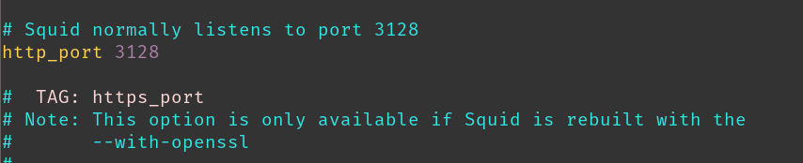

http_port : port

you can control the access of the squid server with acl (Access Control List)

you can create a text file with the list of the ip address with the allowed ip address and include with the acl and deny all other ip address that will prevent the other client to connect to the proxy server.

* create a file with allowed ip address name “allowed_ips.txt”

=>vim allowed_ips.txt
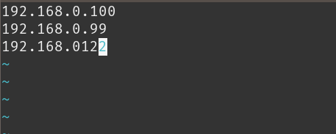

192.168.x.x
192.168.x.x
192.168.x.x
192.168.x.x
192.168.x.x

*now add the file to the acl .

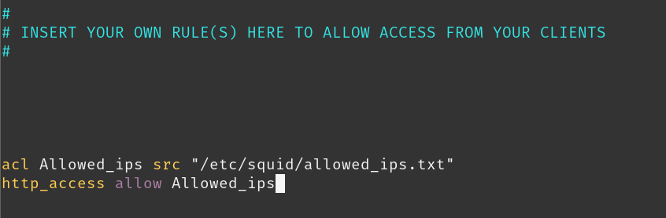

=> vim /etc/squid/squid.conf

## syntax

#acl <name> src “<filepath>”
#http_access allow <name>

acl Allowed_ips src ‘/etc/squid/allowed_ips.txt’
http_access allow Allowed_ips

or you can give access to all the client by allowing all the clients

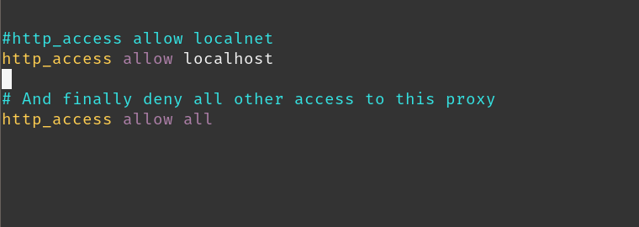

http_access allow all

after changing the configuration we have to restart the service so that the configuration change successfully loaded.

=>systemctl restart squid

Monitor User Access And Cache Of the Server

STEP 1
monitor the access of the user
we go to the file ‘/var/log/squid/access.log’

=> tail -f access.log
=> cat -f access.log | more
STEP 2
monitor the cache of the user
we go to the file ‘/var/log/squid/cache.log’

=> tail -f cache.log
=> cat -f cache.log | more

Thats the basic configuration of setting a squid proxy server in Ubuntu server.

SETTING SQUID PROXY SERVER IN CENTOS

SERVER SIDE CONFIGURATION

STEP 1

update the repository in centos
=> yum update -y
STEP 2
install squid packages
=> yum install squid -y
STEP 3
enable and start the squid service in boot time

=> systemctl enable squid
=> systemctl start squid
STEP 4
check the status of the process
=> systemctl status squid
STEP 5
Edit the squid configuration file in This configuration
→we can write acl for the client who can use the proxy server
→ we can select the cache memory
→ allow or deny specific network for using acl
→ block or allow specific website for the proxy server client

=> vim /etc/squid/squid.conf

* by default squid listen to the port 3128 you can change it and set a different port. If we want to change the port we have to change the line http_port and specify the new port

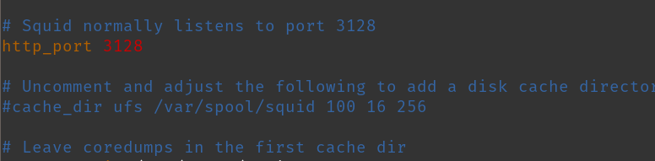

http_port : port

you can control the access of the squid server with acl (Access Control List)

you can create a text file with the list of the ip address with the allowed ip address and include with the acl and deny all other ip address that will prevent the other client to connect to the proxy server.

* create a file with allowed ip address name “allowed_ips.txt”

=>vim allowed_ips.txt

192.168.x.x
192.168.x.x
192.168.x.x
192.168.x.x
192.168.x.x

*now add the file to the acl .
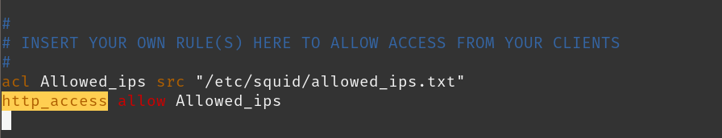

=> vim /etc/squid/squid.conf

## syntax

#acl <name> src “<filepath>”
#http_access allow <name>

acl Allowed_ips src ‘/etc/squid/allowed_ips.txt’
http_access allow Allowed_ips

or you can give access to all the client by allowing all the clients

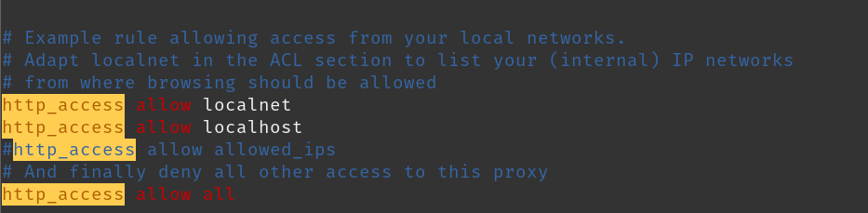

http_access allow all

after changing the configuration we have to restart the service so that the configuration change successfully loaded.

=>systemctl restart squid

Monitor user Access and Cache of the Server

STEP 1
monitor the access of the user
we go to the file ‘/var/log/squid/access.log’

=> tail -f access.log
=> cat -f access.log | more
STEP 2
monitor the cache of the user
we go to the file ‘/var/log/squid/cache.log’

=> tail -f cache.log
=> cat -f cache.log | more

Thats the basic configuration of setting a squid proxy server in centos 7.

***

NFS SERVER

WHAT IS NFS SERVER

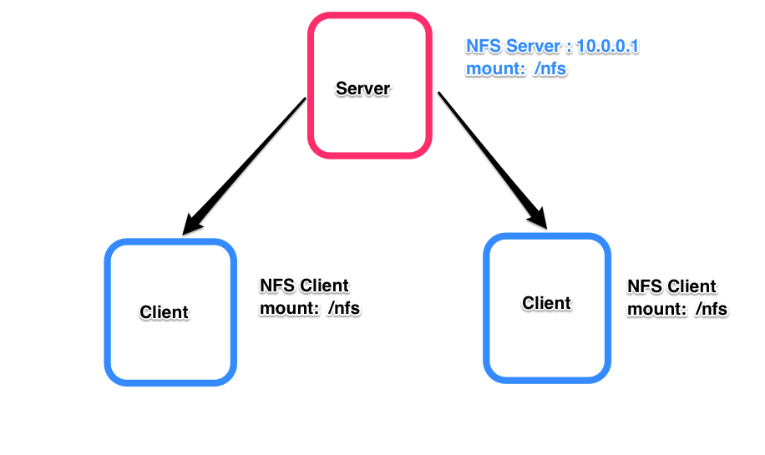

Linux provides a lot of different tools for accessing file on other computer system. For sharing file with a Linux based OS we actually use NFS (that includes Mac OS too because Mac OS is based on the BSD Unix based system ).and when we want to use share file between windows and Linux we use SAMBA. NFS allows you to connect and directly access the resource of other devices that resides on the other computer. The network information service(NIS) maintains the configuration files for all the system on a network. By using NFS you can mount a file system and work with it just like your computer own file system.

NFS DAEMONS

NFS operates over a TCP/IP protocol..The remote computer that holds the file system makes it available on the network. It actually done by exporting the file system .you have to make entry for that file system in the ‘/etc/exports’ .and you have to run several daemons to support that access
The NFS daemons are the following
→ rpc.bind : it takes NFS request from the remote system and translate to the local system.
→ rpc.mountd : performs the mount and unmount option
→ rpc.portmapper : Maps remote request to the appropriate NFS daemon
→ rpc.rquotad : provides user disk quote management
→ rpc.statd : provides locking services when a remote host reboots
→ rpc.lockd : Handles lock recovery for a system that gone down

[ It is recommended to use the NFS server only in the local network if you use it over the internet your system will be open for non secure access ]

SETTING NFS SERVER IN CENTOS

SERVER SIDE CONFIGURATION

requirments
→ Centos server
→ Centos client
→ server ip address 192.168.0.7/24

STEP 1
First install the kernel modules in the centos system
=>yum update
=> yum install nfs-utils nfs-utils-lib -y

STEP 2
we have to add the service to the firewall
=> firewall-cmd –add-service=nfs –permanent
=>firewall-cmd –reload

STEP 3
Enable the nfs service at boot time
=>systemctl enable nfs
=>systemctl start nfs

STEP 4
Create two directory
1) one for root in /var/lib/nfsroot
2) one for public user in varlib/nfspub
=>mkdir -p /var/lib/nfsroot
=>mkdir -p /var/lib/nfspub
STEP 5

Giving the permission to the public directory
=>chmod 777 /var/lib/nfspub
STEP 6

Edit the /etc/exports file for the file system share
=>vim /etc/exports

/var/lib/nfsroot 192.168.0.7/24(rw,sync,no_root,root_squash)
/var/lib/nfspub *(rw,sync,root_squash)

[* → everyone can use it
rw → writing power
sync → data will be synced in both side if the data is modified
root_quash → when logged in with it will logged as a user nobody:nobody
]

STEP 5
apply the change
=> exportfs -ra
CLIENT SIDE CONFIGURATION

STEP 1
install the necessary packages
=>yum install nfs-utils nfs-utils-lib

STEP 2
mount the volume
=> mount -t nfs 192.168.0.7:/var/lib/nfspub /mnt
it will mount the public directory to the /mnt folder

SETTING NFS SERVER IN UBUNTU

SERVER SIDE CONFIGURATION

requirments
→ Ubuntu server
→ Centos client
→ server ip address 192.168.0.7/24

STEP 1
First install the kernel modules in the ubuntu system
=>apt update
=> apt install nfs-kernel-server
STEP 2

we have to add the service to the firewall
=> ufw allow from 192.168.0.7/24 to any port nfs

STEP 3
Enable the nfs service at boot time
=>systemctl enable nfs
=>systemctl start nfs

STEP 4
Create two directory
1) one for root in /var/lib/nfsroot
2) one for public user in varlib/nfspub
=>mkdir -p /var/lib/nfsroot
=>mkdir -p /var/lib/nfspub

STEP 5
Giving the permission to the public directory
=>chmod 777 /var/lib/nfspub
STEP 6
Edit the /etc/exports file for the file system share
=>vim /etc/exports

/var/lib/nfsroot 192.168.0.7/24(rw,sync,no_root,root_squash)
/var/lib/nfspub *(rw,sync,root_squash)

[* → everyone can use it
rw → writing power
sync → data will be synced in both side if the data is modified
root_quash → when logged in with it will logged as a user nobody:nobody
]

STEP 5
apply the change
=> exportfs -ra
CLIENT SIDE CONFIGURATION

STEP 1
install the necessary packages
=>yum install nfs-utils nfs-utils-lib

STEP 2
mount the volume
=> mount -t nfs 192.168.0.7:/var/lib/nfspub /mnt
it will mount the public directory to the /mt folder

***

SAMBA SERVER
WHAT IS SAMBA
Samba is an open source software that is used to communicate with the windows client and share its resources mount the file system like hosts own file system. Samba provides this functionality by using the Common Internet File System (CIFS) SAMBA provides the following service

→ File & print services
→ Authentication and Authorization
→ Name resolution
→ Service announcement (browsing)

SETTING SAMBA SERVER IN CENTOS

SERVER SIDE CONFIGURATION

STEP 1

requirements :
1) Centos server , ip: 192.168.0.50
2) client (ubuntu or centos), ip: 192.168.0.100
3) internet connection

STEP 2

update repository and install the necessary samba packages

=> yum update -y
=>yum install samba samba-client samba-common

STEP 3

create a group and add user in that group who can use the samba share.

=>groupadd test
=>useradd user1
=>useradd user2
=>usermod -a -G test user1
=>usermod -a -G test user2

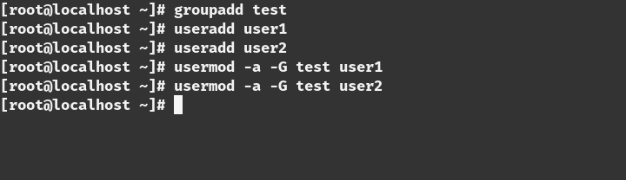

STEP 4

Create a directory and give proper permission for that user and group

=>mkdir /share
=>chmod 777 /share
=>chgrp test /share

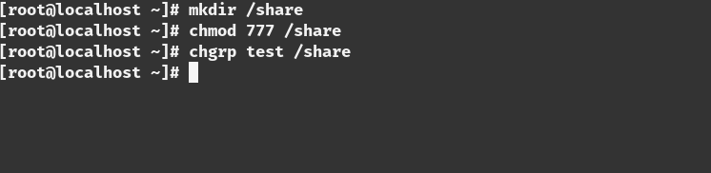

STEP 5

Configure SElinux .you can either disable the SEinux or set the proper Boolean value and security otherwise it will not let you connect to the server .In this we are not going to disable SElinux we will change the Boolean value.

=> setsebool -P samba_export_all_ro=1 samba_export_all_rw=1
=> getsebool –a | grep samba_export
=> semanage fcontext –at samba_share_t "/share(/.*)?"
=> restorecon /share

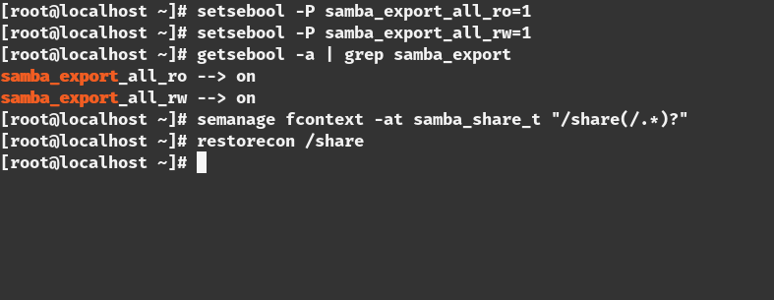

STEP 6

we have to change the firewall settings for allowing the connection
=>firewall-cmd –permanent –add-service=samba
=>firewall-cmd –reload

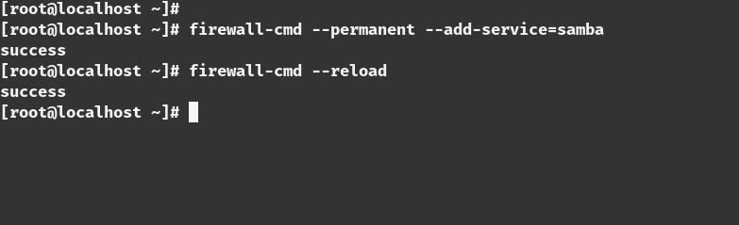
STEP 7

This is the most important path of the part .we need to edit the configuration of the samba share
=> vim /etc/samba/smb.conf

[share]
comment=Directory for for samba share
browsable=yes
path=/share
public=no
valid users=@test
write list=@test
writeable=yes
create mask=0770
Force create mode=0770
force group=test

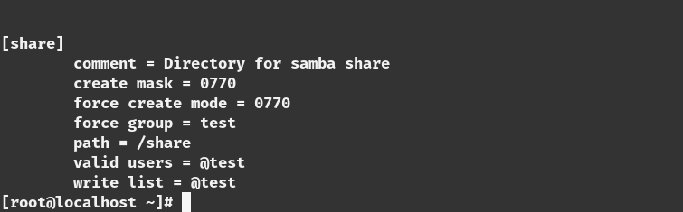
STEP 8

Test the configuration with the ‘testparm’ command.if there is any error in the configuration this command will tell you that
=>testparm

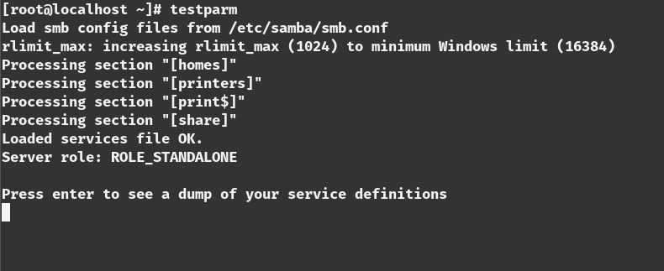

STEP 9

we have to add the user of the test group to the samba
=>smbpasswd -a user1
=>smbpasswd -a user2

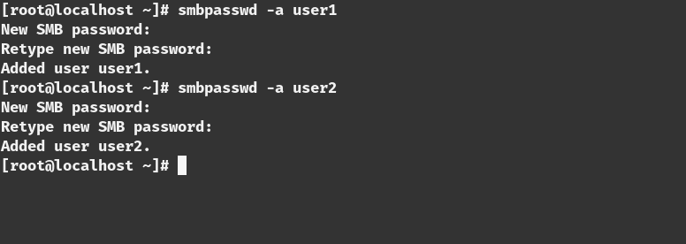

STEP 10

restart the samba server to make the change the in effect
=>systemctl start smb
=>systemctl start nmb

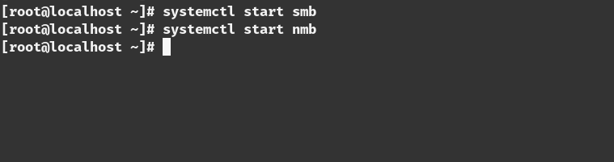

STEP 11

we have to enable the smb and nmb service to make start this on boot time

=>systemctl enable smb
=>systemctl enable nmb

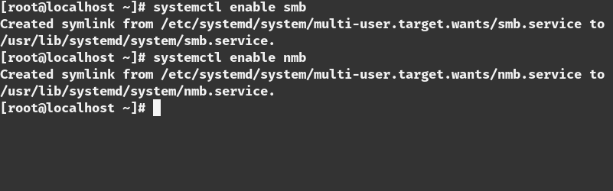

STEP 12

Test the connection from the server
=>smbclient -L localhost -U user1

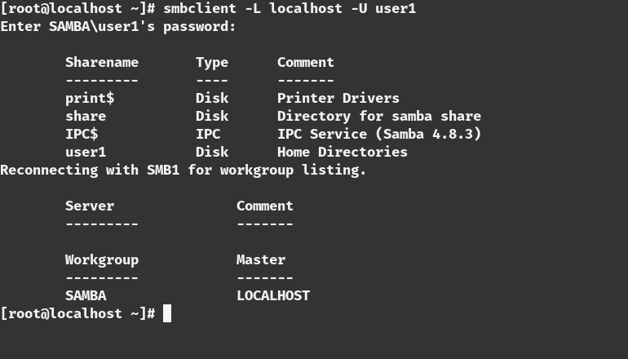
=>smbclient -L localhost -U user2

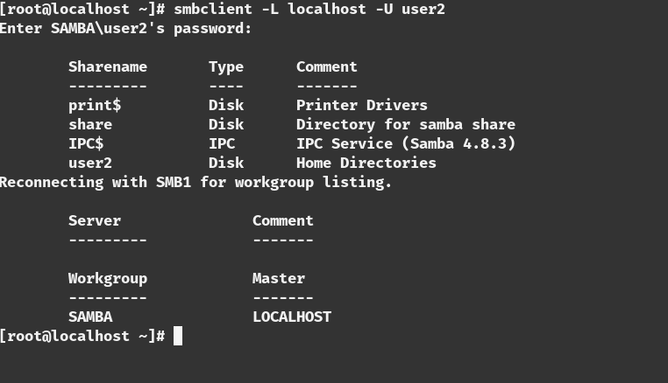

INSTALLING SAMBA CLIENT(LINUX)

STEP 1

install packages in the client
=>yum update -y
=>yum install samba samba-client samba-common -y
=>yum install cifs-utils -y

STEP 2

Test the connection from the client
=>smbclient -L 192.168.0.50 -U user1

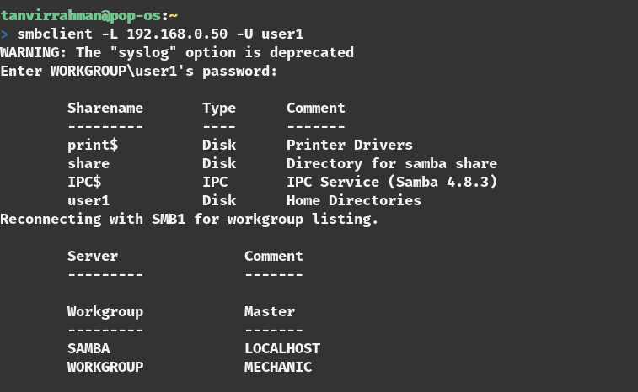

STEP 3

make the directory for mounting and give the proper permission
=>mkdir /share
=>chmod 777 /share

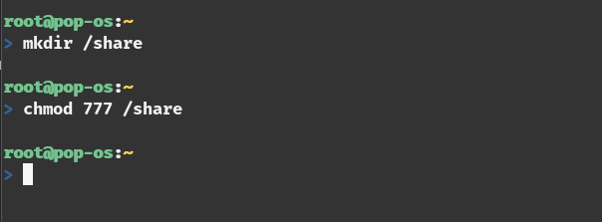

STEP 4

mount the the network share
=>mount //192.168.0.50/share /share -o username=user1

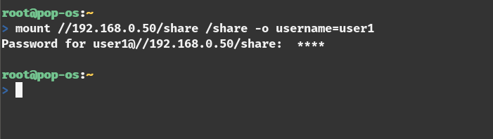

STEP 5
see the the network share
=>mount | grep cifs
ADDITIONAL STEP(PERMANENT MOUNT)

adding a credential file in /share folder
=> vim /share/.smbcredentials
username=user1
password=<password_for_user_1>

adding an entry to the ‘/etc/fstab’ file
=>vim /etc/fstab

//192.168.0.50/share /share cifs credentials=/share/.smbcredentials

TEST SHARE
create a file in the /share folder from the client side
=>touch /share/test.txt

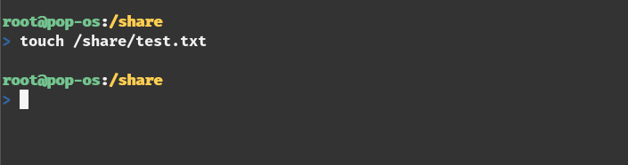

Now test from the server side
=>ls -l /share

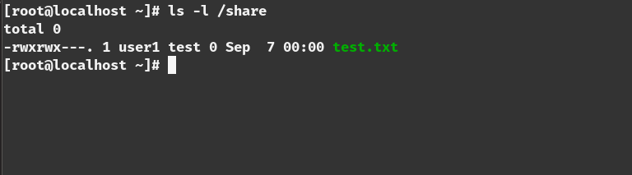

SETTING SAMBA SERVER IN UBUNTU

SERVER SIDE CONFIGURATION

STEP 1

requirements :
1) Ubuntu server , ip: 192.168.0.50
2) client (ubuntu or centos), ip: 192.168.0.100
3) internet connection

STEP 2

update repository and install the necessary samba packages

=> apt update -y
=>apt install samba

STEP 3

create a group and add user in that group who can use the samba share.

=>groupadd test
=>useradd user1
=>useradd user2
=>usermod -a -G test user1
=>usermod -a -G test user2

STEP 4

check the status
=> sudo systemctl status nmbd
=>sudo systemctl status smbd

STEP 5

Create a directory and give proper permission for that user and group

=>mkdir /share
=>chmod 777 /share
=>chgrp test /share

STEP 6

Configure SElinux .you can either disable the SEinux or set the proper Boolean value and security otherwise it will not let you connect to the server. In this we are not going to disable SElinux we will change the Boolean value.

=> setsebool -P samba_export_all_ro=1 samba_export_all_rw=1
=> getsebool –a | grep samba_export
=> semanage fcontext –at samba_share_t "/share(/.*)?"
=> restorecon /share

STEP 7

we have to change the firewall settings for allowing the connection
=>ufw allow ‘Samba’
=>ufw reload

STEP 8

This is the most important path of the part.we need to edit the configuration of the samba share
=> vim /etc/samba/smb.conf

[share]
comment=Directory for for samba share
browsable=yes
path=/share
public=no
valid users=@test
write list=@test
writeable=yes
create mask=0770
Force create mode=0770
force group=test

STEP 8

Test the configuration with the ‘testparm’ command. If there is any error in the configuration this command will tell you that
=>testparm

STEP 9

we have to add the user of the test group to the samba
=>smbpasswd -a user1
=>smbpasswd -a user2
STEP 10

restart the samba server to make the change the in effect
=>systemctl start smbd
=>systemctl start nmbd

STEP 11

we have to enable the smb and nmb service to make start this on boot time

=>systemctl enable smb
=>systemctl enable nmb

STEP 12

Test the connection from the server
=>smbclient -L localhost -U user1

=>smbclient -L localhost -U user2

INSTALLING SAMBA CLIENT(LINUX)

STEP 1

install packages in the client
=apt update -y
=>apt install samba samba-client -y
=>apt install cifs-utils -y

STEP 2

Test the connection from the client
=>smbclient -L 192.168.0.50 -U user1

STEP 3

make the directory for mounting and give the proper permission
=>mkdir /share
=>chmod 777 /share
STEP 4

mount the the network share
=>mount //192.168.0.50/share /share -o username=user1
STEP 5
see the the network share
=>mount | grep cifs
ADDITIONAL STEP(PERMANENT MOUNT)

adding a credential file in /share folder
=> vim /share/.smbcredentials
username=user1
password=<password_for_user_1>

adding an entry to the ‘/etc/fstab’ file
=>vim /etc/fstab

//192.168.0.50/share /share cifs credentials=/share/.smbcredentials

TEST SHARE
create a file in the /share folder from the client side
=>touch /share/test.txt
Now test from the server side
=>ls -l /share
[or you can use any GUI client for sharing the resources .and if you want to share it with windows because thats why the sambe is created you dont need to install packages for that.]

***

COCKPIT

Cockpit is a free open source system monitoring application which is considered a basic web based tool to monitor and configure basic services system health and monitor multiple server and their performances. it will let you start/stop services, generate diagnostic report,manage users,network,vlan, multiple servers with a graphical user interface .you can monitor multiple server with a single interface .its a very important tools for the beginner system administrator and lets you monitor almost everything of a system.

SETTING COCKPIT FOR SERVER IN UBUNTU

STEP 1

Assign static ip address of your UBUNTU system
[you can find they way in the ip address section]

STEP 2
update the repository
=>apt update -y
STEP 3

install cockpit
=>apt install cockpit -y
[you can directly fetch the source code from the github and compile too ]

STEP 4
enable the service in the boot time
=>systemctl enable cockpit.socket

STEP 5

restart the service
=>systemctl restart cockpit.socket

STEP 6
go to web browser and type <ip_address>:9090
[port:9090]

STEP 7

Enter the root user and password to login
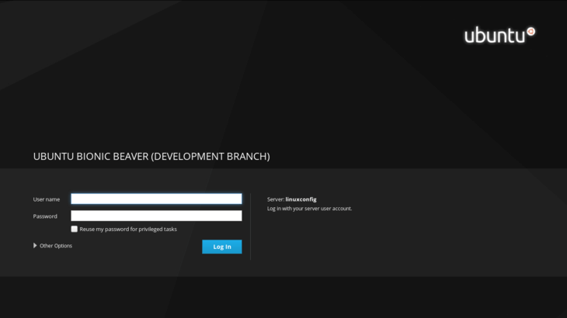

STEP 8
This page you can monitor
→ system memory
→ Disk I/O
→ network traffic
→ CPU performance

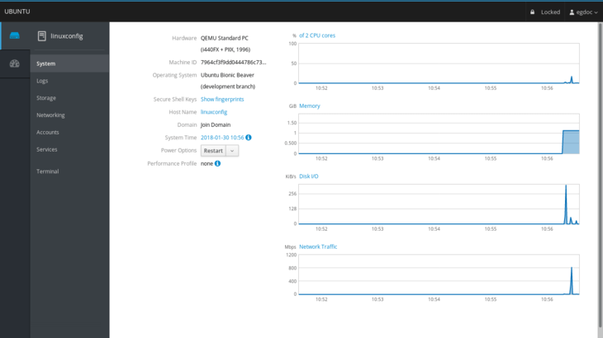

STEP 9
his page you can monitor system logs

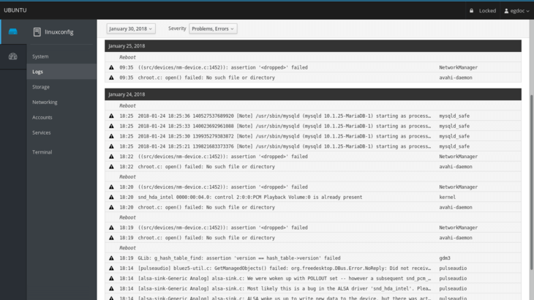
STEP 10

This page you can monitor networking and firewall and network interface,you can add vlan,bridge and team

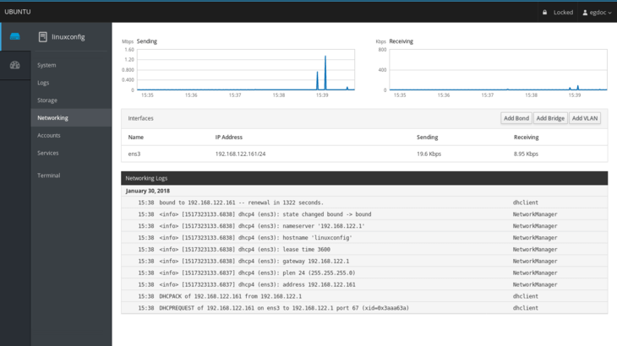
STEP 11
You can also monitor the user .you can add or remove the user from this page.
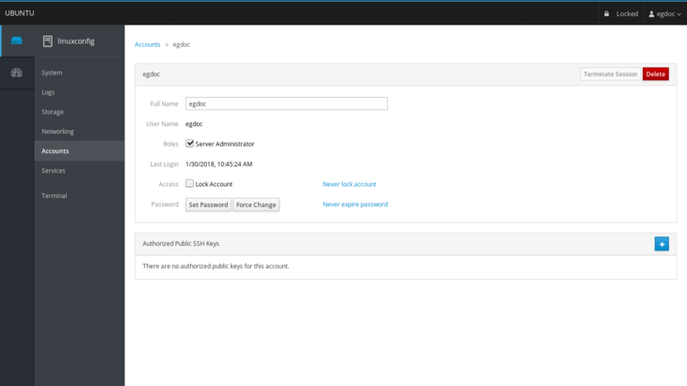
STEP 12
you can monitor and control all the service
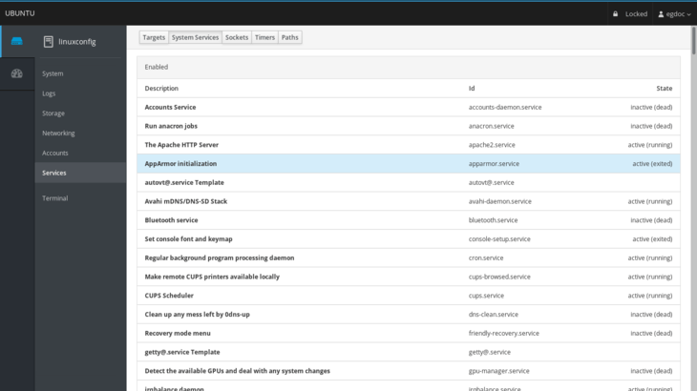

***

SETTING COCKPIT FOR SERVER IN CENTOS
STEP 1
Assign static ip address of your centos system
[you can find they way in the ip address section]

STEP 2
install “epel-release” repository in the system
=>yum install epel-release -y

STEP 3
update the repository
=>yum update -y
STEP 4

install cockpit
=>yum install cockpit
[you can directly fetch the source code from the github and compile too but in centos7 cockpit is in the epel-release so you need to do that]
STEP 5

enable the service in the boot time
=>systemctl enable cockpit.socket

STEP 6
Edit the configuration and disable the SSL

=>vim /usr/lib/systemd/system/cockpit.service

[Unit]
Description=Cockpit Web Service
Documentation=man:cockpit-ws(8)
Requires=cockpit.socket

[Service]
ExecStartPre=/usr/sbin/remotectl certificate --ensure --user=root --group=cockpit-ws --selinux-type=etc_t
ExecStart=/usr/libexec/cockpit-ws --no-tls
PermissionsStartOnly=true
User=cockpit-ws
Group=cockpit-ws

→ add ‘--no-tls’ after the ‘ExecStart=/usr/libexec/cockpit-ws’ line

=>ExecStart=/usr/libexec/cockpit-ws –no-tls

This will disable the SSL.

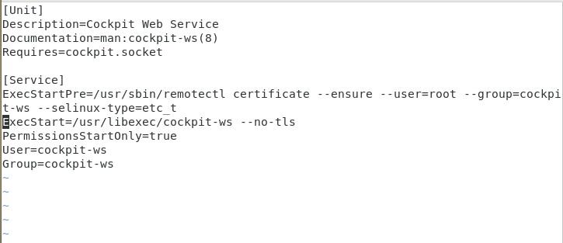
STEP 7
restart the service
=>systemctl restart cockpit.socket

STEP 8

go to web browser and type <ip_address>:9090
[port:9090]
STEP 9

Enter the root user and password to login

STEP 10

This page you can monitor
→ system memory
→ Disk I/O
→ network traffic
→ CPU performance
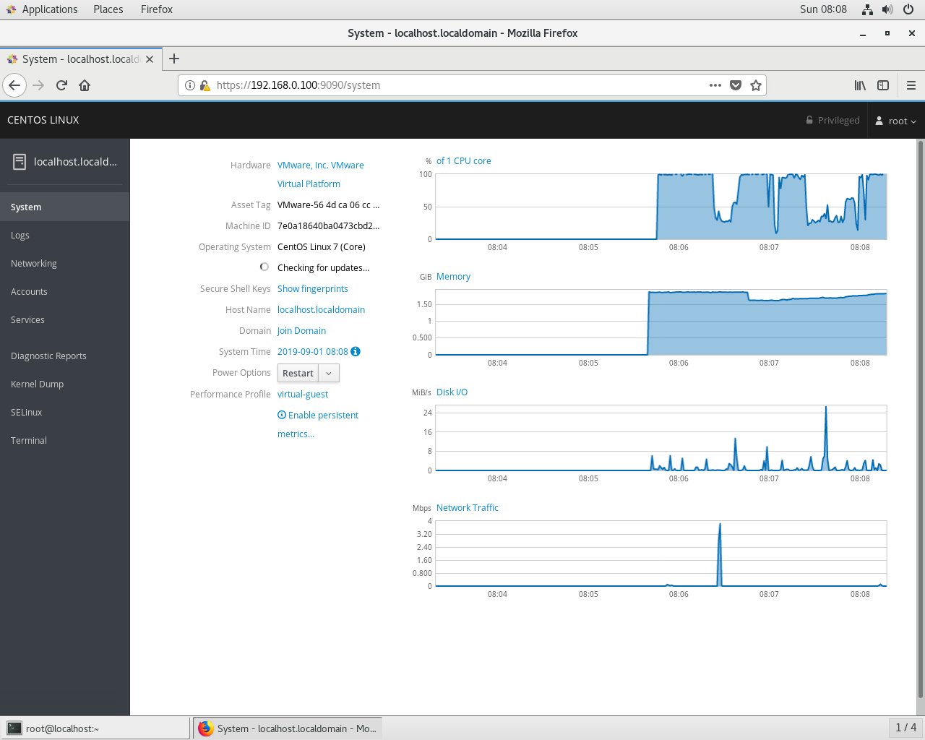

STEP 11
This page you can monitor system logs
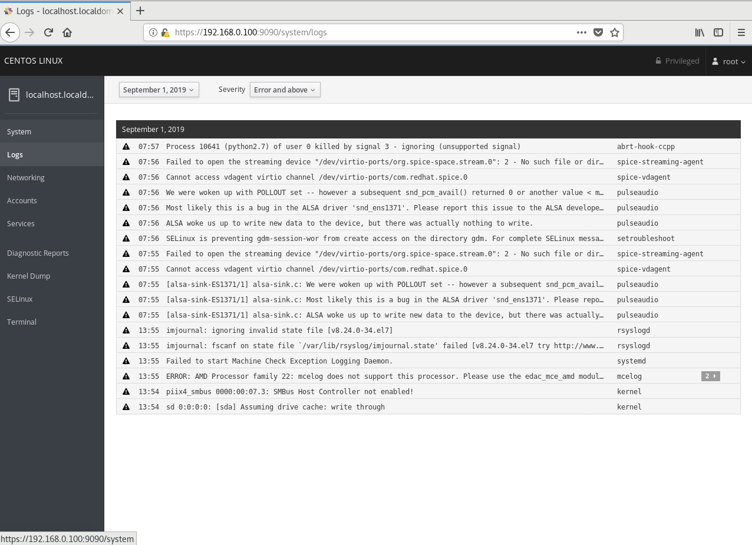
STEP 12
This page you can monitor networking and firewall and network interface,you can add vlan,bridge and team
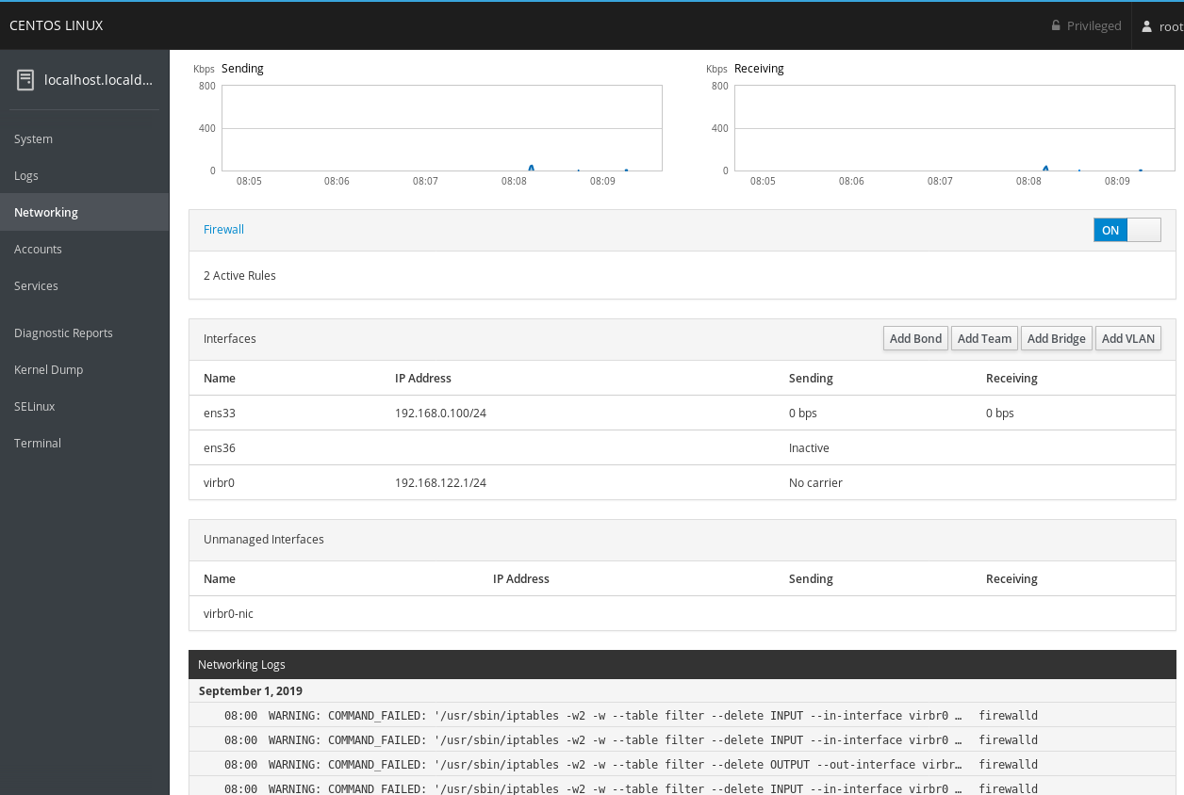
STEP 13

You can also monitor the user .you can add or remove the user from this page.

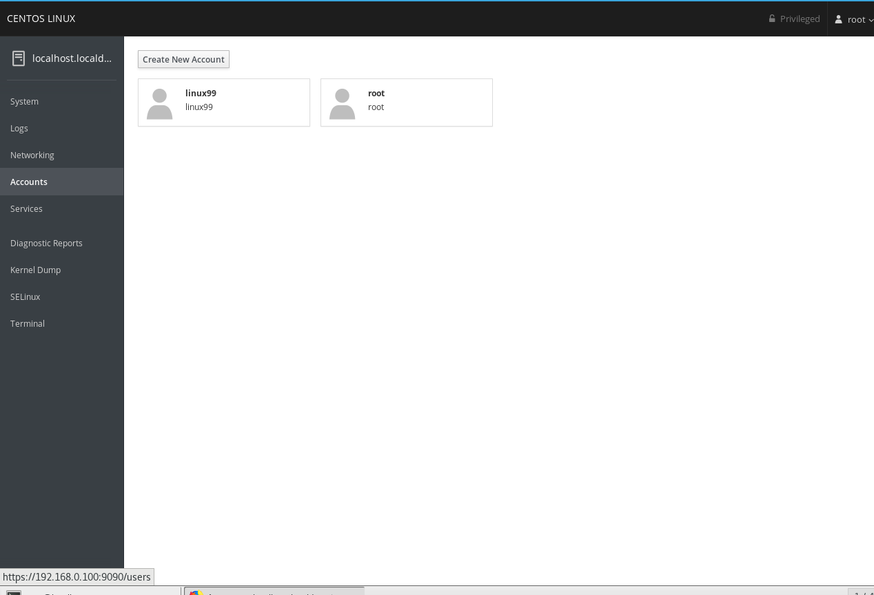

STEP 14
you can monitor and control all the service

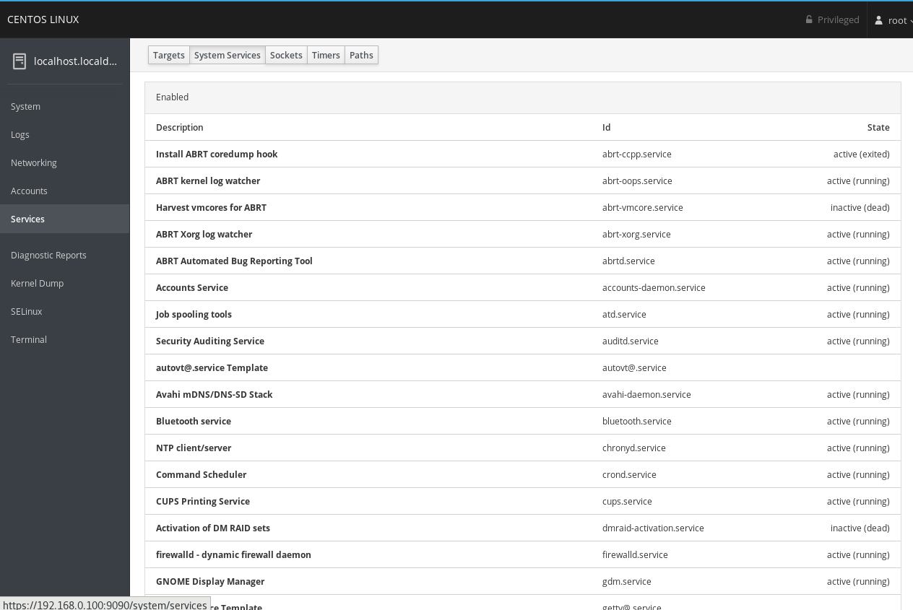
STEP 15
Most Importantly you can generate diagnostic report od the whole system with that.

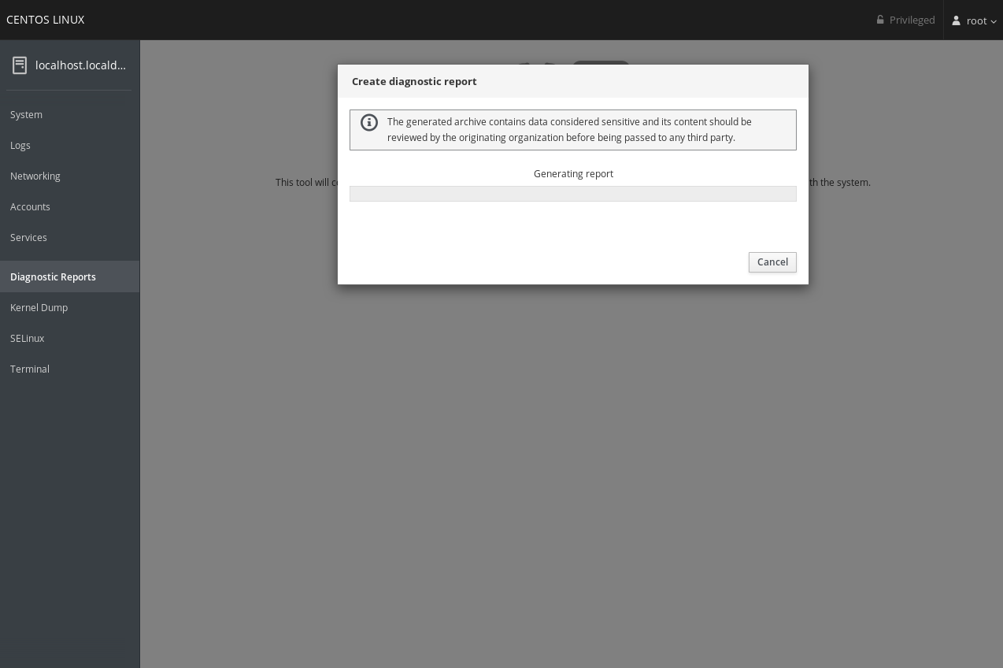

***

AIDE
ADVANCE INTRUSION DETECTION ENVIRONMENT

Any person who have knowledge about IT knows that “No system is 100% secure”.In today’s IT world maintaining server security is one of the biggest challenge , even the best available security is insufficient for the latest vulnerabilities in various products, and against malware/attacks created to target those vulnerabilities. While cyber-security cannot be 100 per cent fool-proof, we can still try to achieve the maximum security possible. unauthorized intrusion in the system is one of the biggest problem ,detecting attackers and the unauthorized access to a server is one of the most important work for a server admin. Because having basic security only gives you the misleading feeling of being secure, rather than actual security. Modern attackers are experts who exploit software vulnerabilities by using technical tools, and devise methods to break into a network to achieve their goals. To handle smart attack attempts, an even smarter security mechanism is needed, Thats why checking system integrity and and detecting intrusion is very important. For checking integrity in Linux server we use a packages called AIDE(Advance Intrusion Detection Environment).Its a file and directory integrity checker.

WHAT DOES IT DO

It creates a database from the regular expression rules that finds from the config files.Once the database is created it is used to check the the intrigrity of the files.It uses several message digest algorithm that are used to check the integrity of the file.and they can detect the version of files

FEATURES

- supported message digest algorithms: md5, sha1, rmd160, tiger, crc32, sha256, sha512, whirlpool (additionally with libmhash: gost, haval, crc32b)
- supported file attributes: File type, Permissions, Inode, Uid, Gid, Link name, Size, Block count, Number of links, Mtime, Ctime and Atime
- support for Posix ACL, SELinux, XAttrs and Extended file system attributes if support is compiled in
- plain text configuration files and database for simplicity
- powerful regular expression support to selectively include or exclude files and directories to be monitored
- gzip database compression if zlib support is compiled in
- stand alone static binary for easy client/server monitoring configurations

SETTING AIDE IN CENTOS

STEP 1

give the server a static ip address.centos server ip address:

ip:192.168.0.100
subnet mask:255.255.255.0
gateway:192.168.0.1
dns:8.8.8.8

your ip address can be different.

STEP 2

update the repository of the centos
=>yum update
STEP 3
install the epel-release
=>yum install epel-release -y
=>yum update
STEP 4
install the aide package
=> yum install aide -y
STEP 5
Create the database
=>aide –init
[This may take some time]

STEP 6

Once the database is created you can move and rename it like the original one to make it work

=>mv /var/lib/aide/aide.db.new.gz /var/lib/aide/aide.db.gz

TESTING THE APPLICATION

STEP 7
For Testing we make a binary file inside the ‘/usr/sbin’ directory
=>touch /usr/bin/testbin
STEP 8
Check the database again
=>aide –check

lets see the output;

AIDE 0.15.1 found differences between database and filesystem!!
Start timestamp: 2019-08-26 07:19:13

Summary:
Total number of files: 160184
Added files: 2
Removed files: 0
Changed files: 0
Added files:
added: /sbin/testbin
added: /usr/sbin/testbin

STEP 9

So we can see aide can detect the change of the file.

STEP 10
if you think this file is not dangerous you can add the file the database so in the next search it will not be shown. Update the database with this command
=>aide –update

SETTING AIDE IN UBUNTU

STEP 1

Give the server a static ip address. centos server ip address:

ip:192.168.0.100
subnet mask:255.255.255.0
gateway:192.168.0.1
dns:8.8.8.8

your ip address can be different.
STEP 2

update the repository of the debian
=>apt update
STEP 3
install the aide package
=> apt install aide -y

[remember aide need additional packages to work.So make sure you install the packages through apt]
STEP 4
Create the database
=>aideinit
[This may take some time]

STEP 5
Once the database is created you can copy and rename it like the original one to make it work
=>cp /var/lib/aide/aide.db.new /var/lib/aide/aide.db
STEP 6

now we need to update the configuration file
=>update-aide.conf
STEP 7
The newly genaerated configuration file is stored in ‘/var/lib/aide/aide.conf.autogenerated’ name.

STEP 8
we need to copy the configuration file to the ‘/etc/aide/aide.conf’ name
to ‘/etc/aide’ directory
=>cp /var/lib/aide/aide.conf.autogenerated /etc/aide/aide.conf

STEP 9
check the database
syntax: aide -c <conf file> --check
=> aide -c /etc/aide/aide.conf --check

STEP 10
For Testing we make a binary file inside the ‘/usr/sbin’ directory
=>touch /usr/bin/testbin

STEP 11
Check the database again
=>aide -c /etc/aide/aide.conf –check

STEP 12
So we can see aide can detect the change of the file.

STEP 13
if you think this file is not dangerous you can add the file the database so in the next search it will not be shown. Update the database with this command
=>aids –update

***

WEBMIN

Webmin is a web based tool for system administration tool.you can compare the webmin with cockpit for UNIX/LINUX based OS you can do almost every administration task you can monitor the Servers,Networking,Firewall,service like ssh,Hardware connectivity,NFS,server security,Client service,Authentication process and most importantly Bandwidth Monitoring

Requirment:

1) Apache web server preinstalled
2) FQDN(Fully Qualified Domain Name)
3) CentOS server
4) ubuntu server
5) Root Access to the server

CONFIGURE WEBMIN IN CENTOS
STEP 1
Create a Repository file in the ‘/etc/yum.repos.d/’ Because web in is not in the Centos system official repository

=>sudo vim /etc/yum,repos.d/webmin.repo

add this line
[webmin]
baseurl = http://download.webmin.com/download/yum
mirrorlist=http://download.webmin.com/download/yum/mirrorlist
enabled=1
gpgcheck=0

STEP 2
Install the packages with yum command
=>sudo yum install webmin
STEP 3
After a successful installation it will finally show you the message and URL to go the web interface
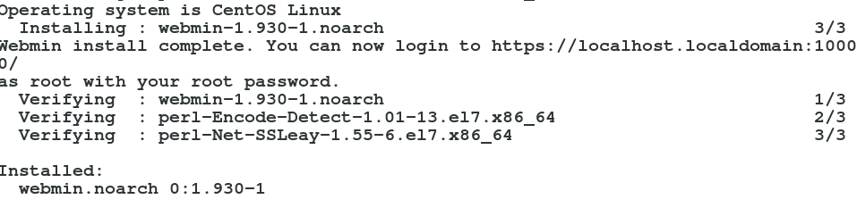
STEP 4
Login with the root user and password in the webmin
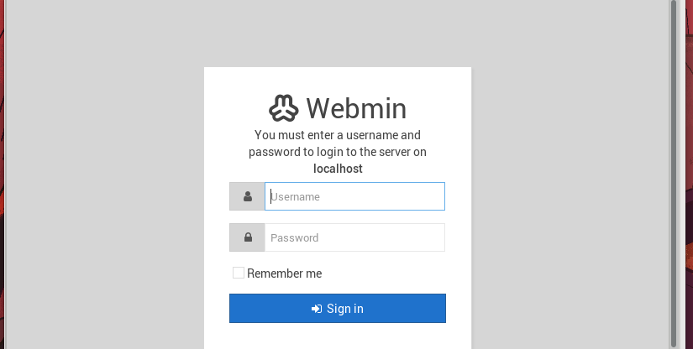
Hardware monitoring
you can monitor the hardware load in the web page in the hardware section
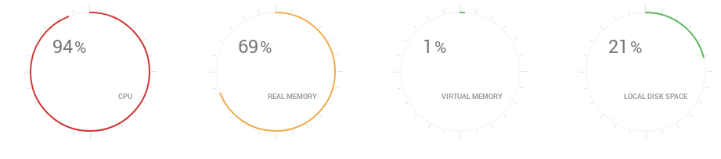
Login and Authentication
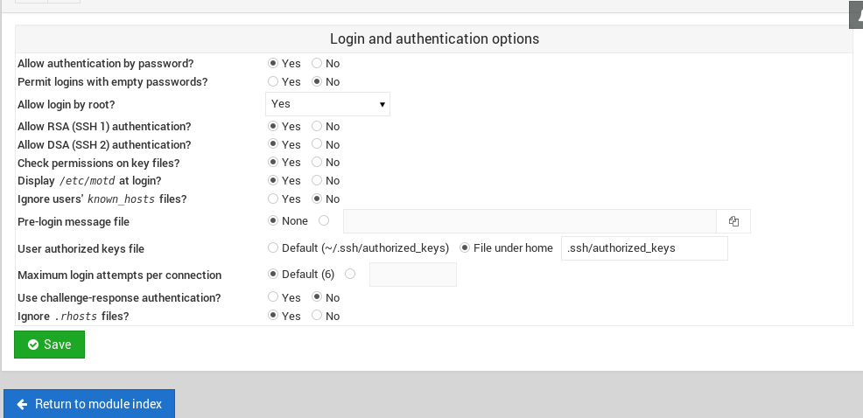

Bandwidth Monitoring and controll
you can control the bandwidth on different network interface with bandwidth monitoring tools. this is very use full tool for controlling bandwidth of the server.
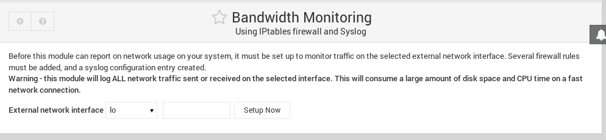

CONFIGURE WEBMIN IN ubuntu
STEP 1
Add gpg key and the repository
=>wget -qO- http://www.webmin.com/jcameron-key.asc | sudo apt-key add

=>sudo add-apt-repository "deb http://download.webmin.com/download/repository sarge contrib"

STEP 2
Install the packages with apt command
=>sudo install webmin
STEP 3
After a successful installation it will finally show you the message and URL to go the web interface

ACCESS WEBMIN WITH FQDN
We need to make a virtual hosting in our apache configuration to make the website accessible using the domain name.(method is giving in the apache web server confiration)
suppose our domain name: example.com
STEP 1
edit the configuration file
=>vim /etc/apache2/sites-available/example.conm

STEP 2
add this configuration

<VirtualHost *:80>
ServerAdmin user.example.com
ServerName example.com
ProxyPass / http://localhost:10000/
ProxyPassReverse / http://localhost:10000/
</VirtualHost>
STEP 3
change the firewall rules
=>sudo ufw allow from any to any port 10000 proto tcp

STEP 4
change the ssl to avoid the secure connection
=>vim /etc/webmin/miniserv.conf

ssl=0

STEP 5

Add this domain to the allowed domain
=>vim /etc/webmin/config

referers=example.com

STEP 6

restart the webmin service and the httpd service to apply the change
=>systemctl restart webmin
=>systemctl restart apache2

you can access the webmin with FQDN now

***

Database Server
Database is an application where data is stored in a very organised way in a computer system. complex data with complex design can be easily stored in the database application and almost all the web application and other desktop application uses some kind of database .There are different kinds of database SQL,NoSQL database. Sql Database use the SQL to query,update,store and Delete the Data.SQL is a language for managing database.
There are a lot of SQL Database like
→mariadb
→ PostgreSQL
→ MS SQL Database
→Sqlite

NoSQL Database are
→ MongoDB
→ Redis
→ LMDB
→ CouchDB
→ CAssandra
we will talk about the mariaDB installation and Configuration

MARIADB SERVER INSTALLATION AND CONFIGURATION IN CENTOS & UBUNTU
STEP 1
Update the repository and install the mariaDB server and enable it on boot time
[in centos]
=>yum update && yum install mariadb-server -y
=>systemctl enable mariadb
→systemctl restart mariadb

[in ubuntu]
=>apt update && apt install mariadb-server mariadb-client -y
=>systemctl enable mariadb
→systemctl restart mariadb

STEP 2
For Production you have Hardening the Security.To do that you have to apply this command
=>mysql_secure_installation
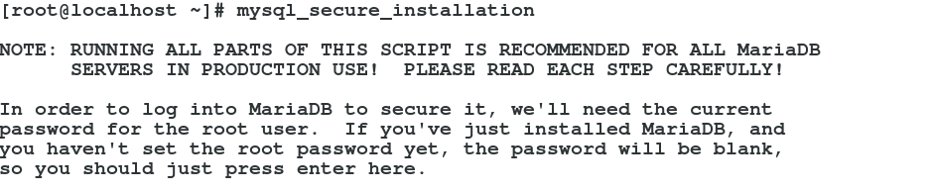
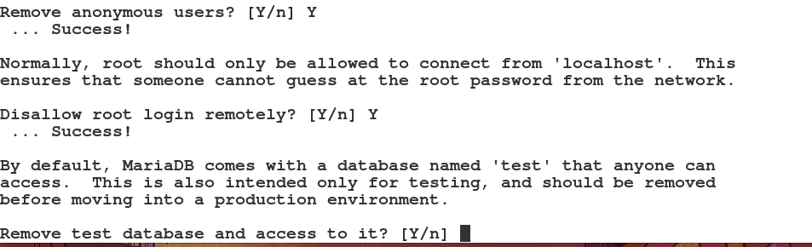
And you have to Enter the password for root login and then configure it

STEP 4

After a Successful installation This Message will be shown
STEP 5

login with the root password
=>mysql -u root -p
Create User In Database
we will create database and a user in mariadb and grant all the permission of a this database

database ‘testdb’create
=>create databse testdb;


user create
=>create user ‘testuser’@localhost identified by ‘password’;
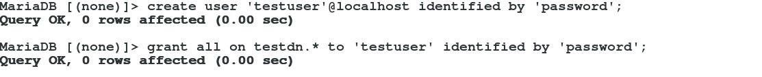
grant permission
=>grant all on testdb.* testuser‘ identified by ‘password’;

login with the user
=> mysql -u testuser -p
password: password

create a table
=>use testdb;
=>create table test(name VARCHAR(100) NOT NULL,id INT NOT NULL);
show the table
=>describe test;

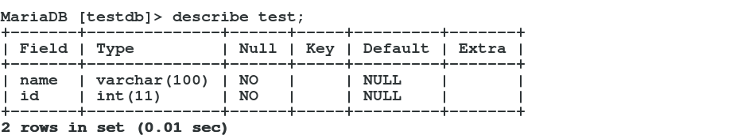

PASSWORD RECOVERY IN MARIADB
STEP 1
First stop the mariadb server
=>systemctl stop mariadb
STEP 2
=>mysqld_safe –skip-grant-tables &

STEP 3
login with root user without any password
=>mysql -u root

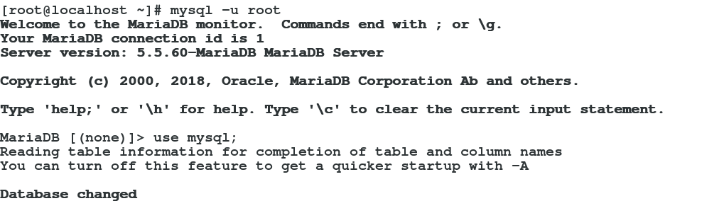

STEP 4
Set the password again using the mysql database
=>use mysql
=>update user SET PASSWORD=PASSWORD(‘your_password’) WHERE USER=’root’;

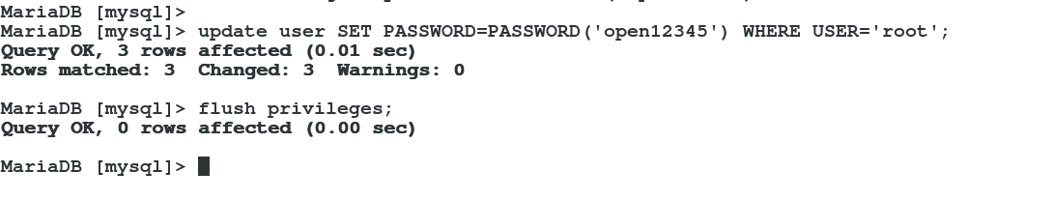

STEP 5
start the service and login with new password
=>systemctl start mariadb
=>mysql -u root -p <new_password>

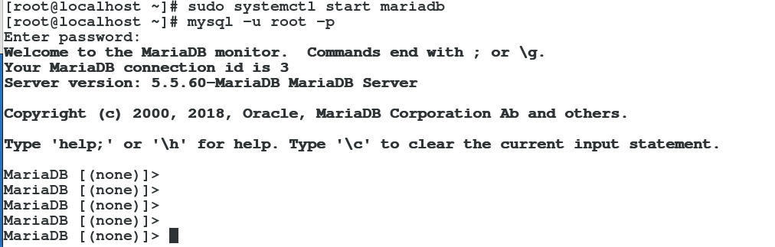

***

IPA SERVER

IPA server is an integrated security information management solution combining
→ Linux (OS)
→ 389 Directory Server
→ MIT Kerberos
→ NTP (Network Time Protocol)
→ DNS (Domain Name Server)
→ Dogtag (Certificate System)
→ web interface (Apache web server)
→ command-line tools
[SAMBA, NFS AND ,MAIL SERVER CAN ALSO BE INCLUDED MANUALLY IN THIS SYSTEM]
.
IPA is an integrated Identity and Authentication solution for Linux/UNIX networked environments. A IPA server provides centralized authentication, authorization and account information by storing data about user, groups, hosts and other objects necessary to manage the security aspects of a network of computers.
IPA is built on top of well known Open Source components and standard protocols with a very strong focus on ease of management and automation of installation and configuration tasks.
Multiple IPA servers can easily be configured in a IPA Domain in order to provide redundancy and scalability. The 389 Directory Server is the main data store and provides a full multi-master LDAPv3 directory infrastructure. Single-Sign-on authentication is provided via the MIT Kerberos KDC. Authentication capabilities are augmented by an integrated Certificate Authority based on the Dogtag project. Optionally Domain Names can be managed using the integrated ISC Bind server.
Security aspects related to access control, delegation of administration tasks and other network administration tasks can be fully centralized and managed via the Web UI or the ipa Command Line tool.

CONFIGURE IPA SERVER IN UBUNTU

STEP 1

Setting up a static ip address for the server and the host

In this lab the server address is
ip: 192.168.0.102
gateway:192.168.0.1
dns: 8.8.8.8

And the client address

ip:192.168.0.103
gateway: 192.168.0.1
dns:192.168.0.102 [server address]

restart the connection to take effect:

nmcli device down <NIC/device> / ifdown <NIC>
nmcli device up <NIC/device> / ifup <NIC>

[important note if you give the client dns to the server address you have to install packages from local repository unless you have a second nic connected to the internet because in order to work with online repository you need a public dns like 8.8.8.8 but if you use the local repo in the client its all fine]

[see the ip address section for the process of giving a static ip address]

STEP 2

set a static host name of the server using ‘hostnamectl’ command
[server]
=> hostnamectl set-hostname “ipa.it.local”
=> exec bash

STEP 3

edit the “/etc/hosts” of the server
=> vim /etc/hosts

[add this line

192.168.0.102 ipa.it.local ipa
192.168.0.103 client1.it.local client1
]

STEP 4
Test with ping command
=> ping ipa.it.local

STEP 5

update the server repository

=>apt update -y

STEP 6
(addional): reboot the system
=>reboot

STEP 7
install “rng-tools” packages in server machine
rng tools is basically used got cryptography
=>apt install rng-tools -y

STEP 8
configure rng-tools
=>vim /etc/default/rng-tools

##set the input source for random random data by adding line

HRNGDEVICE=/dev/urnadom

STEP 9
Enable and start rng-tools

=>systemctl enable rng-tools
=>systemctl start rng-tools

STEP 10
install “free-Ipa” packages in server machine

[server]
=> apt install freeipa-server -y

It will prompt you with this options

Enter the Hostname for kerberos server
=>ipa.it.local
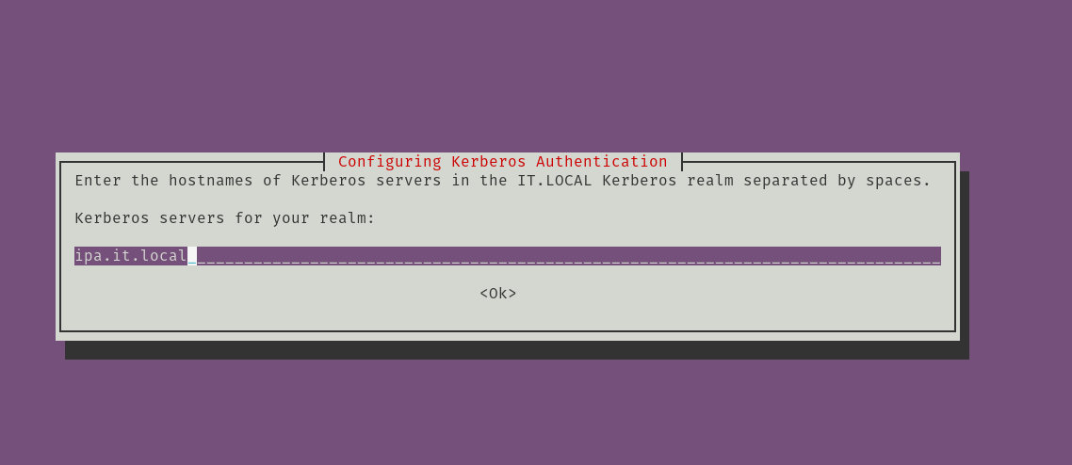

Enter administrative server for kerberos realm
=>ipa.it.local
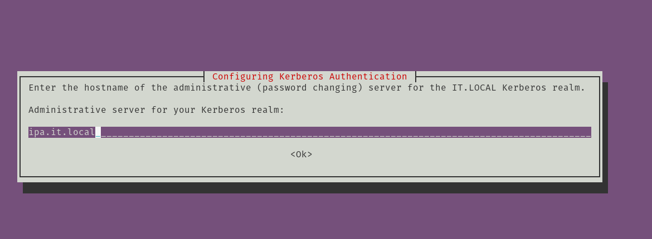

STEP 11

Install IPA server in server machine

[server]
=> ipa-server-install

11-1: Do you want to configure integreted DNS?
=>no
11-2: Server Host name [ipa.test.system]
=>[Enter]
11-3: Please confirm Domain name [test.system]?
=>[Enter]
11-4: Please provide a realm name [TEST.SYSTEM]?
=>[Enter]
11-5: Directory manager password?
=><give_a_password>
example: admin@ipa
11-6: IPA admin Password?
=><give_a_password>
example: admin@redhat
11-7:Continue to configure the system with these values?
=>yes

STEP 12
Enable ufw
[server]
=>ufw enable
STEP 13

Allow tcp port

=> for i in 80 443 389 636 88 464;do sudo ufw allow proto tcp from any to any port $i;done

STEP 14
Allow the udp port

=> for i in 88 464 123;do sudo ufw allow proto udp from any to any port $i;done
STEP 15
Restart the ufw
=>ufw reload
STEP 16
Initialize the admin user [varify weather the admin user get token from the kerberos] [you can login with just the user and password but to login with kerberos you have to issue the command]

[server]
1)=> kinit admin
[password: ] [same password for installation during FreeIPA]
2)=> klist

STEP 17
Reboot the system again
=> reboot
STEP 18

Go to the administration page and login with username and password
[server]

username: admin
password: <admin_password>

[go to web browser to url “http://ipa.test.system”]

STEP 19
create a user in the administration page
[server]

username: <give a username> / ex: ipa1
Firstname: ipa
lastname : user1
password : <give_password> /ex: redhat@ipa1

[you can install ipa server in ubuntu but there are some bug on the software thats why it is not recommended to install it in the ubuntu server.ipa server works perfectly in centos/Redhat/fedora server without issue so the full installation with client side is described in next chapter]

***

CONFIGURE IPA SERVER IN CENTOS

STEP 1
setting up a static ip address for the server and the host
In this lab the server address is
ip: 192.168.0.102
gateway:192.168.0.1
dns: 8.8.8.8

and the client address

ip:192.168.0.103
gateway: 192.168.0.1
dns:192.168.0.102 [server address]

restart the connection to take effect
=> nmcli device down <NIC/device> / ifdown <NIC>
=> nmcli device up <NIC/device> / ifup <NIC>

[important note if you give the client dns to the server address you have to install packages from local repository unless you have a second nic connected to the internet because in order to work with online repository you need a public dns like 8.8.8.8 but if you use the local repo in the client its all fine]

[see the ip address section for the process of giving a static ip address]

STEP 2
set a static host name of the server using ‘hostnamectl’ command
[server]
=> hostnamectl set-hostname “ipa.it.local”
=> exec bash

STEP 3
edit the “/etc/hosts” of the server

=> vim /etc/hosts

[add this line

192.168.0.102 ipa.it.local ipa
192.168.0.103 client1.it.local client1
]
STEP 4
Test with ping commnad
=> ping ipa.it.local
STEP 5
Update the server repository
=>yum update -y

or
[if you use local repository]
=>yum update disablerepo="*" enablerepo='myrepo'

ADDITIONAL STEP
reboot the system
=>reboot
STEP 6
install “free-Ipa” packages in server machine

[server]
=> yum install disablerepo="*" enablerepo='myrepo' ipa-server bind-dyndb-ldap ipa-server-dns -y

[or you can remove all the online repo and add only the local yum repo then the command is]

=> yum install ipa-server bind-dyndb-ldap ipa-server-dns -y

STEP 7
install IPA server in server machine
[server]
=> ipa-server-install --setup-dns

7-1: Do you want to configure integreted DNS?
=>yes
7-2: Server Host name [ipa.test.system]
=>[Enter]
7-3: Please confirm Domain name [test.system]?
=>[Enter]
7-4: Please provide a realm name [TEST.SYSTEM]?
=>[Enter]
7-5: Directory manager password?
=><give_a_password>
example: admin@ipa
7-6: IPA admin Password?
=><give_a_password>
example: admin@redhat
7-7: Do you want to configure DNS Forwarders?
=>yes
7-8: Do you want these servers as DNS Forwarders?
=>yes
7-9: Do you want to search for missing reverse zone?
=>no
7-10: Continue to configure the system with these values?
=>yes

STEP 8
Configure users Home Directory and firewall
[server]
=>authconfig –enablemkhomedir –update

STEP 9
adding service to firewall

1) =>firewall-cmd –premanent –add-service=’freeipa-ldap’
2) =>firewall-cmd –premanent –add-service=’ntp’
3) =>firewall-cmd –premanent –add-service=’http’
4) =>firewall-cmd –premanent –add-service=’https’
5) =>firewall-cmd –premanent –add-service=’ldap’
6) =>firewall-cmd –premanent –add-service=’ldaps’
7) =>firewall-cmd –premanent –add-service=’kerberos’
8) =>firewall-cmd –premanent –add-service=’kpasswd’
9) =>firewall-cmd –premanent –add-service=’dns’
10) => firewall-cmd –reload

STEP 10
checking if everything running
=>ipactl status

STEP 11

adding port to firewall

=>firewall-cmd --permanent --zone=public –add-port={80/tcp,443/tcp,302/tcp,636/tcp,88/tcp,464/tcp,53/tcp,88/udp,464/udp,53/udp,123/udp}
=> firewall-cmd –reload
STEP 12

initialize the admin user [verify weather the admin user get token from the kerberos] [you can login with just the user and password but to login with kerberos you have to issue the command]
[server]
1)=> kinit admin
[password: ] [same password for installation during FreeIPA]
2)=> klist
STEP 13
reboot the system again
=> reboot

STEP 14
Go to the administration page and login with username and password
[server]

username: admin
password: <admin_password>

[go to web browser to url “http://ipa.test.system”]

STEP 15

create a user in the administration page
[server]

username: <give a username> / ex: ipa1
Firstname: ipa
lastname : user1
password : <give_password> /ex: redhat@ipa1

STEP 16
setting reverse dns discovery

[server]
in the administration page go to

[NETWORK SERVICES] →[DNS] → [DNS ZONES] → [ADD.ARPA] → [ADD]

RECORD NAME : 103 //because the last number of ip
is 103 [192.168.0.103]

RECORD TYPE: PTR

HOSTNAME: client1.it.local.

[remember the (.) after the client.it.local in the hostname is important]

That’s all the server configuration now we have to configure the client

CONFIGURE IPA CLIENT IN CENTOS

STEP 1
setting up a static ip address for the server and the host
In this lab the client address

ip: 192.168.0.103
gateway:192.168.0.1
dns:192.168.0.102 [server address]

[see the ip address section for the process of giving a static ip address]

STEP 2
setting up hostname

=>hostnamectl set-hostname client1.it.local

STEP 3

edit the ‘/etc/hosts’ file

=>vim /etc/hosts
192.168.0.103 client1.it.local client1
192.168.0.102 ipa.it.local ipa

STEP 4

restart the NIC to take in effect
=> nmcli device down <NIC/device> / ifdown <NIC>
=> nmcli device up <NIC/device> / ifup <NIC>

STEP 5
test with ping
=>ping client1.it.local
=>ping ipa.it.local

STEP 6
install ipa-client-packages
=> yum install ipa-client
STEP 7
install ipa-client

=>ipa-client-install [yes]

→authoraize enroll computer : admin
→ password : open12345
=>authconfig –enablemkhomedir –update

[now logout from the session and login with the domain username and password that the in the server by admin]

CONFIGURE NFS SERVER ON IPA

WHY INSTALL NFS SERVER?

because when you login from a computer with a domain user and password and store some file .in ipa server if you login with other computer ,you may login with domain user and password because of the central authentication system(ipa) but you will not find the resources that you make on the other computer with the same domain name,that means your data is not roaming .it stuck with the pc that you use .so it fails to complete the central management cause our target is no matter what ip client pc you are using you can login your domain username and password and also you will get your file .you dont need to sit in the same computer. To make that happen we make a nfs server

WHERE WE INSTALL OUR NFS SERVER?

you can install the nfs server inside the IPA server. but it is not recommended . Although in this example we use the ipa server as a nfs server .you can install nfs server at any active ipa client[for example you can install it on “client1”].Basically we choose a client which has a lot of space because all the users resources will save in the nfs server

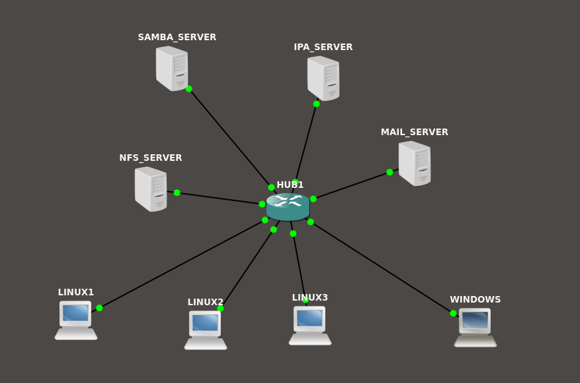

NFS SERVER

STEP 1
Choose the server
we choose the ipa server as a nfs server [ipa.it.local]

STEP 2
Install the nfs server packages
=> sudo yum install nfs-utils

STEP 3
Edit the file /etc/exports
=>vim /etc/exports

/home *(rw,sync)

STEP 4
start the nfs server
=>systemctl enable nfs-server
=>systemctl start nfs-server

STEP 5
start the rpcbind
1) systemctl enable rpcbind
2) systemctl start rpcbind
STEP 6
adding firewall rules
=>firewall-cmd –permanent –add-service nfs
=>firewall-cmd –reload
STEP 7

see the mounted volume for nfs server
=>showmount -e
[if everything goes right you will see the directory that is mounted ]

IPA CLIENT CONFIGURATION

[you have to configure the client1 again to sync data with nfs server ]
STEP 1
install the nfs utils packages
=>sudo yum install nfs-utils

STEP 2
edit /etc/auto.master
=>vim /etc/auto.master

add this line:

/home /etc/auto.autofs

STEP 3
create /etc/auto.autofs
=>vim /etc/auto.autofs

add this line:

syntax: * <ipa_server>:/home/&

* ipa:/home/&

[ for example if the client1 is the nfs server the command will be
=>* client1:/home/&
remember, not the whole domain name just the client name is used
]
STEP 4
start the autofs process

=> systemctl enable autofs
=> systemctl start autofs

after that you can login with any ipa client with domain and password and you will find your own resources

CONFIGURE SAMBA SERVER ON IPA

requirements :
1) Centos server , ip: 192.168.0.50
2) client (ubuntu or centos), ip: 192.168.0.100
3) internet connection

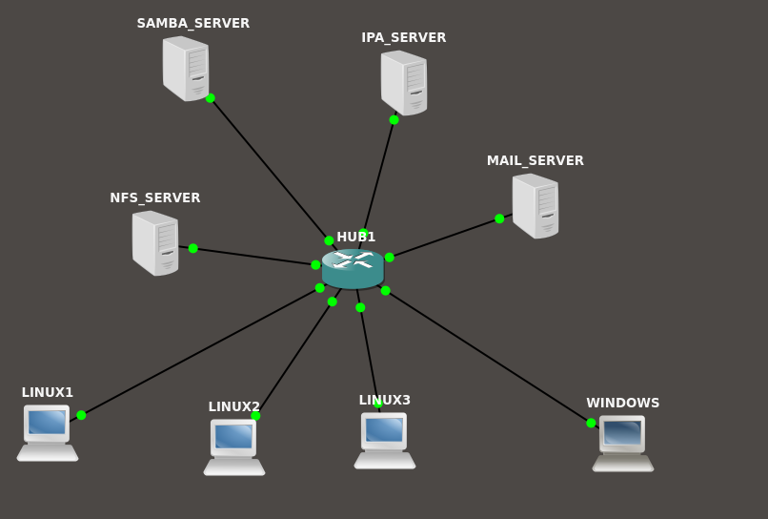

STEP 1

1) Create two user ‘smbuser1’ and ‘smbuser2’ with the IPA server. You can add it with the web interface or with the terminal.[this have to be done with the IPA server]

The samba server have to be a client of the IPA server . We make a client of the IPA server a samba server. And we have to add user from the IPA server and also add this user as a samba client . All the user creation is done by the IPA server. samba server will add the user as a samba user while creating the server.

STEP 2

update repository and install the necessary samba packages

=> yum update -y
=>yum install samba samba-client samba-common

STEP 3

Create a directory and give proper permission for that user and group

=>mkdir /share
=>chmod 777 /share

STEP 4

we have to add the user of the test group to the samba
=>smbpasswd -a smbuser1
=>smbpasswd -a smbuser2
STEP 5

Configure SElinux .you can either disable the SEinux or set the proper Boolean value and security otherwise it will not let you connect to the server. In this we are not going to disable SElinux we will change the Boolean value.

=> setsebool -P samba_export_all_ro=1 samba_export_all_rw=1
=> getsebool –a | grep samba_export
=> semanage fcontext –at samba_share_t "/share(/.*)?"
=> restorecon /share

STEP 6
we have to change the firewall settings for allowing the connection
=>firewall-cmd –permanent –add-service=samba
=>firewall-cmd –reload

STEP 7

This is the most important path of the part. we need to edit the configuration of the samba share
=> vim /etc/samba/smb.conf

[share]
comment=Directory for for samba share
browsable=yes
path=/share
writable = no
write list = smbuser1

STEP 7

Test the configuration with the ‘testparm’ command. if there is any error in the configuration this command will tell you that
=>testparm

STEP 8
restart the samba server to make the change the in effect
=>systemctl start smb
=>systemctl start nmb

STEP 9

we have to enable the smb and nmb service to make start this on boot time
=>systemctl enable smb
=>systemctl enable nmb
STEP 10

Test the connection from the server
=>smbclient -L localhost -U smbuser1

=>smbclient -L localhost -U user2

INSTALLING SAMBA CLIENT
STEP 1
install packages in the client
=>yum update -y
=>yum install samba samba-client samba-common -y
=>yum install cifs-utils -y
STEP 2

Test the connection from the client
=>smbclient -L 192.168.0.50 -U smbuser1
STEP 3

make the directory for mounting and give the proper permission
=>mkdir /share
=>chmod 777 /share
STEP 4

mount the the network share
=>mount //192.168.0.50/share /share -o username=smbuser1

STEP 5
see the the network share
=>mount | grep cifs
ADDITIONAL STEP(PERMANENT MOUNT)

adding a credential file in /share folder
=> vim /share/.smbcredentials
username=smbuser1
password=<password_for_user_1>

adding an entry to the ‘/etc/fstab’ file
=>vim /etc/fstab
add this line
//192.168.0.50/share /share cifs credentials=/share/.smbcredentials

TEST SHARE
create a file in the /share folder from the client side
=>touch /share/test.txt
Now test from the server side
=>ls -l /share

CONFIGURE DHCP SERVER ON

Requirements

→ GNS3 Software
→ ubuntu server OS
→ mikrotik cloud hosted Router OS
→ Virtualbox to boot the OS
→ VPCS (virtual small pc as a client)
→ Internet connection is a Plus

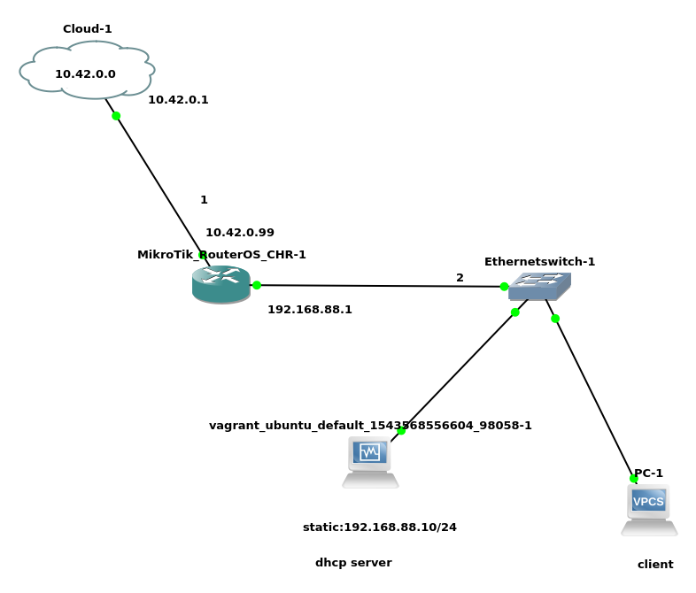
Diagram

Cloud network:10.42.0.0/24
Cloud gateway:10.42.0.1
Mikrotik Router:WAN interface ip:10.42.0.99
Mikrotik Router:LAN interface ip:192.168.88.1
Mikrotik Router:LAN network:192.168.88.0/24

Setting up everything

→ download GNS3 and install it
→ Download MIKROTIK RouterOS (Cloud hosted CHR)(.ova) image.
→ Downlaod UBUNTU Server
→ Download Virtualbox
→ Import the OVA image
a)Go to settings Then Network and activate 4 adapter(adapter1,adapter2,adapter3,adapter4) and
for the first onw Go to Advance and set Promiscuous mode → allow all
→ Then Go to GNS3 → Edit → Preference → VirtualBox Vms → New→ Select VM
→ Finish →

b) Then in the window Select Edit →Networks →Adapters set to 4

c) Then at the last option mark the
Allow GNS3 to use any configured VirtualVox adapter →yes

d) you can change ICON (Optional)

d) Then click Finish

7) install the Ubuntu image go to

a)Go to settings Then Network and activate 4 adapter(adapter1,adapter2,adapter3,adapter4) and
for the first onw Go to Advance and set Promiscuous mode → allow all
→ Then Go to GNS3 → Edit → Preference → VirtualBox Vms → New→ Select VM
→ Finish →

b) Then in the window Select Edit →Networks →Adapters set to 4 (VVI)

c) Then at the last option mark the
Allow GNS3 to use any configured Virtualbox adapter →yes

last two b and c is very very important

→ Boot up the Router OS

username:admin
password:<none>

Router Configuration

[admin@MikroTik] /ip address> add address=10.42.0.193/24 interface=ether1
[admin@MikroTik] /ip address> add address=192.168.88.10/24 interface=ether2
[admin@MikroTik] /ip route> add gateway=10.42.0.1
[admin@MikroTik] /ip firewall nat> add chain=srcnat action=masquerade
[admin@MikroTik] /ip dns> set servers=8.8.8.8
[admin@MikroTik] /> ping yahoo.com

Boot Up the ubuntu server

→ open terminal
→ set up a static ip

→ sudo vim /etc/network/interfaces

auto eth0
iface eth0 inet static
address 192.168.88.10
netmask 255.255.255.0
network 192.168.88.0
gateway 192.168.88.1
-

→ sudo /etc/init.d/networking restart

after that you would be able to connect to the internet

Install DHCP Server

update the repo
→sudo apt-get update
install the dhcp packages
→ sudo apt-get install isc-dhcp-server

Configure the server

→ cd /etc/dhcp
→ vim dhcpd.conf

option domain-name “mydomain.org”;
### just add a domain name
option domain-name-servers 8.8.8.8;

## This is a very basic subnet declaretion

subnet 192.168.88.0 netmask 255.255.255.0{
range 192.168.88.20 192.168.88.200;
option routers 192.168.88.1;

}

#explanation
subnet <give the network> netmask<give subnet>{
range <starting ip in the range(your wish)> <ending ip of the range(your wish) >;
option routers <gateway>}

Restart The server

→ sudo /etc/init.d/isc-dhcp-server restart

Client Side

→ BOOT UP THE CLIENT(in this case I use VPCS)

PC-1> ip dhcp
DDORA
IP 192.168.88.21/24 GW 192.168.88.1→ test it
PC-1> ping 8.8.8.8
84 bytes from 8.8.8.8 icmp_seq=1 ttl=116 time=59.929 ms
84 bytes from 8.8.8.8 icmp_seq=2 ttl=116 time=65.707 ms

→ if you are running linux client just oprn a terminal and type
->dhclient

