Setting Ip address in Debian Server

Every Server needs to have a network connection. without a static ip address you cant run a server . Giving a server a static ip address is the most important think to do.

When you install a server the most of the time your installer automatically configure your server network and gets the ip address from a DHCP server. But to run a server you need a static ip address. So we need to change its network from DHCP to static and give the server a static ip address .Here we talk about how to give static ip address to a debian server.

There are multiple way to give server static address , Here we talk about two method

First Method:

Setting the ip address in a debian machine with a easy method
You have to follow these steps

first:

you need to select a static ip address , subnet mask and the gateway that you give your machine . according to your network specifications.

In his example we used a virtual debian box . And we give the following ip address subnet mask , gateway and Dns

ip address : 192.168.0.10
subnet mask: 255.255.255.0
Gateway:192.168.0.1
DNS: 8.8.8.8

second:

you need to find the network interface that you give the static ip address
A Server can have multiple network interface.

In our virtual machine there are two network interface. We can see the interface from this command

=>ifconfig
or
=> ip address show

result:

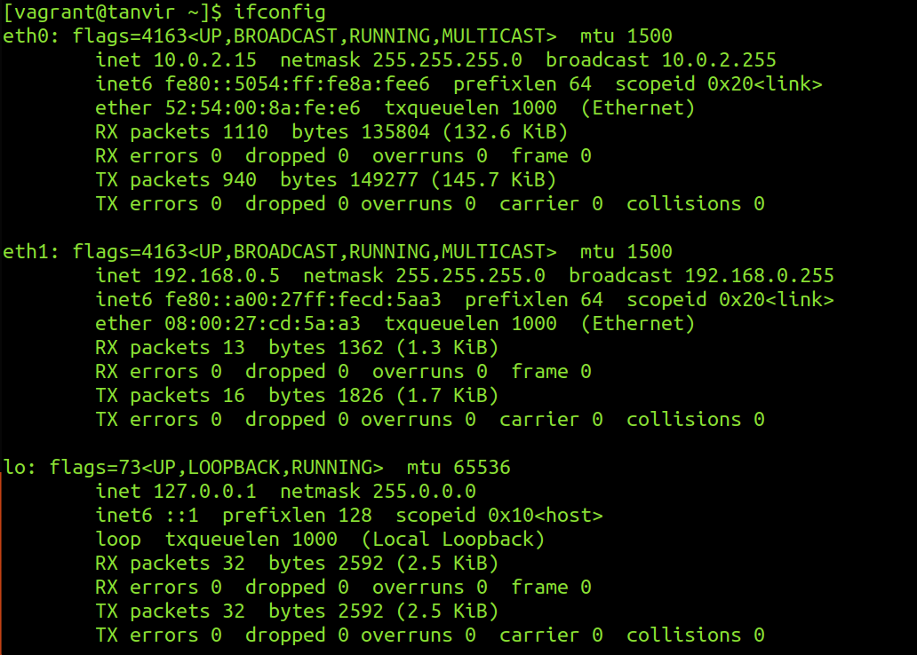
we are currently connected to the server with a ssh connection through eth0.So we cant change the ip address to eth0.this will disconnect the ssh connectivity .we are going to give the static ip address to the eth1 interface

Third:

use the nmtui command and you have to be root to give this command

=>sudo nmtui

After giving this command this screen appear. From there Select The “Edit a connection”

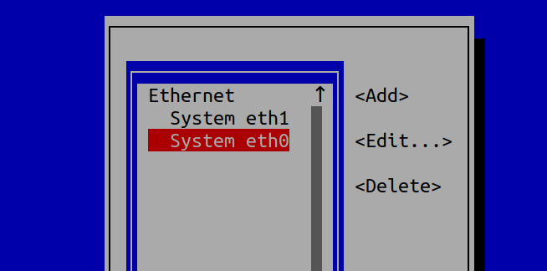

Fourth:
it will show you all the interface .choose your interface in this case we will choose eth1.

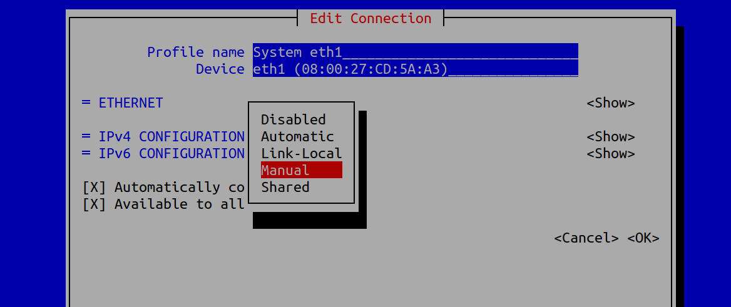

Fifth:
we choose the ipv4 and from the option we choose ‘manual’ and Edit the menu

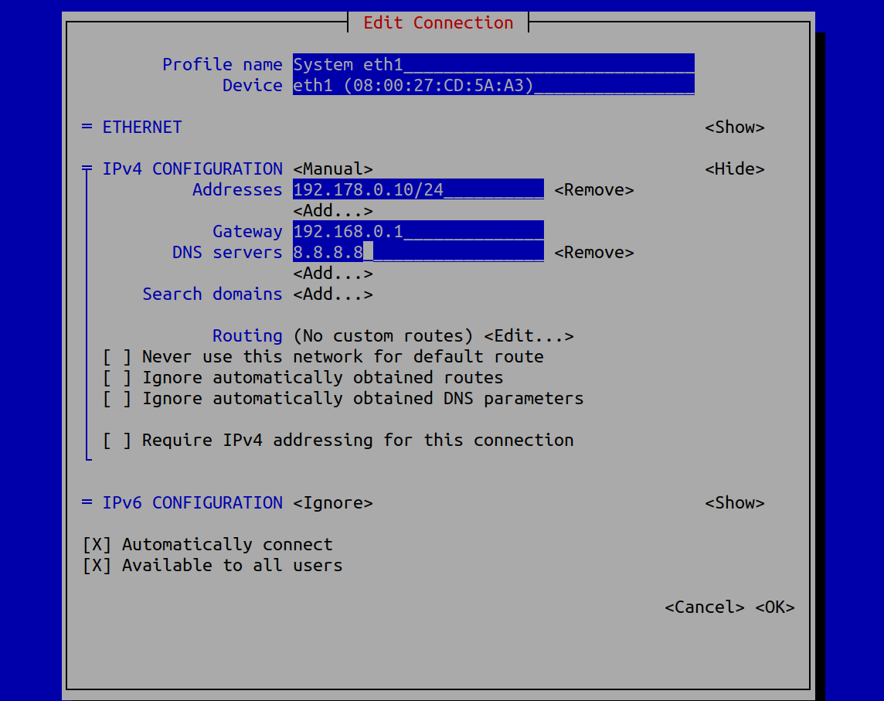

Sixth:
we give the ip address.we have to give the subnet mask with CIDR notation.
Gateway and the The DNS address and click ok. Then quit the program.

Seventh:
if we see our ip address we can see the the ip address still dont change.to make the change we need to restart the interface.

We shutdown the interface with this command

=>sudo ifdown eth1
or
=>nmcli connection down eth1

Then we start the interface again

=>sudo ifup eth1
or
=>nmcli connection up eth1

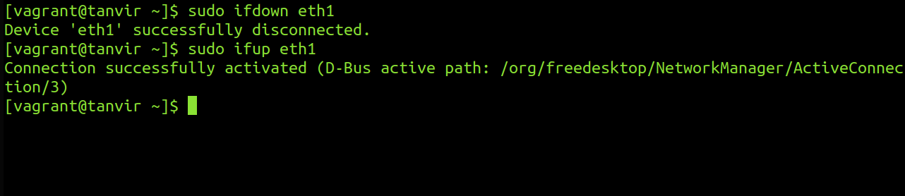

Eighth:
Then if we check ip address using
=>ifconfig eth1

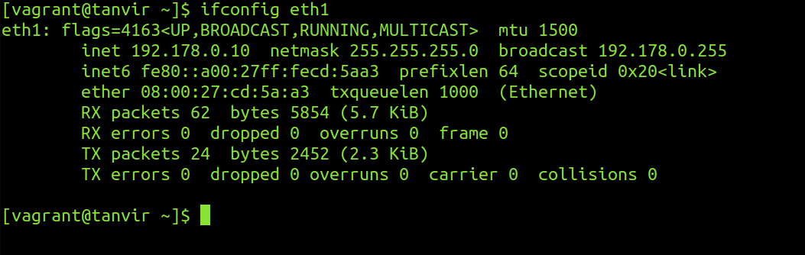

we can see the ip address changed .

Ninth:

We have to test the connection via pinging a network.

=>ping 8.8.8.8

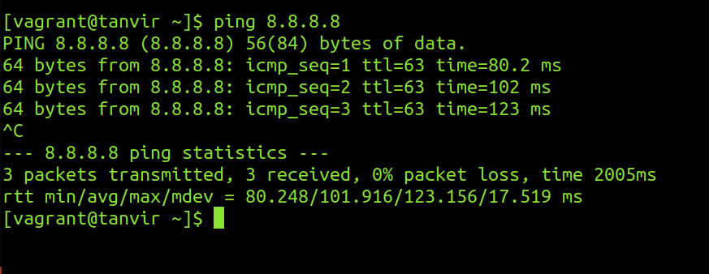

So the connection is up and running.Thats is the easy way of giving a static ip address to a Debian server

