SETTING UP PROXY CHACHING SERVER IN UBUNTU

squid proxy caching server install (server side configuration steps)

1) update the repository in centos
=> apt update -y
or,
=> apt-get update

2) install squid packages
=> apt install squid -y
or,
=> apt-get install squid -y

3) enable and start the squid service in boot time

=> systemctl enable squid
=> systemctl start squid

4) check the status of the process
=> systemctl status squid

5) Edit the squid configuration file in This configuration
→we can write acl for the client who can use the proxy server
→ we can select the cache memory
→ allow or deny specific network for using acl
→ block or allow specific website for the proxy server client

=> vim /etc/squid/squid.conf

* by default squid listen to the port 3128 you can change it and set a different port. If we wnt to change the prt we have to change the line http_port and specify the new port

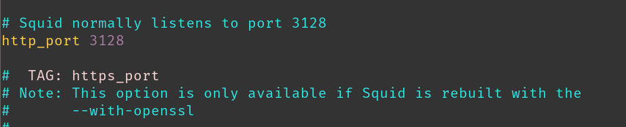

http_port : port

you can control the access of the squid server with acl (Access Control List)

you can create a text file with the list of the ip address with the allowed ip address and include with the acl and deny all other ip address that will prevent the other client to connect to the proxy server.

* create a file with allowed ip address name “allowed_ips.txt”

=>vim allowed_ips.txt
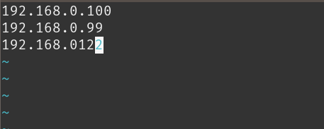

192.168.x.x
192.168.x.x
192.168.x.x
192.168.x.x
192.168.x.x

*now add the file to the acl .

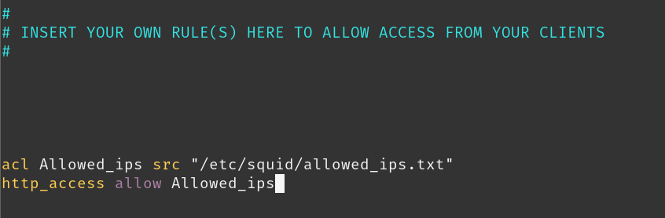

=> vim /etc/squid/squid.conf

## syntax

#acl <name> src “<filepath>”
#http_access allow <name>

acl Allowed_ips src ‘/etc/squid/allowed_ips.txt’
http_access allow Allowed_ips

or you can give access to all the client by allowing all the clients

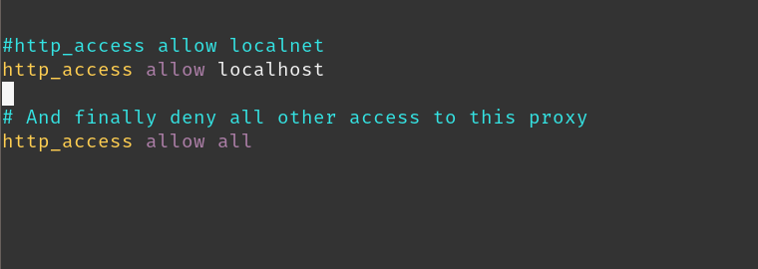

http_access allow all

after changing the configuration we have to restart the service so that the configuration change successfully loaded.

=>systemctl restart squid

MONITOR USER ACCESS AND CACHE OF THE SERVER

1) monitor the access of the user
we go to the file ‘/var/log/squid/access.log’

=> tail -f access.log
=> cat -f access.log | more

2) monitor the cache of the user
we go to the file ‘/var/log/squid/cache.log’

=> tail -f cache.log
=> cat -f cache.log | more

Thats the basic configuration of setting a squid proxy server in Ubuntu server.

