SETTING UP COCKPIT FOR SERVER AND PROCESS ADMINISTTRATION
IN CENTOS SERVER

Cockpit is a free open source system monitoring application which is considered a basic web based tool to monitor and configure basic services system health and monitor multiple server and their performances. it will let you start/stop services, generate diagnostic report,manage users,network,vlan, multiple servers with a graphical user interface .you can monitor multiple server with a single interface.its a very important tools for the beginner system administrator and lets you monitor almost everything of a system.

INSTALLING COCKPIT IN CENTOS:

1) Assign static ip address of your centos system
[you can find they way in the ip address section]

2) install “epel-release” repository in the system
=>yum install epel-release -y

3) update the repository

=>yum update -y

4) install cockpit
=>yum install cockpit

[you can directly fetch the source code from the github and compile too but in centos7 cockpit is in the epel-release so you need to do that]

5) enable the service in the boot time
=>systemctl enable cockpit.socket

6)Edit the configuration and disable the SSL

=>vim /usr/lib/systemd/system/cockpit.service

[Unit]
Description=Cockpit Web Service
Documentation=man:cockpit-ws(8)
Requires=cockpit.socket

[Service]
ExecStartPre=/usr/sbin/remotectl certificate --ensure --user=root --group=cockpit-ws --selinux-type=etc_t
ExecStart=/usr/libexec/cockpit-ws --no-tls
PermissionsStartOnly=true
User=cockpit-ws
Group=cockpit-ws

→ add ‘--no-tls’ after the ‘ExecStart=/usr/libexec/cockpit-ws’ line

=>ExecStart=/usr/libexec/cockpit-ws –no-tls

This will disable the SSL.

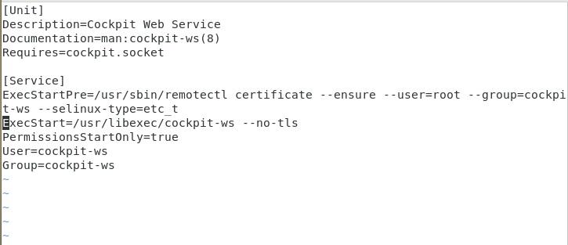
7) restart the service

=>systemctl restart cockpit.socket

8)go to web browser and type <ip_address>:9090

[port:9090]

9)Enter the root user and password to login

10) This page you can monitor
→ system memory
→ Disk I/O
→ network traffic
→ CPU performance
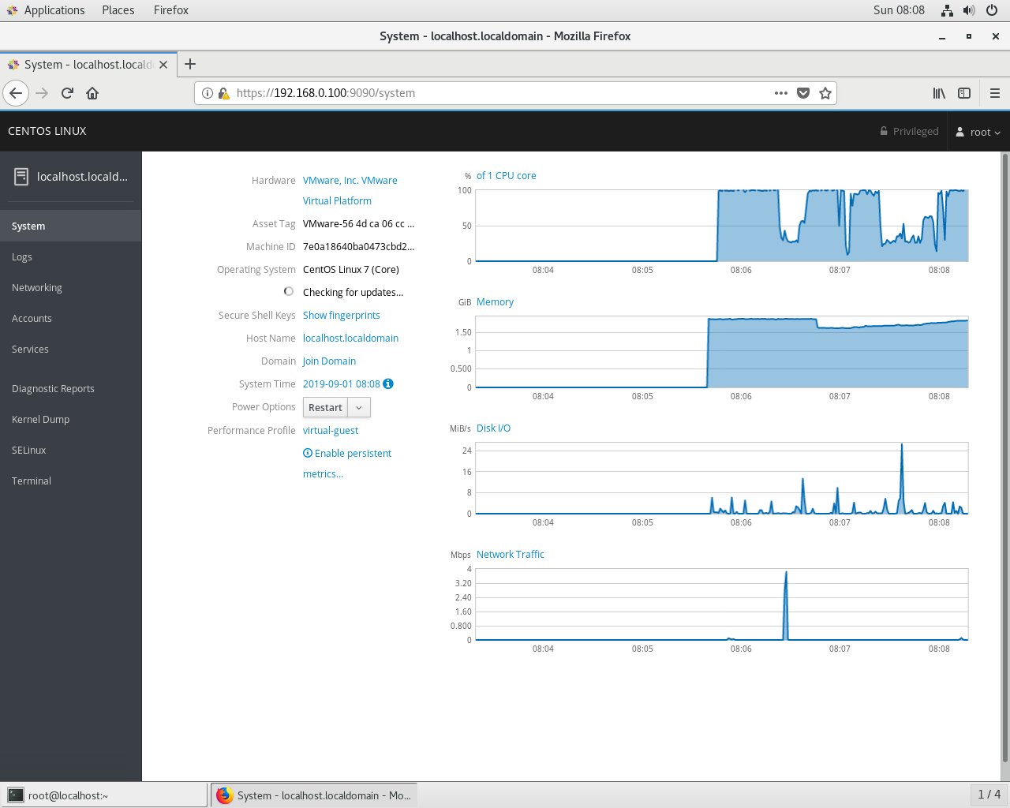

11) This page you can monitor system logs
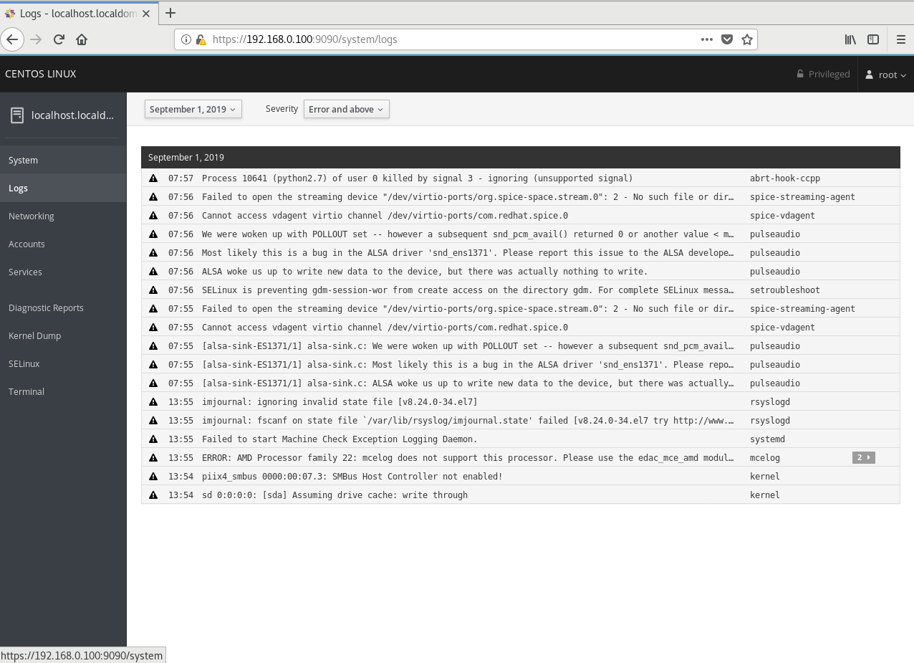

12) This page you can monitor networking and firewall and network interface,you can add vlan,bridge and team
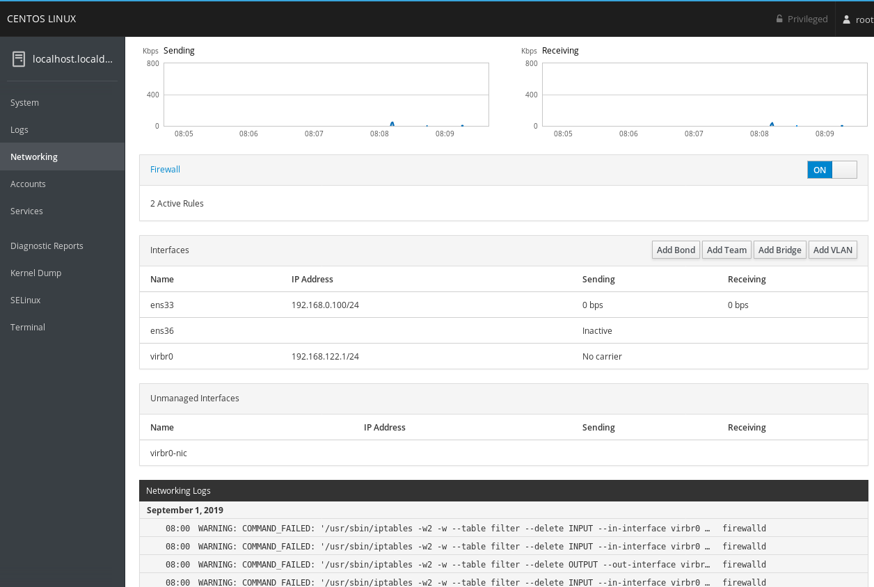
13)
You can also monitor the user .you can add or remove the user from this page.
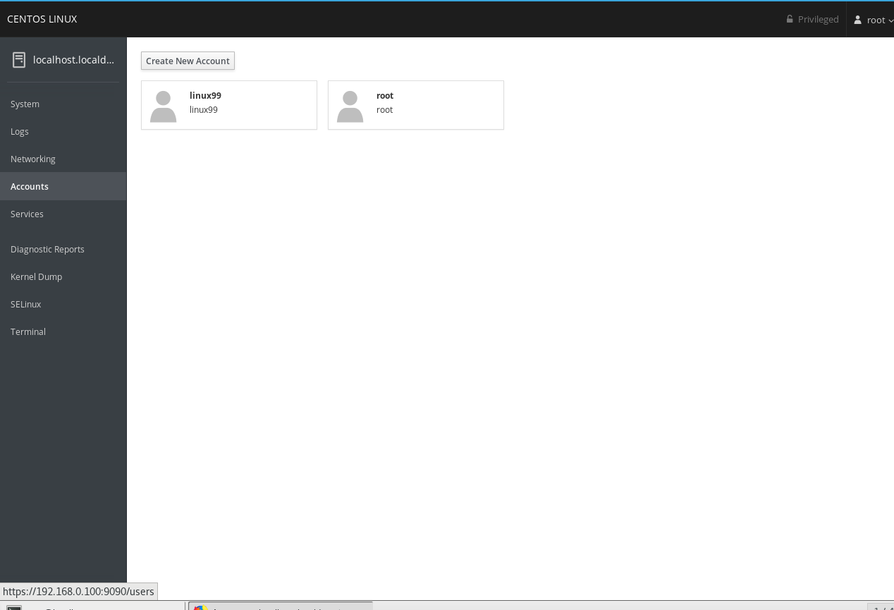

14)
you can monitor and control all the service

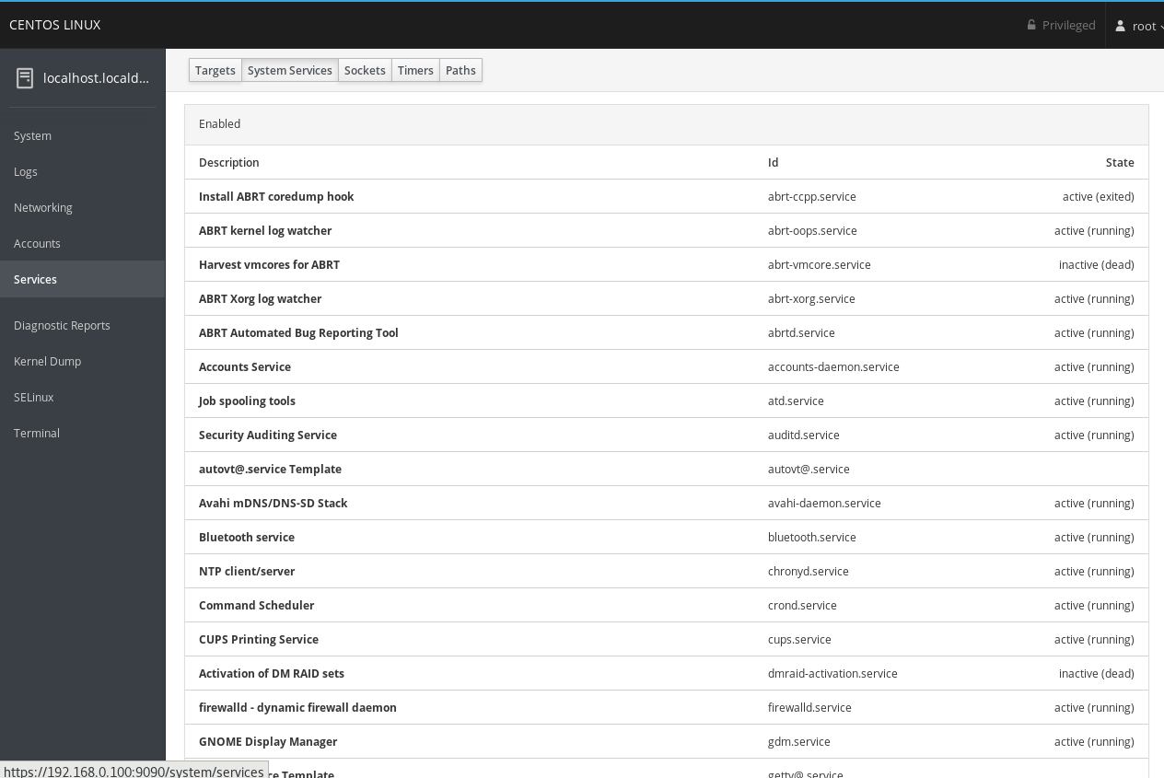

15) Most Importantly you can generate diagnostic report od the whole system with that.
