SETTING UP COCKPIT FOR SERVER AND PROCESS ADMINISTRATION
IN UBUNTU SERVER

INSTALLING COCKPIT IN UBUNTU:

1) Assign static ip address of your UBUNTU system
[you can find they way in the ip address section]

2) update the repository

=>apt update -y

3) install cockpit
=>apt install cockpit -y

[you can directly fetch the source code from the github and compile too ]

4) enable the service in the boot time
=>systemctl enable cockpit.socket

7) restart the service

=>systemctl restart cockpit.socket

8)go to web browser and type <ip_address>:9090

[port:9090]

9)Enter the root user and password to login

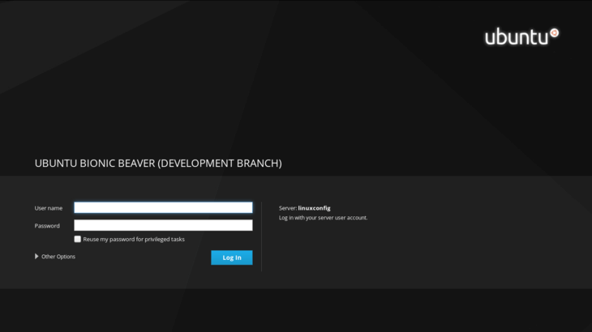

10) This page you can monitor
→ system memory
→ Disk I/O
→ network traffic
→ CPU performance

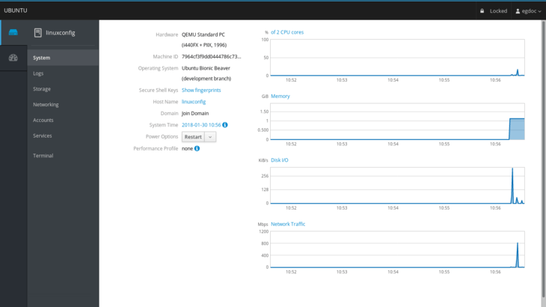

11) This page you can monitor system logs

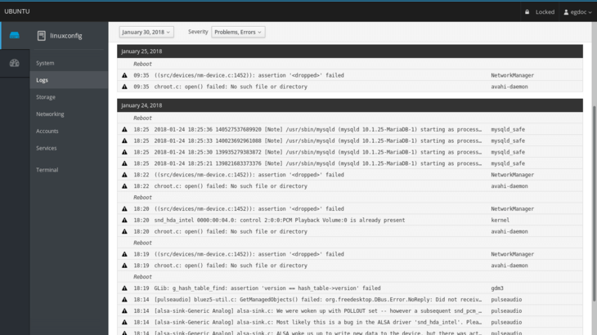
12) This page you can monitor networking and firewall and network interface,you can add vlan,bridge and team

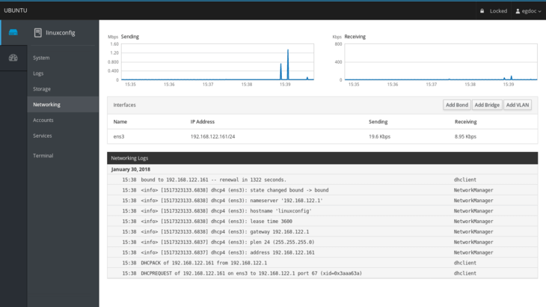

13)
You can also monitor the user .you can add or remove the user from this page.

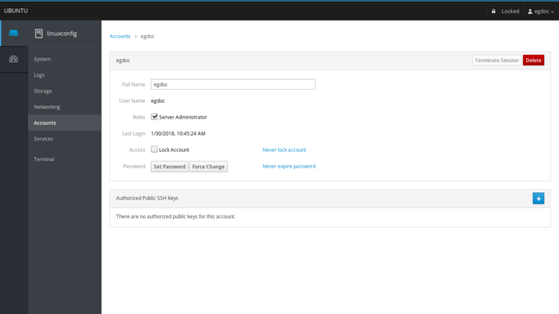

14)
you can monitor and control all the service
