SETTING UP SIMPLE DHCP SERVER IN UBUNTU SERVER ON GNS3

Equipment we use:
1)GNS3 Software
2)ubuntu server OS
3)mikrotik cloud hosted Router OS
4)Virtualbox to boot the OS
5)VPCS (virtual small pc as a client)
6)Internet connection is a Plus

Diagram:

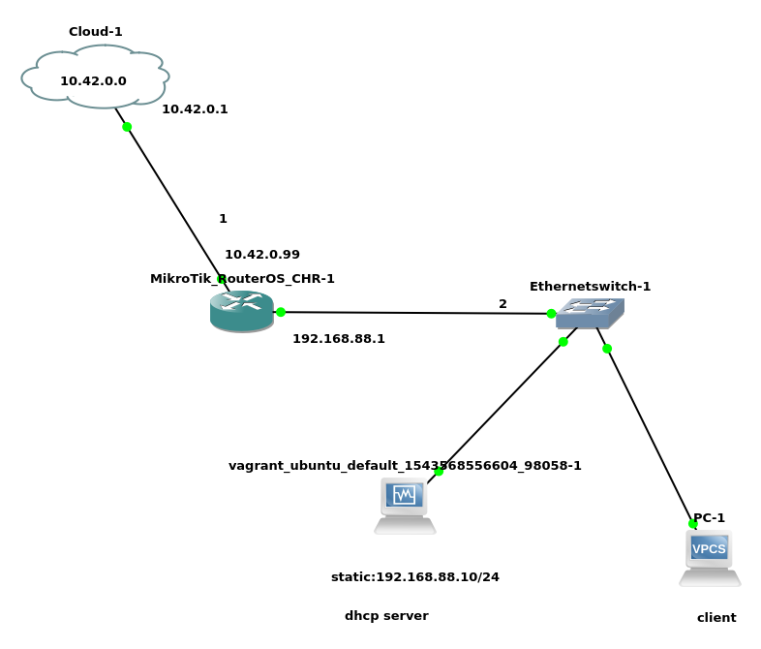
Cloud network:10.42.0.0/24
Cloud gateway:10.42.0.1
Mikrotik Router:WAN interface ip:10.42.0.99
Mikrotik Router:LAN interface ip:192.168.88.1
Mikrotik Router:LAN network:192.168.88.0/24

Setting up every thing:(VVI)

1) first download GNS3 and install it
2)Download MIKROTIK RouterOS (Cloud hosted CHR)(.ova) image.
3) Downlaod UBUNTU Server
5)Download Virtualbox
6) Import the OVA image
a)Go to settings Then Network and activate 4 adapter(adapter1,adapter2,adapter3,adapter4) and
for the first onw Go to Advance and set Promiscous mode → alow all
→ Then Go to GNS3 → Edit → Preference → VirtualBox Vms → New→ Secect VM
→ Finish →

b) Then in the wimdow Select Edit →Networks →Adapters set to 4 (VVI)

c) Then at the last option mark the
Allow GNS3 to use any configured VirtualVox adapter →yes

d) you can change ICON (Optional)

d) Then click Finish

7) install the Ubuntu image go to

a)Go to settings Then Network and activate 4 adapter(adapter1,adapter2,adapter3,adapter4) and
for the first onw Go to Advance and set Promiscous mode → alow all
→ Then Go to GNS3 → Edit → Preference → VirtualBox Vms → New→ Secect VM
→ Finish →

b) Then in the wimdow Select Edit →Networks →Adapters set to 4 (VVI)

c) Then at the last option mark the
Allow GNS3 to use any configured Virtualbox adapter →yes

last two b and c is very very important

Use the same virtualization technique not mixed one for example (do not use the KVM and VIRTUALBOX simultaniously) use virtualbox for all

→ Boot up the Router OS
username:admin
password:<none>

Router Configuration:

[admin@MikroTik] /ip address> add address=10.42.0.193/24 interface=ether1
[admin@MikroTik] /ip address> add address=192.168.88.10/24 interface=ether2
[admin@MikroTik] /ip route> add gateway=10.42.0.1
[admin@MikroTik] /ip firewall nat> add chain=srcnat action=masquerade
[admin@MikroTik] /ip dns> set servers=8.8.8.8
[admin@MikroTik] /> ping yahoo.com

→ Boot up The UBUNTU SERVER

a) open terminal (or if you use base image)
b)set up a static ip (very very imp)
command:

→ sudo vim /etc/network/interfaces

auto eth0
iface eth0 inet static
address 192.168.88.10
netmask 255.255.255.0
network 192.168.88.0
gateway 192.168.88.1
#########################################

→ sudo /etc/init.d/networking restart

c) after that you would be able to connect to the internet

d) install dhcp server

1) first update the reop
→sudo apt-get update
2)install the dhcp packages
→ sudo apt-get install isc-dhcp-server

d)configure the server
→ cd /etc/dhcp
→ vim dhcpd.conf

option domain-name “mydomain.org”;
### just add a domain name
option domain-name-servers 8.8.8.8;

## This is a very basic subnet declaretion

subnet 192.168.88.0 netmask 255.255.255.0{
range 192.168.88.20 192.168.88.200;
option routers 192.168.88.1;

}

