SAMBA SERVER WITH IPA SERVER IN CENTOS 7

installing samba server(server side configuration):

requirements :
1) Centos server , ip: 192.168.0.50
2) client (ubuntu or centos), ip: 192.168.0.100
3) internet connection
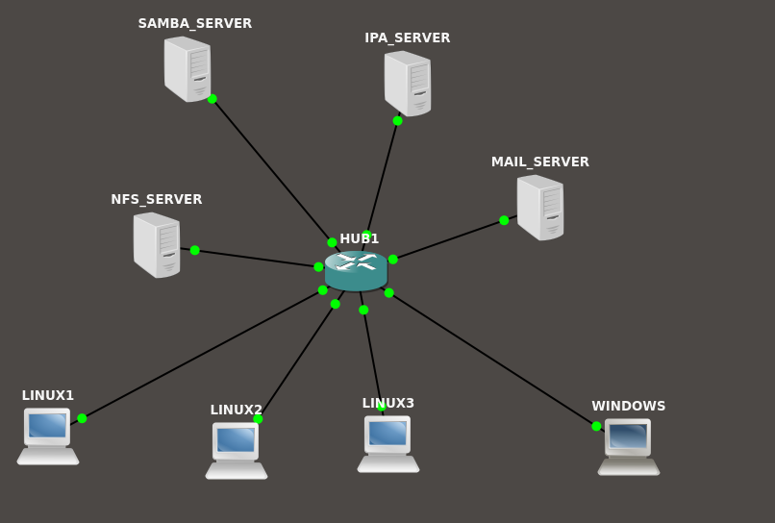

step1:

1) Create two user ‘smbuser1’ and ‘smbuser2’ with the IPA server. You can add it with the web interface or with the terminal.[this have to be done with the IPA server]

The samba server have to be a client of the IPA server . We make a client of the IPA server a samba server. And we have to add user from the IPA server and also add this user as a samba client . All the user creation is done by the IPA server. samba server will add the user as a samba user while creating the server.

step2:

update repository and install the necessary samba packages

=> yum update -y
=>yum install samba samba-client samba-common

step3:

Create a directory and give proper permission for that user and group

=>mkdir /share
=>chmod 777 /share

step4:

we have to add the user of the test group to the samba
=>smbpasswd -a smbuser1
=>smbpasswd -a smbuser2

step5:

Configure SElinux .you can either disable the SEinux or set the proper Boolean value and security otherwise it will not let you connect to the server. In this we are not going to disable SElinux we will change the Boolean value.

=> setsebool -P samba_export_all_ro=1 samba_export_all_rw=1
=> getsebool –a | grep samba_export
=> semanage fcontext –at samba_share_t "/share(/.*)?"
=> restorecon /share

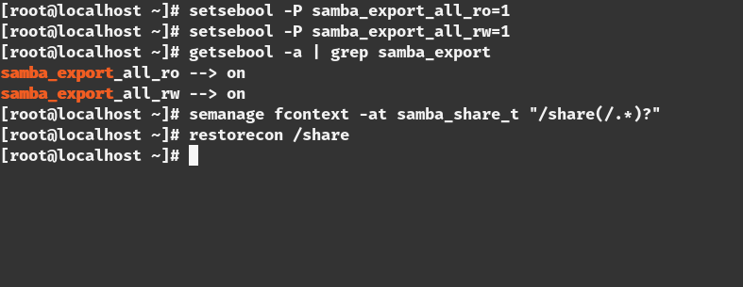

step6:

we have to change the firewall settings for allowing the connection
=>firewall-cmd –permanent –add-service=samba
=>firewall-cmd –reload

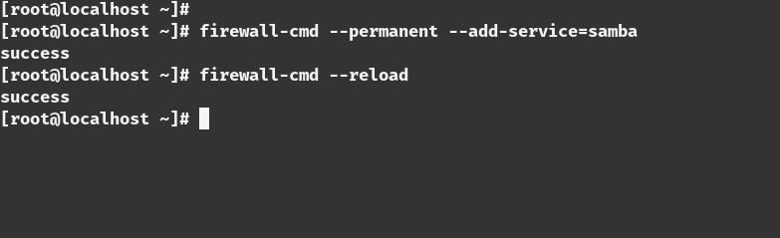

step7:

This is the most important path of the part.we need to edit the configuration of the samba share
=> vim /etc/samba/smb.conf

[share]
comment=Directory for for samba share
browsable=yes
path=/share
writable = no
write list = smbuser1

step8:

Test the configuration with the ‘testparm’ command.if there is any error in the configuration this command will tell you that
=>testparm

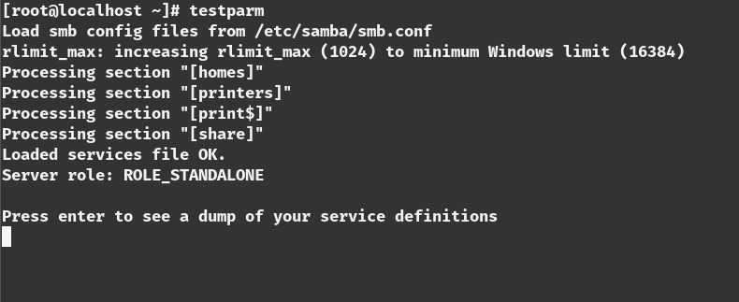

step9:

restart the samba server to make the change the in effect
=>systemctl start smb
=>systemctl start nmb

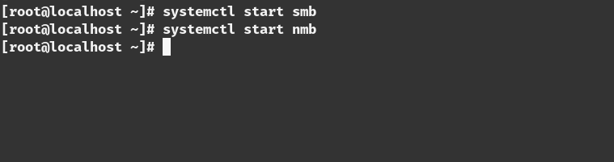
step10:

we have to enable the smb and nmb service to make start this on boot time

=>systemctl enable smb
=>systemctl enable nmb

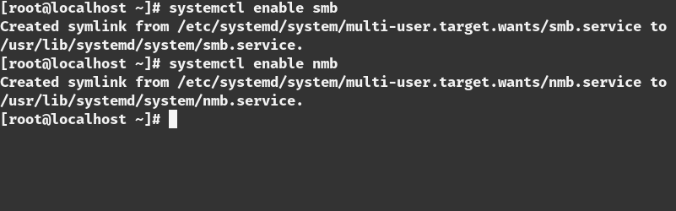

step11:

Test the connection from the server
=>smbclient -L localhost -U smbuser1

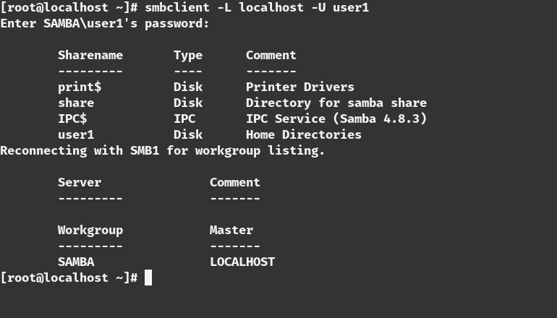
=>smbclient -L localhost -U user2

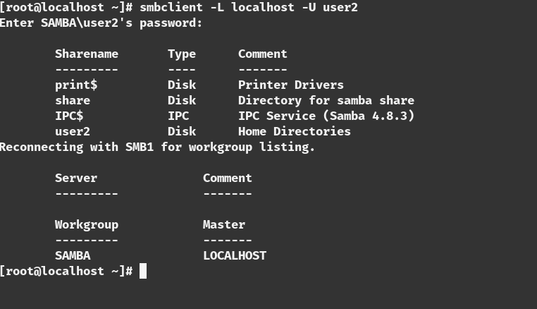

installing samba Client(linux client):

step1:

install packages in the client
=>yum update -y
=>yum install samba samba-client samba-common -y
=>yum install cifs-utils -y

step2:

Test the connection from the client
=>smbclient -L 192.168.0.50 -U smbuser1

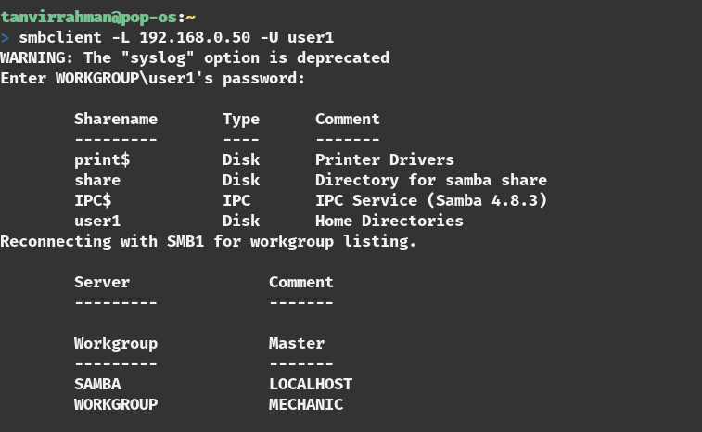

step3:

make the directory for mounting and give the proper permission
=>mkdir /share
=>chmod 777 /share

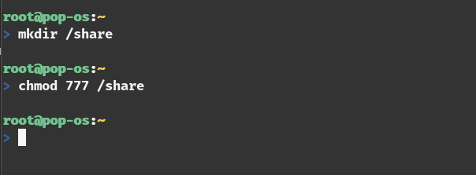

step4:

mount the the network share
=>mount //192.168.0.50/share /share -o username=smbuser1

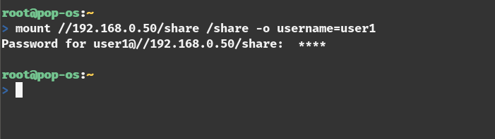

step5:

see the the network share
=>mount | grep cifs

Additional step(permanent mount):

adding a credential file in /share folder
=> vim /share/.smbcredentials
username=smbuser1
password=<password_for_user_1>

adding an entry to the ‘/etc/fstab’ file
=>vim /etc/fstab

//192.168.0.50/share /share cifs credentials=/share/.smbcredentials

Test the share:
create a file in the /share folder from the client side
=>touch /share/test.txt

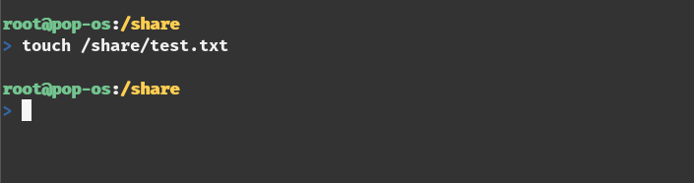

Now test from the server side
=>ls -l /share

