INSTALL AND CONFIGURE OPEN LITESPEED WEB SERVER IN CENTOS7

OpenLiteSpeed is the Open Source edition of LiteSpeed Web Server Enterprise.
Both servers are actively developed and maintained by the same team, and are held to the same high-quality coding standard.
OpenLiteSpeed contains all of the essential features found in LiteSpeed Enterprise, and represents our commitment to support the Open Source community.
It specially designed for handling huge web traffic such as corporate data center.This web server is shipped with a control panel and it replaces the Apache web server. You can use open litespeed web server inset of the apache webser with php and mysql.Its a high performance web server and it is faster than apache web server. It is far more advance than the apache web server.it has built in admin tools,monitoring,logging and a easy used interface for setting up virtual host and block or allow content.

Install litespeed webserver with php and mysql in centos

1) install the ‘epel-release’ repository

=>yum install epel-release -y

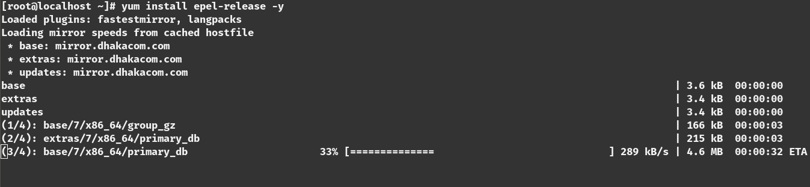

2) install the lite-speed web server repository

=>rpm -ivh http://rpms.litespeedtech.com/centos/litespeedrepo-1.1-1.el7.noarch.rpm

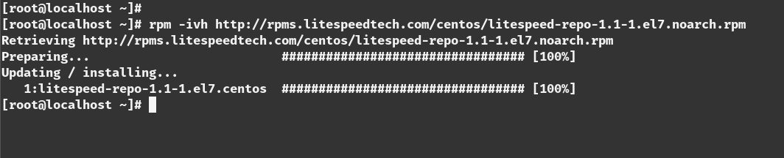

3) install the ‘mariadb-server’ and ‘litespeed’ web server because we will work with php and mariadb with the litespeed webserver

=>yum install openlitespeed mariadb-server -y

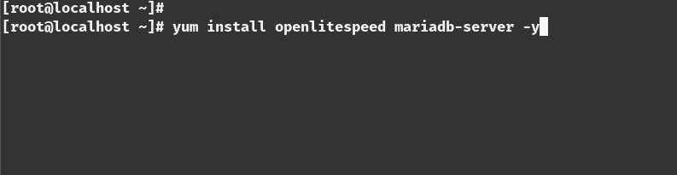

4) install the php and php-mysql library

=> yum install lsphp56 lsphp56-mysql -y

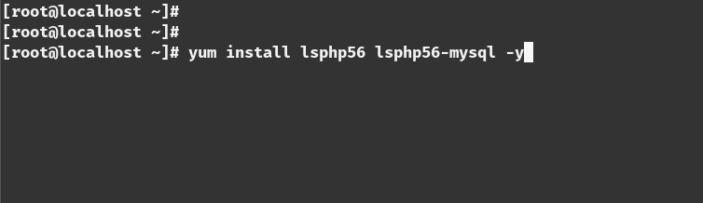

[you can install another version if you want,for example lsphp70,lsphp72,lsphp60 etc]

5) change the admin password of the web server admin panel

=>/usr/local/lsws/admin/misc/admpass.sh

[give the admin name and password]

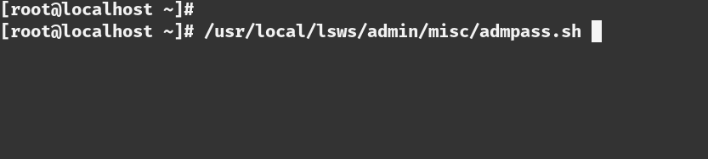

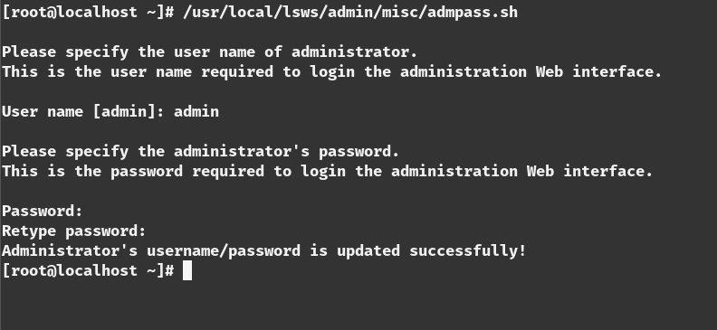

6) create a linkof the php executable

=>ln -sf /usr/local/lsws/lsphp56/lsphp /usr/local/lsws/fcgi-bin/lsphp5

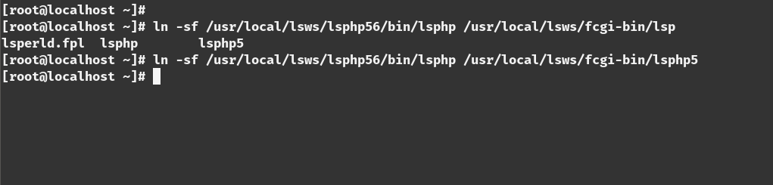

7) Start the mariadb server

=>systemctl start mariadb

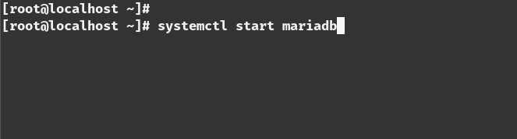

8) Enable the database server for running on boot time

=>systemctl enable mariadb

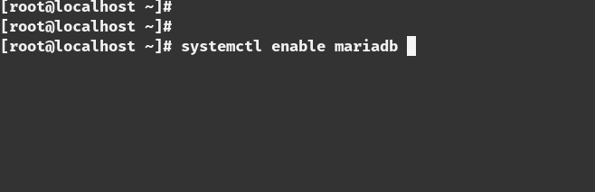

9) Change the mariadb root password

=>mysql_secure_installation

[enter the root password and change the default password]

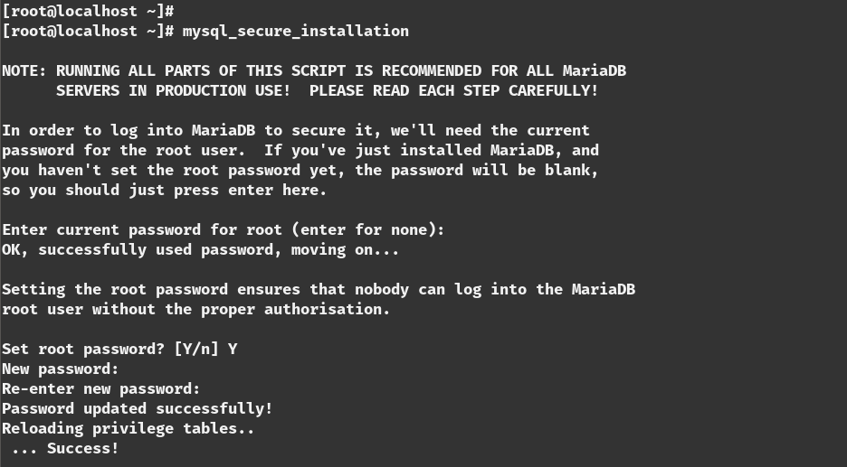

10) see the status of the openlitespeed server

=>systemctl status lsws
or
=>service lsws status

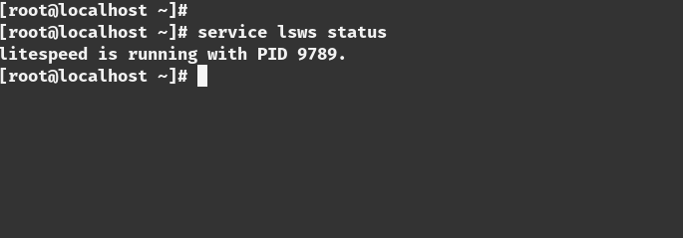
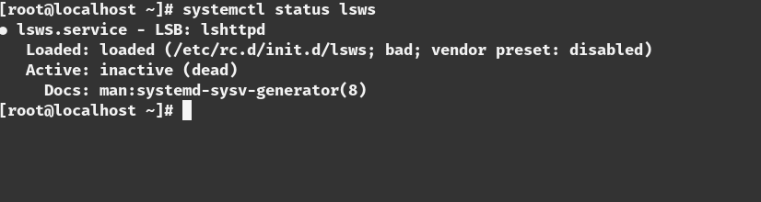

11) Open Terminal and type ‘ifconfig’ to know your ip address

=>ifconfig

12) go to the addres of your host with the browser

=><ip_address>:8088

[8088 port is the main web server port]
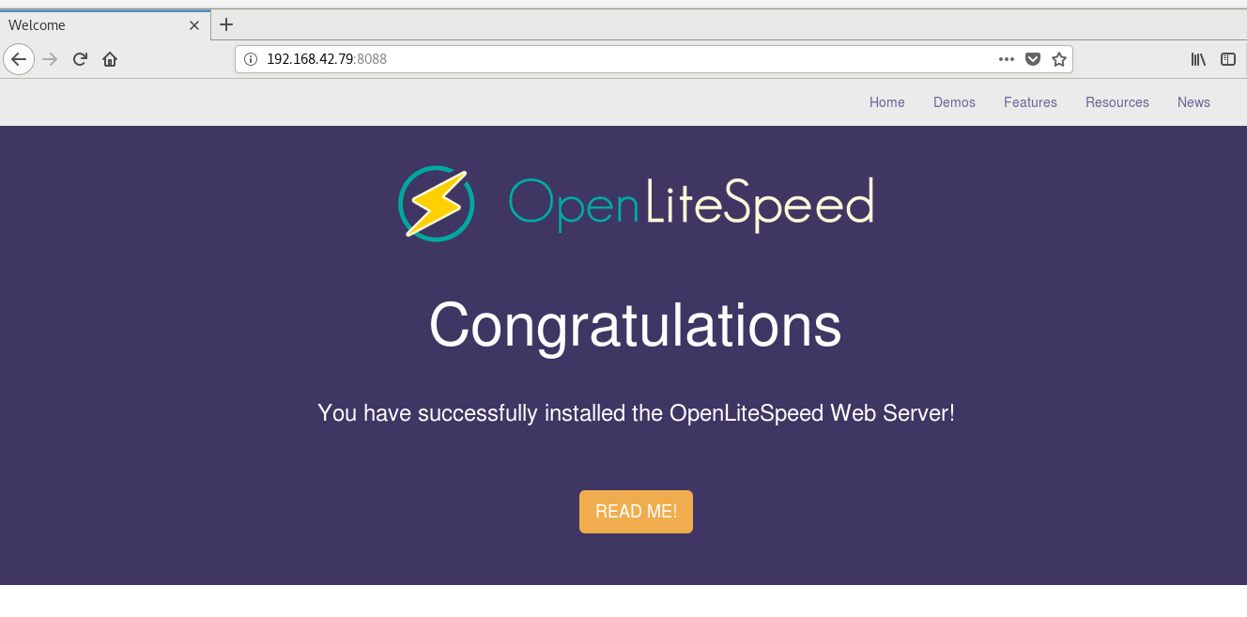

13) Test the installed php by clicking this button

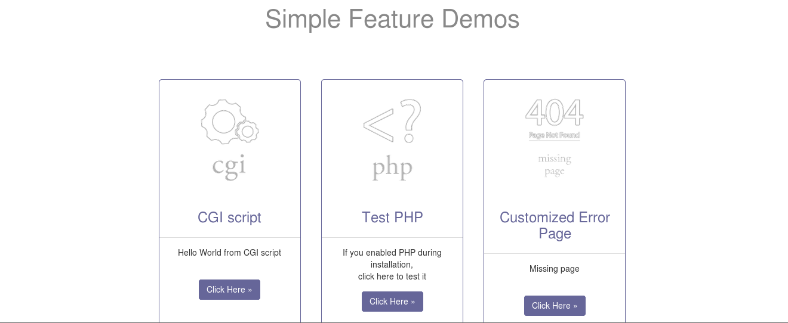

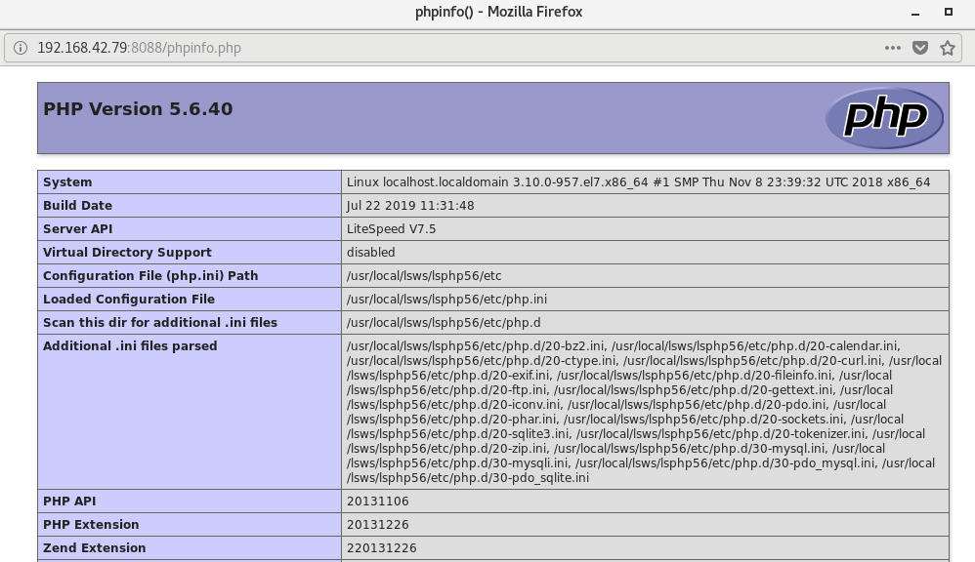
[if this page shows that means php working perfectly]

14) You can change the settings of the blocked content and the upload file permission here

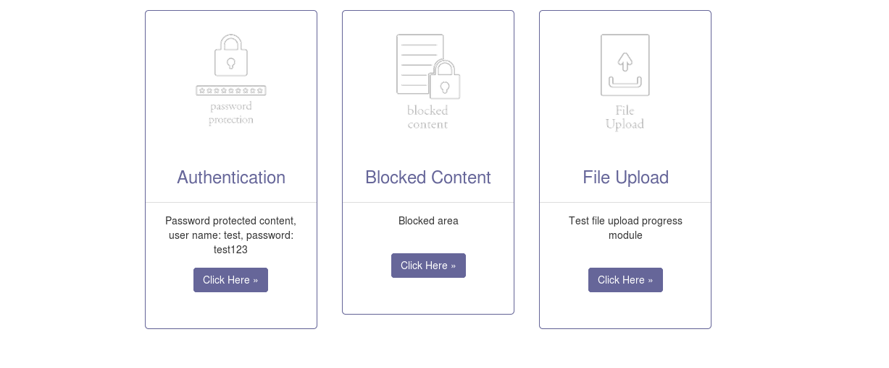

15) Go to the admin panel

=><your_ip>:7080

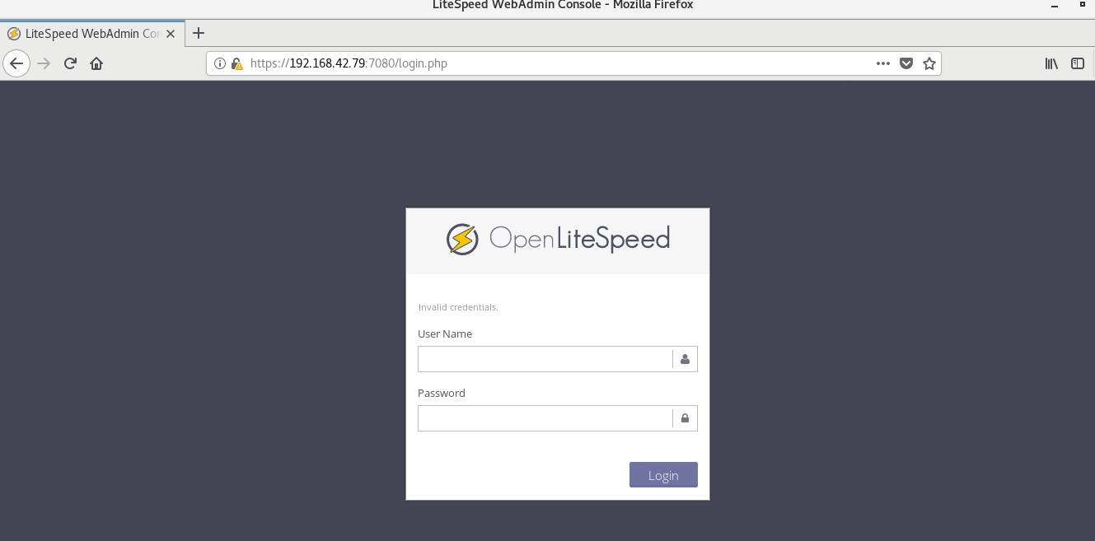

[7080 port is the admin port for the webserver]

16) You can check all the status here

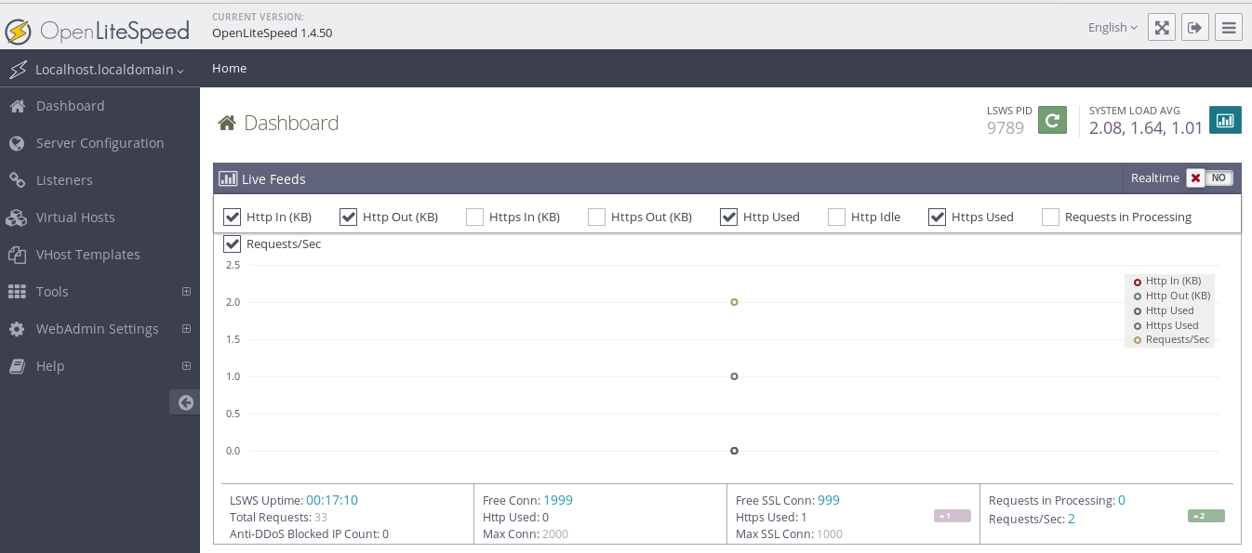

RUN A PHP CODE IN THIS SERVER:

1) go to ‘/usr/local/lsws/Example/html’ directory

=>cd /usr/local/lsws/Example/html

2) you can remove the existing content here [optional]

=>rm -rf *

3) add a php file name ‘index.php’ with you favorite text editor

=>vim index.php

<?php

echo “Working Perfectly”;

?>

4) go to the admin page with the browser and go to the Virtual Host option

5)Select The ‘Example’ host

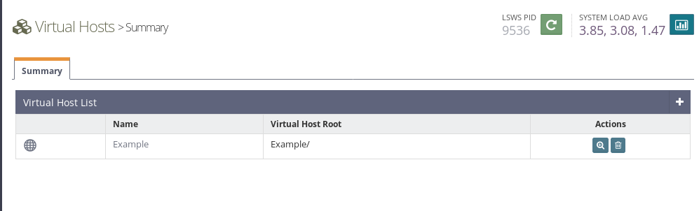

6) add ‘index.php’ to the Auto index option under Index Files

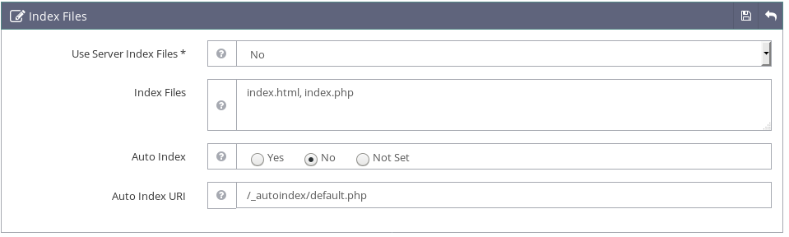

7) Change the ‘Auto load from .htaccess’ to ‘Yes’ Under Rewrite control

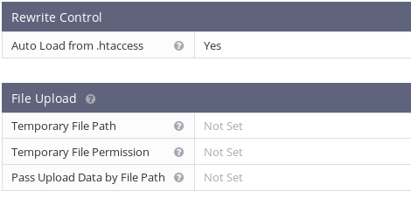

8) restart the web server

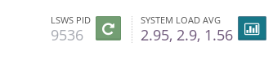

9)visit the page ‘<your_ip>:8088/index.php’

